EECS 3311: Software Design

Lab 5: Design of Tic-Tac-Toe game with undo/redo

Group Members: Dan Sheng login:
Andrew Ferreira login: acferr

Date: March 13, 2017

Tic-Tac-Toe Game Top Level View of Design

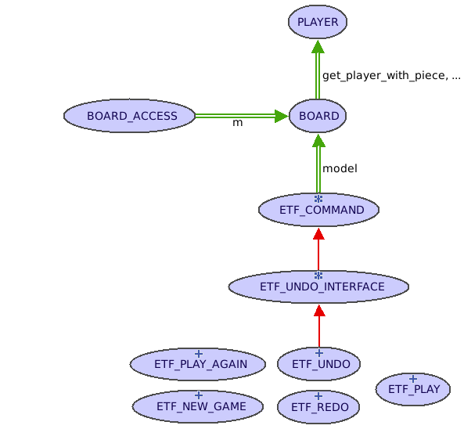
Figure 1: Top level BON diagram of our Tic-Tac-Toe game design.

