The Ultimate Spring Lawn Care & Upkeep Guide
What if this year, your yard didn't just wake up from winter—it truly came alive?
We believe every homeowner deserves a vibrant, healthy green space. It's the perfect backdrop for family moments as the weather warms. That's why we created this essential guide.

Think of this as your personal roadmap. We'll walk you through every step, from assessing winter's impact to establishing a robust maintenance routine. Our approach combines expert knowledge with straightforward, actionable advice. It works for both cool-season and warm-season grass zones in the U.S.
Spring Lawn Care Schedule
A well-planned seasonal lawn care schedule makes spring maintenance easy. Your exact dates may vary based on your location. The North, South, or Transition zone can affect your schedule. Below is a quick monthly overview before we dive into the details.
Month | Primary Focus | Key Tasks | Regional Notes
Early Spring (March) | Preparation & Cleanup | Mower maintenance, debris removal, soil assessment | Cool-season zones: Begin as soil thaws. Warm-season zones: Start earlier in South.
Mid-Spring (April) | Growth & Nourishment | Fertilization, weed prevention, first mows | Warm-season lawns: Prime fertilizing time. Cool-season: Focus on weed control.
Late Spring (May) | Maintenance & Monitoring | Regular mowing, watering adjustment, pest watch | All zones in active growth. Increase watering as temperatures rise.
Early Spring (March) Tasks
March is your setup month. Your lawn is waking up. First, service your lawnmower. Sharpen the blade and change the oil. A clean cut prevents disease from entering damaged, open areas in the turf.
Next, clear away winter debris from your lawn. Remove leaves, branches, and matted grass. This lets sunlight reach the soil and helps it warm up faster. A light raking removes thatch without damaging new growth. It will also prevent matted grass from dying and helps lawns recover from snow mold.
Mid-Spring (April) Tasks
April is when growth kicks into gear. Your lawn is actively greening up and needs fuel. Apply your first round of fertilizer now, if you have warm-season grass like Bermuda or Zoysia.
Weed prevention remains critical. If you didn't apply a pre-emergent in fall, consider a spring application to stop crabgrass. Spot-treat any early weeds that appear.
You'll likely begin mowing this month. Set your mower blade high for the first cut—about 3 inches. This encourages deep root growth and shades out weeds. Never remove more than one-third of the grass blade at once.
Late Spring (May) Tasks
By May, you're in full maintenance mode. Mowing becomes a regular weekly task. Keep your mower blade sharp. Alternate your mowing pattern each time to avoid soil compaction.
As temperatures rise, monitor your lawn's watering needs. Early morning is the best time to water. Aim for deep, infrequent watering.
Watch for signs of pests or disease. Chinch bugs and fungal issues can emerge in late spring. Catching problems early makes them much easier to manage.
Following this spring lawn care schedule ensures your lawn gets exactly what it needs at the right time. Consistency now builds a resilient turf ready for summer. Your neighbors will notice the difference a proper seasonal lawn care routine makes.
Understanding Your Lawn's Spring Needs
Every lawn has a story after winter. Learning its needs is key to recovery. Before starting, know what your lawn needs. This knowledge guides all your decisions, from feeding to mowing.
https://www.youtube.com/watch?v=ZuLOjEiRg0Q
Assessing Winter Damage
Winter can be tough on your lawn. Start by walking your lawn and looking for signs of stress. Check for compacted soil and matted grass areas.
Bare patches are common and need attention. They're chances to repair your lawn. If unsure, the University of Massachusetts lawn diagnostic guide can help.
Identifying Your Grass Type
Knowing your spring grass care is key. Are you caring for cool-season grasses like Kentucky Bluegrass, Fescue, or Ryegrass? Or warm-season varieties like Bermudagrass, Zoysia, or St. Augustine?
The difference is huge. Cool-season grasses grow in spring and fall. Warm-season grasses grow when it's warmer. Your grass type affects feeding, mowing, and watering.
Regional Considerations Across the US
Where you live affects your lawn. The US is divided into three lawn zones:
- Northern Zone: Cool-season grasses (Michigan, New York, Minnesota)
- Southern Zone: Warm-season grasses (Georgia, Texas, Florida)
- Transition Zone: Both cool and warm-season grasses (Missouri, Virginia, Kansas)
Local weather affects your schedule. What works in Atlanta might not in Detroit. Knowing your region helps time tasks right for spring grass care.
Assessing damage, knowing your grass, and considering your location are essential. This knowledge makes every task more effective and efficient.
Early Spring Lawn Preparation
Early spring is like a reset button for your lawn. It's time to get rid of the old and prepare for the new. This foundational work is key for everything that comes next. It ensures your grass gets the sunlight, air, and nutrients it needs after winter.
These initial steps are among the most important lawn maintenance tips we can share. They prevent problems before they start and promote vigorous, healthy growth.
Clearing Winter Debris
Your first task is a thorough clean-up. Winter leaves behind a mess of branches, matted leaves, and general clutter. This debris blocks sunlight and can harbor mold or pests.
We recommend using a sturdy leaf rake or a lawn broom. Remove everything from the surface. Don't just focus on the obvious piles. Check along fences, under trees, and in corners where debris collects.
A quick spring clean-up with a lawn rake to remove dead grass and debris is the perfect way to start the season.
Scotts Lawn Care Experts
Raking and Dethatching
Next, give your lawn a vigorous raking. This does more than just clean. It helps dethatch the lawn by pulling up dead grass stems and roots (thatch) at the soil level.
A thin layer of thatch is normal. Too much acts like a barrier. It prevents water, fertilizer, and air from reaching the soil and roots. Use a spring-tine rake and rake thoroughly until you see more green than brown.
Testing Soil pH and Composition
One of the smartest investments you can make is a simple soil test. It tells you exactly what's happening beneath the surface. You'll learn your soil's pH level and which nutrients are deficient.
Most grasses thrive in slightly acidic soil (pH 6.0 to 7.0). If your pH is off, nutrients become "locked" in the soil and unavailable to your grass, no matter how much you fertilize.
Soil Test Result | What It Means | Recommended Action
pH below 6.0 (Too Acidic) | Nutrients like phosphorus are less available. Aluminum can become toxic. | Apply garden lime according to test recommendations.
pH 6.0 - 7.0 (Ideal Range) | Optimal nutrient availability for most turf grasses. | Maintain with regular, balanced care.
pH above 7.0 (Too Alkaline) | Iron and manganese deficiency, causing yellowing (chlorosis). | Apply elemental sulfur or acidifying fertilizers.
Low Nitrogen (N) | Grass is pale green or yellow, grows slowly. | Apply a nitrogen-rich spring fertilizer.
Low Phosphorus (P) | Poor root development and seedling growth. | Use a starter fertilizer or bone meal.
Testing takes the guesswork out of lawn care. It's a core lawn maintenance tip that saves you money on unnecessary products. You can buy DIY test kits or send a sample to your local cooperative extension office for a detailed report.
Completing these three steps—clearing, raking, and testing—gives your lawn the clean slate it needs. You're now ready to feed, seed, and mow with confidence, knowing the foundation is solid.
Addressing Common Spring Lawn Problems
When winter ends, your lawn might face issues that need quick fixes. Even with great care, lawns can struggle as they come back to life. We're here to guide you in solving these problems.
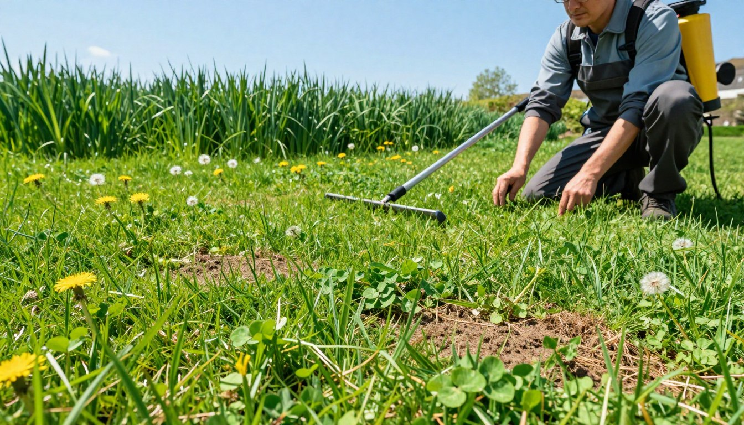
Acting fast is key to keeping your lawn healthy and green all season. A focused spring lawn treatment tackles specific problems without harming your lawn's recovery.
Dealing with Bare Patches
Bare spots often show up after winter. Spring's good weather is perfect for fixing them. For small spots, Scotts® Bare Spot Repair is a good choice. It has seed, fertilizer, and mulch.
For bigger areas, overseeding is best. Lightly rake the soil, apply grass seed that matches your lawn, and keep it moist until it grows. GreenView experts say spring is the best time to overseed before summer heat hits.
Managing Lawn Diseases
Fungal diseases can pop up as it gets warmer and wetter. Snow mold and brown patch are common. Catching them early stops them from spreading.
Most diseases can be managed by improving lawn care. Make sure there's good airflow by trimming trees. Water in the morning so the grass dries by night. Don't overdo nitrogen in early spring, as it can make diseases worse.
"Healthy lawns fight off diseases better than stressed ones. Focus on making your lawn strong through good care, not just using fungicides."
Controlling Spring Pests
As the soil warms up, pests start to move. Grubs and chinch bugs can harm your lawn. It's important to know which pest you're dealing with before treating it.
To control grubs, treat them when they're young and close to the surface. For insects, spot treatments are better than covering the whole lawn. Encourage good bugs and birds to help control pests naturally.
Your spring lawn treatment plan should tackle these issues head-on. We'll help you pick the right solutions to fix your lawn and keep it healthy for the long term.
Spring Fertilization Strategy
Spring feeding is more than just sprinkling granules; it's a strategic decision that sets your lawn's health for months. A proper spring lawn fertilization plan replenishes nutrients lost over winter and encourages the deeper root growth your grass needs. We'll guide you through choosing products, perfecting timing, and selecting between organic and synthetic approaches.
Choosing the Right Spring Fertilizer
The numbers on the bag tell you what's inside. Nitrogen (N) promotes green, leafy growth. Phosphorus (P) supports strong root development. Potassium (K) boosts overall plant health and stress resistance.
For spring, you typically want a formula higher in nitrogen. Many experts recommend specific products based on region. In the North, a product like Scotts Turf Builder Triple Action is popular for its combined feeding and weed prevention. In the South, Scotts Southern Triple Action addresses common warm-season challenges.
Fertilizer Type | N-P-K Ratio | Best For | Key Benefit
Spring Starter | 20-27-5 | New Lawns & Overseeding | High phosphorus for root establishment
Weed & Feed | 28-0-3 | Lawns with weed pressure | Combines fertilization with weed control
All-Purpose Slow-Release | 19-0-6 | Consistent, long-term feeding | Reduces risk of burn and feeds for weeks
Application Timing and Methods
Timing is critical. Apply too early and you mainly feed weeds. Apply too late and your lawn misses its peak growth window. For cool-season grasses like Kentucky bluegrass, aim for March or April. For warm-season grasses like Bermuda, target April.
A second feeding 6-8 weeks later maintains momentum. The Virginia Cooperative Extension provides excellent regional timing guides. For application, use a broadcast or drop spreader for even coverage. Always calibrate your equipment and apply on a calm day to prevent drift.
Organic vs. Synthetic Options
Both paths can lead to a green lawn, but they work differently. Synthetic fertilizers offer precise, fast-acting nutrients. They give your lawn a quick "green-up." Organic options, like compost or milorganite, release nutrients slowly as they break down. They improve soil structure over time.
Your choice depends on your goals. If you want immediate results and don't mind more frequent applications, synthetic may suit you. If you're building long-term soil health and prefer a gentle approach, organic is a great fit. Many homeowners use a blend of both as part of their best lawn care practices.
Remember, whether organic or synthetic, the right strategy feeds your lawn from the roots up. This creates a resilient turf ready for summer.
Effective Crabgrass Control in Spring
A thick, lush lawn naturally fights off weeds. But, some weeds like crabgrass need a special plan in spring. Stopping these weeds early is key to a beautiful yard all season.
Identifying Common Spring Weeds
Knowing your enemy is the first step to control. Spring weeds compete with your grass for resources. Let's look at three common ones.
Dandelions have bright yellow flowers and deep roots. Clover grows in low, spreading patches. Crabgrass is the biggest problem. It starts small but spreads fast, covering your grass.
Understanding crabgrass biology helps you fight it better. This knowledge makes your control efforts more effective.
Weed Name | Key Identification Features | Best Control Method
Dandelion | Bright yellow flower, deep taproot, jagged leaves in a basal rosette. | Spot treatment with post-emergent herbicide or manual removal of the entire root.
Clover | Three-leaf clusters (sometimes four), low-growing, forms dense patches. | Apply a broadleaf weed control product. Improving soil nitrogen can also help grass outcompete it.
Crabgrass | Light green, coarse texture, spreads outward from a central point (prostrate growth). | Pre-emergent herbicide applied in early spring before seeds germinate.
Crabgrass Pre-Emergent Application
The best way to stop crabgrass is to prevent it before it grows. Pre-emergent herbicides create a soil barrier. This stops weed seeds from growing.
Timing is everything. Apply too early or too late, and it won't work. Wait until soil temperatures are 50-55°F for a few days. This is usually when forsythia blooms.
For exact timing, check guides like this one on when to apply crabgrass pre-emergent herbicides.
Products like GreenView Fairway Formula Weed & Feed do it all. They feed your lawn, prevent crabgrass, and control over 200 weeds with one application.
Remember, pre-emergents won't kill existing weeds. For those, you need a post-emergent treatment. By getting the timing right, you save time and effort later.
When to Start Mowing Lawn in Spring
Knowing when to start mowing your lawn in spring is key. Wait until the grass is growing and is about one-third taller than its ideal height. This usually happens when soil temperatures hit 50-55°F for cool-season grasses or 60-65°F for warm-season ones.
Your first mow of the season is important. Mowing too early can harm new growth. Waiting too long lets weeds grow. Here's what you need to know for a great spring mowing.
Ideal Grass Height for First Cut
For the first cut, aim for 2-3 inches. Cool-season grasses like Kentucky bluegrass and fescue do well at 3 inches. Warm-season grasses like Bermuda and Zoysia prefer 2-2.5 inches.
Never cut more than one-third of the grass blade at once. If your grass grew to 4 inches over winter, cut it down to 2.75 inches first. This rule helps prevent shock and promotes thicker turf.
Grass Type | First Mow Timing | Ideal Height | Key Consideration
Cool-Season (Fescue, Bluegrass) | After debris removal, soil ~50°F | 3 inches | Taller height shades roots, conserves moisture
Warm-Season (Bermuda, Zoysia) | Early spring, soil ~60°F | 2-2.5 inches | Lower height promotes lateral growth
Transition Zone Mixes | Watch for consistent growth | 2.5-3 inches | Adjust based on dominant grass type
Mowing Frequency Guidelines
Once you start mowing, keep a regular schedule. In spring's peak, you might need to mow every 5-7 days. As growth slows, extend intervals to 7-10 days.
How often you mow depends on growth, not the calendar. If grass is getting too long, it's time to cut. Regular mowing prevents damage and keeps your lawn looking good.
Proper Mowing Techniques
Sharp mower blades are essential. Dull blades tear grass, leading to disease. Sharpen blades at least once each season for clean cuts.
Vary your mowing pattern each time. This prevents soil compaction and grass leaning. Always mow when grass is dry to avoid clumping and uneven cuts.
Leave grass clippings on the lawn! They decompose quickly, adding nitrogen to the soil. This natural fertilization can cut your need for extra feeding by up to 25%.
Mastering when to start mowing lawn in spring and following these tips ensures your lawn is strong, healthy, and well-maintained by summer.
Spring Lawn Watering Best Practices
Water is the lifeblood of your lawn. Getting your spring watering right is key to strong roots and healthy turf. It's the final step that brings all your springtime lawn maintenance efforts to life.
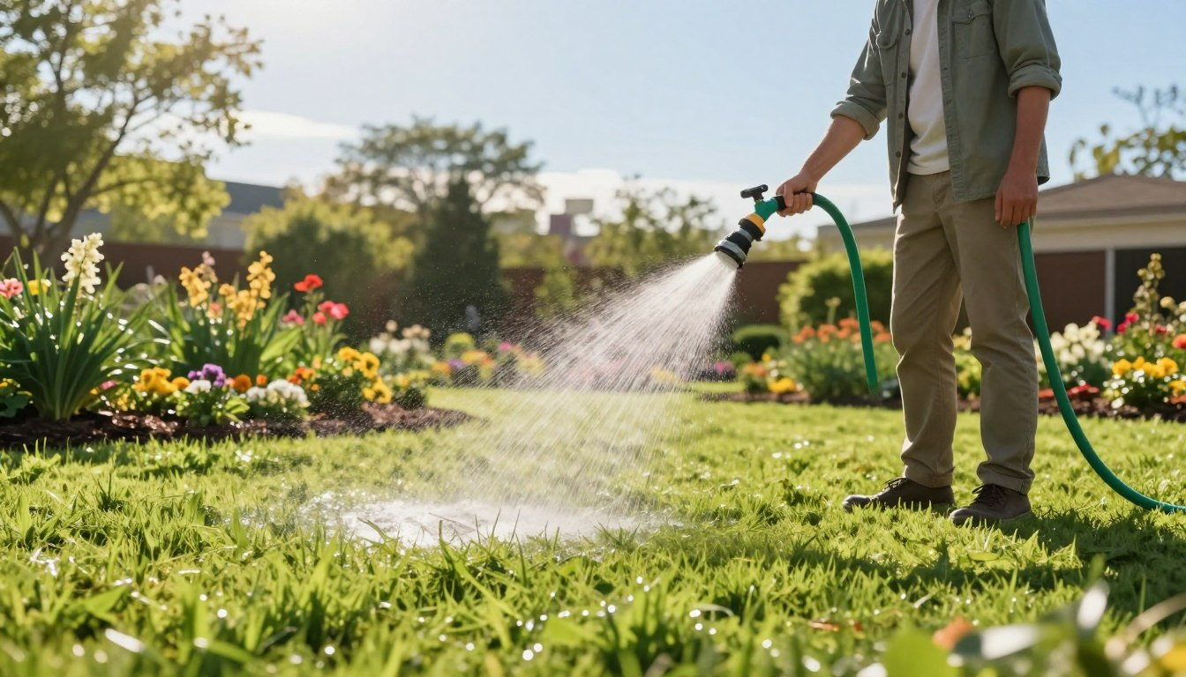
Setting Up Efficient Irrigation
Consistency is everything. Whether you use an in-ground system or a simple hose-end sprinkler, aim for even coverage. Check your sprinkler heads for clogs and misalignment early in the season. A well-tuned system prevents dry spots and wasteful runoff, giving every part of your lawn a fair drink.
Watering Depth and Frequency
The golden rule is water deeply but infrequently. We aim to moisten the soil down to 6-8 inches. This encourages roots to grow deep, making your lawn more drought-tolerant. A great tip is to place an empty tuna can on your lawn while watering. When it's full, you've applied about one inch of water.
For most lawns, one inch per week is perfect. It's best to split this into one or two longer sessions. Always water in the early morning. This reduces evaporation and helps prevent fungal diseases that thrive on damp, cool grass overnight.
Signs of Overwatering and Underwatering
Your lawn will tell you if it's getting too much or too little. Learn to read the signals.
Signs of Overwatering:
- Spongy, soft turf when you walk on it.
- Excessive runoff or puddling.
- Presence of mushrooms or algae.
Signs of Underwatering:
- Grass blades wilt, curl, or take on a bluish-gray tint.
- Your footprints remain visible on the lawn long after you walk.
- Soil is dry and hard several inches down.
By tuning into these practices, you provide the perfect hydration. This makes your lawn care both effective and efficient, setting the stage for a healthy summer.
Spring Overseeding and Lawn Repair
Is your lawn thin or showing bare patches after winter? Spring overseeding is the perfect solution. It repairs damage and builds a thicker, more resilient turf. This step is key to a smart lawn care schedule, making your grass dense and healthy before summer.
When and How to Overseed
Timing is everything for overseeding. You must match the task to your grass type. For cool-season grasses like Kentucky bluegrass or fescue, overseed in early spring. This allows seeds to germinate and establish roots before summer stress.
For warm-season grasses like Bermuda or Zoysia, wait until late spring. Soil temperatures should be above 65°F. The process is simple. First, mow your lawn short and rake away debris to expose the soil. For small bare spots, use Scotts® Bare Spot Repair.
For larger areas, use a core aerator or dethatcher. This opens the soil surface for better seed-to-soil contact, which is key for germination.
Choosing the Right Grass Seed
Choosing the correct seed is essential. You want a blend that complements your lawn and thrives in your local conditions. For repair, consider a "sun and shade" mix if your lawn has varied light exposure.
For a uniform look, choose a pure grass seed that matches your turf type. Brands like Greenview offer specialized products, such as Seeding Success, designed to enhance germination. Always check the seed label for weed content and germination rates to ensure quality.
Grass Type | Ideal Overseeding Time | Recommended Product Type | Key Consideration
Cool-Season (Fescue, Ryegrass, Bluegrass) | Early Spring (March-April) | Cool-season blend or pure seed; Starter fertilizer with seed protection. | Establish before summer heat and drought.
Warm-Season (Bermuda, Zoysia, Centipede) | Late Spring (May-Early June) | Warm-season specific seed; Patch repair products for spots. | Soil temperature must be consistently warm (>65°F).
Mixed or Transition Zone Lawns | Follow cool-season timing | High-quality "Sun & Shade" mix for adaptability. | Choose disease-resistant varieties for longevity.
Post-Seeding Care
Your work after seeding determines success. The most important step is consistent, light watering. Keep the seedbed moist but not soggy. You may need to water lightly 2-3 times a day for the first week or two until seeds sprout.
Once new grass reaches about 3 inches, you can resume normal mowing. Be gentle and ensure your mower blade is sharp. Avoid heavy traffic on seeded areas for at least a month. Hold off on applying any weed control or fertilizer until the new grass has been mowed at least 3-4 times and is well-established.
Integrating overseeding into your spring lawn care schedule pays off with a lush, dense lawn. This repair work fills gaps, improves curb appeal, and creates a stronger turf that can better compete with weeds and withstand the seasons ahead.
Essential Spring Lawn Care Tools
Having the right gear makes preparing your lawn for spring smoother and more effective. The right tools save you time and help you achieve professional-looking results. Let's break down what you need in your shed.
Must-Have Equipment
Every homeowner needs a core set of reliable tools. A sharp, well-maintained lawn mower is non-negotiable for a clean cut. A sturdy leaf rake is perfect for clearing debris and light dethatching.
For applying fertilizer and seed evenly, a broadcast spreader is essential. Scotts offers a great range, and choosing the right model depends on your lawn's size.
The right tool for the job doesn't just make the work easier—it protects your lawn and ensures your efforts pay off.
Spreader Model | Best For Lawn Size | Key Feature
Whirl | Small to Medium | Hand-held, easy maneuvering
EdgeGuard Mini | Small | Prevents product from spreading onto drives
DLX | Medium to Large | Durable construction, even coverage
Elite | Large to Very Large | High capacity, professional-grade results
Specialty Tools Worth Investing In
If you face specific challenges, consider these upgrades. A core aerator relieves soil compaction, allowing air, water, and nutrients to reach the roots. For lawns with thick thatch, a dethatcher (or power rake) can be a season-saving investment.
A simple soil probe helps you check moisture depth and take soil samples. These tools solve problems before they become major headaches.
Maintenance Tips for Lawn Care Equipment
Your tools work hard, so show them some care. For your mower, a spring tune-up is key. Follow this checklist:
- Sharpen or replace the blade for a healthy cut.
- Change the oil and replace the air filter.
- Check the spark plug and drain old fuel.
Clean your spreader and rake after each use to prevent rust and corrosion. A little maintenance extends the life of your equipment and guarantees it's ready when you are.
Conclusion: Setting Your Lawn Up for Summer Success
Your hard work in spring has set the stage. You removed debris, fed your grass, and controlled weeds. You also learned how to water wisely. This groundwork prepares your lawn for summer's tests.
A strong lawn from spring can face summer's heat well. The deep roots you helped grow fight drought. Mowing and fertilizing right keeps your grass dense, pushing out weeds. Your lawn is now ready to grow strong.
Lawn care is an ongoing journey. Each season's efforts build on the last. Keeping an eye on your grass and tweaking your routine keeps it healthy. We're here to support you every step of the way.
TruGreen's lawn care services offer personalized help. Our experts design plans just for your yard. We use science-backed treatments and consistent service. This tailored approach meets your lawn's specific needs.
Enjoy a lush, healthy lawn all summer. A beautiful yard comes from knowing how to care for it. We're committed to helping you achieve that with our expertise and partnership.
FAQ
When should I start my spring lawn care routine?
Start your spring lawn care in early March. Begin by clearing debris and getting your mower ready. The exact start time varies by region and soil warmth. Wait until the ground is thawed and grass starts growing.
What is the most important first step for spring lawn upkeep?
First, remove winter debris like leaves and sticks. This lets sunlight and air reach your lawn. Then, test your soil to plan your spring care.
When is the best time to apply fertilizer in the spring?
Apply fertilizer in mid-spring, around April. This is when your grass is growing fast and needs nutrients. Too early or late can harm your lawn.
How do I prevent crabgrass from taking over my lawn?
Use a pre-emergent herbicide in early spring. Apply it when soil is about 55°F for a few days. This stops crabgrass seeds from growing.
When should I start mowing my lawn in the spring?
Start mowing when your grass is about one-third taller than its ideal height. For the first cut, set your mower to 2-3 inches. Never cut more than one-third of the blade at once.
How often and how much should I water my lawn in spring?
Water deeply but infrequently. Aim for 1 inch of water per week. Water in the morning to reduce evaporation. Adjust based on rainfall and watch for signs of too much or too little water.
Can I overseed my lawn in the spring to fix bare spots?
Yes, overseeding in spring is great for fixing bare spots. For cool-season grasses, early spring is best. For warm-season grasses, late spring works better. Keep the soil moist until the new grass grows.
What’s the difference between dethatching and aerating, and does my lawn need it?
Dethatching removes dead matter, while aeration relieves soil compaction. A light rake in spring can help with thatch. Aeration is good for root health, but only if your soil is heavy or gets a lot of foot traffic.
What are the essential tools I need for spring lawn maintenance?
You'll need a good mower, a rake, and a spreader. For bigger lawns or specific issues, consider a core aerator or dethatcher. Keep your tools in good condition.
How do I know if my lawn has a disease or a pest problem in spring?
Look for circular patches of discolored grass for diseases like snow mold. Pests like grubs can lift the grass. Proper identification is key. Improving your lawn's health through proper care is often the best defense.

