50 cm Contour Pilot Project: Southwestern Ontario
  - Summer 2026

Marcella Gravesande & Sian Bryson
Oversight: Bob Steiss, Adam Hogg
For clarification on the contour toolbox, Sian can be contacted at sbryson18@outlook.com.

Project Status as of 2026-08-20
Initial test of contours for the study area have been uploaded as vector tiles. Contours still have some topographic errors and could use more processing; Smooth Line threshold was too aggressive and caused overlap in dense contours. Would not recommend public release at this time.
Notes on suggested modifications to the workflow can be found in section 8, Next Steps.

Software specs
- ArcGIS Pro 3.5.4
Contents
1. About the pilot project 3
2. Importing imagery 3
3. Running the toolbox 4
4. Smooth and simplify 4
5. Manual edits 5
Preventing manual edits 5
Flagging edits 6
Making edits 7
Case 1: Removing duplicates 7
Case 2: 8
Case 3: Connected loops 8
Healing a manually corrected contour 10
6. Preparing contours for export 13
6.1 Display filters 13
6.2 Creating vector tiles 14
7. Toolbox deep dive 16
7.1. Imagery correction 17
7.2. Contour Generation 18
7.3. Cleaning Contours 18
7.2.1 Endpoint Connectivity 20
8. Future improvements 21
Appendix 25
Functions & tools 25

1. About the pilot project
OMAFA has received many requests for higher frequency topographic contours. These are of interest to drainage contractors and landowners but are intended to be useable by anyone.
The current contours available only have a separation of 1 metre, which is too generalized for precise work at a local scale.
See Marcella’s documentation for info about selecting the study area.
The general workflow of the contour creation is:
- Correct DTM imagery
- Create contours
- Clean up contours

2. Importing imagery
The topographic contours are created using LiDAR-derived Digital Terrain Model (DTM) imagery with a resolution of 0.5m. This imagery is courtesy of the Ontario Ministry of Natural Resources and is hosted by the Ontario GeoHub; it can be found here.
I have been using a mosaic dataset. Note that this is different from creating a mosaic image or a raster dataset. A mosaic dataset is the set of instructions for how to stitch imagery together – it is not an image file and may break if you move the data sources. In the case of corrupted imagery, repair mosaic dataset or repair paths may help.
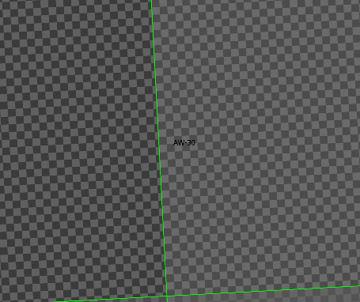
Broken mosaic datasets have a checkered pattern. Running the tools on this imagery will treat the squares as actual elevation imagery and the contours will be a complex grid.
Currently I am storing the DTM as local files. Unzipped, each tile is 2-3 GB; make sure you have adequate storage space.
- Add a new Mosaic Dataset to your geodatabase. This will create an empty mosaic dataset for you to populate.
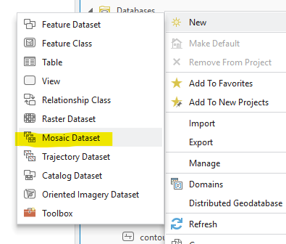

- In the contents pane, right click the empty Mosaic Dataset and select Add Rasters…
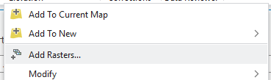

- Change the Input Data parameter to folder.
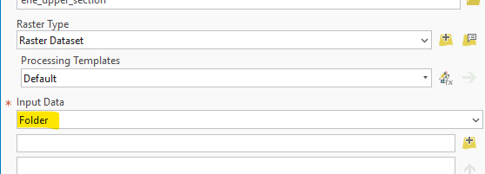

- Select the tile folders you want to add to the dataset.
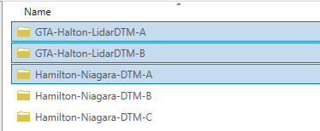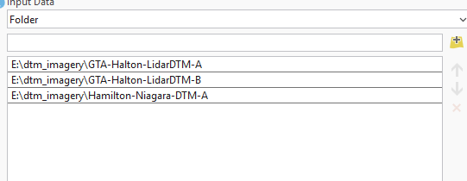

- If you’ve lost track of which folders you’ve already added to the dataset, consider changing Add New Datasets Only to Exclude Duplicates.
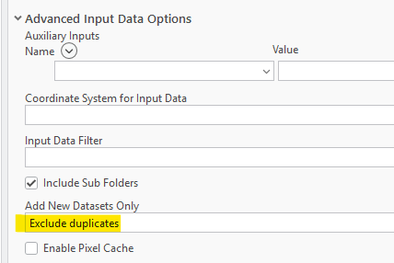

- Calculate statistics seems to be on by default in the Environments pane, but you can also turn it on in the Raster Processing section of the Parameters pane.
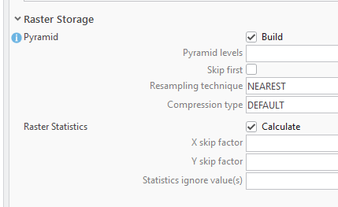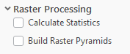

3. Running the toolbox
- Select your area of interest from the grid
- Clip to study area if needed
- Buffer the area of interest (I’ve been doing 1km, could be smaller). If you are doing multiple squares, consider turning on the option to dissolve them.
- Tools can be run together using 0. Run Full Workflow. If you’d like to inspect results between stages or redo a specific stage, you can use 1. Process imagery, ArcGIS Pro’s Contour tool in the Spatial Analyst toolbox, and then 2. Clean contours.
Minimize OneDrive’s access to any of your project files as much as possible; I have run into many issues because of improper syncing.
Parameters
- Workspace: geodatabase where the geoprocessing will occur
- DTM LiDAR Imagery: Imagery, either a mosaic layer or raster image
- Processing area: polygon layer representing the area in which you want to create contours.
- Breaklines: hydro/OHN breaklines for flattening water bodies
- Maximum length of islands to be removed: threshold for how large a closed loop/island needs to be for it to be preserved. Defaults to 100 metres.
- Simplification tolerance: tolerance for Simplify Line; defaults to 1 metre.
- Final Output Contours: Final file name/location for the cleaned contours.
- Coordinate system: may be antiquated/dead code but I’m too scared to remove it. Have been setting it to the coordinate system of the mosaic, which is set to NAD 1983 CSRS Ontario MNR Lambert.

4. Smooth and simplify
Simplification and smoothing should be applied to the contours to reduce their complexity and make them easier to interpret.
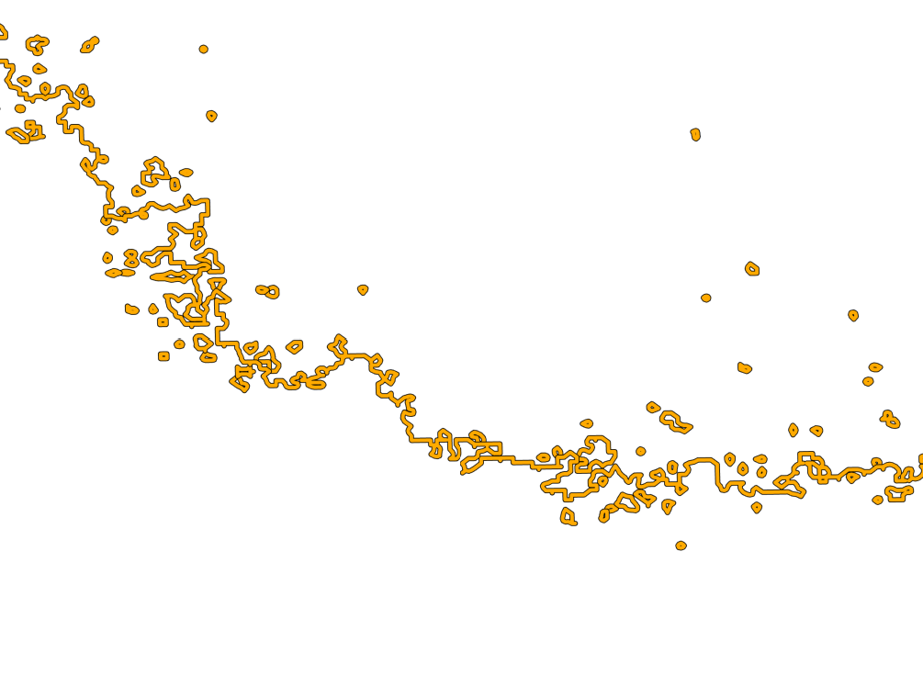 | 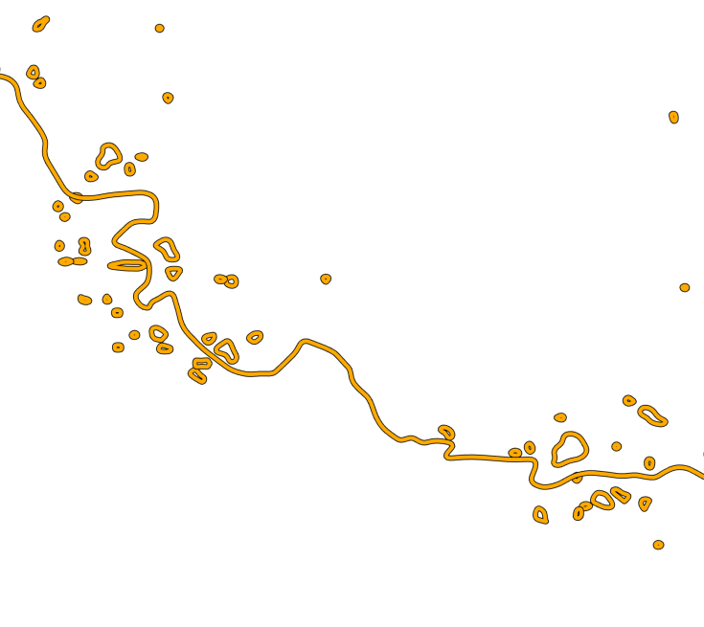 | 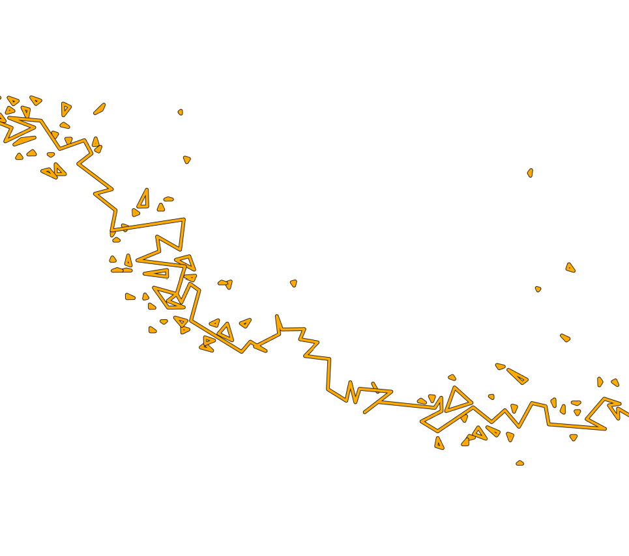
Original | Smooth Line applied | Simplify Line applied

Simplify Line with a tolerance of 1m is applied to the contours by the cleaning script. This should be toned down to 0.5 in the future to prevent clustered contours from overlapping (see section 8).
Smooth Line was applied to a few tiles with a tolerance of 1m, which had a minimal effect on the contours. A tolerance of 2m was applied to the rest of the tiles, which seemed to help with some of the topological errors. It also shrinks hundreds of loop lengths to under 100 metres – it may be worth adding Smooth Line to the cleanup script after applying Simplify Line.
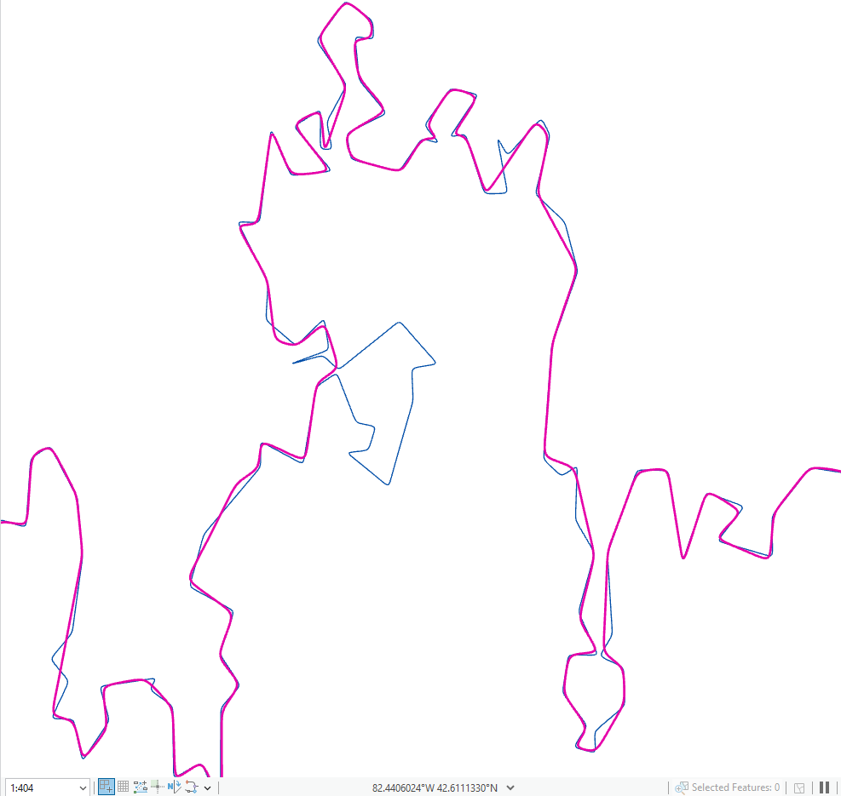
Contours in pink had a 2m smoothing threshold; blue had a 1m smoothing threshold. Part of the geometry collapsed entirely to form a contour that’s much easier to interpret.

5. Manual edits
I have tried to optimize the contour workflow to avoid as many manual edits as possible, but some artifacts are too complex to be safely handled by the script. Depending on your desired standard for the contours, you may have to get your hands dirty and fix the geometry yourself.
Some of these edits will be flagged in the tool messages, but this only occurs in cases where a “mesh” has been created. Some contours are flagged but escape cleaning because they exceeded a precautionary threshold.
I also created this script as an amateur coder and did lean on Copilot for debugging and problem-solving. There may be a problem with my flagging logic that I haven’t noticed.

Preventing manual edits
Complex artifacts are created at the contour generation stage. If there are too many artifacts to quickly resolve by hand, I would suggest regenerating the contours. The script defaults to a Simplify Line threshold of 1. If this threshold has been reduced, that may be the source of your problems. A smaller study area is also helpful; the ArcGIS Contour tool creates messy results when trying to handle very large datasets (this is suspected to be a problem with memory availability).

Flagging edits
To check for lingering artifacts, try symbolizing the cleaned contour layer by graduated colours with 2 or 3 classes and select Shape_Length as the field. Choose 100m (or other value as desired) as the upper limit for the smallest length class and symbolize it with a highly contrasting colour and a thicker line width.
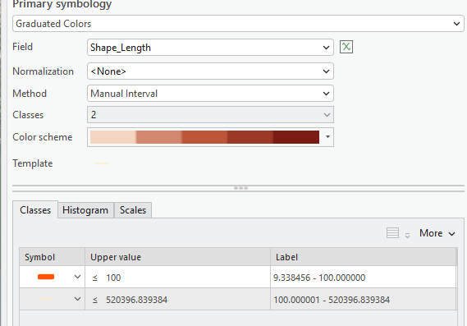

You will also likely need to increase the sample size in the symbology pane.
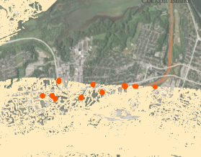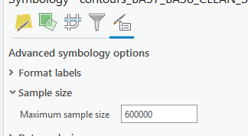

There will be many smaller pieces along the edges; the script protects any of these over 10 metres in length from being deleted. This threshold can be altered in the script itself.
A few missed artifacts are fine, but large problem areas suggest a quality issue with the contours themselves, rather than a problem with the cleaning script. In this case, your time would be better spent generating the contours again instead of manually resolving every one of these edits.

Making edits
Contours that were broken up can be grouped by their share ORIG_ID. Apply Select By Attribute with ORIG_ID as the attribute and create a new working feature class from the selected contours. Note that a selection layer shares the same source data with its parent layer. Deleting segments in a selection layer is a destructive edit. Create a copy with only your target ORIG_ID features.

Case 1: Removing duplicates
For reasons that elude me, sometimes simple errors will be skipped over. The artifact loop within this valid loop should have been removed. The small loop can simply be deleted.
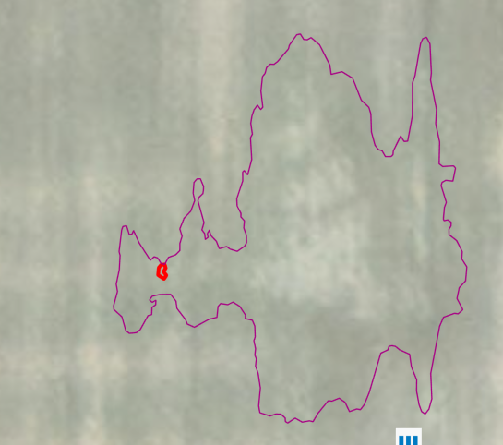

In simple cases like this, just delete the side segments (or leave whichever segment makes the most sense).
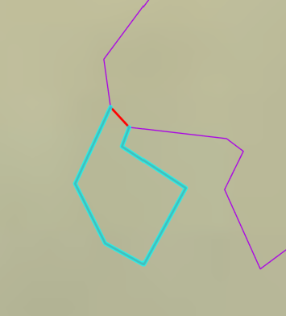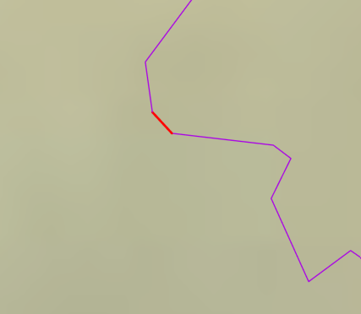
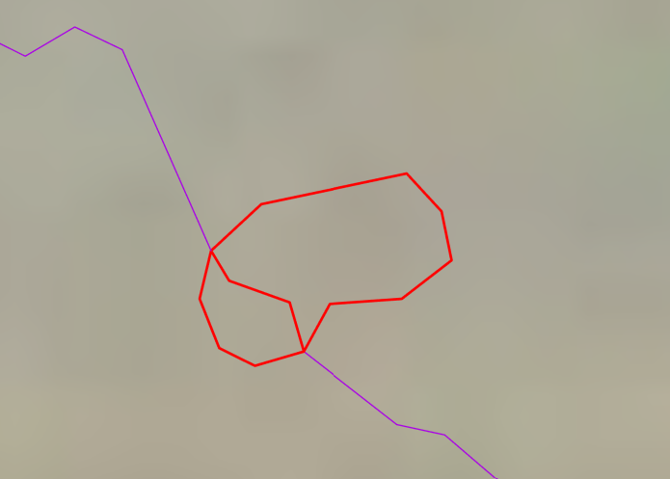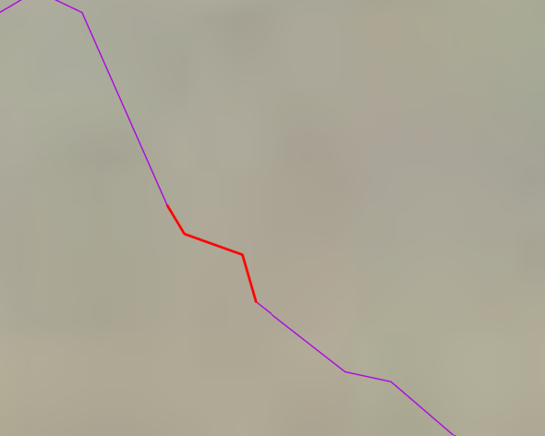

Case 2:
Two segments (red) are bridging this small loop to the main contour segments (purple and cyan). The bottom loop is only 23 m long, so it can be deleted along with the bridging segments.
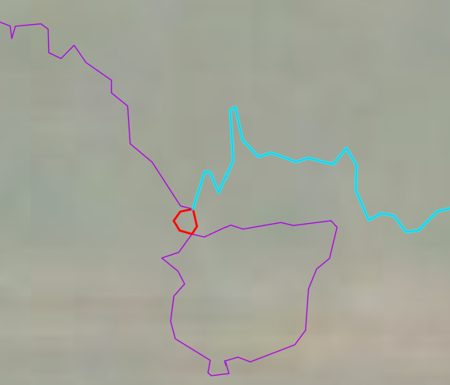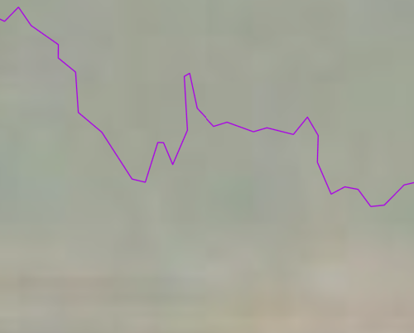
In cases where the loop is larger, check where it exists in relation to the main contour. If the main contour forms a large loop thousands of kilometers long, delete artifact loops inside of it, even if they’re large.

Case 3: Connected loops
These are normally caught by the cleaning function, but they will need to be removed manually if the contour was flagged for complex geometry errors. If a loop is under (or close to) 100m, it can be deleted.
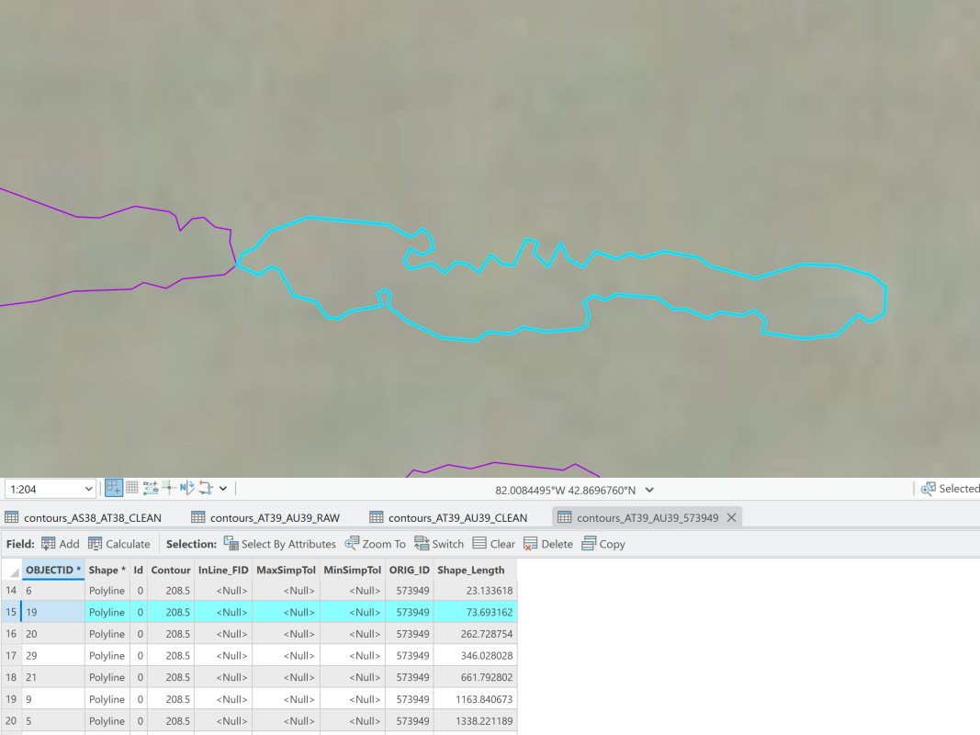
You will also sometimes encounter two contours that are touching each other, but both are longer than 100m.
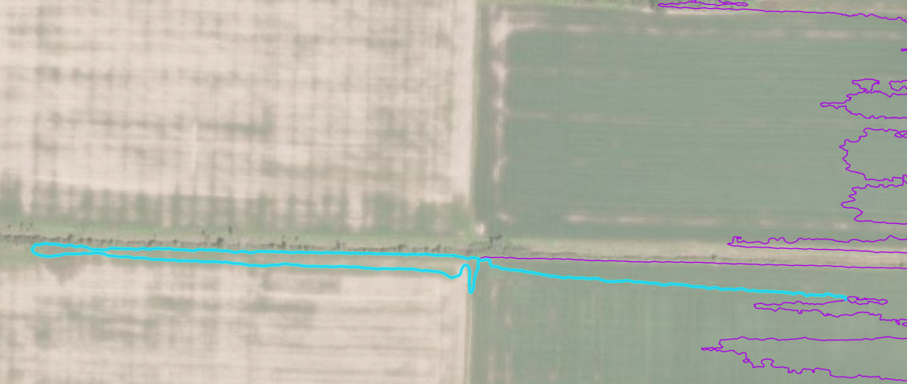
This can occur as a geometric error, but without being dissolved first it won’t break the contours. In cases where the contour has been flagged and dissolved, neither can be removed and you’ll have to shift them out of each other’s way.
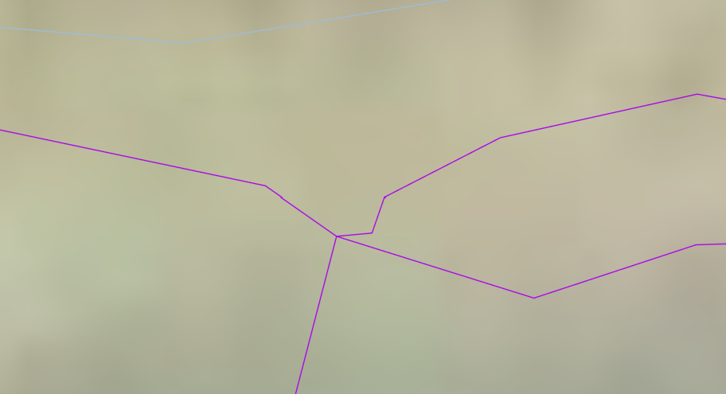
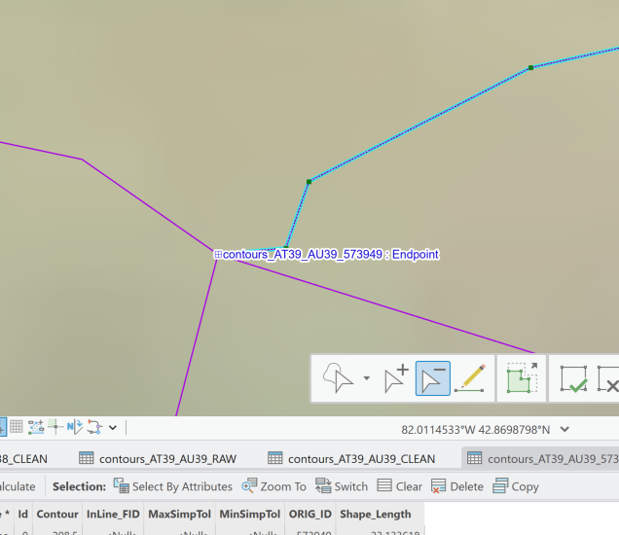
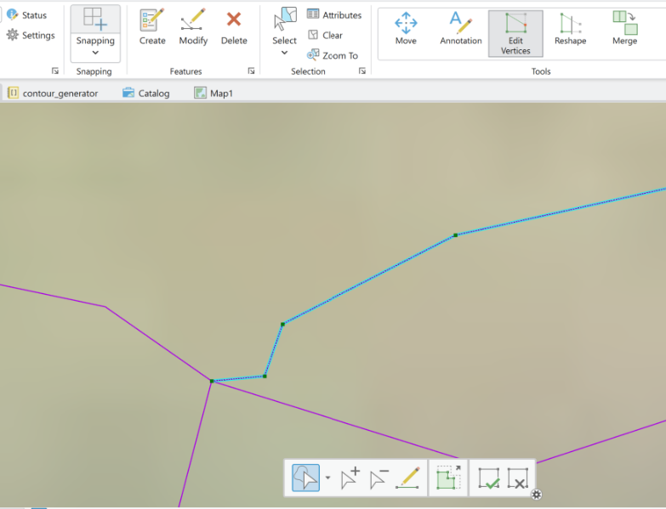
Go into the Edit tab and select Edit vertices in the tools section with your desired line segment selected. Edit the endpoints of both ends of the broken contour. Ensure that snapping is turned on, and that both endpoints snap to each other.

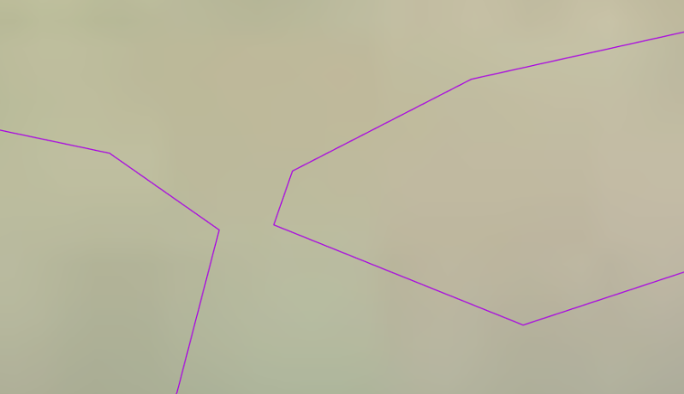
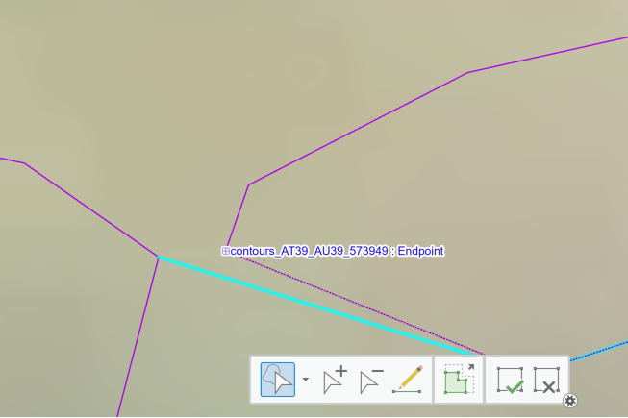

Healing a manually corrected contour
If you’ve caught all the errors, running Dissolve/Pairwise Dissolve should join the fragmented features into one. Your dissolve fields should be ORIG_ID and Contour. Make sure that create multipart features in NOT selected.
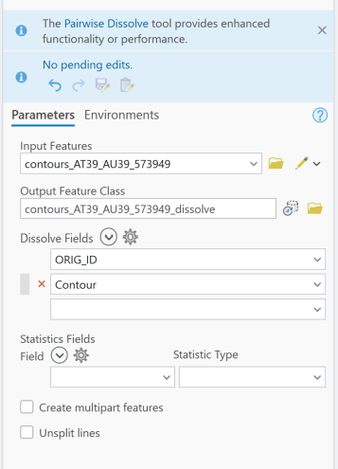
(Unless you separated two 100m+ loops, which will remain separate features). Check the attribute table to make sure. In this case, I left an artifact behind. The 661 m and 346 m features are valid loops, but 0.13 is so small that it has to be an artifact.
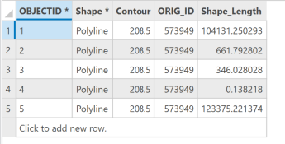
Once you’ve fixed that error, try dissolving again. The main contour is now one continuous line!
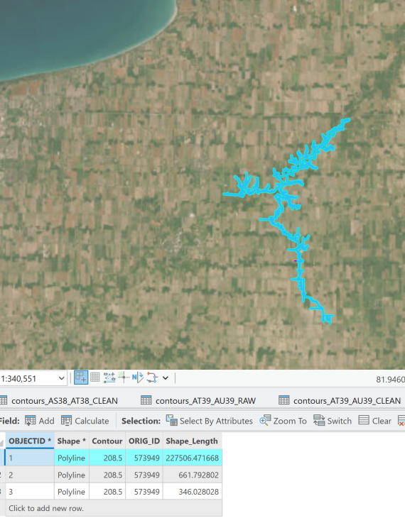
Once you’re happy, make sure you save your edits. You can now delete the features with this ORIG_ID from the original contour file.

6. Preparing contours for export

6.1 Display filters
A display filter can be used to non-destructively reduce the number of contours rendered at large extents. Compare these contours before and after applying a filter.
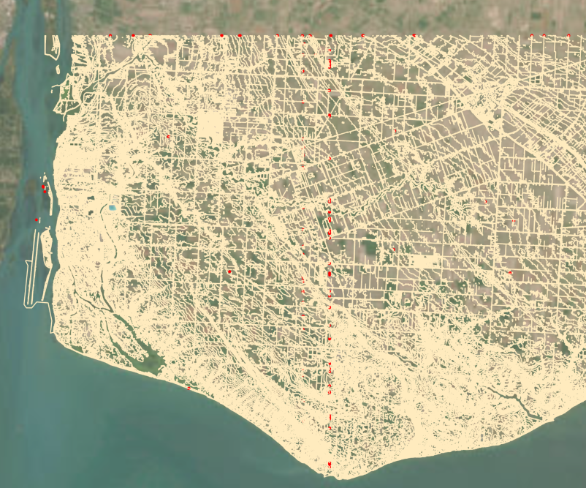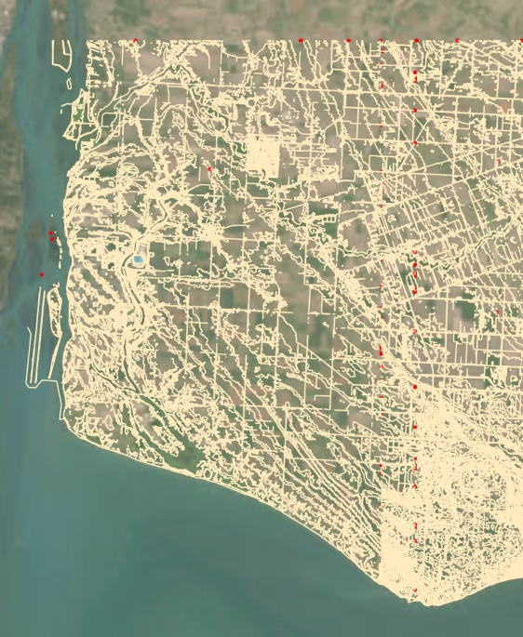
Before After
When zoomed in, all the contours will be rendered. When zoomed out past a certain extent, only contours that match the filter are displayed.
To add a display filter, navigate to the Display Filters tab (funnel icon) of the symbology pane. Add a new display filter. In the SQL editor, enter MOD(Contour, 2) = 0. This applies a modulo function to the data.
An aside on modulo
Modulo returns the remainder from dividing the dividend (Contour) by the modulus (2). So, for a modulus of 2, a contour value of 122 would return 0 (matches the SQL expression), while a contour value of 121 would return 1 and 122.5 would return 0.5 (neither match the SQL expression).
I used 2 for this example, but feel free to experiment with the modulus values for export.
- Modulus = 1: only whole numbers
- Modulus = 2: only whole, even numbers
- Modulus = 2 AND expression evaluates to 1: only whole, odd numbers
- Modulus = 5: only whole numbers ending in 0 or 5

6.2 Creating vector tiles
While smaller files can be uploaded directly to ArcGIS Online/Enterprise with the “share as web layer” option, the contours are too large. You will instead have to create a local vtpk (vector tile package) file and upload it.
- Create a new map with only your contours. Any basemap or other data layers will be added to the vector tiles; we want a clean layer with only the contours. Also ensure you have added the symbology and filters you want in the final product – you cannot modify the symbology of a vector tile once it has been created.
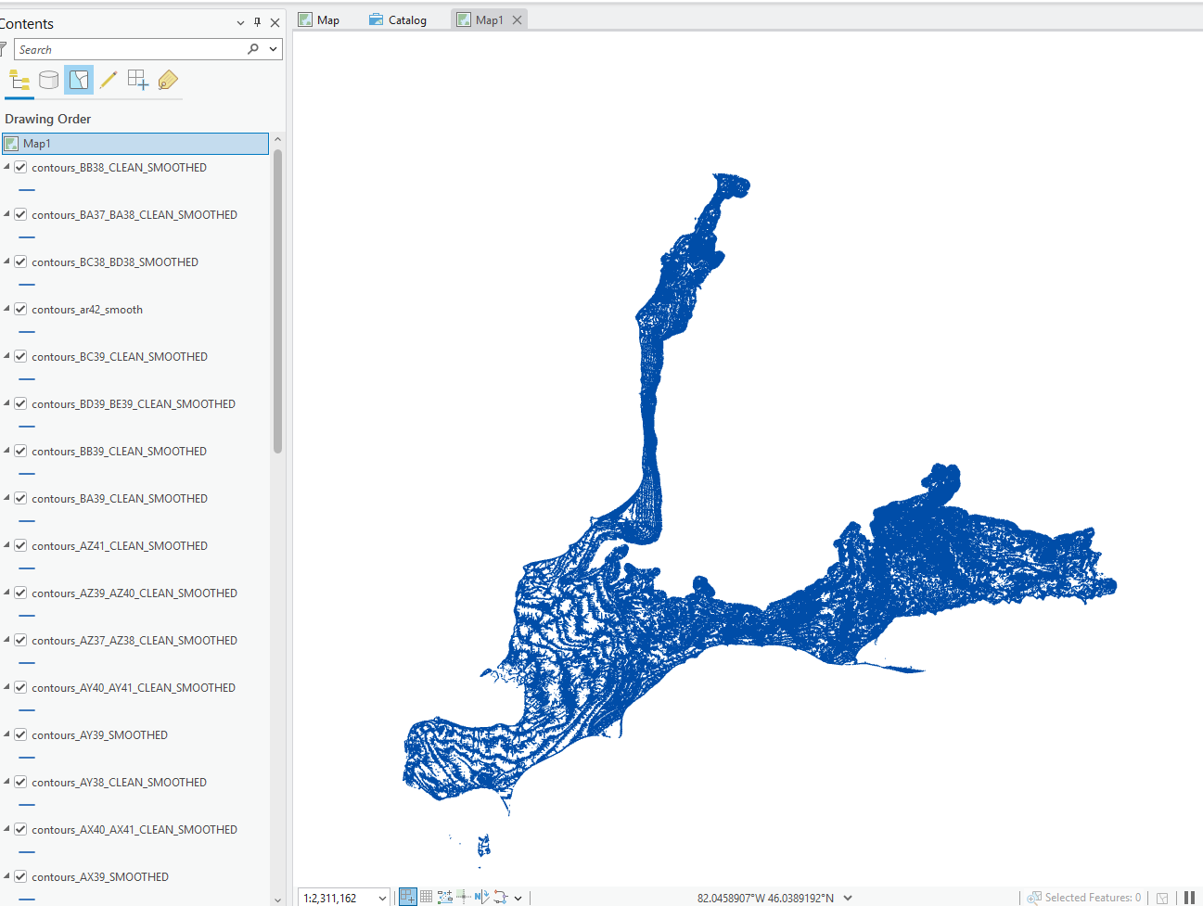

- Create a vector tile index. Use the Create Vector Tile Index tool. I left the maximum vertex count untouched.
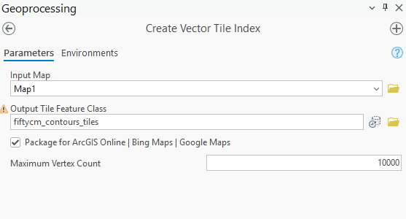
- Create a vector tile package. Open the Create Vector Tile Package tool. Use the vector tile index as the Index Polygons parameter to create a vector tile package. Make sure that the only layers in the map are your contours – if the index polygons are present, they will be exported as part of the tiles.
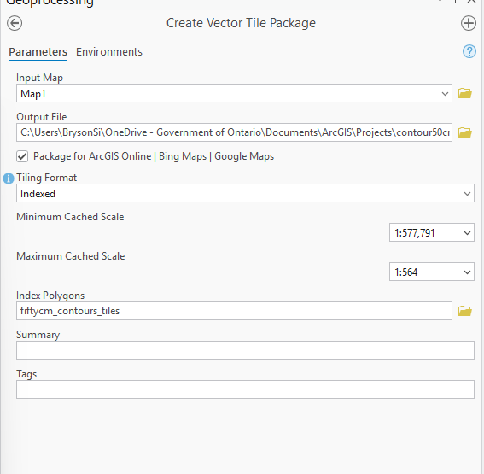
For the cached sizes, I chose 1:577,791 as the smallest and 1:564 as the largest. This can be modified as desired. Limiting this to a smaller range will speed up how long it takes to export the tile package.

You will also need to add a description to the map to export it. Add this in the map properties.

You may get an error that the map’s coordinate system does not match the tiling scheme’s coordinate system. Change this in the map properties.

- Upload the VTPK file to ArcGIS Enterprise. Select New Item and drag the vtpk file into the box.
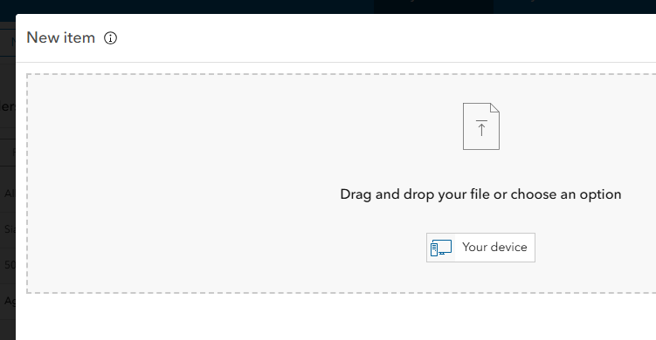

Allow it to create a hosted tile layer.
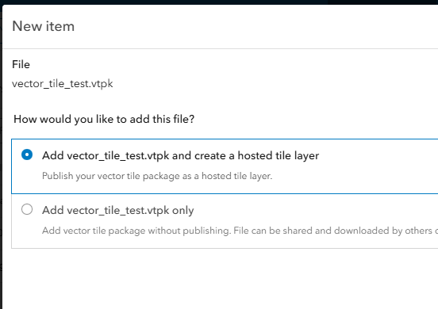
As you can see, I created this tile package with the index as a map layer. The green background is baked in and cannot be removed.
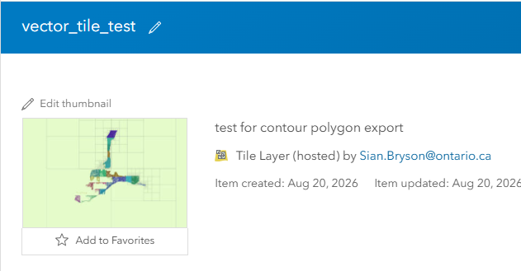

7. Toolbox Information
This is not required reading for running the toolbox itself but is important for maintenance and troubleshooting.
The main executor script (contour_toolbox.pyt) references several geoprocessing scripts stored in the contour_tools folder.
File structure is important: contour_toolbox.pyt should remain on the same level as the contour_tools script folder. Both the .pyt and scripts folder must be moved together. 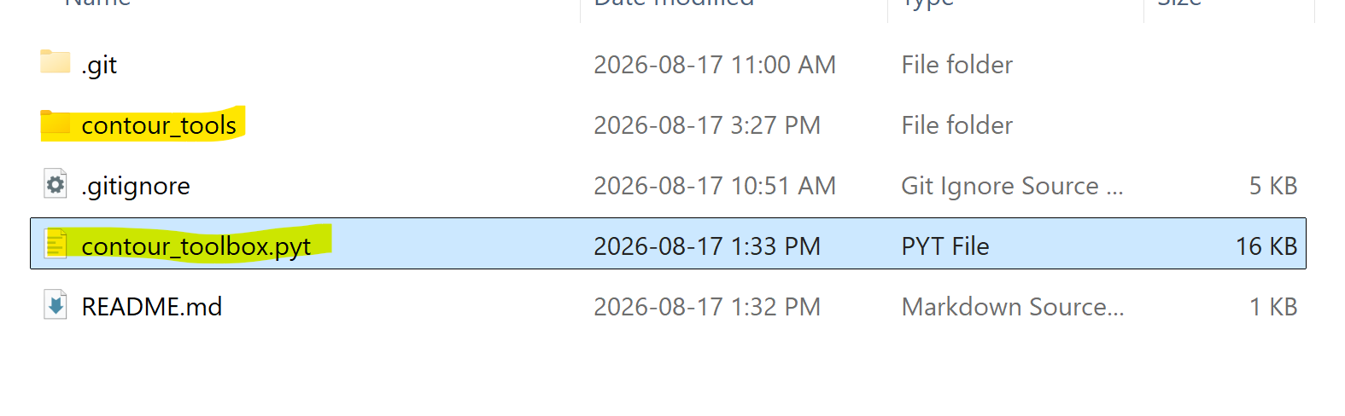
Running the scripts will create a bunch of xml files. These are safe to delete but will be generated again the next time you run the tool.
Contents of contour_tools
- __init__.py: empty file; needed for ArcGIS Pro to detect the package correctly
- utils.py: constants and helper functions. Used as a bit of a dumping ground to make cleanup.py easier to read.
- imagery.py: Smooths DTM imagery and corrects the elevation of waterbodies
- cleanup.py: Removes geometry artifacts in the contours

7.1. Imagery correction
The raw LiDAR-derived DTM will produce poor results without correction. There is a high level of noise in the raw imagery, which can artificially inflate contour and vertex counts in the next steps. Focal statistics are run with a 3x3 window to smooth out some of this noise.
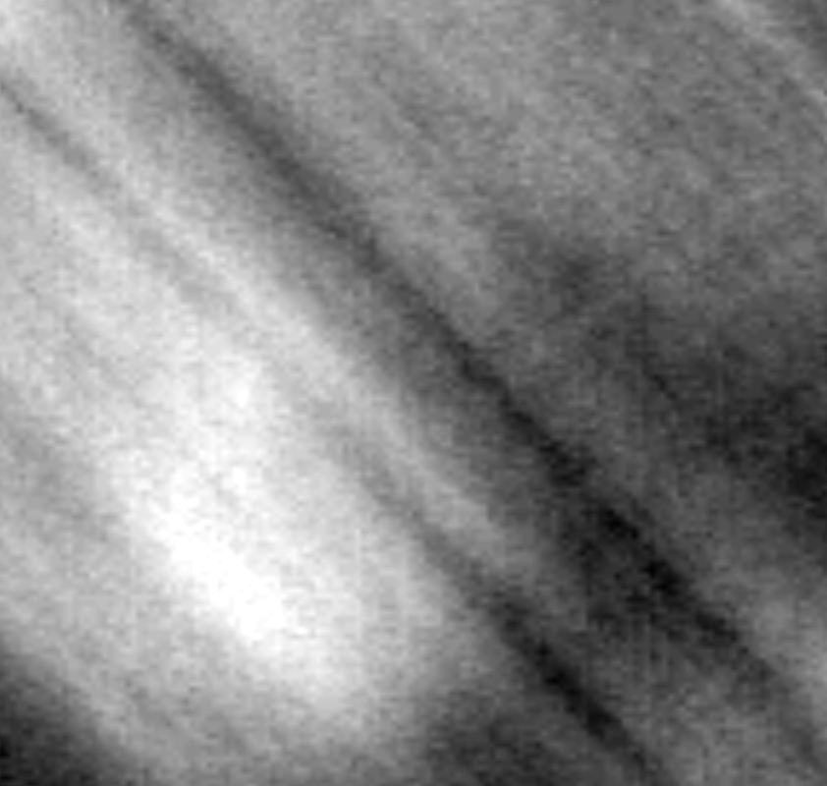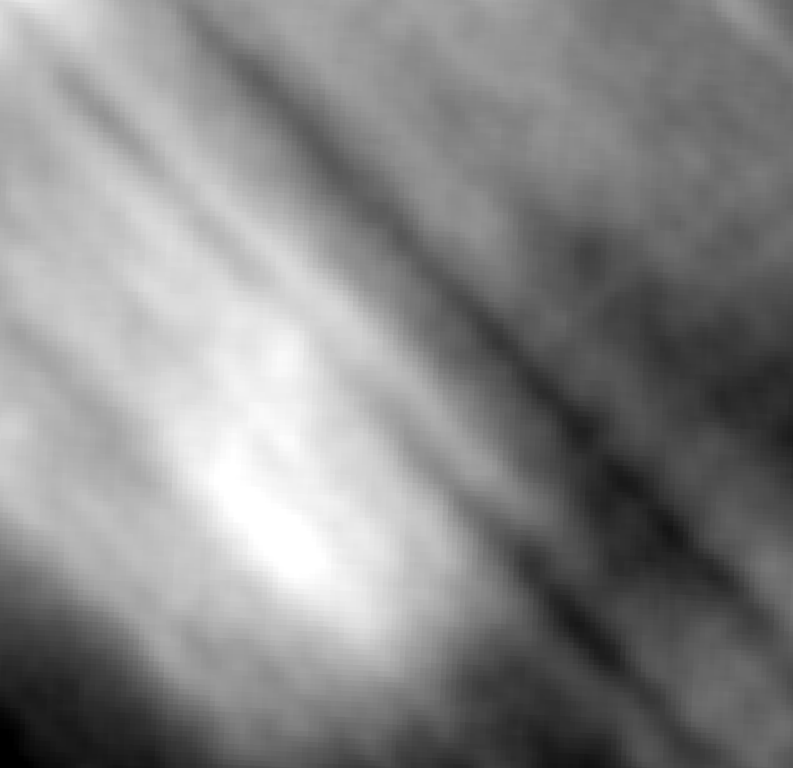
A section of imagery before and after applying focal statistics.
LiDAR often results in triangular artifacts on waterbodies, which should be ignored as they do not represent a real difference in elevation. Contours should be generated around their shorelines instead. The imagery correction tool sets any areas designated as waterbodies by the hydro breaklines to the average elevation of each body.
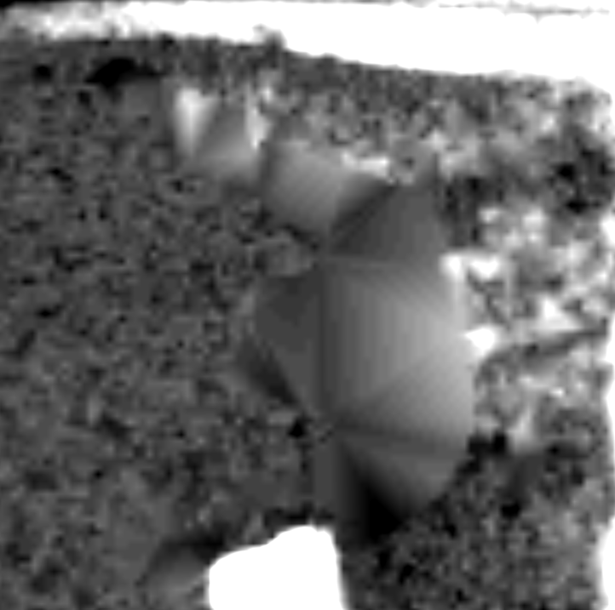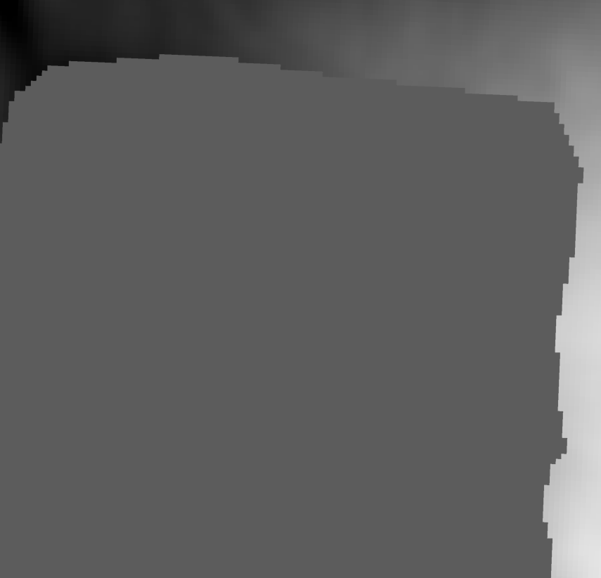
A stormwater retention pond before and after being “flattened.”
Current process for creating the feature with hydro features is combining OHN waterbodies with the hydro breaklines available on GeoHub. I exclude rivers (select by attribute) and merge/dissolve the layers together. In some areas, a waterbody will be covered partly by a feature in one dataset and partly by another.

7.2. Contour Generation
This step uses the basic Contours tool from the Spatial Analyst/3D Analyst toolbox (either toolbox is fine; the tool is the same in both). Use a step of 0.5; the other parameters can be left alone.
Contour generation seems to break down the larger the area is. I noticed both higher frequency and complexity of geometry errors if I used an area larger than 3000 km².
Generation is mostly slower the larger the area covered (and therefore the larger the number of contours generated), but it is heavily affected by other factors. These can include storing imagery or a database on an external hard drive, storing data on the network, available disk space, and performing other tasks on the same machine.

Time taken to generate contours using the default ArcGIS Pro Contours tool (Spatial/3D analyst)

7.3. Cleaning Contours
Clean Contours is simple to run but is easily the most complex set of scripts under the hood.
Scan features
The script first creates a list of which features are touching the edge of the study area using a SelectLayerByLocation cursor. I’ve set the spatial relationship to within a distance to make the selection a little more forgiving.
Next, takes the entire contour feature and examines each feature within it. At each feature, it runs through a list of tests for possible artifacts.
- Detects segments shorter than 10 metres.
- Detects closed loops with a perimeter/circumference shorter than 100 metres
- Detects self-overlaps
- Detects floating segments
Self overlaps
Within each contour, the script looks for vertices with shared coordinates that may indicate a self-intersection/self-overlap.
- The feature is turned into a list of vertices with coordinates.
- The script runs through this list and looks for where the same coordinates appear multiple times.
- If there are fewer than 3 vertices with shared coordinates or the feature is a regular closed loop, the feature is ignored
- If the first number of vertices separating the first and last vertex is greater than 5, the segment is added to a list of shared coordinates for further inspection.
- If the shortest segment length between two shared coordinates is under a specific threshold (I have set it to 20 metres), the overlaps are determined to be caused by a “knot.”
- The OID of the segment is grabbed and added to a list.
- After looping through all features, the OIDs determined to contain knots are Dissolved to break the knots into separate features.
- A spatial join is performed to determine if features that were created during the dissolve overlap with other segments.
- If a feature is under a threshold length and only touches two or fewer other features, it is determined to be an artifact and is removed.
Removing duplicates
From the dissolved features, the script grabs the start and endpoint coordinates of each piece and creates dictionary entries for each set of coordinates. Stores pieces whose start and endpoints match the coordinates with their OID (unique object ID), ORIG_ID (which original contour it came from) and shape length.
If there are more than three pieces in a group, it is marked as complex and is left for manual resolution. If there are multiple pieces with overlapping endpoints, the group items are sorted by shape length.
The script then examines whether the groups are one of two cases:
- The “duplicates” we are seeking to remove typically look like this: a group made up entirely of small segments that share the same endpoints. In this case, only the shortest piece is preserved.


- The selection criteria will also pick up cases like this: a small artifact disrupts what would otherwise be a closed loop. In this case, the group will consist of one or more small pieces and one long piece. These are evaluated as whether the length of the longest piece divided by the length of the shortest piece is under 50.
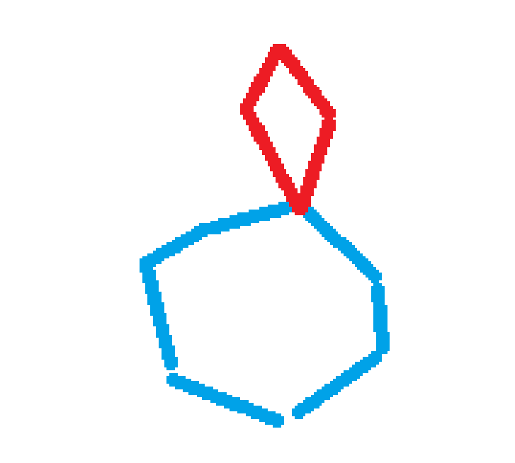

Floating segments
If the feature is in the list of features touching the boundary, it is ignored. If it is not touching, features with floating end points are deleted.
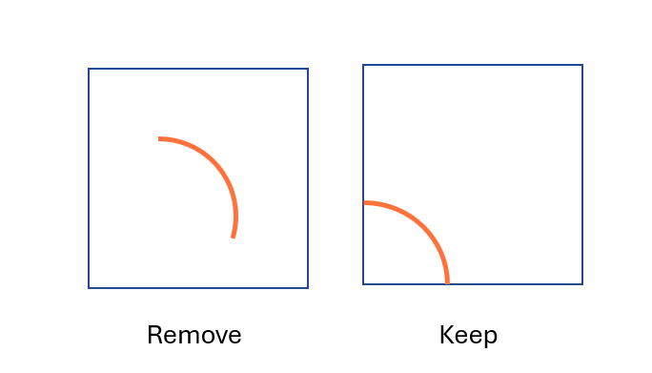
The last artifact removed by the script is floating segments. These are segments whose start and endpoints do not overlap (not loops) and do not touch the edge of the study area at any point.

If a feature meets any of the conditions within the function, its OID will be added to a list and the loop will move on to the next feature.

Timing

As with generation, cleaning time is also highly variable. Cleaning time can be greatly reduced by applying a more aggressive simplify line threshold, but this comes at the cost of contours overlapping each other in dense areas.

8. Future improvements
Update AOI scripts:
All the AOI handling and boundary touching sections of the code were built when I was using areas of interest that had internal grids. These are still functional but can be updated/simplified.
- AOI no longer needs to be converted to a line feature or dissolved
- Could use a Contains spatial relationship rather than Within A Distance.
Imagery
Local storage is annoying; downloading tiles is extremely time and storage consuming. Areas between surveys may also leave gaps with no DTM coverage.
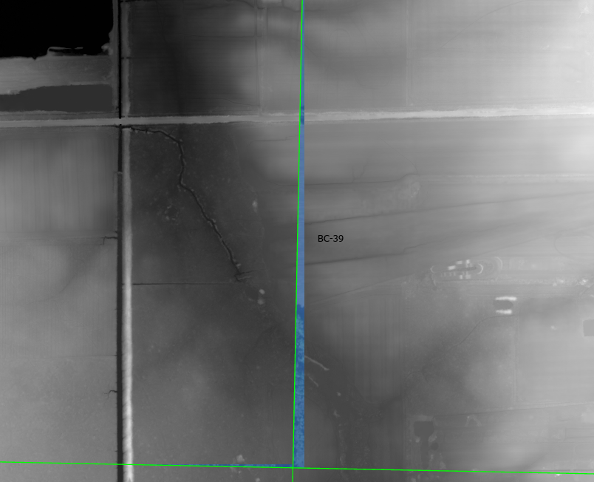
Aggressive simplification & adding smooth line
I’ve been using a simplify line threshold of 1 metre. This works well in areas where contours are spread out and greatly improves the number of geometry artifacts/processing time but leads to bad topography in areas with very dense contours. For the sake of getting the contours finished by the end of my placement I’m prioritizing speed, but the threshold should be reduced later; probably to 0.5.
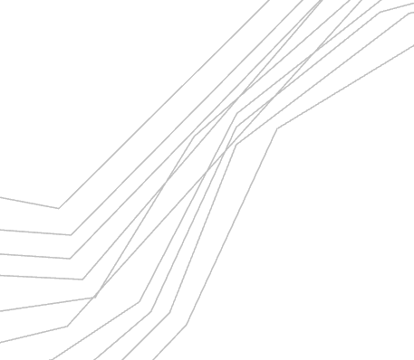
Because smooth line seems to collapse some more complex geometry, it should also be considered as an addition to the script.
Redundant waterbodies
Because the DTM is already hydro flattened, it may be worth revising the watershed feature at this stage to exclude these breaklines unless they’re touching an OHN feature. Finding an average height inflates the runtime of the image processing, especially for larger features, and the work is redundant.
River elevation
For hydro breaklines, the average elevation within a water body is chosen to represent the whole feature. This works well for lakes, but for longer features like rivers the elevation would be inaccurate. Many rivers in the DTM have already been hydro flattened, should inspect how it was done there for consistency.
Script problems
- Knots that are longer than 30 metres are preserved and continue to break up dissolved contours. Worried about removing valid contour segments if this threshold (stored as MAX_KNOT_LENGTH) is increased. There aren’t many knots that are over 30m but there are enough that it makes manual cleaning annoying.
- The script’s workspace/file handling is messy, was established very early into development and has remained unchanged.
- Vismem gets corrupted occasionally and loses the ability to reference the hydro breaklines. I do not understand why this happens. Emptying the local cache (display settings) and the files in %temp% usually fixes it.
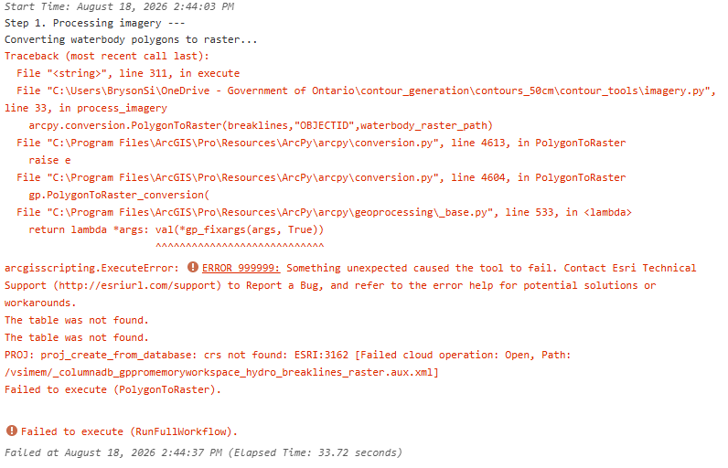

Appendix A. Functions & tools
build_aoi_boundary
Creates a bounding box line feature from the input processing area grid. Used in remove_artifacts to preserve floating segments that touch it.
build_endpoint_counts

clean_contours
Executes the cleanup process defined in remove_artifacts. Deletes any old versions of the working file and creates a new copy from the in_fc parameter. Performs Simplify Line (default threshold value of 1) on the contours before passing them into remove_artifacts.
create_contours
Creates the contours based on the imagery processed by process_imagery() and merges them together. Instead of clipping segments (bulky and slow tool), the processing extent is limited to one 1km x 1km square of the study area at a time.

detect_knots
detect_suspect_geometry

replace_suspect_geometry

deleter and purger
Automate checking whether a file exists, and deleting it if yes. Deleter handles one item at a time, purger checks a list of items.

is_closed_loop
Detects whether a loop is closed or not based on whether its endpoints share the same coordinates.
is_floating_segments
make_layer
Creates a layer that is a subset selection of a feature class. Selects features using a list of object IDs that are either in or not found in a secondary comparison list.
process_imagery
Runs average focal statistics on the input imagery (5x5 window) and flattens the elevation of waterbodies to a local average using Zonal Statistics.

remove_artifacts
remove_fragments
Creates a list of very small segments (under 5 metres long) that may be created by running Dissolve on the contours and deletes them from the input feature class.

remove_duplicate_pieces
Creates a list of duplicate pieces (an artifact that occurs when multiple non-loop segments share the same start and end points) and deletes them from the feature class.

remove_artifacts
Removes more complex artifacts: dangles, standalone lines, 3 and 4-way intersections, and duplicate lines. Uses feature vertices to points and an ArcPy search cursor to inspect the location of line segment endpoints. See Connectivity (section ??) for more information on how this works.

touching_boundary
Returns a true or false value for whether a contour is in the list of features that touch the AOI boundary.

Appendix B. Flagged contour errors
AP43: Missing large pieces of contour
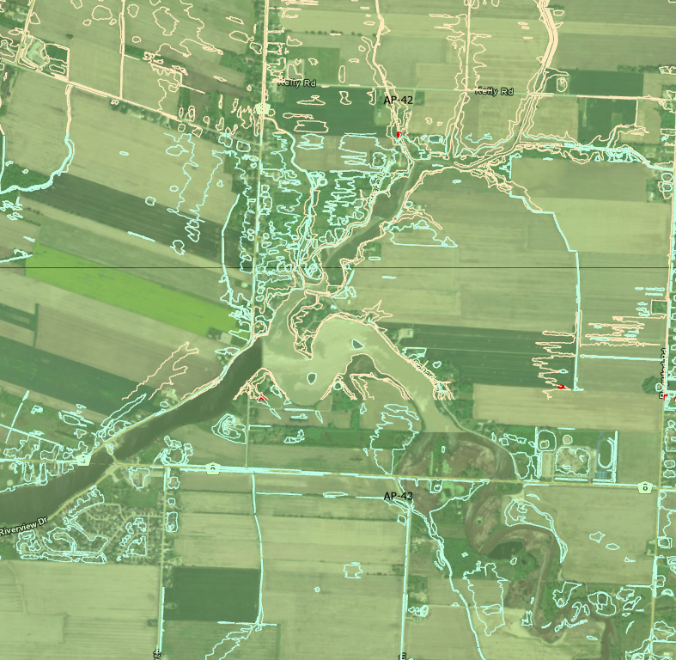
AQ41: Very weird around the island area at the northeast tip. Had some contours that just end.
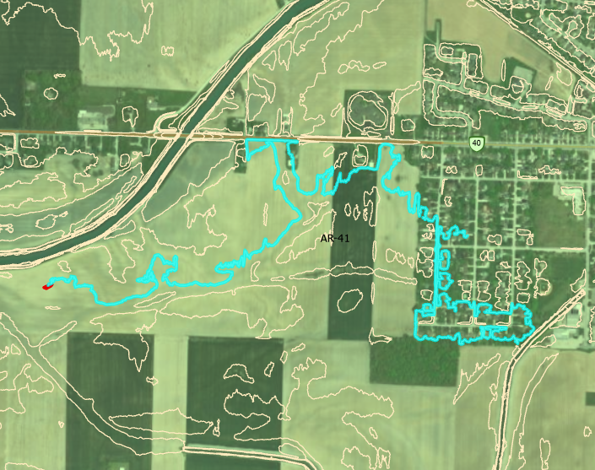

BD39/BE39: Some parts of Lake Erie did not have any associated OHN polygons or breaklines and were not hydro flattened. Created weird artifacts like this.
