**Toward Blockchain-Based Accounting and Assurance**

**Jun DaiMiklos** · **A. Vasarhelyi**

**Rutgers, The State University of New Jersey, Newark Southwestern University of Finance and Economics**

**E-mail: jundaimiklos@newjersey.ac**

**[ABSTRACT]**

Since 2009, blockchain has served as a potentially transformative information technology expected to be as revolutionary as the Internet. Originally developed as a methodology to record cryptocurrency transactions, blockchain’s functionality has evolved into a large number of applications, such as banking, financial markets, insurance, voting systems, leasing contracts, and government service. Despite such advancements, the application of blockchain to accounting and assurance remains under-explored. This paper aims to provide an initial discussion on how blockchain could enable a real-time, verifiable, and transparent accounting ecosystem. Additionally, blockchain has the potential to transform current auditing practices, resulting in a more precise and timely automatic assurance system.

**[KEYWORDS]** *blockchain, smart contract, future accounting, future assurance*

**1. INTRODUCTION**

Blockchain is one of the most important and innovative technologies developed in recent years (Peters and Panayi 2016; Pilkington 2016; PricewaterhouseCoopers [PwC] 2015; Swan 2015a). Originally used for Bitcoin1 trading, blockchain establishes a decentralized public ledger that provides a secure infrastructure for transactions among unfamiliar parties without a central authority. This technology is meant to reduce trading costs, increase transaction settlement speed, reduce fraud risk, improve the auditability of transactions, and increase the effectiveness of monitoring (Swan 2015a; Fanning and Centers 2016; Pilkington 2016; Yermack 2017). Blockchain is evolving from a secure monetary transaction system into part of an ecosystem of emerging technologies that includes artificial intelligence, the Internet of Things (IoT), robotics, and crowdsourcing. These technologies together represent the technical foundation of future commerce (Omohundro 2014; Deloitte 2016; Dorri, Kanhere, and Jurdak 2016; Ferrer 2016). Blockchain is obtaining increased attention from the accounting profession. PwC, for example, views blockchain as the ‘‘next-generation business process improvement software to structurally alter shared practices between customers, competitors, and suppliers’’ (PwC 2016). Similarly, Deloitte (2016) expects that blockchain will improve collaboration among businesses and individuals, the transparency of business processes and data, and, ultimately, the productivity and sustainability of the economy. Recently, blockchain has broadened its technical foundation to support various businesses, such as banking, trading, insurance, data protection, voting, intellectual property, identity authentication, leasing, and government service2 (Atzori 2015; Cointelegraph 2015; De Meijer 2016; Liebenau and Elaluf-Calderwood 2016; Peters and Panayi 2016; Swan 2015a; Trautman 2016; Wall Street Journal [WSJ] 2015; Yermack 2017; Zyskind, Nathan, and Pentland 2015). Accounting and assurance could be among the professions to which blockchain would bring great benefits and fundamentally change the current paradigms. Blockchain’s functions of protecting data integrity, instant sharing of necessary information, as well as programmable and automatic controls of processes, could facilitate the development of a new accounting ecosystem. This technology could also serve as a foundation to enable automatic assurance and help the current auditing paradigm become more agile and precise. However, the potential benefits and challenges that blockchain could bring to the accounting and assurance domains are still under-explored. This paper aims to fill the gap in the literature, and to generate insights for both practitioners and regulators on the acceptance and use of the emerging technology. Specifically, this paper first proposes a blockchain-enabled, real-time, verifiable, and transparent accounting ecosystem. In the ecosystem, blockchain would play the role of the accounting information system, which distributes the power of transaction verification, storage, and management to a group of computers in order to prevent any unauthorized data changes. By incorporating other emerging technologies (e.g., IoT), the system could enable real-time tracking and monitoring of activities of physical objects, and automate the recording and measurement of business performance. This mechanism would facilitate close to real-time reporting of reliable accounting information to interested parties (e.g., managers, auditors, creditors, stakeholders) at various aggregation levels based on their roles and demands. Blockchain is also proposed in this paper as a tool to authenticate any audit-related information. Since blockchain secures the data that are posted on it, auditors could trust the integrity of those data and perform various analyses. Moreover, automatic and agile assurance could be further enabled by ‘‘smart controls,’’ which are computer programs that would operate on blockchain to automatically control business processes against pre-determined rules. Since the original design of blockchain is to enable peer-to-peer digital currency trading, how to adapt the existing blockchain mechanisms to the accounting and auditing sphere is worth careful thought. The main contributions of this paper are threefold. First, it is among the first few studies to introduce blockchain to the accounting and auditing literature. Second, it explores the potential applications and utilization of this technology in the accounting and auditing profession. The discussions and illustrations provide insights to auditors, regulators, and technology vendors, to facilitate the incorporation of blockchain into the existing business procedures, as well as promote the transformation of the current audit model toward the next generation. Third, it provides a discussion on the challenges in the adoption and use of those technologies, as well as potential solutions that could mitigate those concerns. The remainder of this paper proceeds as follows: Section II provides the background of blockchain, and compares the characteristics of blockchain with existing data management technologies such as database and enterprise resource planning (ERP) systems. Section III illustrates the potential applications of blockchain in re-conceiving corporate accounting. Section IV discusses the utilization of blockchain technology to enable an efficient, effective, and timely assurance system. The challenges facing blockchain adoption and implementation, as well as potential research directions, are discussed in Section V. Section VI concludes and discusses the limitations

**2. BACKGROUND**

Blockchain: Background and Applications Blockchain technology was conceived and initiated by Nakamoto (2008). He used a chain of blocks to create a decentralized, publicly available, and cryptographically secure digital currency system. The system, named Bitcoin, enables peer-to-peer digital currency trading. This eliminates the need for financial intermediaries while maintaining transaction safety. The Bitcoin blockchain can be viewed as a new type of accounting database that records the transactions of the digital currency into blocks. The blocks are arranged in linear chronological order and shared to a network (Fanning and Centers 2016; Peters and Panayi 2016; Swan 2015a; Yermack 2017). The main characteristics of the Bitcoin blockchain include: (1) decentralization, (2) strong authentication, and (3) tamper-resistance. The operation and management of the Bitcoin system are designed to be decentralized. This means that all nodes in the system have access to the entire list of transactions. Such access allows nodes to both verify and publish new transaction records onto blocks, which are then periodically added to the end of the main blockchain with a time stamp (Nakamoto 2008). The system is also able to verify the identity of every payer and payee involved based on a public-key cryptography system (Diffie 1988). It also examines whether the payer possesses enough money for the transaction to occur. Moreover, the process of creating a block on the chain is designed to require costly computational resources. This is to ensure the integrity and irreversibility of published transactions, and makes it almost impossible for a single or a small group of malicious parties to tamper with any blockchain records. The blockchain architecture is designed to be a decentralized public database. In this system, every party in the network has the right to read, verify, and update transactions to the chain. In many modern applications, however, this is undesirable. In many cases, such as the use of blockchain within a business or a group of companies, the read and write permissions should be restricted to certain entities. Such systems, known as private blockchains (Pilkington 2016), involve a limited number of participants. The advantage of a private blockchain is that information stored in the chain is only accessible to predetermined entities (e.g., companies only need to share certain accounting records among departments within the organizations or with their suppliers and customers). This design can protect the privacy and confidentiality of business data. Another type of blockchain is a permissioned blockchain (Peters and Panayi 2016). In a permissioned blockchain, trusted parties are preselected by a central authority and given the authorization to verify transactions. The benefit of a permissioned blockchain is that the role of transaction verification is withheld from irrelevant parties, simplifying the verification process and avoiding unwanted manipulation. In addition, permissioned blockchains are generally more scalable (Peters and Panayi 2016). Since only a limited number of parties can verify transactions, the consensus on validated transactions can be reached much quicker. One potential drawback is that this type of blockchain is based on a highly trusted entity model. Such a model requires that verifying entities do not collude to create false transactions. Since many entities within a business relationship have already established a certain level of trust, this concern is minimized, and permissioned blockchain models may still be more appropriate. Since 2009, blockchain has evolved through three phases: blockchain 1.0, 2.0, and 3.0 (Swan 2015a). Blockchain 1.0 purely focuses on the trading of cryptocurrency. The functions of digital money transfer, remittance, and payment comprise a new ecosystem: the ‘‘Internet of Money’’ (Peters and Panayi 2016). Blockchain 2.0 involves similar trading, but with a much broader scope of financial applications. Such applications include derivatives, digital asset ownership, smart property, etc. (Fanning and Centers 2016; Swan 2015a). To expand the trading from simply digital currency to a large variety of products, a new type of application called a ‘‘smart contract’’ (Swan 2015a) was introduced in the second generation of blockchain. Blockchain-based smart contracts are computer programs operating on blockchains that autonomously verify, enforce, and execute the terms in contracts (Kiviat 2015; Peters and Panayi 2016; Zhang, Cecchetti, Croman, Juels, and Shi 2016). Smart contracts allow for the encoding of rules and situations that are agreed upon by the various trading parties. These contracts autonomously execute pre-specified tasks, or settle a contract, by examining changing conditions in conjunction with the contract’s embedded rules. The concept of a ‘‘smart contract’’ was first proposed by Szabo (1994), who noted that the execution and monitoring of contracts mainly relies on a trusted central authority. The new blockchain-based smart contracts decentralize the enforcement power to each node in the blockchain network. Furthermore, as the trading history is distributed to every entity in the network, repudiation or modification of a trade will be almost impossible. Those functions of blockchain help to dramatically reduce the counterparty risk (Kiviat 2015). Figure 1 illustrates an example where a blockchain-based smart contract is used to monitor and operate a loan covenant. When a company and a bank agree upon a covenant, this conditional term is encoded into a smart contract that is then deployed into a blockchain. The nodes in the blockchain network will monitor the conditions and activities of the company against the requirements outlined in the smart contract. Once a violation of the covenant is detected, the blockchain network will automatically activate the portion of the smart contract pertaining to that violation. This could result in actions such as calling in the loan, increasing the interest rate, or the issuance of a warning, based on what was previously agreed upon by the parties. Auditors and the bank’s management could also participate in the mechanism to oversee whether the smart contracts execute in compliance with the predetermined rules. In addition to trading agreements, smart contracts can also encode other terms and execute tasks following the prespecified rules. As the complexity and automation of smart contracts increase, their application could be largely expanded. Future applications may range from peer-to-peer ridesharing to self-issuing bonds or crowdfunding with the promise of future dividends (Jacynycz, Calvo, Hassan, and Sa´nchez-Ruiz 2016; Yuan and Wang 2016). In the long term, smart contracts could facilitate the development of a new type of company called a ‘‘Decentralized Autonomous Organization/Corporation (DAO/DAC).’’ A DAO/DAC is a company that relies on the blockchain technology to self-organize and operate business. In DAO/ DACs, management programs their governance rules and decision-making processes into smart contracts. This creates a structure with decentralized controls on a blockchain network (Jarvenpaa and Teigland 2017). The governance of a DAO/DAC can be achieved by distributing decision-making power to multiple participants within the blockchain network. This would guarantee the execution of an action only when the majority of the participants agree to it (Wright and De Filippi 2015). One of the main considerations of the management of a DAO/DAC is to create a set of appropriate rules that enable effective governance of the specific organizations. A DAO/DAC could collect funds from individuals and pay dividends to crowdfunding investors based on the pre-agreed terms encoded in smart contracts (Swan 2015a). The investors may also participate in decision-making through decentralized voting for approval of future strategies (Wright and De Filippi 2015). Blockchain 3.0 expands blockchain systems further, beyond financial and business applications. Cloud storage products, voting systems, attestation services, or even government administration could be dramatically transformed toward decentralized self-managing and monitoring models (Swan 2016). Linking the IoT with blockchain technology is another novel application (Atzori 2017; Christidis and Devetsikiotis 2016; Zhang and Wen 2016). IoT is a novel paradigm in which ‘‘the pervasive presence around us of a variety of things or objects—such as Radio-Frequency IDentification (RFID) tags, sensors, actuators, mobile phones, etc.—which, through unique addressing schemes, are able to interact with each other and cooperate with their neighbors to reach common goals’’ (Atzori, Iera, and Morabito 2010). Basically, IoT interconnects physical and virtual things via a global network to enable advanced services (Atzori 2017). Blockchain and smart contracts could be used for the control and trading of the physical objects or services. For example, by using IoT technology embedded in automobiles, drivers could negotiate with other cars to reserve a lane by paying a small compensation (Swan 2015a). In addition, peer-to-peer accommodation rental services can be created when both a service vendor and a customer agree on a smart contract. The vendor can then issue a digital key that is installed in the customer’s smartphone to unlock the facility (Hancock and Vaizey 2016). Blockchain and associated smart contract technologies could advance society toward a more automated, flexile, and efficient lifestyle. Although the literature of many other fields has proposed potential applications of blockchain, there is limited research examining the utilization of this technology within accounting and auditing practice. Yermack (2017) provided a brief discussion on using blockchain to enable real-time accounting. He proposed that with voluntary disclosure of a company’s ordinary business transactions via blockchain, interested parties could obtain instant access to accurate financial information. Using the data on blockchain, any information consumer could create his own financial statements, without relying on the judgment of auditors and the integrity of managers. While the detailed mechanisms and paradigms used to support real-time accounting were not designed, the concept is nevertheless noteworthy. Fanning and Centers (2016) suggested that blockchain technology could be of benefit to the auditing profession by making the comparison of corresponding accounting entries, present on the books of each of the trading parties, relatively easy. Explicit illustration on how to achieve such a goal is still missing, but this approach would reduce auditors’ efforts relating to financial transaction testing. Kiviat (2015) illustrated the idea of blockchain-enabled ‘‘triple-entry accounting’’ using the example of Bitcoin transactions. It described the mechanism for posting accounting entries of Bitcoin trades to the blockchain in order to prevent transaction tampering. Unfortunately, this ‘‘triple-entry accounting’’ mechanism is specifically designed for the Bitcoin system, and cannot be directly applied to general corporate accounting systems. Peters and Panayi (2016) discussed the utilization of blockchain to facilitate banking ledger processing. While they provide detailed illustration on how the new technology can automate accounting booking processes, the discussion only focuses on the banking context and not broader general accounting systems. Therefore, this paper aims to extend the literature by imagining and proposing the utilization of blockchain in a generic accounting system. Specifically, this paper provides detailed illustration.

**3. A BLOCKCHAIN-BASED ACCOUNTING ECOSYSTEM**

As mentioned in Section I, the accounting profession could largely benefit from blockchain, and its current paradigm may be eventually changed thanks to this emerging technology. Blockchain, as well as associated smart contracts, can be leveraged to securely store accounting data, to instantly share relevant information with interested parties, and to increase the verifiability of business data. Using blockchain technology, companies are able to generate new accounting information systems that record validated transactions on secure ledgers. Those transactions will include not only monetary exchanges between two parties, such as payments collected from clients, cash deposited to banks, etc., but also the accounting data flow within a company. Such systems would enable close to real-time reporting by instantly broadcasting accounting information to interested parties, such as managers, auditors, creditors, and stakeholders. Because of the dramatic decrease in the unit cost of processing, memory, and storage, as well as the emergence of distributed public ledgers like blockchain, external participants can access companies’ real-time accounting information at low cost. Smart contracts could serve as automatic controls that monitor accounting processes based on predetermined rules. In addition, with the advancement and popularization of IoT, controls could be embedded into the blockchain. These IoT-based controls could be incorporated into various physical objects in order to monitor and enact business processes in real time. Moreover, data analytics can also be used in conjunction with blockchain to discover anomalies and other useful information. In this system, managers, accountants, business partners, and investors could actively collaborate to verify transactions, as well as provide reliable evidence for cross-validation. These components should come together and comprise a real-time, verifiable, and transparent accounting ecosystem. Figure 2 provides an overview of the blockchain accounting ecosystem.

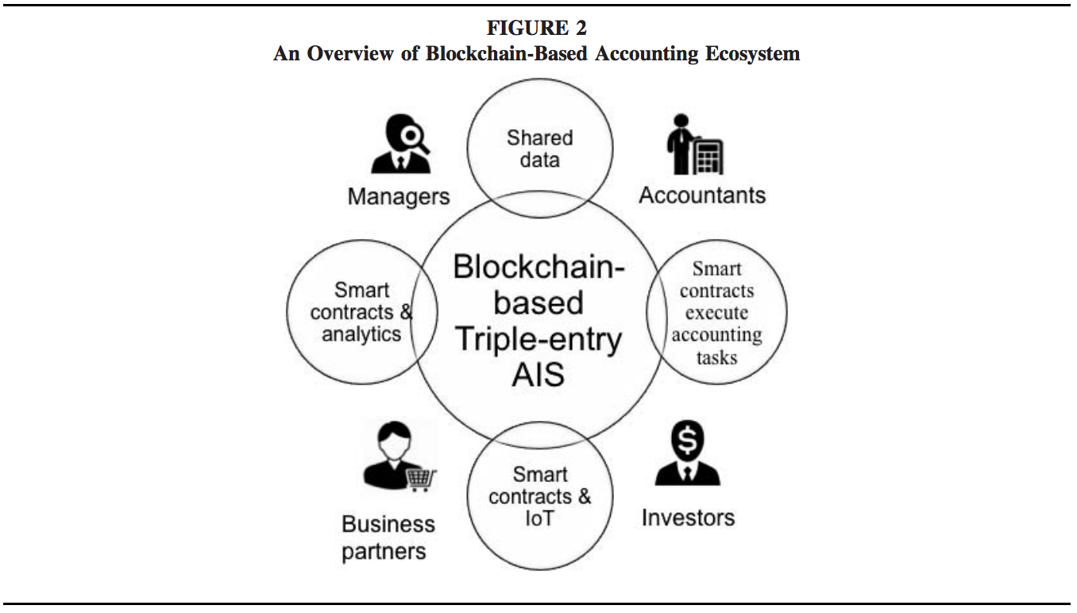

at lower scale are stronger than those at the normal scale, the shape of context offers the connected points of

Triple-Entry Accounting Triple-entry accounting3 has been discussed for years by both academics and professionals (Grigg 2005, 2011; Elias 2011; Tyra 2014; Kiviat 2015; Lazanis 2015). The primitive mechanism of transaction and business activity recording is single-entry bookkeeping, in which each transaction is only recorded in one account (Sangster 2016). Although such a mechanism is simple and efficient, it is fraught with a high risk of errors and fraud, since such issues are difficult to track and repair. To improve the accuracy of the bookkeeping system, traditional financial accounting is based on a double-entry system (Pacioli 1514). This system enables rapid confirmation that the transaction has been correctly entered (Sangster 2016). The double-entry system can reduce the risk of human documentation error, such as accidental deletion of transactions, but it does not provide comprehensive assurance for companies’ financial statements. Although auditors serve as third-party examiners who perform a series of tests on companies’ accounting records and provide their opinions on the accuracy of the financial statements, improvements on the existing reporting and assurance system are still needed. The ‘‘triple-entry system’’ was recently proposed to be utilized as an independent and secure paradigm in order to improve the reliability of companies’ financial statements. The triple-entry system originally required transaction processing authorization from a neutral intermediary, with each party (the two parties involved in the transaction and the intermediary) creating a record for the transaction, resulting in three entries total (Grigg 2005). However, this mechanism requires an independent and reliable intermediary to verify each individual transaction. In addition, entries stored by the intermediary are also exposed to the risk of loss or unauthorized changes due to cyber-attacks. Blockchain technology has the potential to improve this mechanism and mitigate these problems. It could play the role of the intermediary by distributing and automating the storage and verification process, providing a secure foundation that prevents tampering and irregular accounting entries. Because of the nature of blockchain, once an accounting entry is confirmed and added to the chain, it can hardly be altered or destroyed. Moreover, smart contract technology could enable rapid verification of transaction records following accounting standards or pre-specified business rules. By encoding the third accounting entry into blockchain, a transparent, cryptographically secure, and self-verifying accounting information system can be generated, which could facilitate reliable data sharing between business parties and continuous reporting for shareholders.

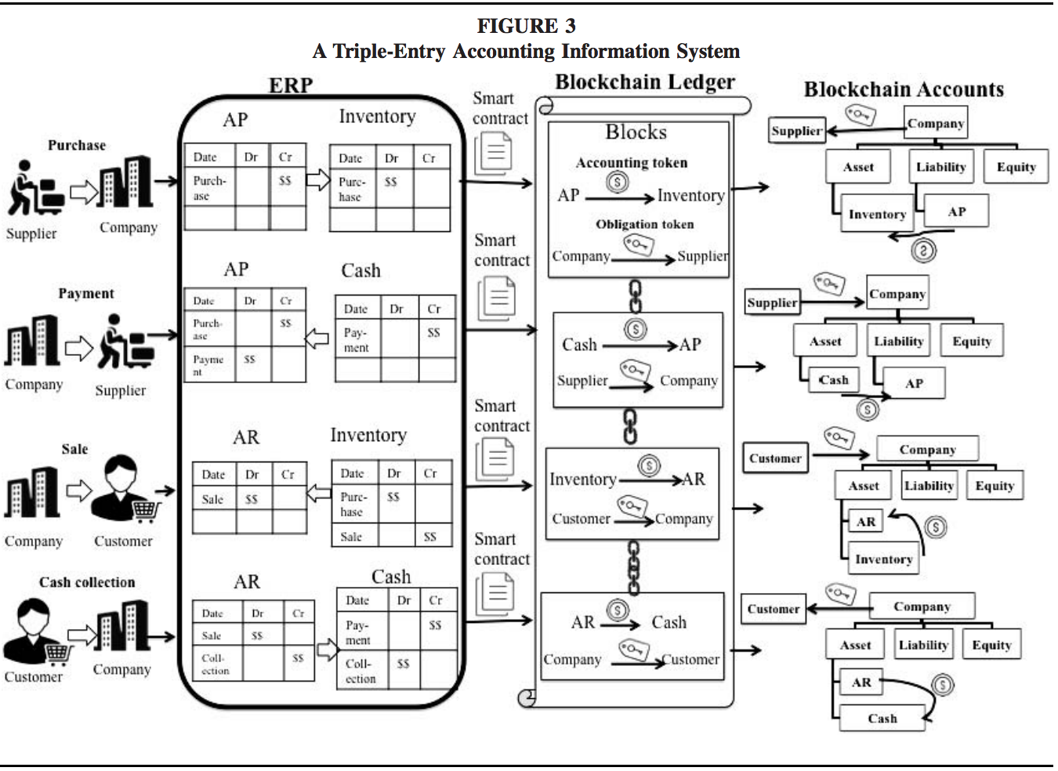

One potential design of the simplified triple-entry accounting information system is shown in Figure 3. This system would record information regarding both transactions between business parties and data flows within an organization. In the system, every transaction would create a record stored in the blockchain ledger, in addition to the entries that have been included in the traditional double-entry system. To reflect data flows within an organization, the entries in the blockchain ledger would be recorded in the form of token transfers between accounts, which together comprise an interlocking system of enduring accounting records. Accounts in the blockchain ledger would be organized in a hierarchical structure to aggregate data at various levels, which enables both instant balancing of the accounting equation and different views of information for different users. Tokens in the blockchain ledger would also be used as certificates to attest to obligation or ownership of assets among business parties. Blockchain technology allows for timely examination of potential errors or fraud within accounting entries (e.g., duplicate payments), as well as automation of transaction verification using data from business partners. Moreover, smart contracts encoded with accounting and business rules could enable efficient control of the recording process. Figure 3 displays the working process of the system, using a simple purchase-sale business cycle as an example. When a company purchases goods from its supplier by credit, it will record Accounts Payable and Inventory in its ERP system. It will simultaneously submit this event in the form of a transfer of a digital token (which is the ‘‘accounting token’’) between two blockchain accounts, to the blockchain ledger. An accounting token in the blockchain ledger can be simply viewed as a symbol for recording and tracking purposes. Each account in the modern double-booking system would have a corresponding blockchain account. A blockchain account is equivalent to a Bitcoin wallet, 4 which contains an account’s unique identifier.

**4. CONCLUSION**

This paper proposes a radically different measurement and assurance paradigm utilizing modern blockchain and associated smart contract technologies. Although the technological world has provided business with computers, Internet, and advanced analytic methods, the essence of the accounting measurement model has remained the late medieval model of double-entry (Pacioli 1514).

Furthermore, auditing’s basic approach (Montgomery 1919) has been very slowly evolving for a century, making the use of technologies limited, at best. The fear is that basing modern accounting and auditing in these old technologies will make the processes redundant, non-flexible, defenseless against modern cyber-attacks, and dependent on anachronistic rules. Consequently, after drawing on multiple disciplines and thought pieces from the accounting profession, this paper argues for a blockchain-based accounting and assurance methodology that would provide real-time, verifiable information disclosure and progressively automated assurance.

However, the difficulties of both the development and implementation of such a radically different technology cannot be ignored. While the goal of this paper is to discuss and provide insights on how blockchain technology could impact the accounting and assurance profession, our study has many limitations.

We point out three important ones.

First, blockchain technology is emerging and rapidly developing. As new algorithms and approaches are introduced, its accounting and assurance applications may need to be expanded and reconsidered.

Second, this paper only provides a general discussion of the role that blockchain technology could play in the accounting and assurance environment. Blockchain’s applications and challenges in specific areas, such as government auditing, need further thoughts.

Third, concepts like triple-entry accounting may be just an adaptation to the extant world, which may not be advanced enough to use going forward in a rapidly changing world.

***My references are at below page.***

**REFERENCES:**

[1] Alles, M. G., A. Kogan, and M. A. Vasarhelyi. 2002. Feasibility and economics of continuous assurance. Auditing: A Journal of Practice & Theory

[2] Allison, I. 2015. Deloitte, Libra, Accenture: The Work of Auditors in the Age of Bitcoin 2.0 Technology.

[3]  M. Alfraheed, A. Dröge, D. Schilberg, and S. Jeschke, “Automated heterogeneous platoons in unstructured environment: Real time tracking of a preceding vehicle using video stream,” in 2014 5th International Conference on Information and Communication Systems (ICICS), 2014, pp. 1–6.

[4]  M. Alfraheed, A. Dröge, R. Kunze, M. Klingender, D. Schilberg, and S. Jeschke, “Real time detection of the back view of a preceding vehicle for automated heterogeneous platoons in unstructured environment using video,” in 2011 IEEE International Conference on Systems, Man, and Cybernetics, 2011, pp. 549–555.

[5]  Y. Bai, L. Zhuo, B. Cheng, and Y. F. Peng, “Surf feature extraction in encrypted domain,” in 2014 IEEE International Conference on Multimedia and Expo (ICME), 2014, pp. 1–6.

[6] G. D. Hong, C. S. Kim, and C. Lee, “LWIR HgCdTe Infrared Photodetector,” The Journal of Korea Navigation Institute, Vol. 14, No. 5, pp. 668-676, Oct. 2010.

[7] S. Jin et al., “FPGA Design and Implementation of a Real-Time Stereo Vision System,” IEEE Trans. Circuits Syst. Video Technol., vol. 20, no. 1, pp. 15–26, Jan. 2010.

[8] C. I. Kim and S. Y. Park, “Fast Stereo Matching of Feature Links,” in Visualization and Transmission 2011 International Conference on 3D Imaging, Modeling, Processing, 2011, pp. 268–274.

[9] J. Lin, D. Yan, X. Hu, Q. Xing, and B. Yang, “Dynamic programming algorithm for stereo correspondence of contour,” in 2012 5th International Congress on Image and Signal Processing, 2012, pp. 866–870.

[10]W. Xiaoli, Y. Lei, W. Lirong, and X. Jing, “Characteristic Point Match Algorithm Based on the SURF in Binocular Stereo Vision,” in 2012 Fifth International Conference on Intelligent Networks and Intelligent Systems, 2012, pp. 302–305.

[11]B. Zhang, Y. Jiao, Z. Ma, Y. Li, and J. Zhu, “An efficient image matching method using Speed Up Robust Features,” in 2014 IEEE International Conference on Mechatronics and Automation, 2014, pp. 553–558.

[12] E. Kiperwasser, O. David, and N. S. Netanyahu, “A Hybrid Genetic Approach for Stereo Matching,” in Proceedings of the 15th Annual Conference on Genetic and Evolutionary Computation, New York, NY, USA, 2013, pp. 1325–1332.

[13]L. Trujillo and G. Olague, “Automated Design of Image Operators that Detect Interest Points,” Evol. Comput., vol. 16, no. 4, pp. 483–507, Dec. 2008.

[14] T. Khan, M. Biglari-Abhari, G. Gimel’farb, and J. Morris, “Fast Point-of-interest Detection from Real-time Stereo,” in Proceedings of the 27th Conference on Image and Vision Computing New Zealand, New York, NY, USA, 2012, pp. 79–84.

[15]L. Trujillo, G. Olague, E. Lutton, and F. Fernández de Vega, “Multiobjective Design of Operators That Detect Points of Interest in Images,” in Proceedings of the 10th Annual Conference on Genetic and Evolutionary Computation, New York, NY, USA, 2008, pp. 1299–1306.

[16] F. Alhwarin, D. Ristić–Durrant, and A. Gräser, “VF-SIFT: Very Fast SIFT Feature Matching,” in Pattern Recognition, 2010, pp. 222–231.

[17] B. Zhang, Y. Jiao, Z. Ma, Y. Li, and J. Zhu, “An efficient image matching method using Speed Up Robust Features,” in 2014 IEEE International Conference on Mechatronics and Automation (ICMA), 2014, pp. 553–558.

[18] B. Zhang, Y. Jiao, Z. Ma, Y. Li, and J. Zhu, “An efficient image matching method using Speed Up Robust Features,” in 2014 IEEE International Conference on Mechatronics and Automation (ICMA), 2014, pp. 553–558.

[19] D. G. Lowe, “Distinctive Image Features from Scale-Invariant Keypoints,” Int. J. Comput. Vis., vol. 60, no. 2, pp. 91–110, Nov. 2004.

[20] D. Liu and J. Yu, “Otsu Method and K-means,” in Proceedings of the 2009 Ninth International Conference on Hybrid Intelligent Systems - Volume 01, Washington, DC, USA, 2009, pp. 344–349.

[21] M. M. H. Daisy, S. TamilSelvi, and L. Prinza, “Gray scale morphological operations for image retrieval,” in 2012 International Conference on Computing, Electronics and Electrical Technologies (ICCEET), 2012, pp. 571–575.

[22]  GONZALEZ, DIGITAL IMAGE PROCESSING USING MATLAB 2E. Tata McGraw-Hill Education, 2009.

[23]  Z. Huijuan and H. Qiong, “Fast image matching based-on improved SURF algorithm,” in 2011 International Conference on Electronics, Communications and Control (ICECC), 2011, pp. 1460–1463.

[24]  N. Dalal and B. Triggs, “Histograms of oriented gradients for human detection,” in 2005 IEEE Computer Society Conference on Computer Vision and Pattern Recognition (CVPR’05), 2005, vol. 1, pp. 886–893 vol. 1.

[25]S. Chen, J. Li, and X. Wang, “A Fast Exact Euclidean Distance Transform Algorithm,” in 2011 Sixth International Conference on Image and Graphics, 2011, pp. 45–49.

[26]  C. Pornpanomchai and A. Phaisitkulwiwat, “Fingerprint Recognition by Euclidean Distance,” in 2010 Second International Conference on Computer and Network Technology, 2010, pp. 437–441.

[27]  VisLab - Dipartimento di Ingegneria dell’Informazione - Parco Area delle Scienze - Università di Parma, “VisLab | Extend Your Vision,” VisLab, 17-Oct-2017. [Online]. Available: http://vislab.it/. [Accessed: 17-Oct- 2017].

.