Secondary Analysis of Clinical Determinants for Ebola Virus Disease (EVD)
  - Clinical Data Platform - North Kivu Outbreak
WHO Clinical Data Platform
2026-04-01

 Data Mapping & Validation
To ensure the integrity of the secondary analysis, a data dictionary mapping exercise will be conducted:
- Variable Alignment: REDCap field names from the EVD project (e.g., diarrhoea_anytime) will be mapped to all the variables from the North Kivu outbreak .
- Harmonization Check: Discrepancies in units (e.g., lab values) or categorical definitions will be resolved and documented in a transparent mapping_logfile.csv to ensure reproducibility.
- Plausibility Filters: Automated checks will flag biologically implausible values (e.g., Ct values <10 or >45) for manual review or exclusion.

1. Study Overview
This SAP outlines the proposed analysis of the 756 defined patients admitted between August 2018 and July 2019 during the North Kivu EVD outbreak. The goal is to identify clinical and laboratory determinants of mortality, with a sub analysis on pediatric populations. ## 1.1 Study Flow Diagram(Figure 1)
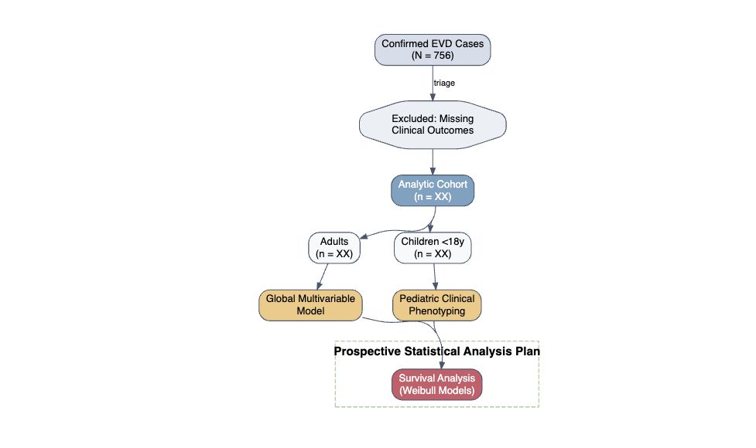
Figure 1: Study Flow Diagram

2. Variable Grouping & Data Harmonization
To analyze the predictors of EVD outcome and complications, we propose this Directed Acyclic Graphs (DAG) (Figure 2) to illustrate hypothesized causal relationships underlying EVD pathophysiology and clinical outcomes.
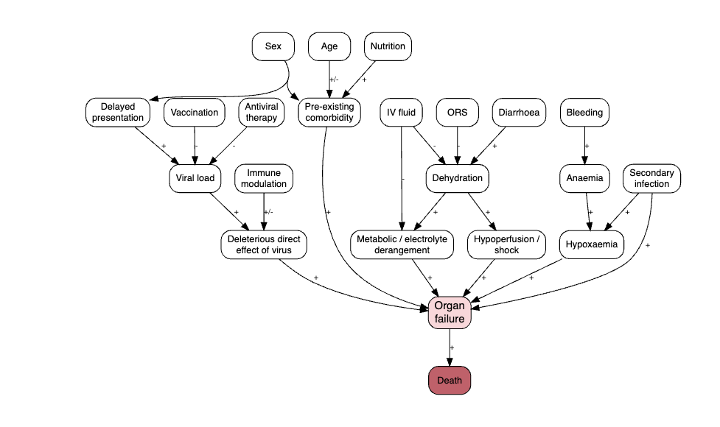
Figure 2: Directed Acyclic Graphs (DAG)
To ensure model parsimony, we will group sparse clinical variables into syndromic categories (Table 1):
- CNS Signs: Agitation, coma, disorientation, seizures, and irritability.
- GI Signs: Diarrhea, vomiting, abdominal pain, and anorexia.
- Renal/Dehydration: Anuria, signs of dehydration, and renal impairment (Creatinine ≥ 1.1 mg/dL).
Table 1: Symptom grouping used for analysis
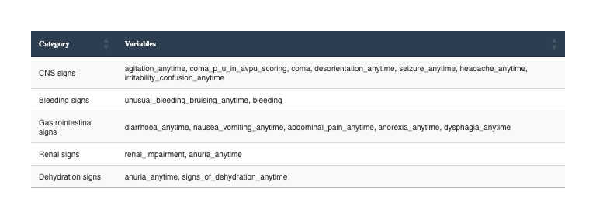

3. Statistical Methodology
We propose a stepwise modeling workflow (Figure 3) to identify independent predictors of clinical outcomes and complications.
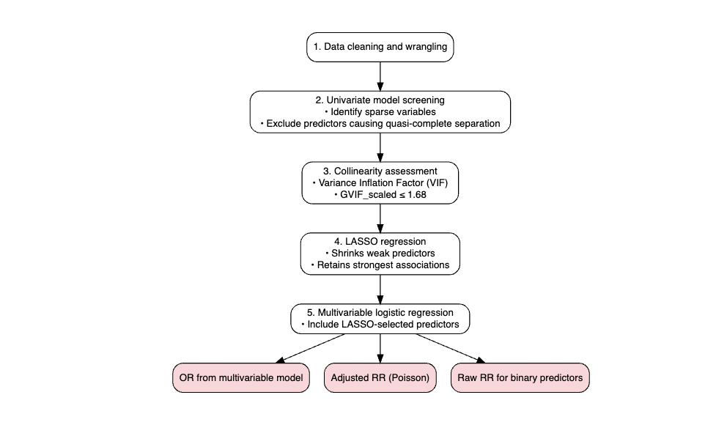
Figure 3: Proposed Stepwise Modeling Workflow for EVD Outcomes.

3.1 Data Preparation and Harmonization
Data cleaning and wrangling are performed using the tidyverse ecosystem.(Wickham et al. 2019) All clinical variables are inspected for consistency, and missingness is addressed through complete-case analysis or multiple imputation, depending on the variable’s importance and the proportion of missing entries.

3.2 Predictor Selection Framework
We will utilize a structured workflow to identify independent predictors:
- Univariate screening : Each potential predictor (demographics, symptoms, and lab values) is evaluated in univariate models. Variables with extreme sparsity or those causing quasi-complete separation are excluded from further modeling.
- Collinearity assessment: Multicollinearity among remaining variables is assessed using the car package. (Fox and Weisberg 2019)
- LASSO regression: Least Absolute Shrinkage and Selection Operator (LASSO) regression is applied via the glmnet package. (Friedman, Hastie, and Tibshirani 2010) This penalized regression technique shrinks coefficients of weaker predictors to zero, retaining only the most stable clinical associations for the final multivariable models.

3.3 Multivariable Modeling and Effect Estimation
The final analytic models will quantify the relationship between selected predictors and EVD outcomes:
- Primary Effect Estimation: To enhance clinical interpretability, we will report Adjusted Risk Ratios (aRR) and 95% confidence intervals (CI). These are derived using Poisson regression with robust standard errors (via the sandwich and lmtest packages [Zeileis, Koll, and Graham (2020)](Zeileis and Hothorn 2002) ), which provides more reliable estimates than odds ratios in settings where the outcome is not rare.
- Sensitivity Analysis: For comparison with historical literature, Adjusted Odds Ratios (aOR) will be computed via global multivariable logistic regression.
- Prognostic Thresholds: For continuous laboratory markers such as Cycle Threshold (Ct) values, we will utilize Receiver Operating Characteristic (ROC) analysis to determine optimal prognostic cut-offs (e.g., Ct $≈23$) for predicting mortality.

3.4 Software and Reproducibility
All analyses are conducted in R version 4.4.1. The use of a scripted, Quarto-based workflow ensures that the transition from the “Light CRF” raw data to the final analytical outputs is fully reproducible and transparent.

4. Pediatric Sub-analysis (Proposed)
Given the demographic distribution, we propose a dedicated focus on the XX pediatric cases:
- Comparison of Clinical Phenotypes
- Survival Comparison: Weibull proportional hazards models stratified by age groups (<5, 5-17) to determine if admission delays impact children differently than adults.

5. Proposed Analytical Outputs
The following outputs are proposed to characterize the North Kivu cohort and identify key clinical determinants of EVD outcomes.
 Expected Output 1: Table 1 - Patient Demographics & Baseline Features
A comprehensive descriptive table stratified by Age Group (Adult vs. Children), Outcome (Deceased vs. Recovered), and Sex (Male vs. Female).
Variables included:
- Demographics: Age at admission (Continuous), Age Group (Categorical), Gender, Patient Occupation, Pregnancy Status.
- Admission Data: Admission Delay (Days), Comorbid conditions (Diabetes, HIV, Chronic Pulmonary Disease).
- Baseline Status: Fever, Diarrhoea, Shock, Confusion, Bleeding (Binary).
- Lab/Diagnostic: Ebola RDT, GeneXpert PCR, Ct (lowest), Ct Below 23, Electrolytes (Hypo/Hyperkaliemia), Renal impairment, Rhabdomyolysis, Severe hypoglycemia, Platelets, Haemoglobin, Calcium.
- Initial Management: Experimental treatment type, Antibacterial/Antimalarial treatment, Fluid management, Blood transfusion.
 Expected Output 2: Epicurve and Case Fatality Rate (CFR)
Visualization of the outbreak progression by week of admission, with bar colors representing Outcome at Discharge. A secondary axis will plot the rolling CFR to monitor changes in mortality over time.

 Expected Output 3: Symptom & Complication Prevalence Maps
Bar charts or Heatmaps summarizing the frequency of the following binary clinical features:
- Symptoms: Abdominal pain, Agitation, Anorexia, Anuria, Chest Pain, Disorientation, Diarrhoea, Difficulty breathing, Dysphagia, Fatigue, Fever, Headache, Hiccups, Myalgia, Seizure, Signs of shock/dehydration.
- Clinical Signs: Conjunctival injection, Lymphadenopathy, Jaundice, Oedema (face/neck), Palpable liver, Pharyngeal erythema, Rash, Sunken eyes, Tenting on skin pinch.
- Severe Complications: Severe thrombocytopenia, Hyper/Hypokaliemia, Renal impairment, Rhabdomyolysis, Severe hypoglycemia.
 Expected Output 4: Prognostic Association Analysis
Visualizations and summary tables for clinical predictors of mortality:
- Outcome by Admission Delay: Analysis of survival probability based on the time from symptom onset to ETU admission.
- Outcome by Viral Load (Ct): Stratification of mortality risk by admission Ct values (e.g., <16, 16-18, 18-20, 20-22).
- Predictor Forest Plot: Presentation of Relative Risks (RR) and 95% CIs for key variables:
  - Continuous: Ct at Admission, Admission Delay, Days from Treatment Initiation.
  - Categorical: Specific Experimental Treatments (Remdesivir, Zmapp, mAb114), Presence of Bleeding Signs, Signs of Renal Impairment, Rhabdomyolysis.

6. Variable Definitions for Analysis(Table 2)
To ensure a transparent and reproducible analytical workflow, Table 2 summarizes the mapping of raw clinical indicators into standardized domains for statistical modeling. Note that this list is non-exhaustive; all available fields from the North Kivu clinical record will be harmonized and remains accessible for exploratory sensitivity analyses.
Table 2: Example of variable definitions
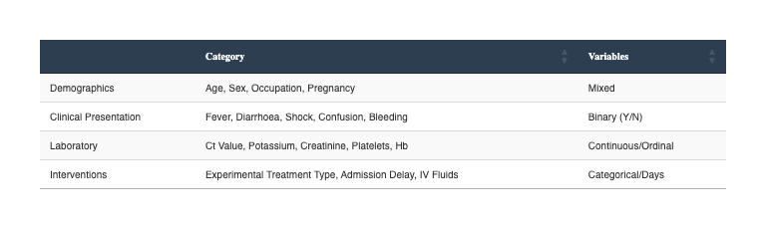

Annexes

Study Documentation and Reproducibility
To support the transparency of this Statistical Analysis Plan, the full technical documentation is provided below. These resources ensure that the variables summarized in Table 2 can be mapped directly to the original collection instruments.
- Full Clinical Questionnaire (PDF): This document contains the complete set of questions, branching logic, and field labels used in the REDCap database.
- Data Codebook (CSV): The structured data dictionary containing variable names, factor levels, and validation rules for the analytic pipeline.

REFERENCES
Fox, John, and Sanford Weisberg. 2019. “An r Companion to Applied Regression.” https://www.john-fox.ca/Companion/.
Friedman, Jerome, Trevor Hastie, and Robert Tibshirani. 2010. “Regularization Paths for Generalized Linear Models via Coordinate Descent” 33. https://doi.org/10.18637/jss.v033.i01.
Wickham, Hadley, Mara Averick, Jennifer Bryan, Winston Chang, Lucy D’Agostino McGowan, Romain François, Garrett Grolemund, et al. 2019. “Welcome to the Tidyverse” 4: 1686. https://doi.org/10.21105/joss.01686.
Zeileis, Achim, and Torsten Hothorn. 2002. “Diagnostic Checking in Regression Relationships” 2. https://CRAN.R-project.org/doc/Rnews/.
Zeileis, Achim, Susanne Koll, and Nathaniel Graham. 2020. “Various Versatile Variances: An Object-Oriented Implementation of Clustered Covariances in r” 95. https://doi.org/10.18637/jss.v095.i01.

