EVD North Kivu 2018–2019 — Descriptive Report
  - Cohort: Adults (18+ y)
VHF North Kivu study group
2026-07-03
Table of contents

Cohort overview
This report describes 386 patients admitted with laboratory-confirmed Ebola virus disease. 126 died among the 343 with a documented recovered/died outcome (case-fatality ratio 36.7%); 41 had no final outcome recorded and 2 were referred — these are retained in all descriptive summaries and excluded only from outcome comparisons.
Table 1: Outcome distribution (all admitted patients)
Outcome | N | %
Recovered | 217 | 56.2%
Died | 126 | 32.6%
Referred | 2 | 0.5%
Unknown/ongoing | 41 | 10.6%

1. Population characteristics
Characteristic | N = 386¹
Age, years | 33 (25 – 44)
age_group
<5 | 0 (0)
5-17 | 0 (0)
18-24 | 90 (23)
25-34 | 115 (30)
35-49 | 122 (32)
50+ | 59 (15)
Sex
Male | 166 (43)
Female | 220 (57)
occupation
Healthcare worker | 45 (19)
Non-healthcare worker | 111 (47)
Unknown | 78 (33)
Missing | 152
pregnant_ana | 15 (5.2)
Missing | 100
Onset→admission delay, days | 4.0 (2.0 – 6.0)
Missing | 7
onset_delay_cat
≤2 days | 111 (29)
3-5 days | 149 (39)
>5 days | 119 (31)
Missing | 7
Any comorbidity | 8 (2.4)
Missing | 50
Ct (lowest) at admission | 24 (21 – 30)
Missing | 90
ct_cat
<20 (high load) | 55 (19)
20-25 | 103 (35)
25-30 | 62 (21)
>30 (low load) | 76 (26)
Missing | 90
Length of stay, days | 11 (5 – 17)
Missing | 25
¹Median (IQR); n (%)
 | Outcome
Characteristic | Overall N = 343¹ | Recovered N = 217¹ | Died N = 126¹ | p-value²
Age, years | 33 (25 – 43) | 33 (25 – 44) | 32 (26 – 42) | 0.91
age_group |  |  |  | 0.54
<5 | 0 (0) | 0 (0) | 0 (0)
5-17 | 0 (0) | 0 (0) | 0 (0)
18-24 | 79 (23) | 53 (24) | 26 (21)
25-34 | 104 (30) | 60 (28) | 44 (35)
35-49 | 108 (31) | 71 (33) | 37 (29)
50+ | 52 (15) | 33 (15) | 19 (15)
sex |  |  |  | 0.50
Male | 147 (43) | 90 (41) | 57 (45)
Female | 196 (57) | 127 (59) | 69 (55)
occupation |  |  |  | 0.008
Healthcare worker | 42 (21) | 33 (27) | 9 (12)
Non-healthcare worker | 89 (45) | 57 (46) | 32 (43)
Unknown | 67 (34) | 33 (27) | 34 (45)
pregnant_ana | 15 (5.9) | 10 (6.0) | 5 (5.6) | 0.88
Onset→admission delay, days | 4.0 (2.0 – 6.0) | 3.0 (2.0 – 6.0) | 5.0 (3.0 – 7.0) | <0.001
onset_delay_cat |  |  |  | <0.001
≤2 days | 103 (31) | 81 (38) | 22 (18)
3-5 days | 128 (38) | 77 (36) | 51 (41)
>5 days | 105 (31) | 54 (25) | 51 (41)
comorbid_any | 7 (2.3) | 3 (1.5) | 4 (3.6) | 0.26
Ct (lowest) at admission | 24 (21 – 31) | 29 (24 – 34) | 21 (19 – 23) | <0.001
ct_cat |  |  |  | <0.001
<20 (high load) | 48 (18) | 9 (5.7) | 39 (38)
20-25 | 90 (34) | 41 (26) | 49 (47)
25-30 | 54 (21) | 42 (26) | 12 (12)
>30 (low load) | 71 (27) | 67 (42) | 4 (3.8)
los_days | 11 (4 – 17) | 16 (11 – 19) | 3 (2 – 5) | <0.001
¹Median (IQR); n (%)
²Wilcoxon rank sum test; Fisher's exact test; Pearson's Chi-squared test

2. Temporal trends and case-fatality
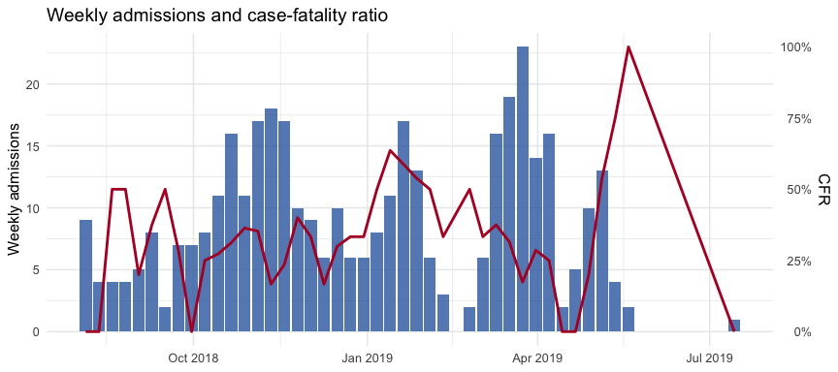

3. Symptoms and clinical signs at admission
The symptom / sign / bleeding blocks arrive from 01_prepare_data.R as clean Yes/No factors named with their dictionary labels (exact strings below).
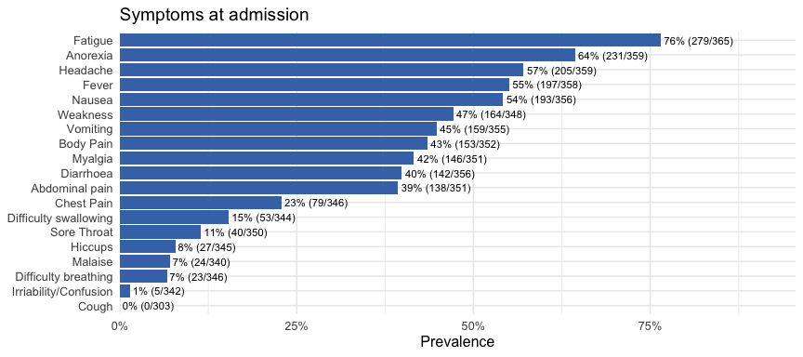
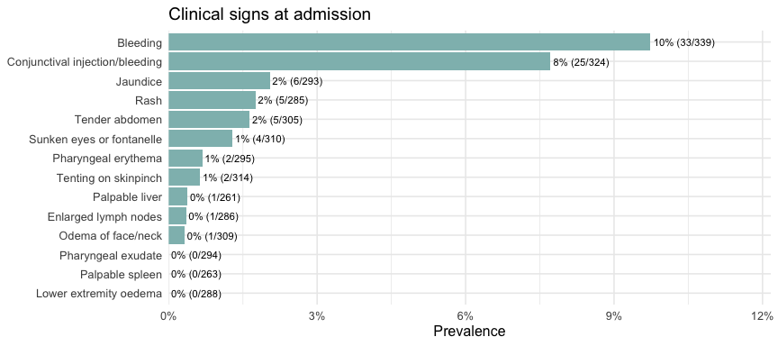
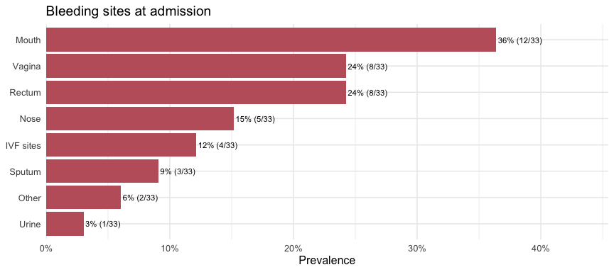
Characteristic | Overall N = 343¹ | Recovered N = 217¹ | Died N = 126¹ | p-value²
Fever | 177 (54) | 109 (53) | 68 (57) | 0.46
Fatigue | 247 (75) | 147 (70) | 100 (83) | 0.013
Weakness | 141 (44) | 79 (39) | 62 (53) | 0.020
Malaise | 20 (6.4) | 15 (7.7) | 5 (4.2) | 0.23
Myalgia | 130 (41) | 76 (37) | 54 (46) | 0.13
Anorexia | 210 (64) | 130 (63) | 80 (66) | 0.51
Sore Throat | 39 (12) | 19 (9.2) | 20 (17) | 0.034
Headache | 180 (55) | 115 (55) | 65 (54) | 0.84
Chest Pain | 75 (24) | 46 (23) | 29 (25) | 0.64
Body Pain | 135 (42) | 80 (39) | 55 (47) | 0.17
Hiccups | 27 (8.5) | 17 (8.4) | 10 (8.7) | 0.93
Cough | 0 (0) | 0 (0) | 0 (0) | >0.99
Difficulty breathing | 22 (6.9) | 10 (5.0) | 12 (10) | 0.070
Difficulty swallowing | 52 (16) | 24 (12) | 28 (24) | 0.005
Abdominal pain | 127 (40) | 75 (37) | 52 (44) | 0.19
Diarrhoea | 130 (40) | 69 (33) | 61 (52) | <0.001
Nausea | 179 (55) | 104 (50) | 75 (64) | 0.018
Vomiting | 147 (45) | 91 (44) | 56 (48) | 0.50
Irriability/Confusion | 4 (1.3) | 1 (0.5) | 3 (2.6) | 0.14
¹n (%)
²Pearson's Chi-squared test; Fisher's exact test

4. Time from onset and outcome
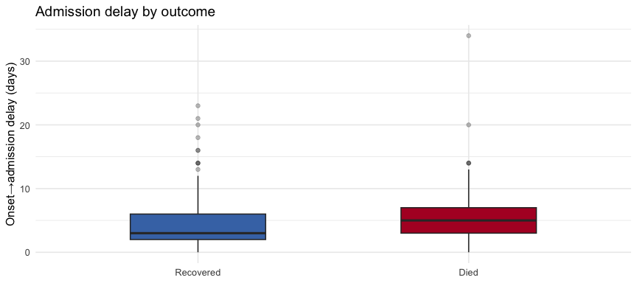
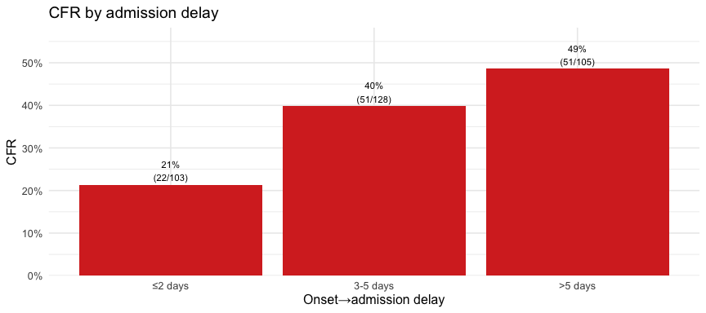

5. Cycle threshold (Ct) at admission
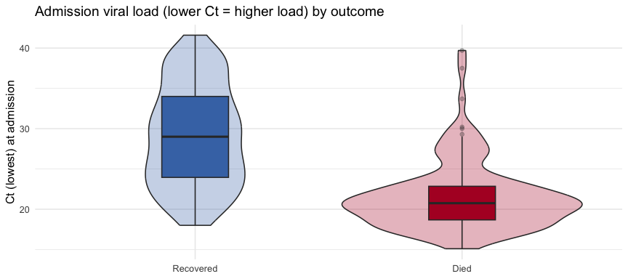
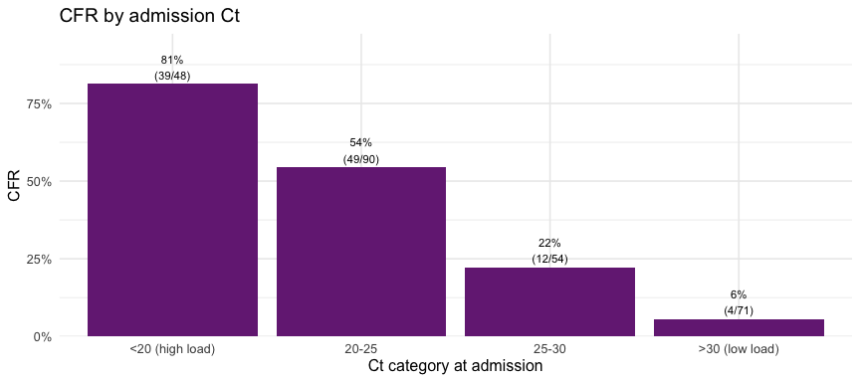

6. Complications (AKI, haemorrhagic, metabolic)
Characteristic | Overall N = 343¹ | Recovered N = 217¹ | Died N = 126¹ | p-value²
Renal impairment (creatinine >1.1 mg/dL) | 101 (53) | 59 (43) | 42 (78) | <0.001
Hyperkalaemia (K >5.5) | 15 (8.6) | 7 (5.4) | 8 (18) | 0.026
Hypokalaemia (K <3.5) | 60 (34) | 48 (37) | 12 (27) | 0.20
Severe hypoglycaemia (<60 mg/dL) | 46 (24) | 23 (17) | 23 (42) | <0.001
Rhabdomyolysis (CK >1000) | 17 (37) | 6 (22) | 11 (58) | 0.014
Severe anaemia (Hb <7 g/dL) | 4 (6.3) | 3 (6.0) | 1 (7.7) | >0.99
Severe thrombocytopenia (<50) | 11 (18) | 8 (16) | 3 (23) | 0.68
¹n (%)
²Pearson's Chi-squared test; Fisher's exact test
 Important
These complications are only assessable in patients who had the relevant lab measured (roughly 45–50% of the cohort once daily labs are included, far fewer at admission alone). The denominator per complication is the measured subset — report it explicitly and treat non-measurement as informative missingness, not as absence of the complication.

7. Treatments
Table 1: Experimental agent received (first/primary)
evd_agent | n | pct
mAb114 | 97 | 25.1%
REGN3470-3471-3479 | 114 | 29.5%
Remdesivir (GS-5734) | 125 | 32.4%
Zmapp | 24 | 6.2%
NA | 26 | 6.7%
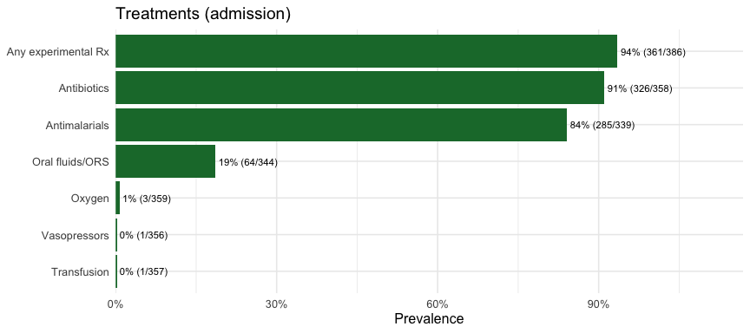
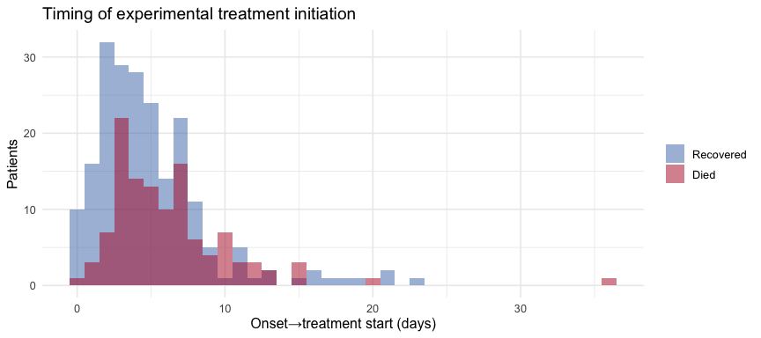
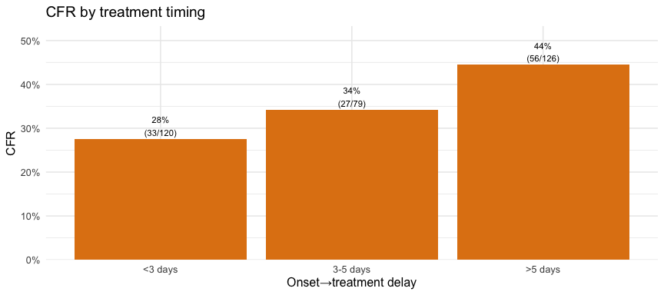

8. Laboratory kinetics during admission
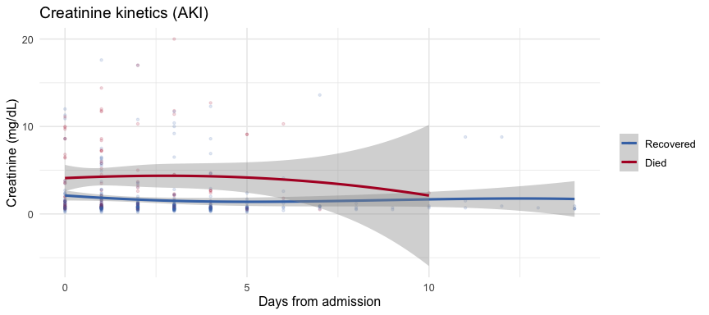
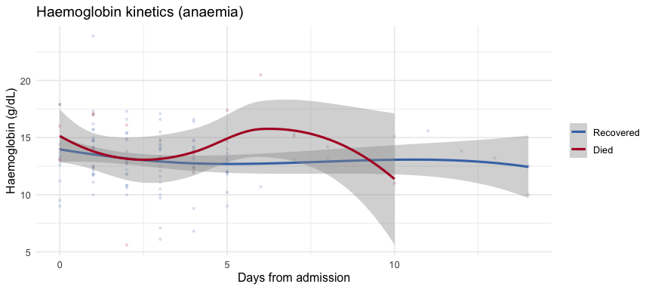
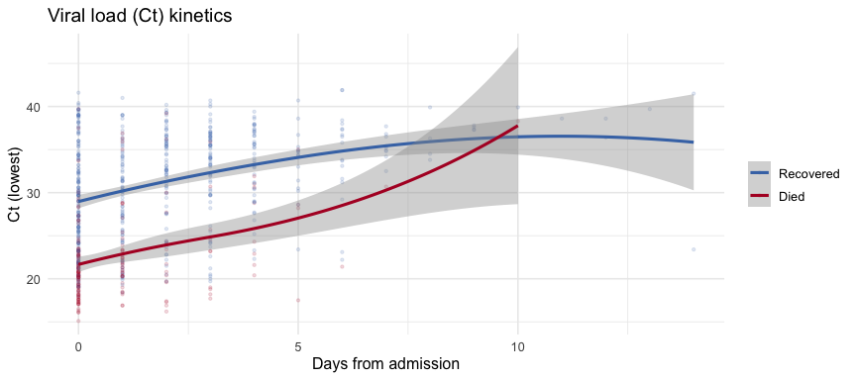

Rendered: 2026-07-03 13:20:37 | subgroup: adults | N = 386 | CFR = 36.7 %

