EVD North Kivu 2018–2019 — Descriptive Report
  - Cohort: Full cohort
VHF North Kivu study group
2026-07-03
Table of contents

Cohort overview
This report describes 463 patients admitted with laboratory-confirmed Ebola virus disease. 150 died among the 408 with a documented recovered/died outcome (case-fatality ratio 36.8%); 52 had no final outcome recorded and 3 were referred — these are retained in all descriptive summaries and excluded only from outcome comparisons.
Table 1: Outcome distribution (all admitted patients)
Outcome | N | %
Recovered | 258 | 55.7%
Died | 150 | 32.4%
Referred | 3 | 0.6%
Unknown/ongoing | 52 | 11.2%

1. Population characteristics
Characteristic | N = 463¹
Age, years | 30 (22 – 40)
Missing | 19
age_group
<5 | 14 (3.2)
5-17 | 44 (9.9)
18-24 | 90 (20)
25-34 | 115 (26)
35-49 | 122 (27)
50+ | 59 (13)
Missing | 19
Sex
Male | 203 (44)
Female | 260 (56)
occupation
Healthcare worker | 45 (17)
Non-healthcare worker | 135 (50)
Unknown | 92 (34)
Missing | 191
pregnant_ana | 16 (4.5)
Missing | 109
Onset→admission delay, days | 4.0 (2.0 – 6.0)
Missing | 9
onset_delay_cat
≤2 days | 140 (31)
3-5 days | 169 (37)
>5 days | 145 (32)
Missing | 9
Any comorbidity | 8 (2.0)
Missing | 58
Ct (lowest) at admission | 24 (21 – 30)
Missing | 110
ct_cat
<20 (high load) | 71 (20)
20-25 | 122 (35)
25-30 | 72 (20)
>30 (low load) | 88 (25)
Missing | 110
Length of stay, days | 12 (5 – 18)
Missing | 32
¹Median (IQR); n (%)
 | Outcome
Characteristic | Overall N = 408¹ | Recovered N = 258¹ | Died N = 150¹ | p-value²
Age, years | 31 (22 – 40) | 32 (22 – 40) | 30 (21 – 40) | 0.71
age_group |  |  |  | 0.42
<5 | 10 (2.6) | 8 (3.3) | 2 (1.4)
5-17 | 38 (9.7) | 20 (8.2) | 18 (12)
18-24 | 79 (20) | 53 (22) | 26 (18)
25-34 | 104 (27) | 60 (24) | 44 (30)
35-49 | 108 (28) | 71 (29) | 37 (25)
50+ | 52 (13) | 33 (13) | 19 (13)
sex |  |  |  | 0.69
Male | 177 (43) | 110 (43) | 67 (45)
Female | 231 (57) | 148 (57) | 83 (55)
occupation |  |  |  | 0.032
Healthcare worker | 42 (19) | 33 (23) | 9 (11)
Non-healthcare worker | 105 (46) | 67 (47) | 38 (46)
Unknown | 79 (35) | 43 (30) | 36 (43)
pregnant_ana | 16 (5.1) | 11 (5.4) | 5 (4.5) | 0.72
Onset→admission delay, days | 4.0 (2.0 – 6.0) | 3.0 (2.0 – 6.0) | 5.0 (3.0 – 8.0) | <0.001
onset_delay_cat |  |  |  | <0.001
≤2 days | 129 (32) | 103 (41) | 26 (18)
3-5 days | 145 (36) | 86 (34) | 59 (40)
>5 days | 126 (32) | 64 (25) | 62 (42)
comorbid_any | 7 (1.9) | 3 (1.3) | 4 (3.0) | 0.27
Ct (lowest) at admission | 24 (21 – 30) | 29 (23 – 34) | 21 (18 – 23) | <0.001
ct_cat |  |  |  | <0.001
<20 (high load) | 61 (20) | 11 (5.8) | 50 (41)
20-25 | 106 (34) | 52 (28) | 54 (44)
25-30 | 63 (20) | 49 (26) | 14 (11)
>30 (low load) | 81 (26) | 77 (41) | 4 (3.3)
los_days | 11 (4 – 18) | 16 (12 – 20) | 3 (2 – 6) | <0.001
¹Median (IQR); n (%)
²Wilcoxon rank sum test; Fisher's exact test; Pearson's Chi-squared test

2. Temporal trends and case-fatality
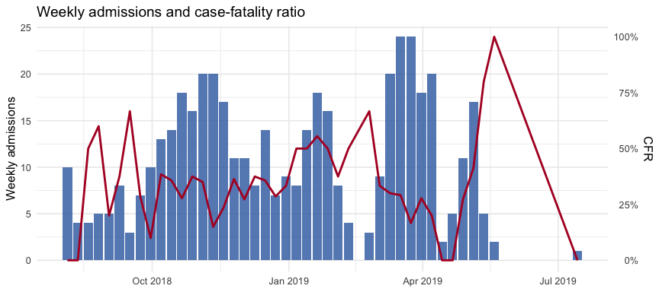

3. Symptoms and clinical signs at admission
The symptom / sign / bleeding blocks arrive from 01_prepare_data.R as clean Yes/No factors named with their dictionary labels (exact strings below).
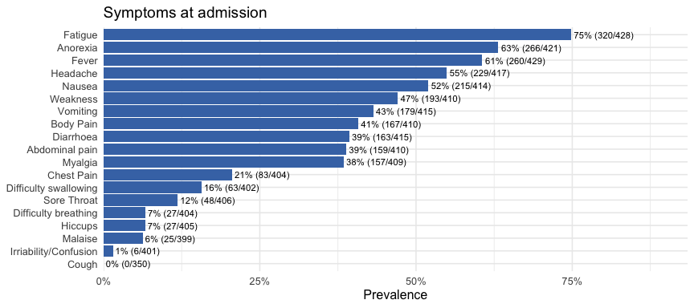
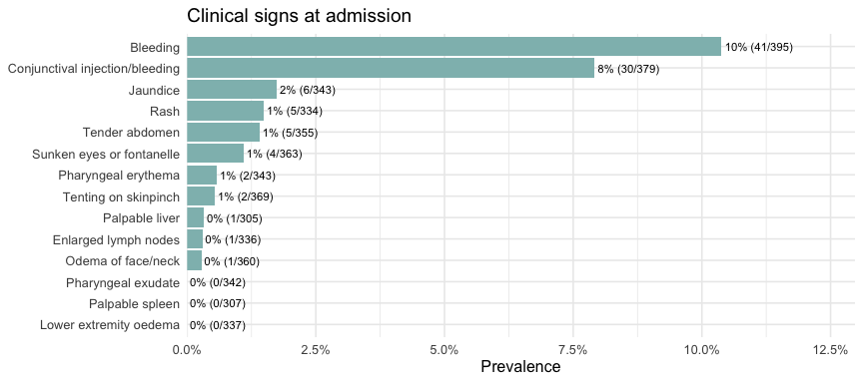
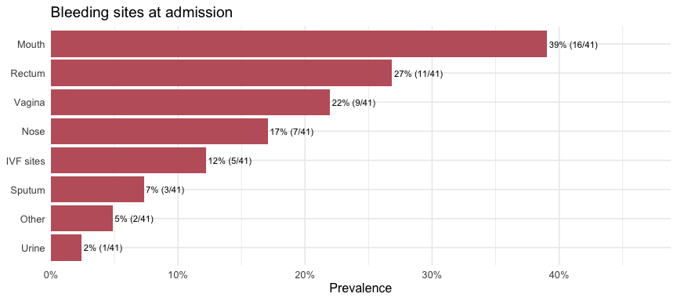
Characteristic | Overall N = 408¹ | Recovered N = 258¹ | Died N = 150¹ | p-value²
Fever | 232 (60) | 144 (59) | 88 (62) | 0.63
Fatigue | 283 (73) | 168 (69) | 115 (80) | 0.021
Weakness | 167 (44) | 91 (39) | 76 (54) | 0.005
Malaise | 21 (5.7) | 15 (6.6) | 6 (4.3) | 0.34
Myalgia | 139 (37) | 77 (33) | 62 (44) | 0.030
Anorexia | 241 (63) | 147 (61) | 94 (65) | 0.40
Sore Throat | 46 (12) | 20 (8.5) | 26 (19) | 0.004
Headache | 202 (53) | 124 (52) | 78 (55) | 0.64
Chest Pain | 79 (21) | 47 (20) | 32 (23) | 0.52
Body Pain | 147 (39) | 85 (36) | 62 (44) | 0.13
Hiccups | 27 (7.3) | 17 (7.3) | 10 (7.2) | >0.99
Cough | 0 (0) | 0 (0) | 0 (0) | >0.99
Difficulty breathing | 25 (6.8) | 11 (4.8) | 14 (10) | 0.049
Difficulty swallowing | 60 (16) | 27 (12) | 33 (24) | 0.002
Abdominal pain | 145 (39) | 84 (36) | 61 (43) | 0.18
Diarrhoea | 148 (39) | 78 (33) | 70 (50) | <0.001
Nausea | 200 (53) | 112 (47) | 88 (63) | 0.003
Vomiting | 165 (44) | 98 (41) | 67 (48) | 0.21
Irriability/Confusion | 5 (1.4) | 2 (0.9) | 3 (2.2) | 0.37
¹n (%)
²Pearson's Chi-squared test; Fisher's exact test

4. Time from onset and outcome
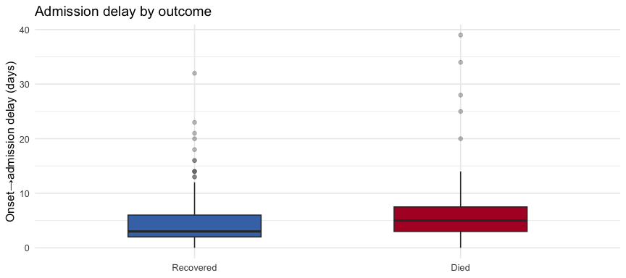
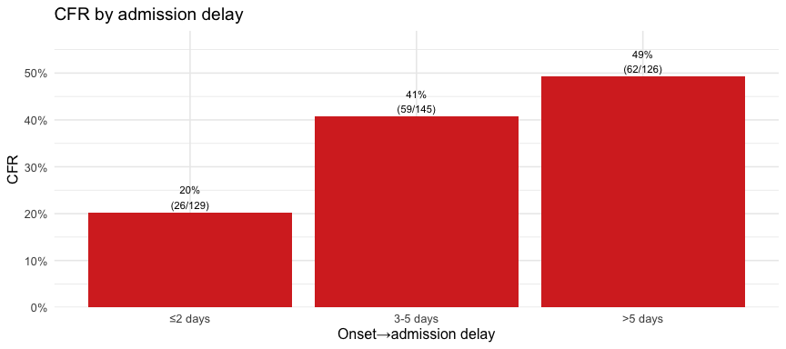

5. Cycle threshold (Ct) at admission
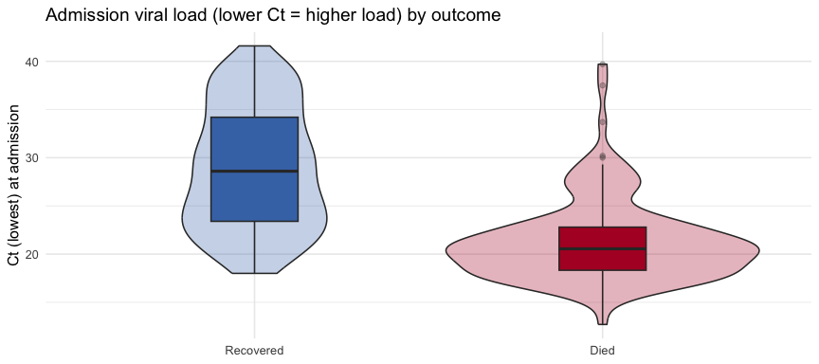
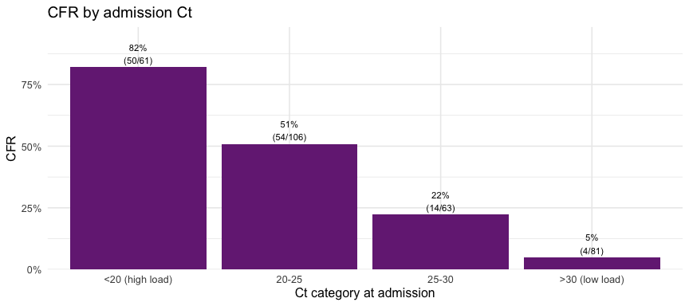

6. Complications (AKI, haemorrhagic, metabolic)
Characteristic | Overall N = 408¹ | Recovered N = 258¹ | Died N = 150¹ | p-value²
Renal impairment (creatinine >1.1 mg/dL) | 107 (49) | 59 (38) | 48 (74) | <0.001
Hyperkalaemia (K >5.5) | 20 (9.9) | 11 (7.4) | 9 (17) | 0.052
Hypokalaemia (K <3.5) | 69 (34) | 56 (38) | 13 (24) | 0.068
Severe hypoglycaemia (<60 mg/dL) | 57 (26) | 31 (20) | 26 (39) | 0.003
Rhabdomyolysis (CK >1000) | 19 (35) | 6 (19) | 13 (54) | 0.007
Severe anaemia (Hb <7 g/dL) | 5 (6.9) | 4 (7.3) | 1 (5.9) | >0.99
Severe thrombocytopenia (<50) | 12 (17) | 9 (17) | 3 (18) | >0.99
¹n (%)
²Pearson's Chi-squared test; Fisher's exact test
 Important
These complications are only assessable in patients who had the relevant lab measured (roughly 45–50% of the cohort once daily labs are included, far fewer at admission alone). The denominator per complication is the measured subset — report it explicitly and treat non-measurement as informative missingness, not as absence of the complication.

7. Treatments
Table 1: Experimental agent received (first/primary)
evd_agent | n | pct
mAb114 | 127 | 27.4%
REGN3470-3471-3479 | 136 | 29.4%
Remdesivir (GS-5734) | 139 | 30.0%
Zmapp | 29 | 6.3%
NA | 32 | 6.9%
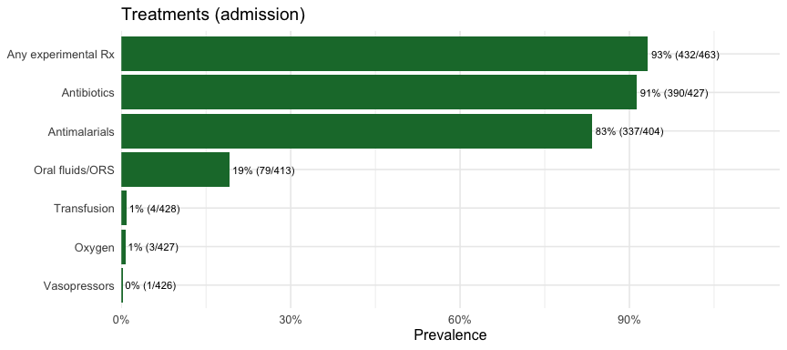
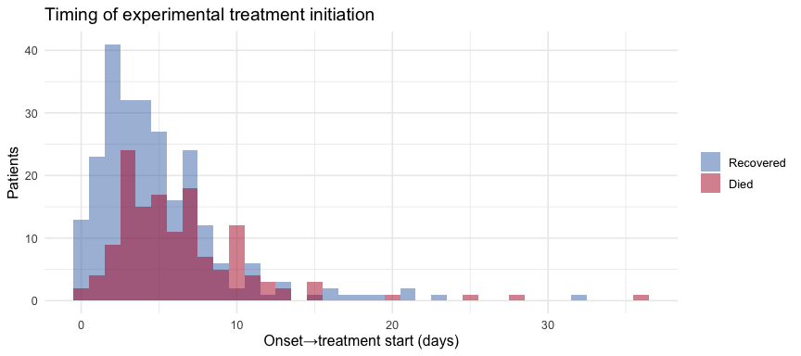
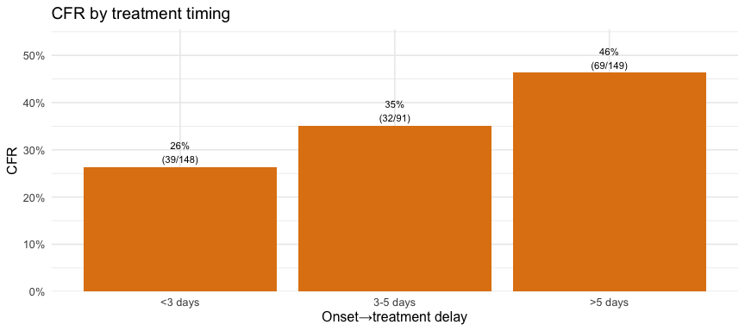

8. Laboratory kinetics during admission
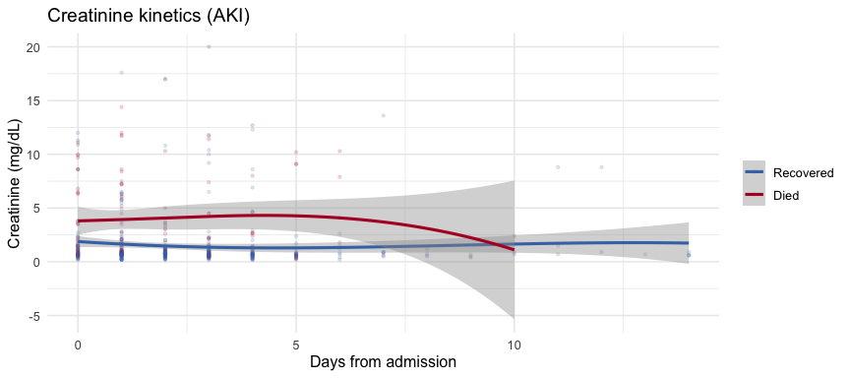
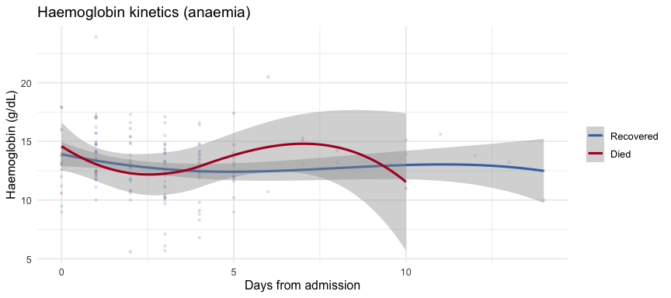
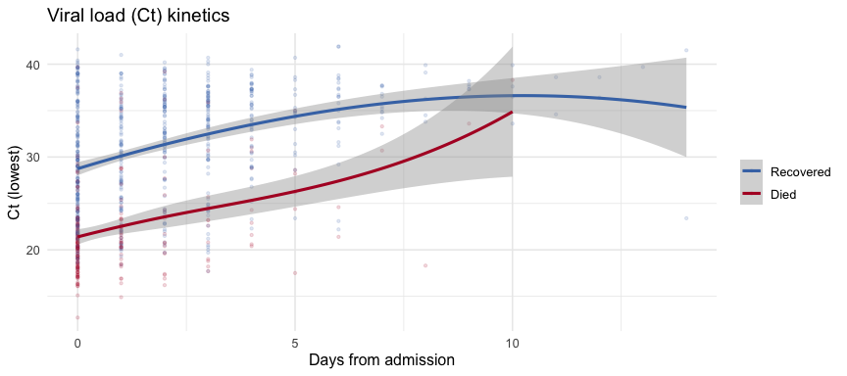

Rendered: 2026-07-03 13:19:27 | subgroup: all | N = 463 | CFR = 36.8 %

