EVD North Kivu 2018–2019 — Descriptive Report
  - Cohort: Children (<18 y)
VHF North Kivu study group
2026-07-03
Table of contents

Cohort overview
This report describes 58 patients admitted with laboratory-confirmed Ebola virus disease. 20 died among the 48 with a documented recovered/died outcome (case-fatality ratio 41.7%); 10 had no final outcome recorded and 0 were referred — these are retained in all descriptive summaries and excluded only from outcome comparisons.
Table 1: Outcome distribution (all admitted patients)
Outcome | N | %
Recovered | 28 | 48.3%
Died | 20 | 34.5%
Unknown/ongoing | 10 | 17.2%

1. Population characteristics
Characteristic | N = 58¹
Age, years | 10.0 (5.0 – 14.0)
age_group
<5 | 14 (24)
5-17 | 44 (76)
18-24 | 0 (0)
25-34 | 0 (0)
35-49 | 0 (0)
50+ | 0 (0)
Sex
Male | 25 (43)
Female | 33 (57)
occupation
Non-healthcare worker | 20 (67)
Unknown | 10 (33)
Missing | 28
pregnant_ana | 1 (2.0)
Missing | 7
Onset→admission delay, days | 4 (2 – 8)
onset_delay_cat
≤2 days | 18 (31)
3-5 days | 17 (29)
>5 days | 23 (40)
Any comorbidity | 0 (0)
Missing | 7
Ct (lowest) at admission | 23 (19 – 29)
Missing | 16
ct_cat
<20 (high load) | 12 (29)
20-25 | 14 (33)
25-30 | 7 (17)
>30 (low load) | 9 (21)
Missing | 16
Length of stay, days | 15 (4 – 21)
Missing | 6
¹Median (IQR); n (%)
 | Outcome
Characteristic | Overall N = 48¹ | Recovered N = 28¹ | Died N = 20¹ | p-value²
Age, years | 10.5 (5.0 – 14.5) | 8.5 (3.5 – 13.0) | 13.5 (7.5 – 16.0) | 0.027
age_group |  |  |  | 0.16
<5 | 10 (21) | 8 (29) | 2 (10)
5-17 | 38 (79) | 20 (71) | 18 (90)
18-24 | 0 (0) | 0 (0) | 0 (0)
25-34 | 0 (0) | 0 (0) | 0 (0)
35-49 | 0 (0) | 0 (0) | 0 (0)
50+ | 0 (0) | 0 (0) | 0 (0)
sex |  |  |  | 0.58
Male | 19 (40) | 12 (43) | 7 (35)
Female | 29 (60) | 16 (57) | 13 (65)
occupation |  |  |  | 0.36
Non-healthcare worker | 13 (59) | 9 (53) | 4 (80)
Unknown | 9 (41) | 8 (47) | 1 (20)
pregnant_ana | 1 (2.3) | 1 (3.8) | 0 (0) | >0.99
Onset→admission delay, days | 4 (2 – 8) | 3 (1 – 6) | 7 (4 – 10) | 0.001
onset_delay_cat |  |  |  | 0.019
≤2 days | 15 (31) | 13 (46) | 2 (10)
3-5 days | 15 (31) | 8 (29) | 7 (35)
>5 days | 18 (38) | 7 (25) | 11 (55)
comorbid_any | 0 (0) | 0 (0) | 0 (0) | >0.99
Ct (lowest) at admission | 23 (19 – 29) | 26 (23 – 34) | 19 (17 – 21) | <0.001
ct_cat |  |  |  | 0.003
<20 (high load) | 11 (31) | 2 (9.5) | 9 (64)
20-25 | 11 (31) | 8 (38) | 3 (21)
25-30 | 6 (17) | 4 (19) | 2 (14)
>30 (low load) | 7 (20) | 7 (33) | 0 (0)
los_days | 14 (4 – 20) | 19 (15 – 24) | 3 (2 – 6) | <0.001
¹Median (IQR); n (%)
²Wilcoxon rank sum test; Fisher's exact test; Pearson's Chi-squared test

2. Temporal trends and case-fatality
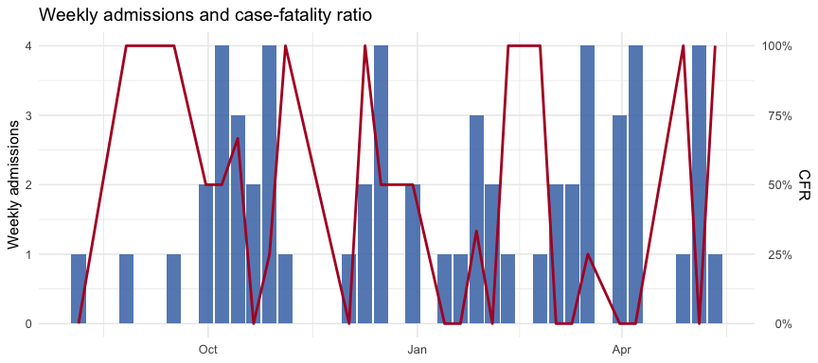

3. Symptoms and clinical signs at admission
The symptom / sign / bleeding blocks arrive from 01_prepare_data.R as clean Yes/No factors named with their dictionary labels (exact strings below).
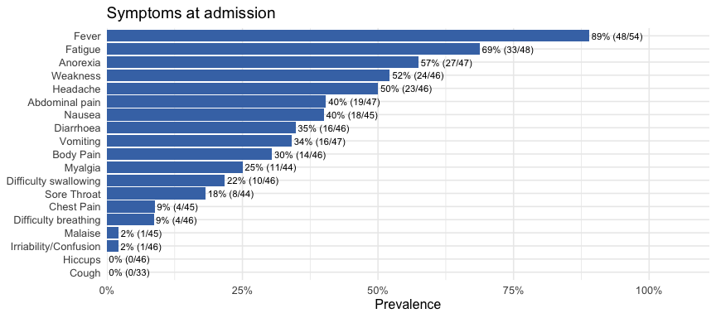
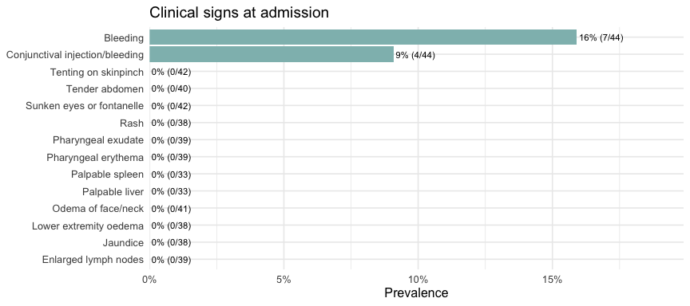
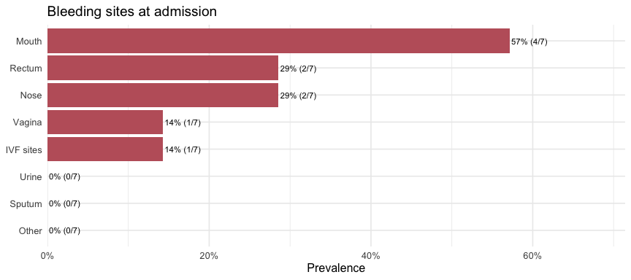
Characteristic | Overall N = 48¹ | Recovered N = 28¹ | Died N = 20¹ | p-value²
Fever | 41 (89) | 24 (92) | 17 (85) | 0.64
Fatigue | 29 (67) | 16 (67) | 13 (68) | 0.90
Weakness | 22 (52) | 10 (45) | 12 (60) | 0.35
Malaise | 1 (2.4) | 0 (0) | 1 (5.0) | 0.49
Myalgia | 9 (23) | 1 (5.0) | 8 (40) | 0.020
Anorexia | 24 (57) | 11 (50) | 13 (65) | 0.33
Sore Throat | 7 (18) | 1 (5.0) | 6 (30) | 0.091
Headache | 21 (50) | 8 (36) | 13 (65) | 0.064
Chest Pain | 4 (9.8) | 1 (4.8) | 3 (15) | 0.34
Body Pain | 12 (29) | 5 (23) | 7 (35) | 0.38
Hiccups | 0 (0) | 0 (0) | 0 (0) | >0.99
Cough | 0 (0) | 0 (0) | 0 (0) | >0.99
Difficulty breathing | 3 (7.1) | 1 (4.5) | 2 (10) | 0.60
Difficulty swallowing | 8 (19) | 3 (14) | 5 (25) | 0.45
Abdominal pain | 16 (38) | 8 (36) | 8 (40) | 0.81
Diarrhoea | 13 (32) | 6 (27) | 7 (37) | 0.51
Nausea | 17 (41) | 6 (27) | 11 (58) | 0.047
Vomiting | 14 (33) | 5 (23) | 9 (45) | 0.13
Irriability/Confusion | 1 (2.4) | 1 (4.5) | 0 (0) | >0.99
¹n (%)
²Fisher's exact test; Pearson's Chi-squared test

4. Time from onset and outcome
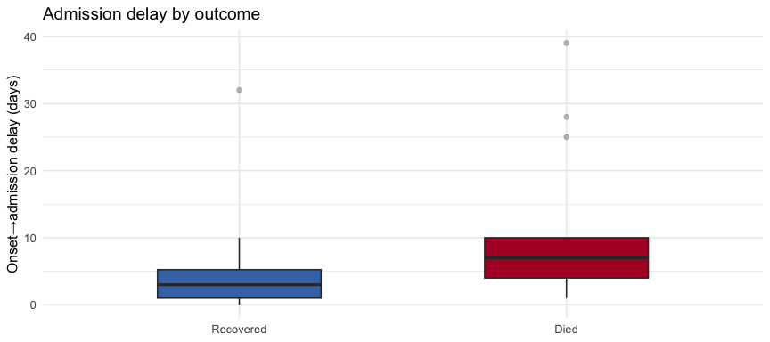
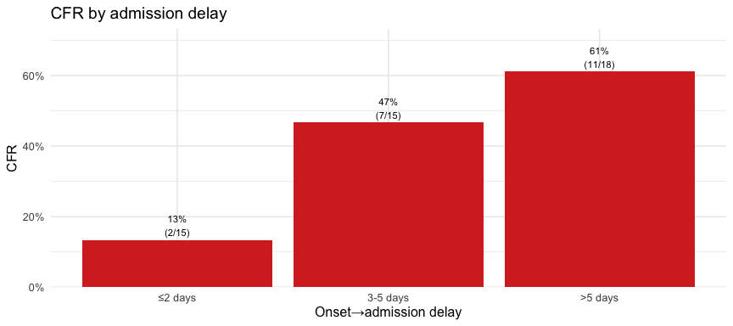

5. Cycle threshold (Ct) at admission
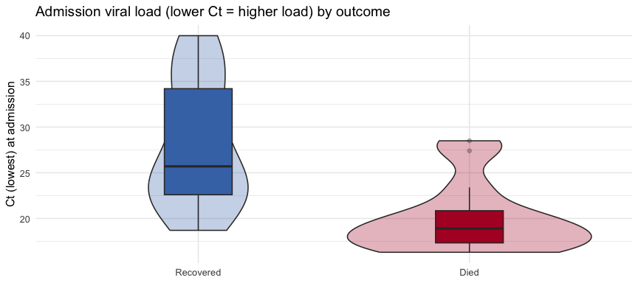
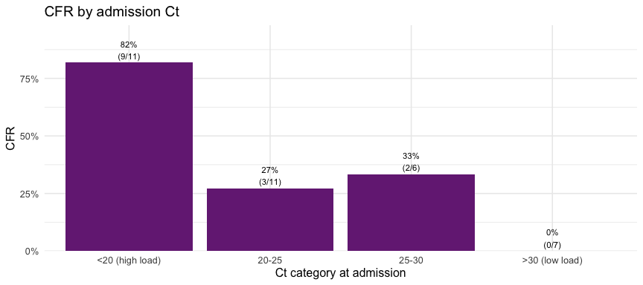

6. Complications (AKI, haemorrhagic, metabolic)
Characteristic | Overall N = 48¹ | Recovered N = 28¹ | Died N = 20¹ | p-value²
Renal impairment (creatinine >1.1 mg/dL) | 6 (25) | 0 (0) | 6 (55) | 0.003
Hyperkalaemia (K >5.5) | 2 (8.7) | 1 (7.1) | 1 (11) | >0.99
Hypokalaemia (K <3.5) | 8 (35) | 7 (50) | 1 (11) | 0.086
Severe hypoglycaemia (<60 mg/dL) | 8 (32) | 5 (36) | 3 (27) | >0.99
Rhabdomyolysis (CK >1000) | 2 (22) | 0 (0) | 2 (40) | 0.44
Severe anaemia (Hb <7 g/dL) | 1 (14) | 1 (33) | 0 (0) | 0.43
Severe thrombocytopenia (<50) | 1 (14) | 1 (33) | 0 (0) | 0.43
¹n (%)
²Fisher's exact test
 Important
These complications are only assessable in patients who had the relevant lab measured (roughly 45–50% of the cohort once daily labs are included, far fewer at admission alone). The denominator per complication is the measured subset — report it explicitly and treat non-measurement as informative missingness, not as absence of the complication.

7. Treatments
Table 1: Experimental agent received (first/primary)
evd_agent | n | pct
mAb114 | 22 | 37.9%
REGN3470-3471-3479 | 12 | 20.7%
Remdesivir (GS-5734) | 13 | 22.4%
Zmapp | 5 | 8.6%
NA | 6 | 10.3%
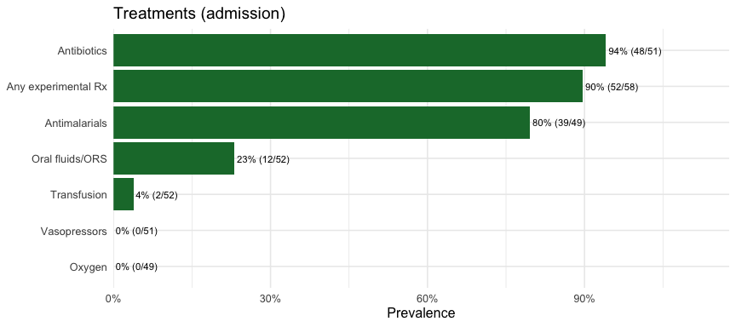
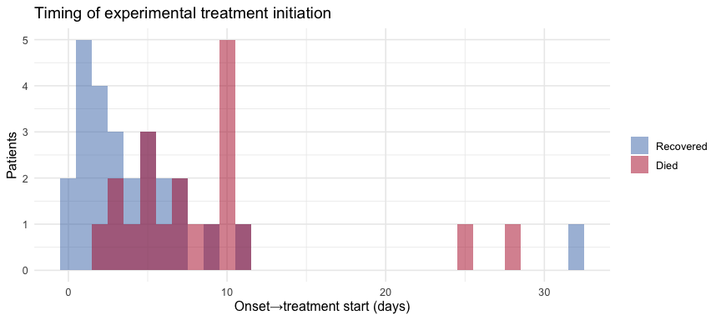
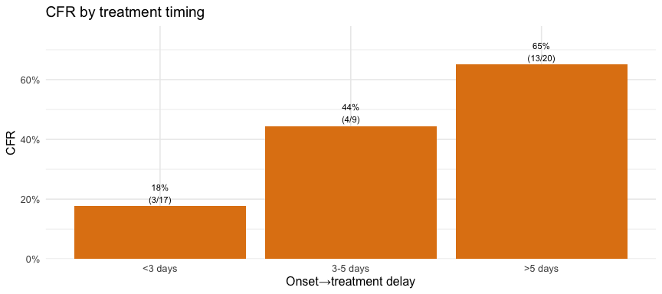

8. Laboratory kinetics during admission
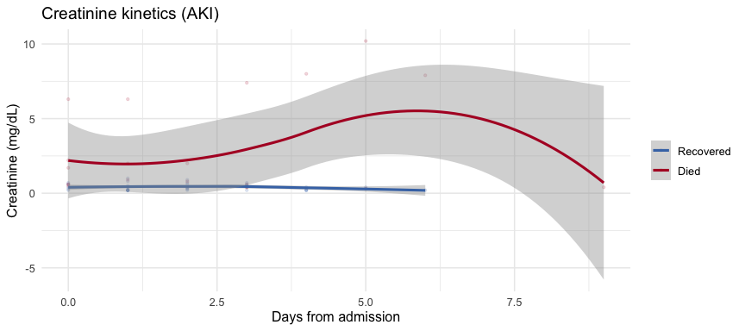
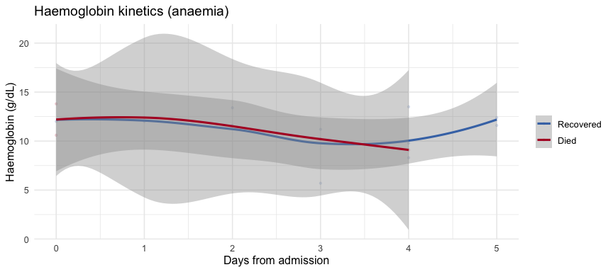
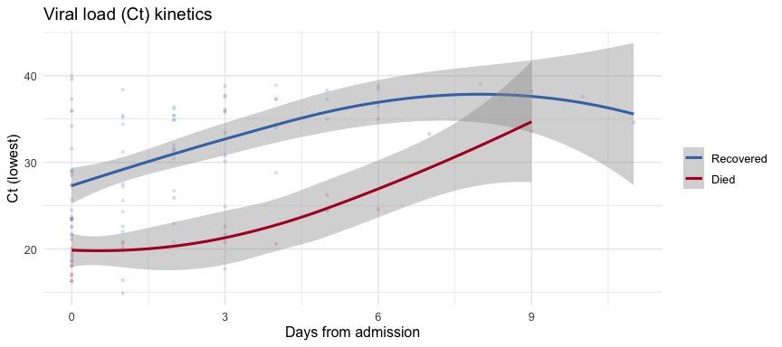

Rendered: 2026-07-03 13:20:02 | subgroup: children | N = 58 | CFR = 41.7 %

