**What is Build & Deployment Process || Every QA must know**

<https://www.youtube.com/watch?v=9jRu-sFC8Xw>

from (17:00 min on wards)

* Build means -making JAR/WAR file(taking code from GIT and compile the code )
* Maven will create a build...so build is happening through maven
* Build is happening thru Maven & jenkins together

once Build& deploy done in DEV envt.. jenkins will trigger to TEST envt and Automation TCs will trigger and ran..when every thing is good,

then moving to stage envt.(will do regression testing)

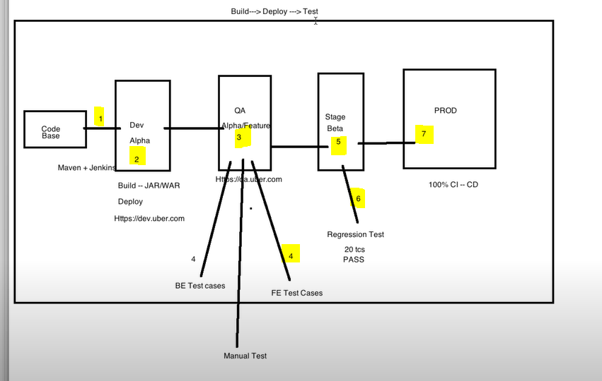

**jenkins pipeline is nothing but list of jenkins jobs in sequence order like below.**

1.Create build job-- from GIT

2.Deploy job -- deploy on DEV Envt.

3.Deploy jon-- deploy on QA envt.

4.Execution of TC suite in QA envt.

5.Deploy on Stage

6.Execution of TC(Regression) suite in Stage envt.

7.Deploy on Prod.

<https://www.youtube.com/watch?v=m0a2CzgLNsc>

Edurekha

-Jenkins role is till the applicaation is packaged.

-finally jenkins will package the application into war/jar file and ready to be delivered.

-we need some tools to deliver that product ..so once the product or the software moves on to the staging server to deploy it we need tools like docker

-Docker is like a virtualization environment which we can create on the fly so it just takes few seconds to create an entire server and deploy something on it so to deploy some software we will need an environment which will replicate the production environment and that's what docker provides

-before starting a pipe line,goto virtual box and in virtual box, we need to enable jenkin service & docker service.next go to jenkins dashboard(ui) and create pipelines

<https://www.youtube.com/watch?v=-1EYMS1Yewg&t=840s>

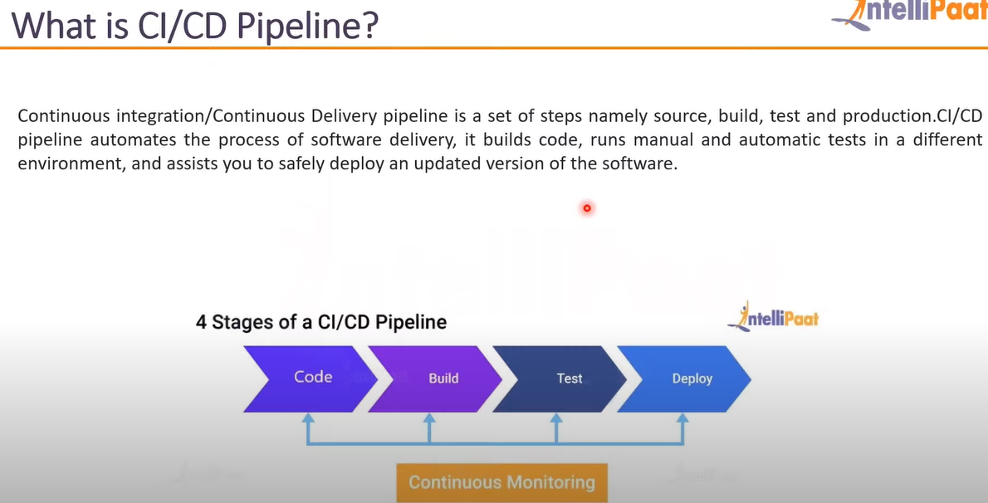

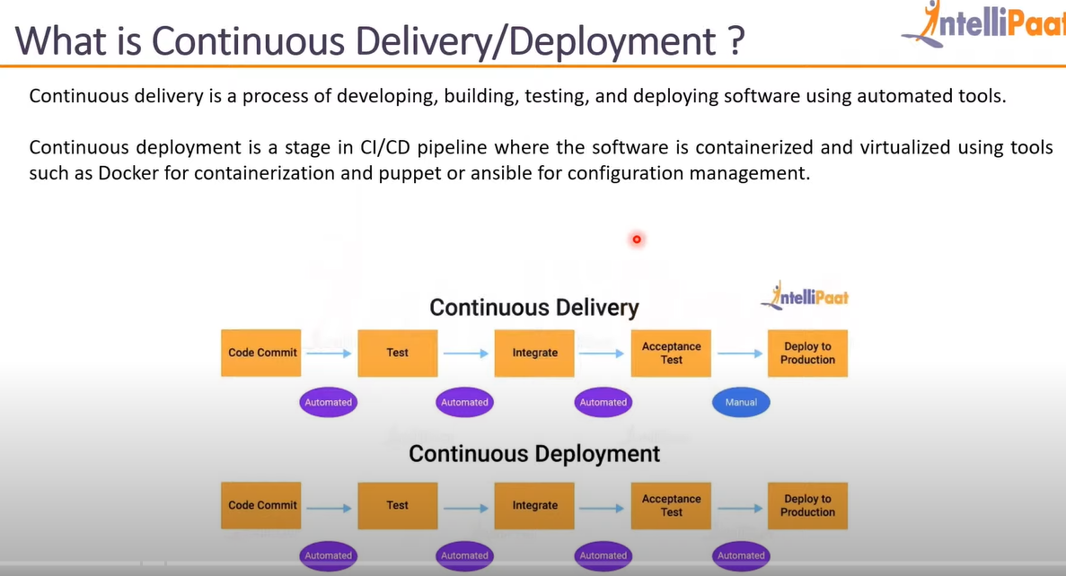

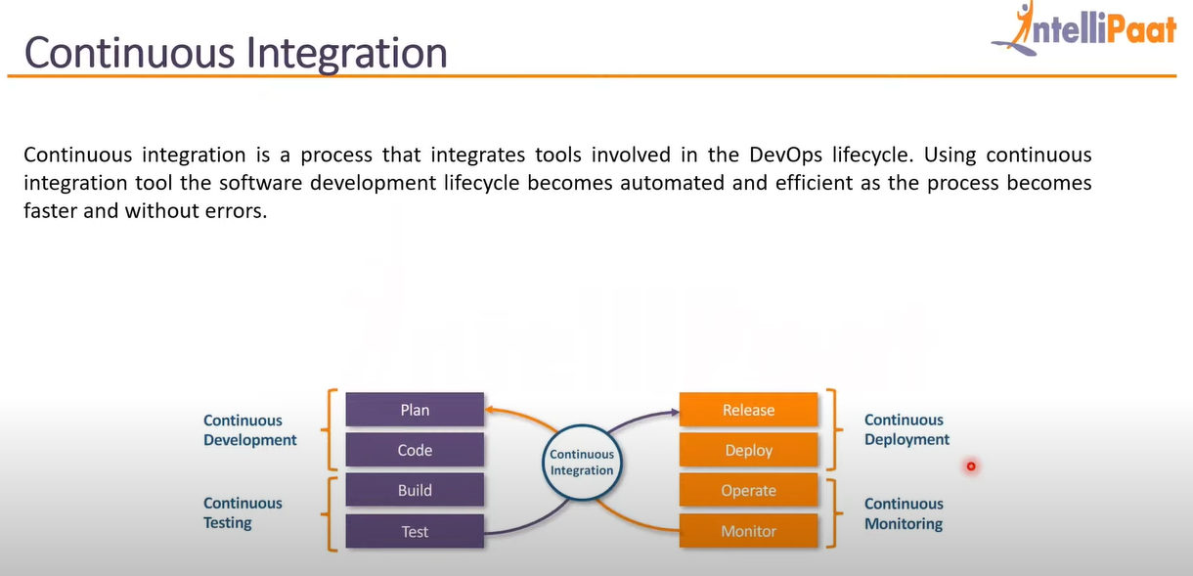

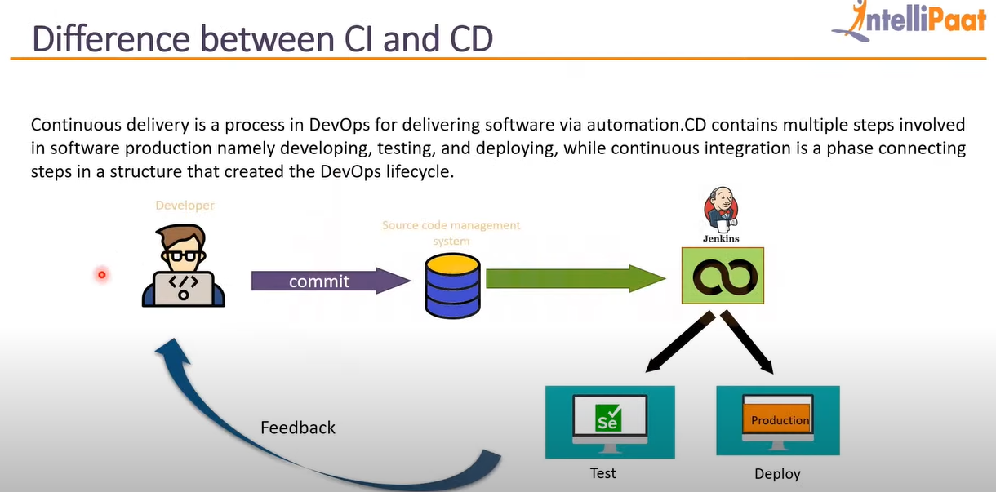

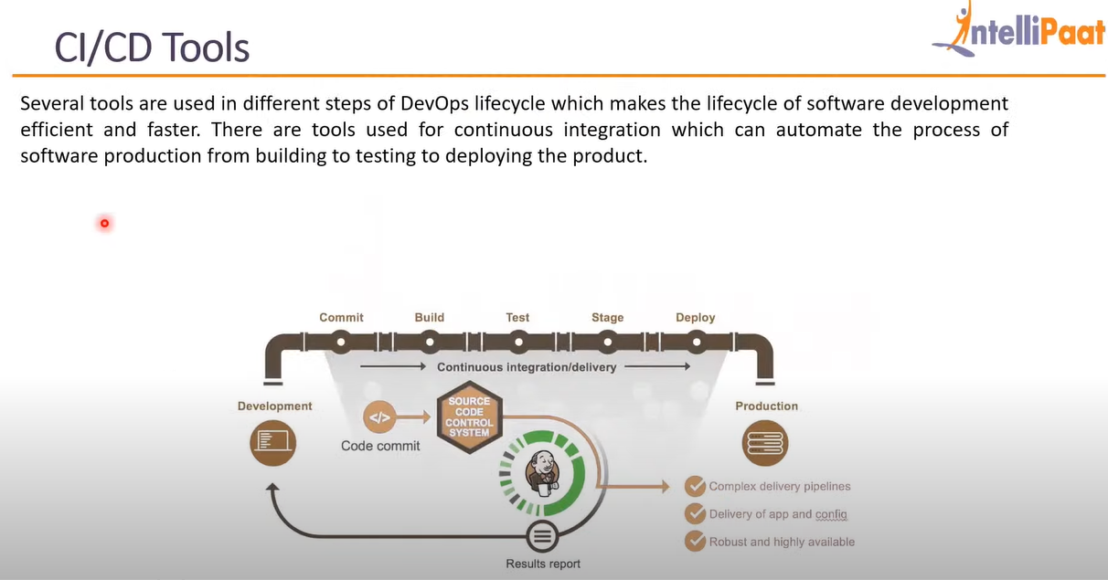

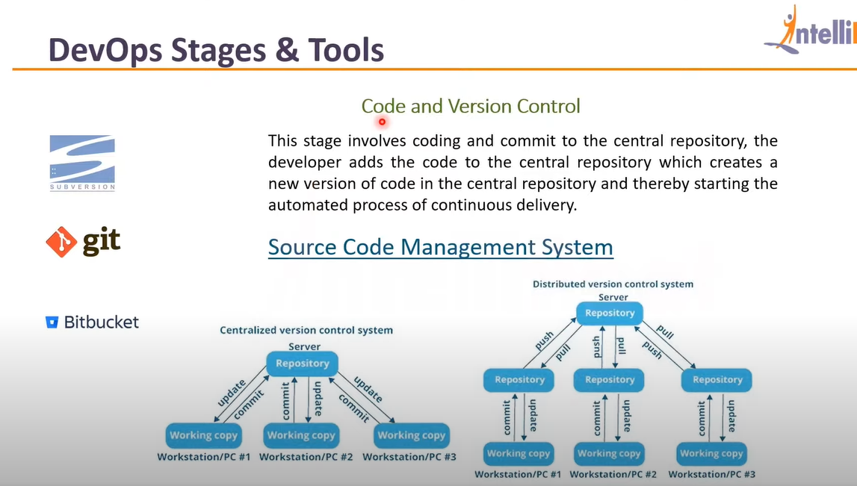

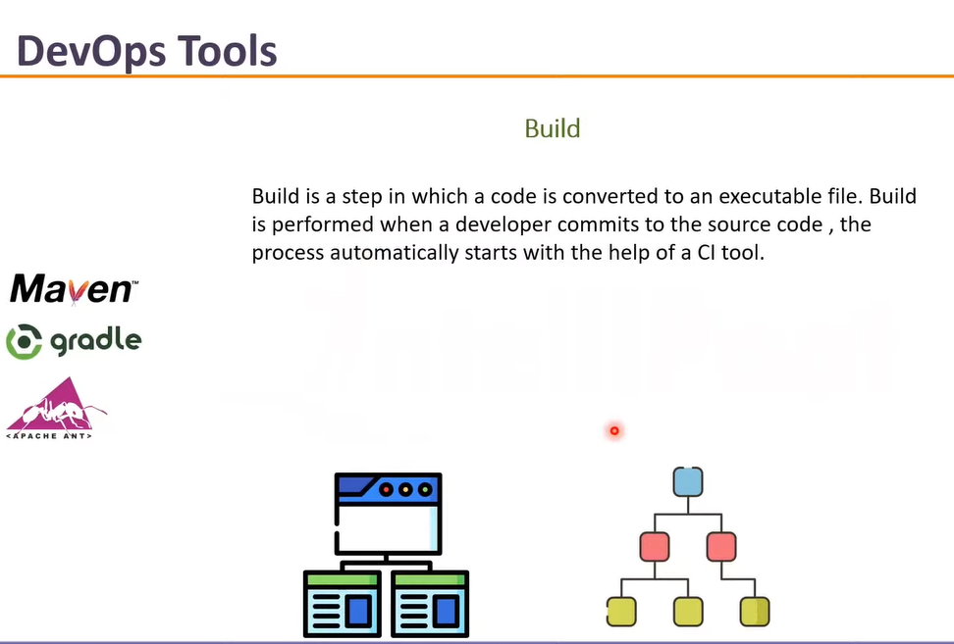

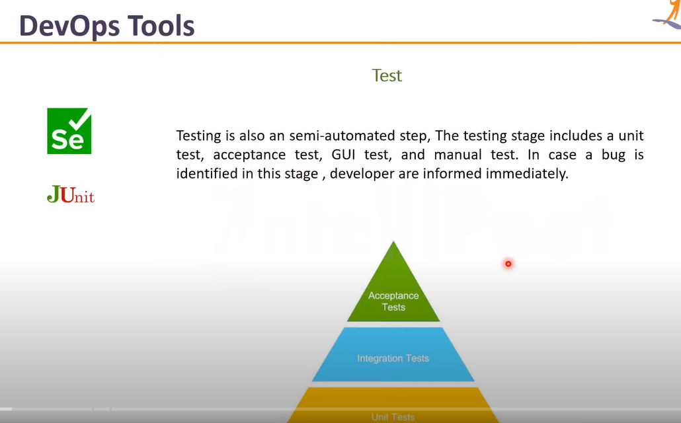

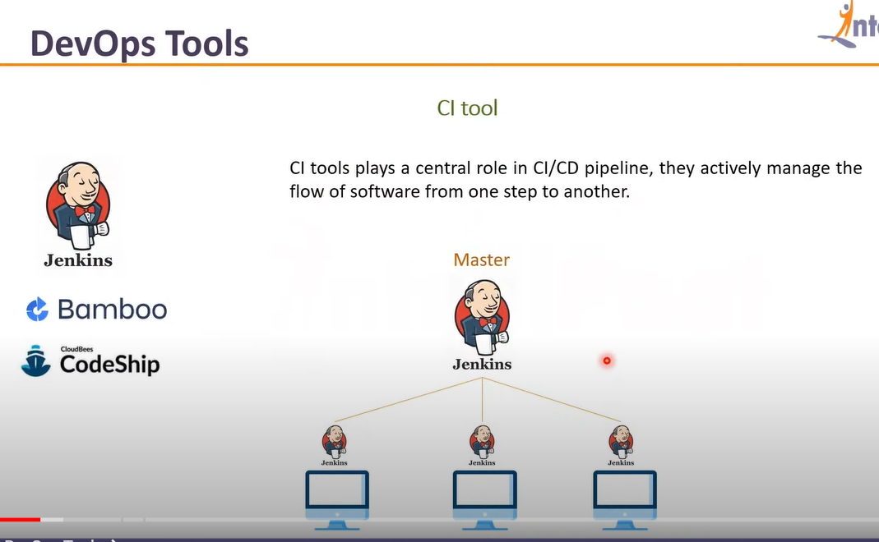

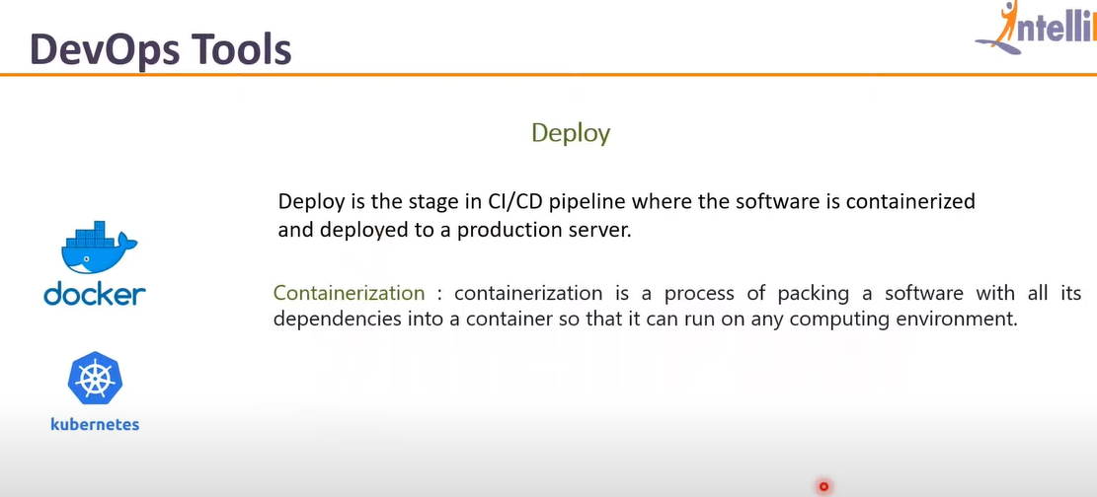

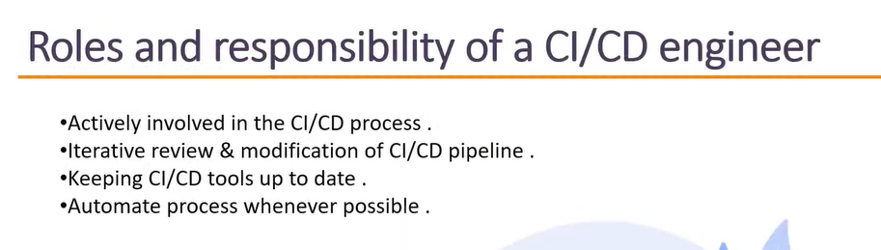

A pipeline is a sequence of events or jobs that can be executed.

<https://opensource.com/article/19/9/intro-building-cicd-pipelines-jenkins>