**Implementing Log4j in Java Project**

* Log4j is a java based logging framework
* Is simple, flexible, reliable and fast
* Is configured through a configuration file
* Log4j.xml OR log4j.properties etc...

**Step 1:**Add Log4j libraries in the java project. We can add jar files or maven dependency

<https://logging.apache.org/log4j/2.x/>...

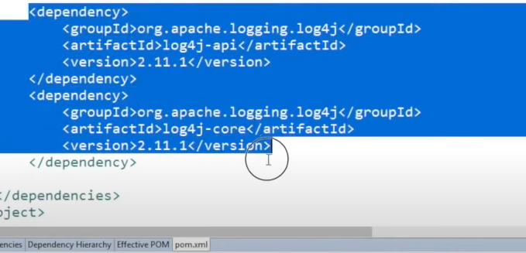

**Step 2** : Create reference for Logger in the class.. Class where you want to add log statements

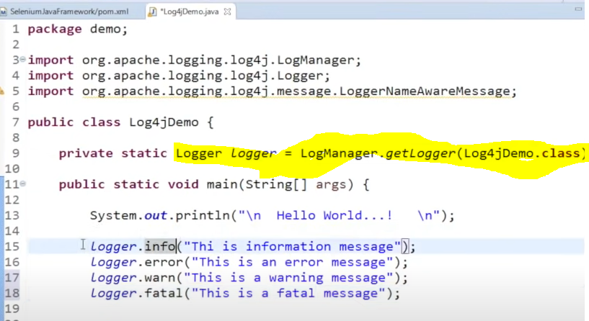

**Step 3 :** Create log4j.xml or log4j.properties file

What is the difference ?

***Step 4*** : Run and Validate

Log4j - log levels

* TRACE-Most detailed information. Expect these to be written to logs only. Since version 1.2.12
* DEBUG-Detailed information on the flow through the system. Expect these to be written to logs only. Generally speaking, most lines logged by your application should be written as DEBUG
* INFO-Interesting runtime events (startup/shutdown). Expect these to be immediately visible on a console, so be conservative and keep to a minimum.
* WARN-Use of deprecated APIs, poor use of API, 'almost' errors, other runtime situations that are undesirable or unexpected, but not necessarily "wrong". Expect these to be immediately visible on a status console.
* ERROR-Other runtime errors or unexpected conditions. Expect these to be immediately visible on a status console.
* FATAL-Severe errors that cause premature termination. Expect these to be immediately visible on a status console.
* OFF-The highest possible rank and is intended to turn off logging.

You can configure to append or overwrite logs in file

You can set logging OFF when not required

in case heavy logging is making your runs slower...

Log4j - Configuration File

Log4j is configured through a configuration file

Configuration files can be written in XML, JSON, YAML, or properties file format

Set of key-value pairs

Within a configuration you can define three main components:

1. Loggers
2. Appenders
3. Layouts

Configuring logging via a file has the advantage that logging can be turned on or off without modifying the application that uses Log4j.

Log4j - FAQ