Get
Get()
response res = given().contentType(ContentType.JSON).when().get("http://google.com");

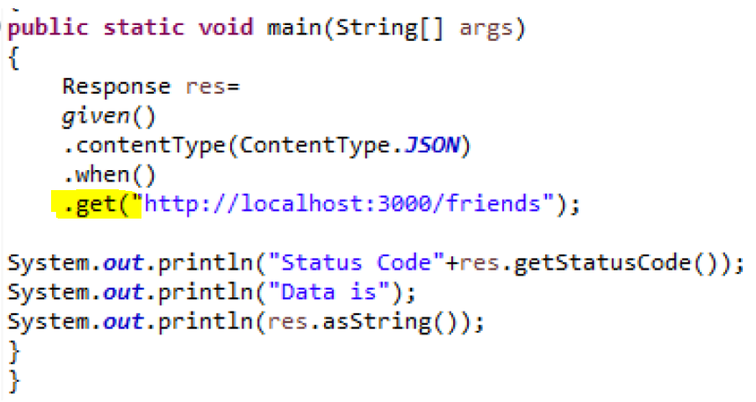
POST

POST(): For post we need payload.
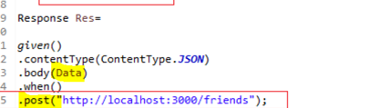

We can create body data using:
1. Java known as Plain Old Java Object (POJO)
2. Using Org.JSON
3. Using already Existing Json File

Using -Plain Old Java Object (POJO)
1.First create one class say POJO_PostReqParameters.java having only key attributes of JSON
2.On above class, create getter and setter methods.
3.Create a class for doing POST request like PostRequest.java under the same package. Declare the object of class POJO_PostReqParameters and set the values of variables declared in that class. Finally, pass the object in the body of Post request

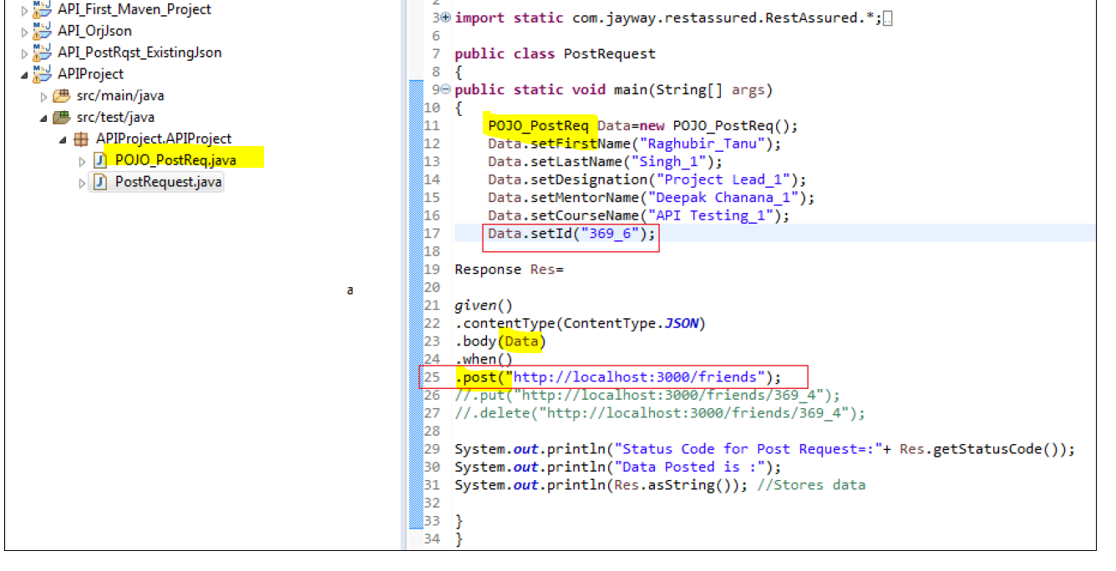

<!-- https://mvnrepository.com/artifact/org.json/json -->
<dependency>
<groupId>org.json</groupId>
<artifactId>json</artifactId>
<version>20190722</version>
</dependency>
Using Org. JSON
- First need to add dependency in pom.xml
- For creating the body data with Org.json we need to create an object of JSONObject class and we have created BasicInfo and we will be using object of the JSONObject class created along with .put method to assign the values to the keys as shown below:
Very Important Note: we have to convert the object of the JSONObject class to string and then only it has be passed in the body method.
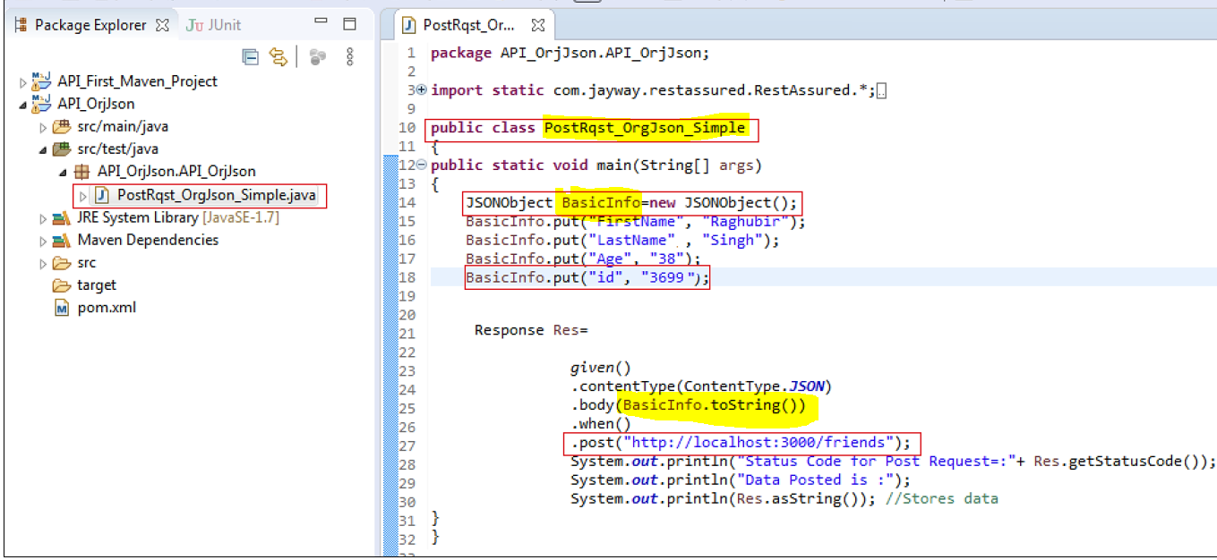
Using Existing Json File
- Create a file with .json extension and paste your payload Json
- Hitting the Post request after reading data from existing Json file where data is already present in the Json file in Json format.
Very Important Note: we have to convert JSONObject into string and then only it has be passed in the body method.

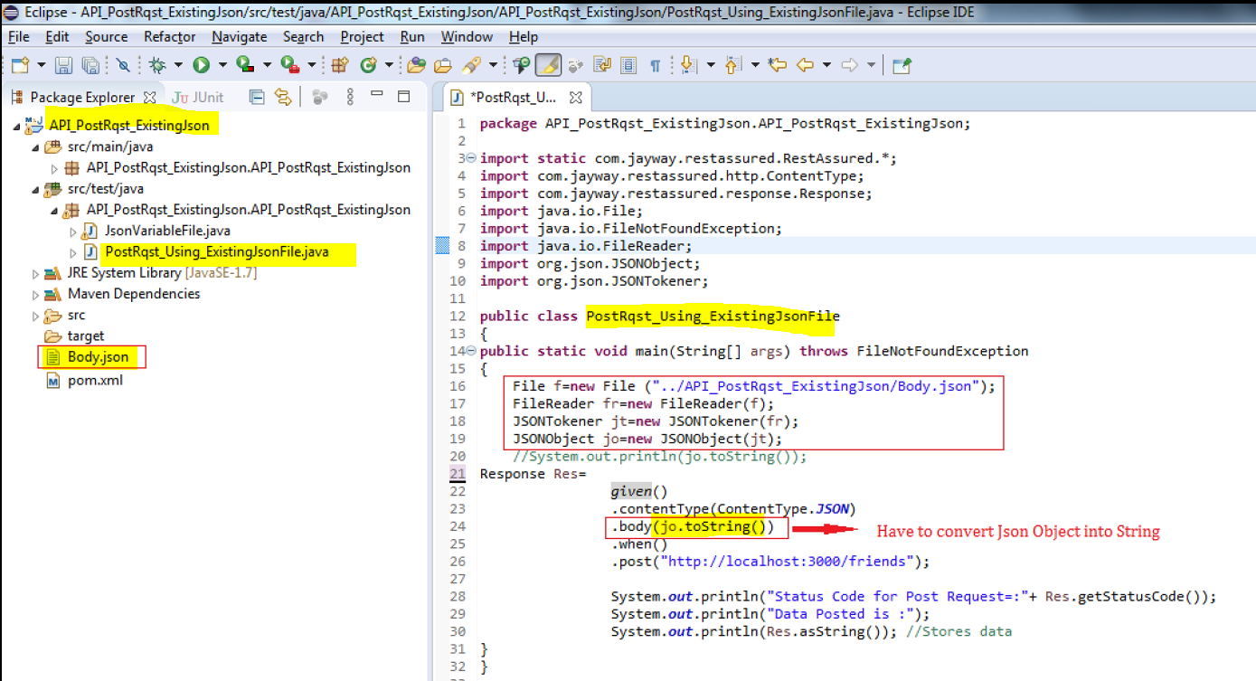

Json Parsing data
