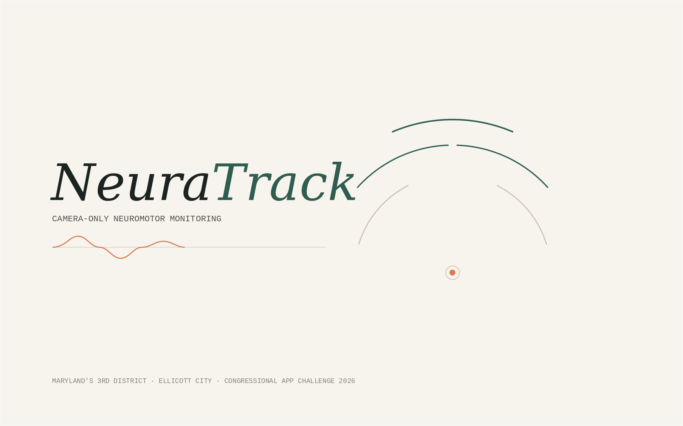
Design System
Visual language, motion, and screen-by-screen design specification
Companion to the NeuraTrack PRD · Congressional App Challenge 2026

1. Starting Point: What Wasn't Working
The project folder already contained four AI-generated mockup screens (Stitch output: neuratrack_pro_dashboard_light, pro_spiral_assessment_light, bilateral_protocol_light, neuratrack_world_class_dashboard) built against a system called "Clinical Precision Pro." Before designing the replacement, it's worth being specific about what wasn't working, because the new direction is a direct response to each of these problems.

1.1 The tone was wrong for the audience
The mockups use a sci-fi "neural command center" vocabulary: labels like NEURAL_PROJECTION_ACTIVE, SYNAPTIC_THRESHOLD_HIT, MOTOR_CORTEX_SPIKE, and a fake glowing 3D brain-scan illustration. This product's real primary users are a 68-year-old managing essential tremor and a home health aide checking in on elderly clients — not a sci-fi thriller's control room. The hacker-terminal tone reads as cold and slightly alarming to exactly the people who most need to feel calm and in control while using it. It also implies the app does things it doesn't do: there is no "neural projection" and nothing resembling brain imaging happening anywhere in this product, and depicting a brain scan risks the same overclaiming problem flagged in the PRD's ethical framing.

1.2 It is the generic "AI-generated dashboard" look
Neon cyan accents on a dark navy base, heavy glassmorphism, ALL_CAPS monospace labels on every field, uniform rounded-rectangle cards stacked edge-to-edge — this is, at this point, the single most common aesthetic produced by AI UI generators across every product category. It doesn't read as considered or credible to a sophisticated judge; it reads as a template. A product asking to be trusted with health data benefits from looking deliberately, specifically designed — not like every other generated dashboard from the last two years.

1.3 Box-on-box monotony
Every one of the four screens is a vertical stack of same-radius, same-border, same-shadow rectangles with no variation in rhythm. Even the existing "Clinical Precision Pro" system's own written guidance (technical minimalism, hairline borders instead of shadows) is undermined in the actual screens by cards nested inside cards inside cards. The result is monotonous, and — per the user's own brief — overuses bubbles/boxes and shadowing rather than using type scale, color fields, and whitespace to create hierarchy.

1.4 What to keep
Not everything was wrong. The instinct toward hairline borders over heavy shadows, a dual-font (display + mono-for-data) strategy, and a cool, precise base palette are all sound and are carried forward — just redirected away from sci-fi-hacker and toward calm, editorial, human-first.

2. The New Direction: Calm Precision
Calm Precision borrows more from high-end consumer health and wellness brands (the visual register of a premium sleep tracker or a well-designed clinical instrument's physical casing) than from enterprise SaaS dashboards. It pairs a warm, paper-like neutral base with a single confident deep-green accent and a human, terracotta secondary — and reserves true black-background "instrument" surfaces for exactly one place: the live 3D capture viewport, where a dark surface is functionally correct (it's where a camera feed and glowing skeleton actually belong) rather than applied as decoration everywhere.

2.1 Principles
- Warm, not clinical-cold. A paper/canvas background instead of stark white or navy-black — the product should feel like a well-made object, not a terminal.
- Hierarchy from type and space, not boxes. Most sections are distinguished by generous whitespace, a rule line, or a full-bleed color field — not by wrapping everything in a bordered card.
- One serif moment. A distinctive editorial serif (Fraunces) is used only for headlines — an unusual, humanizing choice for a health-tech product that immediately reads as considered rather than templated.
- Dark is a place, not a mood. The only dark surface in the entire product is the live capture viewport, where camera + 3D content genuinely benefits from a dark backdrop for contrast and focus.
- Motion has a job. Every animation either confirms an action, reveals content on scroll, or represents real data (the 3D skeleton, the spectrum chart) — never decoration for its own sake.

3. Design Tokens

3.1 Color
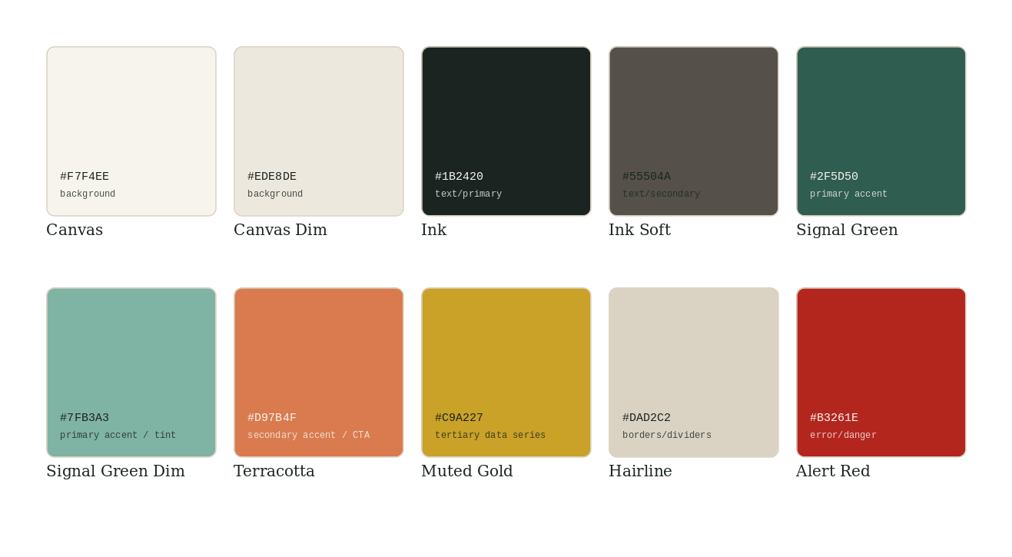
Full palette with usage. All pairings below are pre-verified for WCAG 2.1 AA contrast.
Foreground | Background | Contrast ratio | Use
Ink #1B2420 | Canvas #F7F4EE | 15.1 : 1 | Body text, default
Canvas #F7F4EE | Ink #1B2420 | 15.1 : 1 | Text on the dark capture viewport
Ink Soft #55504A | Canvas #F7F4EE | 7.2 : 1 | Secondary text, captions
Canvas #F7F4EE | Signal Green #2F5D50 | 8.4 : 1 | Text/icons on the green color-field band
Ink #1B2420 | Signal Green Dim #7FB3A3 | 4.9 : 1 | Text on tinted green surfaces (badges)
Canvas #F7F4EE | Terracotta #D97B4F | 3.1 : 1 (large text/icons only) | CTA button background — use bold 18px+ label

3.2 Typography
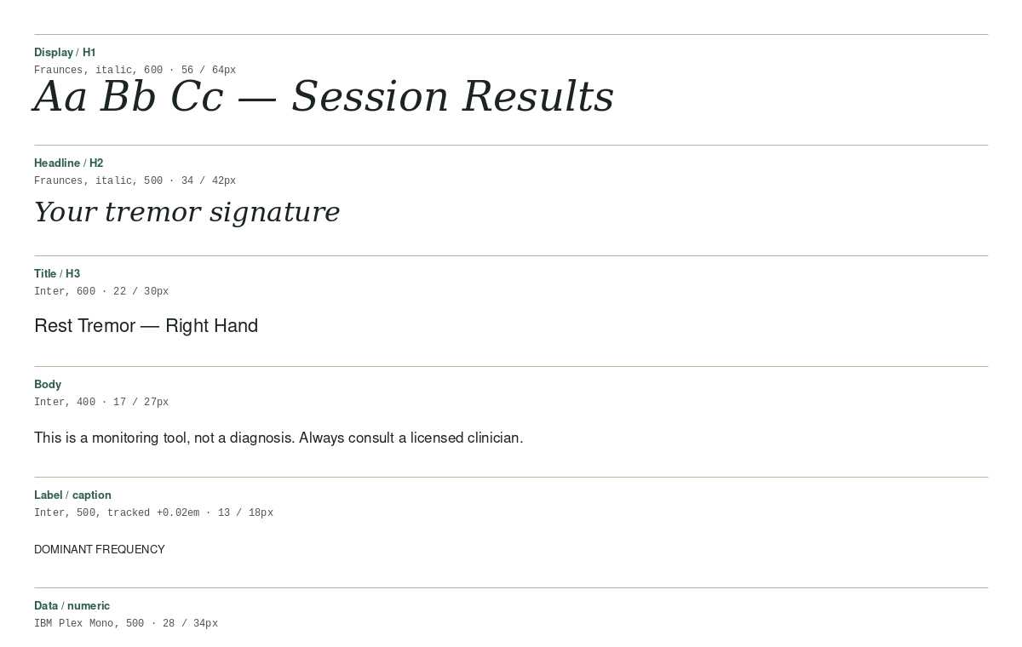
Type scale and pairing. Live pages load Fraunces (display), Inter (UI/body), and IBM Plex Mono (data) from Google Fonts, self-hosted/subsetted for the PWA build.
Role | Font | Weight | Size / Line-height
Display / H1 | Fraunces | 600, italic | 56 / 64
Headline / H2 | Fraunces | 500, italic | 34 / 42
Title / H3 | Inter | 600 | 22 / 30
Body | Inter | 400 | 17 / 27
Label / caption | Inter | 500, +0.02em tracking, uppercase | 13 / 18
Data / numeric readouts | IBM Plex Mono | 500, tabular figures | 28 / 34 (headline data), 15/22 (inline data)
Why Fraunces: it is a high-contrast, warm display serif used by a number of premium wellness/health brands precisely because it reads as considered and human without sacrificing legibility — the opposite of the generic geometric sans-plus-neon-glow combination that reads as "AI dashboard." Inter carries all UI chrome because it is exceptionally legible at small sizes and has full language support for the Spanish localization. IBM Plex Mono is used deliberately (not JetBrains Mono, which reads more "developer terminal") because its slightly more humanist letterforms pair better with a serif headline while still giving tabular figures for clean numeric alignment.

3.3 Spacing & Grid
Token | Value | Use
--space-1 … --space-8 | 4 / 8 / 12 / 16 / 24 / 32 / 48 / 64 px | 4px baseline rhythm throughout
Content max-width | 1200px (desktop), fluid with 24px gutters below 1024px | All screens except the full-bleed landing hero/color-field sections
Grid | 12-column desktop, 8-column tablet, 4-column mobile | Marketing page and dashboard layouts
Section vertical rhythm | 96px between major landing sections, 32px between dashboard cards | Keeps the "airy, not boxed" quality from the critique in §1.3

3.4 Elevation & Shape
- No drop shadows anywhere except the one active/focused capture card, which gets a single soft 8px shadow at 8% opacity — reserved for the single moment elevation communicates something (this element is live and active).
- Hierarchy elsewhere comes from a 1px hairline border (#DAD2C2), a color-field background change, or a rule line — never from stacking shadow intensity.
- Corner radius: 4px for buttons/inputs, 12px for cards/panels, full-round only for pills (nav toggle, status chips). No mixing of sharp and round corners within the same hierarchy level.

3.5 Motion
Token | Value | Use
--ease-out | cubic-bezier(0.16, 1, 0.3, 1) | Entrances, scroll reveals
--ease-in | cubic-bezier(0.7, 0, 0.84, 0) | Exits
--duration-micro | 150ms | Button/press states, toggles
--duration-standard | 250ms | Card reveals, tab switches
--duration-scroll-reveal | 400ms + 40ms stagger per item | Landing page section entrances
prefers-reduced-motion | disables scroll parallax, 3D auto-rotation, and stagger; crossfades replace slides | Applies globally, no exceptions

4. Component Library

Buttons
- Primary: solid Signal Green fill, Canvas text, 4px radius. One primary button per screen (per the ui-ux-pro-max single-primary-action guideline).
- CTA-on-hero: solid Terracotta fill, Ink text (bold, 18px+ for contrast compliance per §3.1).
- Ghost/secondary: transparent fill, 1px Ink border, Ink text; used for "Skip", "Cancel", nav links.
- All buttons: 44px minimum height, visible 2px focus ring in Signal Green offset 2px, 150ms ease-out press-scale (0.97) feedback.

Cards / Panels
- Used only where content is genuinely a discrete, movable unit (a metric card, a history row) — not as a default wrapper for every section.
- White fill on Canvas background, 1px Hairline border, 12px radius, no shadow (see §3.4).

Data readouts
- Numeric values always in IBM Plex Mono with tabular figures; unit label immediately adjacent in Inter, smaller, Ink Soft color — never color alone to convey a good/bad reading.

Status chips
- Pill-shaped, tinted background at 12% of the semantic color + a solid-color left dot (not fill) — dot shape differs (circle/triangle/square) by status type so color-blind users have a non-color cue.

The 3D capture viewport
- The one intentionally dark surface (#0F1613) in the product. Contains the live camera feed (dimmed 40%), the Three.js skeleton overlay, a Hairline-colored pose-guide silhouette, and a circular progress ring for the countdown.

Navigation
- Persistent top bar on all post-onboarding screens: wordmark (left), Patient/Clinician mode toggle (center-right), settings icon (right). No bottom tab bar on desktop; a bottom tab bar (Home / History / Settings, 3 items, icon + label) appears only below 768px, per the bottom-nav-limit guideline.

5. Motion & Interaction Specification
Interaction | Behavior
Landing page scroll | Each section fades in (opacity 0→1) and translates up 24px as it crosses 70% viewport height; children within a section stagger by 40ms. Hero 3D tremor-signature plot auto-rotates slowly and continuously (paused under reduced-motion).
Task countdown | 3-2-1 numerals scale-and-fade (spring, not linear) in the capture viewport; the progress ring sweeps clockwise over the 10s recording, giving continuous, non-verbal feedback.
3D skeleton joints | Each joint sphere recolors continuously (not steppped) along the calm-blue -> hot-amber ramp as rolling jitter changes — this is a data-driven animation, not decorative.
Result reveal | Metric cards count up from 0 to their final value over 400ms when the results screen mounts — confirms "this just happened", not decoration.
Page-to-page navigation | Forward navigation slides content in from the right / fades up; back navigation reverses — consistent directional logic throughout, per navigation-direction guidance.
Toasts (save confirmation, export ready) | Slide up from bottom, auto-dismiss 4s, aria-live="polite" for screen readers.

6. Screen-by-Screen Visual Specification
This section is the visual companion to PRD §10. Each screen below shows its layout wireframe (structure and composition) plus the specific token usage that turns the structure into the finished look.

6.1 Landing / Marketing Page
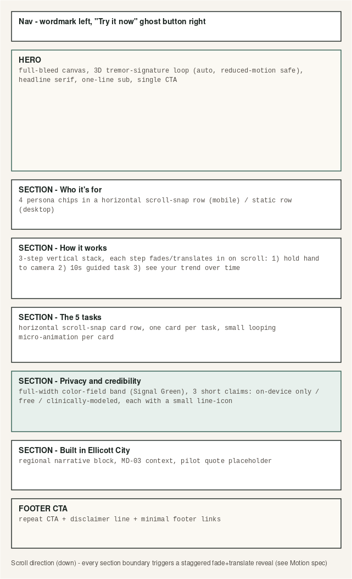
Full-bleed, single-column scroll story. Every section boundary is a scroll-triggered reveal (§5).
Visual detail: the hero is the only place the 3D tremor-signature plot appears without a live camera behind it — it runs on a small loop of pre-recorded/synthetic data, clearly not implying a live reading. Headline is set in Fraunces italic at 56-72px depending on viewport. The "Privacy and credibility" section is the one full-bleed Signal Green color-field band on the page — used exactly once, so it carries maximum weight when it appears. Task preview cards use a subtle line-art icon per task (matching the hero mark's line-art language) rather than photography or 3D renders, keeping the page fast and avoiding stock-photo/AI-image clichés.

6.2 Task Capture Screen
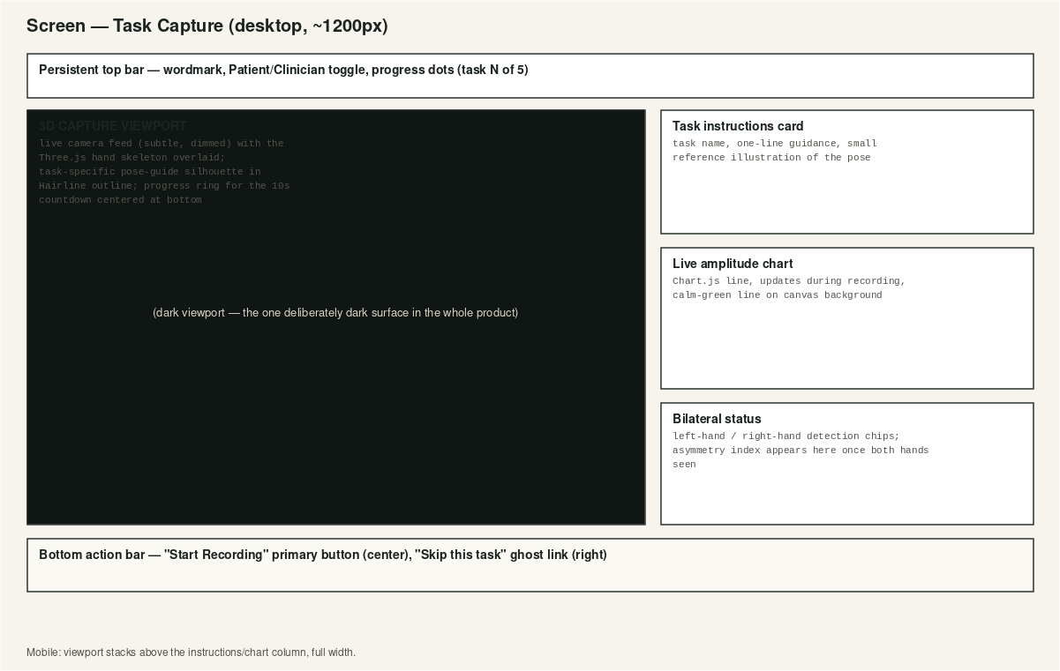
The one screen with a dark surface — reserved for the functional capture viewport.
Visual detail: the instructions card, live chart, and bilateral-status card in the right column all share the white/hairline card treatment; the viewport on the left is the single visual anchor of the screen specifically because everywhere else in the product deliberately avoids heavy dark surfaces — the contrast makes this screen feel focused rather than just "another dark-mode dashboard."

6.3 History / Trends Dashboard
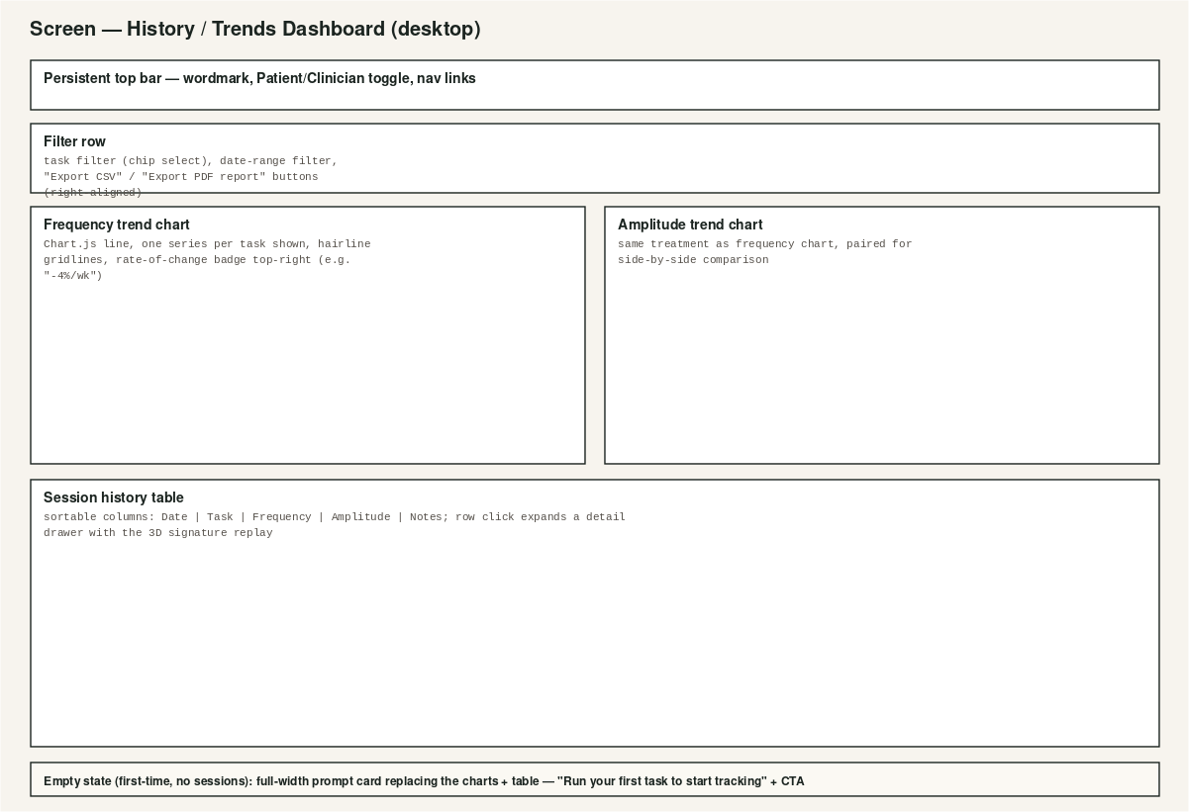
Paired trend charts, sortable history table, empty state replaces the whole content region on a first-time visit rather than showing empty axes.

6.4 Session Results, Consent, Profile, Settings
These screens share a single-column, generously-spaced template (max-width 640px, centered) rather than needing their own dedicated wireframe: a Fraunces headline, one or two hairline-bordered content cards, and a single primary action at the bottom. Session Results additionally includes the classifier pattern-match card (tinted Muted Gold background, per the PRD's ML module) with the disclaimer set in Ink Soft directly beneath it — never smaller than the surrounding body text, and never dismissible.

7. Illustration & Graphic Direction

The brand mark: a five-arc "motion fan" radiating from a tracked joint, standing in for the five fingers/five tasks without attempting a literal, uncanny illustration of a hand. Paired with a hand-drawn signal waveform and the Fraunces wordmark.
This is the illustration system for the whole product: abstracted, line-based, generated from the product's own geometry (arcs, a signal line, a single accent dot) rather than stock photography, generic 3D-rendered icons, or — as in the original mockups — a literal glowing brain scan that overstates what the product measures. Every icon in the product follows the same rules: single 1.5-2px stroke weight, rounded caps, no fill except the small accent-color dot used as a consistent "tracked point" motif across the hero mark, task icons, and the 3D skeleton joints themselves.
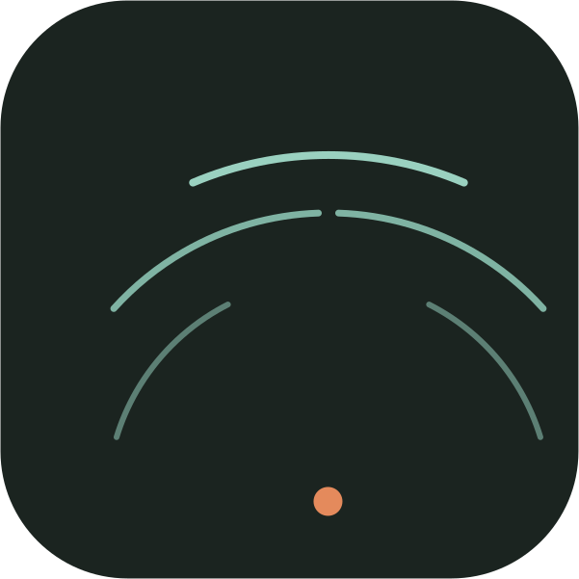
App icon / favicon lockup: the same fan-and-dot mark on the Ink background, for install icons and browser tabs.

8. Accessibility & Responsive Specification
Breakpoint | Layout behavior
< 480px (phone) | Single column everywhere; bottom tab bar (Home / History / Settings) appears; capture viewport goes full-width, instructions/chart stack below it.
480-768px (large phone / small tablet) | Same as mobile with wider gutters (24px); dashboard trend charts stack vertically.
768-1024px (tablet) | 8-column grid; capture screen splits 60/40 instead of 65/35; nav becomes the full top bar (no bottom tabs).
> 1024px (desktop) | Full 12-column layout as specified in the wireframes above; max content width 1200px, centered.
Additional requirements (see PRD §11.3 for the full checklist): large-text mode scales the entire type ramp up one step (body becomes 19px) without truncating any data readout; the tremor heatmap ramp (calm-blue → hot-amber) was deliberately chosen instead of blue→red specifically because red/green and blue/red gradients are the two most common colorblind-failure pairings, and amplitude is always additionally shown as a numeric value and line-thickness change, never color alone.

9. Do's and Don'ts
Do | Don't
Use a hairline border or a color-field band to separate sections. | Wrap every section in its own bordered, shadowed card.
Reserve dark backgrounds for the live capture viewport only. | Use neon cyan-on-navy or any glassmorphism-heavy 'AI dashboard' styling.
Use Fraunces for headlines, sparingly, to create a distinctive editorial moment. | Set body copy or dense UI chrome in the display serif.
Show a disclaimer on every results/classifier screen, same size as body text. | Make the disclaimer small, low-contrast, or dismissible.
Let the 3D skeleton and charts be the visual centerpiece — they're real data. | Add decorative 3D or motion that doesn't represent real data or confirm an action.
Use the blue-to-amber heatmap ramp with a numeric value alongside it. | Rely on a red/green or blue/red gradient, or color alone, to convey a reading.

End of Design System. Paired with the NeuraTrack PRD for functional specification, and the HTML mockups (landing.html, capture.html, dashboard.html) for a working, in-browser expression of everything specified above.

