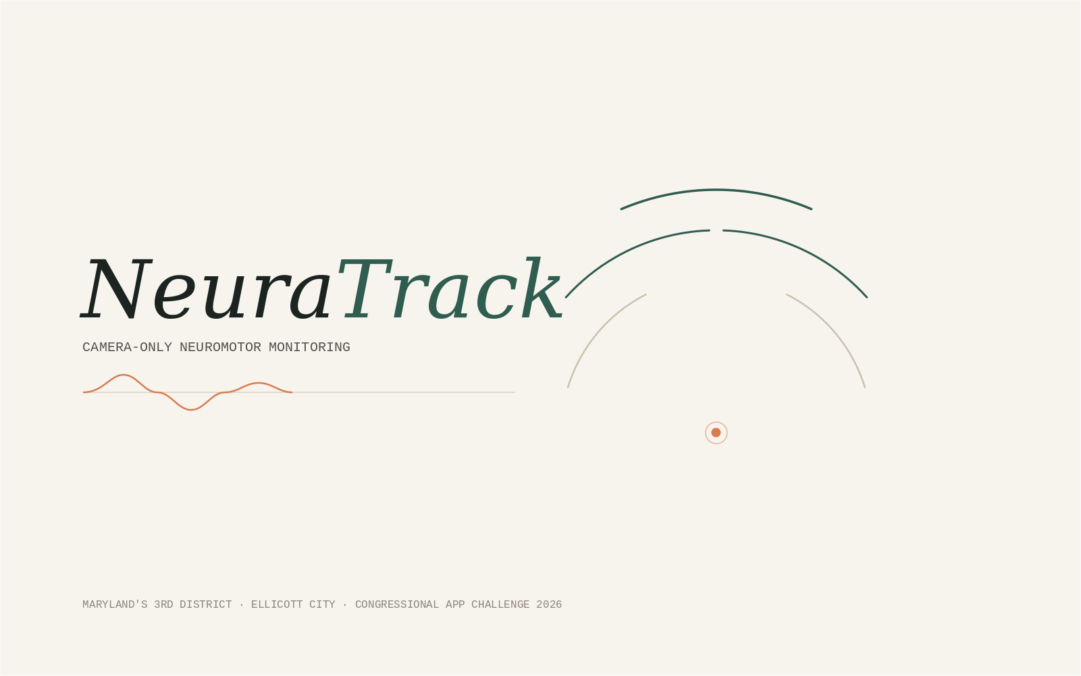
Product Requirements Document
Version 2.0 — Elevated / Bilateral / Spiral / On-device ML edition
Congressional App Challenge 2026 · Maryland's 3rd District · Prepared for Vasudha's team of 2
This document specifies the complete NeuraTrack product: every screen, every function, every data structure, every flow, and the full technical architecture, in enough detail that the app can be built from this document alone using Claude Code, Codex, or a human engineering team.

Table of Contents

1. Executive Summary & Vision
NeuraTrack is a free, camera-only neuromotor monitoring platform that runs entirely in a web browser. It turns a laptop or phone webcam into a multi-task motor assessment instrument — modeled on the standard clinical movement-disorder exam (MDS-UPDRS Part III) — and gives patients, family caregivers, home health aides, and physical therapy students an objective way to track hand tremor, finger-tapping, forearm rotation, and fine-motor drawing control over time, without any wearable hardware and without any video ever leaving the device.
The product exists because objective neuromotor tracking today requires either a clinical visit or a wearable sensor kit costing hundreds of dollars — both of which are out of reach for many patients between appointments, especially in communities with limited neurology access. NeuraTrack closes that gap with hardware nearly everyone already owns.
This version of the product (v2.0) is deliberately elevated beyond a single-metric demo: it tracks both hands to compute a clinically meaningful left-right asymmetry index, adds a digital spiral-drawing task that mirrors real Parkinson's research instruments (Sage Bionetworks' mPower study), and includes an on-device, explainable pattern-recognition model trained on public movement-disorder datasets — all while keeping every claim honest: NeuraTrack monitors and logs; it never diagnoses.

1.1 Product Pillars
- On-device only. All camera frames, hand-landmark inference, signal processing, and machine-learning inference happen locally in the browser. No video frame is ever uploaded.
- Clinically grounded, not clinically overclaiming. Every task and metric traces to a published, standard motor exam item. Every result screen carries a visible, unavoidable disclaimer.
- Zero hardware cost. Works on any laptop, Chromebook, or phone with a front camera and a modern browser.
- Built to grow into a real app. The Phase 1 web MVP is architected so the exact same capture, signal-processing, ML, and rendering code becomes the engine of a native iOS/Android app in Phase 2, without a rewrite.

2. Goals & Success Metrics
Goal | Metric | Target (Phase 1 / CAC submission)
Judges can verify real functionality | Live demo completes end-to-end without a script failure | 100% of rehearsed demo runs
Product is genuinely usable by the target audience | A first-time user (non-technical, 55+) completes one full task unassisted | ≥ 4 of 5 pilot testers
Signal processing is scientifically defensible | Detected frequency error vs. a synthetic known-frequency signal | < 0.3 Hz error (see fft.js unit tests)
App respects privacy claims | Network requests during a session (excluding first-load model/font fetch) | Zero
Performance is real-time, not laggy | Hand-tracking frame rate on a mid-range laptop webcam | ≥ 24 fps sustained
Accessibility is not an afterthought | WCAG 2.1 AA automated + manual audit pass rate | 100% of Critical/High checks (see §11.3)

3. Users & Personas

Diane, 68 — Patient managing early-stage essential tremor
“I just want to know if it's getting worse before my next appointment in four months.”
Needs:
- A simple, low-pressure way to check in on her own symptoms at home.
- Large text, minimal jargon, no account creation friction.
- A way to show her neurologist objective data instead of vague descriptions.
Pain points today:
- Wearable sensor kits are expensive and she doesn't trust herself to set them up correctly.
- Her only current option is to describe symptoms from memory during a rushed appointment.

Marcus, 34 — Home health aide, caseload of 6 elderly clients
“I need something I can pull up on my phone between visits that doesn't require special equipment I have to carry around.”
Needs:
- A fast, repeatable way to log observations per client, per visit.
- Exportable data he can hand off to the case's actual clinician.
- Works reliably on a mid-range Android phone.
Pain points today:
- No standardized way to track tremor progression across visits today — it's all subjective notes.
- Client roster is diverse in tech comfort, so the tool has to work for all of them.

Priya, 17 — Physical therapy program high-school student (also the target CAC judge proxy)
“I want to actually understand the clinical exam I'm learning about, not just read about it in a textbook.”
Needs:
- A hands-on way to see MDS-UPDRS-style tasks digitized and quantified.
- Confidence that the underlying math (FFT, feature extraction) is real and correct.
Pain points today:
- Clinical motor exams are usually only demonstrated in person, with no way to practice or explore the underlying signal independently.

Dr. Nguyen — Movement disorder specialist / clinician mode user
“Between visits I'm flying blind — I only see the patient for fifteen minutes every few months.”
Needs:
- Objective, trend-over-time data rather than a single snapshot.
- A report format she can scan in under a minute.
- Confidence that the tool is not making diagnostic claims she didn't make herself.
Pain points today:
- No inexpensive way today to get continuous motor-symptom data from patients between visits.

4. Scope

4.1 In Scope — Phase 1 (Web MVP, this PRD's primary target)
- A installable Progressive Web App (PWA), fully client-side, deployable as static files to any host (Vercel/Netlify/GitHub Pages).
- Five motor tasks: rest tremor, postural tremor, finger-tapping, pronation-supination, and spiral drawing.
- Bilateral (two-hand) tracking with an asymmetry index wherever both hands are visible.
- On-device signal processing (FFT-based frequency/amplitude analysis, tap decrement, spiral deviation).
- On-device ML pattern-similarity classifier (TensorFlow.js), trained offline on public datasets.
- 3D real-time hand skeleton visualization and a 3D tremor "signature" phase-space plot (Three.js).
- Local session history (IndexedDB), trend charts, CSV/PDF export.
- Patient Mode and Clinician Mode UI toggle.
- Accessibility: large-text mode, color-blind-safe palette, English/Spanish UI.

4.2 Explicitly Out of Scope — Phase 1
- No user accounts, login, or cloud sync of any kind.
- No server, database, or API — the product is 100% static + client-side.
- No diagnostic claims, scoring against clinical severity scales, or medication recommendations.
- No multi-patient roster management (that is a Phase 2 Clinician Portal feature).

4.3 Phase 2 (Future — Native App + Optional Cloud, described for completeness)
- Capacitor-wrapped iOS/Android app reusing the Phase 1 engine unchanged (see §7).
- Opt-in cloud sync, clinician portal, authentication, and push notifications — all additive, never required.

5. Full Feature List
Epic | Feature | Priority
Onboarding | Consent & disclaimer screen (blocking, must acknowledge) | P0
Onboarding | Local profile setup (name, optional condition tag, language) | P0
Onboarding | Camera permission flow with human-readable error recovery | P0
Onboarding | Calibration: hand-size reference + lighting quality check | P0
Capture | Rest tremor task | P0
Capture | Postural tremor task | P0
Capture | Finger-tapping task with amplitude-decrement analysis | P0
Capture | Pronation-supination task | P1
Capture | Spiral-drawing task with deviation scoring | P1
Capture | Bilateral (two-hand) tracking + asymmetry index | P1
Analysis | FFT-based frequency/amplitude extraction (resampled, Hann-windowed) | P0
Analysis | On-device ML pattern-similarity classifier + confidence + feature importance | P1
Visualization | Real-time 3D hand skeleton with tremor heatmap | P0
Visualization | 3D tremor "signature" phase-space plot | P1
Visualization | Live amplitude chart + post-session frequency spectrum chart | P0
History | Local session history with CSV export | P0
History | Trend dashboard (frequency/amplitude over time, rate-of-change) | P1
History | PDF clinician report export | P1
UX | Patient Mode / Clinician Mode toggle | P1
Accessibility | Large-text mode, color-blind-safe palette, English/Spanish | P1
Marketing | Public scroll-story landing page (no camera required) | P0

6. User Flows
The two diagrams below specify every screen transition and decision point in the product. Diagram 1 covers the full session lifecycle from first open to saved history. Diagram 2 zooms into the "Task Capture Loop" box from Diagram 1, showing exactly how a single task recording turns into a result.
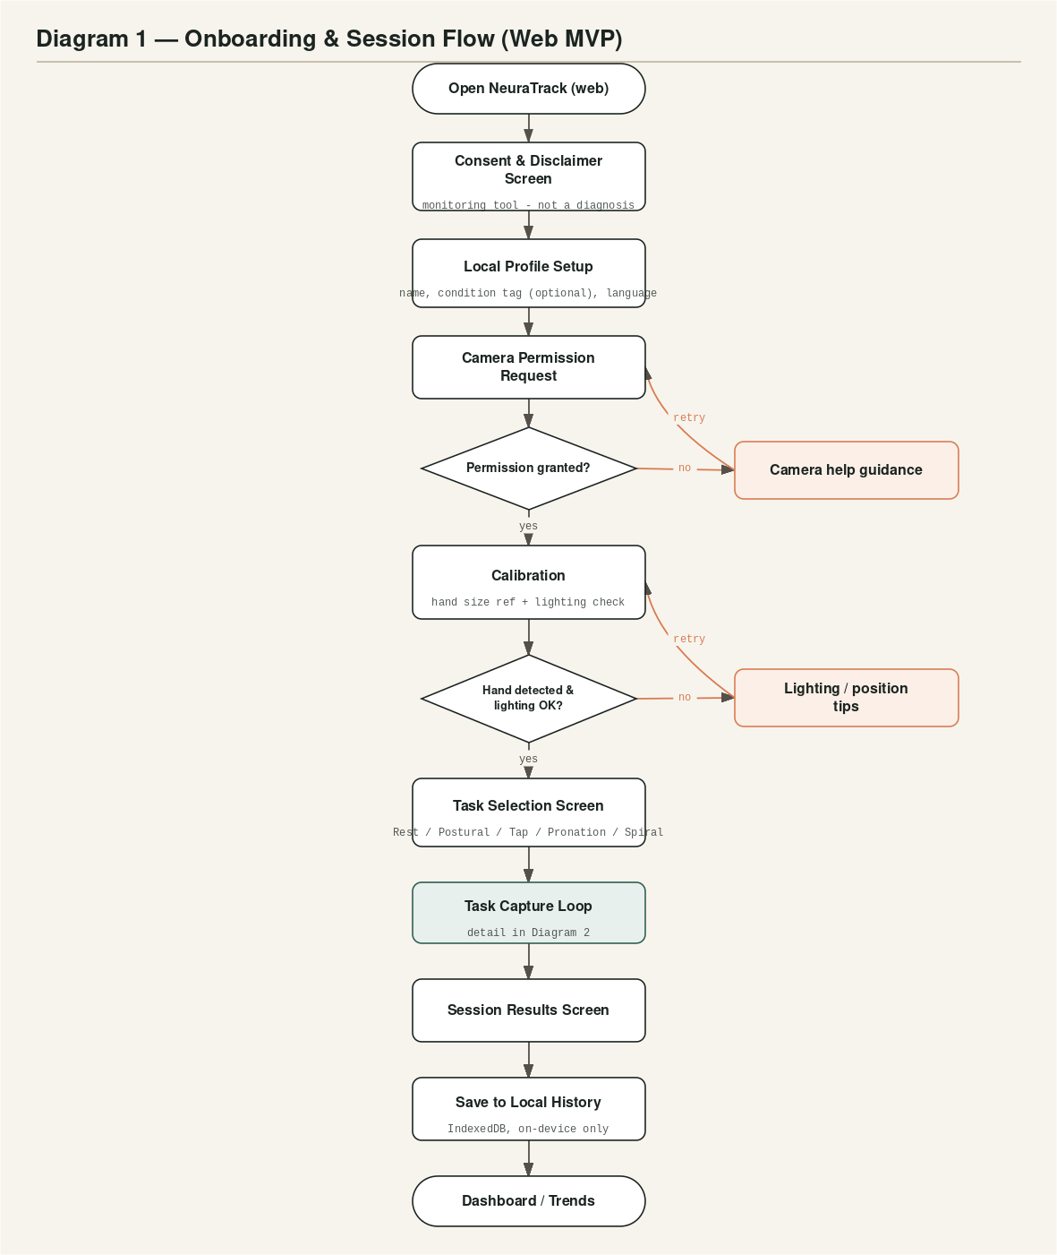
Diagram 1 — Onboarding & Session Flow. Every screen is reachable only in this order on first run; after onboarding is complete once, the app opens directly to the Task Selection / Dashboard screen.
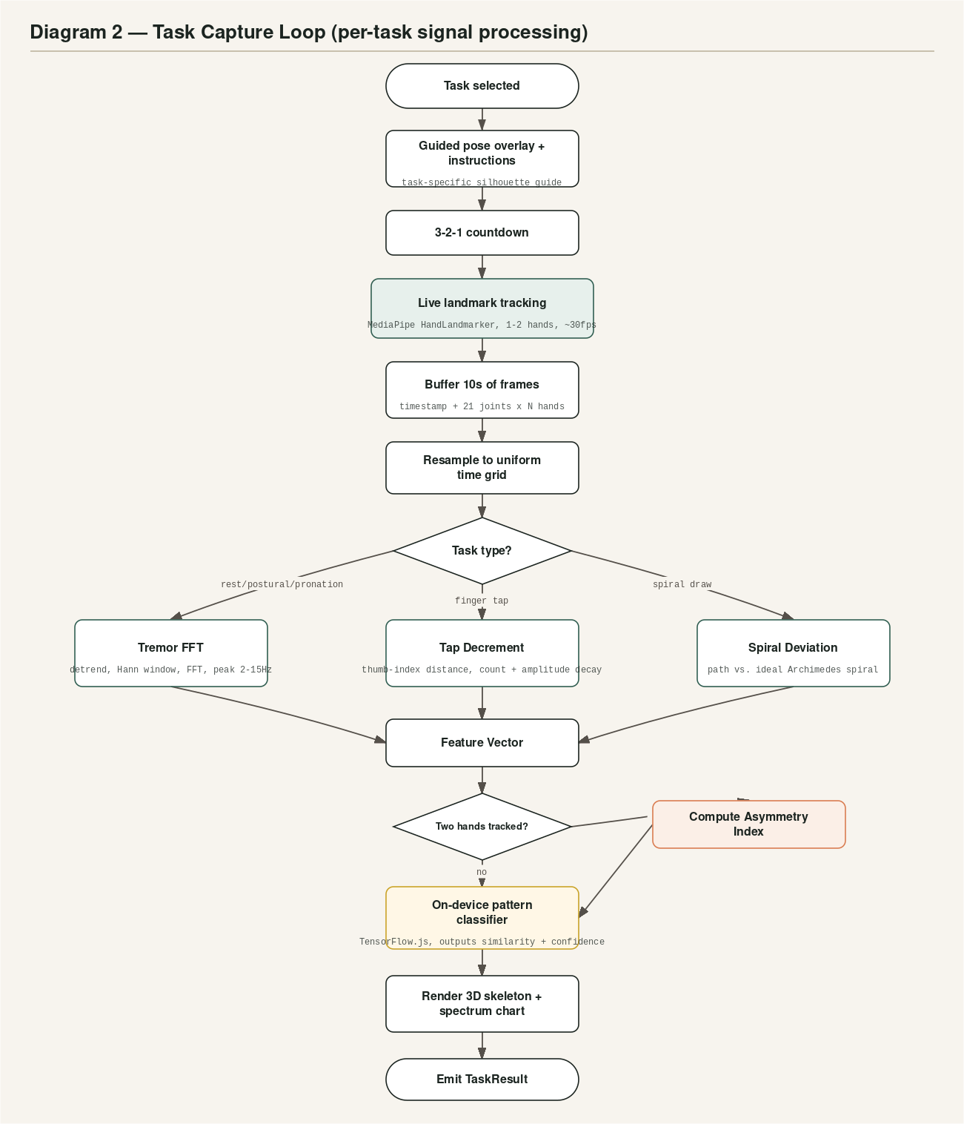
Diagram 2 — Task Capture Loop. This is the same logic for all five tasks; only the guided overlay and the feature-extraction branch differ per task, as shown.

6.1 Narrative walkthrough
A first-time user opens the app and is blocked by the consent screen until they explicitly acknowledge the monitoring-not-diagnosis disclaimer. They set up a local-only profile (no email, no password — just a display name and, optionally, a condition tag used only to pre-select which tasks are shown first). The app requests camera permission; if denied, a plain-language recovery screen explains exactly which browser setting to change, with a retry button. Once granted, a calibration step asks the user to hold their hand naturally in frame for two seconds — this both confirms tracking is working and measures a hand-size reference distance used to normalize all later measurements.
From the task selection screen, the user picks a task; each task shows a guided pose overlay and a 3-2-1 countdown before a fixed 10-second recording begins. During recording, live landmark coordinates are buffered with their frame timestamps. The instant recording ends, the buffer is resampled onto a uniform time grid (correcting for webcam frame-rate jitter) and routed through the task-appropriate feature extraction. If both hands were visible, an asymmetry index is computed. The resulting feature vector is passed to the on-device classifier, and the 3D skeleton and charts render the outcome. The result is saved to local history automatically, and the user can immediately run another task or export/share via CSV or PDF.

7. System Architecture
NeuraTrack Phase 1 has no backend. The entire product is a statically-hosted client bundle; every capability — camera capture, computer vision inference, signal processing, machine learning, 3D rendering, and data storage — executes inside the user's browser.
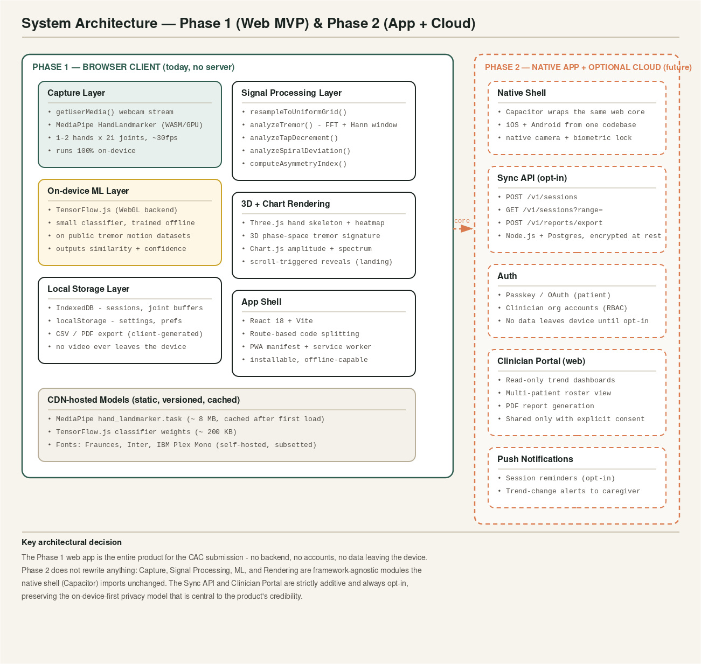
System architecture: Phase 1 (shipped for CAC) is the solid-bordered client-only box. Phase 2 (dashed border) is designed for but not built in this submission — described here to show the product's growth path without implying it exists yet.

7.1 Technology stack
Layer | Technology | Why
UI framework | React 18 + Vite | Fast dev loop, small production bundle, huge ecosystem for a 2-person team on a deadline.
Hand tracking | MediaPipe Tasks Vision — HandLandmarker (WASM + GPU delegate) | Google's production-grade, in-browser hand-tracking model; no server round-trip.
3D rendering | Three.js | Industry-standard WebGL library; runs the skeleton view and tremor-signature plot.
Charts | Chart.js | Lightweight, accessible (keyboard/tooltip support), good default a11y behavior.
Machine learning | TensorFlow.js (WebGL backend) | Runs a small pre-trained classifier fully client-side; no Python server needed at runtime.
Local storage | IndexedDB (via a thin wrapper) + localStorage for preferences | Structured, capacity-appropriate on-device storage for session history.
Styling | CSS with design tokens (custom properties) — see Design System doc | No heavyweight CSS framework; keeps the bundle small and the visual language custom.
Build/deploy | Vite build → static files → any static host | Zero server ops; matches the "free, no infrastructure" pitch.
Phase 2 native shell | Capacitor | Wraps the same web codebase for iOS/Android without a rewrite.
Phase 2 backend (opt-in) | Node.js + Postgres | Only if/when cloud sync ships; entirely additive.

7.2 Why client-only is a feature, not a limitation
Judges and privacy-conscious users alike respond well to a concrete, verifiable claim: open the browser's network tab during a session and there are zero outbound requests carrying personal data. This is also what makes the product free to run at any scale — there is no server cost that grows with users.

8. Data Model
All data lives in the browser's IndexedDB. The diagram below shows every entity, every field, and every relationship. JointFrame data (the raw per-frame joint coordinates) is intentionally never persisted — it exists only in memory during a recording and is discarded the instant analysis produces a TaskResult, keeping the permanent storage footprint small and privacy-conservative.
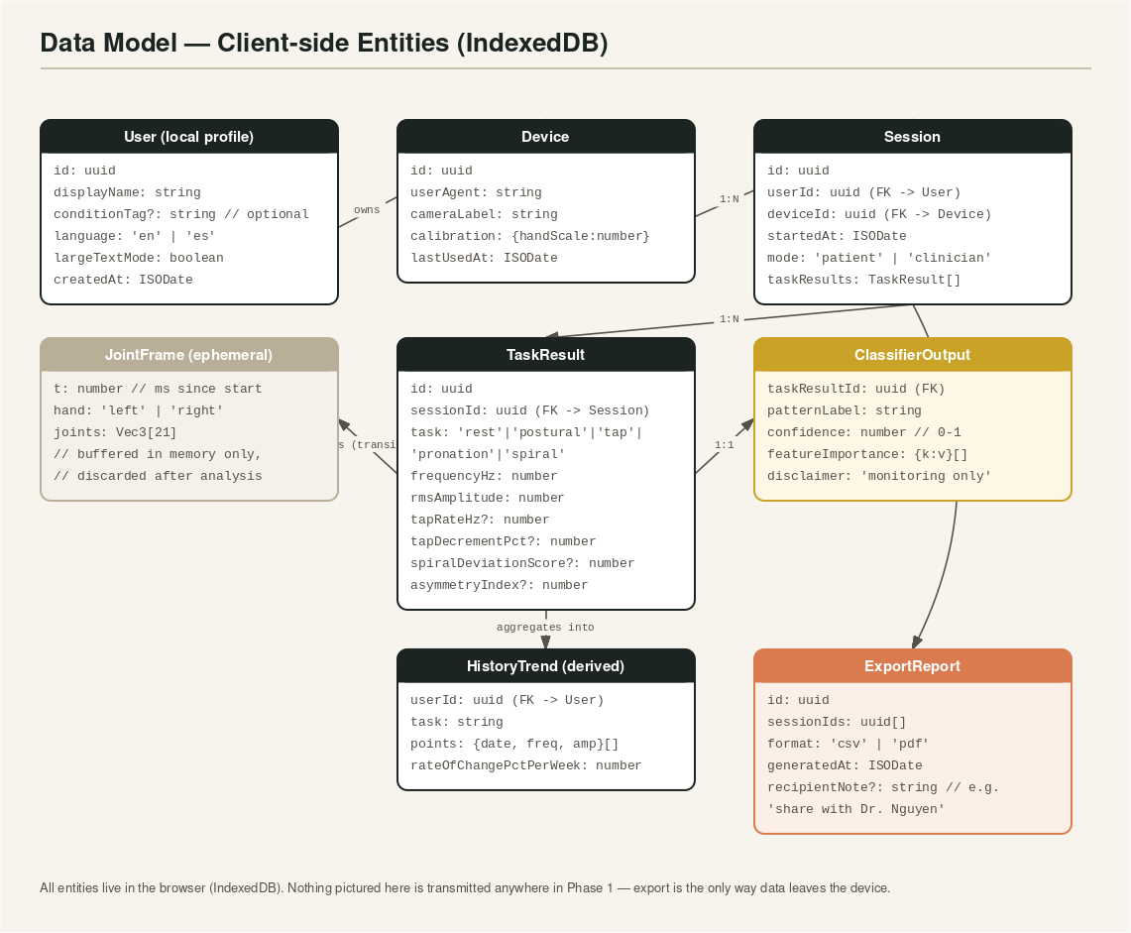
Data model — every entity that exists anywhere in the Phase 1 product, and how they relate.

8.1 Field-level detail: TaskResult (the core record)
Field | Type | Description
id | uuid | Primary key.
sessionId | uuid (FK) | Parent Session this task belongs to.
task | enum | 'rest' | 'postural' | 'tap' | 'pronation' | 'spiral'.
frequencyHz | number | Dominant oscillation frequency from analyzeTremor(), 0 if not applicable to the task.
rmsAmplitude | number | Detrended RMS amplitude, normalized by calibrated hand scale.
tapRateHz | number | null | Only populated for the 'tap' task.
tapDecrementPct | number | null | Only populated for the 'tap' task; positive = amplitude shrank over the recording.
spiralDeviationScore | number | null | Only populated for the 'spiral' task; 0 = perfect trace, 1 = maximum observed deviation.
asymmetryIndex | number | null | Only populated when both hands were tracked during the task.
recordedAt | ISODate | Timestamp of the recording, used for trend ordering.

9. Functions & Modules Specification
This section is the literal API surface of the product: every function, its inputs, its outputs, and what it does. A developer (or an AI coding agent) can implement the product module-by-module directly from this table. fft.js entries marked “(built)” already exist and are unit-tested in the delivered starter code; the rest are the elevation work for this version.

9.1 signal.js — Signal Processing Module
Function | Signature | Description
fftInPlace | (re: Float64Array, im: Float64Array) => void | (built) Iterative radix-2 Cooley-Tukey FFT, in place. Length must be a power of 2.
analyzeTremor | (samples: number[], sampleRateHz: number, minHz=2, maxHz=15) => {frequency, magnitude, rmsAmplitude, spectrum} | (built) Detrends, applies a Hann window, runs FFT, returns the dominant frequency in-band plus RMS amplitude and the full spectrum for charting.
analyzeTapDecrement | (distanceSeries: number[], sampleRateHz: number) => {tapCount, tapRateHz, amplitudeDecrementPct} | (built) Detects taps via a closed/open threshold on thumb-index distance; compares first-half vs second-half tap amplitude.
resampleToUniformGrid | (samples: {t:number, value:number}[], targetHz: number) => number[] | NEW. Linear-interpolates irregularly-timestamped samples onto a uniform grid before any FFT is run, correcting for webcam frame-timing jitter.
analyzeSpiralDeviation | (userPath: {x,y,t}[], idealSpiral: {x,y}[]) => {meanDeviationPx, maxDeviationPx, loopCount, drawDurationMs, normalizedDeviationScore} | NEW. Computes point-to-nearest-curve distance from the user's drawn path to a reference Archimedes spiral, normalized 0-1 by spiral radius.
computeAsymmetryIndex | (leftMetric: number, rightMetric: number) => number | NEW. Returns |L-R| / ((L+R)/2), clamped to [0,1] — a standard normalized bilateral-asymmetry ratio.

9.2 capture.js — Camera & Hand-Tracking Module
Function | Signature | Description
initHandLandmarker | (opts: {numHands: 1|2, delegate: 'GPU'|'CPU'}) => Promise<HandLandmarker> | Loads the MediaPipe WASM runtime and the hand_landmarker.task model from the CDN, caches it after first load.
startCameraStream | (constraints: MediaStreamConstraints) => Promise<MediaStream> | Wraps getUserMedia with friendly error classification (denied / not-found / in-use-by-other-app).
detectFrame | (landmarker, videoEl, timestampMs) => HandLandmarkerResult | Thin wrapper around landmarker.detectForVideo(); called once per animation frame.
calibrateHandScale | (frames: JointFrame[]) => number | Median wrist-to-middle-MCP distance across the calibration window; used to normalize every later distance-based feature so results are comparable regardless of how close the user sits to the camera.

9.3 classifier.js — On-device ML Module
Function | Signature | Description
extractFeatureVector | (result: TaskResult) => number[] | Produces a fixed-order numeric vector [frequency, rmsAmplitude, tapRateHz, tapDecrementPct, spiralDeviationScore, asymmetryIndex], zero-filling any features not applicable to the current task, plus a presence mask so the model knows which entries are real.
loadClassifier | (modelUrl: string) => Promise<tf.LayersModel> | Loads a small pre-trained TensorFlow.js model (trained offline — see §9.5) from a static, versioned CDN URL.
classifyPattern | (model, featureVector: number[]) => {patternLabel, confidence, featureImportance} | Runs inference and returns a descriptive-of-signal label (e.g. 'rest-dominant-4-6hz', 'within-normal-range') — never a disease name — plus a 0-1 confidence and a per-feature importance breakdown for explainability.

9.4 storage.js — Local Persistence & Export Module
Function | Signature | Description
saveSession | (session: Session) => Promise<void> | Writes a completed session (with its TaskResults) to IndexedDB.
getSessionHistory | (userId, task?, rangeDays?) => Promise<TaskResult[]> | Queries local history, optionally filtered by task type and date range.
computeHistoryTrend | (taskResults: TaskResult[]) => HistoryTrend | Fits a simple linear regression to frequency and amplitude over time; returns a rate-of-change-per-week figure used on the Trends screen.
exportCsv | (sessionIds: string[]) => Blob | Serializes selected sessions/results to a flat CSV for spreadsheet use.
exportPdfReport | (sessionIds: string[], recipientNote?: string) => Promise<Blob> | Renders a print-friendly, single-page-per-session summary (charts + table) to PDF entirely client-side.

9.5 render3d.js — 3D & Chart Rendering Module
Function | Signature | Description
createHandScene | (container: HTMLElement) => SceneRefs | Builds the Three.js scene, camera, renderer, 21 joint spheres, and connecting bone lines.
updateHandScene | (sceneRefs, frame: JointFrame) => void | Updates joint positions every frame and recolors each joint from calm-blue to hot-amber based on a rolling per-joint jitter window (see Design System §7 for the color-blind-safe ramp).
createTremorSignaturePlot | (container, pointsBuffer: Vec3[]) => SceneRefs | Renders the fingertip's (x,y,z) trajectory over a recording window as a glowing, slowly-rotating 3D phase-space curve — the visual centerpiece of the demo video.
renderSpectrumChart | (canvasEl, spectrum: {freq,mag}[]) => Chart | Chart.js bar chart of the post-recording frequency spectrum.
renderAmplitudeChart | (canvasEl, series: number[]) => Chart | Chart.js live line chart updated during recording.

9.6 Offline model training (not shipped in the browser bundle)
The classifier is trained offline, once, by the team — not in the browser at runtime. A Python script (train_classifier.py, documented separately from this PRD) pulls public tremor motion data (Sage Bionetworks' mPower Parkinson's mobile study dataset, or the PADS dataset), extracts the same six features listed in extractFeatureVector(), and trains a small logistic-regression or 2-layer neural network. The trained weights are exported via TensorFlow.js's converter and hosted as static files — only the small (~200 KB) weight file ships to users, never the training data or a training pipeline.

10. Screen-by-Screen Functional Specification

10.1 Landing / Marketing Page
Public, no-camera scroll-story page explaining what NeuraTrack is, who it's for, and why it's trustworthy. This is the page judges and first-time visitors see before ever touching a camera.
Entry points: Direct URL / shared link — no login required.
Inputs (user actions / data in) | Outputs (what renders / data out)
Scroll position; CTA click ("Try it now"). | Scroll-triggered section reveals; hero 3D tremor-signature loop (pre-recorded/simulated, not live camera); routes to Consent screen on CTA.
States: Loading (font/3D asset preload skeleton) → Loaded. No error state (fully static).

10.2 Consent & Disclaimer
A blocking screen that must be explicitly acknowledged before any camera access is requested. States clearly that NeuraTrack is a monitoring tool, not a diagnostic device.
Entry points: First app open only; re-shown if local storage was cleared.
Inputs (user actions / data in) | Outputs (what renders / data out)
Checkbox acknowledgment; "Continue" tap (disabled until checked). | Advances to Profile Setup. Nothing is stored until this screen is acknowledged.
States: Default (unchecked, Continue disabled) → Acknowledged (Continue enabled).

10.3 Profile Setup
Minimal local-only profile — no email or password, ever.
Entry points: After consent, first run only.
Inputs (user actions / data in) | Outputs (what renders / data out)
Display name (text); optional condition tag (select: essential tremor / Parkinson's / stroke recovery / other / prefer not to say); language (en/es). | Creates a local User record; advances to Camera Permission.
States: Empty → Filled (Continue enabled once display name is non-empty).

10.4 Camera Permission + Calibration
Requests camera access, then measures a hand-size calibration reference and checks lighting quality before any task is offered.
Entry points: After profile setup; also reachable from Settings ("Recalibrate").
Inputs (user actions / data in) | Outputs (what renders / data out)
Browser permission prompt response; hand held naturally in frame for ~2s. | Stores handScale calibration value on the Device record; live preview with a bounding guide overlay.
States: Requesting permission → Denied (recovery guidance + retry) → Granted, calibrating → Calibrated (auto-advance) → Poor lighting/no hand (inline tips, retry).

10.5 Task Selection / Home Dashboard
The hub screen after onboarding: pick a task, or jump to History/Trends. Returning users land here directly.
Entry points: Post-onboarding; default landing screen thereafter.
Inputs (user actions / data in) | Outputs (what renders / data out)
Task card tap (Rest / Postural / Tap / Pronation / Spiral); nav to History; nav to Settings. | Routes into the Task Capture Loop for the chosen task, or to the History/Trends screen.
States: Default → (if history exists) shows a small "last session" summary strip at top.

10.6 Task Capture (shared template, 5 variants)
The live-capture screen: guided pose overlay, countdown, 10-second recording with a real-time 3D skeleton and live amplitude chart, immediately followed by the computed result.
Entry points: From Task Selection.
Inputs (user actions / data in) | Outputs (what renders / data out)
Body/hand position matching the overlay guide; for the spiral task, a mouse/trackpad/touch-drawn path. | Real-time 3D skeleton + live chart during recording; on completion, frequency/amplitude/tap/spiral/asymmetry metrics, spectrum chart, and classifier pattern-match with confidence.
States: Instructions → Countdown → Recording (progress ring) → Analyzing (brief spinner, <1s) → Result. Error sub-states: hand lost mid-recording (pause + resume guidance), insufficient data (<8 frames, retry prompt).

10.7 Session Results
Post-task summary: the four headline metrics, the classifier's pattern-match card (with the required disclaimer), and next-action buttons.
Entry points: Immediately after a Task Capture completes.
Inputs (user actions / data in) | Outputs (what renders / data out)
"Save & continue" (implicit — auto-saved); "Run another task"; "View history"; "Export this session". | Persists a TaskResult to IndexedDB; renders the result summary.
States: Success (default). If save fails (e.g., storage quota), an inline retry-safe warning — the in-memory result is still viewable and exportable even if the local save failed.

10.8 History / Trends Dashboard
All past sessions for the active local profile, with per-task trend charts and a rate-of-change indicator.
Entry points: From the Home Dashboard or post-Results screen.
Inputs (user actions / data in) | Outputs (what renders / data out)
Task filter; date-range filter; row tap to expand a session's detail; "Export CSV" / "Export PDF report". | Trend line charts (frequency & amplitude over time per task); a sortable history table; downloadable CSV/PDF.
States: Empty (no sessions yet — shows a friendly prompt to run a first task) → Populated. Loading is effectively instant (local data).

10.9 Clinician Report / Export
A focused export flow for generating a print-friendly PDF summary to bring to or share with an actual clinician.
Entry points: From History/Trends ("Export PDF report") or Settings.
Inputs (user actions / data in) | Outputs (what renders / data out)
Session selection (checkboxes); optional recipient note (free text, e.g. "For Dr. Nguyen"). | Generates a client-side PDF (charts + table, no raw video/images) and triggers a browser download.
States: Selecting → Generating (progress) → Ready to download → Downloaded.

10.10 Settings & Accessibility
Profile edits, language, text size, camera recalibration, and data management (clear local history).
Entry points: From the persistent nav (all screens post-onboarding).
Inputs (user actions / data in) | Outputs (what renders / data out)
Toggle large-text mode; language switch; "Recalibrate camera"; "Clear all local data" (destructive, confirm dialog). | Applies immediately (no save button needed) except the destructive clear-data action, which requires explicit confirmation.
States: Default. Clear-data flow: Confirm dialog → Clearing → Cleared (returns to Consent screen, as if first run).

11. Non-Functional Requirements

11.1 Performance
Requirement | Target
Hand-tracking frame rate | ≥ 24 fps sustained on a mid-range 2020-era laptop webcam
Model load time (first visit) | < 4s on a broadband connection; cached (instant) on repeat visits via service worker
Task analysis latency (recording end → result shown) | < 1 second
Initial page load (landing page, no camera) | < 2.5s Largest Contentful Paint on a throttled 4G profile
Layout shift | CLS < 0.1 (reserve space for video/3D containers before they load)

11.2 Privacy & Security
- No video frame, image, or raw landmark buffer is ever transmitted off-device in Phase 1.
- No third-party analytics/tracking scripts. If usage analytics are ever added, they must be aggregate-only, opt-in, and documented.
- Local data is clearable in one action from Settings, with a confirmation step.
- All disclaimers ("monitoring, not diagnosis") are non-dismissible on first view and persistently visible on every results screen.

11.3 Accessibility (WCAG 2.1 AA target)
- Color contrast ≥ 4.5:1 for body text, ≥ 3:1 for large text and UI icons (see Design System doc for verified token pairs).
- The tremor heatmap never relies on color alone — amplitude is also shown numerically and via line thickness.
- All interactive controls ≥ 44×44px touch target, full keyboard operability, visible focus rings.
- prefers-reduced-motion is respected: 3D auto-rotation and scroll parallax are disabled, and chart entrance animation is skipped, when set.
- Large-text mode scales all UI type up one full step without breaking layout or truncating data.
- English and Spanish UI strings ship at launch; the string table is structured for adding more languages later.

11.4 Browser & Device Support
Platform | Support level | Notes
Chrome / Edge (desktop, current − 2 versions) | Fully supported | Primary target; GPU delegate for MediaPipe available.
Safari (desktop, current − 1 version) | Supported with fallback | Falls back to CPU delegate if WebGL/WASM SIMD constraints are hit; feature-detected at load.
Chrome (Android, current − 2 versions) | Fully supported | Validates the "$200 Chromebook / any phone" pitch.
Safari (iOS) | Supported, camera permission UX differs | getUserMedia requires a user gesture; handled by the existing permission-request screen.
Internet Explorer / legacy Edge | Not supported | Explicit "unsupported browser" message with upgrade guidance, rather than a silent failure.

11.5 Offline Support
The app shell, fonts, and ML/vision models are cached by a service worker after first load, so a returning user can open the app and run tasks with no network connection at all. History, export, and all analysis work offline; only the very first visit requires connectivity.

12. Analytics & Telemetry
Phase 1 ships with no analytics by default, consistent with the privacy pillar in §1.1. If the team later wants aggregate, privacy-respecting usage insight (e.g., "which task is most used"), it must be: opt-in via a clearly labeled Settings toggle, aggregate-only (no raw session data, no identifiers), and disclosed in the Consent screen copy before being enabled.

13. Testing & QA Plan

13.1 Unit tests (already in the delivered starter code)
fft.js is unit-tested in test-fft.mjs against a synthetic 5 Hz sine wave, a simulated Parkinsonian-style rest-tremor signal, a still-hand near-zero-amplitude case, and a simulated finger-tap sequence with a known amplitude decrement. Run with:
node test-fft.mjs
New modules (resampleToUniformGrid, analyzeSpiralDeviation, computeAsymmetryIndex, extractFeatureVector) should follow the same pattern: synthetic input with a known correct answer, asserted in a plain Node script with zero dependencies.

13.2 Cross-browser manual QA matrix
Every task × every browser in §11.4's support table, checked for: camera permission flow, tracking stability, 3D rendering, and export functionality.

13.3 Accessibility audit
Run an automated pass (axe or Lighthouse) plus a manual pass against the Pre-Delivery Checklist in the design system documentation (keyboard-only navigation, screen reader labels, reduced-motion, color contrast independently verified in both the light default theme and large-text mode).

13.4 Real-user pilot testing
Per the project roadmap (§14), weeks 8-9 include a small real-world pilot with 2-3 people at a Howard County senior center, PT clinic, or home-health agency. Feedback from this pilot is the single highest-value QA input the team can gather, and should start being scheduled in week 1-2, not week 8.

14. Risks & Mitigations
Risk | Mitigation
Poor lighting or camera angle produces noisy, misleading readings. | Mandatory calibration step with a live lighting-quality check; guided pose overlays; retry-friendly UX.
MediaPipe/TensorFlow.js model load is slow on first visit, especially on slow connections. | Skeleton loading state with clear progress messaging; service-worker caching so it only happens once per device.
Users or judges over-trust the ML classifier as diagnostic. | Non-dismissible disclaimer on every result screen; descriptive-of-signal labels only, never disease names; visible confidence score.
Safari's stricter WASM/WebGL behavior breaks tracking for some users. | Feature detection at load with automatic CPU-delegate fallback and a clear "reduced performance mode" notice.
A 10-second hold is hard for some users with more severe tremor or mobility limits. | Visible countdown and progress ring; ability to abort and retry with zero penalty; no minimum-quality gate blocks completion.
Spiral-drawing task is inaccessible to a mouse/trackpad-limited user with significant tremor. | Generous path tolerance in scoring; touch and stylus input supported; task is optional (P1), never required to use the rest of the app.
Local-only storage means a cleared browser or new device loses history. | CSV/PDF export is promoted proactively after every few sessions, not just buried in Settings; Phase 2's opt-in cloud sync directly addresses this for users who want it.

15. Roadmap (2 people, ~10 weeks)
Weeks | Milestone | Key deliverables
1 | Foundations | React+Vite shell; MediaPipe pipeline validated; landing page skeleton with scroll reveals.
2 | First real measurement | resampleToUniformGrid + analyzeTremor wired to a live joint stream; live amplitude chart.
3-4 | Full task battery | All 5 tasks implemented; guided overlays; per-task feature extraction; bilateral tracking + asymmetry index.
5 | 3D visualization | Three.js hand skeleton + heatmap; 3D tremor-signature phase-space plot.
6 | On-device ML | Offline training script against public tremor datasets; TF.js classifier integrated with confidence + feature importance.
7 | History & export | IndexedDB storage layer; trends dashboard; CSV/PDF export.
8 | Pilot + accessibility | Real-user pilot feedback (Howard County); large-text mode, color-blind-safe palette, ES localization.
9 | Polish & hardening | Cross-browser QA matrix; error-state coverage; performance pass against §11.1 targets.
10 | Submission package | Demo video; written submission; final accessibility + privacy verification pass.

16. Glossary & Clinical References
Terms below are used the way the general movement-disorder literature uses them, for context only — NeuraTrack does not apply clinical diagnostic thresholds, and all figures are general, literature-informed ranges rather than fixed diagnostic cutoffs.
Term | Meaning as used in this product
MDS-UPDRS Part III | The Movement Disorder Society's Unified Parkinson's Disease Rating Scale, motor examination section — the standard clinical exam this product's task battery is modeled on.
Rest tremor | Involuntary oscillation present when the limb is fully supported and relaxed; commonly discussed in the literature in a ~4-6 Hz range for Parkinsonian rest tremor.
Postural / kinetic tremor | Tremor that appears when a limb is held against gravity or during voluntary movement; commonly discussed in a wider ~4-12 Hz range, associated with essential tremor.
Bradykinesia | Slowness and amplitude decay of repetitive movement; the finger-tapping task's amplitude-decrement metric is inspired by this clinical sign.
Asymmetry index | A normalized left-right difference metric; unilateral onset/asymmetry is a commonly discussed early feature of Parkinsonian syndromes in the literature.
FFT / Hann window | Fast Fourier Transform with a Hann taper applied before transforming, standard signal-processing practice to reduce spectral leakage from a finite recording window.
On-device ML | Machine-learning inference that runs entirely on the user's device (via TensorFlow.js), with no data sent to a server.
PWA | Progressive Web App — a website that can be installed and used offline like a native app.

End of PRD. See the companion Design System document for the complete visual language, and the neuratrack-starter/ code for the working, unit-tested reference implementation of the signal-processing core.

