Achal Gupta A00258772

Tom Westman A00222128

Oriyomi Waya A00267265

Comparison of Analytical Tools

2018

Table of Contents

Introduction 2

Critical Capabilities for Business Intelligence and Analytics Platforms. 2

Infrastructure 2

Data Management 2

Analysis and Content Creation 2

Ease of Use, Visual Appeal and Workflow Integration. 2

Comparison Study 3

PowerBI 3

Oracle BI 4

SAS 5

IBM Cognos 6

Tableau 7

SAP 8

Return on Investments (ROI) 9

Scenario Introduction: 10

Large Enterprise: 10

Will look for a matured stable product or a market leader instead of niche and open source tools. 10

Inexperienced Analysts 10

Low Volume Data 11

Mostly Standard Daily Reporting 11

Conclusion 12

References 13

# Introduction

Improvements in technology can act as a catalyst for a company to redefine their business models, enabling new entrants to move into the market. Organizations in many industries must transform themselves into digital enterprises to survive and thrive. Point solutions don’t provide the same capabilities or industry and process expertise needed for digital transformation, and they can only manage a small amount of the overall data within the company. They are ineffective at increasing value throughout the organization and lead to more lost data which inhibits innovation. Individuals inside and outside of the organization require access to the relevant information – from the CEO to the lowest level staff. The correct choice of Business Intelligence software enables the business to deliver information throughout the organization to wherever it is needed and to whomever requires it, instead of information only being transferred to specific processes, people, or applications.

(SAP SE, 2016)

The statistics/ charts in the report below uses the data from the Grid® Report for Business Intelligence Platforms | Spring 2018 conducted by G2 Crowd.

# Critical Capabilities for Business Intelligence and Analytics Platforms.

## Infrastructure

* BI Platform Administration, Security and Architecture.
* Data Source Connectivity and Ingestion
* Virtual Infrastructure which is easy to execute and manage

## Data Management

* Metadata *Management*.
* *Self-Contained Extraction, Transformation and Loading (ETL) and Data Storage.*
* Self-Service Data Preparation. "Drag and drop" user-driven data combination of different sources, and the creation of analytic models such as user-defined measures, sets, groups and hierarchies

## **Analysis and Content Creation**

* Interactive Visual Exploration. Enables the exploration of data via an array of visualization options that go beyond those of basic pie, bar and line charts to include heat and tree maps, geographic maps, scatter plots
* Analytic Dashboards. The ability to create highly interactive dashboards and content with visual exploration and embedded advanced and geospatial analytics to be consumed by others.

## Ease of Use, Visual Appeal and Workflow Integration.

Ease of use to administer and deploy the platform, create content, consume and interact with content, as well as the degree to which the product is visually appealing. This capability also considers the degree to which capabilities are offered in a single, seamless product and workflow, or across multiple products with little integration.

(Cindi Howson, 2018)

# Comparison Study

## PowerBI

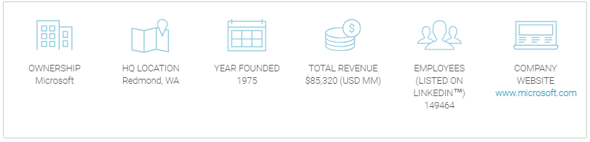

(Grid® Report for Business Intelligence Platforms | Spring 2018, 2018)

Power BI is a suite of business analytics tools that deliver insights throughout your organization. Connect to hundreds of data sources, simplify data prep, and drive ad hoc analysis. Produce beautiful reports, then publish them for your organization to consume on the web and across mobile devices. Everyone can create personalized dashboards with a unique, 360-degree view of their business. And scale across the enterprise, with governance and security built-in. (PowerBI, 2018).

Power BI license starts as low as $9.99 per user per month, which makes it one of the cheapest solution available in the market. Microsoft Power BI is one of the leader in the Gartner’s quadrant with continued strong uptake of PowerBI and high adoption rate and customer interest.

Strengths:

* Low Price – 12% customer says, this was the major factor
* Ease of use and visual appeal – 14% quoted tis as a main factor
* Product Vision – Virtual reality integration in progress
* Customer Experience- strong community, low price, cloud deployment

Weakness:

* Focus on Mode 2 Analytics - agility, speed and self service
* Breadth of use – 59% customers uses PowerBI only for reports and dashboards and not for any complex tasks
* Multiple products- Microsoft Flow, SSRS, Microsoft Teams etc.
* Sales experience – No dedicated analytics and BI salesforce.

(Cindi Howson, 2018)

(Grid® Report for Business Intelligence Platforms | Spring 2018, 2018)

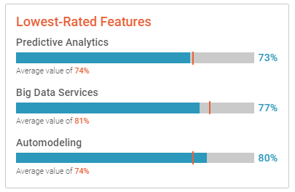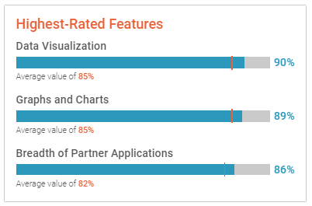

## Oracle BI

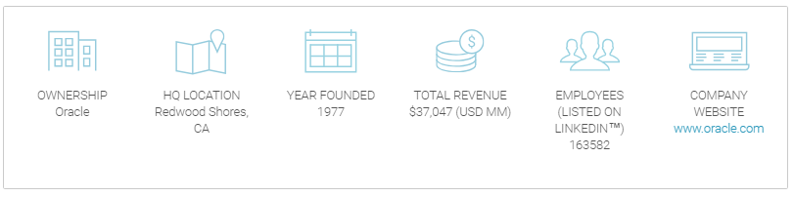

(Grid® Report for Business Intelligence Platforms | Spring 2018, 2018)

Oracle Business Intelligence is the foundation of Oracle’s complete analytics solution, available on-premises and in the Cloud for seamless analysis in any environment. It offers integrated data preparation, data discovery (with advanced exploration) and interactive dashboards via a single design tool supporting both desktop and web-based authoring.

Oracle BI Cloud Services will start at $150 per user per month, Oracle BI has a huge maintenance cost attached to it including cost for software updates and customization of product with additional services.

Strengths:

* Broad use case support optimized for oracle environments
* Flexible, global and hybrid cloud offerings
* Interactive exploration, dashboards, mobile and augmented analytics
* **Product vision**

Weakness

* **Sales experience**
* **Customer experience and operations**
* **Oracle-centric appeal**
* **Product gaps**

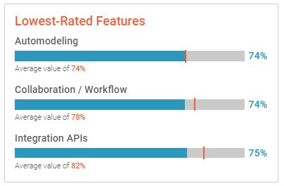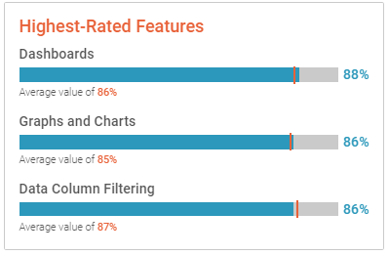

## SAS

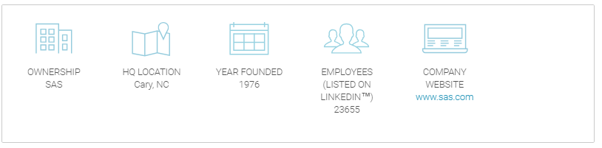

**SAS** is a command driven software package used for statistical analysis and data visualization. It is primarily used by companies to carry out jobs involving large data and to generate models used to gain insights and for problem solving. Principally designed for those whose work involves statistics, it is arguably one of the most widely used statistical software packages within industry or academia. Appropriate for SMB or large organizations in all industries.

**Strengths**: Learning SAS language has huge job market potential, it is easy to learn, easy to debug and it the ability to handle large databases. The software offers strong data analysis abilities, flexible 4 Generation Programming Language (4GL) and SAS Studio. It provides data formatting support, up-to-date data encryption algorithms and provide management for key features. Other strengths include:

* Provides a wide range of advanced statistical methods and algorithms
* Analyzes options and output options are very customizable
* The quality of graphics with ODS (Output Delivery System) is publication ready
* Provides spontaneous customer service

**Weaknesses:**

* It is a paid software, the starting price is $8,000.00 and initial set –up for a medium organization could run up to millions of dollars.
* It is quite expensive and being a closed environment, you cannot gain access without a license
* It is not open source, so their algorithms are not made public
* It is difficult to do text mining which involves extracting information from text for decision making
* It is more difficult to use especially compared to tools like RStudio, it has more procedures and lines of code.

(Flair, 2018)

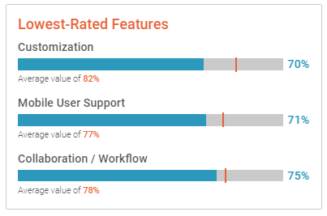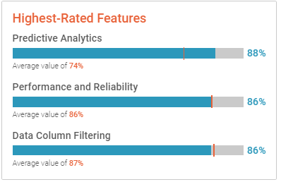

## IBM Cognos

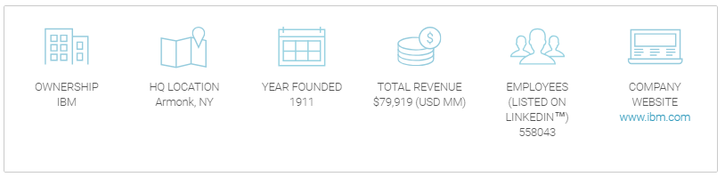

**IBM Cognos:** Is an integrated business intelligence suite which offers a wide range of functionality to help you understand your company’s data. Which include viewing and creating reports, analyzing data, monitoring events and metrics to help make effective business decision.

Workgroup for 25 users or less starts at $1,990 per month. Standard pricing can support companies of all sizes starts at $10,000 per month. Large enterprise, which can support 150 plus users, starts at $19,950 a month

**Strengths:**

* It offers a simple intuitive web-based environment
* Smart self-service and dash-boarding allows for improved data visualization which enables users to drag and drop onto the screen on mobile device or desktop
* Simple interface allows users to create ad-hoc pixel perfect reports
* Ensures data protection with layers of permissions, authorizations and history
* In addition, the mobile app allows users to access reports on the go without rewriting. It comes with cloud services which offers lower IT infrastructure costs. They offer internet-based modelling and search capabilities. It is appropriate for small companies.

**Weaknesses:**

* They do not offer business support
* There are issues with IBM handling the required data volumes of their users.
* It is difficult to use especially for those who have no prior experience
* Reports can take too long to generate
* Cognos files can be too large and can clog your system

(VIKAS_MANORIA, 2012)

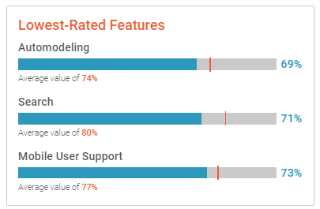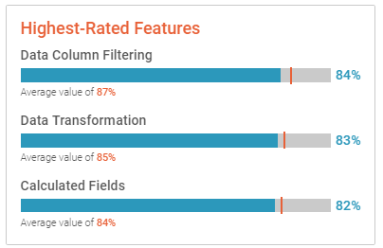

## Tableau

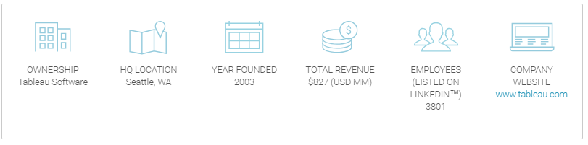

Tableau helps people transform data into actionable insights. Explore with limitless visual analytics. Build dashboards and perform ad hoc analyses in just a few clicks. Share your work with anyone and make an impact on your business. From global enterprises to early-stage start-ups and small businesses, people everywhere use Tableau to see and understand their data.

Tableau Server On-premise/Public cloud license starts around $35 per user per month and a fully hosted option can cost up to $42 per user per month which makes it bit high on costs as compared to tools like PowerBI but the customer satisfaction offered by tableau is unmatched.

Strengths:

* **"Gold standard" for interactive visual exploration**
* **Focus on customer experience and success**
* **Expanding deployments and standardization rates**
* **Flexible deployment options**

Weakness:

* **Market mainstreaming**
* **Pricing and packaging**
* **Lack of complex data model support**
* **Product vision**

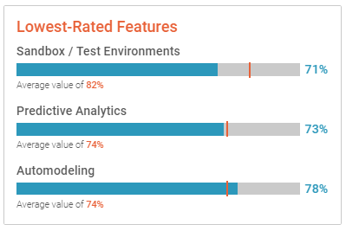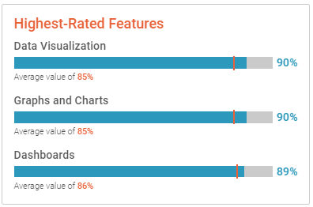

## SAP

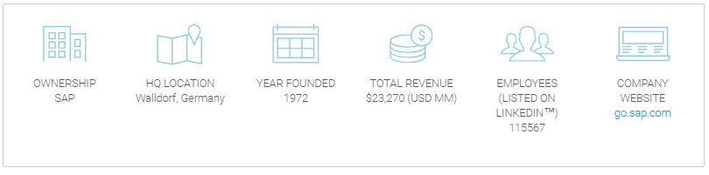

SAP Business Objects (BO or BOBJ) is an enterprise software company, specializing in business intelligence (BI, with components that provide performance management, planning, reporting, query and analysis, and enterprise information management. Business Objects also offers consulting and education services to help customers deploy its business intelligence projects. Other toolsets enable universes (the Business Objects name for a semantic layer between the physical data store and the front-end reporting tool) and ready-written reports to be stored centrally and made selectively available to communities of the users.

Business Objects Enterprise version for large enterprises starts from $55000 per annum, cloud license for BO starts from $21 per month per user.

Strengths:

* **Closed loop functionality and innovation**
* **Pre-packaged analytic content- It includes data models, data stories including visualization, template SAP Digital Boardroom agendas, and advise and recommendations on using data sources such as S/4HANA, SAP BW, Marketing (SAP Hybris Marketing or SAP Hybris Marketing Cloud), SAP Success Factors or SAP Hybris Cloud for Customer**
* **Broad spectrum offering**
* **Cloud-centred, hybrid vision**

Weakness:

* **Functional limitations**
* **Product quality and performance**
* **Interoperability**
* **Customer support**

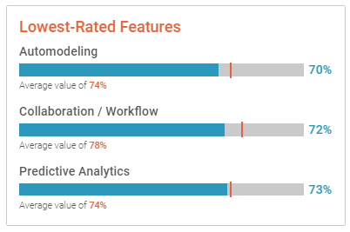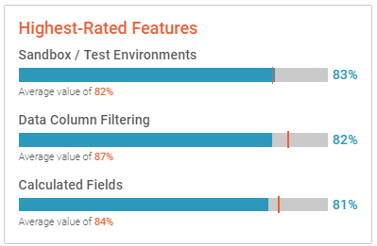

# Return on Investments (ROI)

ROI is often termed as one of the critical factor which determines a success or failure of a business decision. Below graph highlights the payback period in months for various BI tools.

We see that Power BI leads this segment followed by Tableau. The low license cost is major contributing factor towards the same. PowerBI focuses on Ad hoc reporting, fast and agile delivery method and thus is a good match for projects who are not fixed on requirements and are still experimenting with reports and insights.

Tableau with high customer satisfaction, top industry line features and ease of use is not far behind in terms of ROI and can be considered as a better alternative for Large organizations with inexperienced analysts who require daily standards reports.

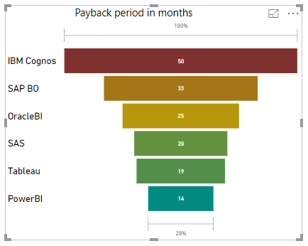

# Scenario Introduction:

Below are various factors which correlates with the given scenario of the Large Enterprise with Inexperienced Analysts and low volume of data requiring daily standard reporting, and also mentioned the corresponding features of Tableau which makes it a perfect fit for the organization.

## Large Enterprise:

### Will look for a matured stable product or a market leader instead of niche and open source tools.

* Tableau is the market leader with very high customer satisfaction rate and hence the obvious choice for the organisation
* Scalability is very important for large enterprise and Tableau is able to function well even when everybody within the organization uses it at the same time
* Tableau provides virtual infrastructure which is easy to execute and maintain
* Tableau also offers server on Linux which is attractive in large enterprises

#### High quality product.

* Tableau's core product strengths continue to be its intuitive interactive visualization and exploration, and analytic dashboarding capabilities, for almost any data source — leveraging its extensive set of data connectors, with both in-memory and direct query access for larger datasets. This combination, which includes drag-and-drop advanced functions such as forecasting, clustering, automated geocoding and assisted formula editing, allows users to do deep exploration and manipulation of their data more easily and quickly than with most competing platforms.

#### Comparatively High Budget

* Tableau is a perfect fit as company is equipped to handle comparatively higher software license cost of tableau and will also be benefited by the Tableau’s special large deals discounts

#### Secure product

* Tableau provide best in class features for Authentication, Authorization, Data and Network Security.

## Inexperienced Analysts

#### Product must be easy to use, setup, administrate.

* Tableau reports can be simply created by drag and drop, it offers data connectors to almost all kind of data sources, high flexibility over deployment to cloud platforms such as AWS, Azure, Google Cloud etc. One major feature of tableau is the availability of Automatic updates thus inexperienced analytics don’t need to worry about regular software updates.

#### Dedicated customer support i.e. high quality of support.

* Tableau is the market leader in customer satisfaction, with 94% of reference customers scoring it as "excellent."

#### High availability of learning opportunities.

* Tableau offers both free and paid resources for learning Tableau starting right from the basics to advanced concepts. Thus, one has a very easy access to high quality learning resources

#### Well setup online community.

* Tableau has a very mature online community which helps both product and users grow in harmony. Its well-attended annual user conference, which topped 14,000 attendees in 2017, is further evidence of user satisfaction and customer success

## Low Volume Data

#### Low volume of data and hence no major requirement constraints are required.

* Tableau offers data support from spreadsheets to Hadoop to cloud services.

## Mostly Standard Daily Reporting

#### Product should focus more on Mode 1 Analytics capabilities rather than Mode 2 i.e. Adhoc reports.

* Tableau provides high flexibility on deployment servers and hence an availability of highly stable environment. Also, organisation can benefit from any existing cloud services and can just integrate Tableau reports on current cloud environment.

(AJENSTAT, 2018)

# Conclusion

We believe that Ease of use, Setup, administration and doing business with will be a major factor for such a scenario, the comparison below compares various related important factors and gives an overall Average score. Tableau can be seen as the clear winner from the comparison with an average score of 84.

# References

AJENSTAT, F. (2018, February 27). *Tableau named a leader in the Gartner Magic Quadrant for six years in a row*. Retrieved from Tableau.com: https://www.tableau.com/about/blog/2018/2/tableau-named-leader-gartner-magic-quadrant-six-years-row-82534

Cindi Howson, R. S. (2018, February 26). *Magic Quadrant for Analytics and Business Intelligence Platforms*. Retrieved from gartner.com: https://www.gartner.com/doc/reprints?id=1-3TXXSLV&ct=170221&st=sb

Flair, D. (2018, Mar 16). *What is SAS Programming – SAS Features*. Retrieved from data-flair.training: https://data-flair.training/blogs/sas-features/

*Grid® Report for Business Intelligence Platforms | Spring 2018*. (2018). Retrieved from G2crowd.com: https://www.g2crowd.com/gated_content/tokens/ddd9a631-de18-4c35-92e5-eb4e4f5eea34

*PowerBI*. (2018). Retrieved from Microsoft.com: https://powerbi.microsoft.com/en-us/

SAP SE. (2016). *SAP BusinessObjects Analytics*. Retrieved from SAP.com: https://www.sap.com/uk/products/bi-platform.html?campaigncode=CRM-GB18-PPC-GGB_LA1FC1&source=ppc-UK-google-it-anabo-brand-standard&gclid=CKC9rZPYl94CFZeMhQodtYAGMg&gclsrc=ds#pdf-asset=e65abd4e-777c-0010-82c7-eda71af511fa&page=12

VIKAS_MANORIA. (2012, May 3). *IBM Business Intelligence Software & Its Capabilities*. Retrieved from www.ibm.com: https://www.ibm.com/developerworks/community/blogs/ibm-bi-