Private Swimming Lesson
Relational Databases Oracle SQL Project
Achal Gupta
A00258772

Table of Contents
1. Introduction 1
2. Original Data 1
3. ERD – Entity Relationship Diagram 4
4. Extended ERD with table and column names 4
5. Create Table Statements 4
6. Adding Constraints 5
7. Insert Statements 7
8. Tables 11
9. Single Table Queries 13
10. Joins 13
11. Summary Queries 14
12. Updates, Inserts, Deletes 15
13. Uions/Intersect 15
14. Creating Views 15
15. Creating Stored Procedures 16
16. Function – Use to Calculate Age 16
17. M Statemnt 16
18. Transaction Processing 16
19. Security 16
20. System Catalogs 16
21. Alter tables/constraints DDL 16
22. Real World Scenarios 16

Introduction
A database is required by the National Swimming Authority (NSA) to hold information on swimmers who need one to one private swimming lessons. The aim of the project is to create a central database for NSA which will store information about the instructors, the swimmers, the lessons that are organised, the pool used, and the college where the instructor learned to teach swimming. The database also stores information of Swimming schools where instructor has signed up for lessons.
Relationships between various tables and constraints on various columns will be implemented in the database. And finally an ERD diagram will be prepared to visualize the blueprint of database.
Document attempts to cover following aspects of SQL commands

Data Manipulation – Insert, Updates, Deletes, Merge
Data Description – Create, Alter, Drop
Data Control – Grant, Revoke

Various SELECT queries are explored in the document to gather meaningful insights from the database. Concepts of Joins, Sub queries, corelated queries, triggers. Stored procedures and functions etc. are explored in the document.

Original Data

Private_Swimming_Lessons PSL

3 | Gupta | Achal | Private_Swimming_Lessons |  | PSL | Msc DA 2018 | Ok

A database is required by the National Swimming Authority (NSA) to hold information on swimmers who need one to one private swimming lessons.The database called Private_Swimming_Lessons will store information about the instructors, the swimmers, the lessons that are organised, the pool used, and the college where the instructor learned to teach swimming (as well as lifesaving and other areas relevant to a sporting and healthy lifestyle). In the majority of cases, the instructor will have signed up with a Swim School (a private company that promotes/publicises the work of swimming instructors), so the database also stores information about the swimming school for to which the instructor is attached.

The following details have been captured after some preliminary discussions between the key users and a team of systems analysts and database designers:
An instructor may provide many lessons and a lesson is delivered by a single instructor
A swimmer participates in many lessons and a lesson is provided to a single swimmer
A pool hosts many lessons and a lesson takes place in a single pool
A college educates many instructors and an instructor attends a single college
A swimming school provides many instructors and an instructor signs up with a single swimming school.

Instructor (Instructor_ID, FName, Sname, Address, Town, County, Specialism (Front Crawl, Backstroke, Breaststroke, Butterfly), Date_Of_Birth, Gender, Mobile_No, Reputation (Fair, Good, Excellent), Qualifications (Level 1, Level 2, Level 3), College_Id, Swimming_School_Id)

Swimmer (Swimmer_Id, ForeName, Surname, Address, Town, County, Date_Of_Birth, Gender, Fav_Stroke (Front Crawl, Backstroke, Breaststroke, Butterfly), Commitment (Fair, Good, Excellent), Weakness (area that has scope for most improvement)
Pool (Pool_Id, Length (express in metres), Width (express in metres), Shallow_End_Depth, (express in metres), Deep_End_Depth, (express in metres), Water_Quality (Dirty, Clean), Pool_Type (Indoor, Outdoor), Yr_Running_Cost)
Lesson (Instructor_Id, Swimmer_Id, Pool_Id, Lesson_Date, Topic, Instructor_Fee, Topic (Breathing, Turning, Use of Feet, Arm Action), Start_Time, End_Time, Progress(Poor, Fair, Good, Excellent))
College (College_Id, Name, City, County, Specialism (Engineering, Business, Science, Sport), Yr_Established, Campus_Size (express in hectares)

Swimming_School (Swimming_School_Id, Name, City, County, Specialism (Children, Teenagers, Adults, Retired, Elite Swimmers), Yr_Established,Email, Web_Site)

*********************************************MODIFIED*************************************************

Private_Swimming_Lessons PSL

A database is required by the National Swimming Authority (NSA) to hold information on swimmers who need one to one private swimming lessons. The database called Private_Swimming_Lessons will store information about the instructors, the swimmers, the lessons that are organised, the pool used, and the college where the instructor learned to teach swimming (as well as lifesaving and other areas relevant to a sporting and healthy lifestyle). In the majority of cases, the instructor will have signed up with a Swim School (a private company that promotes/publicises the work of swimming instructors), so the database also stores information about the swimming school for to which the instructor is attached.

The following details have been captured after some preliminary discussions between the key users and a team of systems analysts and database designers:
An instructor may provide many lessons and a lesson is delivered by a single instructor
A swimmer participates in many lessons and a lesson is provided to a single swimmer
A pool hosts many lessons and a lesson takes place in a single pool
A college educates many instructors and an instructor attends a single college
A swimming school provides many instructors and an instructor signs up with a single swimming school.

College (College_Id, Name, City, County, Specialism, Yr_Established, Campus_Size)

Swimming_School (Swimming_School_Id, Name, City, County, Specialism, Yr_Established, Email, Web_Site)

Instructor (Instructor_ID, FName, Sname, Address, Town, County, Specialism, Date_Of_Birth, Gender, Mobile_No, Reputation, Qualifications, College_Id, Swimming_School_Id)

Swimmer (Swimmer_Id, ForeName, Surname, Address, Town, County, Date_Of_Birth, Gender, Fav_Stroke, Commitment, Weakness)

Pool (Pool_Id, Length, Width, Shallow_End_Depth, Deep_End_Depth, Water_Quality, Pool_Type, Yr_Running_Cost)

Lesson (Instructor_Id, Swimmer_Id, Pool_Id, Lesson_Date, Topic, Instructor_Fee, Topic, Start_Time, End_Time, Progress)

*********************************************PHASE 3*************************************************

College
College_Id
Name
City
County
Specialism
Yr_Established
Campus_Size

Swimming_School
Swimming_School_Id
Name
City
County
Specialism
Yr_Established
Email
Web_Site

Instructor
Instructor_Id
FName
Sname
Address
Town
County
Specialism
Date_Of_Birth
Gender
Mobile_No
Reputation
Qualifications
College_Id
Swimming_School_Id

Swimmer
Swimmer_Id
ForeName
Surname
Address
Town
County
Date_Of_Birth
Gender
Fav_Stroke
Commitment
Weakness

Pool
Pool_Id
Length
Width
Shallow_End_Depth
Deep_End_Depth
Water_Quality
Pool_Type
Yr_Running_Cost

Lesson
Instructor_Id
Swimmer_Id
Pool_Id
Lesson_Date
Topic
Instructor_Fee
Topic
Start_Time
End_Time
Progress

ERD – Entity Relationship Diagram
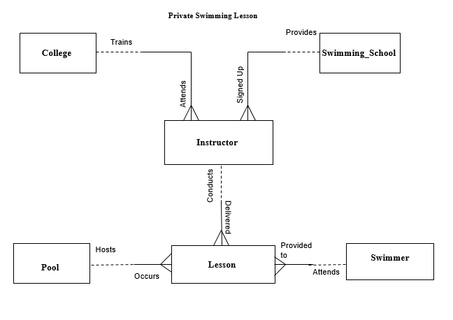

Extended ERD with table and column names

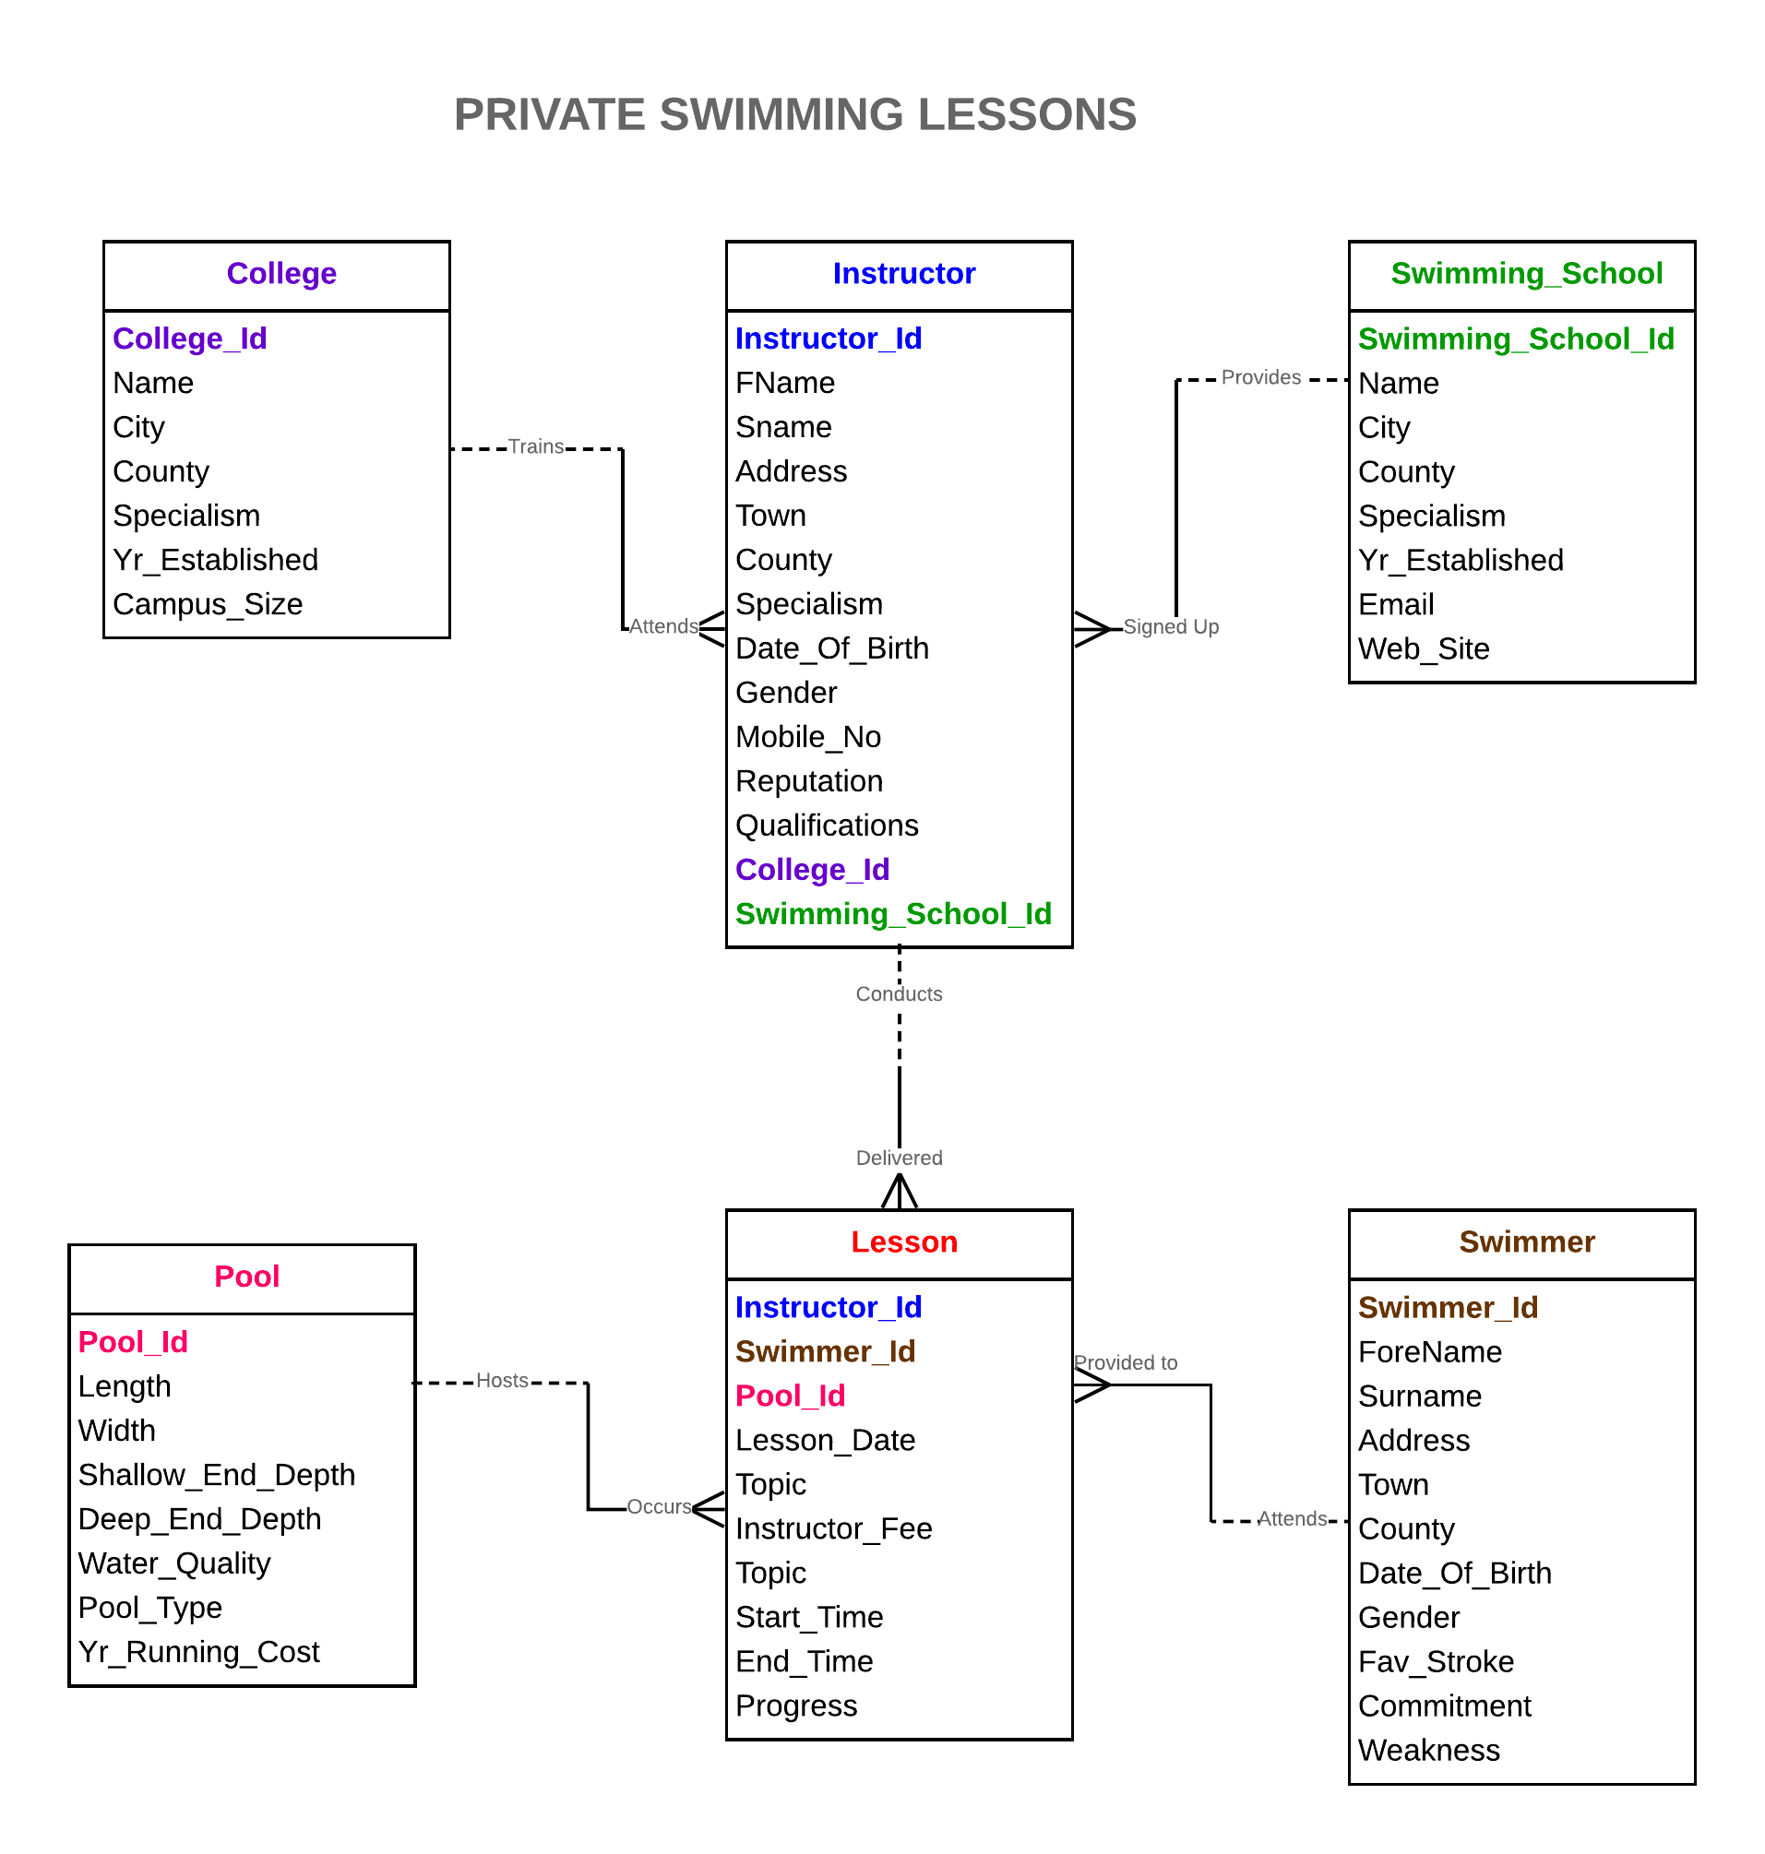

Create Table Statements

DROP TABLE Lesson;

DROP TABLE Pool;

DROP TABLE Swimmer;

DROP TABLE Instructor;

DROP TABLE Swimming_School;

DROP TABLE College;

DROP TABLE College;

CREATE TABLE College (
College_Id NUMBER(3, 0),
Name VARCHAR2(35),
City VARCHAR2(11),
County VARCHAR2(11),
Specialism VARCHAR2(13),
Yr_Established NUMBER(4, 0),
Campus_Size NUMBER(2, 0)
);

DROP TABLE Swimming_School;

CREATE TABLE Swimming_School (
Swimming_School_Id NUMBER(5, 0),
Name VARCHAR2(27),
City VARCHAR2(12),
County VARCHAR2(9),
Specialism VARCHAR2(14),
Yr_Established NUMBER(4, 0),
Email VARCHAR2(45),
Web_Site VARCHAR2(31)
);

DROP TABLE Instructor;

CREATE TABLE Instructor (
Instructor_Id NUMBER(4, 0),
FName VARCHAR2(7),
Sname VARCHAR2(8),
Address VARCHAR2(38),
Town VARCHAR2(27),
County VARCHAR2(10),
Specialism VARCHAR2(12),
Date_Of_Birth DATE,
Gender VARCHAR2(6),
Mobile_No VARCHAR2(10),
Reputation VARCHAR2(9),
Qualifications VARCHAR2(7),
College_Id NUMBER(3, 0),
Swimming_School_Id NUMBER(5, 0)
);

DROP TABLE Swimmer;

CREATE TABLE Swimmer (
Swimmer_Id NUMBER(4, 0),
ForeName VARCHAR2(7),
Surname VARCHAR2(9),
Address VARCHAR2(26),
Town VARCHAR2(12),
County VARCHAR2(10),
Date_Of_Birth DATE,
Gender VARCHAR2(6),
Fav_Stroke VARCHAR2(12),
Commitment VARCHAR2(9),
Weakness VARCHAR2(11)
);

DROP TABLE Pool;

CREATE TABLE Pool (
Pool_Id NUMBER(3, 0),
Length NUMBER(2, 0),
Width NUMBER(2, 0),
Shallow_End_Depth NUMBER(1, 0),
Deep_End_Depth NUMBER(1, 0),
Water_Quality VARCHAR2(5),
Pool_Type VARCHAR2(7),
Yr_Running_Cost NUMBER(5, 0)
);

DROP TABLE Lesson;

CREATE TABLE Lesson (
Instructor_Id NUMBER(4, 0),
Swimmer_Id NUMBER(4, 0),
Pool_Id NUMBER(3, 0),
Lesson_Date DATE,
Topic VARCHAR2(11),
Instructor_Fee NUMBER(5, 2),
Start_Time VARCHAR2(11),
End_Time VARCHAR2(11),
Progress VARCHAR2(9)
);

Adding Constraints

--Primary Keys(PK)
ALTER TABLE College ADD CONSTRAINT College_College_Id_PK PRIMARY KEY ( College_Id );

ALTER TABLE Swimming_School ADD CONSTRAINT SS_Swimming_School_Id_Pk PRIMARY KEY ( Swimming_School_Id );

ALTER TABLE Instructor ADD CONSTRAINT Instructor_Instructor_Id PRIMARY KEY ( Instructor_Id );

ALTER TABLE Swimmer ADD CONSTRAINT Swimmer_Swimmer_Id PRIMARY KEY ( Swimmer_Id );

ALTER TABLE Pool ADD CONSTRAINT Pool_Pool_Id_Pk PRIMARY KEY ( Pool_Id );

ALTER TABLE Lesson ADD CONSTRAINT Lesson_Ins_Swim_Pool_Id_Pk PRIMARY KEY ( Instructor_Id, Swimmer_Id, Pool_Id );

--Foreign Keys(FK)
ALTER TABLE Instructor ADD CONSTRAINT Instructor_College_Id_Fk FOREIGN KEY ( College_Id ) REFERENCES College ( College_Id );

ALTER TABLE Instructor ADD CONSTRAINT Ins_Swimming_School_Id_Fk FOREIGN KEY ( Swimming_School_Id ) REFERENCES Swimming_School ( Swimming_School_Id );

ALTER TABLE Lesson ADD CONSTRAINT Lesson_Instructor_Id_Fk FOREIGN KEY ( Instructor_Id ) REFERENCES Instructor ( Instructor_Id );

ALTER TABLE Lesson ADD CONSTRAINT Lesson_Swimmer_Id_Fk FOREIGN KEY ( Swimmer_Id ) REFERENCES Swimmer ( Swimmer_Id );

ALTER TABLE Lesson ADD CONSTRAINT Lesson_Pool_Id_Fk FOREIGN KEY ( Pool_Id ) REFERENCES Pool ( Pool_Id );

--Check Constraints(CK)
ALTER TABLE College ADD CONSTRAINT College_Specialism_Ck CHECK ( Specialism IN ('Engineering', 'Business', 'Science', 'Sport') );

ALTER TABLE Swimming_School ADD CONSTRAINT Swimming_School_Specialism_Ck CHECK ( Specialism IN ('Children', 'Teenagers', 'Adults', 'Retired', 'Elite Swimmers' ) );

ALTER TABLE Instructor ADD CONSTRAINT Instructor_Specialism_Ck CHECK ( Specialism IN ('Front Crawl', 'Backstroke', 'Breaststroke', 'Butterfly') );

ALTER TABLE Instructor ADD CONSTRAINT Instructor_Reputation_Ck CHECK ( Reputation IN ('Fair', 'Good', 'Excellent') );

ALTER TABLE Instructor ADD CONSTRAINT Instructor_Qualifications_Ck CHECK ( Qualifications IN ('Level 1', 'Level 2', 'Level 3') );

ALTER TABLE Swimmer ADD CONSTRAINT Swimmer_Fav_Stroke_Ck CHECK ( Fav_Stroke IN ('Front Crawl', 'Backstroke', 'Breaststroke', 'Butterfly') );

ALTER TABLE Swimmer ADD CONSTRAINT Swimmer_Commitment_Ck CHECK ( Commitment IN ('Fair', 'Good', 'Excellent') );

ALTER TABLE Pool ADD CONSTRAINT Pool_Water_Quality_Ck CHECK ( Water_Quality IN ('Dirty', 'Clean') );

ALTER TABLE Pool ADD CONSTRAINT Pool_Pool_Type_Ck CHECK ( Pool_Type IN ('Indoor', 'Outdoor') );

ALTER TABLE Lesson ADD CONSTRAINT Lesson_Progress_Ck CHECK ( Progress IN ('Poor', 'Fair', 'Good', 'Excellent') );

ALTER TABLE Lesson ADD CONSTRAINT Lesson_Topic_Ck CHECK ( Topic IN ('Breathing', 'Turning', 'Use of Feet', 'Arm Action') );

-- Unique Constraints (UQ)

ALTER TABLE Instructor ADD CONSTRAINT Instructor_Mobile_No_Uq UNIQUE ( Mobile_No );

-- Not Null Constraints (NN)

ALTER TABLE College MODIFY Name CONSTRAINT College_Name_Nn NOT NULL;

ALTER TABLE Swimming_School MODIFY Name CONSTRAINT Swimming_School_Name_Nn NOT NULL;

ALTER TABLE Instructor MODIFY Fname CONSTRAINT Instructor_Fname_Nn NOT NULL;

ALTER TABLE Instructor MODIFY Sname CONSTRAINT Instructor_Sname_Nn NOT NULL;

ALTER TABLE Swimmer MODIFY ForeName CONSTRAINT Swimmer_ForeName_Nn NOT NULL;

ALTER TABLE Swimmer MODIFY Surname CONSTRAINT Swimmer_Surname_Nn NOT NULL;

Insert Statements

/* Table Name:College */

/*College_Id,Name,City,County,Specialism,Yr_Established,Campus_Size */
Insert Into College Values (101,'Maynooth University','Maynooth','Maynooth','Sport',1658,7);
Insert Into College Values (102,'Athlone Institute of Technology','Athlone','Westmeath','Business',1762,8);
Insert Into College Values (103,'Carlow College','Carlow','Carlow','Science',1793,8);
Insert Into College Values (104,'Cork Institute of Technology','Bishopstown','Cork','Engineering',1757,20);
Insert Into College Values (105,'Dublin City University','Dublin','Dublin','Business',1748,16);
Insert Into College Values (106,'University of Limerick','Limerick','Limerick','Sport',1977,10);
Insert Into College Values (107,'University College Cork','Cork','Cork','Engineering',1729,9);
Insert Into College Values (108,'Letterkenny Institute of Technology','Letterkenny','Letterkenny','Science',1644,4);
Insert Into College Values (109,'Limerick Institute of Technology','Limerick','Limerick','Engineering',1601,24);
Insert Into College Values (110,'Waterford Institute of Technology','Waterford','Waterford','Engineering',1897,16);
commit;

/* Table Name:Swimming_School */

/*Swimming_School_Id,Name,City,County,Specialism,Yr_Established,Email,Web_Site */
Insert Into Swimming_School Values (1000,'Athlone RSC Water Polo Club','Athlone','Westmeath','Children',1945,'athlone.waterpolo@gmail.com','www.athlonerscwaterpoloclub.com');
Insert Into Swimming_School Values (2000,'3D Masters Swimming Club','Dublin','Dublin','Teenagers',1946,'3dtrimasters@gmail.com',NULL);
Insert Into Swimming_School Values (3000,'Aer Lingus Masters SC','Swords','Dublin','Adults',1947,'aerlingusmasters@gmail.com',NULL);
Insert Into Swimming_School Values (4000,'Ards Leisure Centre','Newtownards','Down','Retired',1948,'ardsswimmingclub@gmail.com','www.ardsswimmingclub.co.uk');
Insert Into Swimming_School Values (5000,'Asgard Masters SC','Arklow','Wicklow','Elite Swimmers',1949,NULL,NULL);
Insert Into Swimming_School Values (6000,'Limerick Masters SC','Limerick','Limerick','Children',1950,'turmack@eircom.net','www.limerickmasterssc.com');
Insert Into Swimming_School Values (7000,'Celtic Waves SC','Grove Island','Limerick','Teenagers',1951,'celticwavessc@gmail.com','www.celticwavessc.ie');
Insert Into Swimming_School Values (8000,'Waterford Crystal SC','Newtown','Waterford','Children',1952,'secretarywaterfordcrystalswimming@outlook.com','www.teamunify.com');
Insert Into Swimming_School Values (9000,'Irish SAC Swim Club','Dublin','Dublin','Teenagers',1953,NULL,NULL);
Insert Into Swimming_School Values (10000,'NAC Masters SC','City10','Country10','Adults',1954,'secretary@nacmasters.com','www.nacmasters.com');
commit;

/* Table Name:Instructor */

/*Instructor_Id,FName,Sname,Address,Town,County,Specialism,Date_Of_Birth,Gender,Mobile_No,Reputation,Qualifications,College_Id,Swimming_School_Id */
Insert Into Instructor Values (111,'Dessie','Dolan','4 Retreat Mews','Athlone','Westmeath','Front Crawl','18-Oct-1985','Female','899-850853','Excellent','Level 1',102,1000);
Insert Into Instructor Values (222,'Michael','Ennis','Main st Monasterevin','Crocknamurleog','Donegal','Backstroke','28-May-1987','Male','899-843805','Fair','Level 2',101,2000);
Insert Into Instructor Values (333,'Joe','Fallon','Brewery rd Stillorgan','Glencolumbkille','Donegal','Butterfly','18-Jul-1985','Female','899-856955','Excellent','Level 3',103,3000);
Insert Into Instructor Values (444,'Martin','Flanagan','12 Main St.','Ballyliffin','Donegal','Breaststroke','09-Sep-1990','Male','899-844431','Good','Level 1',104,4000);
Insert Into Instructor Values (555,'Derek','Heavin','Athboy Gate Trim','Ballymore','Westmeath','Backstroke','11-Aug-1985','Male','899-818243','Excellent','Level 1',101,5000);
Insert Into Instructor Values (666,'Ger','Heavin','Carrick rd','Falcarragh (or Cross Roads)','Donegal','Butterfly','09-Dec-1987','Female','899-819295','Good','Level 2',102,6000);
Insert Into Instructor Values (777,'Fergal','Wilson','Liscannor','Creeslough','Donegal','Breaststroke','11-Dec-1990','Female','899-819876','Fair','Level 3',103,1000);
Insert Into Instructor Values (888,'Aidan','Lennon','Abbey hse Abbey st','Freshford','Kilkenny','Backstroke','22-Mar-1989','Female','899-865829','Good','Level 2',104,2000);
Insert Into Instructor Values (999,'Niall','McCusker','101 South Main st','Glenties','Donegal','Butterfly','23-Jul-1980','Male','899-846591','Fair','Level 1',101,3000);
Insert Into Instructor Values (1110,'Paul','McFlynn','68 Lower Main st','Glassan','Westmeath','Front Crawl','02-Feb-1985','Male','899-866649','Excellent','Level 2',102,4000);
Insert Into Instructor Values (1221,'Kieran','McKeever','1 Annavilla Grove','Clonmany','Donegal','Breaststroke','05-Feb-1987','Female','899-844439','Excellent','Level 3',103,5000);
Insert Into Instructor Values (1332,'David','O Neill','Rose`s Street 56','Clogh-Chatsworth','Kilkenny','Butterfly','12-Feb-1992','Male','899-823333','Fair','Level 2',104,6000);
Insert Into Instructor Values (1443,'Paddy','Bradley','Doonbeg Kilrush','Castlepollard','Westmeath','Front Crawl','20-Oct-1983','Female','899-876327','Excellent','Level 1',105,1000);
Insert Into Instructor Values (1554,'Eamonn','Burns','33 Ballagh Bushy','Collinstown','Westmeath','Backstroke','02-Jun-1981','Male','899-815835','Good','Level 2',106,2000);
Insert Into Instructor Values (1665,'Joe','Cassidy','141 Lr Glanmire rd','Ballybofey-Stranorlar','Donegal','Breaststroke','17-Mar-1988','Male','899-837407','Excellent','Level 3',107,3000);
Insert Into Instructor Values (1776,'Dermot','Dougan','4 Dominic st','Carrick','Donegal','Front Crawl','29-Aug-1989','Female','899-878273','Good','Level 2',108,4000);
Insert Into Instructor Values (1887,'Seamus','Downey','Batterfield Firie','Culdaff','Donegal','Backstroke','18-Sep-1982','Male','899-817406','Fair','Level 3',105,5000);
Insert Into Instructor Values (1998,'Fergal','McCusker','6 Cillmhuire','Dunkineely','Donegal','Breaststroke','05-Sep-1983','Female','899-855356','Good','Level 1',106,6000);
Insert Into Instructor Values (2109,'Enda','Muldoon','Newgrove Business Park Ballinode Road ','Castlecomer-Donaguile','Kilkenny','Front Crawl','09-May-1987','Female','899-852557','Fair','Level 2',107,7000);
Insert Into Instructor Values (2220,'Benny','Murray','4 Church st','Callan','Kilkenny','Backstroke','29-Sep-1990','Male','899-835041','Excellent','Level 3',108,8000);
commit;

/* Table Name:Swimmer */

/*Swimmer_Id,ForeName,Surname,Address,Town,County,Date_Of_Birth,Gender,Fav_Stroke,Commitment,Weakness */
Insert Into Swimmer Values (4200,'Enda','Muldoon','4 Retreat Mews','Athlone','Westmeath','24-Aug-04','Female','Front Crawl','Fair','Breathing');
Insert Into Swimmer Values (3709,'Benny','Murray','3 Portroe','Castlefin',' Donegal','18-Apr-12','Male','Backstroke','Good','Turning');
Insert Into Swimmer Values (4416,'Eoin','McCloskey','2a Rossnakill','Delvin',' Westmeath','15-Mar-97','Male','Breaststroke','Excellent','Use of Feet');
Insert Into Swimmer Values (3959,'Damien','McCusker','27 Claddagh House','Ballyshannon',' Donegal','28-Sep-96','Male','Front Crawl','Fair','Arm Action');
Insert Into Swimmer Values (3955,'Dermot','Heaney','105 Main st','Greencastle',' Donegal','01-Apr-99','Male','Backstroke','Excellent','Breathing');
Insert Into Swimmer Values (4371,'Ronan','Rocks','Ballinacor Hse.','Brinlack',' Donegal','07-Aug-11','Female','Breaststroke','Good','Turning');
Insert Into Swimmer Values (4455,'Anthony','Tohill','2 Abbey st','Dunfanaghy',' Donegal','10-Feb-40','Male','Front Crawl','Excellent','Use of Feet');
Insert Into Swimmer Values (4324,'Aidan','Lyons','5 Market st ','Donegal',' Donegal','22-Aug-40','Female','Backstroke','Good','Arm Action');
Insert Into Swimmer Values (4454,'David','Mitchell','21 The Century Bar Main st','Gowran',' Kilkenny','23-Mar-94','Male','Butterfly','Fair','Breathing');
Insert Into Swimmer Values (4181,'Fergal','Murray','3 Eyre st','Johnstown',' Kilkenny','21-Feb-38','Female','Breaststroke','Good','Turning');
Insert Into Swimmer Values (4175,'Shane','Deering','4 Main Street','Bridge End',' Donegal','10-Aug-83','Female','Backstroke','Fair','Use of Feet');
Insert Into Swimmer Values (4224,'Dessie','Dolan','9 Killucan','Burtonport',' Donegal','30-Mar-85','Female','Butterfly','Excellent','Arm Action');
Insert Into Swimmer Values (3595,'Michael','Ennis','3 Summerfield Hse','Ballynacargy',' Westmeath','25-Mar-90','Male','Front Crawl','Excellent','Breathing');
Insert Into Swimmer Values (3973,'Joe','Fallon','2 Royal Lodge Rd.','Athlone','Westmeath','30-Apr-42','Male','Backstroke','Good','Turning');
Insert Into Swimmer Values (4349,'Derek','Heavin','91 Bridge st','Carrigans',' Donegal','26-Jan-88','Male','Butterfly','Excellent','Use of Feet');
Insert Into Swimmer Values (4489,'Ger','Heavin','12 Castle st','Convoy',' Donegal','13-Feb-59','Female','Breaststroke','Good','Arm Action');
Insert Into Swimmer Values (3587,'Fergal','Wilson','6 Cluain Ard','Goresbridge',' Kilkenny','21-Jun-93','Male','Backstroke','Fair','Breathing');
Insert Into Swimmer Values (4015,'Henry','Downey','4 Retreat Mews','Athlone','Westmeath','02-Sep-16','Male','Breaststroke','Good','Turning');
Insert Into Swimmer Values (3785,'Sean','Marty','46 Elm Court','Inistioge',' Kilkenny','10-Apr-10','Male','Backstroke','Fair','Use of Feet');
Insert Into Swimmer Values (4379,'Jean','McBride','45 Castle st','Athlone','Westmeath','16-Feb-36','Female','Butterfly','Good','Arm Action');
commit;

/* Table Name:Pool */

/*Pool_Id,Length,Width,Shallow_End_Depth,Deep_End_Depth,Water_Quality,Pool_Type,Yr_Running_Cost */
Insert Into Pool Values (601,46,22,1,5,'Clean','Indoor',12000);
Insert Into Pool Values (611,41,48,2,3,'Clean','Outdoor',25000);
Insert Into Pool Values (621,47,50,1,5,'Clean','Indoor',36000);
Insert Into Pool Values (631,47,45,2,5,'Clean','Outdoor',12000);
Insert Into Pool Values (641,48,49,2,5,'Clean','Indoor',9000);
Insert Into Pool Values (651,49,48,2,3,'Clean','Indoor',25000);
Insert Into Pool Values (661,43,41,2,4,'Clean','Outdoor',12000);
Insert Into Pool Values (671,49,47,2,4,'Clean','Indoor',19000);
Insert Into Pool Values (681,48,43,1,3,'Clean','Outdoor',17000);
Insert Into Pool Values (691,40,41,2,5,'Clean','Indoor',12000);
Insert Into Pool Values (701,48,46,2,5,'Clean','Outdoor',25000);
Insert Into Pool Values (711,42,44,2,5,'Clean','Indoor',21000);
Insert Into Pool Values (721,41,49,2,3,'Clean','Outdoor',12000);
Insert Into Pool Values (731,43,48,1,4,'Clean','Outdoor',43000);
Insert Into Pool Values (741,44,46,1,5,'Clean','Indoor',25000);
Insert Into Pool Values (751,46,46,1,4,'Clean','Outdoor',12000);
Insert Into Pool Values (761,41,45,1,4,'Clean','Indoor',33000);
Insert Into Pool Values (771,50,41,1,3,'Dirty','Outdoor',12000);
Insert Into Pool Values (781,46,42,1,3,'Dirty','Outdoor',12000);
Insert Into Pool Values (791,47,43,1,5,'Dirty','Indoor',12000);
commit;

/* Table Name:Lesson */

/* Instructor_Id,Swimmer_Id,Pool_Id,Lesson_Date,Topic,Instructor_Fee,Start_Time,End_Time,Progress */
Insert Into Lesson Values (111,4200,601,'11-Aug-18','Breathing',4.00,'12:00:00 PM','01:00:00 PM','Poor');
Insert Into Lesson Values (222,4349,611,'18-Nov-18','Turning',142.00,'02:00:00 PM','03:00:00 PM','Fair');
Insert Into Lesson Values (333,4489,621,'25-Dec-18','Use of Feet',221.00,'04:00:00 PM','05:00:00 PM','Good');
Insert Into Lesson Values (444,3587,631,'10-Feb-18','Arm Action',255.00,'06:00:00 PM','07:00:00 PM','Excellent');
Insert Into Lesson Values (555,4015,641,'25-Oct-18','Breathing',202.00,'08:00:00 PM','09:00:00 PM','Poor');
Insert Into Lesson Values (666,3785,651,'10-Feb-18','Turning',217.00,'10:00:00 PM','11:00:00 PM','Poor');
Insert Into Lesson Values (777,4379,601,'18-Nov-18','Breathing',239.00,'10:00:00 PM','11:00:00 PM','Fair');
Insert Into Lesson Values (888,4200,611,'16-Nov-18','Turning',130.00,'06:00:00 AM','09:00:00 AM','Good');
Insert Into Lesson Values (999,3709,621,'12-Jan-18','Use of Feet',228.00,'04:00:00 AM','07:00:00 AM','Excellent');
Insert Into Lesson Values (1110,4416,631,'19-Feb-18','Arm Action',242.00,'06:00:00 AM','07:00:00 AM','Poor');
Insert Into Lesson Values (111,3959,641,'10-Sep-18','Use of Feet',225.00,'08:00:00 AM','10:00:00 AM','Fair');
Insert Into Lesson Values (222,3955,651,'28-Oct-18','Breathing',130.00,'10:00:00 AM','11:00:00 AM','Good');
Insert Into Lesson Values (333,4371,741,'09-Nov-18','Turning',107.00,'12:00:00 PM','01:00:00 PM','Excellent');
Insert Into Lesson Values (444,4200,751,'25-May-18','Use of Feet',202.00,'02:00:00 PM','03:00:00 PM','Poor');
Insert Into Lesson Values (1998,3709,761,'13-Apr-18','Arm Action',258.00,'04:00:00 PM','05:00:00 PM','Fair');
Insert Into Lesson Values (2109,4416,741,'13-Mar-18','Breathing',128.00,'06:00:00 PM','07:00:00 PM','Good');
Insert Into Lesson Values (2220,3959,751,'23-Jan-18','Breathing',256.00,'08:00:00 PM','09:00:00 PM','Poor');
Insert Into Lesson Values (888,3955,761,'08-Jul-18','Turning',132.00,'10:00:00 PM','11:00:00 PM','Fair');
Insert Into Lesson Values (999,4371,741,'03-Nov-18','Use of Feet',108.00,'08:00:00 AM','10:00:00 AM','Good');
Insert Into Lesson Values (1110,3785,741,'25-Feb-18','Arm Action',246.00,'09:00:00 AM','11:00:00 AM','Excellent');
commit;
Describe College ;
Describe Swimming_School ;
Describe Instructor ;
Describe Swimmer ;
Describe Pool ;
Describe Lesson ;

Select * from College ;
Select * from Swimming_School ;
Select * from Instructor ;
Select * from Swimmer ;
Select * from Pool ;
Select * from Lesson ;

Select count(*) from College ;
Select count(*) from Swimming_School ;
Select count(*) from Instructor ;
Select count(*) from Swimmer ;
Select count(*) from Pool ;
Select count(*) from Lesson ;

Tables

College
College_Id | Name | City | County | Specialism | Yr_Established | Campus_Size
101 | Maynooth University | Maynooth | Maynooth | Sport | 1658 | 7
102 | Athlone Institute of Technology | Athlone | Westmeath | Business | 1762 | 8
103 | Carlow College | Carlow | Carlow | Science | 1793 | 8
104 | Cork Institute of Technology | Bishopstown | Cork | Engineering | 1757 | 20
105 | Dublin City University | Dublin | Dublin | Business | 1748 | 16
106 | University of Limerick | Limerick | Limerick | Sport | 1977 | 10
107 | University College Cork | Cork | Cork | Engineering | 1729 | 9
108 | Letterkenny Institute of Technology | Letterkenny | Letterkenny | Science | 1644 | 4
109 | Limerick Institute of Technology | Limerick | Limerick | Engineering | 1601 | 24
110 | Waterford Institute of Technology | Waterford | Waterford | Engineering | 1897 | 16

Swimming_School
Swimming_School_Id | Name | City | County | Specialism | Yr_Established | Email | Web_Site
1000 | Athlone RSC Water Polo Club | Athlone | Westmeath | Children | 1945 | athlone.waterpolo@gmail.com | www.athlonerscwaterpoloclub.com
2000 | 3D Masters Swimming Club | Dublin | Dublin | Teenagers | 1946 | 3dtrimasters@gmail.com | NULL
3000 | Aer Lingus Masters SC | Swords | Dublin | Adults | 1947 | aerlingusmasters@gmail.com | NULL
4000 | Ards Leisure Centre | Newtownards | Down | Retired | 1948 | ardsswimmingclub@gmail.com | www.ardsswimmingclub.co.uk
5000 | Asgard Masters SC | Arklow | Wicklow | Elite Swimmers | 1949 | NULL | NULL
6000 | Limerick Masters SC | Limerick | Limerick | Children | 1950 | turmack@eircom.net | www.limerickmasterssc.com
7000 | Celtic Waves SC | Grove Island | Limerick | Teenagers | 1951 | celticwavessc@gmail.com | www.celticwavessc.ie
8000 | Waterford Crystal SC | Newtown | Waterford | Children | 1952 | secretarywaterfordcrystalswimming@outlook.com | www.teamunify.com
9000 | Irish SAC Swim Club | Dublin | Dublin | Teenagers | 1953 | NULL | NULL
10000 | NAC Masters SC | Dublin | Dublin | Adults | 1954 | secretary@nacmasters.com | www.nacmasters.com

Instructor
Instructor_Id | FName | Sname | Address | Town | County | Specialism | Date_Of_Birth | Gender | Mobile_No | Reputation | Qualifications | College_Id | Swimming_School_Id
111 | Dessie | Dolan | 4 Retreat Mews | Athlone | Westmeath | Front Crawl | 18-Oct-1985 | Female | 899-850853 | Excellent | Level 1 | 102 | 1000
222 | Michael | Ennis | Main st Monasterevin | Crocknamurleog | Donegal | Backstroke | 28-May-1987 | Male | 899-843805 | Fair | Level 2 | 101 | 2000
333 | Joe | Fallon | Brewery rd Stillorgan | Glencolumbkille | Donegal | Butterfly | 18-Jul-1985 | Female | 899-856955 | Excellent | Level 3 | 103 | 3000
444 | Martin | Flanagan | 12 Main St. | Ballyliffin | Donegal | Breaststroke | 09-Sep-1990 | Male | 899-844431 | Good | Level 1 | 104 | 4000
555 | Derek | Heavin | Athboy Gate Trim | Ballymore | Westmeath | Backstroke | 11-Aug-1985 | Male | 899-818243 | Excellent | Level 1 | 101 | 5000
666 | Ger | Heavin | Carrick rd | Falcarragh (or Cross Roads) | Donegal | Butterfly | 09-Dec-1987 | Female | 899-819295 | Good | Level 2 | 102 | 6000
777 | Fergal | Wilson | Liscannor | Creeslough | Donegal | Breaststroke | 11-Dec-1990 | Female | 899-819876 | Fair | Level 3 | 103 | 1000
888 | Aidan | Lennon | Abbey hse Abbey st | Freshford | Kilkenny | Backstroke | 22-Mar-1989 | Female | 899-865829 | Good | Level 2 | 104 | 2000
999 | Niall | McCusker | 101 South Main st | Glenties | Donegal | Butterfly | 23-Jul-1980 | Male | 899-846591 | Fair | Level 1 | 101 | 3000
1110 | Paul | McFlynn | 68 Lower Main st | Glassan | Westmeath | Front Crawl | 02-Feb-1985 | Male | 899-866649 | Excellent | Level 2 | 102 | 4000
1221 | Kieran | McKeever | 1 Annavilla Grove | Clonmany | Donegal | Breaststroke | 05-Feb-1987 | Female | 899-844439 | Excellent | Level 3 | 103 | 5000
1332 | David | O Neill | Rose`s Street 56 | Clogh-Chatsworth | Kilkenny | Butterfly | 12-Feb-1992 | Male | 899-823333 | Fair | Level 2 | 104 | 6000
1443 | Paddy | Bradley | Doonbeg Kilrush | Castlepollard | Westmeath | Front Crawl | 20-Oct-1983 | Female | 899-876327 | Excellent | Level 1 | 105 | 1000
1554 | Eamonn | Burns | 33 Ballagh Bushy | Collinstown | Westmeath | Backstroke | 02-Jun-1981 | Male | 899-815835 | Good | Level 2 | 106 | 2000
1665 | Joe | Cassidy | 141 Lr Glanmire rd | Ballybofey-Stranorlar | Donegal | Breaststroke | 17-Mar-1988 | Male | 899-837407 | Excellent | Level 3 | 107 | 3000
1776 | Dermot | Dougan | 4 Dominic st | Carrick | Donegal | Front Crawl | 29-Aug-1989 | Female | 899-878273 | Good | Level 2 | 108 | 4000
1887 | Seamus | Downey | Batterfield Firie | Culdaff | Donegal | Backstroke | 18-Sep-1982 | Male | 899-817406 | Fair | Level 3 | 105 | 5000
1998 | Fergal | McCusker | 6 Cillmhuire | Dunkineely | Donegal | Breaststroke | 05-Sep-1983 | Female | 899-855356 | Good | Level 1 | 106 | 6000
2109 | Enda | Muldoon | Newgrove Business Park Ballinode Road | Castlecomer-Donaguile | Kilkenny | Front Crawl | 09-May-1987 | Female | 899-852557 | Fair | Level 2 | 107 | 7000
2220 | Benny | Murray | 4 Church st | Callan | Kilkenny | Backstroke | 29-Sep-1990 | Male | 899-835041 | Excellent | Level 3 | 108 | 8000

Swimmer
Swimmer_Id | ForeName | Surname | Address | Town | County | Date_Of_Birth | Gender | Fav_Stroke | Commitment | Weakness
4200 | Enda | Muldoon | 4 Retreat Mews | Athlone | Westmeath | 24-Aug-1984 | Female | Front Crawl | Fair | Breathing
3709 | Benny | Murray | 3 Portroe | Castlefin | Donegal | 18-Apr-1988 | Male | Backstroke | Good | Turning
4416 | Eoin | McCloskey | 2a Rossnakill | Delvin | Westmeath | 15-Mar-1987 | Male | Breaststroke | Excellent | Use of Feet
3959 | Damien | McCusker | 27 Claddagh House | Ballyshannon | Donegal | 28-Sep-1986 | Male | Front Crawl | Fair | Arm Action
3955 | Dermot | Heaney | 105 Main st | Greencastle | Donegal | 01-Apr-1989 | Male | Backstroke | Excellent | Breathing
4371 | Ronan | Rocks | Ballinacor Hse. | Brinlack | Donegal | 07-Aug-1999 | Female | Breaststroke | Good | Turning
4455 | Anthony | Tohill | 2 Abbey st | Dunfanaghy | Donegal | 10-Feb-1995 | Male | Front Crawl | Excellent | Use of Feet
4324 | Aidan | Lyons | 5 Market st | Donegal | Donegal | 22-Aug-1985 | Female | Backstroke | Good | Arm Action
4454 | David | Mitchell | 21 The Century Bar Main st | Gowran | Kilkenny | 23-Mar-1994 | Male | Butterfly | Fair | Breathing
4181 | Fergal | Murray | 3 Eyre st | Johnstown | Kilkenny | 21-Feb-1990 | Female | Breaststroke | Good | Turning
4175 | Shane | Deering | 4 Main Street | Bridge End | Donegal | 10-Aug-1983 | Female | Backstroke | Fair | Use of Feet
4224 | Dessie | Dolan | 9 Killucan | Burtonport | Donegal | 30-Mar-1985 | Female | Butterfly | Excellent | Arm Action
3595 | Michael | Ennis | 3 Summerfield Hse | Ballynacargy | Westmeath | 25-Mar-1990 | Male | Front Crawl | Excellent | Breathing
3973 | Joe | Fallon | 2 Royal Lodge Rd. | Athlone | Westmeath | 30-Apr-1980 | Male | Backstroke | Good | Turning
4349 | Derek | Heavin | 91 Bridge st | Carrigans | Donegal | 26-Jan-1988 | Male | Butterfly | Excellent | Use of Feet
4489 | Ger | Heavin | 12 Castle st | Convoy | Donegal | 13-Feb-1993 | Female | Breaststroke | Good | Arm Action
3587 | Fergal | Wilson | 6 Cluain Ard | Goresbridge | Kilkenny | 21-Jun-1993 | Male | Backstroke | Fair | Breathing
4015 | Henry | Downey | 4 Retreat Mews | Athlone | Westmeath | 02-Sep-1995 | Male | Breaststroke | Good | Turning
3785 | Sean | Marty | 46 Elm Court | Inistioge | Kilkenny | 10-Apr-2000 | Male | Backstroke | Fair | Use of Feet
4379 | Jean | McBride | 45 Castle st | Athlone | Westmeath | 16-Feb-1999 | Female | Butterfly | Good | Arm Action

Pool
Pool_Id | Length | Width | Shallow_End_Depth | Deep_End_Depth | Water_Quality | Pool_Type | Yr_Running_Cost
601 | 46 | 22 | 1 | 5 | Clean | Indoor | 12000
611 | 41 | 48 | 2 | 3 | Clean | Outdoor | 25000
621 | 47 | 50 | 1 | 5 | Clean | Indoor | 36000
631 | 47 | 45 | 2 | 5 | Clean | Outdoor | 12000
641 | 48 | 49 | 2 | 5 | Clean | Indoor | 9000
651 | 49 | 48 | 2 | 3 | Clean | Indoor | 25000
661 | 43 | 41 | 2 | 4 | Clean | Outdoor | 12000
671 | 49 | 47 | 2 | 4 | Clean | Indoor | 19000
681 | 48 | 43 | 1 | 3 | Clean | Outdoor | 17000
691 | 40 | 41 | 2 | 5 | Clean | Indoor | 12000
701 | 48 | 46 | 2 | 5 | Clean | Outdoor | 25000
711 | 42 | 44 | 2 | 5 | Clean | Indoor | 21000
721 | 41 | 49 | 2 | 3 | Clean | Outdoor | 12000
731 | 43 | 48 | 1 | 4 | Clean | Outdoor | 43000
741 | 44 | 46 | 1 | 5 | Clean | Indoor | 25000
751 | 46 | 46 | 1 | 4 | Clean | Outdoor | 12000
761 | 41 | 45 | 1 | 4 | Clean | Indoor | 33000
771 | 50 | 41 | 1 | 3 | Dirty | Outdoor | 12000
781 | 46 | 42 | 1 | 3 | Dirty | Outdoor | 12000
791 | 47 | 43 | 1 | 5 | Dirty | Indoor | 12000

Lesson
Instructor_Id | Swimmer_Id | Pool_Id | Lesson_Date | Topic | Instructor_Fee | Start_Time | End_Time | Progress
111 | 4200 | 601 | 11-Aug-2018 | Breathing | 174.00 | 12:00:00 PM | 01:00:00 PM | Poor
222 | 4349 | 611 | 18-Nov-2018 | Turning | 142.00 | 02:00:00 PM | 03:00:00 PM | Fair
333 | 4489 | 621 | 25-Dec-2018 | Use of Feet | 221.00 | 04:00:00 PM | 05:00:00 PM | Good
444 | 3587 | 631 | 10-Feb-2018 | Arm Action | 255.00 | 06:00:00 PM | 07:00:00 PM | Excellent
555 | 4015 | 641 | 25-Oct-2018 | Breathing | 202.00 | 08:00:00 PM | 09:00:00 PM | Poor
666 | 3785 | 651 | 10-Feb-2018 | Turning | 217.00 | 10:00:00 PM | 11:00:00 PM | Poor
777 | 4379 | 601 | 18-Nov-2018 | Breathing | 239.00 | 10:00:00 PM | 11:00:00 PM | Fair
888 | 4200 | 611 | 16-Nov-2018 | Turning | 130.00 | 06:00:00 AM | 09:00:00 AM | Good
999 | 3709 | 621 | 12-Jan-2018 | Use of Feet | 228.00 | 04:00:00 AM | 07:00:00 AM | Excellent
1110 | 4416 | 631 | 19-Feb-2018 | Arm Action | 242.00 | 06:00:00 AM | 07:00:00 AM | Poor
111 | 3959 | 641 | 10-Sep-2018 | Use of Feet | 225.00 | 08:00:00 AM | 10:00:00 AM | Fair
222 | 3955 | 651 | 28-Oct-2018 | Breathing | 130.00 | 10:00:00 AM | 11:00:00 AM | Good
333 | 4371 | 741 | 09-Nov-2018 | Turning | 107.00 | 12:00:00 PM | 01:00:00 PM | Excellent
444 | 4200 | 751 | 25-May-2018 | Use of Feet | 202.00 | 02:00:00 PM | 03:00:00 PM | Poor
1998 | 3709 | 761 | 13-Apr-2018 | Arm Action | 258.00 | 04:00:00 PM | 05:00:00 PM | Fair
2109 | 4416 | 741 | 13-Mar-2018 | Breathing | 128.00 | 06:00:00 PM | 07:00:00 PM | Good
2220 | 3959 | 751 | 23-Jan-2018 | Breathing | 256.00 | 08:00:00 PM | 09:00:00 PM | Poor
888 | 3955 | 761 | 08-Jul-2018 | Turning | 132.00 | 10:00:00 PM | 11:00:00 PM | Fair
999 | 4371 | 741 | 03-Nov-2018 | Use of Feet | 108.00 | 08:00:00 AM | 10:00:00 AM | Good
1110 | 3785 | 741 | 25-Feb-2018 | Arm Action | 246.00 | 09:00:00 AM | 11:00:00 AM | Excellent

Single Table Queries

Q1) List the First Name, Last Name, Age (Calculate (Today's Date – Date of Birth) in years), Town and Commitment all the swimmers who lives in Athlone and have 'Good' commitment towards the swimming lessons. Order the results by First Name of swimmers.

Clear Screen
Select Forename, Surname, round((sysdate - Date_Of_Birth)/365.25) Age, Town, Commitment
From Swimmer
Where Town = 'Athlone'
And Commitment = 'Good'
Order By Forename;

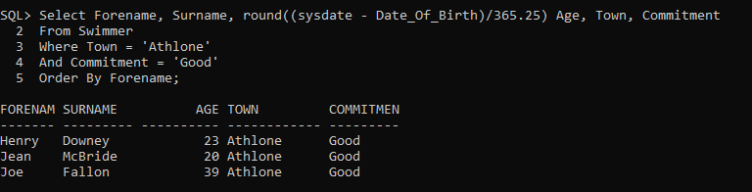

Q2) List ForeName, SurName, Town, County and Age (Calculate (Today's Date – Date of Birth) in years) of Instructors who are located in Westmeath and Donegal county and have Age between 25 and 30 years

Clear Screen
Select Fname, Sname, Town, County, round((sysdate - Date_Of_Birth)/365.25) Age
From Instructor
Where County In ('Westmeath', 'Donegal')
And round((sysdate - Date_Of_Birth)/365.25) Between 25 And 30;

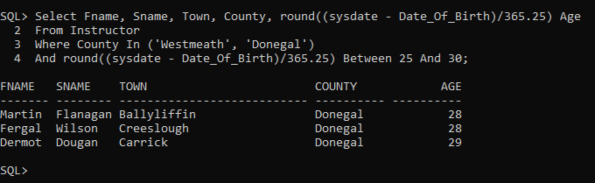

Q3) List Name, City, Specialism, Year of establishment of Colleges who have name containing 'Uni' anywhere in the name and who are at least a century (100 years) older i.e established before or on 1918.

Clear Screen
Select Name, City, Specialism, Yr_Established
From College
Where Name Like '%Uni%'
And Yr_Established <= 1918;

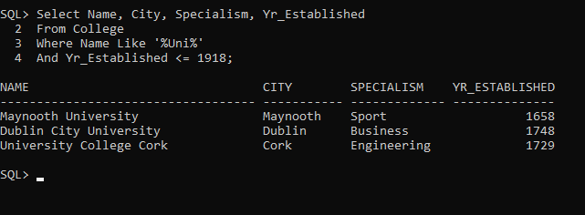

Joins

Q4) List First Name, Town of Instructors, Name, Specialism, Year Established of Colleges where the Instructors have gained their education, Name, Specialism and Year Established of Swimming Schools where they have signed up for teaching. Restrict records to Female Instructors belonging to County Donegal who studied at college with campus size of at least 5 hectares and are now signed up with a swimming school in County Dublin.

Clear Screen
Select I.Fname, I.Town, C.Name, C.Specialism, C.Yr_Established, SS.Name Name_SS, SS.SPecialism Specialism_SS, SS.Yr_Established Yr_Established_SS
From Instructor I, College C, Swimming_School SS
Where C.College_Id = I.College_Id
And SS.Swimming_School_Id = I.Swimming_School_Id
And I.Gender = 'Female'
And I.County = 'Donegal'
And C.Campus_Size >= 5
And SS.County = 'Dublin';

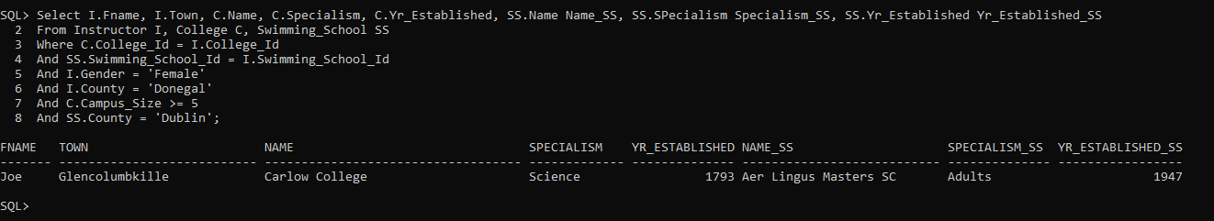

Q5) List Topic, Instructor Fee of Lessons, Area(Length * Width) and Yearly running costs of Pools, Surname, Age (Calculate (Today's Date – Date of Birth) in years) in years and Weakness of Swimmers, Surname, Specialism, and reputation of Instructors, Name, Year Established of College and Name and Email of Swimming School. Restrict Lessons with a Topic of 'Breathing', 'Turning' and 'Use of Feat' taken by Swimmers with 'Breathing; weakness given at Pool with an Area (Length * Width) greater than 2000 sq metres, given by Instructors who specialises in technique other than 'Breaststroke' and Studied in college established between year 1600 and 1699 and are signed up with swimming schools whose email is recorded in database.

Clear Screen
SELECT L.Topic, L.Instructor_Fee, (P.Length * P.Width) Area, P.Yr_Running_Cost, S.Surname, round((sysdate - S.Date_Of_Birth)/365.25) Age
, S.Weakness, I.Sname, I.Specialism, I.Reputation, C.Name, C.Yr_Established, SS.Name, SS.Email
FROM Lesson L, Swimmer S, Pool P, Instructor I, College C, Swimming_School SS
Where S.Swimmer_Id = L.Swimmer_Id
And P.Pool_Id = L.Pool_Id
And L.Instructor_Id = I.Instructor_Id
And C.College_Id = I.College_Id
And SS.Swimming_School_Id = I.Swimming_School_Id
And L.Topic In ('Breathing', 'Turning', 'Use of Feet')
And S.Weakness = 'Breathing'
And round((sysdate - S.Date_Of_Birth)/365.25) > 20
And P.Length * P.Width > 2000
And I.Specialism Not In ('Breaststroke')
And C.Yr_Established Between 1600 And 1699
And SS.Email Is Not Null;

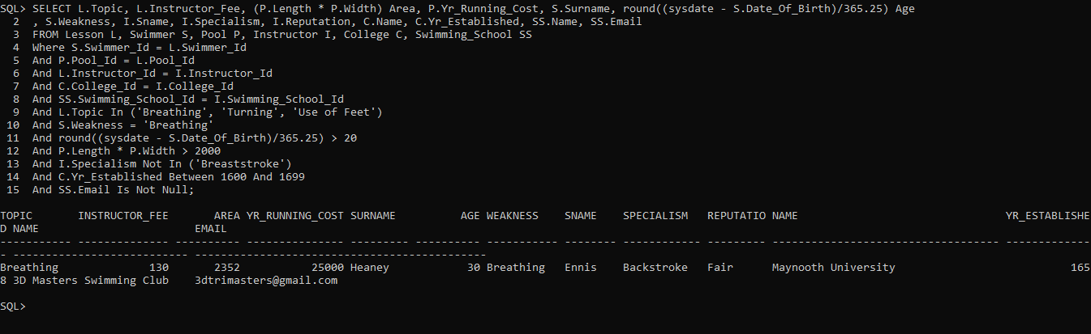

Q6) Name the College and Swimming school pairs which have same city.

Clear Screen
Select C.Name Name_College, SS.Name Name_Swimming_School
From College C, Swimming_School SS
Where C.City = SS.City;

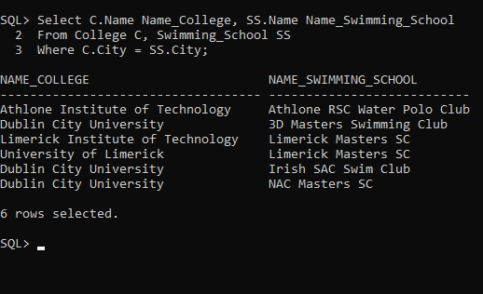

Q7) List the Topic and Instructor Fee for the lesson with second highest Instructor Fee.

Clear Screen
Select L1.Topic, L1.Instructor_Fee
From Lesson L1
Where 1 = --need to provide (N-1) value, for 2nd highest give 1
(Select Count(Distinct (L2.Instructor_Fee))
From Lesson L2
Where L2.Instructor_Fee > L1.Instructor_Fee);

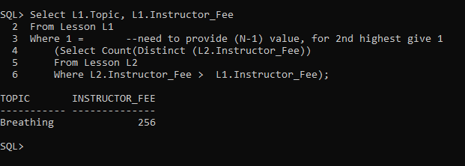

-- We can also use RANK() function to find out second highest fee
Clear Screen
Select Topic, Instructor_Fee
From
(Select L1.Topic, L1.Instructor_Fee, Rank() Over(Order By L1.Instructor_Fee Desc) Rank
From Lesson L1)
Where Rank = 2;
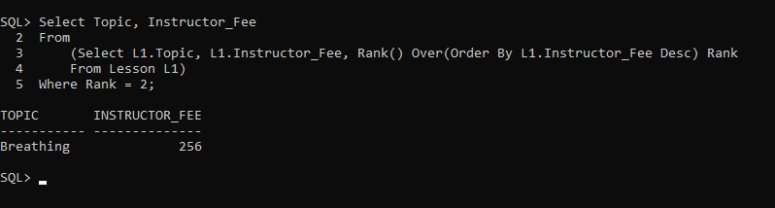

Q8) List the Names of colleges who have not trained and Instructors. Using Full Outer Join (+) or Left Join

Clear Screen
Select C.Name
From College C, Instructor I
Where C.College_Id = I.College_Id(+)
And I.College_Id Is Null;
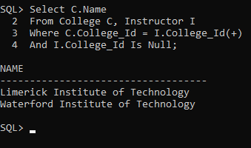

-- Same can be achieved using a Left Join
Clear Screen
Select C.Name
From College C
Left Join Instructor I On C.College_Id = I.College_Id
Where I.College_Id Is Null;
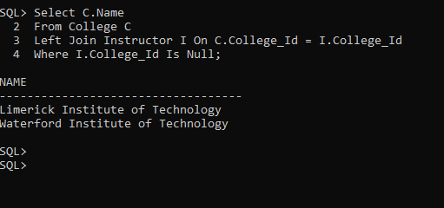

Summary Queries

Q9) Give Average, Minimum, Maximum and Difference between Maximum and Avg Area (Length * Width) of all the Pools with Clean Water Quality for each Type of Pool. Using a Common Table Expression (CTE).

--Using CTE (Common Table Expression) a complex qy=uery can be structured in a better way to increase readability.
Clear Screen
With Pool_Area AS (
Select Length * Width As Area, Yr_Running_Cost, Pool_Type, Water_Quality
From Pool)
Select Pool_Type, Avg(Area), Min(Area), Max(Area)
From Pool_Area
Where Water_Quality = 'Clean'
Group By Pool_Type;

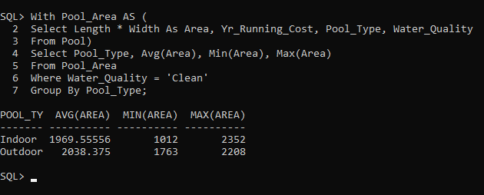

Q10) Give Average, Minimum, Maximum Instructor Fee for lessons for each county of school where the corresponding Instructor of lesson has signed up. Only Include Rows where Avg Instructor Fee is greater than 220. Order the results by County Name in reverse alphabetical order.

Clear Screen
Select SS.County, Avg(L.Instructor_Fee),Min(L.Instructor_Fee),Max(L.Instructor_Fee)
From Lesson L, Instructor I, Swimming_School SS
Where L.Instructor_Id = I.Instructor_Id
And SS.Swimming_School_Id = I.Swimming_School_Id
Group By SS.County
Having Avg(L.Instructor_Fee) > 220
Order By SS.County Desc;

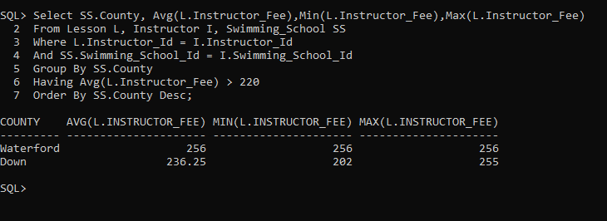

Q11) Give the First Name, Sur Name, Age, Gender, Reputation and Qualification level of Instructors. Restrict the records to Instructors who does not studied at Colleges located in Letterkenny county and are signed up with School whose email is recorded in database. List only those instructors whose fee for the lesson is greater than the overall average Instructor Fee for all lessons. Consider lessons conducted at Indoor where Yearly Running cost is greater than any Yearly running cost of Outdoor type of pools.

Clear Screen
SELECT I.Fname, I.Sname, round((sysdate - I.Date_Of_Birth)/365.25) Age, I.Gender, I.Reputation, I.Qualifications
FROM Lesson L, Swimmer S, Pool P, Instructor I, College C, Swimming_School SS
Where S.Swimmer_Id = L.Swimmer_Id
And P.Pool_Id = L.Pool_Id
And L.Instructor_Id = I.Instructor_Id
And C.College_Id = I.College_Id
And SS.Swimming_School_Id = I.Swimming_School_Id
And C.County Not In ('Letterkenny')
And SS.Email Is Not NUll
And SS.Email Like '%com'
And L.Instructor_Fee >
(Select Avg(Instructor_Fee) From Lesson)
And P.Pool_Type = 'Indoor'
And P.Yr_Running_cost > Any
(Select Yr_Running_Cost
From Pool
Where Pool_Type = 'Outdoor');
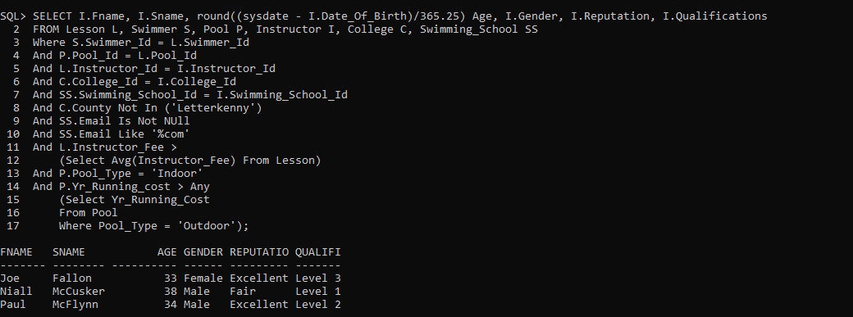

Q12) List the First name, Last Name, Commitment, Weakness of the swimmers who have taken lessons in Indoor pools. (Subquery + Exists)

Clear Screen
Select S.Forename, S.Surname, S.Commitment, S.Weakness
From Swimmer S
Where Exists
(Select *
From Pool P, Lesson L
Where P.Pool_Id = L.Pool_Id
And S.Swimmer_Id = L.Swimmer_Id
And P.Pool_Type = 'Indoor');
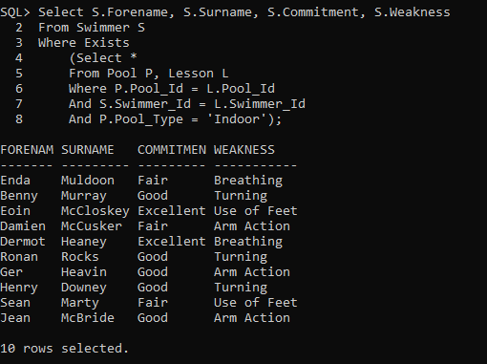

Updates, Inserts, Deletes
Q13) Update the Instructor Fee and increase it by 10% where Instructor have excellent reputation and lessons happen in a Indoor pool

Clear Screen
Update Lesson
Set Instructor_Fee = Instructor_Fee * 1.1
Where Instructor_Id In
(Select I.Instructor_Id
From Instructor I, Lesson L, Pool P
Where L.Instructor_Id = I.Instructor_Id
And L.Pool_Id = P.Pool_Id
And I.Reputation = 'Excellent'
And P.Pool_type = 'Indoor');
Rollback;
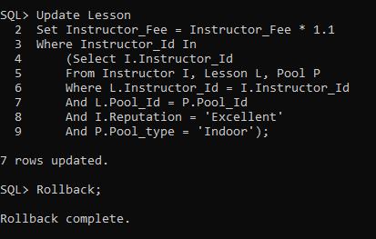

Q14) Insert a record in College table.

Clear Screen
Insert Into College
SELECT 111, Name,City, County, Specialism, Yr_Established, Campus_Size
FROM College
WHERE Name Like 'Athlone%';
ROLLBACK;
-- Rollback will undo the insert and keep the orignal table.
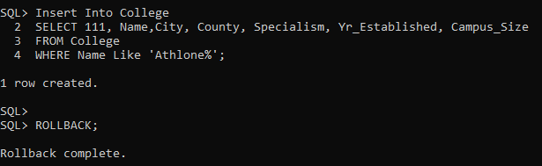

Q15) According to a new security norm, all pools with Deep End Depth less than or equal to 3 metres are not qualified for any swimming lessons. Hence, delete all Pools where Deep_End_Depth is less than or equal to 3.

----Alter Table and Disable Constraint and also any Dependent Constraints like foreign keys using CASCADE----
Clear Screen
ALTER TABLE POOL DISABLE CONSTRAINT POOL_POOL_ID_PK CASCADE;

--------------------------Enable Server Output----------------
Set Serveroutput On;

--------------------Define a After Delete Trigger-------------
----------------Trigger will display the ID of rows deleted and the username-------
Create Or Replace Trigger Pool_After_Delete_Trg
After Delete
On Pool
For Each Row
Begin
DBMS_OUTPUT.PUT_LINE('Swimming Pool with ID '||:Old.Pool_Id||' is delete by user '||user);
END;
/
------------------Perform Delete---------------
Delete
From Pool
Where DEEP_END_DEPTH <= 3;
ROLLBACK;
-----------------Disable Server Output----------------
Set serveroutput off;

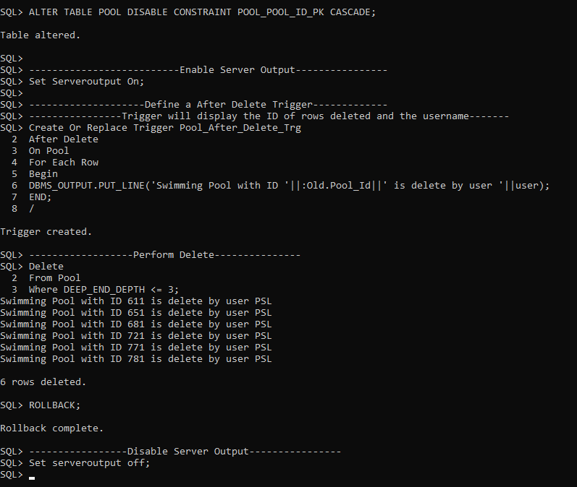
-----------------Enable All Disablesd PK Constraints-------------------
------------Explore System tables to create a generic query-------------
Clear Screen
begin
for cur in (SELECT constraint_name , table_name
FROM all_constraints
WHERE CONSTRAINT_NAME = 'POOL_POOL_ID_PK' )
loop
execute immediate 'ALTER TABLE '||cur.table_name||' MODIFY CONSTRAINT "'||cur.constraint_name||'" ENABLE ';
end loop;
end;
/
-----------------Enable All Disablesd FK Constraints-------------------
begin
for cur in (SELECT constraint_name , table_name FROM all_constraints
WHERE R_CONSTRAINT_NAME = 'POOL_POOL_ID_PK' )
loop
execute immediate 'ALTER TABLE '||cur.table_name||' MODIFY CONSTRAINT "'||cur.constraint_name||'" ENABLE ';
end loop;
end;
/

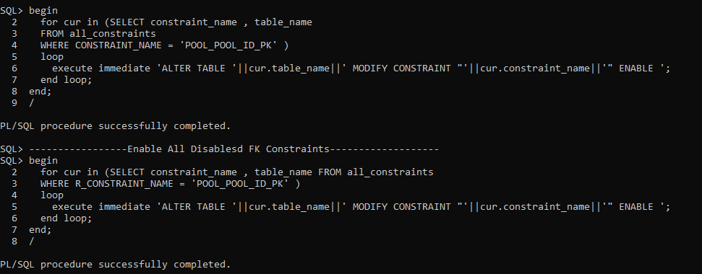

Unions/Intersect

Q16) List Forename, Surname, Address, Town, County, Date of birth, Gender, Reputation of Instructors
And Forename, Surname, Address, Town, County, Date of birth, Gender, Commitment of Swimmer; who lives in County Westmeath.

Clear Screen
Select Fname, Sname, Address, Town, County, Date_of_birth, Gender, Reputation
From Instructor
Where County = 'Westmeath'
Union
Select Forename, Surname, Address, Town, County, Date_of_birth, Gender, Commitment
From Swimmer
Where County = 'Westmeath';

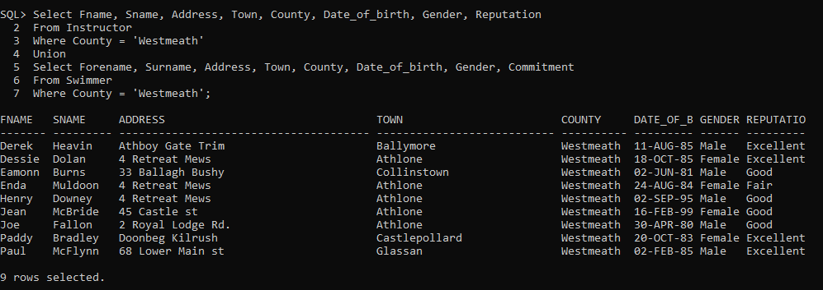

Creating Views

Q17) Government of Ireland wants to promote Swimming in Westmeath and county and have launched a scheme by offering a 10% discount on Instructor Fee to Swimmers of county Westmeath who have Good commitment. Create a View which stores Lname, Age, Gender, Commitment, Weakness, Town of Swimmer along with Before and After Discount Instructor fee for the lessons they are enrolled in and the Lname of Instructor and Average depth of Pool the lesson is conducted in.

Clear Screen
Drop View Swimming_Promotion;
Create View Swimming_Promotion As
Select S.Surname, round((sysdate - S.Date_Of_Birth)/365.25) Age, S.Gender, S.Commitment, S.Weakness, S.Town,
L.Instructor_Fee Instructor_Fee_Before, L.Instructor_Fee * 0.9 Instructor_Fee_After
From Swimmer S, Lesson L
Where L.Swimmer_Id = S.Swimmer_Id
And S.County = 'Westmeath'
And S.Commitment = 'Good';
Select * From Swimming_Promotion;

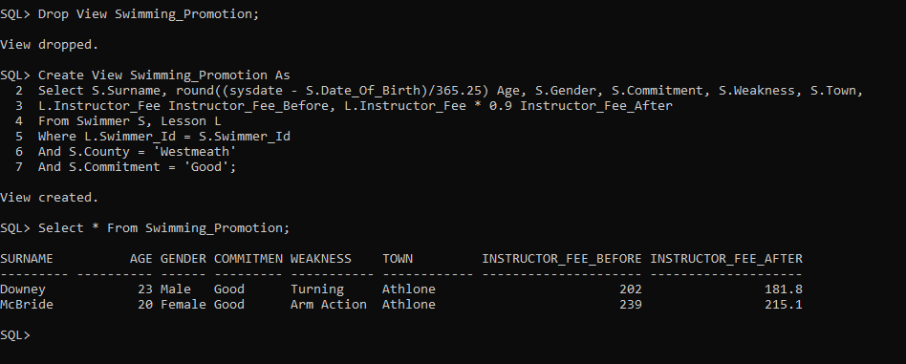

Q18) Create a function to convert Date in Georgian format to Julian format. Then utilize the function to return the Julian values od Date of Birth of Instructors.
Clear Screen
Create or Replace Function Julian_Dt_Fun(Georgian_Dt Date)
Return Number
Is Julian_Dt Number;
Begin
Select TO_NUMBER(TO_CHAR(Georgian_Dt, 'YYYYDDD'))-1900000 Into Julian_Dt From Dual;
Return(Julian_Dt);
End Julian_Dt_Fun;
/
Select Julian_Dt_Fun(Date_Of_Birth) As DOB_Julian
From Instructor;
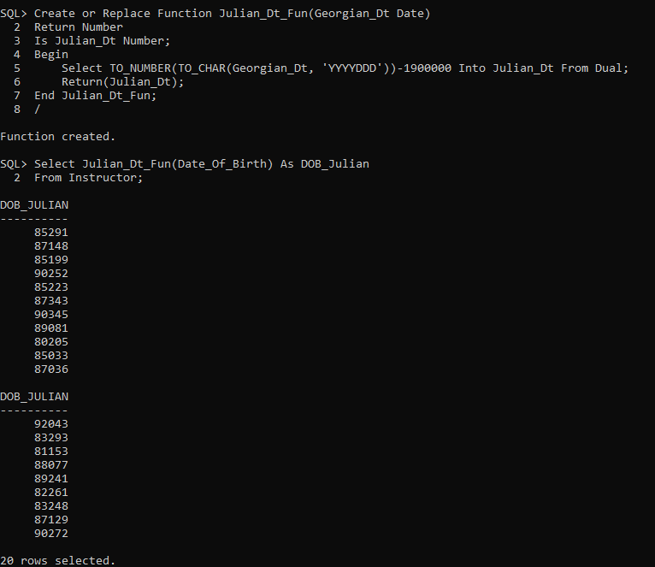

Q19) Create a Stored Procedure to Merge records of College table to a Global Temporary table. Update Campus_Size in temp table where the College already exist in temp table and Insert colleges which are not present.

Clear Screen
Create global temporary table CollegeMerge
on commit preserve rows
as
Select * FROM College Where 1=0;
Insert Into CollegeMerge Values (101,'Maynooth University','Maynooth','Maynooth','Sport',1658,10);
Insert Into CollegeMerge Values (111,'NUIG','Galway','Galway','Sport',1669,20);
commit;
Select * From CollegeMerge;
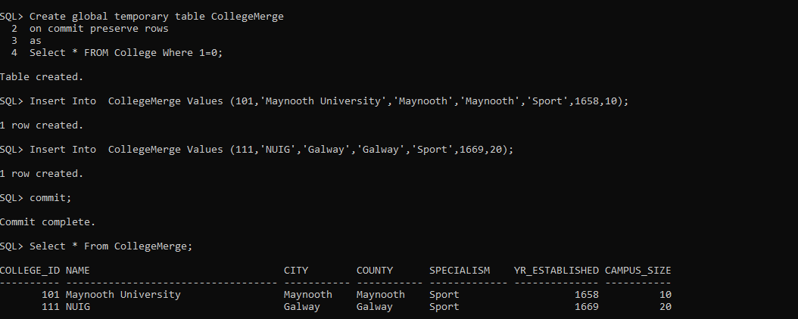

Create Or Replace Procedure College_Merge_SP
IS
BEGIN

Merge Into CollegeMerge CM
Using (Select * From COLLEGE) C
On (C.College_Id = CM.College_Id)
When Matched then
Update set CM.Campus_Size = C.Campus_Size
When Not Matched then
Insert (College_Id,NAME,CITY,COUNTY,SPECIALISM,YR_ESTABLISHED,CAMPUS_SIZE) Values (C.COllege_Id,C.NAME,C.CITY,C.COUNTY,C.SPECIALISM,C.YR_ESTABLISHED,C.CAMPUS_SIZE);
commit;
End;
/
exec College_Merge_SP;
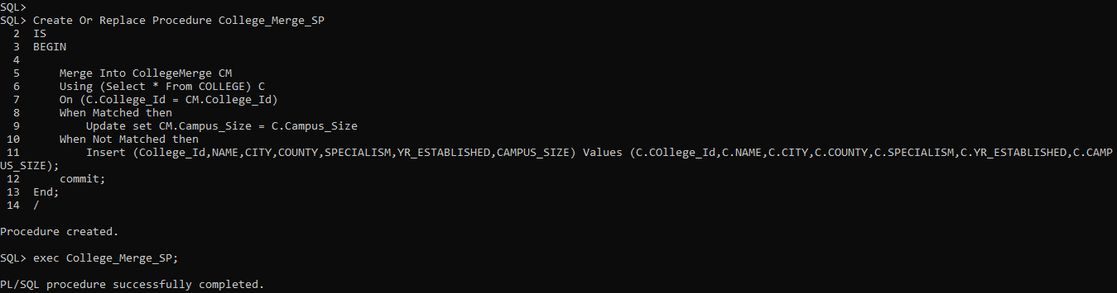
Select * From CollegeMerge;
Truncate Table CollegeMerge;
Drop Table CollegeMerge;
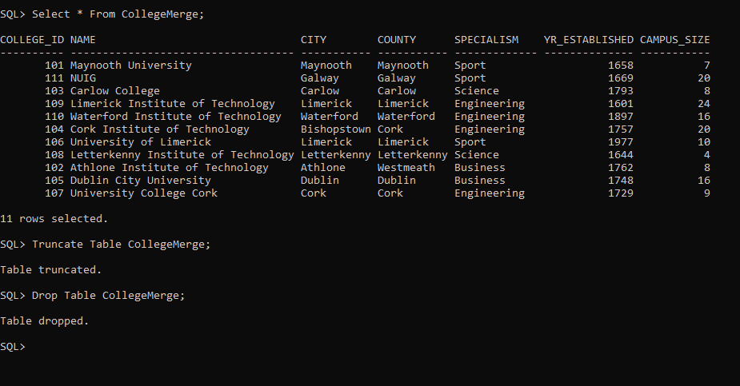

Q20) Create a new user and grant only Select permission to the user. Verify the same by checking that new user is not able to Delete records in College table.

Clear Screen
Create User PSL_ReadOnly Identified By AchalGupta;
Grant Connect To PSL_ReadOnly;
Grant Select On College To PSL_ReadOnly;
Connect PSL_READONLY
AchalGupta
Select * From PSL.College Where College_Id = 101;
Delete from PSL.College;
