SHAP Summary Beeswarm Plot

1. Purpose of the Visualisation
The SHAP summary beeswarm plot was generated to explain how the XGBoost model uses customer-level features when predicting credit card default risk. It provides a global view of feature importance and shows whether feature values tend to push the model output towards or away from the default class.2. SHAP Summary Beeswarm Plot
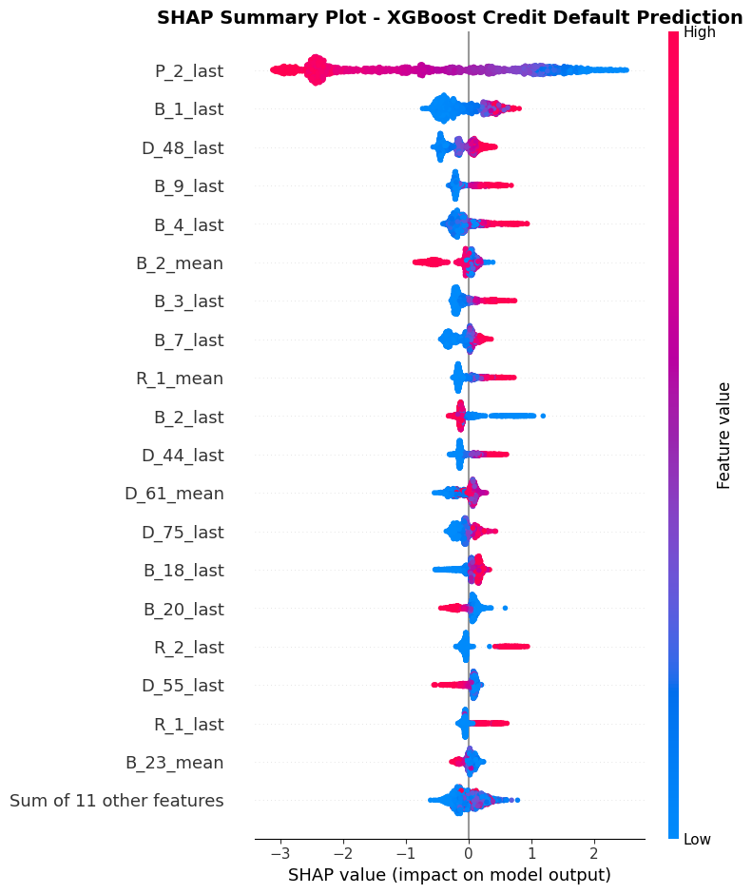
Figure 1. SHAP summary beeswarm plot for the XGBoost model.

3. How to Read the Plot
Plot element | Meaning
Y-axis | Features, ranked by their overall importance.
X-axis | SHAP value, representing the impact on the model's raw output.
Red/pink dots | Relatively high values of the corresponding feature.
Blue dots | Relatively low values of the corresponding feature.
Positive SHAP values | Push the model output towards class 1 (default).
Negative SHAP values | Push the model output away from class 1 (default).
Each dot | One customer observation in the 2,000-customer SHAP sample.
Important: the SHAP values in this analysis explain the XGBoost model's raw output (log-odds), not the predicted default probability directly.

4. Key Observations and Interpretation

4.1 P_2_last – Most Influential Feature
P_2_last has the widest SHAP-value distribution and the highest mean absolute SHAP importance (approximately 1.534). High feature values (red/pink dots) are mostly associated with negative SHAP values, while low feature values (blue dots) tend to appear on the positive side. In this model, higher values of P_2_last generally push predictions away from default, whereas lower values tend to push predictions towards default.

4.2 B_1_last
High values of B_1_last are generally associated with positive SHAP values, while low values are concentrated more on the negative side. This suggests that higher values of B_1_last generally push the model output towards default.

4.3 D_48_last
Higher values of D_48_last tend to appear on the positive side of the plot, whereas lower values are more concentrated around negative SHAP values. This indicates that higher values generally push predictions towards default in the fitted model.

4.4 Other Influential Features
The plot shows several other features with directional patterns. Higher values of B_9_last, B_4_last, B_3_last and R_1_mean generally appear on the positive SHAP side, indicating a tendency to push the model output towards default. In contrast, higher values of B_2_mean generally appear on the negative side, tending to push predictions away from default.

5. Overall Findings
- Unequal feature importance: P_2_last is substantially more influential than the other features.
- Different directions of influence: high values of some features push predictions towards default, while high values of others push predictions away from default.
- Customer-level variation: the spread of SHAP values indicates that a feature's contribution can vary across customers, potentially reflecting different customer profiles and feature interactions.

6. Limitations and Considerations
- SHAP values describe how the fitted model uses features; they do not establish causal relationships.
- The plot shows relative feature values and model contributions, but it does not by itself establish the financial meaning of anonymised feature codes such as P_2_last or B_1_last. Their definitions should be checked against the dataset documentation before assigning business interpretations.
- The SHAP values explain the model's raw output (log-odds), not probabilities.
- The interpretation is based on a reproducible sample of 2,000 customers from the reserved validation dataset, rather than every customer in the dataset.

7. Report-Ready Summary
The SHAP summary beeswarm plot was generated to investigate the global interpretability of the XGBoost credit default prediction model. The visualisation illustrates the contribution of individual features to the model's predictions across a sample of 2,000 customers from the reserved validation dataset. The results indicate that P_2_last is the most influential feature, with considerably higher SHAP importance than the remaining features. High values of this feature are generally associated with negative SHAP values, indicating a tendency to reduce the model output towards default. Conversely, lower values are generally associated with positive SHAP values, increasing the model output towards default. Other influential features include B_1_last, D_48_last, B_9_last and B_4_last. The plot also demonstrates that different features influence predictions in different directions. For example, higher values of B_1_last generally increase the model output towards default, whereas higher values of B_2_mean generally decrease it. Overall, the visualisation demonstrates that the XGBoost model relies on multiple customer-level features when predicting credit default risk, although P_2_last has a particularly strong influence. These findings provide insights into the model's decision-making process and improve its interpretability. However, SHAP values represent model associations rather than causal relationships.

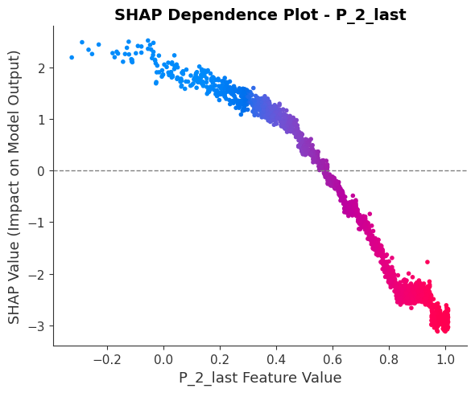SHAP Dependence Analysis – P_2_last
The SHAP dependence plot was generated to investigate the relationship between the values of P_2_last and their contributions to the XGBoost model's credit default predictions.
The visualisation reveals a strong non-linear relationship between P_2_last and its SHAP values. Customers with relatively low values of this feature generally have positive SHAP values, indicating that the feature contributes towards increasing the model output for the default class. As the feature value increases, its SHAP contribution gradually decreases.
Around the feature value range of 0.55–0.60, the SHAP values cross zero, indicating a transition from positive to negative contributions. At higher feature values, particularly above approximately 0.8, the SHAP values become strongly negative. This suggests that higher values of P_2_last generally contribute to reducing the model output towards the default class.
Overall, the findings indicate that P_2_last is an important feature in identifying credit default risk. Its influence is not linear, as different feature-value ranges have considerably different contributions to the model predictions. However, these findings represent the behaviour of the trained model and should not be interpreted as evidence of a causal relationship.

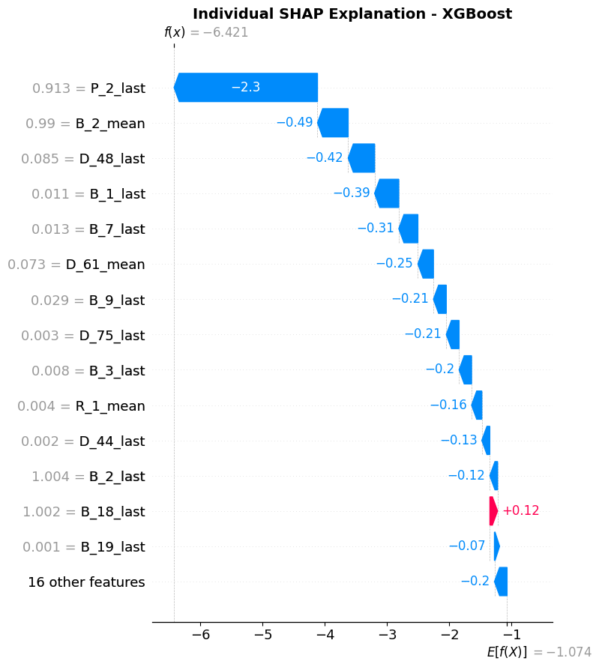
Individual Customer-Level SHAP Explanation
The SHAP waterfall plot was generated to explain the XGBoost model's prediction for an individual customer selected from the reserved validation dataset.
The model predicted a default probability of 0.16%, classifying the customer as a non-defaulter. The actual outcome was also non-default, indicating that the prediction was correct for this observation.
The waterfall plot illustrates how individual feature contributions move the model output from the baseline value of approximately -1.074 to the final output of approximately -6.421. The most influential feature was P_2_last, with a SHAP contribution of approximately -2.30, indicating a strong contribution towards reducing the model output for default. Other important features included B_2_mean, D_48_last, B_1_last, and B_7_last, which also contributed negatively.
In contrast, B_18_last contributed positively, with a SHAP value of approximately +0.12, slightly increasing the model output towards default. However, this positive contribution was relatively small compared with the negative contributions from other features.
Overall, the individual SHAP analysis demonstrates how the XGBoost model combines multiple features to generate a customer-specific prediction. It provides transparency into the model's decision-making process by identifying the strongest factors influencing an individual prediction.

