10. Implementing transctions to ensure data integrity and consistency. (use BEGINTRANSACTION/STARTTRANSACTION, COMMIT, ROLLBACK along with other sql queries).

use dbmt13;
show databases;
start transaction;
COMMIT;
Create database Job;
show databases;
use Job;
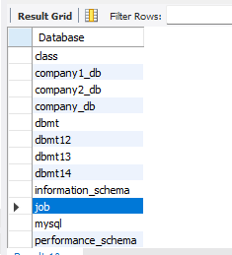
CREATE TABLE account4(
account_id INT PRIMARY KEY,
name VARCHAR(50),
balance DECIMAL(10,2)
);
INSERT INTO account4 VALUES
(1,'Ashwini',1000.00),
(2,'Nikita',500.00);
SELECT*FROM account4;
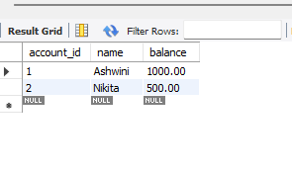
START TRANSACTION;
UPDATE account4
SET balance=balance-200
WHERE account_id=1;
SELECT*FROM account4;
UPDATE account4
SET balance=balance+200
WHERE account_id=2;
SELECT*FROM account4;
COMMIT;
