**3 months poor Vs good function**

design = ~ three_month_status + Donor_Age + Donor_Gender_M_F

contrast_3P <- c("three_month_status", "Poor", "Good")

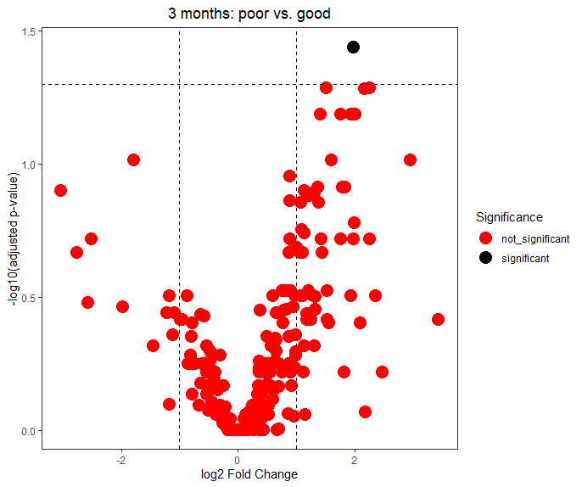

**12 month poor Vs good function**

design = ~ twelve_month_status + Donor_Age + Donor_Gender_M_F

contrast_12P <- c("twelve_month_status", "Poor", "Good")

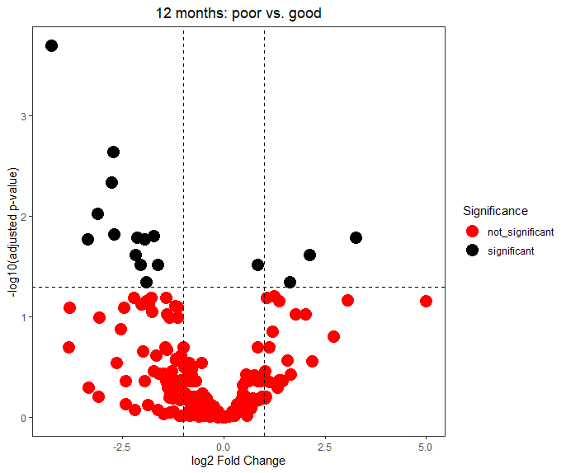

**3 months Good vs 12 months Good**

design = ~ time_point + Donor_Age + Donor_Gender_M_F

contrast <- c("time_point", "twelve_P", "three_P")

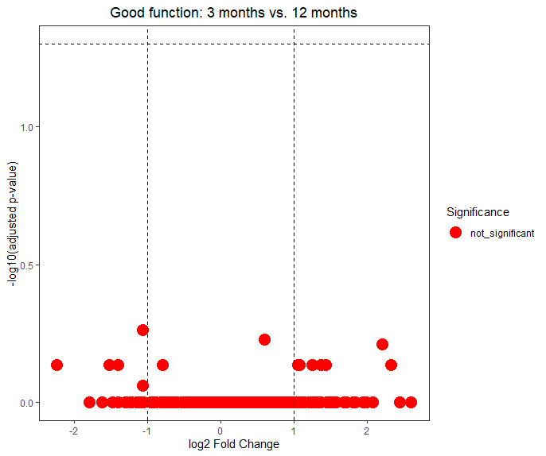

**3 months poor Vs 12 months poor**

design = ~ time_point + Donor_Age + Donor_Gender_M_F

contrast <- c("time_point", "twelve_P", "three_P")

