**Methods**

The raw sequencing reads were first quality-checked using FastQC1 and adapter sequences were trimmed using TrimGalore (available online at https://www.bioinformatics.babraham.ac.uk/projects/trim_galore/). The filtered reads were then mapped to the hg38 reference genome using Bowtie 2, and the genomic coordinates of the mapped reads were assigned to the reference genome annotation file using Bedtools 3. The annotation file used was based on the hg38 assembly and provided the genomic coordinates for known small RNA genes and features. The miRBase database (release v22.0) was used to identify and annotate microRNAs. The expression levels of small RNAs were quantified using R, and differential expression analysis was performed using the using DESeq2 package 4.

**Results**

Figure 1. Differential expression of miRNAs in individuals with poor versus good function at 3 months, highlighting the significant (Padj< 0.05) upregulation of a miRNA (hsa-miR-486-5p) in the poor functional status group compared to the good functional status group, after accounting for the effects of donor age and gender.

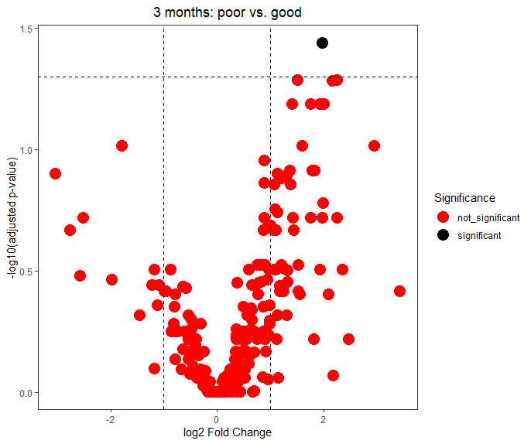

Figure 2. Differential expression of miRNAs in individuals with poor versus good function at 3 months, highlighting the significant (Padj< 0.05) downregulation and upregulation of miRNAs in the poor functional status group compared to the good functional status group, after accounting for the effects of donor age and gender.

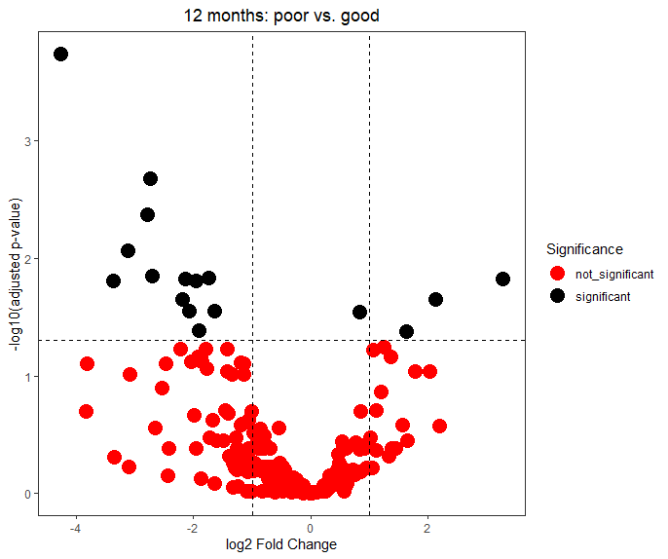

Figure 3. Differential expression of miRNAs in individuals with good function at 3 months versus 12 months. None of the miRNAs showed a significant difference in expression between the two time points.

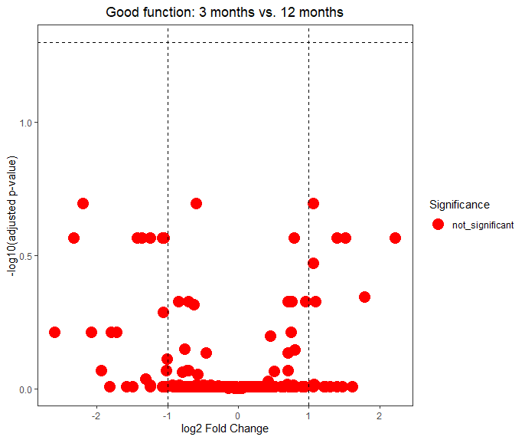

Figure 4. Differential expression of miRNAs in individuals with poor function at 3 months versus 12 months, highlighting the significant (Padj< 0.05) upregulation of two miRNAs (hsa-miR-15b-5p and hsa-miR-24-3p) in the 3 months group compared to the 12 months group, after accounting for the effects of donor age and gender.

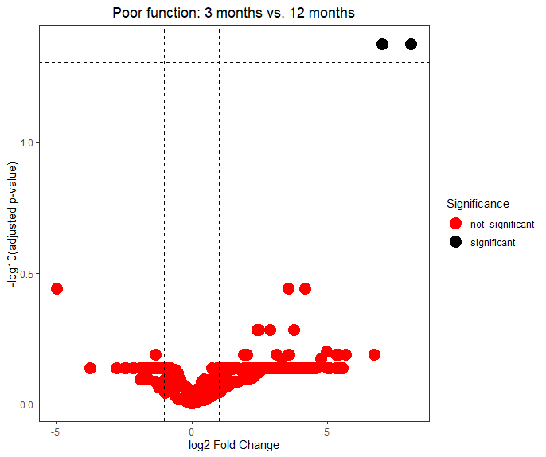

Figure 5. Unsupervised Hierarchical Clustering of miRNA expression based on top 100 miRNAs in Individuals with good and poor three-month functional status.

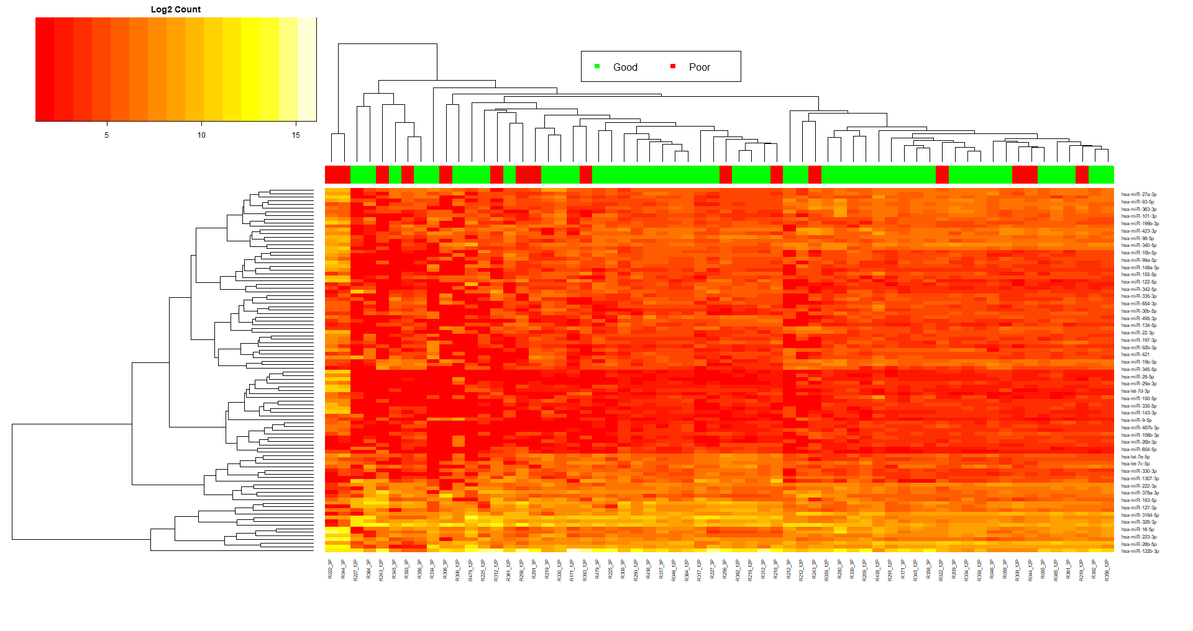

Figure 6. Unsupervised Hierarchical Clustering of miRNA expression based on top 100 miRNAs in Individuals with good and poor twelve-month functional status.

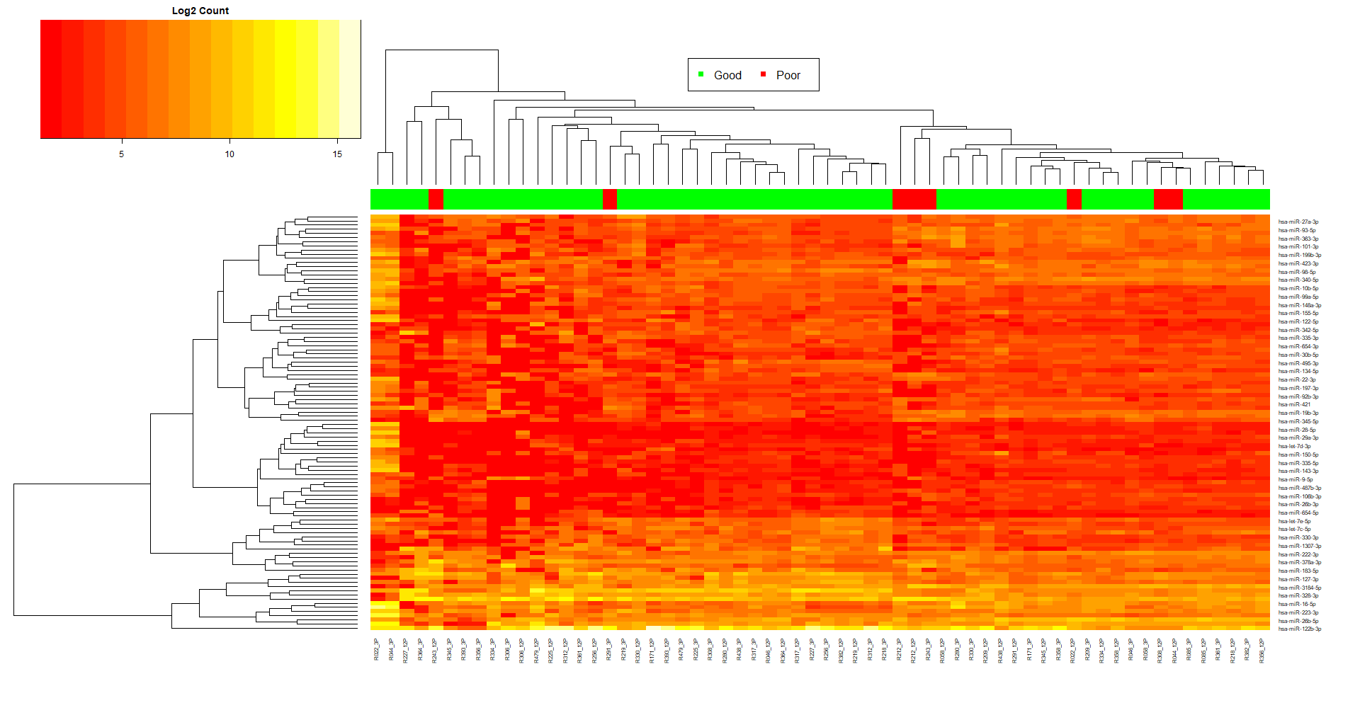

1. Andrews, S. FastQC: a quality control tool for high throughput sequence data. Vol. 2020 (2010).

2. Langmead, B., Trapnell, C., Pop, M. & Salzberg, S.L. Ultrafast and memory-efficient alignment of short DNA sequences to the human genome. *Genome biology* **10**, R25 (2009).

3. Quinlan, A.R. & Hall, I.M. BEDTools: a flexible suite of utilities for comparing genomic features. *Bioinformatics* **26**, 841-842 (2010).

4. Love, M.I., Huber, W. & Anders, S. Moderated estimation of fold change and dispersion for RNA-seq data with DESeq2. *Genome biology* **15**(2014).