CSET400C Capstone Project - Milestone-2 Report
Bennett University | School of Computer Science Engineering and Technology
Course Code: CSET400C (0-0-12-6) | Academic Session: 2026–27
Course Coordinator: Dr. Jabir Ali
Deadline: 23 / 30 November 2026 | Total Marks: 30

Project Title: HORIZON AI

Autonomous Multi-Dimensional Urban Impact Assessment & Future Simulation Engine for Delhi-NCR

1. System Architecture & High-Level Design
HORIZON AI follows a modular, decoupled micro-service oriented architecture with clean separation between the presentation layer, the API gateway, the causal computational simulation core, and spatial datasets.
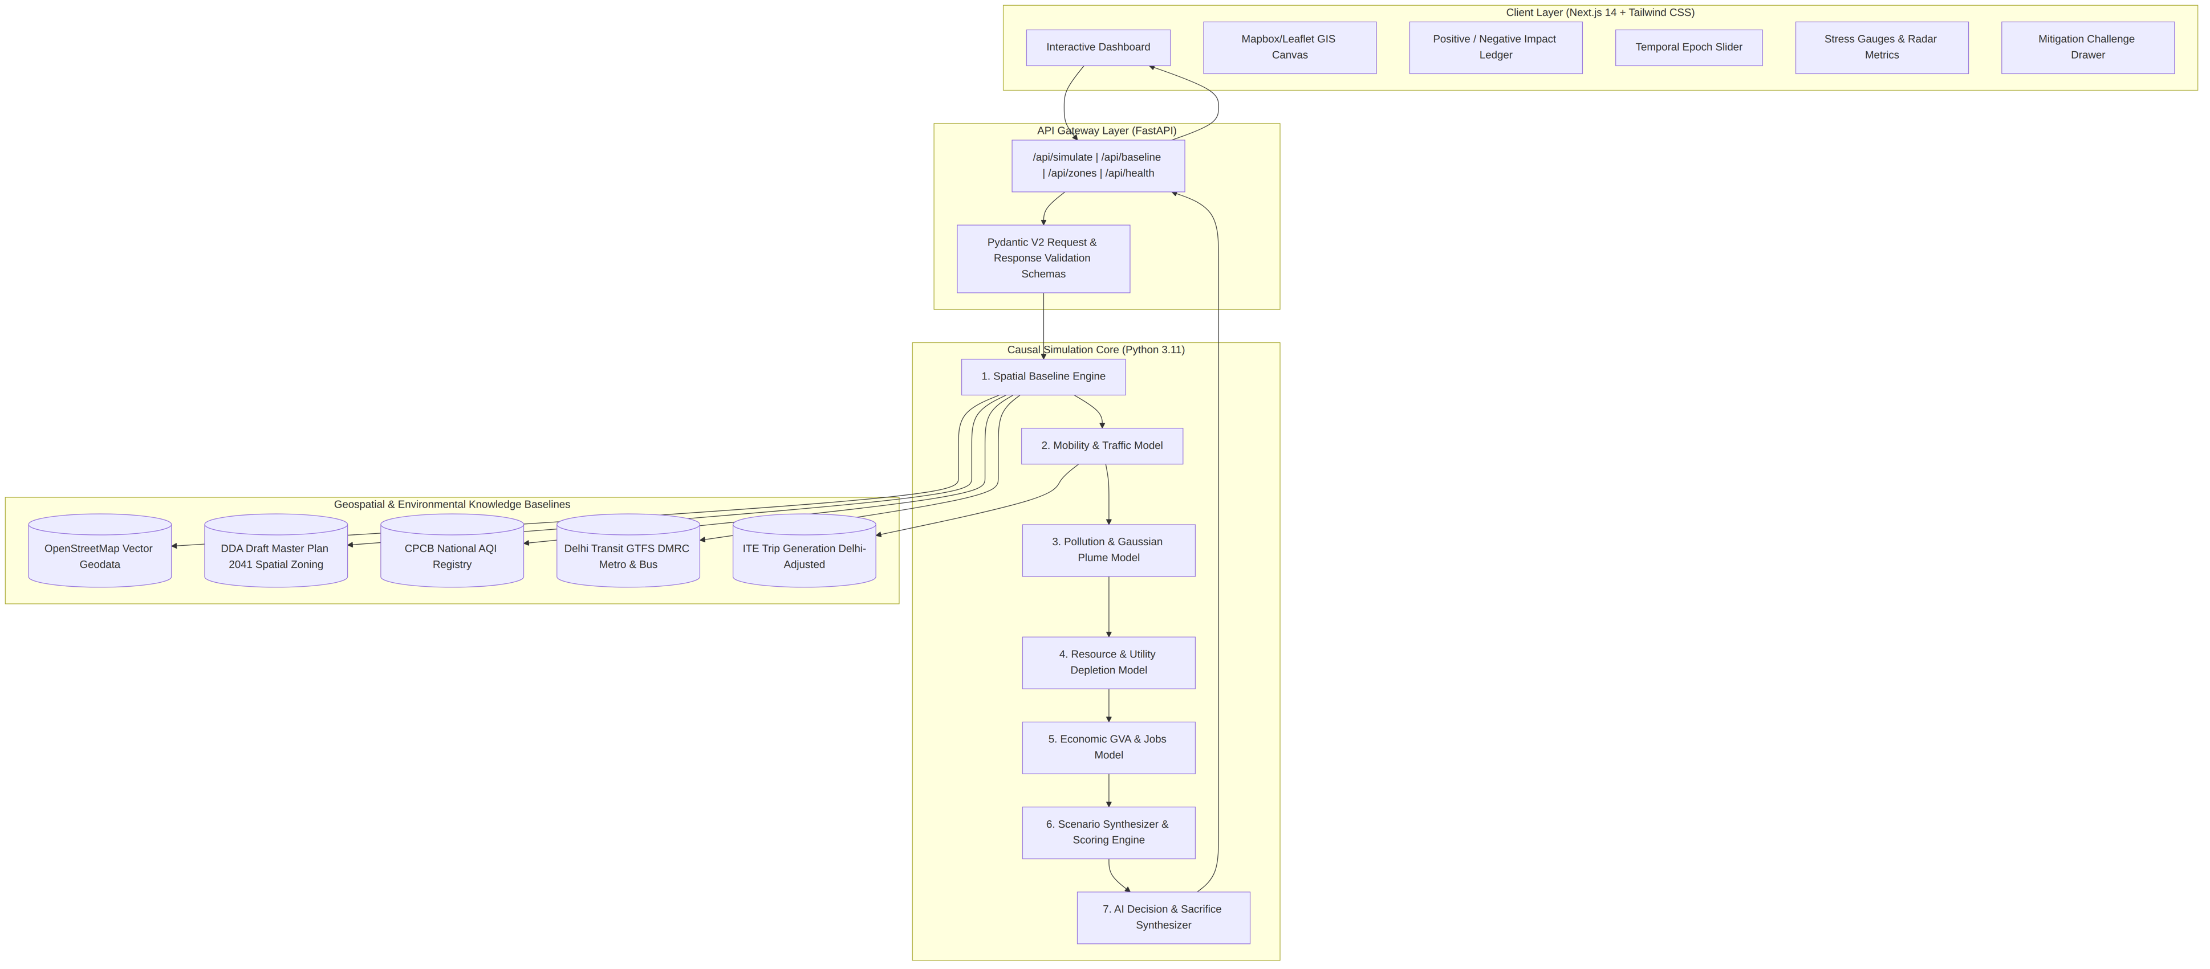

2. UML Diagrams & Data Flow Models

2.1 Use-Case Diagram
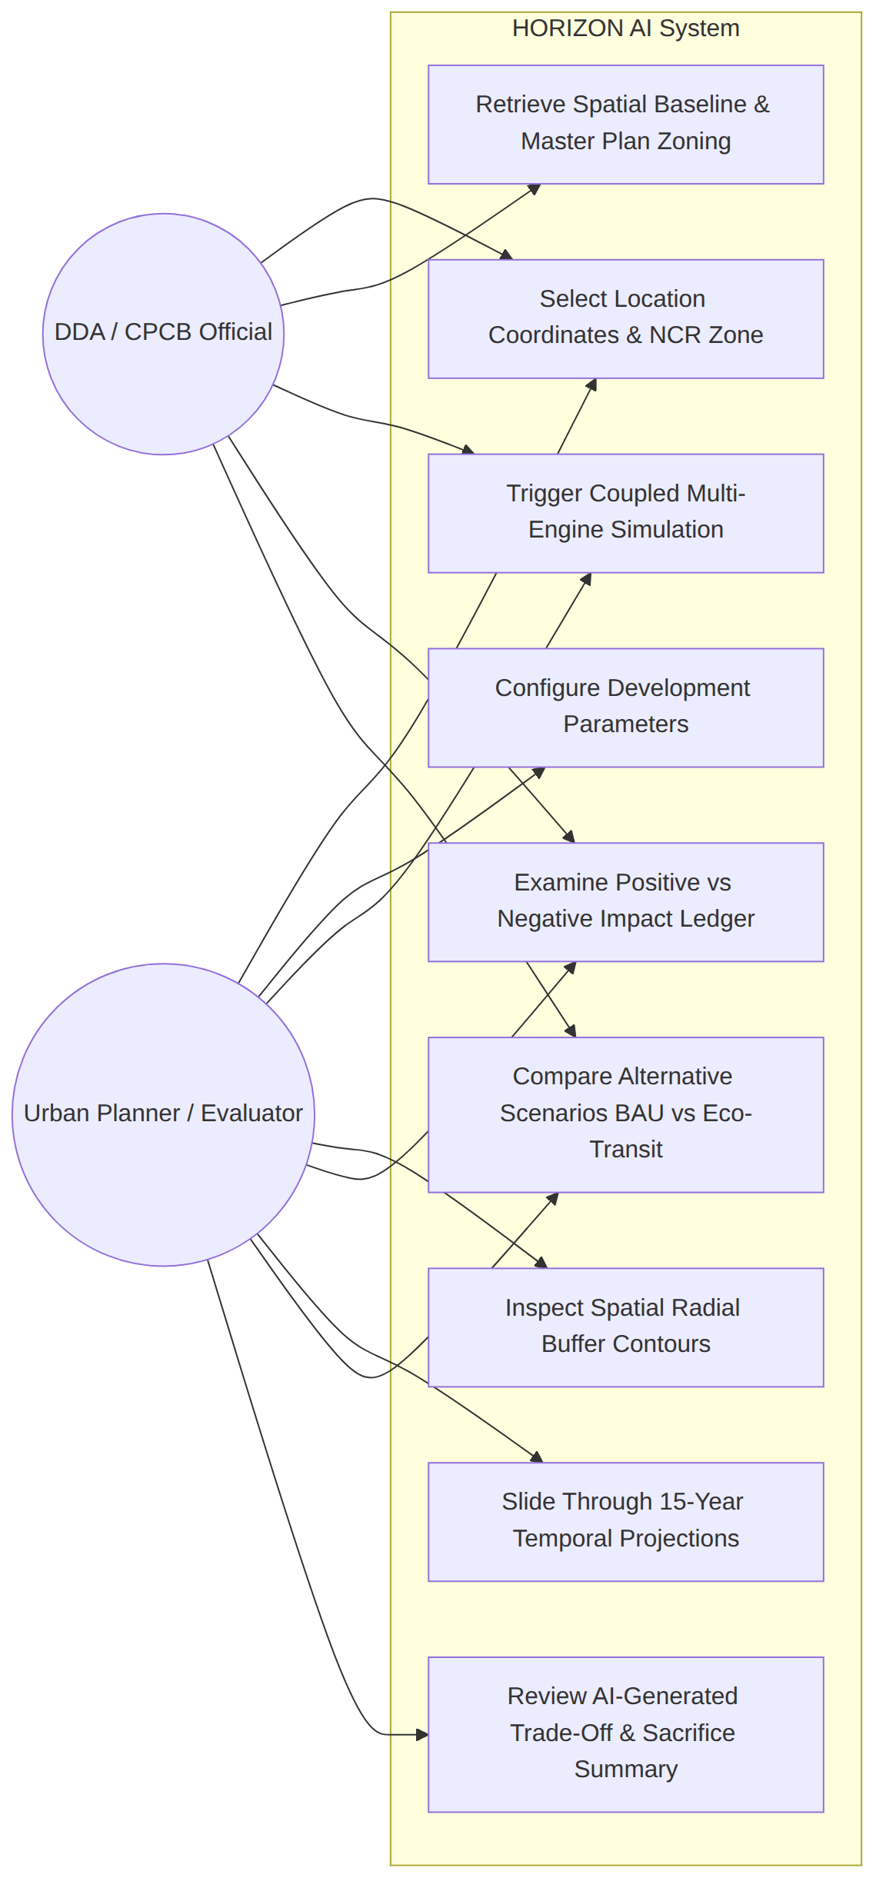

2.2 Data Flow Diagram (DFD Level 0 - Context Diagram)
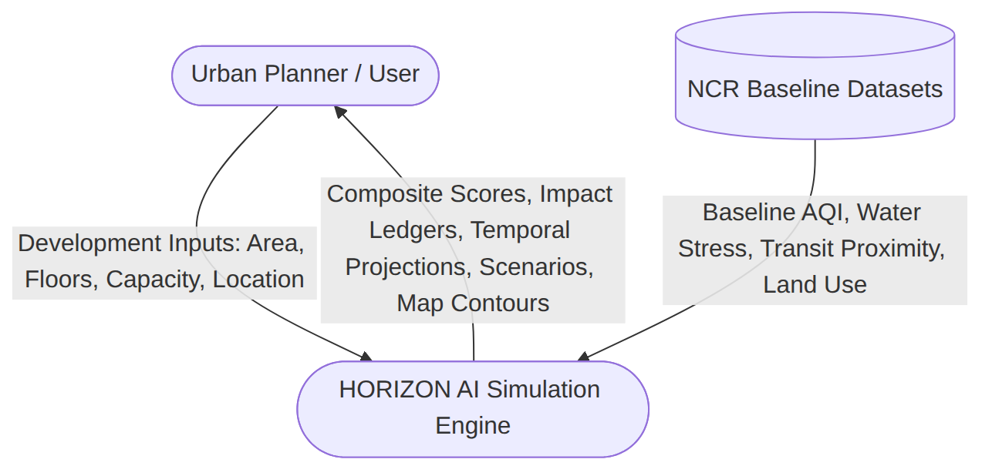

2.3 Data Flow Diagram (DFD Level 1)
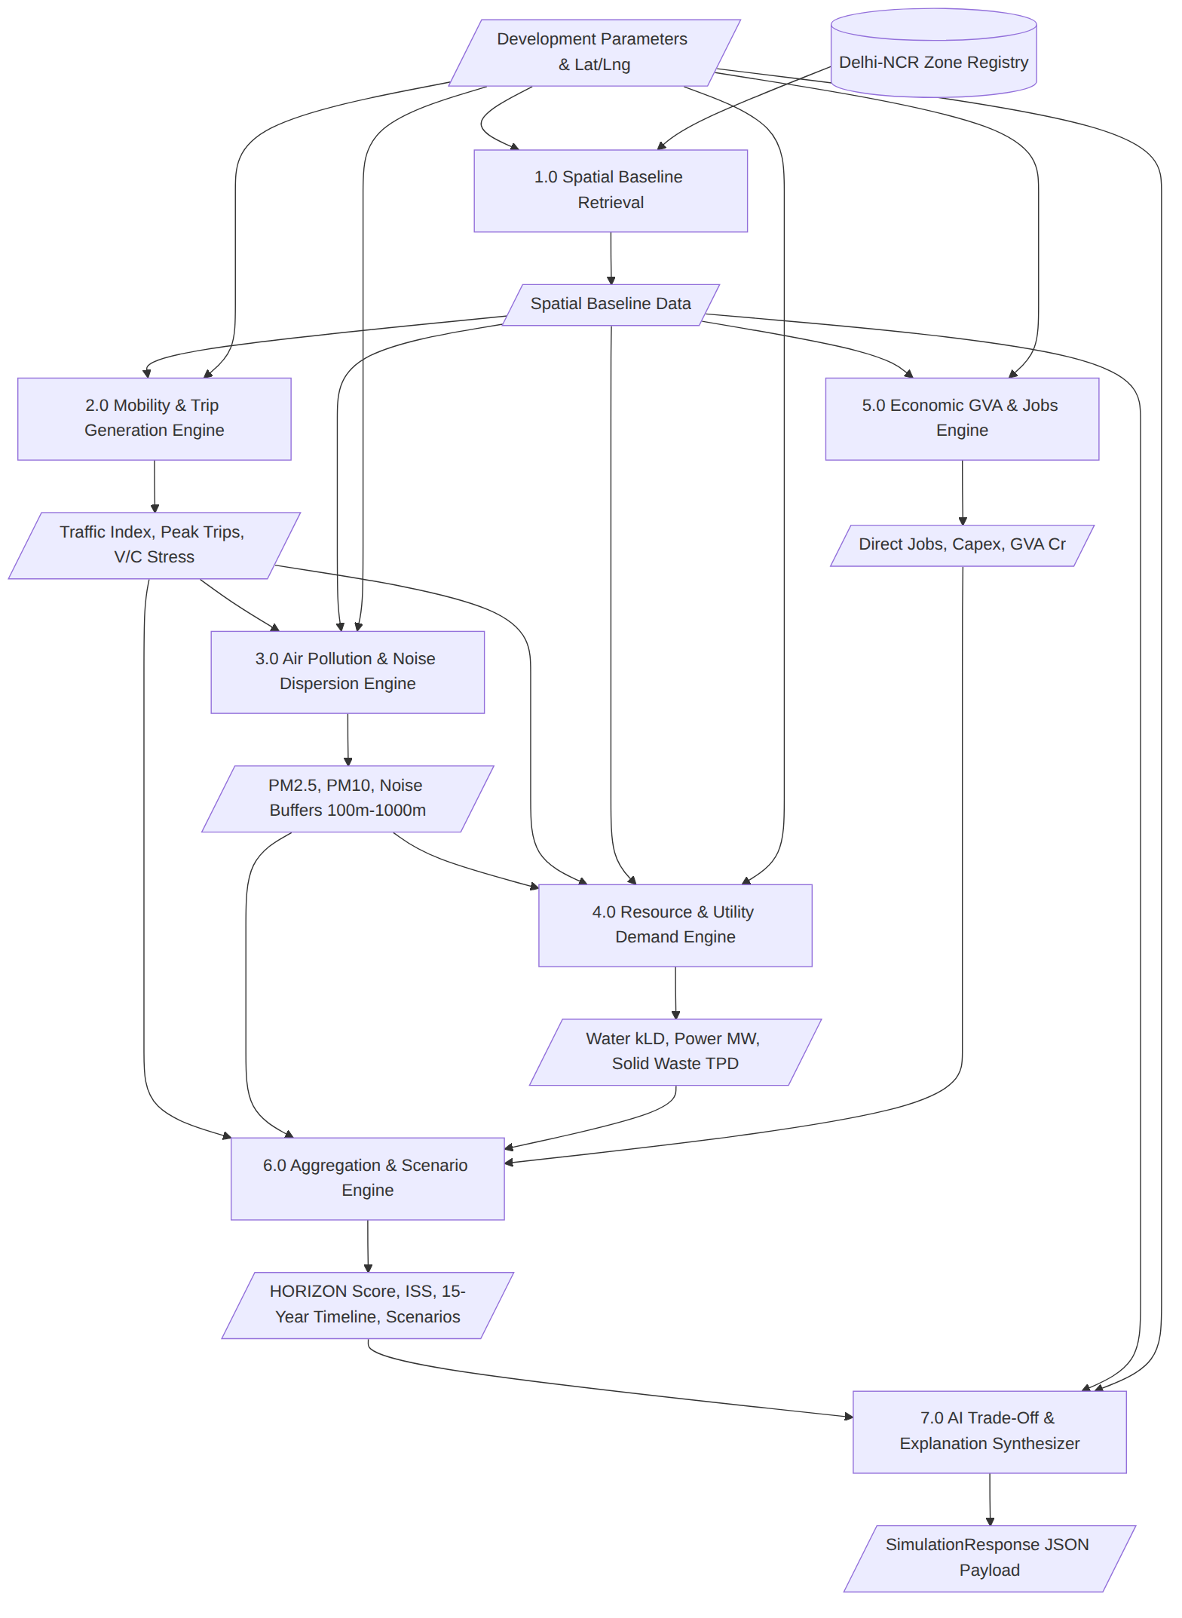

3. Data Schema & Component Design
The system relies on strict Pydantic v2 schemas defined in backend/models/development_schema.py:

3.1 Input Models
- LocationInput: Geocoded coordinates (lat, lng), address string, and planning zone_name.
- DevelopmentInput: dev_type (12 categories: mall, residential, highway, hospital, data_center, etc.), built_up_area_sqft, floors, visitor_capacity_daily, parking_spaces, green_area_hectares, operating_hours_per_day, construction_duration_months.

3.2 Output Models
- SpatialBaselineData: Baseline AQI PM2.5/PM10, water stress rating, existing road capacity %, metro and bus proximity in meters, population density.
- SpatialBufferMetrics: Radial distance buckets (100m, 300m, 500m, 1000m) with distance-decayed PM2.5, PM10, noise (dB), and traffic spillovers.
- PositiveImpactItem & NegativeImpactItem: Itemized impacts with quantified values, category classifications, and severity levels.
- DimensionScores: 7 normalized sub-scores (Economic, Social, Environmental, Mobility, Resources, Infrastructure, Climate Resilience).
- TemporalPoint: Multi-year trajectories for Years 2026, 2028, 2031, 2036, and 2041.
- ScenarioOutput: 3 counterfactual futures with net utility scores and policy modifications.
- SimulationResponse: Root response enclosing scores, explainers, data sources, and confidence index.

4. Working Prototype / MVP Implementation Evidence

4.1 Implemented Modules Breakdown
- Backend Service Layer (backend/services/):
  - spatial_engine.py: Encapsulates 10 Delhi-NCR spatial zones with geofences, baseline AQI, transit nodes, and DDA Master Plan 2041 zoning overlays.
  - mobility_model.py: Calculates trip generation rates, peak-hour surges, and road capacity degradation.
  - pollution_model.py: Implements spatial Gaussian-style dispersion buffers across 100m–1000m radii.
  - resource_model.py: Estimates water demand (kLD), groundwater stress rating, peak power load (MW), and solid waste.
  - economic_model.py: Estimates Capex (₹ Cr), annual Opex, direct/indirect employment, and municipal property tax yield.
  - scenario_engine.py: Aggregates the composite HORIZON Score (0–100), Infrastructure Stress Index (ISS 0–100), builds temporal time-series, and counterfactual scenario variants.
  - llm_explainer.py: Synthesizes plain-language executive trade-offs, explicit sacrifices, and actionable mitigation measures.
- Frontend UI Dashboard (frontend/src/):
  - MapContainer.tsx: Interactive Leaflet/Mapbox vector map showing development anchors, spatial buffer radiuses, transit lines, and zone polygons.
  - FormDrawer.tsx: Dynamic configuration drawer for selecting typology, sizing, capacity, and green buffers.
  - PositiveNegativeLedger.tsx: Dual-panel comparative breakdown showing quantifiable gains versus environmental sacrifices.
  - StressGauge.tsx & RadarMetrics.tsx: Real-time visual meters for ISS (Infrastructure Stress Index) and multi-dimensional balance.
  - TemporalTimeline.tsx: Interactive slider projecting 15-year future trajectories (2026–2041).
  - ChallengeDrawer.tsx: Counterfactual scenario selector allowing planners to test green mitigations on the fly.

5. Milestone-2 Test Cases & Initial Validation Plan
The following test suites are established to satisfy the Milestone-2 testing criterion:
Test Suite ID | Target Component | Validation Objective | Expected Behavior
TC-01 | spatial_engine.py | Coordinate-to-zone nearest mapping | Correctly identifies Noida Sector 62, Cyber City, Dwarka Corridor.
TC-02 | mobility_model.py | Trip generation by typology | Commercial mall generates higher peak vehicle trips than school or solar farm.
TC-03 | pollution_model.py | Radial buffer decay | PM2.5 and noise pollution decrease monotonically from 100m to 1000m.
TC-04 | resource_model.py | Water stress critical threshold | Exceeding 150 kLD in a Critical aquifer zone triggers a “Critical” drawdown flag.
TC-05 | economic_model.py | Capex & Jobs proportionality | Larger built-up area generates proportionally higher Capex and employment.
TC-06 | scenario_engine.py | Score normalization | HORIZON Score and ISS always remain strictly bounded between 0.0 and 100.0.
TC-07 | api/simulate | End-to-end integration latency | API handles standard payload and returns within 500ms with HTTP 200.

6. Completed Work vs Remaining Work for Final Evaluation

Completed Work (Milestone-2)
- ☒ Full core causal simulation backend (7 modular microservices).
- ☒ Pydantic v2 validation and error handling for all development parameters.
- ☒ Responsive Next.js frontend with live map, gauges, ledgers, and sliders.
- ☒ Integration with Delhi-NCR geospatial baseline points and Master Plan 2041 zoning.
- ☒ Dynamic counterfactual scenario generator and AI explainer.

Remaining Work for Final Evaluation
- ☐ Implement automated unit and regression test suite (pytest) in backend.
- ☐ Conduct latency and load benchmarking under concurrent simulation requests.
- ☐ Validate simulated PM2.5 and traffic spikes against published CPCB/DDA historical case studies.
- ☐ Compile the final 20–40 page Capstone Project Report following Section 12 formatting guidelines.
- ☐ Prepare final presentation slide deck and rehearsed live demonstration script.

