1. Class="gLFyf"

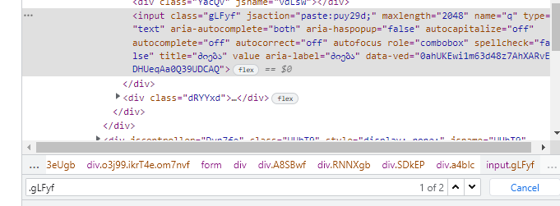

1. Data-ved ="0ahUKEwil9PiZ5sz7AhXkgP0HHQ-4CfoQ4dUDCBA"



1. //\*[@id="gb"]/div/div[1]/div/div[2]/a