For some reasons, there are large gaps between pages. Please move to the next page if you cannot find my response.

SCI - 201:  Assignment 3  Due Saturday, February 9, 11:59 AM,  electronic submission (drop box A3) | Student ID:  Last Name:  Score: /27
________________________________________________________________

1. [8] Short answer questions:

- [1] How grey body differs from black body? (2-3 sentences)

Grey body does not absorb all radition and emit a portion of them based on a constant ε less than 1, while for black body the constant is 1.

- [1] What is emissivity?

The emissitivity of a material is its surface's relative ability to emit radiation energy.

- [1] What is expression for energy flux from grey body?

It is 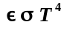, where ε is the emissitivity constant, σ is the Stefan-Boltzmann constant, and T is the temperature.

- [1] Calculate the maximum wavelength of radiation for Sun and then for Earth. [1] What are corresponding frequencies?

By Wien's Law, the wavelength of radiation for
- the Sun: 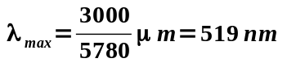, frequency is 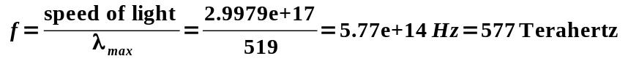
- the Earth: 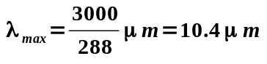, frequency is 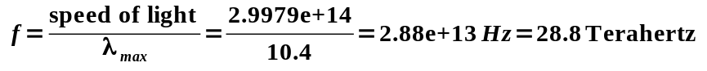

- [1] What is difference in passing Earth atmosphere by solar and earth radiation?

Solar radiation is being reflected off by objects on Earth, which is about 30% of the incoming solar flux (Albedo). Since the atmosphere is a grey body, the Earth radiation is being partly absorbed by the atmostphere.

- [2] Describe greenhouse effect. (2-4 sentences)
Since Earth's radiation wavelengths are longer than that of the Sun, the atmostphere absorbs radiation and then emit part of them back to the Earth. Hence the greenhouse effect.

2. [10] A two-layer model.

- [1] First, repeat one layer modeling of atmosphere (as it was done in class). The layer is transparent to visible light but a blackbody for infrared. Also, assume albedo for visible light is 0.3. Solution should include diagram of energy flow and energy balances of your choice as well as numerical values for mean Earth surface temperature and layer temperature.
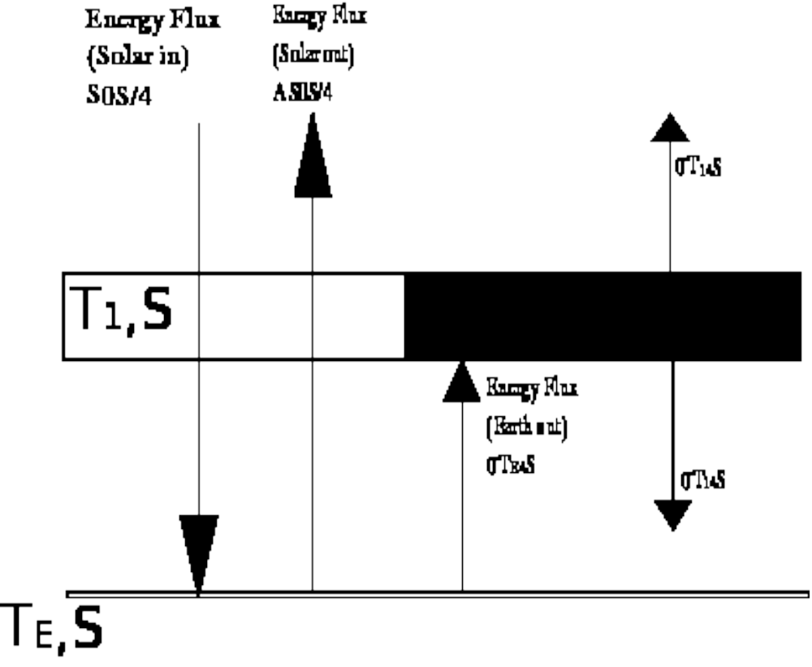
(note: The 4 in T_{E4} and T₁₄ above should be exponents)
Balance of Earth surface and Layer (solve for Layer temperature):
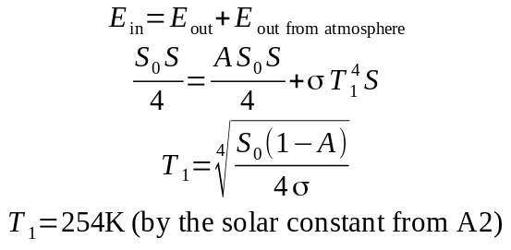
Balance of layer (solve for Average temperature of Earth):
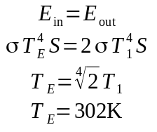
Second, insert another atmospheric layer into the model, just like the first one and:

- [2] Draw diagram of all energy fluxes for this case.
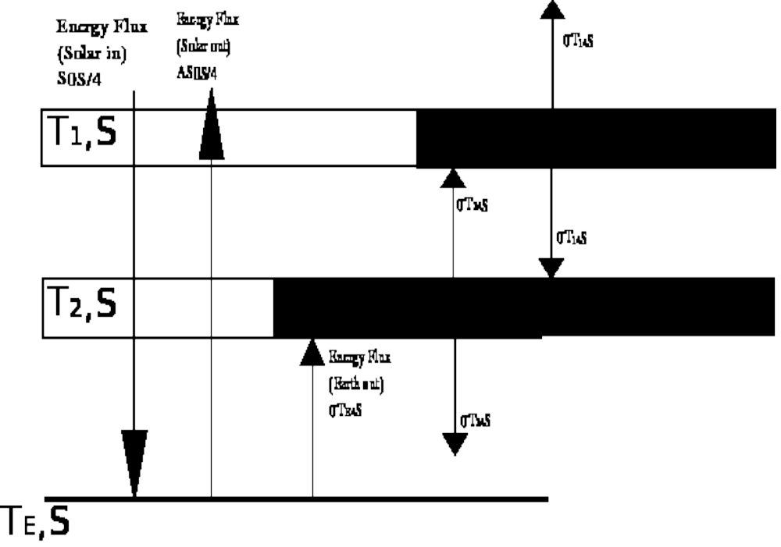
(note: The 4 in T_{E4} , T₁₄ and T₂₄ above should be exponents)

- [2] Write energy balance for the system Earth +Atmosphere, then obtain the temperature the top (layer one) atmospheric layer. Does this part of the exercise seem familiar in any way?

The answer is the same in 2a).

- [2] Write energy balance for the top layer (layer 1). Insert the value you found in c into the energy balance for layer 1, and solve for the temperature of layer 2 in terms of layer 1 (don’t calculate the number).
The balance is
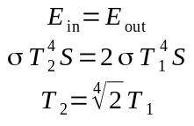

- [2] Write energy balance for the layer 2. Insert the value you found in d into the energy balance for layer 2, and solve for the temperature of Earth in terms of layer 1 (don’t calculate the number).
The balance is
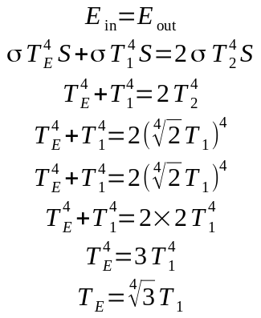

- [1] Calculate numerical values for T2 and TE
T₂ = 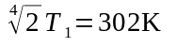
T_{E} = 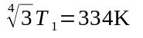

3. [5] Nuclear Winter. [3] Let’s go back to the 1-layer model (2(a)), but let’s change it so that the atmospheric layer absorbs visible light rather than allowing to pass through. This could happen if the upper atmosphere was filled with dust. Also, let’s assume that there is reflection of incoming solar radiation (atmospheric albedo) equal to 0.3. What is the temperature of the ground in this case? (shortcut hint: first balance is for E+A boundary; the second one is for E surface). [2] For the sake of exercise, instead of E surface balance write the second one for the layer and find the earth temperature from it. Any surprises?

The question implies that no radiation will go through the atmostphere. So the balance for the E+A boundary is
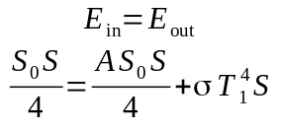

The energy for Earth surface is just the energy coming from the atmosphere:
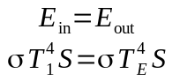

So, we get
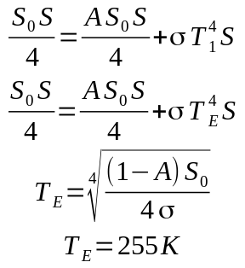

Now consider the atmosphere instead:
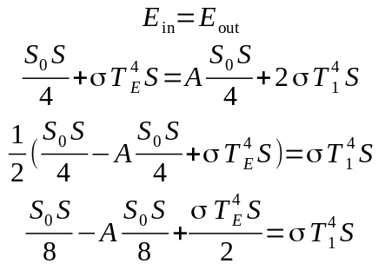

Substitute the above into the E+A balance:
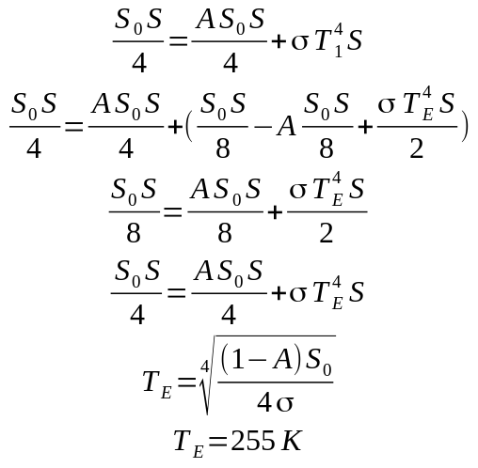
The result is the same. Therefore the second balance can be either for the Earth's surface or for the atmosphere.

- [4] Grey Layer. One more time let’s go back to the 1-layer model (2(a)). Modify the model assuming everything the same, but layer is grey body for IR with emissivity ε=0.6. Solution should include diagram of energy flows and energy balances of your choice as well as numerical values for mean Earth surface temperature and layer temperature.
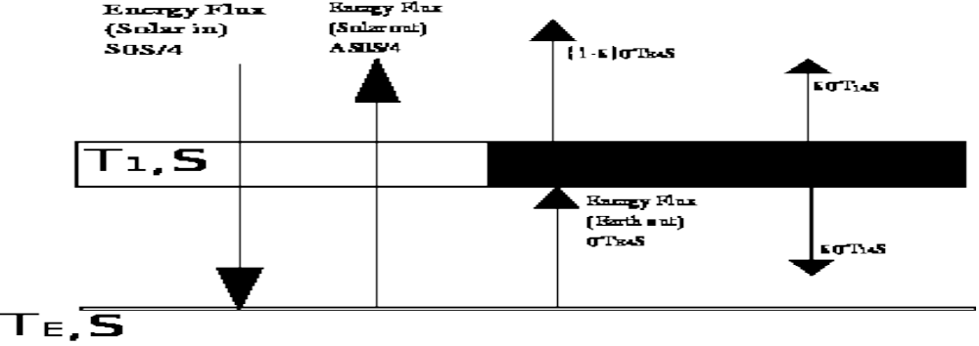
Balance for layer:
The energy flux from Earth is 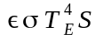because the remaining flux emits through the atmosphere.
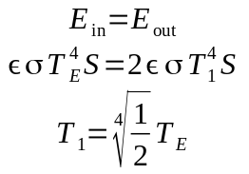
Surface + Layer balance:
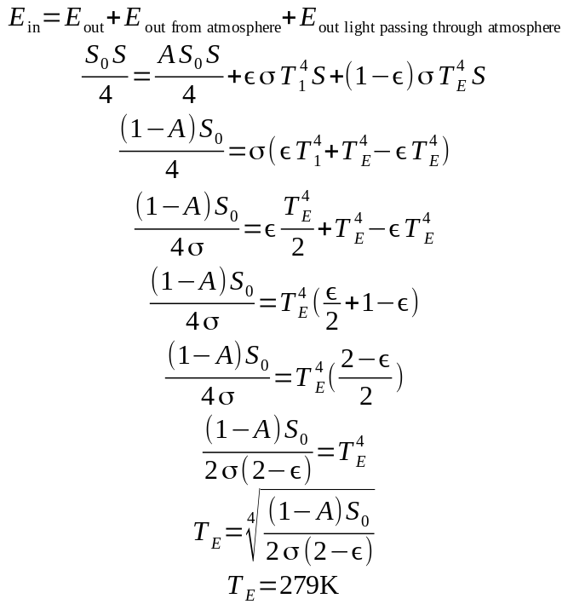
Now substitue T_{E} into the layer balance:
