SCI - 201:  Assignment 5  Due Tuesday, March 12, 23:59,  electronic submission (drop box A5) | Student ID:  Last Name:  Score: /19
________________________________________________________________

1. [8] Read material (Chapter 2) posted at LEARN (Executive Summary, pp.131-132, Introduction and Scope and Concept of Radiative Forcing, Chemically and Radiatively Important Gases, pp 133-142) and answer following questions:

- [0.5] What is the most abundant greenhouse gas in the atmosphere?

- [0.5] Why this gas is not presented in IPCC RF estimations?

- [0.5] For the period 1750-2005 what are increase in the concentration of CO2 (provide initial and final values as well as percentage). [0.5] What is RF created by it?

- [1] List 2 sources of that increase

- [0.5] For the period 1750-2005 what are increase in the concentration of CH4 (provide initial and final values as well as percentage). [0.5] What is RF created by it?

- [1] List 2 sources of that increase

- [0.5] For the period 1750-2005 what are increase in the concentration of N2O (provide initial and final values as well as percentage). [0.5] What is RF created by it?

- [1] List 2 sources of that increase

- [1] What human activity contributes the most to climate change? What this activity releases?

2. [4] Introduction to feedbacks

- [2] Provide definition of feedback, including negative and positive feedbacks

- [1] Provide example of positive feedback

- [1] Provide example of negative feedback

3. [6] Numerical questions. For this set of questions we are going to use our one layer model and its solution:

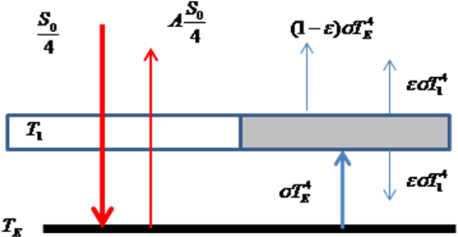 | 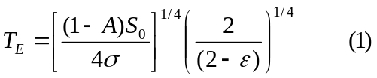  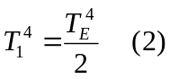

We investigate the variances of solar constant and how it affects the Earth temperature. Within last 25 years observed solar constant changes:

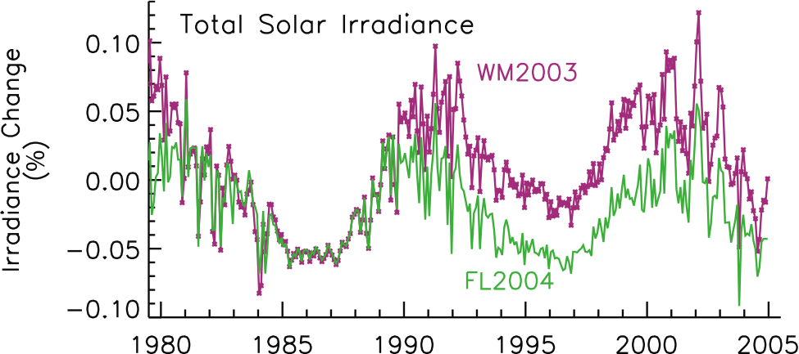

You can see that there were maximum variations +0.1% and -0.1%. Assuming

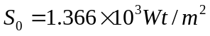 that zero level on the graph corresponds to

- [1] Calculate Smax and Smin of solar constant based on these numbers (round your answer to 4 digits)

b.[3] calculate RF (in Wt/m2) corresponding to Smax and Smin and indicate which one is positive and which one is negative and why.

c.[2] Using Eq. 1 calculate TEmax and TEmin corresponding to Smax and Smin, assuming albedo A=0.3 and value ε=0.79. (Round answers to 5 significant digits)

d.[1] what is climate sensitivity parameter for RF created by solar constant variations presented in this case (use total spans of RF and TE variations)

