SCI - 201:  Assignment 6  Due Tuesday, March 19, 23:59,  electronic submission (drop box A6) | Student ID: 20392255  Last Name: Chan  Score: /18
________________________________________________________________

- [2] List likelihood terminology used by IPCC and its meaning. For example “likely means >66% probability”. List all 10 and make it in table.

Terminology | Likelihood probability of the outcome
Virtually certain | > 99%
Very likely | > 90%
Likely | > 66%
About as likely as not | 33 to 66%
Unlikely | < 33%
Very unlikely | < 10%
Exceptionally unlikely | < 1%

- [8] This question is based on IPCC- Chapter 6 posted at LEARN.

- Read Executive Summary and make (one sentence) statements based on IPCC terminology for the following: (underline terminology words, see example)

[0.0] sea level during the last interglacial and current time

sea level was likely between 4 and 6 m higher during the last interglacial

[0.5] feedback of glacial-interglacial CO2 variations on climate variation

It is very likely that CO2 have strongly amplified climate variation

[0.5] have CO2 variations triggered the end of glacial periods?
It is unlikely that CO2 triggered the end of glacial periods.

[0.5] Have current atmospheric concentrations of CO2 exceed natural range of the last 650 kyr?

It is very likely that the current atmospheric concentrations of CO2 exceed natural range of the last 650kyr.

[0.5] Can the rise of GMST since 1950 be reproduced without including anthropogenic greenhouse gases

It is very likely that the rise of GMST since 1950 be reproduced without including anthropogenic greenhouse gases.

[0.5] was marine carbon cycle responsible for glacial-interglacial CO2 variations?

It is very likely that marine carbon cycle responsible for glacial-interglacial CO2 variations.

[.5] will GMST be significantly influenced by a natural orbitally induced forcing during coming centuries?

It is virtually certain that GMST will not be significantly influenced by a natural orbitally induced forcing during coming centuries.

- [1] Read Box 6.2: “What Caused the Low Atmospheric Carbon Dioxide
Concentrations During Glacial Times?” Do we have answer on this question? P.446

No answer – it remains a question.

- Read Frequently Asked Question 6.1 What Caused the Ice Ages and Other Important Climate Changes Before the Industrial Era? P.449.

[1.5] what are Milankovitch cycles (list all 3 and explain what orbital changes they represent)

Milankovitch cycles are cycles which have regular variations in the Earth's orbit around the Sun.

- Tilt – change in tilt of the Earth's axis
- Eccentricity – change in eccentricity of the orbit
- Precision – changes in the direction of the axis tilt at a given point of the order

[0.5] Do these cycles change global annual mean of solar radiation?

Yes.

[1.5] How eccentricity changes can lead to onset of glacial period?

When the orbit is “squeeze” snow might not melt, which allowed ice sheet to grow.

[0.5] when is next glacial period to begin?

30000 years later.

3. [8] Numerical questions. For this set of questions we are going to use our one layer model and its solution:

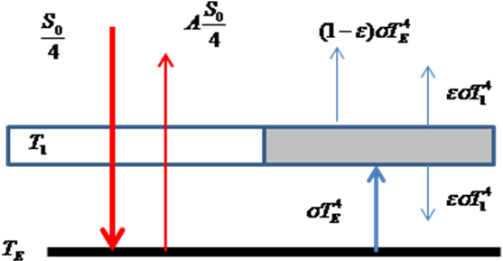

We investigate the variances of solar constant during 1750-2005 and how it affects the Earth temperature.

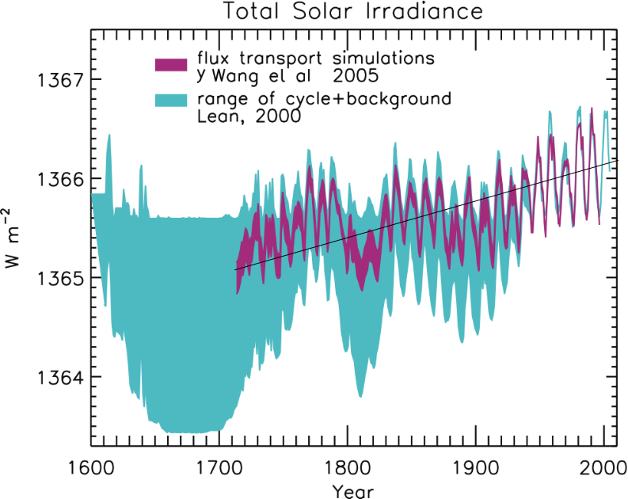
a).[1] Using the picture estimate the change in solar constant between 1750 and 2005. (First, draw the line between 1750 and 2005, then estimate)

change = 1366.2 – 1365.2 = 1.1 Wm^-2

b). [2] Estimate radiative forcing created by this change

RF = (1-A) (change) / 4
= (1-0.3) 1.1 / 4
= 0.1925
= 0.2 Wm^-2

c). [0.5] what is RF due to the change in solar constant according to IPCC? (provide the number and range of uncertainty)

RF = 0.12 Wm^-2, range is 0.06 to 0.30

d). [0.5] Is the value from our model (you got in b) within this uncertainty?

Yes.

e) [2] Recall the value of climate sensitivity parameter (A5, 3(d)) to estimate the maximum possible temperature increase caused by this RF.

Sensitivity parameter = 0.29 K (Wt/m^2)

f). [1] Now use i) the total human made RF created between 1750 and 2005 (IPCC) and ii) and climate sensitivity parameter (found in A5, 3(d)) to estimate the temperature increase caused by this human made RF

Temperature increased = 0.29 * 0.2
= 0.058 K

g). [1] what can be concluded based on the results of e and f in terms of causing of global warming (few sentences)

Solar irradiance seems to have a very low impact on temperature, since the GMST has increased by 1K in the past century, whereas the value in f) is relatively low.

