SCI - 201:  Assignment 2  Due Thursday, January 31, 23:59 | Student ID:  Last Name:  Score: /23

________________________________________________________________

. Short answer questions:

- [0.5] List 4 phases of matter
Solid, liquid, gas, plasma.

- [0.5] In what phase molecules of matter have the lowest kinetic energy
Solid.

- [0.5] Provide definition of Internal Energy of object
Internal energy is the total kinetic and potential energy of the molecules of a substance.

.

- [0.5] How Internal Energy can be changed?
The internal energy of a system can be changed by heating, cooling, or by doing work.

- [1] What is Heat?
Heat is the amount of energy in transit.

- [1.5] What are the ways (mechanisms) of Heat transfer? Write 1-2 sentences for each mechanisms
Conduction is the transfer of heat by placing multiple objects in direct contact.
Convection is the transfer of heat by the up or down movement of gas and liquid.
Radiation is the transfer of heat through eletromagnetic waves moving in vacuum.

- [1] Make definition of Black Body (1 sentence)
A Black Body is an object that is both a perfect emitter and perfect absorber of radiation.

- [2] Define Stefan-Boltzmann Law (it should include what object are considered, Law formula, as well as description of all terms in the formula)
The Stefan-Boltzmann Law is
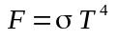
where
F = flux of energy(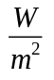)
T = temperature (K)
σ = 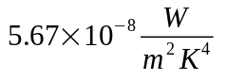

- [0.5] What is solar constant (1 sentence)
It is the energy flux from the Sun at Earth's mean distance from the Sun.

- [1] If you put some object at some temperature in out of space and isolate it from all other objects in the Universe, what would be temperature trend for the object and why?
The side that has contact with the Sun will become warm; the side that does not have contact will have a temperature of 0K.

- [1] Why Temperature of the Earth (being placed out of space) doesn’t have the same trend?
The Earth's atmostphere circulates heat and attempts to reach thermal equilibrium, so the dark side will never be 0K.

. Numerical questions assuming all objects are Black Bodies (solar system data can be found at: http://nssdc.gsfc.nasa.gov/planetary/factsheet/index.html)

- [2] Estimate the total power (Joules per second) radiated out into space by the Sun, assuming Black Body assumption
The Sun's radius 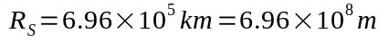
Surface area of the Sun 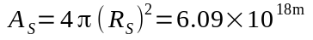
Temperature of the Sun 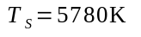
Energy Flux 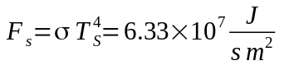
Total Power from the Sun 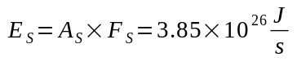

- [3] Estimate solar constant at the Earth and Mercury
Distance between Earth and the Sun 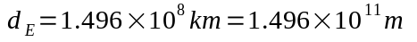
Distance between Mercury and the Sun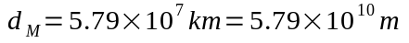
Solar constant at Earth 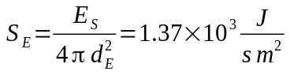
Solar constant at Mercury 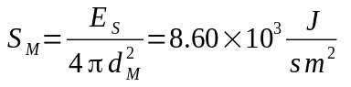

- [4] Estimate temperature of the Earth and the Mercury (use solar constants calculated previously, solution should also include diagram of energy flow and energy balance equation)
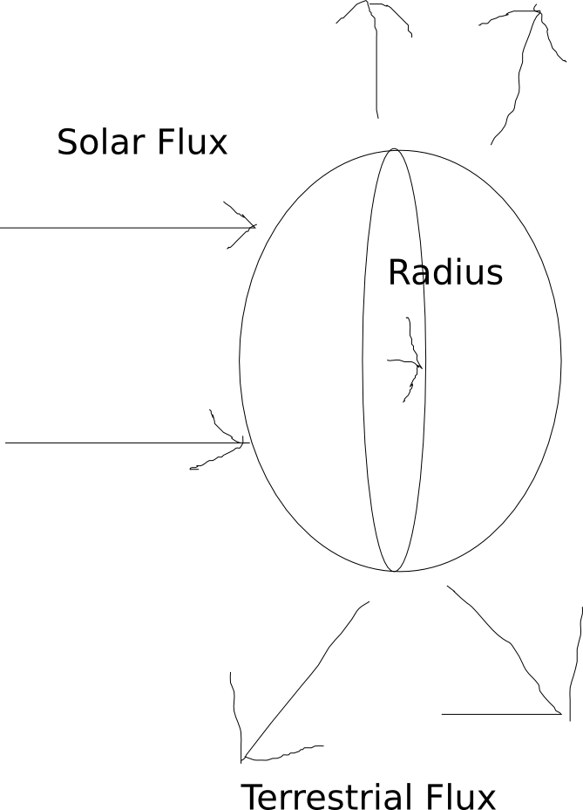
Radius of Earth 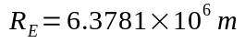
Radius of Mercury
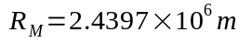

Energy balance for Earth (let 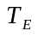 be the temperature of Earth):
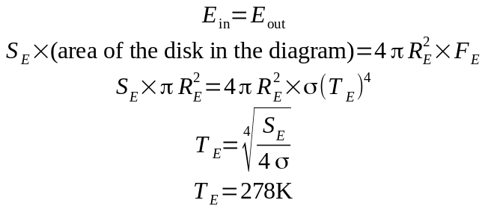
Simularly for 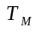, the temperature of Mercury:
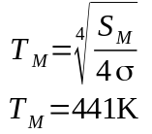

- [1] What is Albedo? What are values for Earth and Mercury? (for the second question google and provide reference)
Albeto is the percentage of light reflected from an object.
Earth's Albeto = 0.3
Mercury's Albedo = 0.1

- [2] Modify solution c, taking into account albedo and [1] briefly explain the difference

Average temperature of Earth:
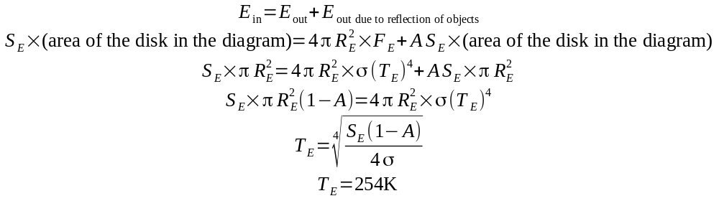

Average temperature of Mercury:
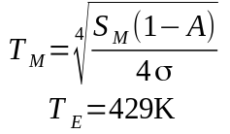
The average temperature in [d] are lower than that of [c], since part of the light are being reflected by some objects on the planet, hence the planets do not absorb as much energy as if they are pure black bodies.

