SCI - 201:  Assignment 4  Due Tuesday, March 5, 23:59,  electronic submission (drop box A4) | Student ID:  Last Name:  Score: /21
________________________________________________________________

- [10] Read material (Chapter 2) posted at LEARN (Executive Summary, pp.131-132, Introduction and Scope and Concept of Radiative Forcing, pp 133-137) and answer following questions:

The term radiative forcing (RF) is used to indicate that Earth’s radiative balance is being pushed away from its normal state.

[0.5] Where the referred balance is considered?

c) at the top of atmosphere

[0.5] Why “radiative” word is used?
Because the factors that contribute to RF change the balance between incoming Solar radiation and outgoing infrared radiation within Earth's atmostphere

[0.5] What units are used to measure RF
Watt per square metre

[0.5] What makes RF positive or negative

Warming makes RF positive, and cooling makes RF negative

Look at the paper used for A1 (fig. 3) and answer the following questions. Please keep in mind that the resolution of the data is about 1000 years, so it doesn’t have accuracy to display current (100-200 years) trends, so data can be considered to reflect trends before 1750.

[1] what are max and min concentration of CO2 during last 400000 years before 1750

Min: 250 ppm
Max: 280 ppm

[1] what are max and min concentration of CH4 during last 400000 years before 1750
Min: 450 ppb
Max: 700 ppb

Back to the material (Chapter 2)

[0.5] What is current (2005) concentration of CO2
380ppm

[0.5] What is current (2005) concentration of CH4

1900ppb

[2] Compare to 1750 what is RF (in Wt/m2 as well as indicate positive or negative) due to

net deforestation: -0.2 W/m^2

increases in solar irradiance: 0.12 W/m^2

increase in global mean concentration of CO2: 100ppm

increase in global mean concentration of CH4 : 1200ppb

[2] what is climate sensitivity parameter and how Radiative Forcing related to the GMST

climate sensitivity parameter is the measurement of how responsive the temperature the climate system is to a change in the radiative forcing.

[1] What is the total net of RF caused by human activities between 1750 and 2005 and what is the main contributor to this.

1.6 W/m^2

2. [11] Numerical questions. For this set of questions we are going to use our one layer model and its solution:

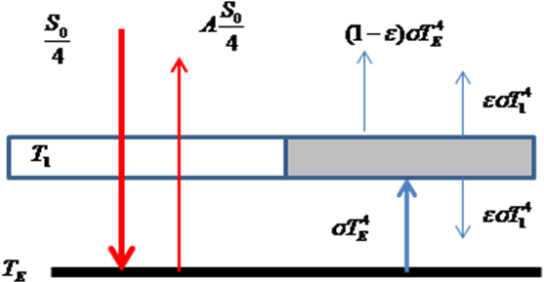 | 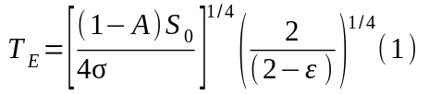  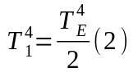
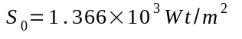
[2] Assuming and A=30%, find the value of ε which provides the current earth temperature of 15º C

Rearrange equation one for episilon:

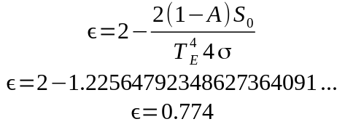

[1] Substitute the answer for ε into Eq. 1 and calculate TE. If calculation gives the current earth temperature, you got correct ε. If not, check your solution and redo it until you get correct answer

T_E = 287.9…
T_E = 288K

[1] calculate atmospheric temperature

From equation 2,
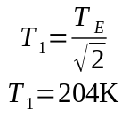

b) [3] If we increase the value of ε (received in part a) by 0.1, but keeping solar constant and albedo the same, what is the value of RF ( in Wt/m2) would be created?

Let ε_1 = ε + 0.1. Then consider the difference of the 2 fluxes that comes out/pass through the atmosphere to the outer space:

Flux 1:
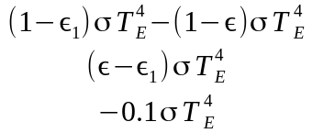

Flux 2:

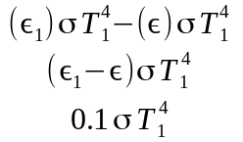
Net Flux:

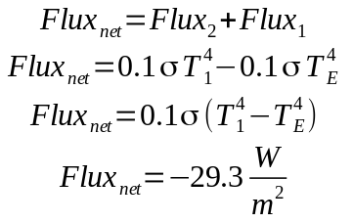

[1] Based on the sign of the answer the energy coming from the system (E+A) is increased or decreased?

descreased

1] Temperature of the system is expected to increase or decrease?

Increase because less energy is going out

[1] Forcing created by increasing ε is negative or positive?

positive

[1] calculate the value of TE with increased (by 0.1) ε

TE = 294K

