Day 7 - 04th June 2025

Java

|  |  |
| --- | --- |
| Java basics | Data Types, Variables, Operators, Control Statements, Loops, Arrays, Classes, Objects, |

Task 1:

Create a code to display

“Hello guys!!!! “

“We are learning Java”

Using a single output statement…

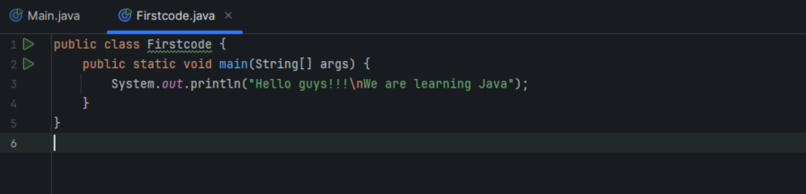

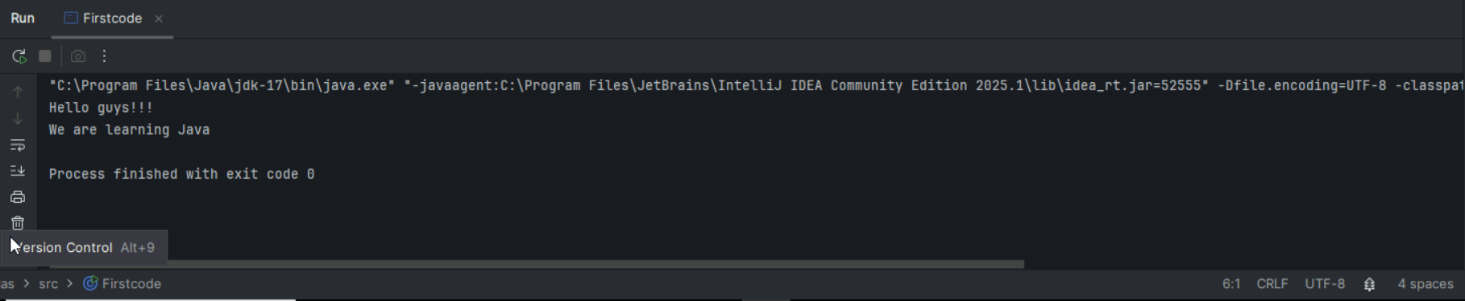

Task 2:

 Write a Program in Java to Add two Numbers.

Input: 2 3

Output: 5

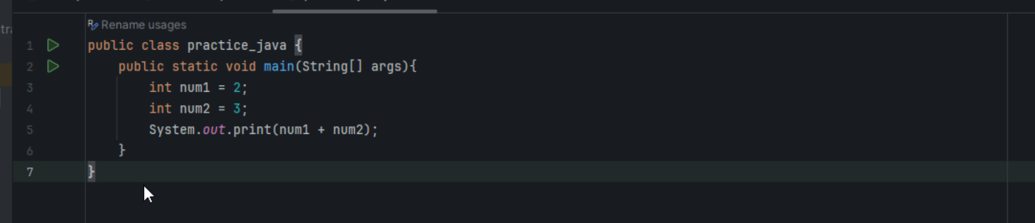

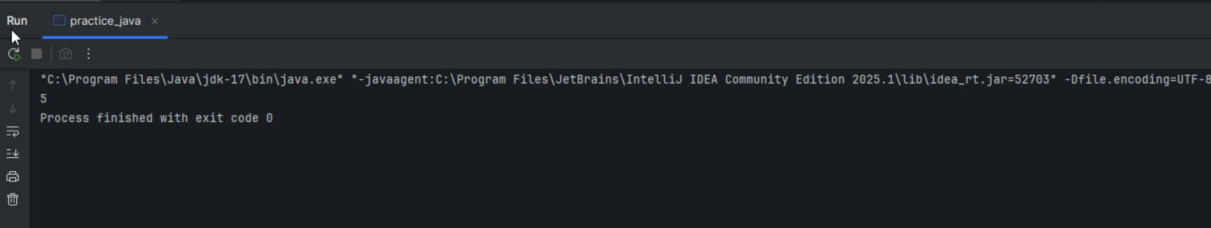

Task 003:

Write a Program to Swap Two Numbers

Input: a=2  b=5

Output: a=5  b=2

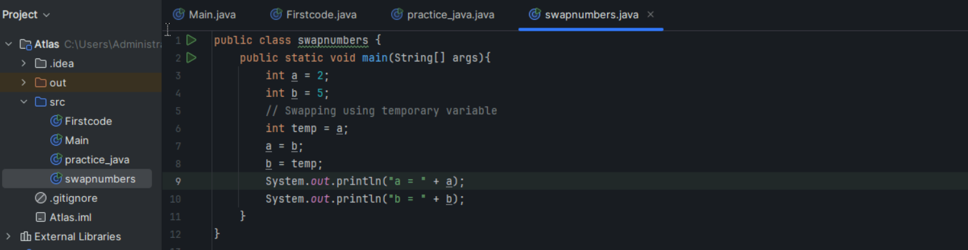

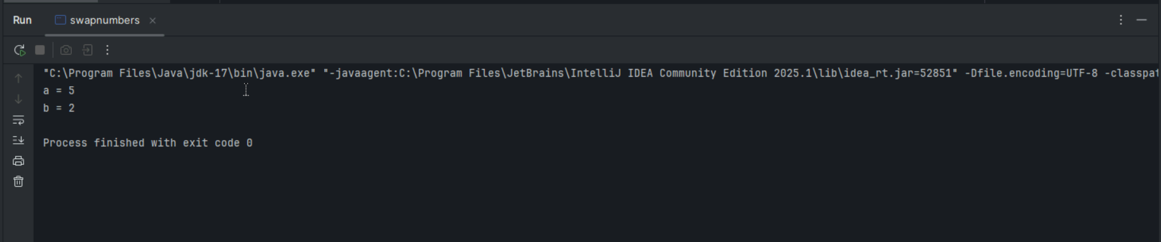

Task 004:

 Create a code in which you have 4 methods add, subtract, multiply and divide (return type int) with a main [method..to](http://method..to) all all the other methods

Out put:

Main started

Sum of 2 numbers is …..

Diff of 2 numbers is —-

Product of 2 numbers ….

Division of 2 numbers is ….

Main ended

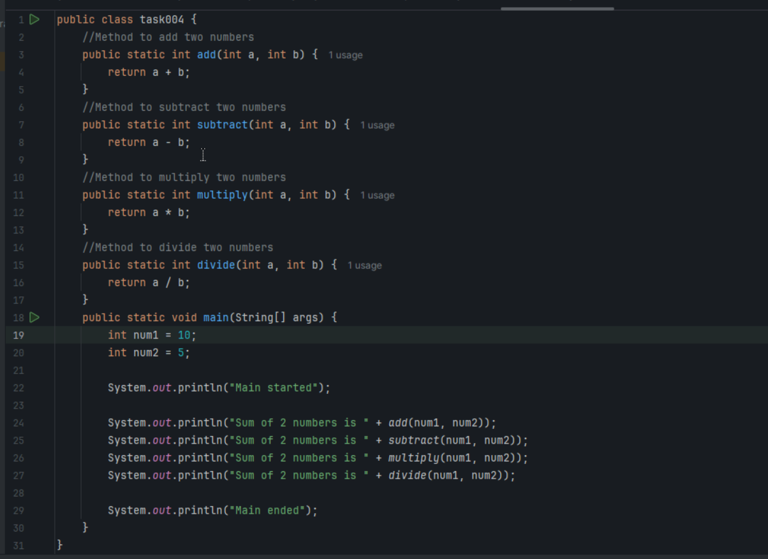

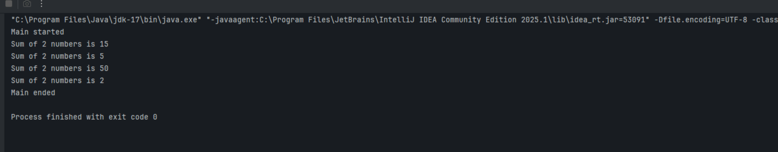

Task 005:

Write a program to check if a is greater or b.. Use ternary op

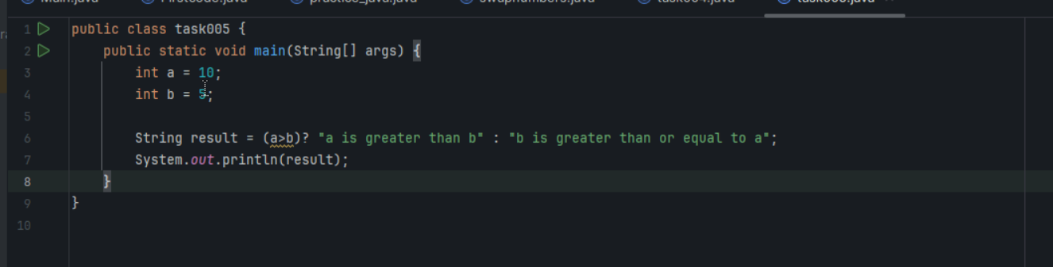

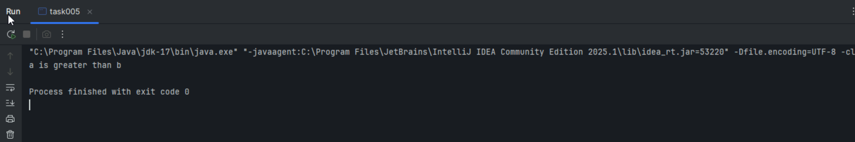

Task 006:

Write a program to take input from the user and display it to the user

Input:

Id : Prasunamba

Pwd: 123456789

Output:

Hi ,

Your login id is Prasuanmba

And your pwd is *********

HInt :

For scanner … import java.util.scanner;

Scanner sc = new Scanner([System.in](http://system.in));

Id = sc.nexLine();

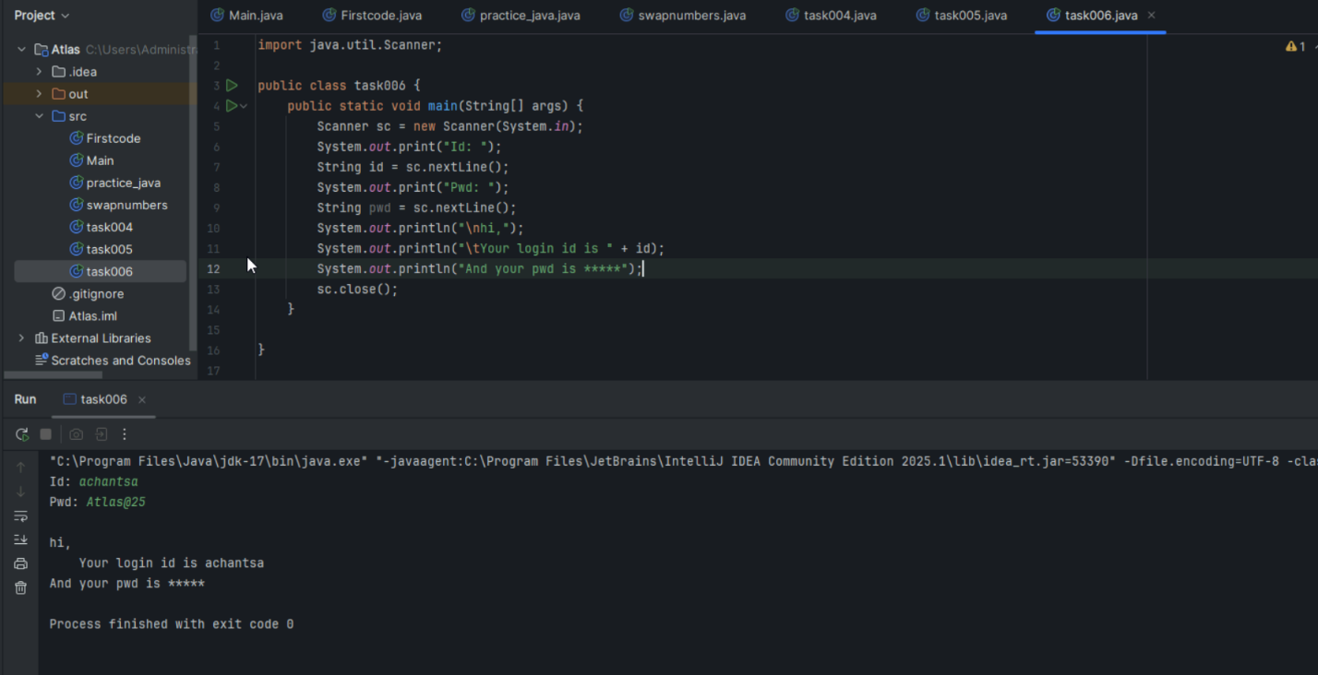

Task 007:

Write a program to create a class named Customer

Call the customer class in Task007 class using an object

Hint

In the main method

Class Customer{

  Void accept(){

sysout(“accept customer called”);

}

Void display(){

sysout(“display customer called”);

}

}

Public class Test007{

psvm(String[] argos){

Customer cobj = new Customer();

cobj.accept();

cobj.display();

}

}

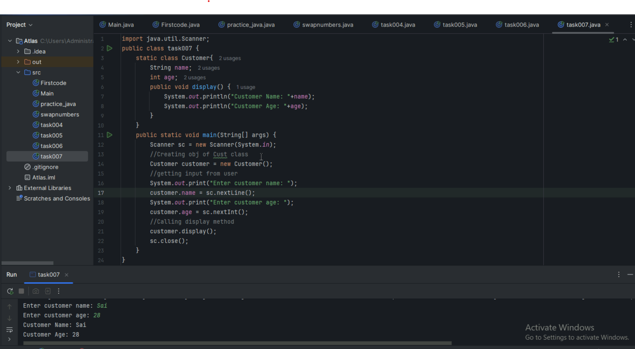

Task 008:

Wap to check the greater of 2 numbers

Hint:

Use if else

If ( num1 > num2){

sout(“num1 is greater”);

}

Else {

sout(“num2 is greater”);

}

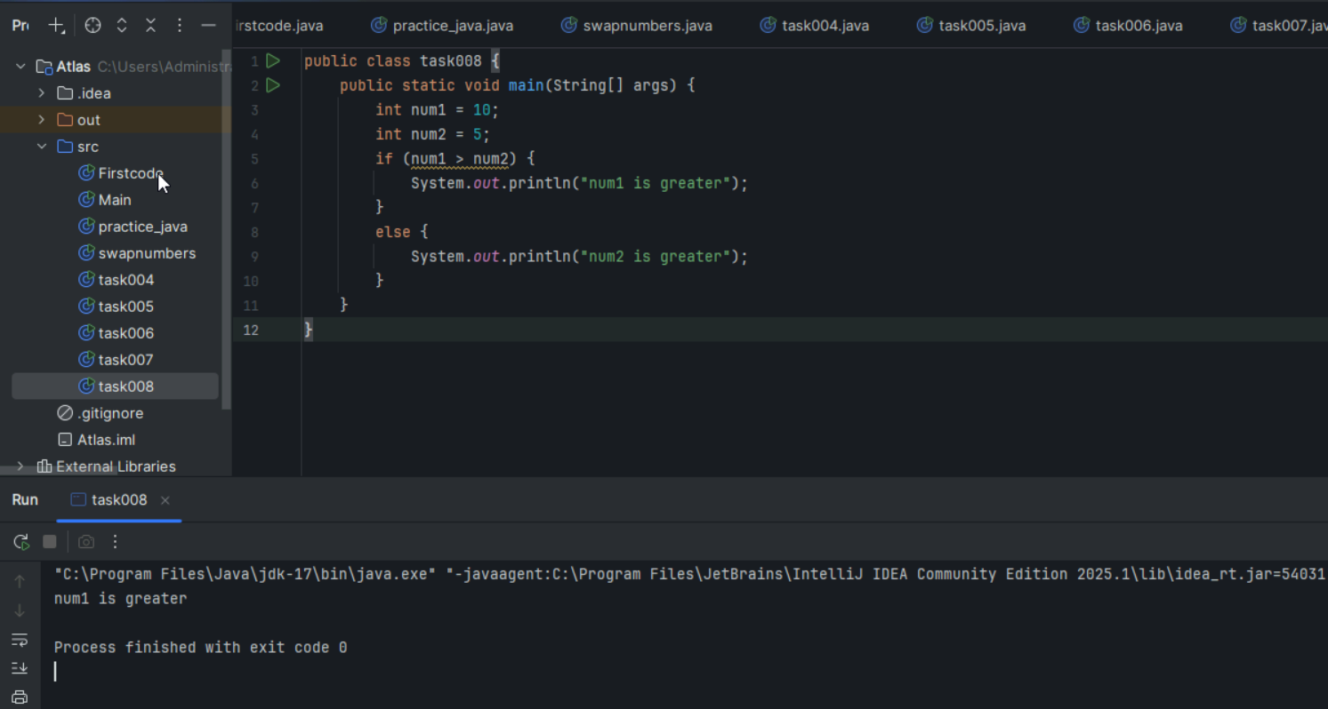

Task 009

Wap to check greater of 3 numbers

Hint 👍

Use elseif

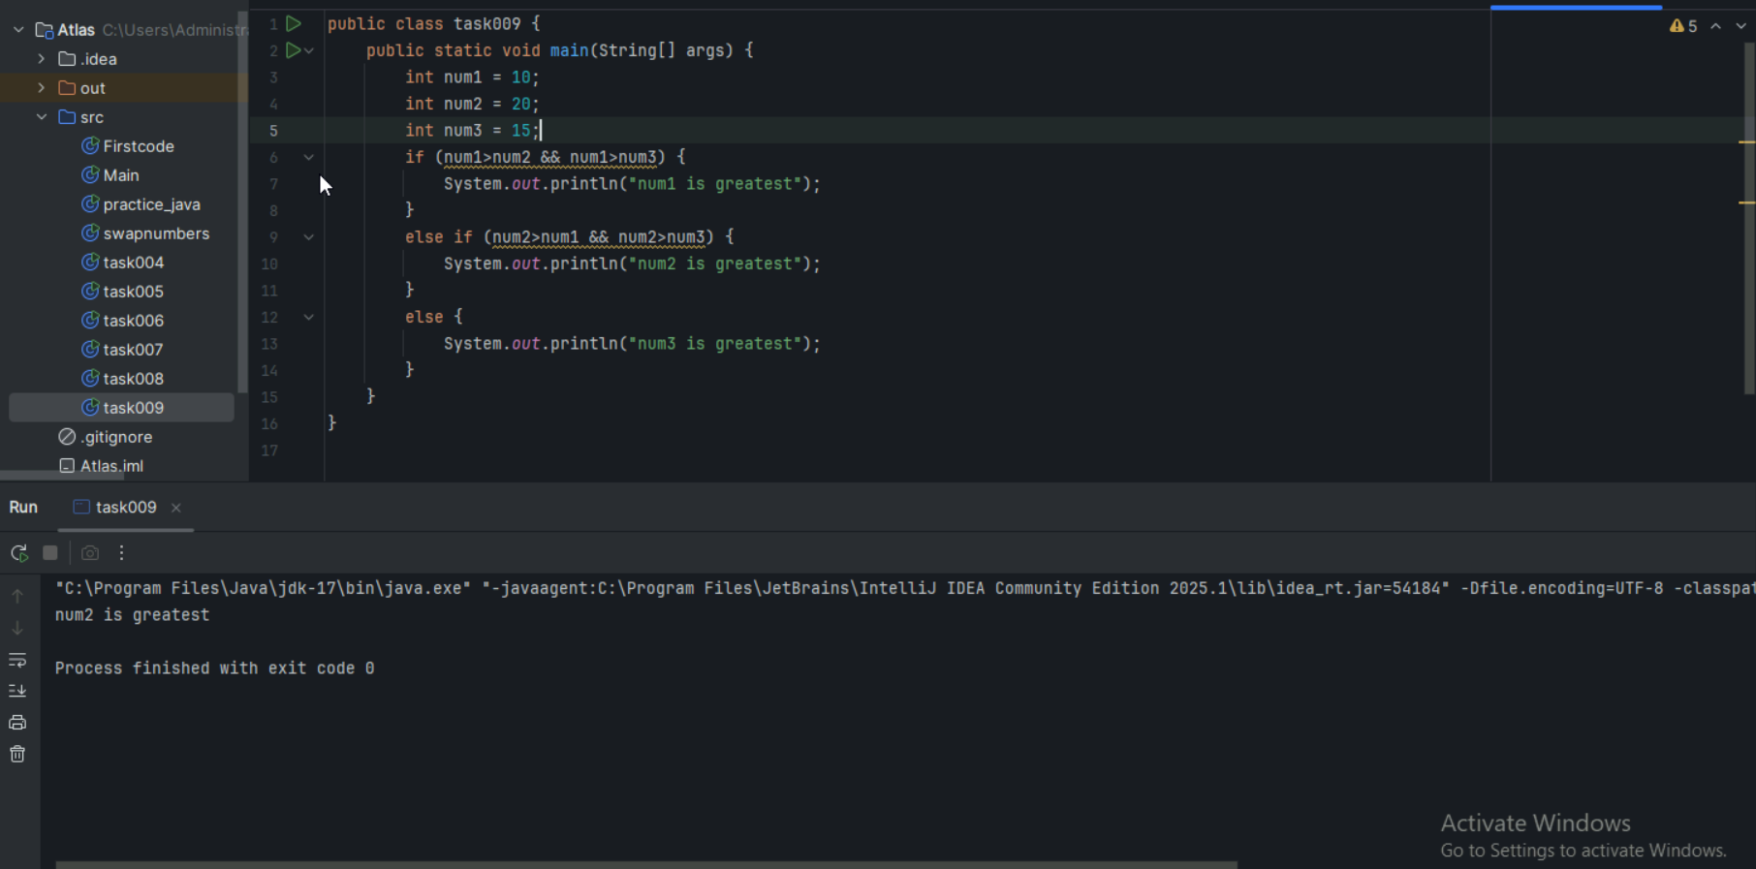

Task 010:

Wap to check if check week days

1  ===> sunday

2 ===> monday

So on

8 and above ===> invalid input

Hint : use Switch case

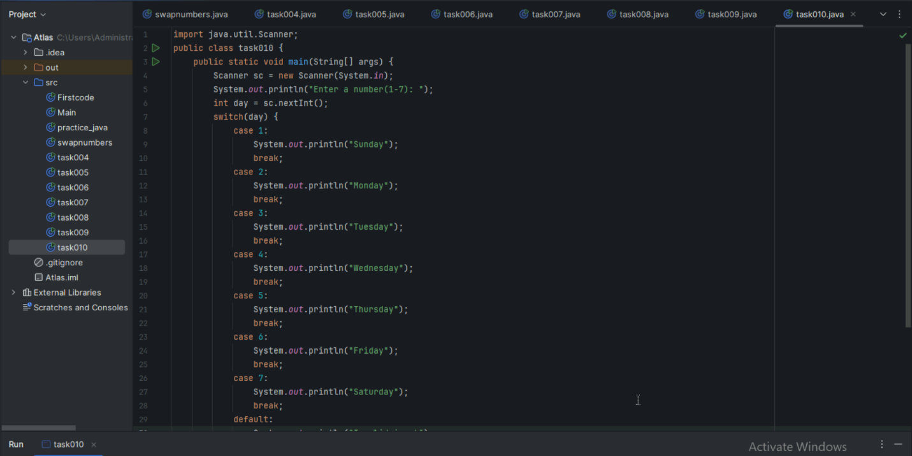

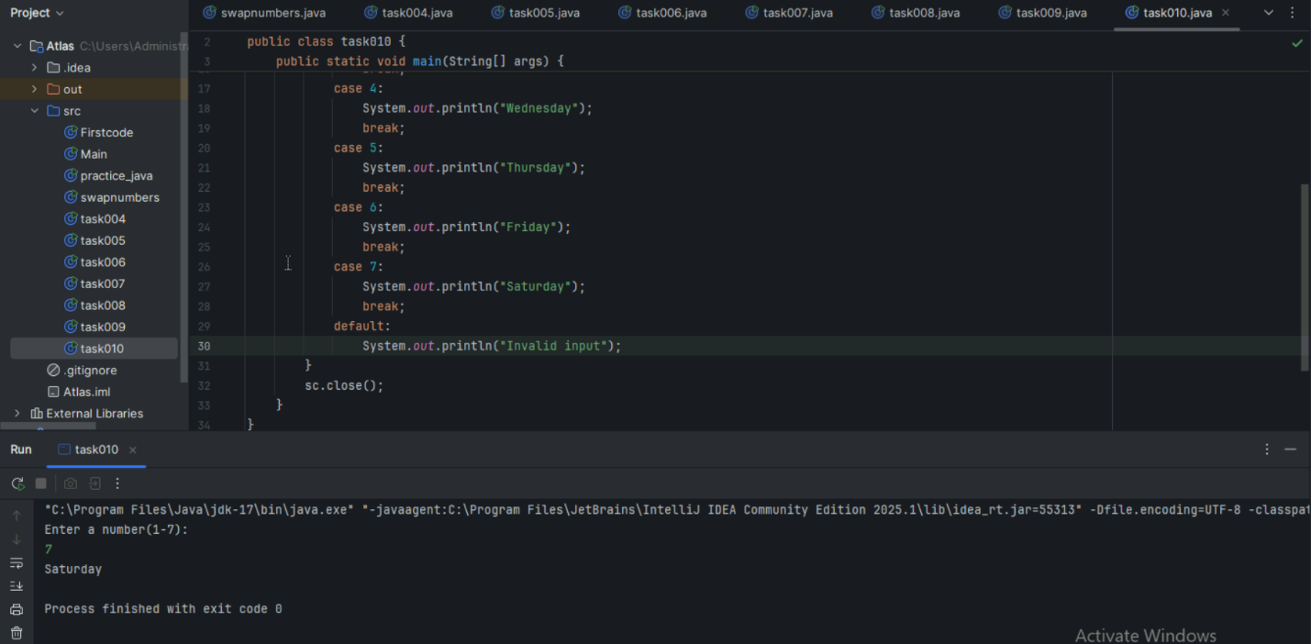

Task 011:

Wap to check loginid and password validation

Hint use while loop

Scanner sc = new Scanner(System.in);

String loginid = “Prasunamba”

String pwd = “12345867”

Int Count = 0;

While (loginid == “Prasunamba” && pwd == “12345867”){

sout(“ you have logged in for  ”+ count++ +” times”);

sout(“enter ur login id and password”);

loginid = sc.NextLine();

pwd = sc.NextLine();

}

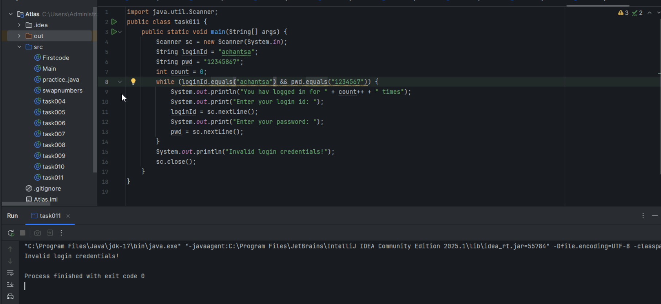

Task 012:

Same as above qn but use do while loop

Scanner sc = new Scanner(System.in);

String loginid = “Prasunamba”

String pwd = “12345867”

Int Count = 0;

do{

sout(“ you have logged in for  ”+ count++ +” times”);

sout(“enter ur login id and password”);

loginid = sc.NextLine();

pwd = sc.NextLine();

}While (loginid == “Prasunamba” && pwd == “12345867”);

sc.close();

While and do while loops - indefinite loops

For loop is definite…

For (initialization exp; condition exp; incre or decre exp)

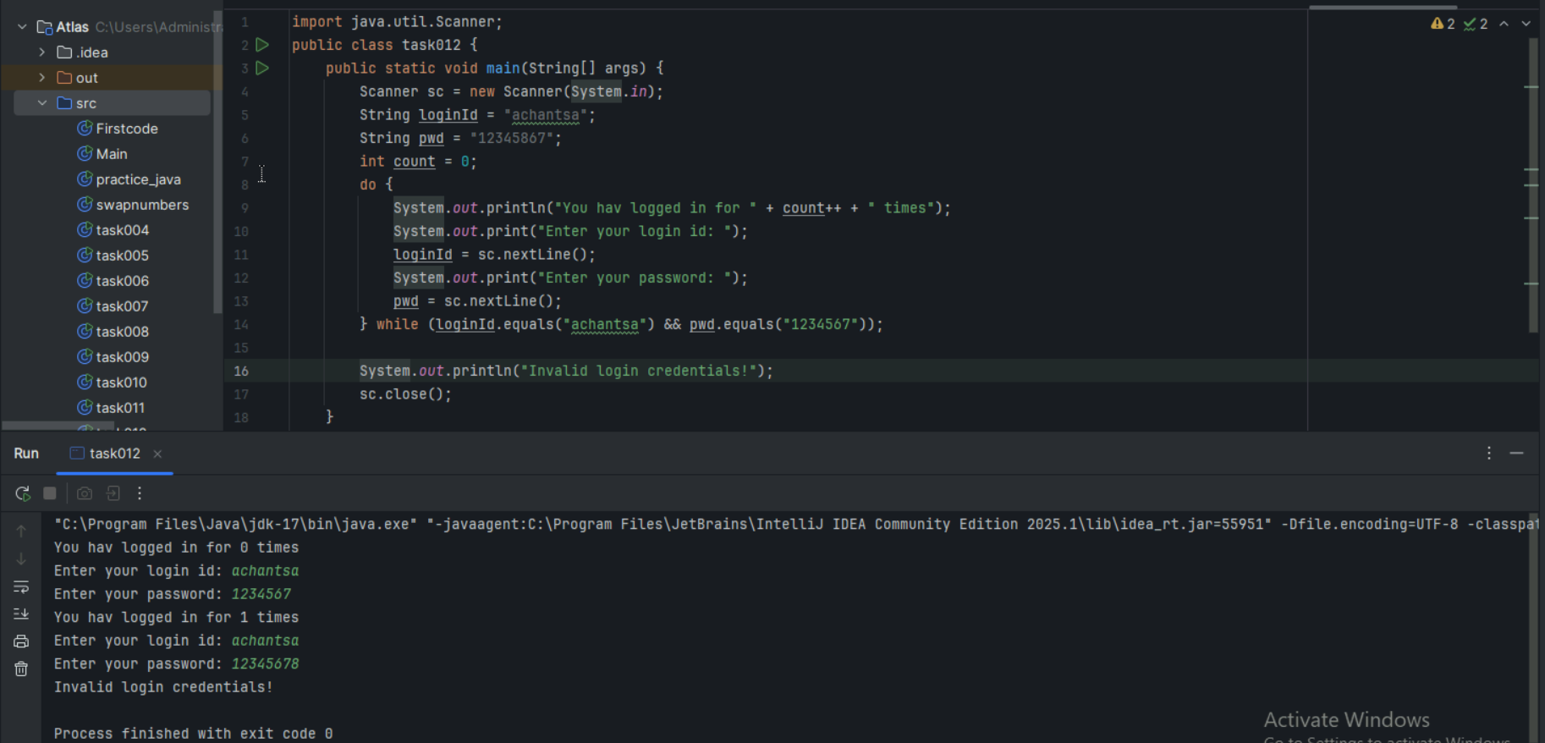

Task 013:

Wap to display numbers from 10 to 1 .. skip 7 and 5.

for(int i= 10; i >0; i–){

If ( i == 5 || i == 7){

Continue;

sout(i);

}

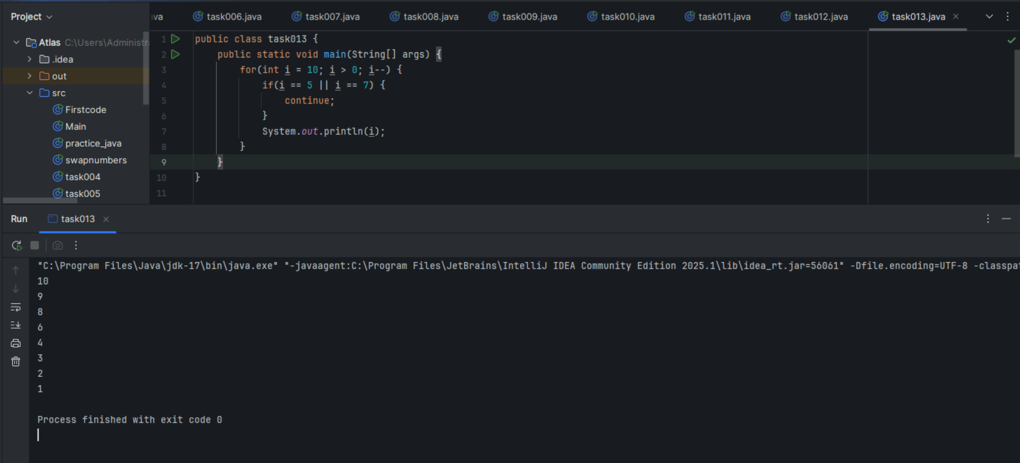

Task 014:

Arrays:

Try the below code and display the output…

Now play with it try to access arr of 5th index and see the output…and try to access arr of -1 index and see the output..

package Arrays;

public class Demo01 {

public static void main(String[] args) {

// TODO Auto-generated method stub

char[] arr = {'a','e','i','o','u'};

System.out.println(arr);

String[] names = {"Meena", "Tina", "Veena", "heena"};

System.out.println(names[0]);

names[1]= "Reena";

System.out.println(names[1]);

System.out.println(names.length);

System.out.println(names[4]);

//Exception in thread "main" java.lang.ArrayIndexOutOfBoundsException

}

}

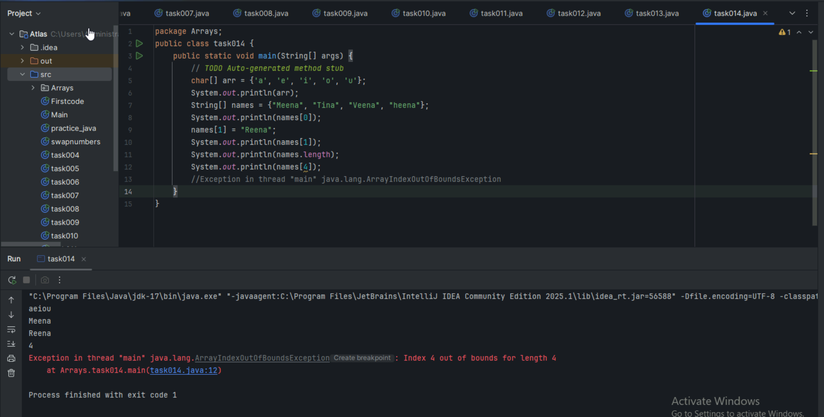

Strings:

Task 015:

package StringHandling;

public class Demo01 {

public static void main(String[] args) {

// TODO Auto-generated method stub

String str1 = "Java Strings "; // string Literal

String str2 = new String(str1); // obj of the string - new keyword

String str3 = new String("are easy to learn ");

char ch[] = {'S', 't', 'r' ,'i', 'n', 'g'};

String str4 = new String(ch);

System.out.println(str1 + "\n" + str2 + "\n" +str3 + "\n" +str4);

}

}

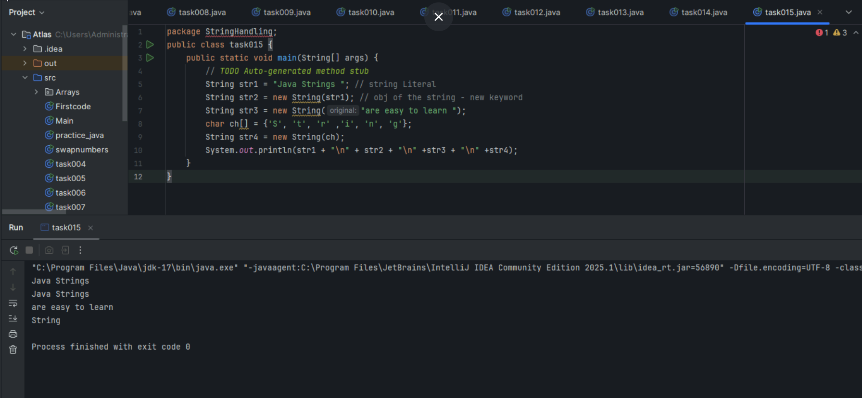

Task 016

Enums or Enumerations

What is the output of the below code snippet

package Enumerations;

enum color{

red, blue, green, yellow

}

public class Demo01 {

public static void main(String[] args) {

color c1 = color.yellow;

System.out.println(c1);

}

}

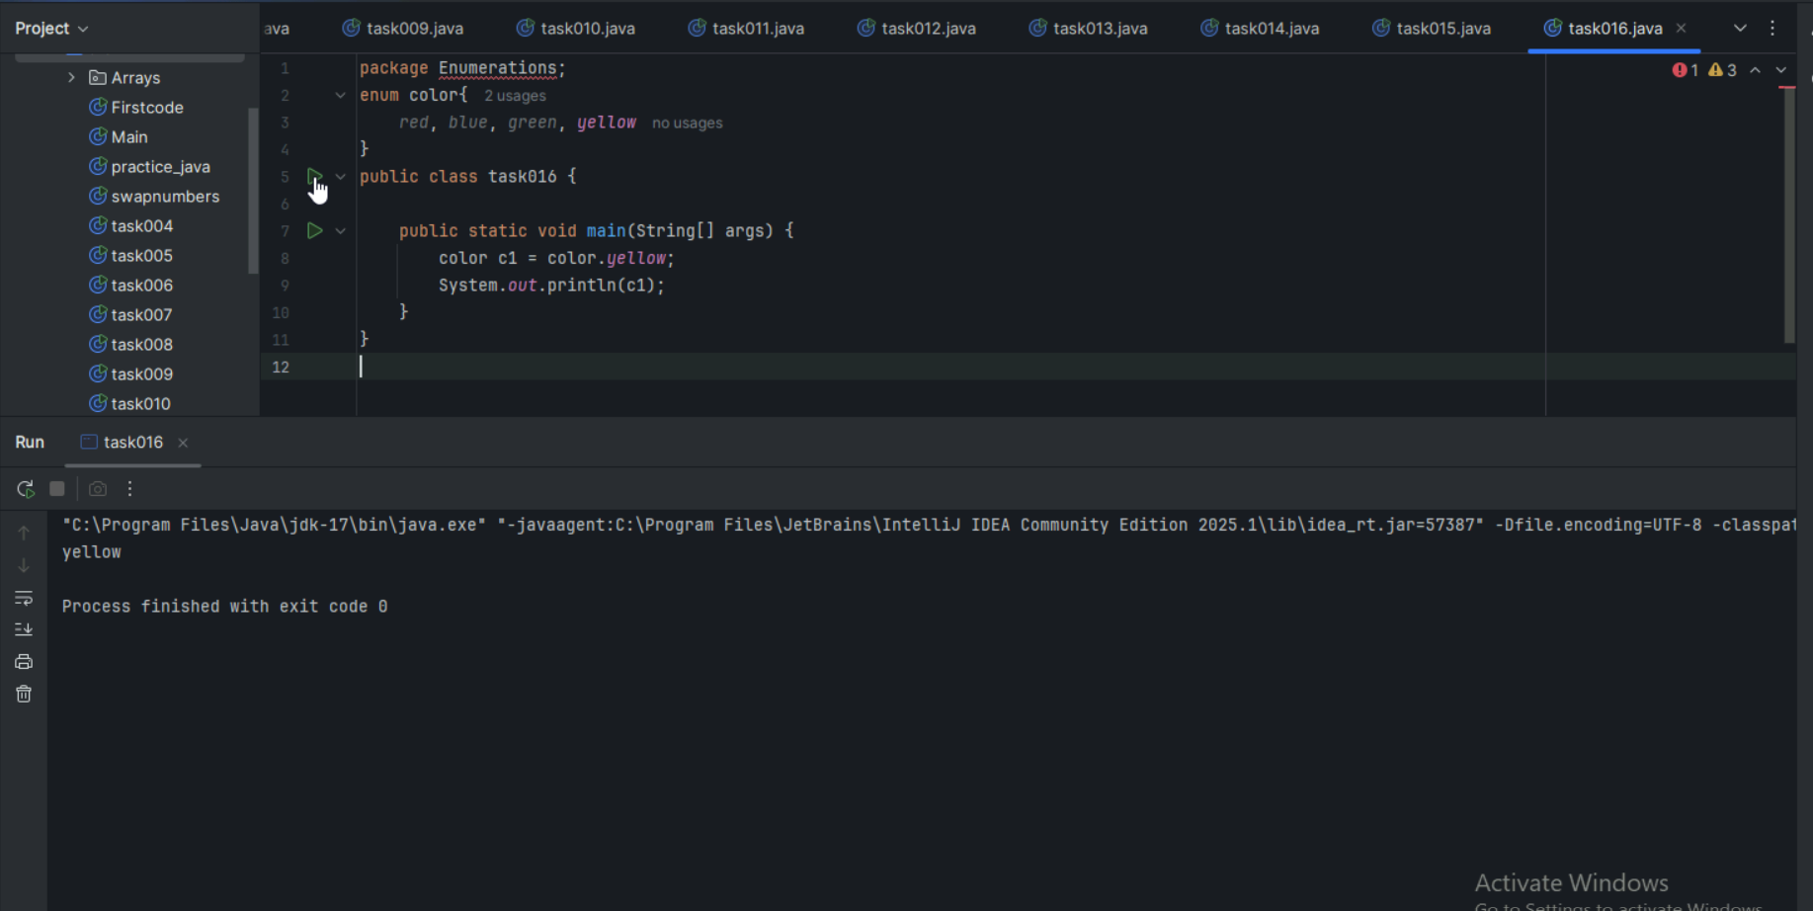

Task 017:

Getter and setter

Create a program name Person.java

public class Person {

   private String name;

   // Getter

   public String getName() {

     return name;

   }

   // Setter

   public void setName(String newName) {

     this.name = newName;

   }

}

Create another program named Task017.java

public class Task017{

  public static void main(String[] args) {

    Person myObj = new Person();

    myObj.name = "John";

    System.out.println(myObj.name);

  }

}