Lab 1: BASIC NEURON MODEL
Objectives:
- Implement a basic artificial neuron with selectable activation functions (sigmoid, tanh, ReLU) and observe its output on sample inputs.
- Visualize and compare common activation functions.
- Build a simple 3-layer feedforward neural network and perform a forward pass on random input to inspect outputs and shapes.
Theory:
An artificial neuron computes a weighted sum of its inputs and adds a bias to form a pre-activation value z = w^{T} x + b, which is then passed through a nonlinear activation function to produce the final output. The choice of activation introduces nonlinearity and strongly influences learning dynamics and representational capacity. In this lab, three common activations are used. The sigmoid function σ(x) = 1/(1 + e^(−x)) maps real inputs to (0, 1) and is often interpreted as a probability; however, it saturates at the extremes, which can lead to vanishing gradients. The tanh function is similarly sigmoidal but zero-centered in (−1, 1), offering symmetric saturation and often faster convergence than sigmoid in some settings. The ReLU function, ReLU(x) = max(0, x), retains linearity for positive inputs and zeroes out negatives, mitigating vanishing gradients on the positive side but risking “dead” neurons when activations remain negative. For numerical stability, the sigmoid implementation clips its input to prevent overflow in the exponential.
Building upon the single neuron, the simple network here is a one-hidden-layer feedforward model. Given inputs X, the network computes the hidden pre-activation Z1 = XW1 + b1, applies a sigmoid nonlinearity A1 = σ(Z1), then produces output pre-activations Z2 = A1W2 + b2 and final activations A2 = σ(Z2). Weights are initialized from small Gaussian distributions and biases are initialized to zero for the network (the standalone neuron uses random bias). No learning or backpropagation is performed; the focus is purely on forward propagation and understanding how dimensionalities and activations flow through the layers.
Algorithm:
For Simple Perceptron:
- Start
- Initialize parameters
- BasicNeuron.forward(inputs): compute z = inputs·weights + bias; apply activation f according to the selected mode (sigmoid with clipping, tanh, or ReLU); return f(z) (or z if no activation).
- SimpleNetwork.forward(X): compute Z1 = XW1 + b1, A1 = sigmoid(Z1), Z2 = A1W2 + b2, A2 = sigmoid(Z2); return A2.
- Plot_activation_functions(): generate x over [−5, 5], compute curves for sigmoid, tanh, and ReLU, and render them on separate subplots.
- End
Code:
Simple Neuron:
import numpy as np
import matplotlib.pyplot as plt
class Neuron:
def __init__(self, n_inputs: int, activation: str 'sigmoid'):
self.weights = np.random.randn(n_inputs) * 0.5
self.bias = np.random.rand() * 0.5
self.activation = activation

def sigmoid(self, x):
return 1 / (1 + np.exp(-np.clip(x, -250, 250)))

def tanh(self, x):
return np.tanh(x)

def relu(self, x):
return np.maximum(0, x)

def fwd(self, inputs):
z = np.dot(inputs, self.weights) + self.bias
if self.activation == 'sigmoid':
return self.sigmoid(z)
elif self.activation == 'relu':
return self.relu(z)
elif self.activation == 'tanh':
return self.tanh(z)
else:
return z

def plot_activation_functions():
x = np.linspace(-5, 5, 100)

fig, axs = plt.subplots(1, 3, figsize=(15, 4))

sigmoid = 1 / (1 + np.exp(-x))
tanh = np.tanh(x)
relu = np.maximum(0, x)

functions = [sigmoid, tanh, relu]
titles = ["Sigmoid Function", "Tanh Function", "ReLU Function"]
colors = ['b-', 'r-', 'g-']

for i in range(3):
axs[i].plot(x, functions[i], colors[i], linewidth=2)
axs[i].set_title(titles[i])
axs[i].grid(True)
plt.tight_layout()
plt.show()

class SimpleNetwork:
def __init__(self, input_size: int, hidden_size: int, output_size: int):
self.input_size = input_size
self.hidden_size = hidden_size
self.output_size = output_size

self.W1 = np.random.randn(input_size, hidden_size) * 0.5
self.b1 = np.zeros((1, hidden_size))
self.W2 = np.random.randn(hidden_size, output_size)
self.b2 = np.zeros((1, output_size))

def sigmoid(self, x):
return 1 / (1 + np.exp(-np.clip(x, -250, 250)))

def fwd(self, X):
self.z1 = np.dot(X, self.W1) + self.b1
self.a1 = self.sigmoid(self.z1)
self.z2 = np.dot(self.a1, self.W2) + self.b2
self.a2 = self.sigmoid(self.z2)
return self.a2

neuron = Neuron(3, activation='sigmoid')
inputs = np.array([0.5, -0.2, 0.8])
outputs = neuron.fwd(inputs)
print(f"Neuron output: {outputs:.4f}")

plot_activation_functions()

network = SimpleNetwork(2, 4, 1)
X = np.random.randn(5, 2)
output = network.fwd(X)
print(f"Network output shape: {output.shape}")
print(f"Sample outputs: {output.flatten}")

OUTPUTS:
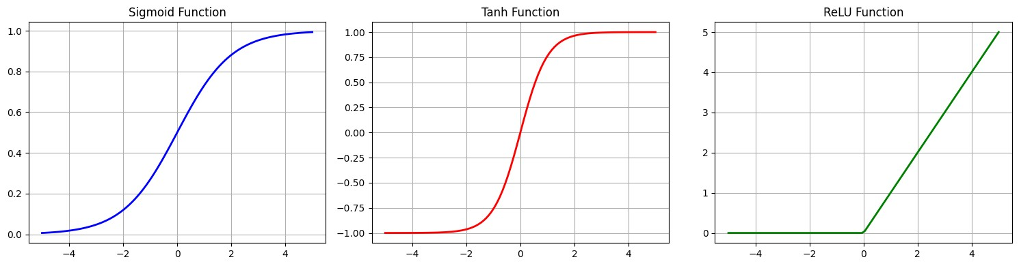
Neuron output: 0.4979

Network output shape: (5, 1)
Sample outputs: [0.20838155 0.19331024 0.20639103 0.19175342 0.18570214]

CONCLUSION:
The implementation demonstrates how a single neuron and a minimal feedforward network transform inputs through affine mappings followed by nonlinear activations. The plotted activation functions highlight characteristic behaviors—sigmoid and tanh saturate for large magnitudes while ReLU is piecewise linear with sparsity for negatives. Forward passes produce outputs of expected shapes (e.g., (5, 1) for a 5×2 input batch), confirming correct vectorized operations. Because parameters are randomly initialized and no training is performed, outputs are not meaningful predictions; nonetheless, the exercise clarifies forward propagation mechanics, numerical stability considerations (input clipping for sigmoid), and how activation choices affect signal flow. Potential next steps include adding loss functions, backpropagation with gradient descent, experimenting with ReLU or LeakyReLU in hidden layers, and seeding randomness for reproducibility.

