Lab 2: PERCEPTRON IMPLEMENTATION
Objectives:
- Implement and train Rosenblatt’s Perceptron on simple binary datasets.
- Visualize the linear decision boundary learned for linearly separable gates (AND/OR).
- Demonstrate the perceptron’s limitation on non-linearly separable data (XOR).
Theory:
The perceptron is the earliest linear classifier, modeling a neuron that computes a weighted sum of inputs plus a bias and then applies a discontinuous step activation to produce a binary prediction. Geometrically, the perceptron learns a linear decision boundary (a line in 2D) defined by,
w1 x1 + w2 x2 + b = 0
that separates the two classes. Learning proceeds via the perceptron update rule, which adjusts weights only on mistakes:
w ← w + η (y − ŷ) x and b ← b + η (y − ŷ), where η is the learning rate,
y ∈ {0,1} is the target,
and ŷ ∈ {0,1} is the predicted label from the step function applied to the linear output
For linearly separable datasets, the Perceptron Convergence Theorem guarantees that this rule will find a separating hyperplane in a finite number of updates. Logic gates illustrate these properties neatly: AND and OR are linearly separable in the 2D binary input space, so the perceptron converges; XOR is not linearly separable because its positive and negative examples cannot be split by a single line, so the perceptron continues making errors and does not converge. The visualization of the learned boundary and the epoch-wise error counts provide an intuitive view of both successful separation and failure on XOR.
Algorithm:
- Start
- Initialize parameters
- Set learning rate $η$and maximum iterations $\text{max_iter}$.
- Initialize all weights $w_{i}=0$for $i=1…m$.
- Initialize bias $b=0$.
- Create an empty list errors to track misclassifications per epoch.
- Training Loop (for each epoch = 1 to max_iter)
  - Set errors = 0.
  - For each training example $(X_{i},y_{i})$:
    - Compute weighted sum:$z=W⋅X_{i}+b$
    - Apply activation function (Step Function): $\hat{y_{i}}=\{\begin{matrix}1, & \text{if }z≥0 \\ 0, & \text{otherwise}\end{matrix}$
  - Compute error:$e_{i}=y_{i}-\hat{y_{i}}$
  - Update weights and bias (only if prediction is wrong): $W=W+η×e_{i}×X_{i}$
$$b=b+η×e_{i}$$
  - If $e_{i}≠0$, increment errors by 1.
- After each epoch, record errors in the list.
- If errors == 0, the perceptron has converged → stop training.
- To predict for new input data $X$Compute: $z=W⋅X+b$ and Apply step activation function:$\hat{y}=\{\begin{matrix}1, & z≥0 \\ 0, & z<0\end{matrix}$
- End
Code:
import numpy as np
import matplotlib.pyplot as plt
class Perceptron:
def __init__(self, learning_rate: float = 0.1, max_iter: int = 1000):
self.learning_rate = learning_rate
self.max_iter = max_iter
self.weights = None
self.bias = None
self.errors = []

def activation(self, x):
return np.where(x >= 0, 1, 0)
def fit(self, X, y):
n_samples, n_features = X.shape
self.weights = np.zeros(n_features)
self.bias = 0
for epoch in range(self.max_iter):
errors = 0
for i in range(n_samples):
# Forward pass
linear_output = np.dot(X[i], self.weights) + self.bias
prediction = self.activation(linear_output)

# Update weights if prediction is wrong
error = y[i] - prediction
if error != 0:
self.weights += self.learning_rate * error * X[i]
self.bias += self.learning_rate * error
errors += 1

self.errors.append(errors)
if errors == 0:
print(f"Converged after {epoch + 1} epochs")
break
return self

def predict(self, X):
linear_output = np.dot(X, self.weights) + self.bias
return self.activation(linear_output)

def plot_decision_boundary(self, X, y, title="Perceptron Decision Boundary"):
plt.figure(figsize=(10, 8))
# Create a mesh
h = 0.02
x_min, x_max = X[:, 0].min() - 1, X[:, 0].max() + 1
y_min, y_max = X[:, 1].min() - 1, X[:, 1].max() + 1
xx, yy = np.meshgrid(np.arange(x_min, x_max, h), np.arange(y_min, y_max, h))
mesh_points = np.c_[xx.ravel(), yy.ravel()]
Z = self.predict(mesh_points)
Z = Z.reshape(xx.shape)
plt.contourf(xx, yy, Z, alpha=0.8, cmap=plt.cm.RdYlBu)
scatter = plt.scatter(X[:, 0], X[:, 1], c=y, cmap=plt.cm.RdYlBu, edgecolors='black')
plt.colorbar(scatter)
plt.title(title)
plt.xlabel('Feature 1')
plt.ylabel('Feature 2')
plt.show()

def create_logic_gate_data(gate_type: str):
if gate_type.upper() == 'AND':
X = np.array([[0, 0], [0, 1], [1, 0], [1, 1]])
y = np.array([0, 0, 0, 1])
elif gate_type.upper() == 'OR':
X = np.array([[0, 0], [0, 1], [1, 0], [1, 1]])
y = np.array([0, 1, 1, 1])
elif gate_type.upper() == 'XOR':
X = np.array([[0, 0], [0, 1], [1, 0], [1, 1]])
y = np.array([0, 1, 1, 0])
else:
raise ValueError("Supported gates: AND, OR, XOR")

return X, y

X_and, y_and = create_logic_gate_data('AND')
perceptron_and = Perceptron(learning_rate=0.1, max_iter=100)
perceptron_and.fit(X_and, y_and)

predictions = perceptron_and.predict(X_and)
print("AND Gate Results:")
for i, (input_vals, target, pred) in enumerate(zip(X_and, y_and, predictions)):
print(f" Input: {input_vals}, Target: {target}, Prediction: {pred}")

# Plot decision boundary
perceptron_and.plot_decision_boundary(X_and, y_and, "AND Gate - Perceptron")

# XOR Gate (will not converge)
print("\nTrying XOR Gate (should not converge):")
X_xor, y_xor = create_logic_gate_data('XOR')
perceptron_xor = Perceptron(learning_rate=0.1, max_iter=100)
perceptron_xor.fit(X_xor, y_xor)

predictions_xor = perceptron_xor.predict(X_xor)
print("XOR Gate Results:")
for i, (input_vals, target, pred) in enumerate(zip(X_xor, y_xor, predictions_xor)):
print(f" Input: {input_vals}, Target: {target}, Prediction: {pred}")

OUTPUTS:
Converged after 4 epochs
AND Gate Results:
Input: [0 0], Target: 0, Prediction: 0
Input: [0 1], Target: 0, Prediction: 0
Input: [1 0], Target: 0, Prediction: 0
Input: [1 1], Target: 1, Prediction: 1
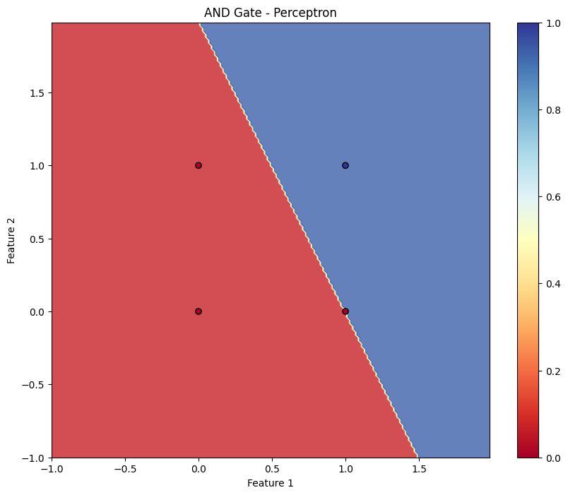
Trying XOR Gate (should not converge):
XOR Gate Results:
Input: [0 0], Target: 0, Prediction: 1
Input: [0 1], Target: 1, Prediction: 1
Input: [1 0], Target: 1, Prediction: 0
Input: [1 1], Target: 0, Prediction: 0

CONCLUSION:
The perceptron successfully learned linear decision boundaries for linearly separable logic gates (e.g., AND), converging within a small number of epochs and producing correct predictions across all inputs. The plotted boundary visually confirms the separation. When applied to XOR, the model failed to converge, illustrating the fundamental limitation of a single-layer perceptron on non-linearly separable problems. This lab reinforces the perceptron learning rule, the geometry of linear classification, and the importance of separability. Extensions include experimenting with different learning rates, shuffling samples per epoch, tracking error vs. epochs, and addressing XOR by adding a hidden layer (multi-layer perceptron), using non-linear feature mappings, or employing kernel methods.

