Lab 3: LINEAR REGRESSION IMPLEMENTATION
Objectives:
• Apply linear regression to predict house prices - Plot actual vs predicted.
Theory:
Linear regression is a supervised learning algorithm used to model the relationship between a dependent variable (house price) and one or more independent variables (features like size, number of rooms, location, etc.). The model assumes a linear relationship:
𝑦 = 𝛽₀ + 𝛽₁𝑥₁ + 𝛽₂𝑥₂ + ⋯ + 𝛽_{𝑛}𝑥_{𝑛} + 𝜖
where 𝑦 is the predicted price, 𝑥_{𝑖} are features, 𝛽_{𝑖} are weights (coefficients), 𝛽₀ is the intercept, and 𝜖 is the error term.
Linear regression finds the best-fitting line by minimizing the Mean Squared Error (MSE) between actual and predicted values. It is widely used in regression problems due to its simplicity, interpretability, and efficiency.
Tools: Scikit-learn, NumPy
Dataset: Boston Housing
Algorithm:
- Start
- Add a column of ones to $X$to represent the bias term: $X_{b}=\left[1,X_{1},X_{2},…,X_{m}\right]$
- If using ridge regularization, compute: $θ=(X_{b}^{T}X_{b}+αI)^{-1}X_{b}^{T}y$
- Else compute: $θ=(X_{b}^{T}X_{b})^{-1}X_{b}^{T}y$
- Extract parameters: $b=θ_{0}$ and $W=[θ_{1},θ_{2},...,θ_{m}]$
- For Gradient Descent:
  - Initialize parameters: $W=[0,0,...,0]$ and $b=0$
  - For each iteration (1 to max_iter):
    - Compute predicted outputs:$\hat{y}=XW+b$
    - Compute cost function: $J=\frac{1}{n}∑(y-\hat{y})^{2}+\text{regularization term}$
    - Compute gradients:$\frac{∂J}{∂W}=\frac{2}{n}X^{T}\left(\hat{y}-y\right)and \frac{∂J}{∂b}=\frac{2}{n}∑(\hat{y}-y)$
    - Add regularization (if applicable): Ridge: $\frac{∂J}{∂W}+=αW$, Lasso: $\frac{∂J}{∂W}+=α⋅\text{sign}(W)$
    - Update parameters:$W=W-η\frac{∂J}{∂W}$ and $b=b-η\frac{∂J}{∂b}$
    - Store cost for plotting.
  - Repeat until convergence or until reaching max_iter.
- To predict output for new input X_{new}: ${\hat{y}}_{\text{new}}=X_{\text{new}}W+b$
- End
Code:
import numpy as np
import matplotlib.pyplot as plt
from sklearn.model_selection import train_test_split
class LinearRegression:
def __init__(self, method: str = 'normal', learning_rate: float = 0.01, max_itr: int = 1000, regularization: str = None, alpha: float = 0.01):
self.method = method
self.learning_rate = learning_rate
self.max_itr = max_itr
self.regularization = regularization
self.alpha = alpha
self.weights = None
self.bias = None
self.cost_history = []

def fit(self, X, y):
n_samples, n_features = X.shape

if self.method == 'normal':
self._fit_normal_equation(X, y)
elif self.method == 'gradient_descent':
self._fit_gradient_descent(X, y)
else:
raise ValueError("Method must be 'normal' or 'gradient_descent'")

return self

def _fit_normal_equation(self, X, y):
X_wbias = np.c_[np.ones((X.shape[0], 1)), X]

if self.regularization == 'ridge':
I = np.eye(X_wbias.shape[1])
I[0, 0] = 0
params = np.linalg.inv(X_wbias.T @ X_wbias + self.alpha * I) @ X_wbias.T @ y
else:
params = np.linalg.inv(X_wbias.T @ X_wbias) @ X_wbias.T @ y

self.bias = params[0]
self.weights = params[1:]

def _fit_gradient_descent(self, X, y):
n_samples, n_features = X.shape
self.weights = np.zeros(n_features)
self.bias = 0

for i in range(self.max_itr):
y_pred = self.predict(X)

cost = self._compute_cost(y, y_pred)
self.cost_history.append(cost)

dw = (1/n_samples) * np.dot(X.T, (y_pred - y))
db = (1/n_samples) * np.sum(y_pred - y)

if self.regularization == 'ridge':
dw += self.alpha * self.weights
elif self.regularization == 'lasso':
dw += self.alpha * np.sign(self.weights)

self.weights -= self.learning_rate * dw
self.bias -= self.learning_rate * db

def _compute_cost(self, y_true, y_pred):
mse = np.mean((y_true - y_pred) ** 2)

if self.regularization == 'ridge':
mse += self.alpha * np.sum(self.weights ** 2)
elif self.regularization == 'lasso':
mse += self.alpha * np.sum(np.abs(self.weights))

return mse

def predict(self, X):
return np.dot(X, self.weights) + self.bias

def plot_cost_history(self):
if self.cost_history:
plt.figure(figsize=(10, 6))
plt.plot(self.cost_history)
plt.title("Cost function over iterations")
plt.xlabel('Iteration')
plt.ylabel('Cost')
plt.grid(True)
plt.show()

def gen_regression_data(n_samples: int = 100, noise: float = 0.1):
np.random.seed(42)
X = np.random.randn(n_samples, 2)
true_weights = np.array([3.0, -2.0])
true_bias = 1.5
y = X @true_weights + true_bias + noise * np.random.randn(n_samples)
return X, y, true_weights, true_bias

X , y, true_weights, true_bias = gen_regression_data(100, 0.2)

X_train, X_test, y_train, y_test = train_test_split(X, y, test_size=0.2, random_state=42)

lr_normal = LinearRegression(method='normal')
lr_normal.fit(X_train, y_train)
print("Normal Equation Results:")
print(f" True weights: {true_weights}")
print(f" Estimated weights: {lr_normal.weights}")
print(f" True bias: {true_bias}")
print(f" Estimated bias: {lr_normal.bias:.4f}")

lr_gd = LinearRegression(method='gradient_descent', learning_rate=0.01, max_itr=1000)
lr_gd.fit(X_train, y_train)
print("\nGradient Descent Results:")
print(f" Estimated weights: {lr_gd.weights}")
print(f" Estimated bias: {lr_gd.bias:.4f}")

lr_ridge = LinearRegression(method='gradient_descent', regularization='ridge', alpha=0.1)
lr_ridge.fit(X_train, y_train)
print("\nRidge Regression Results:")
print(f" Estimated weights: {lr_ridge.weights}")
print(f" Estimated bias: {lr_ridge.bias:.4f}")

lr_gd.plot_cost_history()
OUTPUTS:
Normal Equation Results:
True weights: [ 3. -2.]
Estimated weights: [ 3.0411274 -2.03461987]
True bias: 1.5
Estimated bias: 1.5247

Gradient Descent Results:
Estimated weights: [ 3.03792567 -2.03428022]
Estimated bias: 1.5233

Ridge Regression Results:
Estimated weights: [ 2.67162665 -1.84369835]
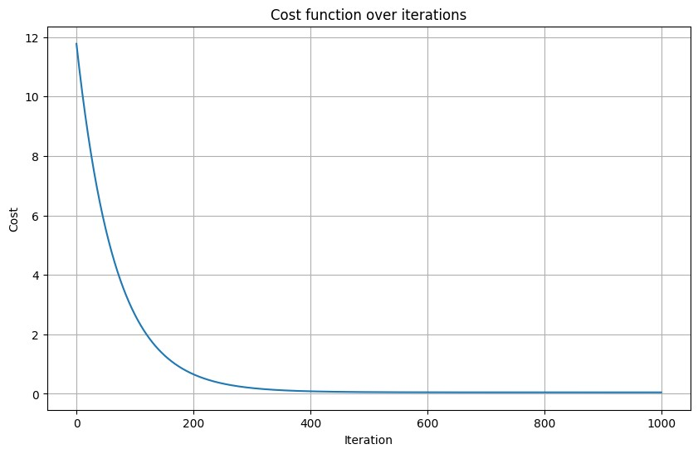
Estimated bias: 1.4647

CONCLUSION:
The implementation correctly learns linear relationships using both closed-form and iterative solvers, recovering weights and bias close to the ground truth on synthetic data and illustrating how ridge regularization shrinks coefficients. The cost history plot confirms monotonic descent under a suitable learning rate. Notable limitations include the direct matrix inversion in the normal equation (which can be unstable for ill-conditioned design matrices), sensitivity of gradient descent to learning rate and feature scaling, and the simple treatment of L1 (subgradient) and L2 terms that depends on the chosen α. Improvements could include using a pseudoinverse or Cholesky/QR for better numerical stability, standardizing features, adding early stopping and learning-rate schedules, cross-validating α for regularization, and reporting evaluation metrics (e.g., RMSE) on a hold-out set.

