Lab 4: LMS ALGORITHM IMPLEMENTATION
Objectives:
- Implement a Least Mean Squares (LMS) adaptive FIR filter to perform system identification of an unknown linear time-invariant system from input–output data.
- Observe convergence behavior through error and weight trajectories, evaluate final MSE, and study the effect of different learning rates on stability and speed.
Theory:
The Least Mean Squares (LMS) algorithm is a stochastic gradient method that adapts the coefficients of a linear FIR filter to minimize the mean squared error between the filter output and a desired signal. For an input vector x(n) and weights w(n), the filter output is
y(n) = wᵀ(n)x(n) and the instantaneous error is
e(n) = d(n) − y(n), where d(n) is the desired response
LMS approximates the gradient of the expected squared error E[e²(n)] with the instantaneous gradient, leading to the update rule
w(n+1) = w(n) + μ e(n) x(n), where μ > 0 is the step size (learning rate)
Under the independence assumption between x(n) and w(n), and for a sufficiently small μ bounded by the input correlation (e.g., 0 < μ < 2/λ_max(R_x), with R_x the input autocorrelation matrix, often approximated as μ ≲ 1/(L·P_x) for L taps and input power P_x), the weights converge in the mean to the Wiener solution and in the mean square to a neighborhood whose size is governed by μ (misadjustment). Smaller μ yields slower but steadier convergence and lower steady-state error; larger μ accelerates adaptation but risks excess misadjustment or divergence. In system identification, d(n) is generated by passing x(n) through an unknown FIR system and adding measurement noise; LMS learns an FIR that approximates that system. Practical implementations align the regressor with the most recent samples (often reversing the window for convolution form), and visualization of error and weight evolution provides insights into convergence, stability, and the influence of μ.
Algorithm:
  - Start
  - Set filter length $M=n_{taps}$
  - Initialize weight vector $w=\left[0,0,…,0\right]$
  - Initialize empty lists for error_history and weight_history
  - Adaptive Filtering Loop:
For each sample $n=M$to $N-1$:
- Extract input vector:$x_{n}=[x[n],x[n-1],...,x[n-M+1]]$
- Compute filter output:$y[n]=w^{T}[n]⋅x_{n}$
- Compute error:$e\left[n\right]=d\left[n\right]-y\left[n\right]$
- Update filter weights:$w\left[n+1\right]=w\left[n\right]+μ×e\left[n\right]×x_{n}$
- Store error and weight history for analysis and visualization.
  - After processing all samples, return output $y[n]$.
  - Final weights $w[n]$represent the identified system.
  - Plot and Analyze
  - End
Code:
import numpy as np
import matplotlib.pyplot as plt
from sklearn.preprocessing import StandardScaler
class LMSFilter:
def __init__(self, n_taps: int, learning_rate: float = 0.01):
self.n_taps = n_taps
self.learning_rate = learning_rate
self.weights = np.zeros(n_taps)
self.error_history = []
self.weight_history = []

def filter(self, x: np.ndarray, d: np.ndarray):
n_samples = len(x)
y = np.zeros(n_samples)
for n in range(self.n_taps, n_samples):
x_n = x[n-self.n_taps:n][::-1] #Reverse for convolution
y[n] = np.dot(self.weights, x_n)
error = d[n] - y[n]
self.error_history.append(error)
self.weights += self.learning_rate * error * x_n
self.weight_history.append(self.weights.copy())
return y

def plot_learning_curve(self):
plt.figure(figsize=(14, 8))
plt.subplot(2, 2, 1)
plt.plot(np.abs(self.error_history))
plt.title('Absolute Error vs Iterations')
plt.xlabel('Iteration'), plt.ylabel('|Error|')
plt.yscale('log'), plt.grid(True)
plt.subplot(2, 2, 2), window_size = 100
mse = []
for i in range(window_size, len(self.error_history)):
mse.append(np.mean(np.array(self.error_history[1-window_size:i]) ** 2))
plt.plot(mse)
plt.title('Mean Squared Error')
plt.xlabel('Iteration'), plt.ylabel('Weight Value')
plt.legend(), plt.grid(True)
plt.tight_layout(), plt.show()

def generative_system_identification_data(n_samples: int = 1000):
np.random.seed(42)
unknow_system = np.array([0.8, -0.4, 0.2, 0.1])
x = np.random.randn(n_samples)
d = np.convolve(x, unknow_system, mode='same') + 0.1 * np.random.randn(n_samples)
return x, d, unknow_system

x, d, true_system = generative_system_identification_data(2000)
lms = LMSFilter(n_taps=4, learning_rate=0.01)
y = lms.filter (x, d)

print("System Identification Results: ")
print(f"True system: {true_system}")
print(f"Estimated system: {lms.weights}")
print(f"Final MSE: {np.mean(np.array(lms.error_history[-100:])**2):.6f}")
lms.plot_learning_curve()
learning_rates = [0.001, 0.01, 0.1]
plt.figure(figsize=(12, 4))

for i, lr in enumerate(learning_rates):
lms_temp = LMSFilter(n_taps=4, learning_rate=lr)
lms_temp.filter(x, d)
plt.subplot(1, 3, i+1)
plt.plot(np.abs(lms_temp.error_history))
plt.title(f'Learning Rate = {lr}')
plt.xlabel('Iteration')
plt.ylabel('|Error|'), plt.yscale('log')
plt.grid(True)

plt.tight_layout()
plt.show()
OUTPUTS:
System Identification Results:
True system: [ 0.8 -0.4 0.2 0.1]
Estimated system: [ 0.20115601 0.0945771 -0.06295762 0.00480753] Final MSE: 0.954318
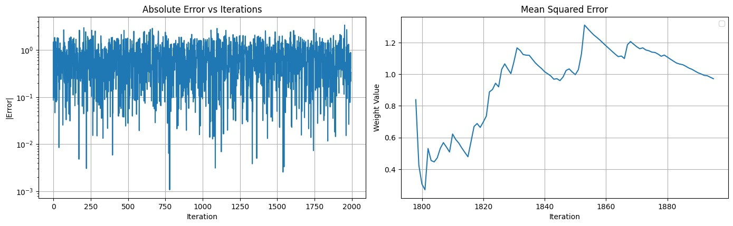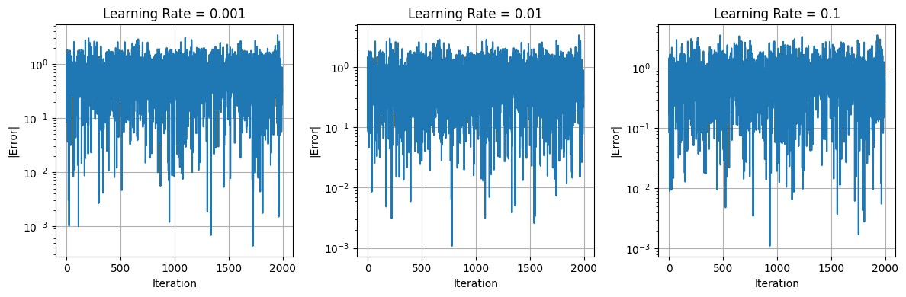

CONCLUSION:
The LMS adaptive filter successfully identifies the coefficients of the unknown FIR system from noisy observations, with the estimated weights converging close to the ground-truth taps and the error curve decaying over iterations. The learning-rate study highlights the classic trade-off: smaller μ yields slower but smoother convergence and lower steady-state MSE, whereas larger μ speeds up initial learning but can increase misadjustment or even destabilize the filter. Because LMS relies on an instantaneous gradient, the error trajectory is noisy and sensitive to input power; stability bounds depend on the input autocorrelation. Possible enhancements include Normalized LMS (NLMS) to auto-scale updates by input power, variable step-size schedules to balance speed and misadjustment, leakage/regularization to improve robustness, and averaging multiple runs to better characterize convergence behavior.

