Lab 5: MULTILAYER PERCEPTRON AND BACKPROPAGATION
Objectives:
- Build and train a multilayer perceptron (MLP) for nonlinear binary classification, demonstrate its ability to solve the XOR problem, and evaluate performance on a nonlinearly separable dataset (circles) with different activations and regularization while visualizing the training loss trajectory.
Theory:
A Multilayer Perceptron (MLP) is a type of feedforward artificial neural network that maps sets of input data onto appropriate outputs.
It consists of multiple layers of nodes — an input layer, one or more hidden layers, and an output layer — where each node (neuron) is connected to every neuron in the subsequent layer.
Each connection has an associated weight, and every neuron has a bias term. The learning process involves adjusting these weights and biases to minimize the difference between the predicted and target outputs.
An MLP with $L$layers can be represented as:
- Input layer: Receives feature vector $X=[x_{1},x_{2},...,x_{n}]$
- Hidden layers: Perform non-linear transformations using activation functions
- Output layer: Produces the final prediction $\hat{y}$
The neurons in each layer perform the following computation:
$$z^{(l)}=W^{(l)}a^{(l-1)}+b^{(l)} \\ a^{(l)}=f(z^{(l)})$$
Where:
- $W^{(l)}$: weight matrix connecting layer $l-1$to layer $l$
- $b^{(l)}$: bias vector of layer $l$
- $f(⋅)$: activation function
- $a^{(l)}$: output (activation) of layer $l$
The process of computing the output of the network for a given input is called forward propagation.
- Input vector $X$passes through each layer.
- Each neuron computes a weighted sum of inputs, applies bias, and uses an activation function to generate output.
- The final output $\hat{y}$is obtained at the output layer.
Mathematically:
$$\hat{y}=f(W^{(L)}⋅f(W^{(L-1)}⋅...f(W^{(1)}X+b^{(1)})+b^{(L-1)})+b^{(L)})$$For binary classification, the Cross-Entropy Loss is commonly used:
$$J(W,b)=-\frac{1}{m}\sum_{i=1}^{m}{}[y_{i}log⁡({\hat{y}}_{i})+(1-y_{i})log⁡(1-{\hat{y}}_{i})]$$The Backpropagation algorithm is the cornerstone of MLP training. It minimizes the cost function 𝐽(𝑊,𝑏) using gradient descent, by calculating how much each weight contributes to the total error and adjusting it accordingly.
Algorithm:
- Start
- Define network architecture (number of layers and neurons).
- Initialize weights $W_{i}$and biases $b_{i}$for each layer using Xavier initialization:
$$W_{i}∼N(0,\frac{1}{\sqrt{n_{\text{inputs}}}})$$
- Set learning rate $η$and number of epochs.
- Forward Propagation:
  - For each layer $l=1,2,...,L$:
  - Compute the linear combination: $z^{(l)}=a^{(l-1)}W^{(l)}+b^{(l)}$
  - Apply activation function: $a^{(l)}=f(z^{(l)})$
    - Hidden layers: sigmoid/tanh/ReLU
    - Output layer: sigmoid (for binary classification)
- The final output is: $\hat{y}=a^{(L)}$
- Use Cross-Entropy Loss for binary classification: $J=-\frac{1}{m}∑[ylog⁡(\hat{y})+(1-y)log⁡(1-\hat{y})]$
- Add regularization: L2: $+\frac{λ}{2m}∑W^{2}$ and L1: $+\frac{λ}{m}\sum{}∣W∣$
- Backward Propagation:
  - Output Layer Error: $δ^{(L)}=(\hat{y}-y)⊙f^{'}(a^{(L)})$
  - Hidden Layer Errors (Propagate Backwards): $δ^{(l)}=(δ^{(l+1)}W^{(l+1)T})⊙f^{'}(a^{(l)})$
  - Compute Gradients: $\frac{∂J}{∂W^{\left(l\right)}}=\frac{1}{m}a^{\left(l-1\right)T}δ^{\left(l\right)}+λW^{\left(l\right)}$ and $\frac{∂J}{∂b^{\left(l\right)}}=\frac{1}{m}∑δ^{\left(l\right)}$
- For each layer, update weight and bias: $W^{(l)}=W^{(l)}-η\frac{∂J}{∂W^{(l)}}$ and $b^{(l)}=b^{(l)}-η\frac{∂J}{∂b^{(l)}}$
- Repeat forward and backward propagation for each epoch.
- Track cost history over time to monitor convergence.
- After training: $\hat{y}=\{\begin{matrix}1, & \text{if }a^{\left(L\right)}>0.5 \\ 0, & \text{otherwise}\end{matrix}$
- End

Code:
import numpy as np
import matplotlib.pyplot as plt
from sklearn.datasets import make_circles
from sklearn.preprocessing import StandardScaler
from sklearn.model_selection import train_test_split
from typing import List
class MLP:
def __init__(self, layers: List[int], learning_rate: float = 0.01, activation: str = 'sigmoid', regularization: str = None, lambda_reg: float = 0.01):
self.layers = layers
self.learning_rate = learning_rate
self.activation = activation
self.regularization = regularization
self.lambda_reg = lambda_reg
self.weights = []
self.biases = []
self.cost_history = []
for i in range(len(layers) - 1):
w = np.random.randn(layers[i], layers[i+1]) / np.sqrt(layers[i])
b = np.zeros((1, layers[i+1]))
self.weights.append(w)
self.biases.append(b)

def sigmoid(self, x):
return 1 / (1 + np.exp(-np.clip(x, -250, 250)))
def sigmoid_d(self, x):
return x * (1 - x)
def tanh(self, x):
return np.tanh(x)
def tanh_d(self, x):
return 1 - x**2
def relu(self, x):
return np.maximum(0, x)
def relu_d(self, x):
return (x > 0).astype(float)
def activate(self, x):
if self.activation == 'sigmoid':
return self.sigmoid(x)
elif self.activation == 'tanh':
return self.tanh(x)
elif self.activation == 'relu':
return self.relu(x)
def activate_d(self, x):
if self.activation == 'sigmoid':
return self.sigmoid_d(x)
elif self.activation == 'tanh':
return self.tanh_d(x)
elif self.activation == 'relu':
return self.relu_d(x)

def fwd_propagate(self, X):
self.layer_inputs = [X]
self.layer_ouputs = [X]
current_input = X
for i in range(len(self.weights)):
z = np.dot(current_input, self.weights[i]) + self.biases[i]
self.layer_inputs.append(z)

if i < len(self.weights) - 1: a = self.activate(z)
else: a = self.sigmoid(z)

self.layer_ouputs.append(a)
current_input = a
return current_input

def bwd_propagate(self, X, y):
m = X.shape[0]
dW = [np.zeros_like(w) for w in self.weights]
db = [np.zeros_like(b) for b in self.biases]
output_error = self.layer_ouputs[-1] - y
delta = output_error * self.sigmoid_d(self.layer_ouputs[-1])
for i in range(len(self.weights) - 1, -1, -1):
dW[i] = np.dot(self.layer_ouputs[i].T, delta) / m
db[i] = np.mean(delta, axis=0, keepdims=True)

#Regularization
if self.regularization == 'l2':
dW[i] += self.lambda_reg * self.weights[i]
elif self.regularization == 'l1':
dW[i] += self.lambda_reg * np.sign(self.weights[i])
if i > 0: delta = np.dot(delta, self.weights[i].T) * self.activate_d(self.layer_ouputs[i])

return dW, db

def fit(self, X, y, epochs: int = 1000, verbose: bool = True):
for epoch in range(epochs):
output = self.fwd_propagate(X)
cost = self.compute_cost(y, output)
self.cost_history.append(cost)
dW, db = self.bwd_propagate(X, y)
for i in range(len(self.weights)):
self.weights[i] -= self.learning_rate * dW[i]
self.biases[i] -= self.learning_rate * db[i]

if verbose and epoch % 100 == 0:
print(f"Epoch {epoch}, Cost: {cost:.6f}")

return self

def compute_cost(self, y_true, y_pred):
m = y_true.shape[0]
cost = -np.mean(y_true * np.log(y_pred + 1e-15) + (1 - y_true) * np.log(1 - y_pred + 1e-15))
if self.regularization == 'l2':
l2_cost = sum(np.sum(w**2) for w in self.weights)
cost += self.lambda_reg * l2_cost / (2 * m)
elif self.regularization == 'l1':
l1_cost = sum(np.sum(np.abs(w)) for w in self.weights)
cost += self.lambda_reg * l1_cost / m
return cost

def predict(self, X):
output = self.fwd_propagate(X)
return (output > 0.5).astype(int)
def probability(self, X):
return self.fwd_propagate(X)
def plot_training_history(self):
plt.figure(figsize=(10, 6))
plt.plot(self.cost_history)
plt.title('Training Cost History')
plt.xlabel('Epoch')
plt.ylabel('Cost')
plt.show()

def solve_gate_problem(gate, X, y):
mlp = MLP(layers=[2, 4, 1], learning_rate=1.0, activation='sigmoid')
mlp.fit(X, y, epochs=2000, verbose=False)
predictions = mlp.predict(X)
probabilities = mlp.probability(X)
print(f"{gate} Problem Solution: ")
print("Input -> Target | Prediction | Probability")
for i in range(len(X)):
print(f"{X[i]} -> {y[i][0]} | {predictions[i][0]} | {probabilities[i][0]:.4f}")

mlp.plot_training_history()
return mlp
X = np.array([[0, 0], [0, 1], [1, 0], [1, 1]])
gates = {
"AND": np.array([[0], [0], [0], [1]]),
"OR": np.array([[0], [1], [1], [1]]),
"XOR": np.array([[0], [1], [1], [0]])
}
for name, y in gates.items():
solve_gate_problem(name, X, y)
# Generate more complex classification data
X, y = make_circles(n_samples=300, noise=0.1, factor=0.3, random_state=42)
y = y.reshape(-1, 1)
# Split data
X_train, X_test, y_train, y_test = train_test_split(X, y, test_size=0.2, random_state=42)
# Standardize features
scaler = StandardScaler()
X_train_scaled = scaler.fit_transform(X_train)
X_test_scaled = scaler.transform(X_test)
# Train MLP
mlp = MLP(layers=[2, 10, 5, 1], learning_rate=0.1, activation='relu',
regularization='l2', lambda_reg=0.01)
mlp.fit(X_train_scaled, y_train, epochs=1000, verbose=True)
# Evaluate
train_accuracy = np.mean(mlp.predict(X_train_scaled) == y_train)
test_accuracy = np.mean(mlp.predict(X_test_scaled) == y_test)
print(f"\nCircles Classification Results:")
print(f"Training Accuracy: {train_accuracy:.4f}")
print(f"Test Accuracy: {test_accuracy:.4f}")
# Plot training history
mlp.plot_training_history()

OUTPUTS:
AND Problem Solution:
Input -> Target | Prediction | Probability
[0 0] -> 0 | 0 | 0.0011
[0 1] -> 0 | 0 | 0.0399
[1 0] -> 0 | 0 | 0.0396
[1 1] -> 1 | 1 | 0.9436
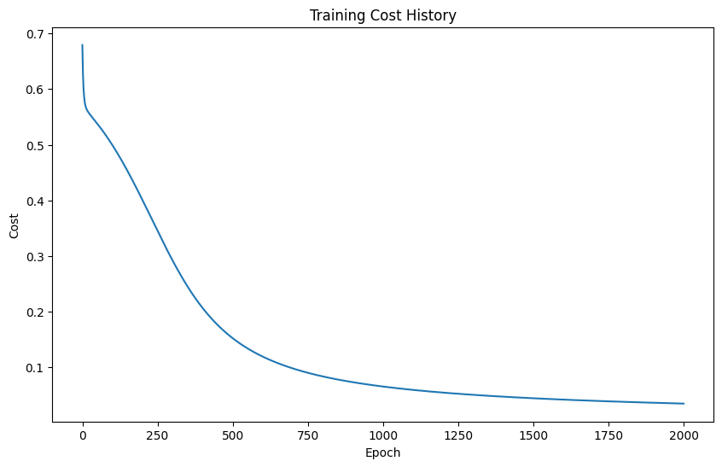
OR Problem Solution:
Input -> Target | Prediction | Probability
[0 0] -> 0 | 0 | 0.0626
[0 1] -> 1 | 1 | 0.9632
[1 0] -> 1 | 1 | 0.9661
[1 1] -> 1 | 1 | 0.9954
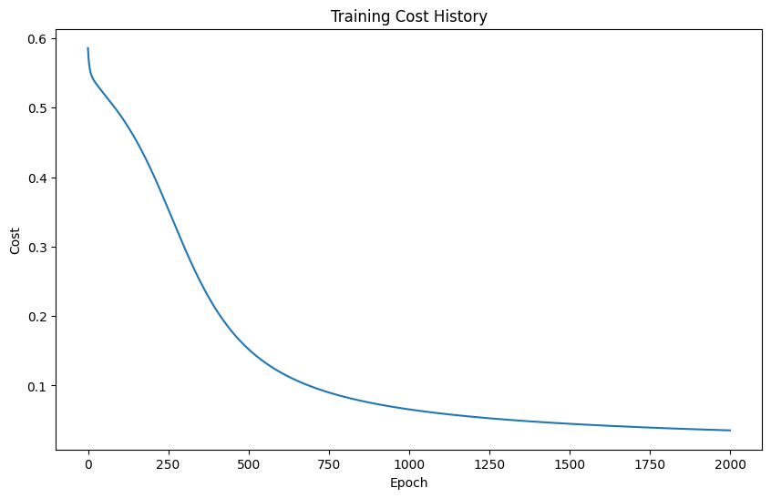
XOR Problem Solution:
Input -> Target | Prediction | Probability
[0 0] -> 0 | 0 | 0.0763
[0 1] -> 1 | 1 | 0.8924
[1 0] -> 1 | 1 | 0.8613
[1 1] -> 0 | 0 | 0.1479
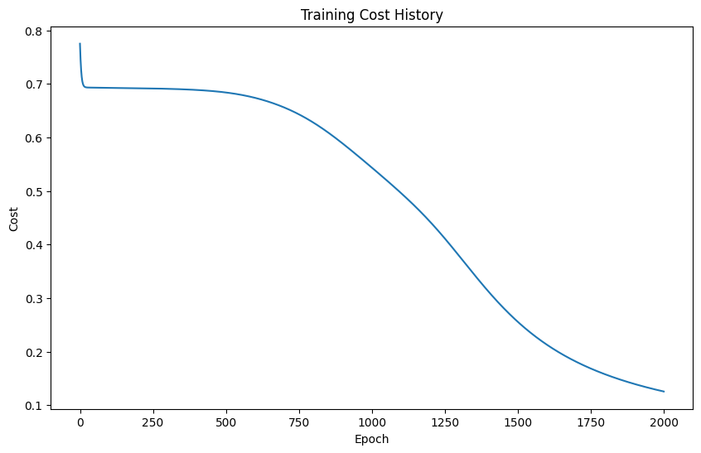
Epoch 0, Cost: 0.657634
Epoch 100, Cost: 0.613950
Epoch 200, Cost: 0.578480
Epoch 300, Cost: 0.542739
Epoch 400, Cost: 0.492434
Epoch 500, Cost: 0.429004
Epoch 600, Cost: 0.375375
Epoch 700, Cost: 0.333514
Epoch 800, Cost: 0.302171
Epoch 900, Cost: 0.279630

Circles Classification Results:
Training Accuracy: 0.9958
Test Accuracy: 1.0000
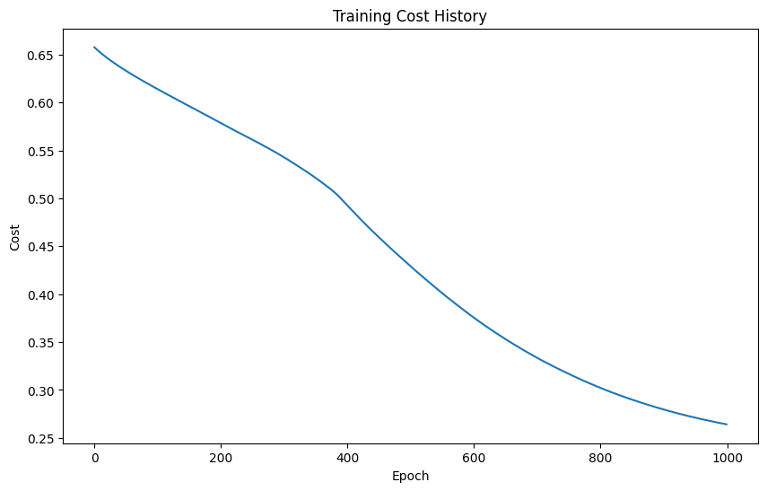
CONCLUSION:
The MLP successfully learns nonlinear decision boundaries, solving XOR and achieving strong accuracy on the circles dataset after feature scaling and regularization. Forward propagation coupled with backpropagation and cross-entropy enables stable training, while the cost history confirms convergence. The experiment highlights how activation choice, initialization, and regularization influence learning; for ReLU-based networks, He initialization and techniques like mini-batching, early stopping, and learning-rate scheduling can further improve stability and generalization. Note that with a sigmoid output and cross-entropy loss, the output-layer gradient can be simplified to delta = a − y for faster convergence, and regularization gradients are typically scaled consistently with the cost (e.g., λ/m for L2).

