Lab 5: RBF NETWORKS IMPLEMENTATION
Objectives:
- Implement a Radial Basis Function (RBF) network that uses Gaussian basis functions with centers obtained via K-means, fit the output weights by least squares for regression and classification tasks, visualize basis activations, and compare the RBF network’s classification performance against a small MLP on a nonlinearly separable dataset.
Theory:
A Radial Basis Function (RBF) Network is a type of artificial neural network that uses radial basis functions as activation functions.
Unlike traditional feedforward networks such as the Multilayer Perceptron (MLP), which use global activation functions (like sigmoid or ReLU), RBF networks use localized, distance-based activations, making them particularly effective for function approximation, interpolation, and pattern classification.
An RBF network typically consists of three layers:
- Input Layer – Receives the input features.
- Hidden Layer – Applies radial basis (usually Gaussian) functions centered at specific points.
- Output Layer – Combines the weighted outputs of the hidden layer to produce the final prediction.
The output of an RBF network can be expressed as: $\hat{y}(x)=\sum_{i=1}^{N_{c}}{}w_{i} ϕ_{i}(∥x-c_{i}∥)$
Where:
- $\hat{y}(x)$: predicted output
- $N_{c}$: number of RBF centers
- $w_{i}$: weight associated with the $i^{th}$neuron
- $c_{i}$: center (prototype) of the $i^{th}$radial basis function
- $ϕ_{i}(⋅)$: radial basis function, often Gaussian
The Gaussian function is the most commonly used RBF due to its smoothness and locality:
$$ϕ_{i}(x)=exp⁡(-\frac{∥x-c_{i}∥^{2}}{2σ^{2}})$$
Where:
- $∥x-c_{i}∥$: Euclidean distance between the input $x$and center $c_{i}$
- $σ$: spread (width) of the Gaussian, controlling how localized the activation is
The function attains its maximum value (1) when $x=c_{i}$and decays exponentially with distance.
Algorithm:
- Start
- Choose the number of RBF centers $n_{\text{centers}}$and Gaussian spread $σ$.
- Initialize RBF centers randomly or by applying K-Means clustering on the input data $X$.
- Determine RBF Centers using K-Means
  - Randomly select $n_{\text{centers}}$data points from $X$as initial centers.
  - Repeat until convergence or until reaching max_iter:
  - Compute Euclidean distance from each point $x_{i}$to all centers $c_{j}$: $d_{ij}=∥x_{i}-c_{j}∥$
  - Assign each data point to the nearest center.
  - Update each center $c_{j}$as the mean of all assigned points: $c_{j}=\frac{1}{∣S_{j}∣}\sum_{x_{i}∈S_{j}}{}x_{i}$
- The final centers $C=[c_{1},c_{2},…,c_{n_{\text{centers}}}]$are used for RBF computation.
  - To compute design matrix (Φ) each input sample $x_{i}$and center $c_{j}$, we compute the Gaussian RBF activation: $ϕ_{ij}=exp⁡(-\frac{∥x_{i}-c_{j}∥^{2}}{2σ^{2}})$
  - This forms the design matrix: $Φ=[\begin{matrix}ϕ_{11} & ϕ_{12} & … & ϕ_{1n_{c}} \\ ϕ_{21} & ϕ_{22} & … & ϕ_{2n_{c}} \\ ⋮ & ⋮ & ⋱ & ⋮ \\ ϕ_{m1} & ϕ_{m2} & … & ϕ_{mn_{c}}\end{matrix}]$
- Determine output weights $W$using the least squares solution: $W=(Φ^{T}Φ)^{-1}Φ^{T}y$ or equivalently using the Moore–Penrose pseudoinverse: $W=Φ^{+}y$
- For Prediction, each new input data $X_{\text{new}}$:
  - Compute the Gaussian activations: $ϕ_{j}(x_{\text{new}})=exp⁡(-\frac{∥x_{\text{new}}-c_{j}∥^{2}}{2σ^{2}})$
  - Compute output: $\hat{y}=\sum_{j=1}^{n_{\text{centers}}}{}w_{j}ϕ_{j}(x_{\text{new}})$
- Calculate Mean Squared Error (MSE) for regression tasks: $\text{MSE}=\frac{1}{n}\sum_{i=1}^{n}{}(y_{i}-{\hat{y}}_{i})^{2}$
- For classification, apply threshold: $\hat{y}=\{\begin{matrix}1, & \text{if }\hat{y}≥0.5 \\ 0, & \text{otherwise}\end{matrix}$
- End
Code:
import numpy as np
import matplotlib.pyplot as plt
from sklearn.model_selection import train_test_split
from sklearn.datasets import make_circles
from sklearn.preprocessing import StandardScaler
class MLP:
def __init__(self, layers: List[int], learning_rate: float = 0.01, activation: str = 'sigmoid', regularization: str = None, lambda_reg: float = 0.01):
self.layers = layers
self.learning_rate = learning_rate
self.activation = activation
self.regularization = regularization
self.lambda_reg = lambda_reg
self.weights = []
self.biases = []
self.cost_history = []
for i in range(len(layers) - 1):
w = np.random.randn(layers[i], layers[i+1]) / np.sqrt(layers[i])
b = np.zeros((1, layers[i+1]))
self.weights.append(w)
self.biases.append(b)

def sigmoid(self, x):
return 1 / (1 + np.exp(-np.clip(x, -250, 250)))
def sigmoid_d(self, x):
return x * (1 - x)
def tanh(self, x):
return np.tanh(x)
def tanh_d(self, x):
return 1 - x**2
def relu(self, x):
return np.maximum(0, x)
def relu_d(self, x):
return (x > 0).astype(float)
def activate(self, x):
if self.activation == 'sigmoid':
return self.sigmoid(x)
elif self.activation == 'tanh':
return self.tanh(x)
elif self.activation == 'relu':
return self.relu(x)
def activate_d(self, x):
if self.activation == 'sigmoid':
return self.sigmoid_d(x)
elif self.activation == 'tanh':
return self.tanh_d(x)
elif self.activation == 'relu':
return self.relu_d(x)
def fwd_propagate(self, X):
self.layer_inputs = [X]
self.layer_ouputs = [X]
current_input = X
for i in range(len(self.weights)):
z = np.dot(current_input, self.weights[i]) + self.biases[i]
self.layer_inputs.append(z)
if i < len(self.weights) - 1: a = self.activate(z)
else: a = self.sigmoid(z)
self.layer_ouputs.append(a)
current_input = a
return current_input

def bwd_propagate(self, X, y):
m = X.shape[0]
dW = [np.zeros_like(w) for w in self.weights]
db = [np.zeros_like(b) for b in self.biases]
output_error = self.layer_ouputs[-1] - y
delta = output_error * self.sigmoid_d(self.layer_ouputs[-1])
for i in range(len(self.weights) - 1, -1, -1):
dW[i] = np.dot(self.layer_ouputs[i].T, delta) / m
db[i] = np.mean(delta, axis=0, keepdims=True)
#Regularization
if self.regularization == 'l2':
dW[i] += self.lambda_reg * self.weights[i]
elif self.regularization == 'l1':
dW[i] += self.lambda_reg * np.sign(self.weights[i])
if i > 0: delta = np.dot(delta, self.weights[i].T) * self.activate_d(self.layer_ouputs[i])
return dW, db

def fit(self, X, y, epochs: int = 1000, verbose: bool = True):
for epoch in range(epochs):
output = self.fwd_propagate(X)
cost = self.compute_cost(y, output)
self.cost_history.append(cost)
dW, db = self.bwd_propagate(X, y)
for i in range(len(self.weights)):
self.weights[i] -= self.learning_rate * dW[i]
self.biases[i] -= self.learning_rate * db[i]
if verbose and epoch % 100 == 0:
print(f"Epoch {epoch}, Cost: {cost:.6f}")
return self

def compute_cost(self, y_true, y_pred):
m = y_true.shape[0]
cost = -np.mean(y_true * np.log(y_pred + 1e-15) + (1 - y_true) * np.log(1 - y_pred + 1e-15))
if self.regularization == 'l2':
l2_cost = sum(np.sum(w**2) for w in self.weights)
cost += self.lambda_reg * l2_cost / (2 * m)
elif self.regularization == 'l1':
l1_cost = sum(np.sum(np.abs(w)) for w in self.weights)
cost += self.lambda_reg * l1_cost / m
return cost
def predict(self, X):
output = self.fwd_propagate(X)
return (output > 0.5).astype(int)
def probability(self, X):
return self.fwd_propagate(X)
def plot_training_history(self):
plt.figure(figsize=(10, 6)), plt.plot(self.cost_history)
plt.title('Training Cost History'), plt.xlabel('Epoch')
plt.ylabel('Cost'), plt.show()

class RBFNetwork:
def __init__(self, n_centers: int, sigma: float = 1.0):
self.n_centers = n_centers
self.sigma = sigma
self.centers = None
self.weights = None
def gaussian_rbf(self, x, center):
distance = np.linalg.norm(x - center, axis=1)
return np.exp(-(distance ** 2) / (2 * self.sigma ** 2))
def kmeans_center(self, X, max_itr: int = 100):
n_samples, n_features = X.shape
self.centers = X[np.random.choice(n_samples, self.n_centers, replace=False)]
for _ in range(max_itr):
distances = np.sqrt(((X - self.centers[:, np.newaxis])**2).sum(axis=2))
closest_centers = np.argmin(distances, axis=0)
new_centers = np.array([X[closest_centers == k].mean(axis=0) for k in range(self.n_centers)])
#check for convergence
if np.allclose(self.centers, new_centers): break
self.centers = new_centers

def compute_design_matrix(self, X):
n_samples = X.shape[0]
phi = np.zeros((n_samples, self.n_centers))
for i, center in enumerate(self.centers):
phi[:, i] = self.gaussian_rbf(X, center)
return phi
def fit(self, X, y):
self.kmeans_center(X)
phi = self.compute_design_matrix(X)
self.weights = np.linalg.pinv(phi) @ y
return self

def predict(self, X):
phi = self.compute_design_matrix(X)
return phi @ self.weights
def plot_rbf(self, X):
if X.shape[1] == 2:
plt.figure(figsize=(15, 3))
plt.subplot(1, 4, 1)
plt.scatter(X[:, 0], X[:, 1], alpha=0.6)
plt.scatter(self.centers[:, 0], self.centers[:, 1], c='red', s=100, marker='x', label='Centers')
plt.title('Data and RBF Centers')
plt.legend()
for i in range(min(3, self.n_centers)):
plt.subplot(1, 4, i + 2)
phi = self.gaussian_rbf(X, self.centers[i])
scatter = plt.scatter(X[:, 0], X[:, 1], c=phi, cmap='viridis')
plt.colorbar(scatter)
plt.title(f'RBF {i+1}')
plt.tight_layout()
plt.show()

def compare_rbf_mlp():
X, y = make_circles(n_samples=200, noise=0.1, factor=0.3, random_state=42)
X_train, X_test, y_train, y_test = train_test_split(X, y, test_size=0.3, random_state=42)
scaler = StandardScaler()
X_train_scaled = scaler.fit_transform(X_train)
X_test_scaled = scaler.transform(X_test)
rbf = RBFNetwork(n_centers=10, sigma=0.5)
rbf.fit(X_train_scaled, y_train)
rbf_pred = (rbf.predict(X_test_scaled) > 0.5).astype(int)
rbf_accuracy = np.mean(rbf_pred == y_test)
mlp = MLP.MLP(layers=[2, 10, 1], learning_rate=0.1, activation='relu')
mlp.fit(X_train_scaled, y_train.reshape(-1, 1), epochs=500, verbose=False)
mlp_pred = mlp.predict(X_test_scaled).flatten()
mlp_accuracy = np.mean(mlp_pred == y_test)
print("RBF vs MLP Comparison:")
print(f"RBF Accuracy: {rbf_accuracy:.4f}")
print(f"MLP Accuracy: {mlp_accuracy:.4f}")
# Plot RBF functions
rbf.plot_rbf(X_train_scaled)
return rbf, mlp

np.random.seed(42)
X = np.linspace(-3, 3, 100).reshape(-1, 1)
y = np.sin(X).flatten() + 0.1 * np.random.randn(100)

rbf = RBFNetwork(n_centers=8, sigma=0.5)
rbf.fit(X, y)

y_pred = rbf.predict(X)

plt.figure(figsize=(12, 4))
plt.subplot(1, 2, 1)
plt.scatter(X, y, alpha=0.6, label='Data')
plt.plot(X, y_pred, 'r-', linewidth=2, label='RBF Prediction')
plt.scatter(rbf.centers, np.zeros(len(rbf.centers)), c='red', s=100, marker='x', label='RBF Centers')
plt.title("RBF Network Function Approximation")
plt.legend()
plt.grid(True)

plt.subplot(1, 2, 2)
centers_list = [3, 5, 8, 12]
for n_centers in centers_list:
rbf_temp = RBFNetwork(n_centers=n_centers, sigma=0.5)
rbf_temp.fit(X, y)
y_pred_temp = rbf_temp.predict(X)
mse = np.mean((y - y_pred_temp)**2)
plt.plot(X, y_pred_temp, label=f'{n_centers} centers (MSE: {mse:.3f})')

plt.scatter(X, y, alpha=0.3, c='black')
plt.title('Effect of Number of Centers')
plt.legend()
plt.grid(True)
plt.tight_layout()
plt.show()

compare_rbf_mlp()

OUTPUTS:
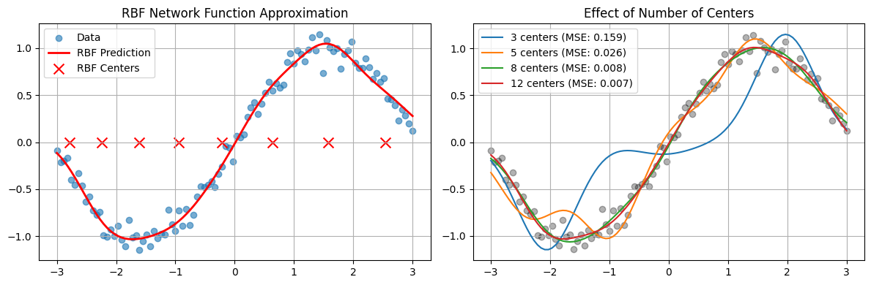
RBF vs MLP Comparison:
RBF Accuracy: 1.0000
MLP Accuracy: 1.0000
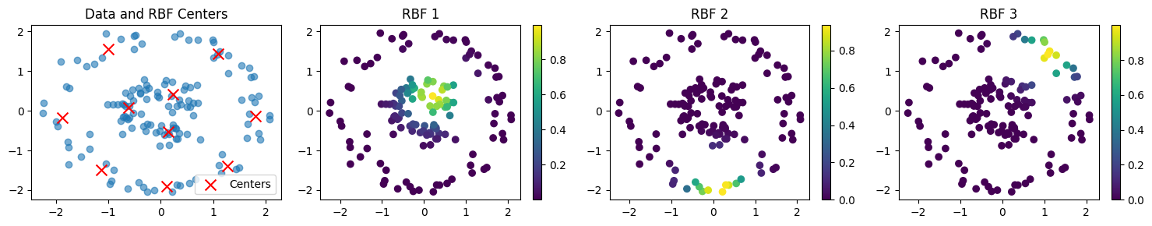
CONCLUSION:
The RBF network successfully captures nonlinear structure by transforming inputs into localized Gaussian responses and solving a simple linear system for the output weights. In function approximation, an appropriate number of centers with a suitable σ yields a smooth fit to sin(x), while varying the number of centers illustrates the trade-off between underfitting and overfitting. On the circles dataset, the RBF model provides a competitive nonlinear decision boundary with fast, stable training; the MLP can match or exceed performance with sufficient capacity and tuning but requires iterative nonconvex optimization. Practical considerations include selecting σ and the number of centers (ideally via validation), guarding against empty K-means clusters and ill-conditioning, and adding regularization (e.g., ridge on the output weights) to improve generalization.

