Lab 5: SELF-ORGANIZING MAPS (SOM)
Objectives:
- Implement a 2D Self-Organizing Map (Kohonen network) to perform topology-preserving vector quantization on unlabeled data.
- Train the SOM with a decaying learning rate and neighborhood, visualize the learned codebook, U-matrix, and hit histogram, and map data points to the discrete grid.
Theory:
A Self-Organizing Map is an unsupervised, competitive-learning neural network that projects high-dimensional data onto a typically low-dimensional (often 2D) grid while preserving topological relationships. Each node on the grid holds a weight vector of the same dimensionality as the inputs, and learning proceeds by repeatedly selecting a data sample, finding its Best Matching Unit (BMU)—the node whose weight is closest to the sample—and then pulling the BMU and its neighboring nodes’ weights toward that sample. The amount of adaptation decays with both time and grid distance from the BMU, commonly via a Gaussian neighborhood function. This cooperative adaptation produces an ordered codebook that reflects the structure of the data: nearby nodes on the grid represent similar prototypes in input space, enabling topology-preserving mapping and clustering.
In the provided implementation, the weights are initialized randomly and updated with a linearly decaying learning rate and neighborhood radius. For a sample x, the BMU is argmin over nodes of ||w − x||² in input space. Nodes within the current neighborhood radius (measured on the 2D grid) update their weights w ← w + α(t) h(dist_grid, σ(t)) (x − w), where h is Gaussian with current radius σ(t). Over training, the neighborhood shrinks, transitioning from global organization to local fine-tuning. After training, the U-matrix summarizes average distances between neighboring codebook vectors, highlighting cluster borders (high distances) versus homogeneous regions (low distances). A hit histogram shows how often each node wins as BMU, revealing data density over the map. Z-score normalization of inputs, as done here, improves stability by aligning feature scales.
Algorithm:
- Start
- Create a grid of neurons of size width × height.
- Initialize each neuron’s weight vector $W[i,j]$randomly in the input space.
- Set initial values for learning rate $η_{0}$and neighborhood radius $r_{0}$.
- For each epoch (t = 1 to epochs) Select a random input sample: $x(t)∈X$ and find the Best Matching Unit (BMU):by computing Euclidean distance between input vector and all neuron weights: $d_{ij}=∥x(t)-W[i,j]∥$
- The neuron with the minimum distance is the BMU: $\text{BMU}=arg⁡\underset{i,j}{min⁡}d_{ij}$
- Update Learning Parameters (Decay):
  - Learning rate: $η(t)=η_{0}(1-\frac{t}{T_{\text{max}}})$
  - Neighborhood radius: $r(t)=r_{0}(1-\frac{t}{T_{\text{max}}})$, where $T_{\text{max}}$is the total number of iterations.
- Update Weights of BMU and its Neighbors: For each neuron $W[i,j]$within the current radius $r(t)$: $W[i,j](t+1)=W[i,j](t)+η(t)⋅h_{b,i}(t)⋅[x(t)-W[i,j](t)]$, where the neighborhood function $h_{b,i}(t)$is Gaussian: $h_{b,i}(t)=\exp\left(-\frac{∥r_{b}-r_{i}∥^{2}}{2r(t)^{2}}\right)$ and $r_{b},r_{i}$represent coordinates of the BMU and neighboring neuron respectively.
- Repeat for all samples in the dataset during the epoch.
- After sufficient epochs, neuron weights stabilize and form an organized feature map.
- Similar inputs are mapped to nearby neurons, preserving input space topology.
- Each input vector $x_{i}$is mapped to the location of its BMU on the grid.
- For each neuron, compute the average distance between its weight vector and neighboring neurons.
- Hit Histogram:
  - Count how many data samples are mapped to each neuron.
  - Used to identify dense and sparse regions of data representation.
- Display:
  - SOM weight grid (for 2D data)
  - U-Matrix (color-coded distances)
  - Hit histogram (activation frequency)
  - Original vs Mapped data comparison
- End
Code:
import numpy as np
import matplotlib.pyplot as plt
class SOM:
def __init__(self, width: int, height: int, input_dim: int, learning_rate: float = 0.5, neighborhood_radius: float = None):
self.width = width
self.height = height
self.input_dim = input_dim
self.learning_rate = learning_rate
self.neighborhood_radius = neighborhood_radius or max(width, height) / 2
self.weights = np.random.random((width, height, input_dim))
self.coordinates = np.array([[i, j] for i in range(width) for j in range(height)])
def get_bmu(self, sample):
distances = np.sum((self.weights - sample) ** 2, axis=2)
bmu_idx = np.unravel_index(np.argmin(distances), distances.shape)
return bmu_idx
def neighborhood_function(self, distance, radius):
return np.exp(-(distance ** 2) / (2 * radius ** 2))
def update_weights(self, sample, bmu_idx, itr, total_itr):
#Decay learning rate and neighborhood radius
current_learning_rate = self.learning_rate * (1 - itr / total_itr)
current_radius = self.neighborhood_radius * (1 - itr / total_itr)
#calculate distances from BMU
bmu_coord = np.array(bmu_idx)
for i in range(self.width):
for j in range(self.height):
node_coord = np.array([i, j])
distance = np.linalg.norm(node_coord - bmu_coord)
#Update if within beighborhood
if distance <= current_radius:
influence = self.neighborhood_function(distance, current_radius)
self.weights[i, j] += (current_learning_rate * influence * (sample - self.weights[i, j]))

def train(self, data, epochs: int):
n_samples = len(data)
for epoch in range(epochs):
for itr in range(n_samples):
sample = data[np.random.randint(0, n_samples)]
bmu_idx = self.get_bmu(sample)
self.update_weights(sample, bmu_idx, epoch * n_samples + itr, epochs * n_samples)
if epoch % 100 == 0: print(f"Epoch {epoch}/{epochs}")

def map_data(self, data):
mapped = np.zeros((len(data), 2))
for i, sample in enumerate(data):
bmu_idx = self.get_bmu(sample)
mapped[i] = bmu_idx
return mapped
def get_u_matrix(self):
u_matrix = np.zeros((self.width, self.height))

for i in range(self.width):
for j in range(self.height):
neighbors = []

for di in [-1, 0, 1]:
for dj in [-1, 0, 1]:
ni, nj = i + di, j + dj
if 0 <= ni < self.width and 0 <= nj < self.height and (di != 0 or dj != 0):
neighbors.append(self.weights[ni, nj])

if neighbors:
distances = [np.linalg.norm(self.weights[i, j] - neighbor) for neighbor in neighbors]
u_matrix[i, j] = np.mean(distances)
return u_matrix

def visualize_som(self, data=None, labels=None):
fig, axs = plt.subplots(1, 3, figsize=(15, 5))

if self.input_dim == 2:
axs[0].set_title('SOM Weight Vectors')
for i in range(self.width):
for j in range(self.height):
axs[0].plot(self.weights[i, j, 0], self.weights[i, j, 1], 'bo', markersize=5)
if i < self.width - 1:
axs[0].plot([self.weights[i, j, 0], self.weights[i+1, j, 0]], [self.weights[i, j, 1], self.weights[i+1, j, 1]], 'b-', alpha=0.5)
elif j < self.height - 1:
axs[0].plot([self.weights[i, j, 0], self.weights[i, j+1, 0]], [self.weights[i, j, 1], self.weights[i, j+1, 1]], 'b-', alpha=0.5)
if data is not None:
axs[0].scatter(data[:, 0], data[:, 1], c='red', alpha=0.5, s=10)
axs[0].grid(True)

u_matrix = self.get_u_matrix()
im1 = axs[1].imshow(u_matrix.T, cmap='viridis', origin='lower')
axs[1].set_title('U-Matrix')
plt.colorbar(im1, ax=axs[1])

if data is not None:
hit_histogram = np.zeros((self.width, self.height))
for sample in data:
bmu_idx = self.get_bmu(sample)
hit_histogram[bmu_idx] += 1

im2 = axs[2].imshow(hit_histogram.T, cmap='hot', origin='lower')
axs[2].set_title('Hit Histogram')
plt.colorbar(im2, ax=axs[2])

plt.tight_layout()
plt.show()

def generate_som_data():
np.random.seed(42)

cluster1 = np.random.multivariate_normal([2, 2], [[0.5, 0], [0, 0.5]], 50)
cluster2 = np.random.multivariate_normal([-2, 1], [[0.3, 0.1], [0.1, 0.3]], 50)
cluster3 = np.random.multivariate_normal([0, -2], [[0.4, -0.1], [-0.1, 0.6]], 50)

data = np.vstack([cluster1, cluster2, cluster3])
labels = np.hstack([np.zeros(50), np.ones(50), np.ones(50)*2])

return data, labels

# Generate data
data, labels = generate_som_data()

# Normalize data
data_normalized = (data - np.mean(data, axis=0)) / np.std(data, axis=0)

# Create and train SOM
som = SOM(width=10, height=10, input_dim=2, learning_rate=0.5)
som.train(data_normalized, epochs=500)

# Visualize results
som.visualize_som(data_normalized, labels)

# Map data to SOM grid
mapped_data = som.map_data(data_normalized)

plt.figure(figsize=(12, 5))

# Original data
plt.subplot(1, 2, 1)
scatter = plt.scatter(data[:, 0], data[:, 1], c=labels, cmap='viridis')
plt.title('Original Data')
plt.colorbar(scatter)

# Mapped data
plt.subplot(1, 2, 2)
scatter = plt.scatter(mapped_data[:, 0], mapped_data[:, 1], c=labels, cmap='viridis')
plt.title('Data Mapped to SOM Grid')
plt.colorbar(scatter)
plt.xlabel('SOM X')
plt.ylabel('SOM Y')

plt.tight_layout()
plt.show()
OUTPUTS:
Epoch 0/500
Epoch 100/500
Epoch 200/500
Epoch 300/500
Epoch 400/500
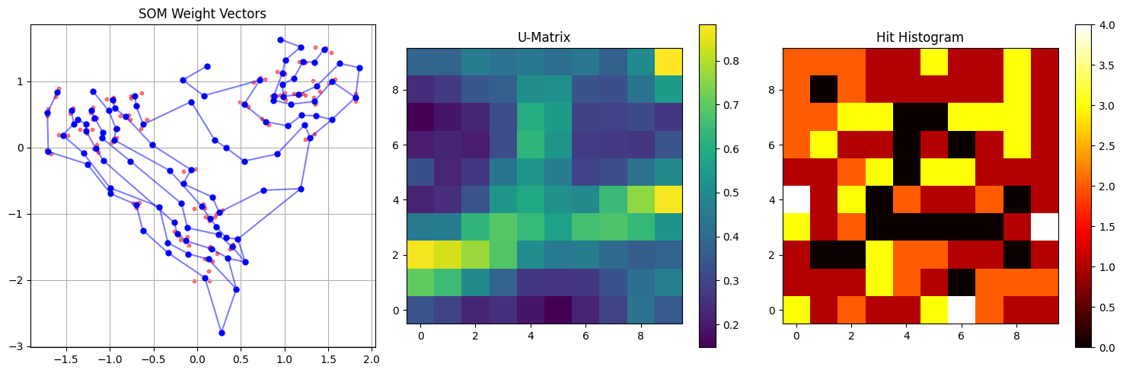
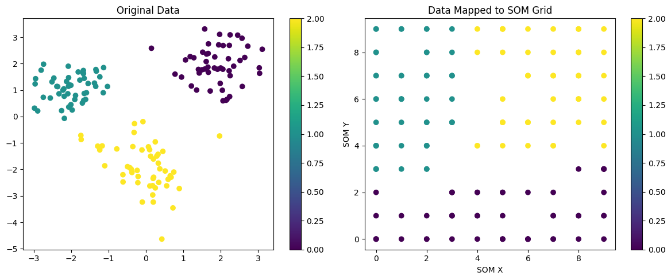

CONCLUSION:
The SOM organizes the input space into a lattice of prototype vectors that preserve neighborhood relationships, enabling intuitive visualization and clustering without labels. The U-matrix clearly delineates cluster boundaries through high inter-neuron distances, while the hit histogram concentrates activity in regions representing high data density. Linear decay of the learning rate and neighborhood produces a coarse-to-fine ordering, and input normalization supports stable convergence. Limitations include sensitivity to schedule choices (decay rate and final radius), random initialization, and the computational cost of full-grid updates per sample; improvements could leverage exponential decay schedules, toroidal grids to reduce edge effects, PCA-based weight initialization, or batch SOM variants for faster, more stable training.

