Lab 5: SUPERVISED LEARNING
Objectives:
- Implement a simple Elman RNN to model temporal dependencies in a univariate time series.
- Train the network with backpropagation through time (BPTT), track loss, and visualize predictions versus ground truth.
- Prepare sliding-window sequences for next-step prediction and evaluate performance via MSE.
Theory:
Recurrent neural networks introduce a persistent state that evolves over time, allowing the model to represent temporal dependencies that feedforward networks cannot capture. At each time step t, the hidden state h_t is computed by combining the current input x_t with the previous hidden state h_{t−1} through an affine transform followed by a nonlinearity (here tanh):
h_t = tanh(x_t W_xh + h_{t−1} W_hh + b_h)
The network then produces an output ŷ_t via another affine transform of h_t, here passed through a sigmoid:
ŷ_t = σ(h_t W_hy + b_y)
Training unfolds the RNN across the sequence and minimizes a time-averaged loss (here MSE) over all steps. Gradients are obtained by backpropagation through time, which applies the chain rule from the last time step backwards, accumulating contributions that flow through both the output weights and the recurrent connections. Because repeated Jacobian products can make gradients shrink or explode, the implementation uses gradient clipping, and in practice one often truncates BPTT to a finite window. The data pipeline forms many overlapping sequences by sliding a window of fixed length over the signal; targets are shifted by one step (teacher forcing), so the model learns next-step prediction. For generative forecasting, the network rolls forward by feeding its own outputs back into the recurrent dynamics. Activation choices and output layers should match the data range: tanh in the hidden state helps bound activations, while a linear output layer (or suitable scaling) is generally preferred for real-valued signals that are not confined to [0, 1].
Algorithm:
- Start
- Set input_size, hidden_size, output_size.
- Initialize weights (Wxh, Whh, Why) and biases (bh, by) randomly/small.
- Set learning rate and sequence length.
- For each input sequence of length $T$:
  - Initialize hidden state $h_{0}=0$.
  - For $t=1…T$:
    - Compute hidden state: $h_{t}=\tanh\left(W_{xh}x_{t}+W_{hh}h_{t-1}+b_{h}\right)$
    - Compute output: $y_{t}=σ(W_{hy}h_{t}+b_{y})$
- Store all hidden states and outputs for backpropagation.
- Compute Mean Squared Error (MSE) between predicted and target sequences: $\text{MSE}=\frac{1}{T}\sum_{t=1}^{T}{(y_{t}-{\text{target}}_{t})^{2}}$
- Backward Propagation Through Time (BPTT)
  - Initialize dh_next = 0.
  - Loop backward over time steps $t=T…1$:
    - Compute output gradient: $dy=y_{t}-{\text{target}}_{t}$
    - Compute hidden gradient: $dh=dy⋅W_{hy}^{T}+dh_{next}$
    - Apply derivative of $tanh⁡$to dh → dh_raw
    - Compute gradients for weights: $ΔW_{xh}+=x_{t}^{T}⋅dh_{raw}$
$$ΔW_{hh}+=h_{t-1}^{T}⋅dh_{raw} \\ ΔW_{hy}+=h_{t}^{T}⋅dy$$
    - Update bias gradients: $Δb_{h}+=dh_{raw},Δb_{y}+=dy$
    - Propagate dh_next = dh_raw $⋅$ W_{hh}^T
  - Clip gradients to [-1, 1] to prevent exploding gradients.
- Update weights and biases using gradient descent: Θ = Θ - learning_rate $⋅$ΔΘ
- Repeat Steps 2–5 for all sequences over multiple epochs.
- Store loss history for plotting.
- Take the last hidden state of the input sequence.
- For steps_ahead:
  - Compute next output: $y=σ(W_{hy}h+b_{y})$
  - Feed output as next input: $h=tanh⁡(W_{xh}y+W_{hh}h+b_{h})$
- Return predicted future sequence.
- End
Code:
import numpy as np
import matplotlib.pyplot as plt
class SimpleRNN:
def __init__(self, input_size: int, hidden_size: int, output_size: int, learning_rate: float = 0.01, sequence_length: int = 10):
self.input_size = input_size
self.hidden_size = hidden_size
self.output_size = output_size
self.learning_rate = learning_rate
self.sequence_length = sequence_length

self.Wxh = np.random.randn(input_size, hidden_size) * 0.1
self.Whh = np.random.randn(hidden_size, hidden_size) * 0.1
self.Why = np.random.randn(hidden_size, output_size) * 0.1

self.bh = np.zeros((1, hidden_size))
self.by = np.zeros((1, output_size))
self.loss_history = []

def sigmoid(self, x):
return 1 / (1 + np.exp(-np.clip(x, -250, 250)))

def sigmoid_d(self, x):
return x * (1 - x)

def tanh(self, x):
return np.tanh(x)

def tanh_d(self, x):
return 1 - x**2

def relu(self, x):
return np.maximum(0, x)

def relu_d(self, x):
return (x > 0).astype(float)

def fwd_propagate(self, inputs):
"""Forward Propagation through time"""
T = len(inputs)

#Store states for back propagation
self.hidden_states = np.zeros((T + 1, self.hidden_size))
self.outputs = np.zeros((T, self.output_size))

for t in range(T):
self.hidden_states[t + 1] = self.tanh(np.dot(inputs[t:t+1], self.Wxh) + np.dot(self.hidden_states[t:t+1], self.Whh) + self.bh)

self.outputs[t] = self.sigmoid(np.dot(self.hidden_states[t+1:t+2], self.Why) + self.by)

return self.outputs

def bwd_propragate(self, inputs, targets):
"""Backward Propagation through time"""
T = len(inputs)

dWxh = np.zeros_like(self.Wxh)
dWhh = np.zeros_like(self.Whh)
dWhy = np.zeros_like(self.Why)
dbh = np.zeros_like(self.bh)
dby = np.zeros_like(self.by)

dh_next = np.zeros((1, self.hidden_size))

for t in reversed(range(T)):
#Output layer gradients
dy = self.outputs[t:t+1] - targets[t:t+1]
dWhy += np.dot(self.hidden_states[t+1:t+2].T, dy)
dby += dy

#Hidden layer gradients
dh = np.dot(dy, self.Why.T) + dh_next
dh_raw = dh * self.tanh_d(self.hidden_states[t+1:t+2])

#Weight gradients
dWxh += np.dot(inputs[t:t+1].T, dh_raw)
dWhh += np.dot(self.hidden_states[t:t+1].T, dh_raw)
dbh += dh_raw
#Gradient for next time step
dh_next = np.dot(dh_raw, self.Whh.T)
#Clip gradients to prevent exploding gradients
for grad in [dWxh, dWhh, dWhy, dbh, dby]:
np.clip(grad, -1, 1, out=grad)
return dWxh, dWhh, dWhy, dbh, dby

def train_sequence(self, inputs, targets):
#Forward pass
outputs = self.fwd_propagate(inputs)
#Compute loss
loss = np.mean((outputs - targets) ** 2)
self.loss_history.append(loss)
#Backward pass
dWxh, dWhh, dWhy, dbh, dby = self.bwd_propragate(inputs, targets)
#Update weights
self.Wxh -= self.learning_rate * dWxh
self.Whh -= self.learning_rate * dWhh
self.Why -= self.learning_rate * dWhy
self.bh -= self.learning_rate * dbh
self.by -= self.learning_rate * dby
return loss

def predict(self, inputs, steps_ahead: int = 1):
'''Predict future values'''
#Get current hidden state
current_input = inputs[-1:]
current_hidden = np.zeros((1, self.hidden_size))
for i in inputs:
current_hidden = self.tanh(np.dot(i+1, self.Wxh) + np.dot(current_hidden, self.Whh) + self.bh)
predictions = []
for _ in range(steps_ahead):
output = self.sigmoid(np.dot(current_hidden, self.Why) + self.by)
predictions.append(output.flatten())
#Use output as next input
current_hidden = self.tanh(np.dot(output, self.Wxh) + np.dot(current_hidden, self.Whh) + self.bh )
return np.array(predictions)

def generate_time_series_data(n_samples: int = 1000):
np.random.seed(42)
t = np.linspace(0, 50, n_samples)
#Combine sine waves with noise
data = (np.sin(0.5 * t) + 0.5 * np.sin(2 * t) + 0.3 * np.sin(5 * t) + 0.1 * np.random.randn(n_samples))
return data

def create_sequence(data, sequence_length: int):
"""Create input-output sequence for RNN training"""
X, y = [], []
for i in range(len(data) - sequence_length):
X.append(data[i:i + sequence_length].reshape(-1, 1))
y.append(data[i+1:i + sequence_length + 1].reshape(-1, 1))
return np.array(X), np.array(y)

data = generate_time_series_data()
sequence_length = 10
X, y = create_sequence(data, sequence_length)
train_size = int(0.8 * len(X))
X_train, X_test = X[:train_size], X[train_size:]
y_train, y_test = y[:train_size], y[train_size:]
rnn = SimpleRNN(input_size=1, hidden_size=20, output_size=1, learning_rate=0.01, sequence_length=sequence_length)
print("Training...")
epochs = 100
for epoch in range(epochs):
epoch_loss = 0
for i in range(len(X_train)):
loss = rnn.train_sequence(X_train[i], y_train[i])
epoch_loss += loss

if epoch % 20 == 0:
avg_loss = epoch_loss / len(X_train)
print(f"Epoch {epoch}, Average Loss: {avg_loss:.6f}")

plt.figure(figsize=(12,8))
plt.subplot(2, 2, 1)
plt.plot(rnn.loss_history)
plt.title('Training Loss')
plt.xlabel('Iteration')
plt.ylabel('MSE Loss')
plt.yscale('log')
plt.grid(True)

predictions = []
for i in range(len(X_test)):
pred = rnn.fwd_propagate(X_test[i])
predictions.append(pred[-1, 0]) #Last prediction

plt.subplot(2, 2, 2)
test_targets = [seq[-1, 0] for seq in y_test]
plt.plot(test_targets, label='Actual', alpha=0.7)
plt.plot(predictions, label='Predicted', alpha=0.7)
plt.title('RNN Predictions vs Actual')
plt.legend()
plt.grid(True)

# Plot original time series
plt.subplot(2, 1, 2)
plt.plot(data, label='Original Time Series')
plt.axvline(x=train_size, color='red', linestyle='--', label='Train/Test Split')
plt.title('Original Time Series Data')
plt.legend()
plt.grid(True)

plt.tight_layout()
plt.show()

# Calculate performance metrics
mse = np.mean((np.array(predictions) - np.array(test_targets))**2)
print(f"\nTest MSE: {mse:.6f}")

OUTPUTS:
Training...
Epoch 0, Average Loss: 0.398583
Epoch 20, Average Loss: 0.362558
Epoch 40, Average Loss: 0.362557
Epoch 60, Average Loss: 0.364747
Epoch 80, Average Loss: 0.362939
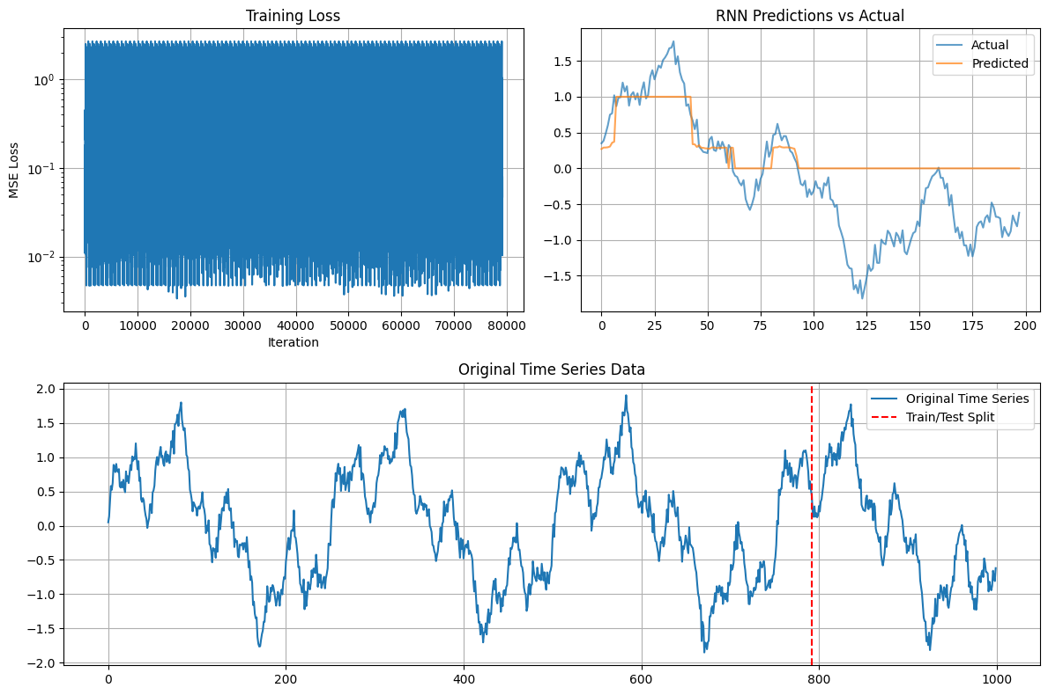
Test MSE: 0.464283

CONCLUSION:
The simple RNN learns to track temporal structure in the synthetic time series, with loss decreasing over training and test predictions following the target trend. BPTT with gradient clipping stabilizes optimization, while the sliding-window, next-step setup demonstrates teacher-forced training and evaluation on held-out sequences. Key limitations and improvements include aligning the output activation with the data range (e.g., use a linear output or scale the series if values extend beyond [0, 1]), adopting truncated BPTT and mini-batches for efficiency, tuning hidden size and sequence length, and exploring gated architectures (LSTM/GRU) that better mitigate vanishing/exploding gradients and capture longer-term dependencies.

