Student Survey Preliminary Analysis

Introduction
This report examines how students in Nepal understand politics at a time shaped by the Gen-Z movement and continuing uncertainty about the country’s direction. It asks how closely students follow political affairs, how they participate, whether they feel able to influence government, and how they interpret recent political change. It also looks beyond political attitudes to decisions that bear directly on their futures, including voting, employment, and aspirations comprising whether they want to remain in Nepal or go abroad.
The analysis draws on 836 responses from the final non-pilot sample and is organized around three connected themes. Theme 1 covers political salience, news consumption, civic involvement, political efficacy and electoral participation. Theme 2 examines perceptions of stability, interpretations of the Gen-Z movement and expectations for Nepal’s political future. Theme 3 turns to migration intentions, personal aspirations and views of Nepal within South Asia. The findings describe patterns and associations within the sample and should not be read as evidence that one factor caused another.

Chapter 1 Political, Civic engagement and participation
This chapter examines the extent and form of political and civic engagement among the students surveyed. The analysis covers how students view the place of politics in Nepal, how often they follow political news, what political and civic activities they join, how much influence they believe they have over government decisions, and whether they vote when eligible. These measures capture different aspects of engagement that would be missed if participation were judged only through voting or protest.
The purpose is to see whether these forms of engagement move together. Comparisons by age and education show how political attitudes and news habits vary across the student population. Measures of political activity, efficacy and voting then show whether attention to politics is accompanied by participation and a sense of influence. The ordered probit analysis examines whether news consumption and political involvement remain associated with the belief that politics is central to living in Nepal after accounting for demographic differences.
These components place the Gen-Z movement within the broader political lives of students. Political salience captures whether students see politics as relevant to everyday life. News consumption shows how closely they follow political developments, while reported activities indicate whether that attention is accompanied by participation. Political efficacy adds another dimension by examining whether students believe they can influence government decisions. Voting connects these attitudes and activities to formal political institutions and helps distinguish political disengagement from practical barriers to participation.
Examining these components together helps us understand the different ways students relate to Nepal’s political system. It allows us to distinguish students who follow politics but rarely participate from those who combine political awareness with activity, confidence and voting. This provides context for interpreting their attention to and involvement in the Gen-Z movement. This chapter, although it does not measure satisfaction with the government directly but shows whether students feel connected to politics and capable of acting within it. The subsequent chapter builds on this foundation by examining their views of political stability, youth representation, the effects of the Gen-Z movement and Nepal’s political future.

Political salience
Political salience refers to the importance students attach to politics in their everyday lives. Political decisions can shape access to education, employment, public services and economic opportunities. This section examines whether students recognise that connection by looking at their agreement or disagreement with the statement that involvement in politics is central to living in Nepal.
Since the survey was conducted after the Gen-Z movement, these responses also help place recent youth mobilization within students’ broader political attitudes. The results are compared across age cohorts and education levels to see whether the perceived importance of politics differs across stages of student life. These comparisons show where opinions vary.
Table 1 Response to “politics is central to living in Nepal” against age cohort.
Age cohort | Strongly Agree | Agree | Neutral | Disagree | Strongly Disagree | Total Observations
18-21 | 31 (8.5%) | 94 (25.7%) | 66 (18.0%) | 98 (26.8%) | 77 (21.0%) | 366
22-25 | 40 (10.9%) | 116 (31.7%) | 65 (17.8%) | 89 (24.3%) | 56 (15.3%) | 366
26-29 | 13 (16.7%) | 19 (24.4%) | 16 (20.5%) | 18 (23.1%) | 12 (15.4%) | 78
30-35 | 2 (14.3%) | 5 (35.7%) | 1 (7.1%) | 5 (35.7%) | 1 (7.1%) | 14

Table 2 Response to “politics is central to living in Nepal” against Education level
Education level and year | Strongly Agree | Agree | Neutral | Disagree | Strongly Disagree | Total Observations
Bachelors’ 1st year | 16 (10.6%) | 42 (27.8%) | 35 (23.2%) | 33 (21.9%) | 25 (16.6%) | 151
Bachelors’ 2nd year | 19 (10.9%) | 48 (27.6%) | 29 (16.7%) | 41 (23.6%) | 37 (21.3%) | 174
Bachelors’ 3rd year | 19 (9.0%) | 58 (27.5%) | 31 (14.7%) | 63 (29.9%) | 40 (19.0%) | 211
Bachelors’ final year | 21 (10.8%) | 61 (31.3%) | 35 (17.9%) | 49 (25.1%) | 29 (14.9%) | 195
Masters’ 1st year | 5 (7.9%) | 17 (27.0%) | 13 (20.6%) | 18 (28.6%) | 10 (15.9%) | 63
Masters’ 2nd year | 6 (20.7%) | 8 (27.6%) | 5 (17.2%) | 5 (17.2%) | 5 (17.2%) | 29

Figure 1: Response patterns by age cohort and education
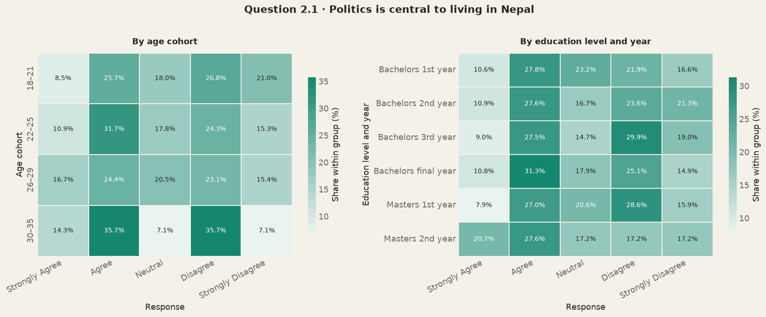
Figure 1 Response patterns by age cohort and education
The age and education cross-tabulations do not show a steady increase in political salience among older students or more educated ones. The clearest difference appears among respondents aged 18-21. 47.8% of them disagreed that politics is central to living in Nepal, while 34.2% agreed. The breakdown in education is less orderly. Final-year bachelor’s and second-year master’s students leaned more towards agreement whereas the disagreement was prevalent in other groups. The distribution therefore defers across the group and does not give a consistent outlook.
The next section brings these mixed responses into sharper view by combining the two agreement categories and comparing them with the two disagreement categories. Neutral responses are left out. The resulting ratio shows which view is dominant within the particular group.

Agreement to disagreement ratios
To make the direction of these responses easier to compare, the two agreement categories are combined and divided by the two disagreement categories.
$$Agreement-to-Disagreement ratio=\frac{Strongly Agree + Agree}{Strongly Disagree + Disagree}$$
Neutral responses are excluded from the calculation. A ratio above one means that more respondents agreed than disagreed, while the ratio below means that the disagreement was more common. A ratio of one indicates an equal number on both sides. The ratio therefore provides a simpler comparison of which position is more common within each age or education group.
Among the age cohorts, respondents aged 18–21 show the clearest tendency towards disagreement. Their agreement-to-disagreement ratio is 0.71, meaning that for every respondent who agreed, about 1.4 respondents disagreed. The ratios for those aged 22–25 and 26–29 are 1.08 and 1.07 respectively, showing only a slight lean towards agreement. The ratio increases to 1.17 among respondents aged 30–35, but this group contains only 14 respondents. The age results therefore separate the youngest cohort from the others more clearly than they show a steady increase in political salience with age.
The education results are more mixed. First-year bachelor’s students are evenly divided, with a ratio of 1.00. Second- and third-year bachelor’s students lean towards disagreement, with ratios of 0.86 and 0.75. The ratio moves slightly above one among final-year bachelor’s students, at 1.05, before falling to 0.79 among first-year master’s students. Second-year master’s students record the strongest agreement ratio, at 1.40. Education level therefore does not have a strong clear relationship with political salience.
One possible explanation for the age pattern is that politics becomes more immediate as students move closer to employment and greater economic responsibility. Government policy, regulation, public services and access to opportunities may become more visible as students begin to make decisions about work and their future. Younger students may still follow politics or participate in a specific event, such as the Gen-Z movement, without seeing continued political involvement as central to everyday life.
The uneven education pattern shows that this explanation is only partial. If education or proximity to employment were the main reason, agreement would be expected to rise more consistently across academic levels. Instead, the results suggest that political salience may also depend on personal experience, political interest and contact with public institutions.
Age and education alone therefore provide only a limited explanation of why students consider politics central to life in Nepal. The next section examines political-news consumption, allowing us to consider whether political salience is connected more closely to how regularly students follow political developments.
Table 3 Age cohort
Age cohort | Agree n | Disagree n | Agree/disagree ratio | Direction
18-21 | 125 | 175 | 0.71 | More disagreement
22-25 | 156 | 145 | 1.08 | More agreement
26-29 | 32 | 30 | 1.07 | More agreement
30-35 | 7 | 6 | 1.17 | More agreement
Table 4 Education level and year
Education level and year | Number of individuals who agree | Number of individuals who disagree | Agree/disagree ratio | Direction
Bachelors’ 1st year | 58 | 58 | 1.00 | Equal
Bachelors’ 2nd year | 67 | 78 | 0.86 | More disagreement
Bachelors’ 3rd year | 77 | 103 | 0.75 | More disagreement
Bachelors’ final year | 82 | 78 | 1.05 | More agreement
Masters’ 1st year | 22 | 28 | 0.79 | More disagreement
Masters’ 2nd year | 14 | 10 | 1.40 | More agreement

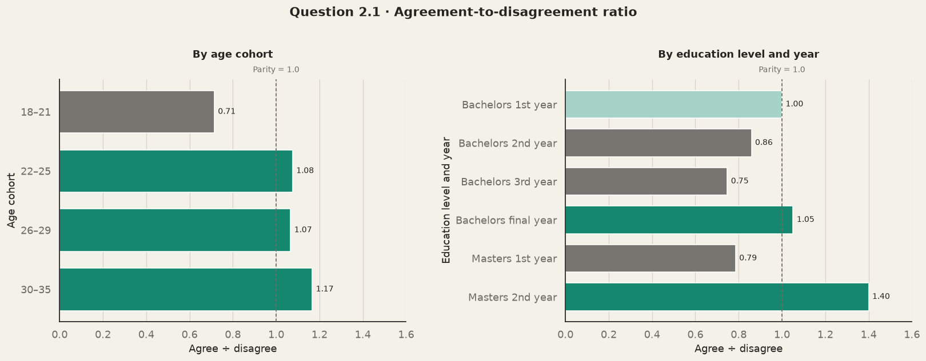
Figure 2 Agreement to disagreement ratios

Political news consumption
Political news consumption shows how closely students follow events that may shape their political views and participation. The survey asked whether respondents followed political news daily, several times a week, weekly, occasionally or never. Comparing these responses across age and education helps us understand whether regular attention to politics differs across stages of student life.
Table 5 Age cohort
Age cohort | Daily | Several times a week | Weekly | Occasionally | Never | Total n
18-21 | 164 (43.6%) | 100 (26.6%) | 20 (5.3%) | 83 (22.1%) | 9 (2.4%) | 376
22-25 | 206 (56.0%) | 103 (28.0%) | 7 (1.9%) | 48 (13.0%) | 4 (1.1%) | 368
26-29 | 64 (82.1%) | 6 (7.7%) | 3 (3.8%) | 5 (6.4%) | 0 (0.0%) | 78
30-35 | 12 (85.7%) | 2 (14.3%) | 0 (0.0%) | 0 (0.0%) | 0 (0.0%) | 14

Table 6 Education level and year
Education level and year | Daily | Several times a week | Weekly | Occasionally | Never | Total n
Bachelors’ 1st year | 61 (39.4%) | 39 (25.2%) | 12 (7.7%) | 38 (24.5%) | 5 (3.2%) | 155
Bachelors’ 2nd year | 77 (43.3%) | 55 (30.9%) | 6 (3.4%) | 36 (20.2%) | 4 (2.2%) | 178
Bachelors’ 3rd year | 114 (53.8%) | 58 (27.4%) | 7 (3.3%) | 31 (14.6%) | 2 (0.9%) | 212
Bachelors’ final year | 123 (62.1%) | 45 (22.7%) | 1 (0.5%) | 27 (13.6%) | 2 (1.0%) | 198
Masters’ 1st year | 43 (68.3%) | 12 (19.0%) | 4 (6.3%) | 4 (6.3%) | 0 (0.0%) | 63
Masters’ 2nd year | 27 (93.1%) | 2 (6.9%) | 0 (0.0%) | 0 (0.0%) | 0 (0.0%) | 29

The age pattern is clear. Daily political-news consumption rises from 43.6% among respondents aged 18–21 to 56.0% among those aged 22–25, 82.1% among those aged 26–29 and 85.7% among those aged 30–35. When daily consumption and consumption several times a week are combined, frequent news use increases from 70.2% in the youngest cohort to 84.0%, 89.8% and even 100% in the older cohorts. A similar progression appears across education levels. Frequent news consumption increases from 64.6% among first-year bachelor’s students to 74.2% in the second year, 81.2% in the third year and 84.8% in the final year. It reaches 87.3% among first-year master’s students and 100% among second-year master’s students. The wider pattern shows more regular political-news consumption at higher levels of education and age.
Here also, one possible explanation is that political developments become more relevant as students approach employment and take on greater economic and social responsibilities. Older students may also have had more time to develop regular news habits or encounter government policy and public institutions directly. Education may strengthen the habit of seeking and discussing current affairs.
The findings here add some nuance to the political-salience results. Although respondents aged 18–21 were more likely to disagree that politics is central to living in Nepal, 70.2% still followed political news frequently (daily or several times a week). Political attention and political salience may therefore be connected. The descriptive tables cannot show whether frequent news consumption is associated with stronger political salience after differences in age, education and other characteristics are considered. The ordered-probit analysis in Section 4 tests whether frequent news consumption and active involvement remain associated with stronger agreement that politics is central to living in Nepal.
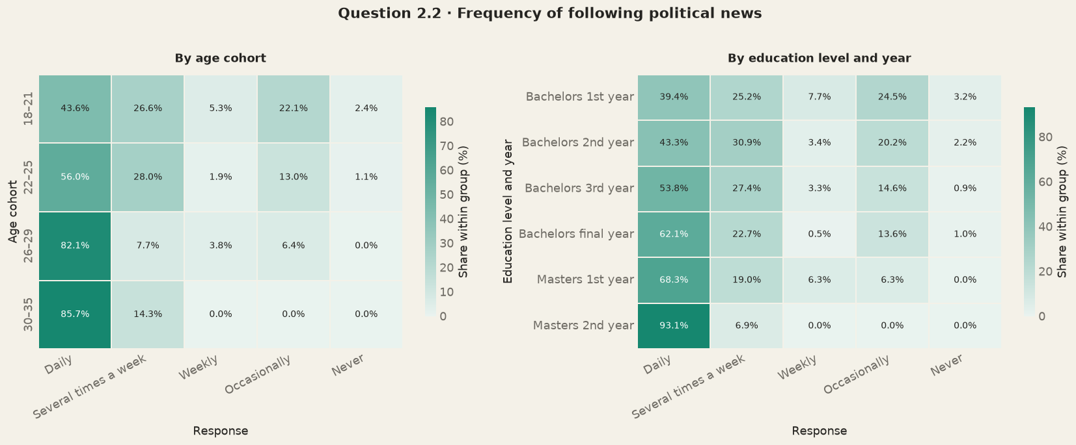
Figure 3 Response patterns by age cohort and education

Political involvement and activity
Political involvement is measured in two ways: whether students describe themselves as politically active and whether they report taking part in specific activities. These measures capture different things. A student may attend a protest or public meetings without identifying themselves as politically active, so relying only on self-description could miss some forms of participation. We therefore use both measures.
The activity count covers six activities undertaken in the previous 12 months: attending a campaign or rally, volunteering for a party or campaign, joining a protest or demonstration, attending a public meeting or discussion, contacting an elected representative, and joining a ward user committee. Each activity adds one point, giving a score from zero to six. Higher scores indicate participation in a wider range of activities. A score of six means the respondent reported all six. The count measures breadth, not frequency or intensity. Someone who repeatedly took part in one or two activities could score lower than someone who took part once in four or five. Even with this limit, the measure helps show whether participation is concentrated in a few activities or extends across several forms.
Only 20.2% of respondents described themselves as actively involved in politics or political organization, while 79.8% said they were not. The activity-based measure, on the other hand, gives a different picture. 54.1% of the total students had participated in at least one. Political participation was therefore more common than the self-reported measure of active involvement suggests.
Public meetings or discussions were the most common activity, reported by 31.7% of respondents, followed by protests or demonstrations (29.4%). Around one fifth had attended a campaign or rally (20.9%), and a similar share had contacted an elected representative (20.2%). Formal involvement was less common: 10.6% had volunteered for a party or campaign, and 4.4% had joined a ward user committee.
Participation was usually limited to a small number of activities. Nearly half of the respondents reported no activity, while 23.3% reported one and 13.5% reported two. Only 17.2% had participated in three or more activities. The average was 1.17 activities, and the median was one. Broad involvement across several forms of political activity was therefore concentrated among a relatively small group.
The gap between self-described political involvement and reported participation is analytically important. Students may attend a protest or public meeting in response to a particular issue without regarding themselves as politically active. The two measures are included separately in the subsequent analysis to examine whether political salience is associated with political self-identification, participation across different activities, or both. This distinction is particularly relevant to the Gen-Z movement, which may have drawn students into a specific episode of political action without producing a continuing political identity. Because the activity questions cover the previous 12 months, some reported participation may have occurred during the movement. The survey does not identify when each activity took place or whether it was connected to the movement, so it cannot establish that the movement caused broader participation. A later comparison of general political activity with attention to and involvement in the Gen-Z movement examines how far these different forms of engagement coincide.
The figures nevertheless show that participation extended well beyond the 20.2% of students who described themselves as politically active. More than half reported at least one activity, including 31.7% who attended a public meeting or discussion and 29.4% who joined a protest or demonstration. This gap offers one way of understanding how the Gen-Z movement could reach beyond a small group of established activists. Students did not have to see themselves as politically active, or participate regularly across several activities, to join collective action over an issue that directly concerned them. The later comparison of general political activity with attention to and involvement in the movement examines how far these forms of engagement coincided.
Table 7 Active involvement in politics or political organizations
Category | Frequency | Percent
Yes | 169 | 20.2
No | 667 | 79.8

Table 8 3 Political involvement and activity
Political activity in previous 12 months | Number of individuals who said YES | Percentage of individuals who said YES | Total number of individuals
Attended campaign/rally | 175 | 20.9 | 836
Volunteered for party/campaign | 89 | 10.6 | 836
Joined protest/demonstration | 246 | 29.4 | 836
Joined public meeting/discussion | 265 | 31.7 | 836
Contacted elected representative | 169 | 20.2 | 836
Joined ward user committee | 37 | 4.4 | 836

The next section examines whether political-news consumption, self-described active involvement and the breadth of reported activities are associated with a stronger belief that politics is central to living in Nepal.
Table 9 Political involvement index count
Maybe this is not important (but keeping it here for now)
Statistic | Value
Respondents | 836
Mean | 1.17
Median | 1
Standard deviation | 1.47

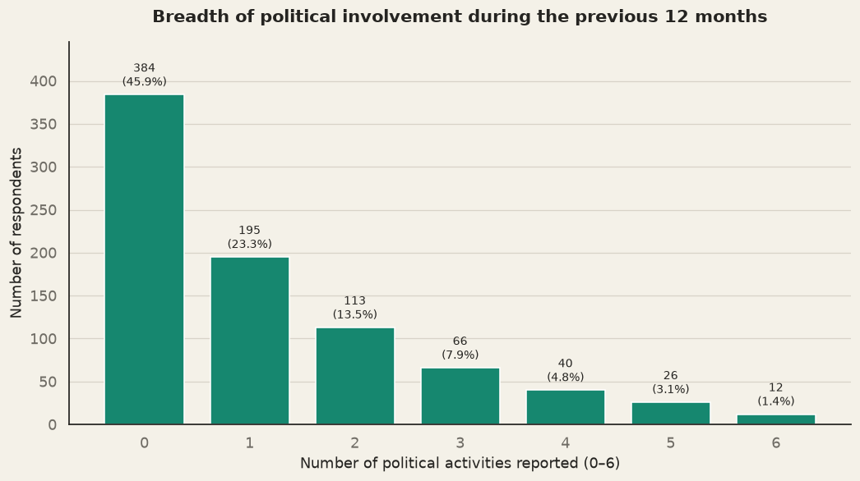
Figure 4 3 Political involvement and activity

4 Factors associated with viewing politics as central
The descriptive results so far give us a sense that political salience, news consumption and political involvement do not always move together. News consumption increases with age and education, while political salience follows a less consistent pattern. Students also report more participation in specific activities than their self-description as politically active would suggest. Since these characteristics may overlap, the cross-tabulations alone cannot tell us whether news consumption or political involvement has its own association with political salience. A multivariable model examines these relationships while accounting for differences in respondents’ backgrounds.
Political salience is measured through five ordered responses, ranging from “strongly disagree” to “strongly agree.” We therefore use an ordered probit model. This model preserves the ranking of the five responses without assuming that the distance between “strongly disagree” and “disagree” is the same as the distance between “neutral” and “agree.” It estimates whether a characteristic is associated with a greater tendency to choose a higher rather than a lower agreement category.
The analysis uses three measures from the preceding sections. Frequent political-news consumption identifies students who follow political news daily or several times a week. Self-reported active involvement captures whether they see themselves as active in politics or a political organization, while the activity count records how many of the six listed activities they reported taking part in during the previous 12 months. These measures capture related but distinct aspects of engagement: attention to politics, political self-identification and reported behaviour.
Models 1 to 3 include these three measures separately, along with the same background and demographic controls. Model 4 includes all three together to examine whether each remains associated with political salience after their overlap is taken into account. Model 5 groups the activity count into none, one, two to three, and four to six activities. This checks whether the relationship differs across levels of involvement instead of assuming that every additional activity has the same association with political salience.
All models use the same complete-case sample of 816 respondents and adjust for place lived most of life, school background, whether a close family member lives abroad, gender, age, education stage, ethnicity, religion and province. HC1 robust standard errors are reported. Political efficacy is examined separately because confidence in influencing government may shape political salience while political salience may also shape that confidence. The model estimates associations within the survey sample and does not establish that news consumption or involvement causes students to view politics as more central.
Table 11 Ordered probit results
Predictor / model statistic | (1) News | (2) Active politics | (3) Involvement count | (4) Joint | (5) Grouped involvement
Frequently follows political news | 0.242** (0.098) | -- | -- | 0.201** (0.099) | 0.196** (0.099)
Actively involved in politics/organizations | -- | 0.416*** (0.109) | -- | 0.419*** (0.121) | 0.400*** (0.118)
Political involvement count, 0-6 | -- | -- | 0.050 (0.031) | -0.015 (0.034) | --
One activity | -- | -- | -- | -- | 0.061 (0.096)
Two to three activities | -- | -- | -- | -- | 0.010 (0.111)
Four to six activities | -- | -- | -- | -- | -0.015 (0.171)
Background and demographic controls | Yes | Yes | Yes | Yes | Yes
Outcome categories | 5 | 5 | 5 | 5 | 5
Observations | 816 | 816 | 816 | 816 | 816
Standard errors | HC1 robust | HC1 robust | HC1 robust | HC1 robust | HC1 robust
Log likelihood | -1232.8 | -1227.4 | -1234.2 | -1225.4 | -1225.3
AIC | 2515.6 | 2504.8 | 2518.5 | 2504.8 | 2508.5
The results of the ordered probit model are consistent with the pattern seen in the descriptive analysis. Students who followed political news frequently were more likely to agree that politics is central to living in Nepal (coefficient = 0.242, p < 0.05). The association was stronger among students who described themselves as actively involved in politics or political organizations (coefficient = 0.416, p < 0.01). In contrast, the number of political activities a student had participated in was not clearly associated with political salience. These relationships were estimated after accounting for differences in age, education and other background characteristics. Self-reported involvement and the activity count are included separately because students may take part in political activities without describing themselves as politically active. A student may, for example, attend a protest or public meeting as a response to a particular issue without viewing it as part of an ongoing political identity. Including both measures lets us examine whether political salience is associated with political self-identification, reported participation, or both.
The same pattern appears when the three measures are examined together. Frequent news consumption remains positively associated with political salience (coefficient = 0.201, p < 0.05), as does self-described political involvement (coefficient = 0.419, p < 0.01). The activity count remains statistically inconclusive. Grouping students according to whether they reported one, two to three, or four to six activities produces a similar result: none of these groups differs significantly from students who reported no activity.
Placed in the context of Nepal’s Gen-Z movement, the results offer a possible explanation for how participation could spread beyond regular political activists. The social-media ban provided the immediate trigger for the September 2025 protest, while anger over corruption, nepotism and unaccountable government had been building beforehand, much of it through online discussion. This combination is documented. (for example, by Human Rights Watch). The survey findings describe a student population in which participation extended well beyond the 20.2% who identified as politically active: 54.1% reported at least one political activity during the previous year. A smaller politically committed group may have helped create the initial momentum, while a wider group of politically attentive students could join once the ban gave their broader frustrations an immediate focus. The movement therefore did not have to depend entirely on students with an established political identity or experience across several forms of participation. A student could follow political developments closely and join a protest over a specific issue without viewing politics as a continuing part of everyday life.

5 Political Efficacy
Political efficacy captures the sense of influence that students believe their engagement can affect government decisions. Political efficacy is examined separately from the ordered probit model because the direction of the relationship is unclear in cross-sectional data. Confidence may encourage students to participate, but participation may also strengthen their confidence that they can influence government.
Confidence was high among the students surveyed. Of the 836 respondents, 39.4% were very confident that they could influence government decisions and another 42.3% were confident. Together, 81.7% expressed confidence, compared with 13.4% who were neutral and 4.9% who were not confident or not at all confident.
Table 12 5 Political efficacy
Category | Frequency | Percent
Very Confident | 329 | 39.4
Confident | 354 | 42.3
Neutral | 112 | 13.4
Not Confident | 34 | 4.1
Not at all confident | 7 | 0.8

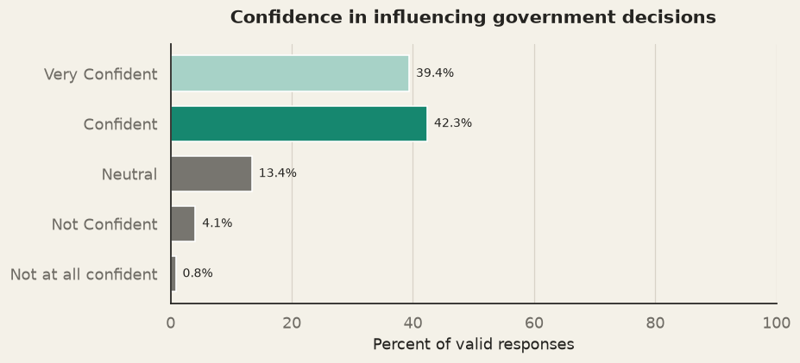
Figure 5 5 Political efficacy
The descriptive comparison shows that confidence increases with the breadth of political involvement. Among students who reported no political activity, 31.0% were very confident. This rose to 33.8% among those reporting one activity, 49.7% among those reporting two or three, and 70.5% among those reporting four to six activities. When the two confidence categories are combined, the proportion increases from 76.6% among students reporting no activity to 96.1% among those reporting four to six. Students with broader political experience therefore tend to express greater confidence in their ability to influence government.
Table 13 Political efficacy by breadth of involvement
Political-involvement breadth | Very Confident | Confident | Neutral | Not Confident | Not at all confident | Total n
None | 119 (31.0%) | 175 (45.6%) | 65 (16.9%) | 21 (5.5%) | 4 (1.0%) | 384
One activity | 66 (33.8%) | 89 (45.6%) | 31 (15.9%) | 7 (3.6%) | 2 (1.0%) | 195
Two to three activities | 89 (49.7%) | 70 (39.1%) | 14 (7.8%) | 5 (2.8%) | 1 (0.6%) | 179
Four to six activities | 55 (70.5%) | 20 (25.6%) | 2 (2.6%) | 1 (1.3%) | 0 (0.0%) | 78
The timing of the survey gives this pattern added relevance. Students responded after a youth-led protest had forced political authorities to confront demands raised outside established party structures. The movement was followed by the withdrawal of the social-media ban, the prime minister’s resignation and a wider political transition, giving young people visible examples of political pressure being followed by government action. Students who participated in several activities may therefore have gained a stronger sense that collective action can affect political decisions.
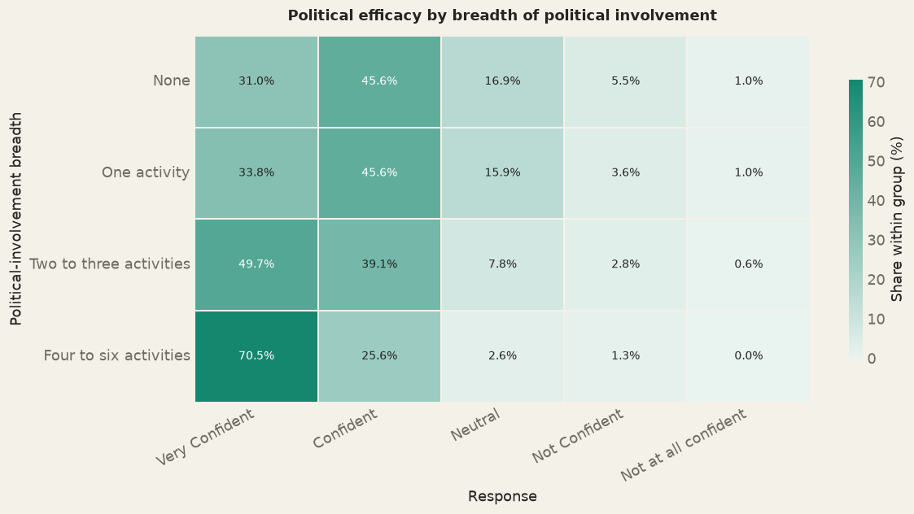
Figure 6 5 Political efficacy
More political involvement shows greater confidence in influencing government decisions

6 Past electoral participation
The earlier sections examined whether students follow politics, participate in political activities and believe they can influence government decisions. Voting provides a different test of engagement because it takes place through formal political institution. It is often associated with trust in political institutions. Distrust, however, does not always lead people to withdraw from elections. Some may abstain, while others continue to vote but support anti-establishment parties or candidates as a way of challenging the existing political order. This section examines whether respondents who were old enough to vote participated in the 2022 elections and why some did not. Because these elections took place before the Gen-Z movement, they provide a baseline for asking whether non-participation reflected a loss of faith in the political parties of the time or whether practical barriers prevented students from voting.
The analysis is limited to the 460 respondents, who were old enough to have voted in 2022.
Table 14 6 Past electoral participation
Election | Voted | Did not vote | Voted, level unknown | Total valid voters | Self-reported turnout (%)
Federal | 228 | 224 | 8 | 460 | 49.6%
Local | 222 | 228 | 10 | 460 | 48.3%

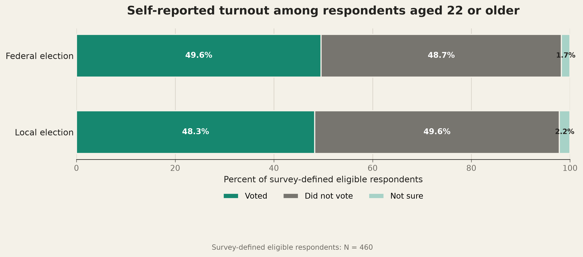
Figure 7 6 Past electoral participation
Table 16 Consistency across federal and local elections
Federal-election response | Yes | No | Row total
Yes | 213 (94.2%) | 13 (5.8%) | 226
No | 8 (3.6%) | 215 (96.4%) | 223
Column total | 221 | 228 | 449
Among these respondents, 49.6% reported voting in the 2022 federal election and 48.3% in the local election. The similarity between the two figures suggests that students did not treat one level of election as substantially more accessible or important than the other. For context, the Election Commission reported national turnout of about 61% among registered voters in the 2022 federal election. The same respondents also tended to behave consistently across the two elections. Among those who reported voting in one election, more than 94% of them reported in voting in the other election as well.
Table 15 Reasons for not voting
Reason | Federal | Local
Did not register | 71.9% | 70.2%
Away from registered voting location | 13.8% | 15.8%
Health/family issue | 2.2% | 2.6%
Not interested in voting process | 2.7% | 2.6%
Did not trust political parties/candidates | 3.1% | 2.2%
Intentionally boycotted the election | 1.8% | 1.3%
My vote would make no difference | 1.8% | 1.8%
Failure to register was the main reason students gave for not voting, followed by being away from their registered voting location. Only a small proportion cited distrust of parties or candidates, lack of interest, intentional boycotting or the belief that one vote would make no difference. Lower turnout in this sample therefore appears to reflect barriers to electoral access more than political apathy.
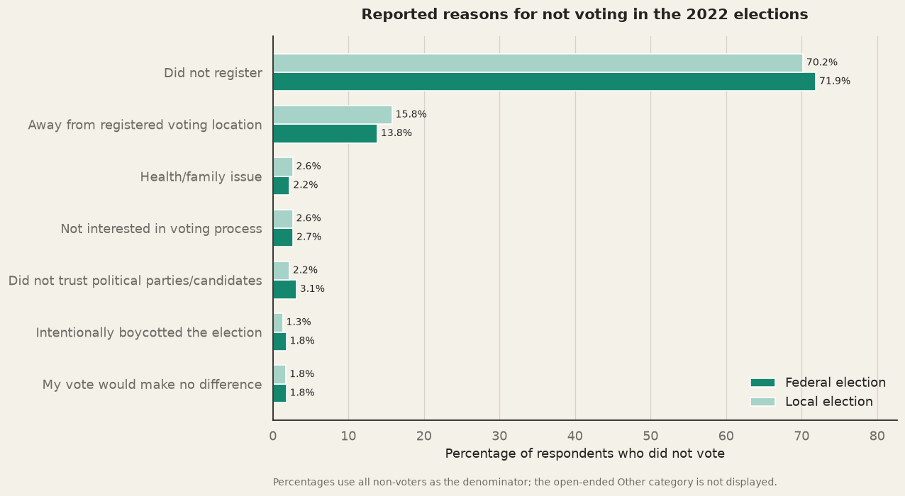
Figure 8 Reasons for not voting
Past voting also provides the starting point for the analysis of future electoral intention in Chapter 2. That analysis examines whether students who stayed outside the 2022 elections now expect to vote following the Gen-Z movement and the political changes that followed. The reasons reported here remain relevant even if future voting intention is high. The willingness to vote may not always translate into turnout unless the individual themselves register and can reach the place where they are registered to vote.
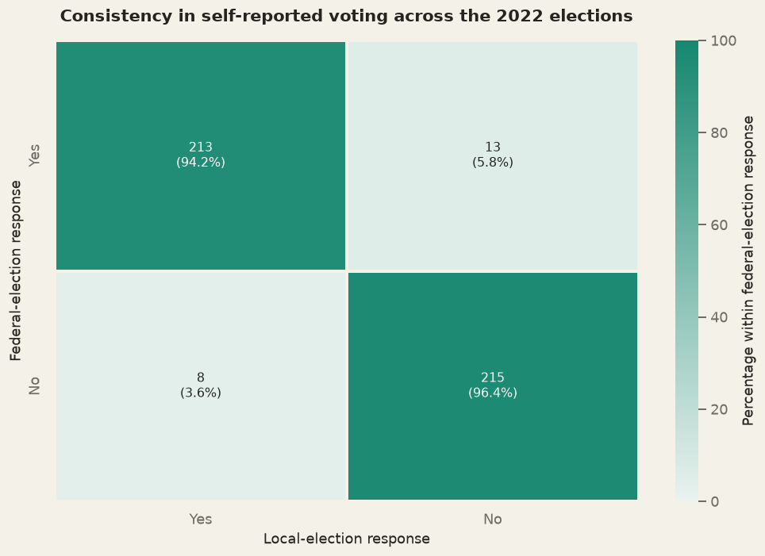
Figure 9 Consistency across federal and local elections

Chapter 2 Political instability the Gen-Z movement and Nepal's political future
The previous chapter examined how students follow politics, take part in civic life, and approach elections. This chapter turns to their assessment of Nepal’s political direction. It asks how stable they consider the country today, what they believe produces instability, and whether the Gen-Z movement has changed the place of young people in politics. It also examines what they expect from the government and where they see risks and hope in the years ahead.
A majority describe Nepal as politically stable and believe it to be more stable than it was one or five years earlier. Yet they identify persistent problems. Corruption, weak accountability, failures to make and carry out policy, and limited economic opportunities all feature strongly in their explanations of instability. Their view of the present is therefore more hopeful than a simple account of political crisis would suggest, but that hope depends on whether institutions can address problems they regard as longstanding.
The Gen-Z movement gives these concerns a concrete political setting. Students most often associate the protest with corruption, distrust of political leaders and institutions, nepotism, unemployment, and poor public services. Their answers nevertheless show how closely they connect the movement to their wider judgment of Nepal’s governance.
Students also believe the movement had consequences beyond the protest itself. Most of them think that it marked a turning point in Nepal’s political history and encouraged greater civic and political participation among young people. However, they are not entirely confident about whether the current government represents youth interest or will continue to do so. This difference raises a question for the chapter.
The chapter looks ahead as well as back in time. Many respondents expect Nepal to become more stable over the next five years, even as they remain uncertain about changes in government and the possibility of further major political events. Youth participation is their most widely shared source of hope. Confidence in improving employment and economic prospects is weaker. Taken together, these responses suggest that political optimism rests on two expectations: that young people will remain involved, and that institutions will respond to the governance and economic concerns that drew them into public life.
The analysis begins by connecting past voting with stated intentions to vote in the next local election. It then examines assessments of stability, students’ proximity to the Gen-Z movement, their views of its causes and consequences, and their expectations for Nepal’s political future. The chapter closes by comparing perceived risks with sources of hope.

2.1 Voting Intention
Chapter 1 showed how students participated in elections before the Gen-Z movement. Among respondents old enough to vote in 2022, turnout was close to half. Most non-voters said they had either not registered or were away from the place where they were registered, rather than deliberately rejecting the electoral process. This section asks whether that earlier pattern carries into students’ intention to vote in the 2027 local election.
Because the survey was conducted after the Gen-Z movement, these intentions were formed in a different political context from the 2022 elections. Among previous non-voters, the willingness to participate in the next election could reflect approval of the government that emerged after the movement. It could also reflect the experience of seeing a youth-led movement produce major political consequences and a desire to influence what happens next through the ballot.
The survey shows strong voting intentions among both past voters and non-voters. Of those who voted in the 2022 federal election, 98.2% said they were likely to vote in the 2027 federal election. The figure remained high, at 83.2%, among those who did not vote. Local elections followed almost the same pattern: 98.2% of previous local voters and 83.6% of non-voters said they were likely to vote in 2027 (Figure 10).
Although intention is high across both the groups. The past participation separates the groups. The difference between past voters and non-voters is about 15 percentage points for both federal and local elections. The association is just moderate in each case (Cramér’s V = 0.25; p < 0.001). Voting intention was high across both groups, but it was strongest among respondents who had voted before. The high level of intention among past non-voters suggests that many remain willing to engage through elections despite not participating in 2022. This high voting intention reflect renewed confidence in the establishment that was formed as a byproduct of the movement and also a desire to influence political change through the ballot.
Table 17 Federal election
 | Will Vote in Federal Future Election
Voted in 2022 federal election | Likely | Unlikely | Total Observation
Yes | 221 (98.2%) | 4 (1.8%) | 225
No | 173 (83.2%) | 35 (16.8%) | 208

Table 18 Local election
 | Will Vote in 2027 Local Election
Voted in 2022 local election | Likely | Unlikely | Total Observation
Yes | 215 (98.2%) | 4 (1.8%) | 219
No | 178 (83.6%) | 35 (16.4%) | 213

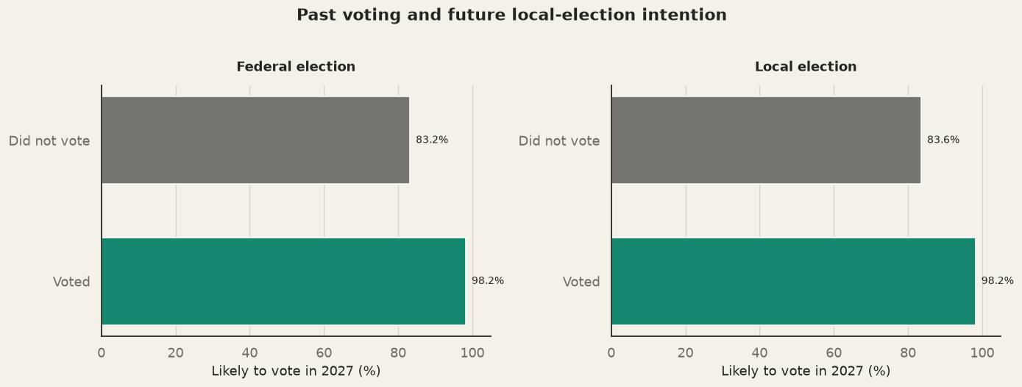
Figure 10: Bridge analysis Past voting and future electoral intention

2.2 Perception of Political Stability
High voting intention shows that students expect to remain engaged in elections, but it does not tell us how they judge Nepal’s political environment. The stability questions provide a separate view. At the time of the survey, 60.2% described Nepal as stable or very stable. Another 22.3% were neutral, while 17.5% considered it unstable or very unstable (Figure 11). The response looks positive, but there is no clear consensus.
Students were more positive when comparing the present with the past. Nearly three quarters said Nepal was more stable than it had been one year earlier (74.7%), while 75.9% said it was more stable than five years earlier (Figure 12). The closeness of these figures suggests a broad perception that political conditions have improved across both short and long-time frames. This shows that students rate the present political stability moderately, but they see a clear improvement over time.

Table 19 Political stability today
Assessment | Frequency | Percent
Very Unstable | 26 | 3.1
Unstable | 119 | 14.4
Neutral | 184 | 22.3
Stable | 454 | 55.0
Very Stable | 43 | 5.2

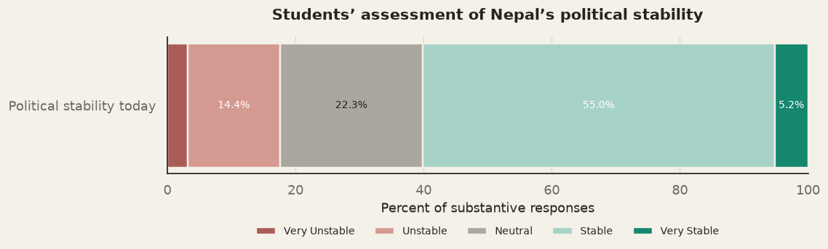
Figure 11: Political Stability Today
Table 20 How the present compares with the past
 | More stable | About the same | Less stable
Comparison
Compared with one year ago | 74.7% | 16.2% | 9.1%
Compared with five years ago | 75.9% | 14.9% | 9.3%

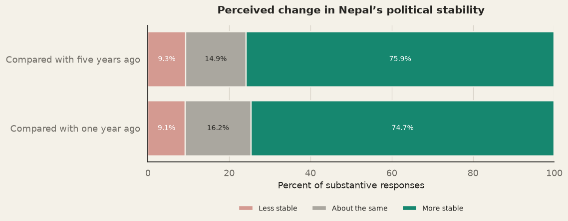
Figure 12 How the present compares with the past
Taken together, these results indicate cautious optimism about the political environment. This is consistent with the high voting intention in Section 2.1, although we cannot pinpoint whether perceived stability has driven this intention to vote.

2.3 Youth Engagement in the Movement
Students in the survey paid close attention to the Gen Z movement. As figure 13 shows, illustrates that of the respondents, 26.8% reported engaging directly and 57.1% followed it very closely, which together make up 83.9% of students closely engaging. A further 13.9% followed it somewhat closely, and only 2.3% reported little or no attention. This shows high engagement of students. Most respondents aged 18 to 21 and 22 to 25 either followed the movement closely or took part in it directly (Table 20).
Age Cohort | Engaged Directly | Closely Followed | Followed somewhat closely | Heard about it but followed very little | Did not follow at all
18-21 | 21.01% | 59.78% | 17.02% | 2.66% | 0.80%
22-25 | 30.71% | 55.98% | 11.96% | 1.09% | 0.27%
Table 20: Age cohort and engagement with the movement

For Figure 14, the five response categories are grouped into three. Respondents who engaged directly are labelled "Directly engaged", those who followed the movement very closely or somewhat closely are labelled "Closely followed", and those who followed it very little or not at all are labelled "Limited attention". The original five categories remain the basis for the descriptive results above. The grouped variable allows clearer comparisons with voting, political efficacy and expectations of political change.

2. 3 .1 Political News Consumption and Gen-Z Movement Engagement
Respondents who followed political news more often were also more likely to take part directly in the Gen-Z movement. Those who consumed political news rarely were less likely to be directly involved. To check this relationship, we used Cramér's V test. The result shows a small but positive relationship between how often respondents consume political news and how much they engage with the movement (Cramér's V = 0.21, p < 0.001). Among many reasons following political news could be linked to direct engagement.

Table 21 Attention to and engagement with the movement
 | Frequency | Percent
Response
Engaged directly | 224 | 26.8
Followed very closely | 477 | 57.1
Followed somewhat closely | 116 | 13.9
Heard about it but followed very little | 15 | 1.8
Did not follow it at all | 4 | 0.5
Total | 806

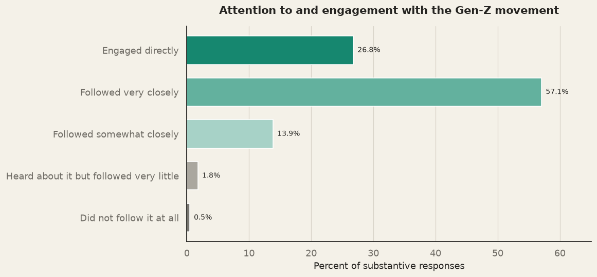
Figure 13 Attention to and engagement with the movement

Table 22 Political news consumption and Gen Z attention
 | Directly engaged | Closely followed | Limited attention | Total n
Political-news consumption
Frequent | 184 (28.0%) | 462 (70.3%) | 11 (1.7%) | 657
Less frequent | 40 (22.3%) | 131 (73.2%) | 8 (4.5%) | 179

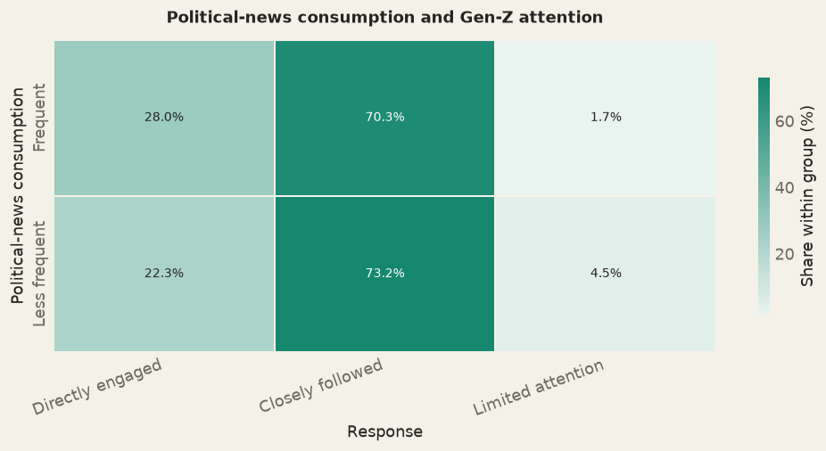
Figure 14 Political news consumption and Gen Z attention
2.3.2 Political Involvement and Gen-Z Movement Engagement
Students who were actively involved in politics were more likely to engage directly in the movement. Among politically involved respondents, 45.6% reported direct engagement in the Gen-Z movement, compared with 22% of those who were not actively involved in politics (Figure15) . This points to a moderate association between political involvement and direct engagement. Political news consumption is therefore only weakly related to direct engagement, whereas prior political involvement is a clearer marker of who took part.
The next section examines how this highly attentive student sample interprets the Gen-Z movement and the wider political instability around it.

Table 23 Political involvement and Gen Z attention
Outcome: n (row %) | Directly engaged | Closely followed | Limited attention | Total n
Actively involved in politics
Yes | 77 (45.6%) | 89 (52.7%) | 3 (1.8%) | 169
No | 147 (22.0%) | 504 (75.6%) | 16 (2.4%) | 667

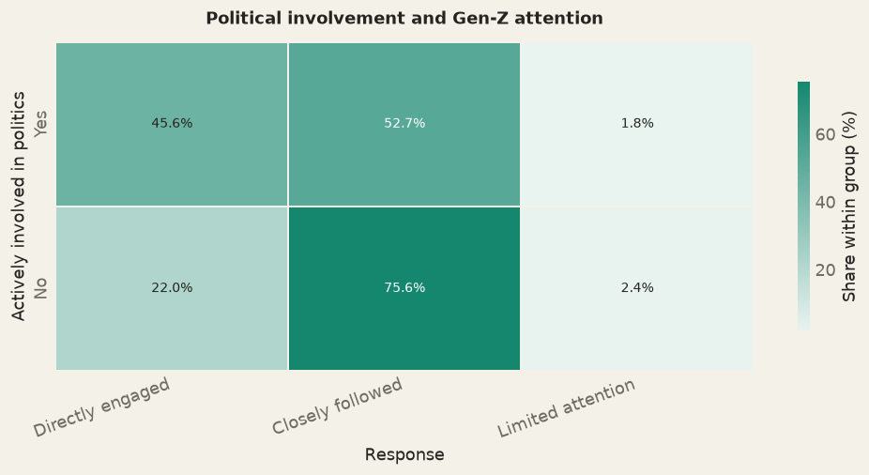
Figure 15 : Political involvement and Gen Z attention

2.4 From the Gen-Z Movement to Wider Political Instability
Having established that most respondents followed or took part in the Gen-Z movement, this section examines how they explain it. Students were asked what they think led to the Gen-Z protest and which factors they consider most important. The section then moves from the Gen-Z movement itself to how students explain political instability in Nepal more broadly. Here, students were asked about the reasons behind the country's repeated political problems, beyond this one event. The two sets of questions are presented separately because they cover different outcomes. The first relates to a Gen-Z movement, while the second relates to a long-running pattern behind political instability. Keeping them apart makes it easier to see whether students explain the two in the same way or differently.

2.4.1 What Students Believe Caused the Gen Z Movement
Figure 16 shows how students responded to eight proposed causes of the Gen-Z movement. The causes are ranked by the share of respondents who agreed or strongly agreed, and the figure keeps the original five response categories: strongly agree, agree, neutral, disagree and strongly disagree.
Governance-related explanations were the most widely accepted. Agreement was highest for corruption at 93.8%, followed by distrust of leaders, parties and institutions at 90.2%, and nepotism and elite capture at 89.2%. Economic and service-related causes also received broad agreement, with unemployment and limited economic opportunities at 85.2% and poor public services at 85.0%. The social media ban was endorsed by 80.6% of respondents.
Agreement was lower for the rising cost of living at 63.2%, while 22.2% disagreed. Foreign or external influence received the least agreement at 49.4%, with 18.9% neutral and 31.7% disagreeing. It was also the only cause that fewer than half of respondents endorsed. Overall, students saw the Gen-Z movement as caused mainly by domestic governance failures and economic concerns, with far less agreement on external explanations.

Table 24 What students believe caused the Gen Z movement
 | Agree or strongly agree (%) | Neutral (%) | Disagree or strongly disagree (%)
Proposed cause
Corruption | 93.8 | 2.6 | 3.6
Distrust of leaders, parties, and institutions | 90.2 | 6.6 | 3.2
Nepotism and elite capture | 89.2 | 6.7 | 4.1
Unemployment and limited economic opportunities | 85.2 | 7.1 | 7.8
Poor public services | 85.0 | 9.9 | 5.2
Social-media ban | 80.6 | 11.5 | 7.9
Rising cost of living | 63.2 | 14.6 | 22.2
Foreign or external influence | 49.4 | 18.9 | 31.7

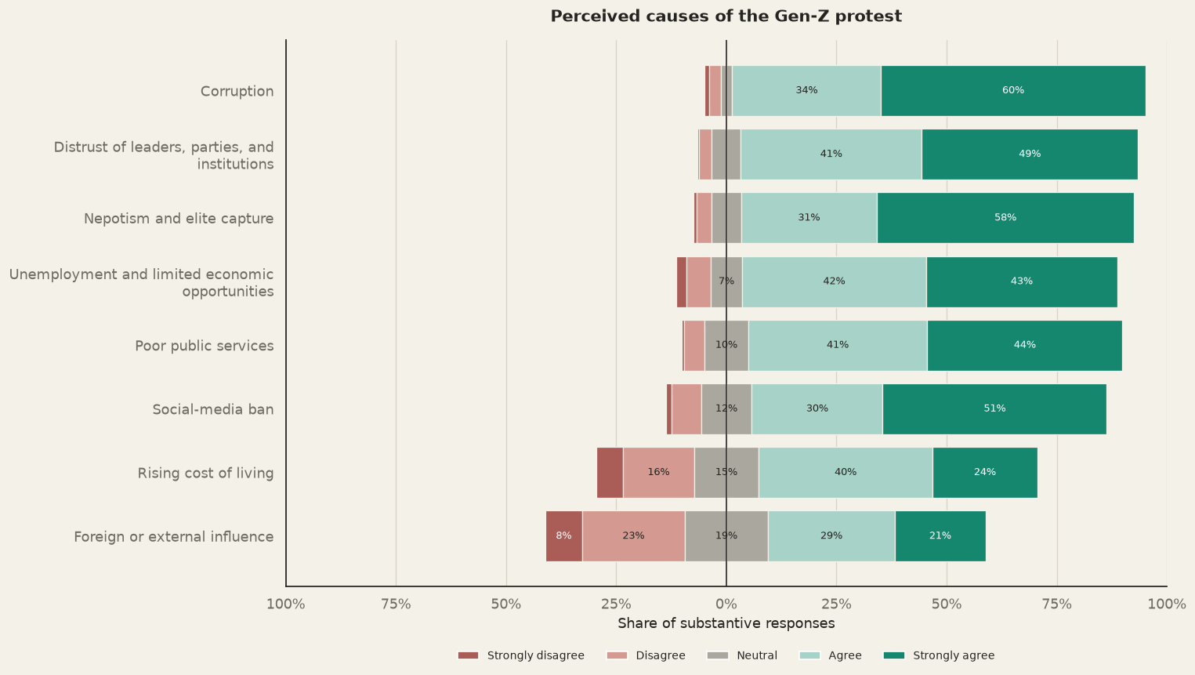
Figure 16 What students believe caused the Gen Z movement

2.4.2 What Students Believe Causes Political Instability
To identify the broad institutional and political conditions that students believe cause political instability, respondents were given several statements and asked how much they agreed with each. Their answers were recorded under five categories: strongly agree, agree, neutral, disagree and strongly disagree.
Students located failures in governance and institutional performance as a main cause behind political instability. As Figure 17 shows, agreement was highest for corruption at 95.9 per cent, followed by failure to implement policies at 93.9 per cent, frequent government changes and party conflict at 93.0 per cent, and failure to formulate policies at 92.8 per cent. A further 89.6 per cent agreed that movement, violence and civic unrest contribute to instability. Frequent transfers of government officials ranked last, but it still received agreement from 63.9 per cent of respondents.
Comparing the causes of the Gen-Z movement with the causes of political instability, students named corruption as the main reason in both cases. Agreement on corruption was 93.8 per cent for the movement and 95.9 per cent for political instability. Foreign or external influence was seen differently, 76.0 per cent, agreed that it contributes to political instability, but only 49.4 per cent agreed that it was a cause of the Gen-Z movement. Students therefore saw external influence as a possible factor in the country's instability, but not as a main reason for the Gen-Z movemnet itself.

Students mainly believed in domestic governance and institutional failure for both the Gen-Z movement and political instability. The Gen-Z movement was also linked to unemployment, economic pressure and the social-media ban. Many students also saw protests and unrest as a cause of instability. This suggests that they see the two as connected: political failures can lead to Gen-Z movement essentially a protest, and protest can add to the sense of instability.

Table 25 What students believe causes political instability
 | Agree or strongly agree (%) | Neutral (%) | Disagree or strongly disagree (%)
Proposed cause
Corruption | 95.9 | 2.4 | 1.7
Failure to implement policies | 93.9 | 4.1 | 2.0
Frequent government changes and party conflict | 93.0 | 4.7 | 2.3
Failure to formulate policies | 92.8 | 3.2 | 4.0
Lack of accountability | 92.1 | 5.6 | 2.3
Protests, violence, and civic unrest | 89.6 | 6.2 | 4.2
Conflict between levels of government | 89.0 | 7.1 | 4.0
Foreign or external influence | 76.0 | 15.3 | 8.7
Frequent transfers of government officials | 63.9 | 18.0 | 18.1

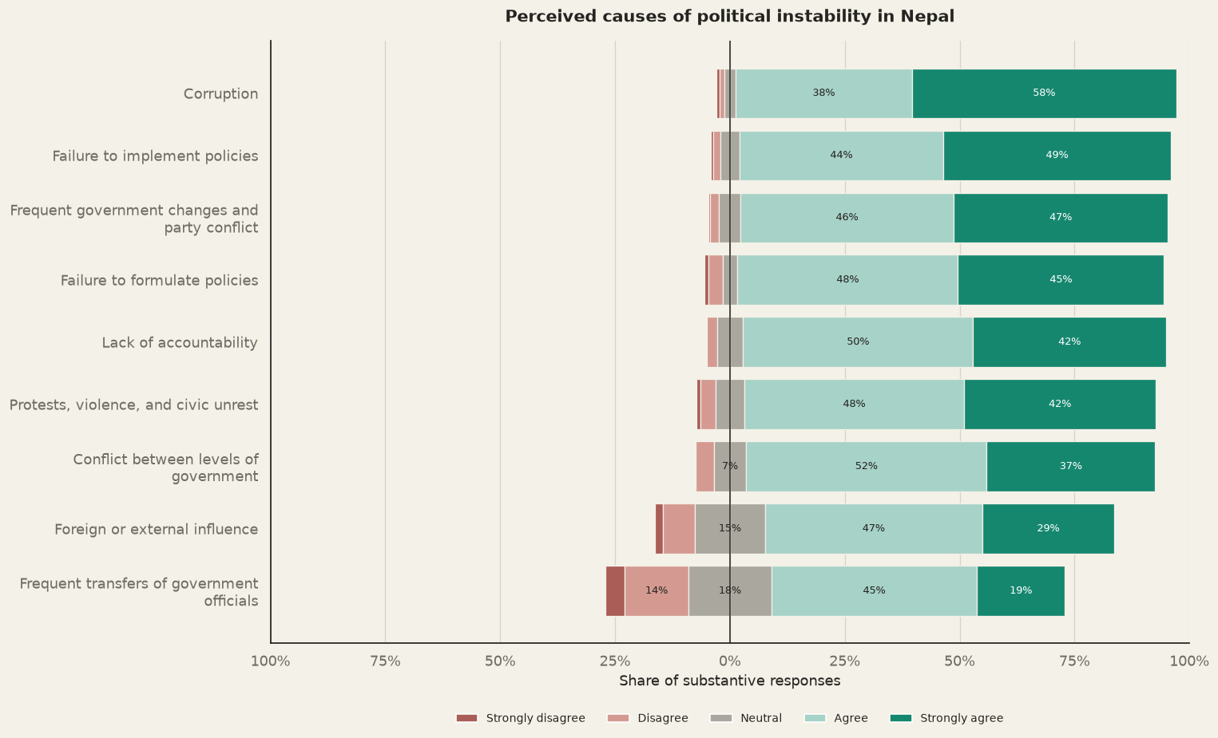
Figure 17 What students believe causes political instability

Table 26 Where the explanations overlap
 | Cause of Gen-Z movement(%) | Cause of political instability (%) | Difference (instability − movement, pp)
Explanation appearing in both batteries
Corruption | 93.8 | 95.9 | 2.2
Foreign or external influence | 49.4 | 76.0 | 26.6

2.5 What Students Believe the Gen-Z Movement Changed
This section looks at what students think the movement changed in politics. Students were given six statements covering how important the movement was, how it affected participation and inclusion, how it affected party politics, and how far they trust the government to represent the interests of young people. The statements are presented together so they can be compared, but they are not combined into a single scale. The top three changes that students believed happened after Gen-Z movement are increased public support for Rastriya Swatantra Party (RSP), movement was a political turning point, greater youth civic and political participation.
Table 27 What students believe the Gen Z movement changed
 | Agree or strongly agree (%) | Neutral (%) | Disagree or strongly disagree (%)
Proposed cause
Increased public support for RSP | 91.9 | 6.1 | 1.9
Political turning point | 91.8 | 6.2 | 1.9
Greater youth civic and political participation | 91.2 | 5.9 | 2.9
Inclusion of youth voices in mainstream politics | 84.6 | 9.9 | 5.5
Current government represents youth interests | 77.9 | 16.4 | 5.7
Government will continue to advance youth interests | 76.8 | 17.3 | 6.0

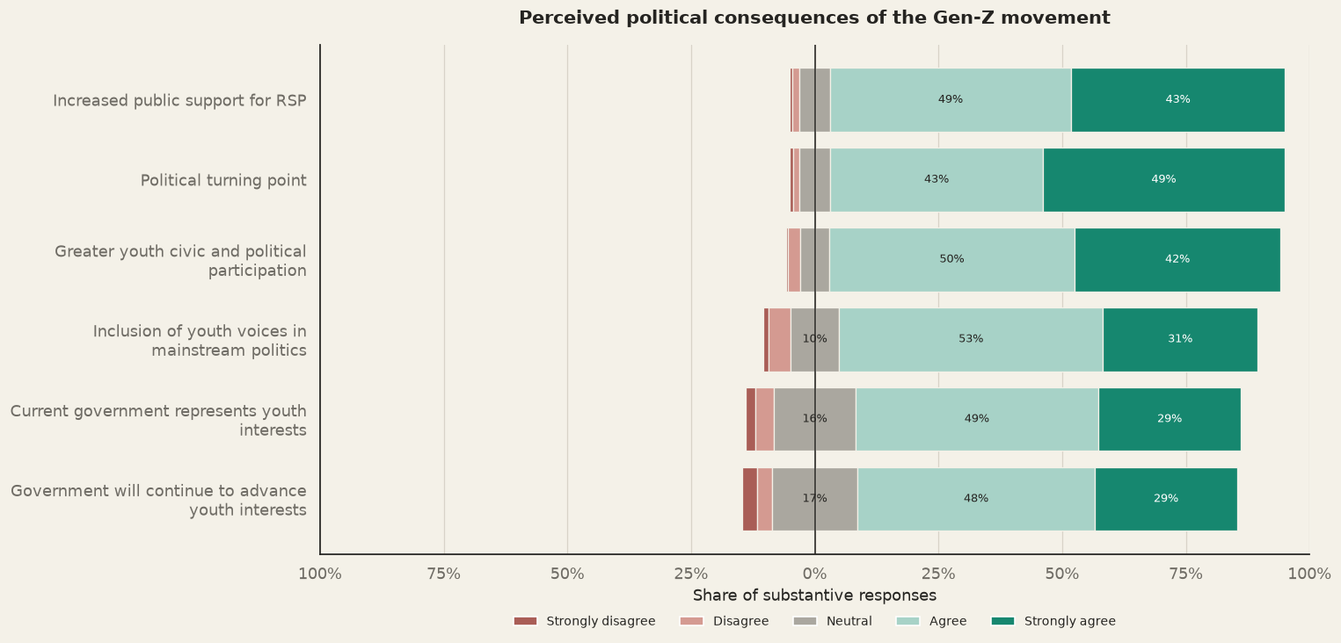
Figure 18 What students believe the Gen Z movement changed

2.5.1 Gen-Z Movement a Political Turning Point
A total of 91.8 per cent of students agreed or strongly agreed that the Gen-Z movement was a major turning point in Nepal's political history. Students therefore tended to see the movement as an important event that changed the course of politics in the country. This view was shared by students who were actively involved in politics and those who were not. Among students who were actively involved in politics, 88.7 per cent saw the movement as a turning point, compared with 92.6 per cent of those who were not. The belief was therefore held strongly in both groups (Figure 19). A Cramér's V test found no association between being actively involved in politics and seeing the Gen-Z movement as a turning point.
Table 28 Turning point belief by prior political involvement
Outcome: n (row %) | Agree | Neutral | Disagree | Total n
Actively involved in politics
Yes | 149 (88.7%) | 13 (7.7%) | 6 (3.6%) | 168
No | 616 (92.6%) | 39 (5.9%) | 10 (1.5%) | 665

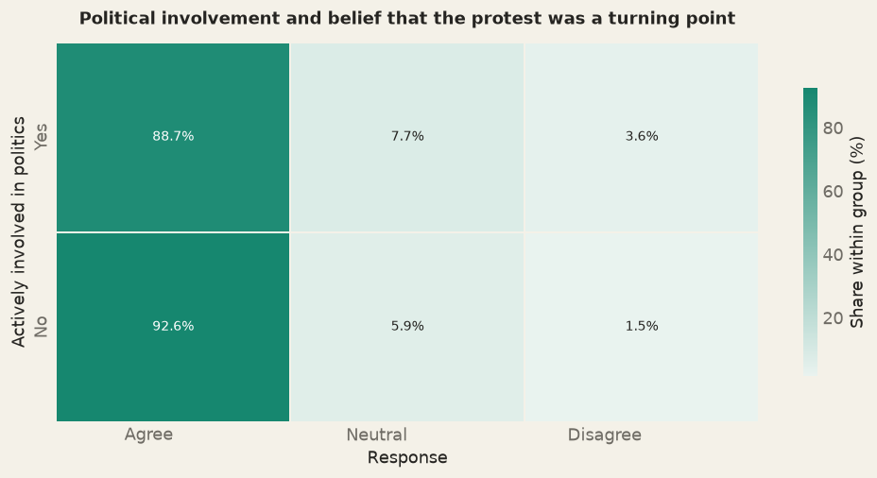
Figure 19 Turning point belief by prior political involvement
2.5.2 Perceived Effects of the Gen-Z Movement on Participation, Party Politics and Representation
Among the statements on the movement's effects, agreement was highest for increased public support for the Rastriya Swatantra Party (RSP), at 91.9 per cent. This was followed by greater youth civic and political participation at 91.2 per cent and the inclusion of youth voices in mainstream politics at 84.6 per cent (Figure 19). Students were therefore more confident about youth mobilization than about the inclusion of youth voices in institutions.
The RSP result shows what students think the movement did to the party system. It does not show their own support for the RSP. Agreement was lower on whether the government serves young people. Students were less sure that the government would advance youth interests. A total of 77.9 per cent agreed that the current government represents youth interests, and 76.8 per cent expected it to continue advancing them. This points to uncertainty among students about whether institutions will keep representing them.

The results show that students perceive the Gen-Z movement as a real turning point in Nepal's politics. Most of them believed that it increased support for the RSP and believe that movement led to greater youth civic and political participation and gave young people more space in mainstream politics. At the same time, they were less sure that the government would advance the interests of young people. These are the students' perceptions of what the movement has changed so far. The next section looks ahead, examining whether students expect political stability in the future or anticipate further political change.
.

2.6 Future Stability and Expectations of Political Change
Having examined how students see the Gen-Z movement and what they think it changed, this section turns to what they expect for the future. It asks whether students expect Nepal's politics to become more stable and whether they foresee further political change. Together, these questions give a fuller picture of how students see the country's political direction.

2.6.1 Expected Stability and Political Turnover
Figure 20 shows that a large majority of respondents, 83.5 per cent, expected Nepal to be more stable in five years. Only 9.2 per cent expected stability to stay about the same, and 7.4 per cent expected the country to become less stable. This points to optimism about the direction of change. However, the question asks respondents to compare the future with the present, so it should not be read as a rating of how stable the country will be.
Expectations of government change were marked by uncertainty, especially in the short term. Figure 21 shows that for change within one year, 46.1 per cent answered, "don't know", while 18.4 per cent thought it likely and 35.5 per cent thought it unlikely. For the next federal election, uncertainty fell to 31.0 per cent. Even so, more students thought a change of government was unlikely, at 45.1 per cent, than likely, at 23.8 per cent.
Students were divided on whether a major political event would occur within five years. Figure 21 shows that 41.3 per cent thought it was likely and 46.5 per cent thought it unlikely, while 12.2 per cent were unsure. Opinion was somewhat more open on whether a new political force would emerge. In this case, 41.1 per cent thought it likely, 38.2 per cent thought it unlikely and 20.7 per cent did not know. Overall, there is no settled view among students on what form future political change will take.
Overall, the findings show a gap between students' optimism about Nepal's future direction and their confidence about how the country will get there. Students may believe that Nepal will become more stable, yet remain unsure about a change of government, a major political event or the rise of a new political force. To understand this better, we need to look at what lies behind their optimism and their fears.

Table 29 Expected stability five years from now
 | Frequency | Percent
Expected stability in five years
More stable | 601 | 83.5
About the same | 66 | 9.2
Less stable | 53 | 7.4

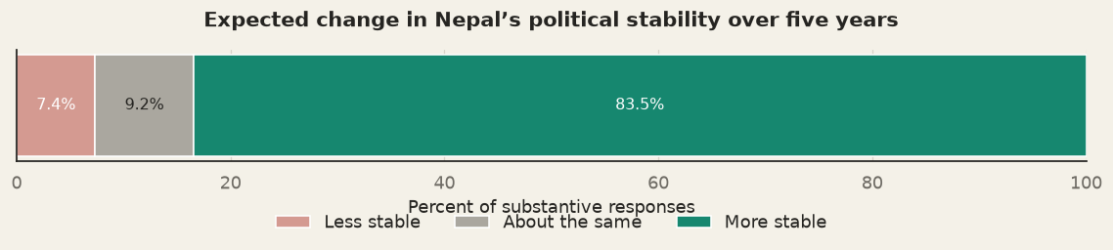
Figure 20 Expected stability five years from now

Table 30 Expectations of government change
 | Likely (%) | Don't know (%) | Unlikely (%)
Expected political change
Government change within one year | 18.4 | 46.1 | 35.5
Government change before next federal election | 23.8 | 31.0 | 45.1
Major political event within five years | 41.3 | 12.2 | 46.5
New political force within five years | 41.1 | 20.7 | 38.2

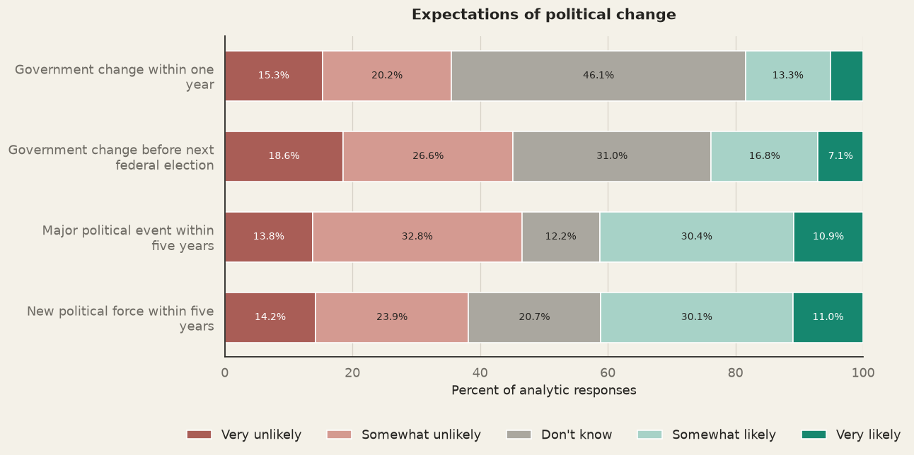
Figure 21 Expectations of government change

2.7 Risks to Future Stability and Sources of Hope
The expectation that Nepal will become more stable does not mean that students see the road ahead as easy. This section examines the risks students link to Nepal's future stability and the developments that give them hope.

2.7.1 Perceived Risks to Nepal's Future Stability
Students were asked about eight possible risks to Nepal's future stability. As Figure 22 shows, a clear majority agreed or strongly agreed that each one is a risk. Agreement was highest for corruption at 96.0%, followed by unemployment and limited economic opportunities at 94.6% and lack of accountability at 94.1%. Because these three figures are close, they are best read as a cluster, not a strict ranking.
Rising cost of living at 88.1%, ethnic or religious conflict at 88.0% and political exclusion at 87.4% formed a second group, followed by social media misinformation at 84.1%. Foreign or external influence ranked last, but was still seen as a risk by 79.7% of respondents. It also had the largest neutral share at 13.9%, while no more than 6.4% disagreed with any item. As in the discussion of the movement in Section 2.4, external influence received the least agreement, but it remained a majority concern.
The results suggest that students see many sources of risk. Agreement was highest for corruption, lack of accountability and unemployment, which points to governance failures and economic insecurity as the main concerns.

Table 31 Perceived risks to Nepal's future stability
 | Agree or strongly agree (%) | Neutral (%) | Disagree or strongly disagree (%)
Perceived risk
Corruption | 96.0 | 2.2 | 1.8
Unemployment and limited economic opportunities | 94.6 | 3.2 | 2.2
Lack of accountability | 94.1 | 4.3 | 1.6
Rising cost of living | 88.1 | 7.5 | 4.3
Ethnic or religious conflict | 88.0 | 6.7 | 5.3
Political exclusion | 87.4 | 9.8 | 2.8
Social-media misinformation | 84.1 | 11.0 | 4.9
Foreign or external influence | 79.7 | 13.9 | 6.4

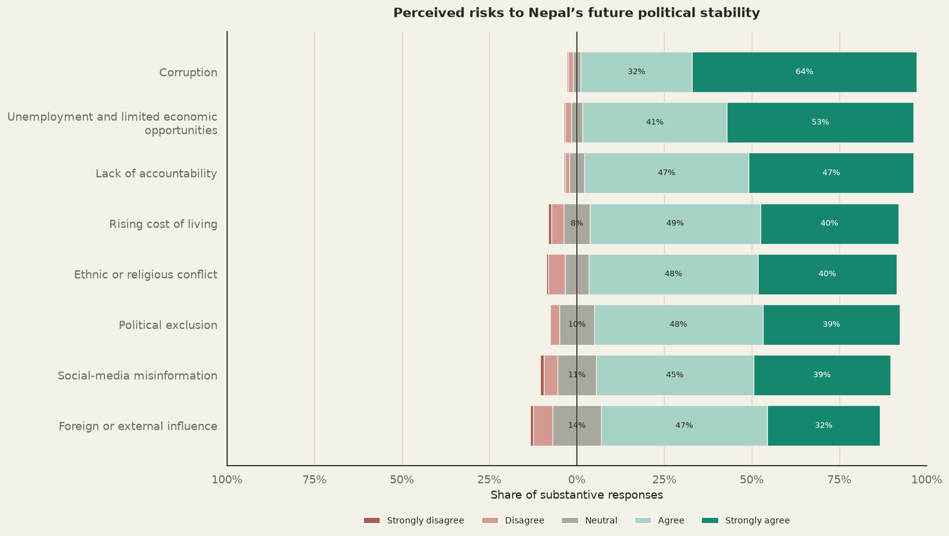
Figure 22 Perceived risks to Nepal's future stability

2.7.2 Sources of hope for Nepal

Youth political participation was the most common source of hope at 82.2 per cent, followed by governance and anti-corruption reforms at 69.8 per cent and improved democracy at 67.1 per cent. Economic and employment prospects ranked last, but a majority of respondents, 58.4 per cent, still saw them as a source of hope. Given the earlier results, the high place of youth participation suggests that students see greater youth engagement as important for the country's politics. (Figure 23)

Students' optimism appears to be conditional, not unconditional. They expect Nepal to become more stable, but they also see serious threats on the way, mainly corruption, unemployment and limited economic opportunities, and weak accountability. Their hope rests more on youth political participation and institutional reform than on economic prospects, although a majority still see the economy as a source of hope. Students were also unsure how this change would come about. Many did not know whether the government would change in the near term, and opinion was split on whether a major political event or a new political force would emerge. These findings suggest that students picture a more stable future and place their hope in political engagement and governance reform.

Table 32 Sources of hope for Nepal
 | Agree or strongly agree (%) | Neutral (%) | Disagree or strongly disagree (%)
Source of hope
Youth political participation | 82.2 | 14.3 | 3.5
Governance and anti-corruption reforms | 69.8 | 18.7 | 11.5
Improved democracy | 67.1 | 23.3 | 9.6
Economic and employment prospects | 58.4 | 22.0 | 19.6

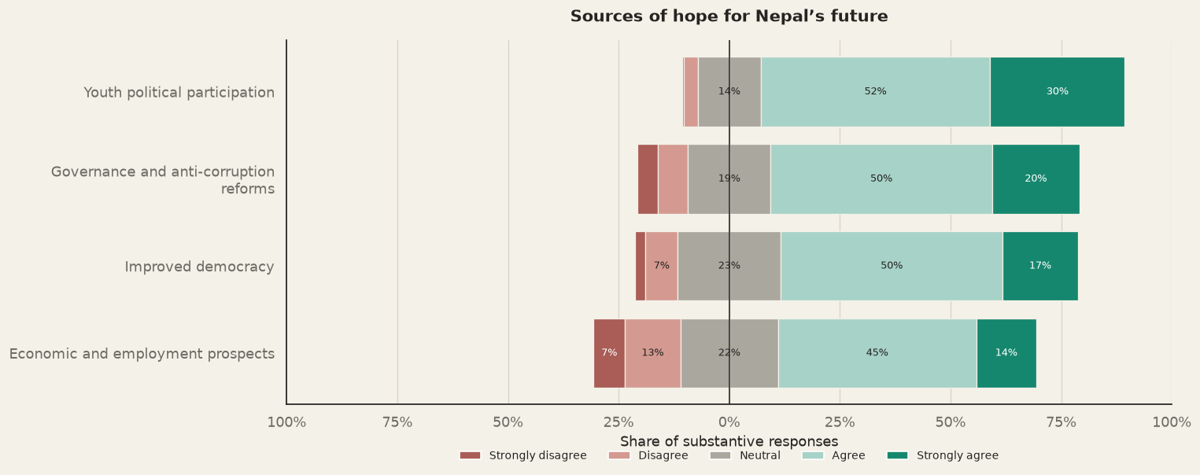
Figure 23 Sources of hope for Nepal

The findings in this chapter show a student population that is engaged, attentive and cautiously hopeful. Most students intend to take part in voting, and most either followed the Gen-Z movement closely or took part in it directly. More than nine in ten saw the movement as a turning point, and most expect Nepal to be more stable in five years than it is today. However, this optimism is tempered by an awareness of risk: students identified corruption, unemployment and weak accountability as the main threats to stability. They also remain uncertain whether the government will change or any political turnover. Their hope rests most on youth political participation, followed by governance and anti-corruption reform. The next chapter places these views in a wider context. It examines how students interpret youth-led protests elsewhere in South Asia, whether they intend to migrate, and what they hope for as young people, before turning to the sources of hope for both South Asia and Nepal.

Chapter 3 South Asian Outlook, Migration Intensions and Youth Aspirations
Recent regional experience has shown how economic grievances and institutional dissatisfaction can reinforce each other. In Bangladesh student demonstration, initially focused on public sector job quotas and it widened into broader challenge to governance and political accountability. In Sri Lanka as well, economic mismanagement contributed to mass mobilization. In Nepal, the youth led protests reflected frustration and lack of economic opportunities. Even though the triggers and political outcomes should not be collapsed into a single protest model, they a relevant background for examining how Nepali students interpret youth mobilization in South Asia. This chapter primarily pinpoints the focus on South Asia; on how the youths have viewed the protests in neighbors. Furthermore, the chapter goes onto shed light on respondents’ intention to migrate and they plan to do in the future before going into the broader perspective of what could be the source of hope for both South Asia and Nepal.
3.1 South Asia’s Economic and Governance Context
South Asia’s macroeconomic performance indicators provide mixed signals. Even though the region has comparatively strong growth, the aggregate output has not translated into employment. The World Bank’s regional update in April 2026 projects growth of 6.3 percent in 2026. Even if India is excluded the growth is projected at about 4.1 percent. On the other hand, the World Bank reports that only 59 percent of working age population in South Asia are employed. Additionally, the female-labor force participation is low at 32 percent while the formal sector accounts for only 10 percent of employment. These conditions weaken the connection between economic growth and productive jobs. The young population experience development through availability and quality of work, the returns to education and prospect of independent livelihood. Recent youth led protests in Bangladesh and Sri Lanka’s mass mobilization during its economic crisis have brought these concerns into focus.
Furthermore, the economic opportunity is shaped by the quality of institutions that formulate policy, regulate markets, and deliver public services. Even though it cannot be used for an individual’s experience of governance, the World Bank’s Worldwide Governance Indicators (WGI) provide a comparative framework to view governance in South Asia. Across dimensions, voice and accountability, political stability, government effectiveness, regulatory quality, rule of law and control of corruption, the indicator provides a country’s relative position in global distribution in percentile terms. In South Asia, other than Bhutan, economies have scored less than 42 on WGI. It is 35 for Nepal. It points out in the direction that South Asian economies have governance issues, and it have direct economic consequence. It leads to unpredictable regulation, corruption, and limited state capacity which in turn can raise the costs and risks of investment, constrain growth and weaken confidence in public institutions. The following sections delve into the perception of Nepali students about recent causes of protests in South Asia and what are the sources of hope for the region.
3.2 Nepali Student’s Perceptions of Youth Protests across South Asia
The survey asked students about how closely they followed protests in South Asia and if they believed protests spilled over across national borders. In addition, they were also asked what they perceived as the principle causes of youth dissent in South Asia. These questions capture students’ interpretations of regional political developments, but they do not measure the actual diffusion of protest or establish causal links between events in different countries.
3.2.1 Attention to protests elsewhere in Asia
A total of 47.6 percent of responses indicate that students followed protests elsewhere in Asia somewhat or very closely. Of total respondents, 40.6 percent did not follow protests around South Asia very closely while 11.9 percent did not follow the protests at all. Therefore, the regional protests formed part of the information environment for larger share of students, even though attention was less in comparison to Nepal’s own Gen-Z movement.
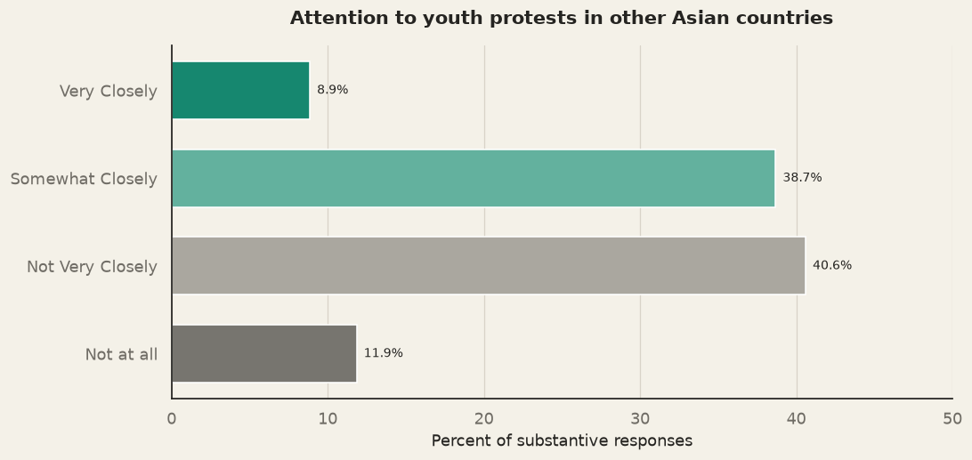
This distinction is relevant. Domestic political developments are directly connected to students’ own institutions, rights and opportunities. Even if events in other countries facilitate a reference point, they can shape how young people understand collective action, political accountability, and possibilities for institutional change. The interpretation should be limited to this level because the survey does not identify which events or channels drove respondents’ attention.
3.2.2 Perceived cross border influence of protest
Even though a little over half didn’t follow the protest in other South Asian countries closely or in any format, about three quarters of the respondents, 75.8 percent, agreed or strongly agreed that there has been cross-border spillover across South Asia. This finding suggests that students perceive that rather than being nationally isolated, youth mobilization is regionally connected. It is consistent with the visibility of protests through media. The cross-border influence may involve shared grievances, digital communication, identification of demonstration effect of seeing young people challenge established political arrangements.
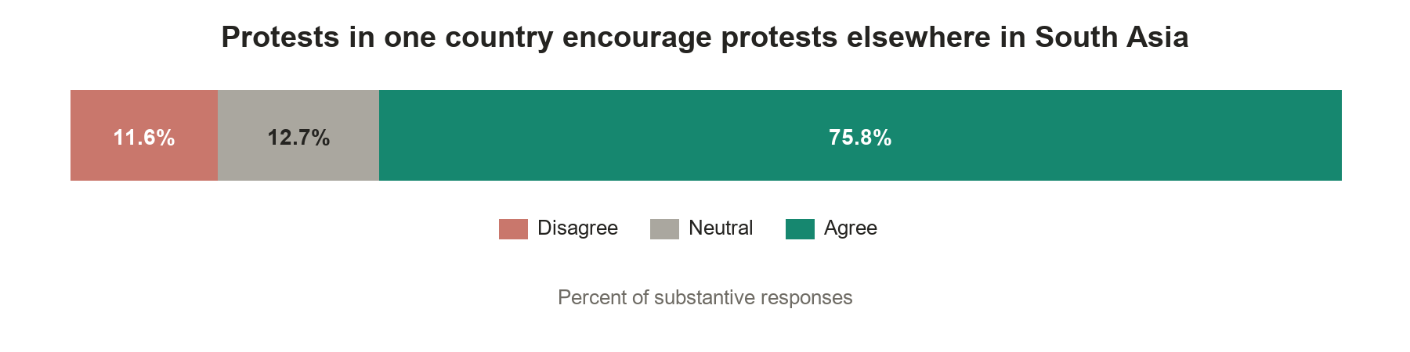
3.2.3 Perceived Drivers of Youth Dissent
In the survey, students frequently identified poor governance, corruption and public services, 89.1 percent, and unemployment and limited economic opportunities, 89 percent, as causes of youth dissent across South Asia. Likewise, distrust in leaders, political parties and institutions, and nepotism and elite capture were also recognized. Even though small but substantial respondents agreed that political exclusion and foreign or external influence as a cause of uprising.
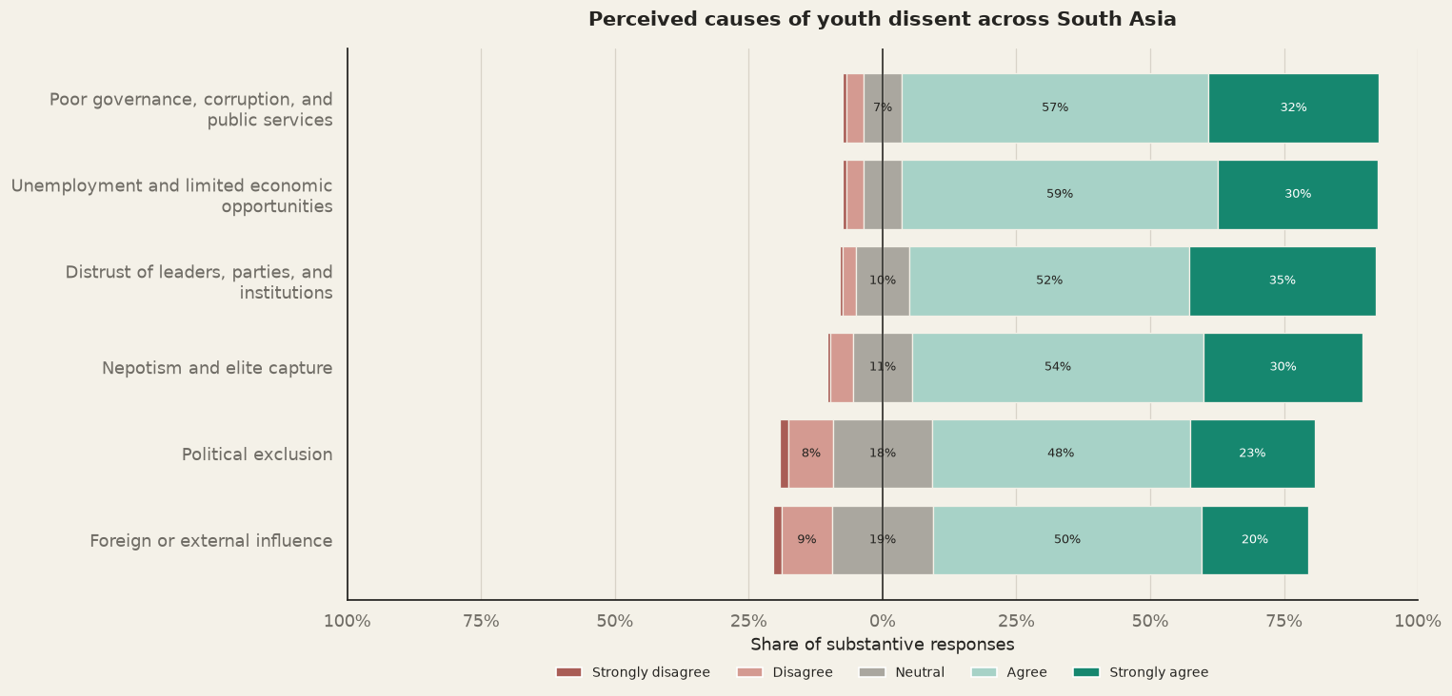
Among the mentioned causes, the ordering needs to be studied. The students’ responses place governance and economic opportunities at the center of regional youth protest. It is evidence that the region’s growth has not generated enough quality employment while concerns about corruption, accountability and institutional responsiveness have become visible in recent protest movements. Therefor the survey suggests that students interpret protest through a combined political-economic lens in which employment prospects and fairness of institutions are connected. The interpretation is consistent with World Bank’s analysis of youth mobilization in South Asia. It also frames job creation as economic as well as a social challenge. In addition, UNDP’s discussion of Bangladesh where protest began around job quotas intensified into demands concerning governance, rule of law and human rights.
3.3 Political Stability: Nepal and South Asian Region
The perception of youth about the protests provides a bridge to questions of political stability. The survey distinguishes between assessments of the current stability of South Asia, expectations for the next five years, perceived sources of risk, and views about the future stability of Nepal. The respondents may recognize substantial current risks even though they remain hopeful that political and institutional conditions can improve.
3.3.1 Assessment of South Asia’s Current Stability and Future Outlook
Among responses, 51.9 percent rated South Asia as stable or very stable at the time of the survey. The complete distribution helps to show why the assessment should be described as mixed rather than positive. Provided that half of the responses agreed on regional stability, about a fourth selected neutral category and the remaining quarter said unstable. The difference of 27.7 percentage points in positive and negative assessment should not be treated as equivalent to confidence in stability. Looking forward to the next five years, 76.8 percent of the respondents were very or somewhat optimistic about regional stability. Compared with 7.6 percent who have somewhat or very pessimistic view and 15.5 percent who opted for neutral position, optimism exceeded pessimism by 69.2 percentage points. Hence, the forward-looking assessment is more positive that the evaluation of current conditions. Youths distinguish between the region’s present political and economic pressures and its potential to become more stable. Therefore, the contrast between present and future assessments point out that students do not project current conditions forward but expect some improvement over time. This may reflect an expectation that political mobilization, institutional reform or generational change can improve the region’s trajectory.
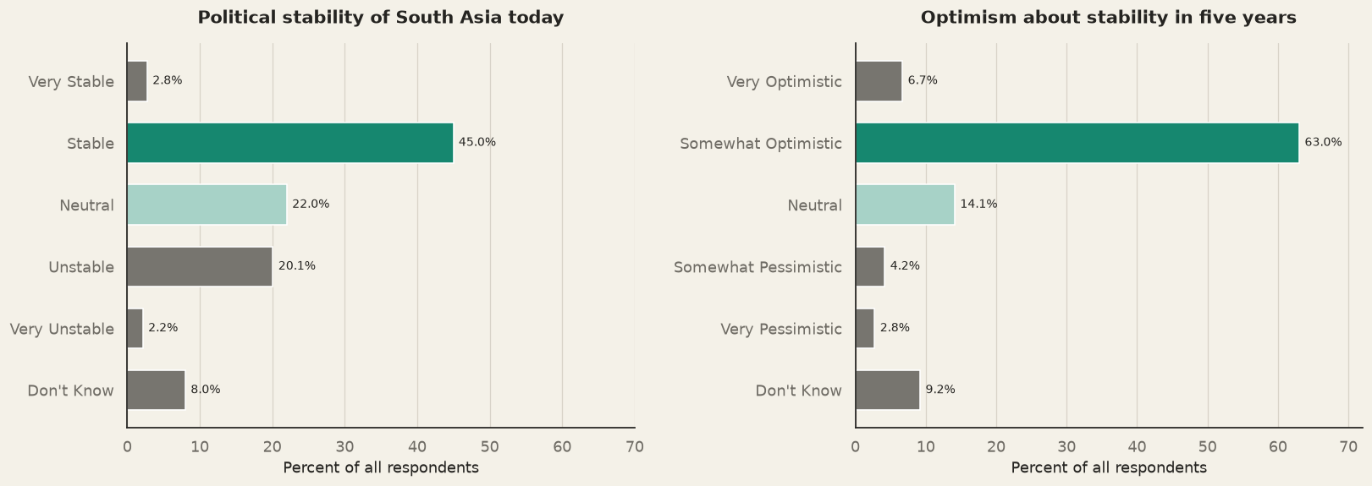
3.3.2 Perceived risks to regional stability
Perceptions of the regional risk factors are overarching. Among seven risks, four in five respondents identified six of them as potential factors. Corruption and lack of accountability, 90.6 percent, and unemployment and limited economic opportunities, 90.3 percent, were the frequently identified threats with a gap of 0.3 percent. Additionally, political exclusion and ethnic or religious conflict had 85.8 percent followed by rising cost of living at 84.1 percent and misinformation on social media at 82.6 percent. Among the potential risks foreign or external influence was the least frequently selected, with 77 percent of the respondents agreeing on it.
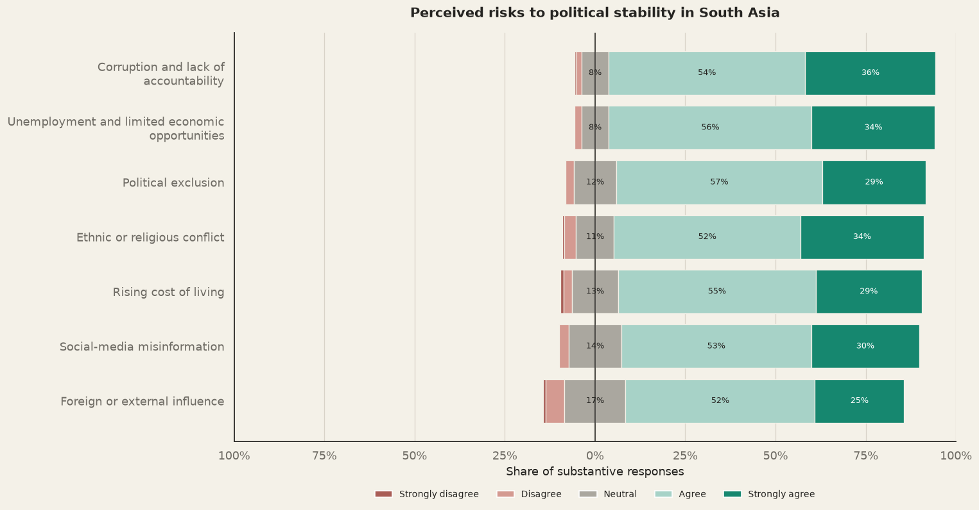
The findings suggest that stability as a multidimensional condition. The quality of governance, economic pressures, inclusion, social cohesion and information environment are all essential. The nearly equivalent perceived level for corruption and unemployment reinforces the earlier find that students connect institutional performance with economic opportunity. These results suggest students do not define stability only as the absence of political violence or conflict between states. Instead, it is connected to performance and legitimacy of domestic institutions, distribution of economic opportunities, social cohesion and the quality of public information.
3.3.3 Nepal and South Asia in comparative perspective
The study’s Nepal focused findings in Chapter 2 suggest that student’s expectations for the country’s political future are also shaped by a mixture of concern and optimism. For both Nepal and South Asia, unemployment and limited economic opportunities were identified as a risk by more than 90 percent of the respondents. Likely perceptions on political exclusion, rising living costs, misinformation, foreign influence and ethnic or religious conflict were also similar.
GRAPH (required a comparison table for Nepal and South Asia) 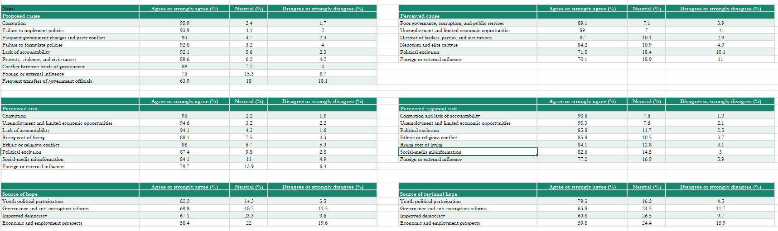
Figure XXXX illustrates similartiy in responses, suggesting students’ view on Nepal’s political and economic challenges is part of broader regional pattern. But it does not imply identical national and regional risks or similar policy responses are required. Rather, it hints toward a set of concerns, employment, exclusion, accountability and social cohesion, among the students. Only significant concern is for perception on employment, which is salient given the importance students attach to education to work transitions and future economic prospects

3.4 Migration Intentions and Future Opportunity
After the wider regional perceptive and student’s perceptions about political stability, the analysis turns to their personal futures. Migration intention is treated as one dimension of how students assess the country of origin and destination’s educational and economic opportunities.
3.4.1 Family migration experience and current intentions
For 42.5 percent of the respondents a close family member had lived abroad. Among those reporting family migration, 16.1 percent reported the family member had returned permanently, while 83.7 percent said they had not returned. Therefore, migration is familiar within the family networks of sizeable share of the students while permanent return is uncommon among the families represented.
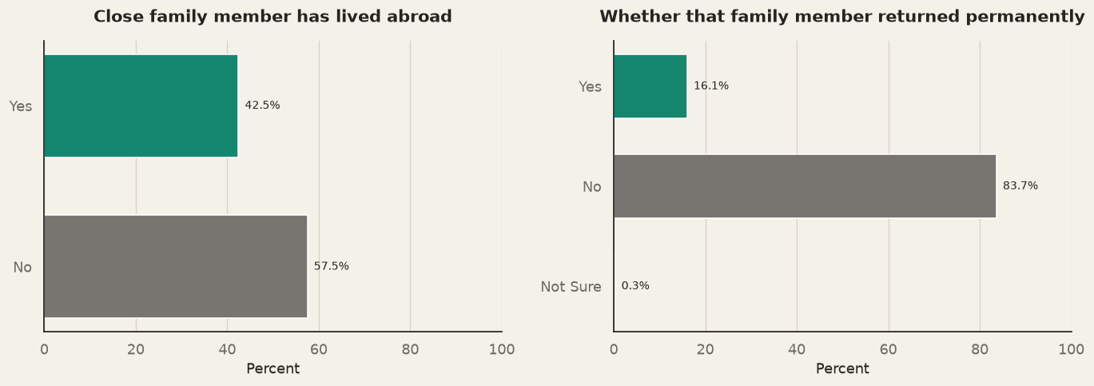
When asked about their plan to stay in Nepal or going abroad, largest share of the respondents had planned to stay in Nepal, 50.4 percent, and 37 percent had planned to go abroad while 12.7 percent were still undecided. The undecided group is important as it represents sizeable pool whose future choices may depend on admission opportunities, scholarships, household finances, and changes in domestic conditions.
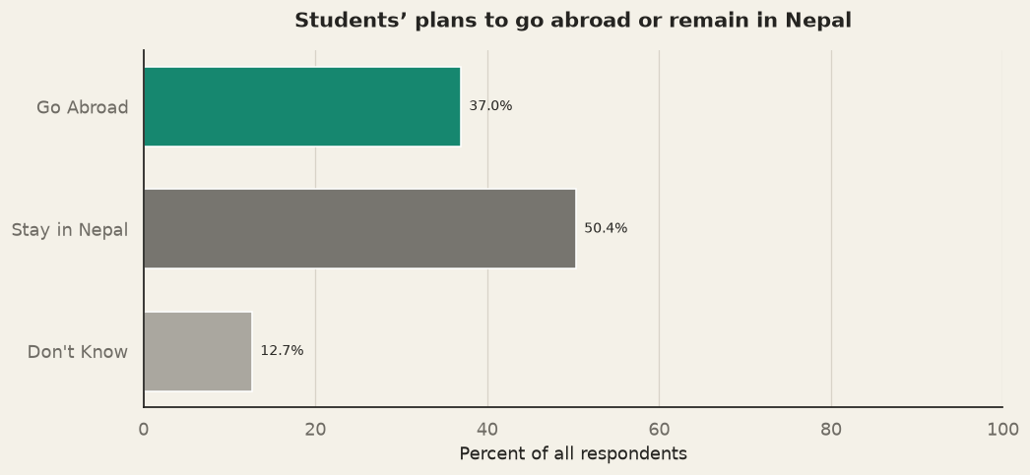

The intensions to migrate vary across student characteristics. The urban-rural difference comparison is distinct. From the survey, students in urban setting were 17.8 percentage points more likely to plan to go abroad than those in rural settings. Conversely, 63.3 percent of rural background students planned to stay, compared with 41.1 percent of urban-background students. These differences may reflect variation in access to information, institutional pathways, financial resources and exposure to international education or employment networks. The education stage comparison moves in similar direction. Amongst the respondents, 38.6 percent of bachelor’s students planned to go abroad and 23.9 percent of master’s students. This may reflect educational timing, completion of qualifications or immediate labor market plans. About the gender difference, the bivariate test didn’t produce any significant effect of gender on the plan to migrate, as 40.1 percent of male planned to migrate while 33.2 percent of the female planned to do so.
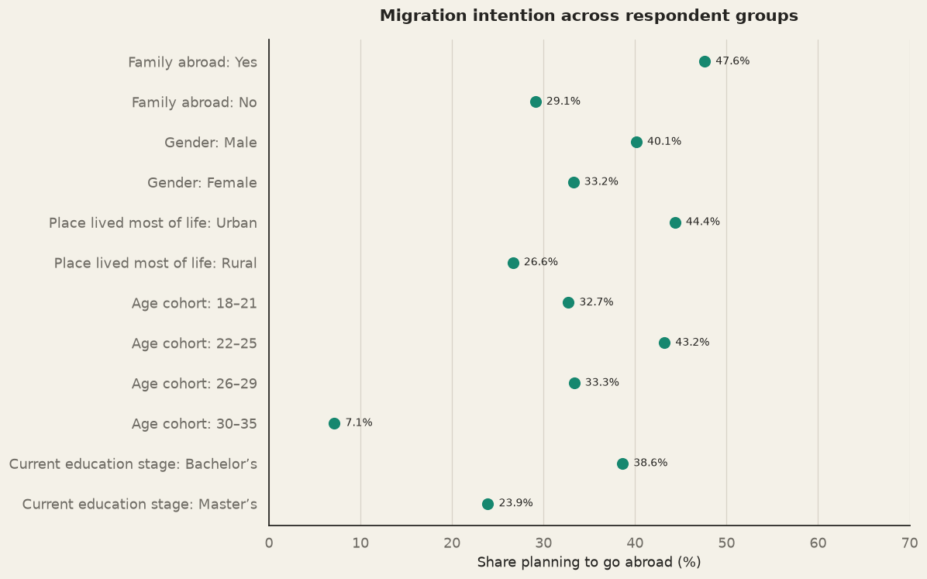
3.4.2 Intended activities abroad and in Nepal
The overseas pathway is predominantly a combined human-capital and livelihood strategy. More than half of those planning to leave, 55.7 percent, expected to study and work, while 22.0 percent intended to work alone and 19.7 percent to study alone. Only 2.6 percent identified travel. Taken together, study and work feature in 97.4 percent of overseas plans when the combined and single-purpose categories are considered. This indicates that students generally associate going abroad with education, employment or both, rather than primarily with short-term travel.
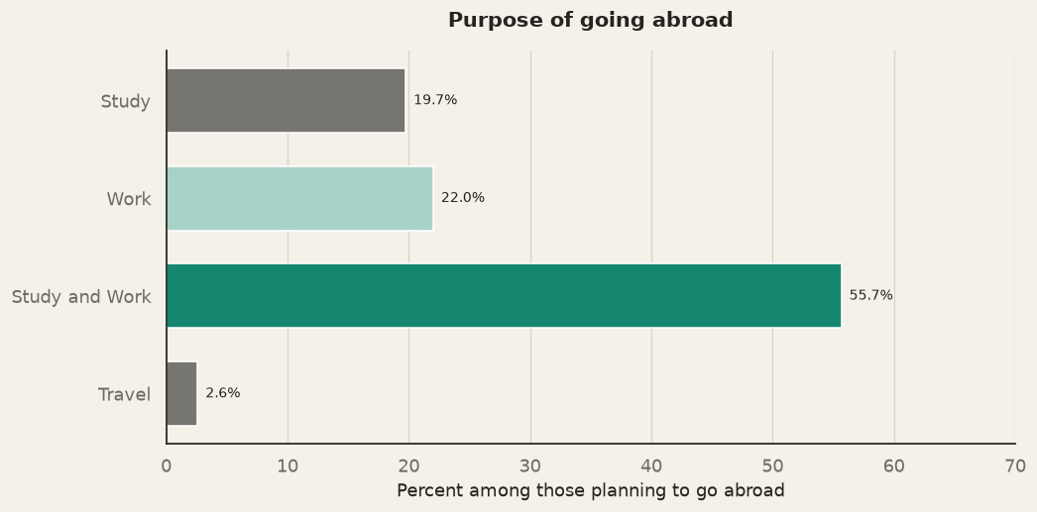
Among those planning to remain in Nepal, the emphasis on education and employment is equally clear. A combined 53.2 percent planned to study and seek a job, while 32.8 percent planned to pursue further study. A further 8.3 percent expected to combine study with starting a business, and 3.3 percent planned to start a business. Only small shares selected job-seeking alone, 10.4 percent, or a combination of job-seeking and business activity, 1.0 percent. In other words, 86.0 percent of stayers identified either a study-and-job pathway or further study alone.
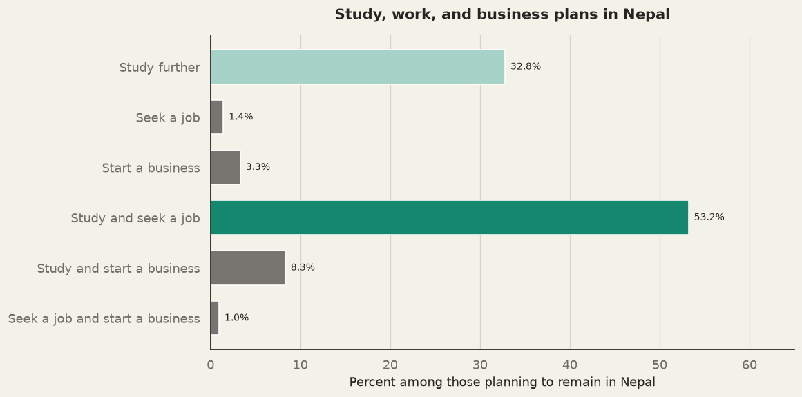
So, students who plan to leave and those who plan to stay share a strong orientation towards education and work. The main distinction is where they expect to pursue these goals. For policy, this means that reducing migration aspirations is unlikely to be achieved through appeals to patriotism or political stability alone. It requires credible domestic pathways linking education with productive employment, entrepreneurship, skills development and career progression. The separate World Bank–ADB consultation with 1,004 Nepali youth also identified quality education, entrepreneurship, skills development and quality jobs as priorities, while listing political instability, corruption, remittance dependence and brain drain among major concerns.
3.4.3 Migration Intention and Political Expectations
Migration plans do not move in a simple linear direction with optimism in political outcomes. The cross tabulation between intention to migration and expected stability of Nepal provide a check against an assumption that students who expect political improvement will prefer to stay in Nepal. Among those expecting Nepal to become more stable, 36.8 percent planned to go abroad, and 51.9 percent planned to stay, while 11.3 percent were undecided. Among those expecting conditions to remain about the same, 34.8 percent planned to leave, 47.0 percent to stay and 18.2 percent were undecided. Among those expecting Nepal to become less stable, 43.4 percent planned to leave, 49.1 percent to stay and 7.5 percent were undecided.
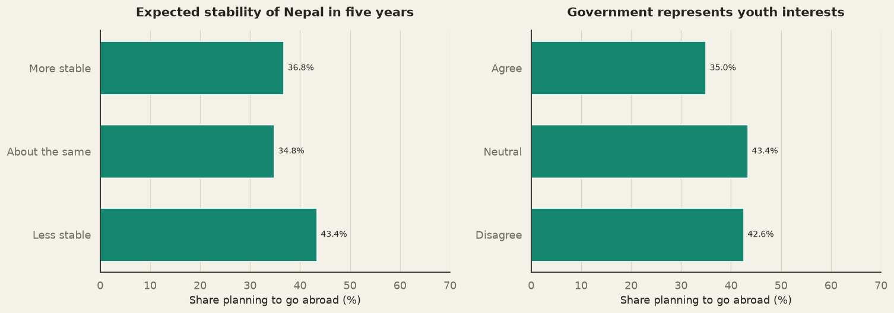
The proportion planned to leave is somewhat higher among those expecting declining stability, but the difference is not statistically distinguishable in the reported test. Similarly, 35.0 percent of respondents who agreed that government represents youth interests planned to leave, compared with 43.4 percent of neutral respondents and 42.6 percent of those who disagreed. The association is again weak. The results do not demonstrate that political outlook is irrelevant, rather they show that these measures do not strongly sort students into stay-or-leave categories in this sample. Students may expect political stability to improve and still consider overseas study or work an attractive route to their goals.
3.4.4 Analysis of the intention to go abroad
The figure XXXX(below) illustrates the probit model comparing the respondents with a definite plan to go abroad with definite plan to stay in Nepal while excluding the undecided respondents. After holding other factors constant, respondents having a close family member abroad were associated with a 20.1 percentage-point higher probability of planning to go abroad. A rural background was associated with an 18.1 percentage-point lower probability, while being a master’s student was associated with a 37.5-percentage point lower probability than being a bachelor’s student, but this should be interpreted with caution as the sample size for master’s student is smaller. A five-year increase in age was associated with an 11.8 percentage-point higher probability. However, the model reports statistically non-significant estimates for political and related engagement variables. The result, therefore, points out that family exposure and position in life-course determine the migration aspirations.
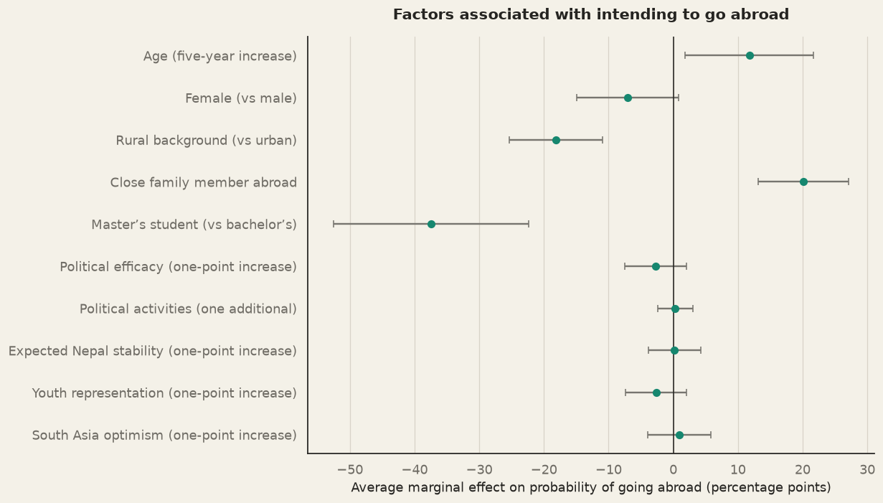
3.5 Sources of Hope and Prospects for the Future
Towards the end the chapter closes by presenting the responses the participants perceive could be the sources of hope, for both Nepal and South Asia. It indicates which forms of political, institutional and economic change respondents believe could improve the region’s prospects. Amongst other factors, the respondents believe that youth participation and reform in governance are major aspects on which the region can improve.
3.5.1 Sources of hope for South Asia
Youth participation is perceived as the major source of hope, as 79.3 percent of participants attest to it. And the gap between youth participation and other sources of hope is also huge. Second, to youth participation, 63.8 percent of respondents agree that anti-corruption and governance reforms are necessary. It is followed by improved democracy, by 63.8 percent. On the other side of the agreement spectrum, only 4.5 percent disagreed that youth participation can be a source of hope, followed by 11.7 percent on governance, 9.7 percent on democracy and 15.9 percent for economic and employment prospects. Neutral responses infer something different about the ranking. About a quarter of the respondents were neutral about governance reform, improved democracy, and economic and employment prospects. Therefore, students appear certain about the value of youth involvement if institutions, democratic processes or labor markets will deliver improvement, which may reflect visibility of youth mobilization.

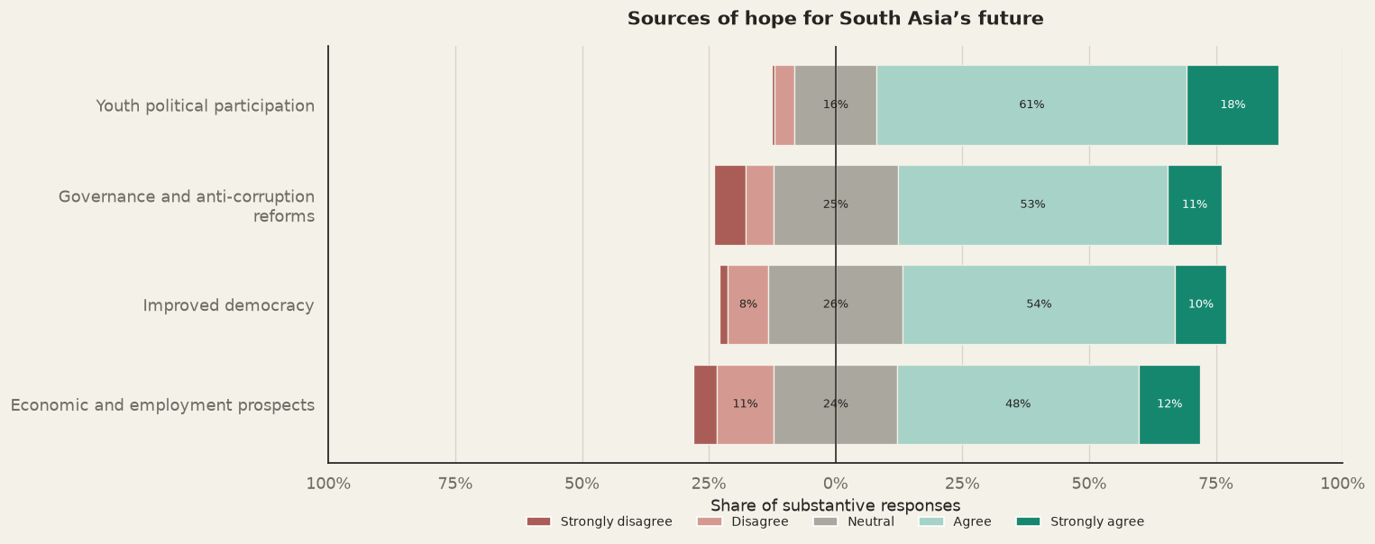
The contrast in what the respondents perceive as risk and hope is also important. Even though unemployment and limited economic opportunities were the widely recognized threats to regional stability, respondents did not recognize that economic and employment opportunities could generate a source of hope. Instead, they recognized that youth participation has potential to generate change in the ability of economies to deliver opportunities young people seek. The protest may have created pressure for reform but translating that pressure into more jobs and better livelihoods requires institutional capacity and sustained policy implementation.
3.5.2 Shared sources of hope for Nepal and South Asia
The Nepal-South Asia comparison shows continuity of students’ sources of hope. In both context youth participation leads, with 82.2 percent agreement for Nepal and 79.3 percent for South Asia. Meanwhile governance and anti-corruption reforms and improved democracy also receive broad support. On the other hand, for both Nepal and South Asia, economic and employment prospects attract lower levels of agreement. The same direction for risks and hope, for both Nepal and South Asia, suggests that students do not sharply separate the sources of political hope for their country from that of the region. A particular concern is the lower ratings for economic and employment prospects. It is an irony that unemployment and economic opportunities is identified a s major risk for political stability, yet majority of respondents agree employment and economic opportunities not as major sources of hope.
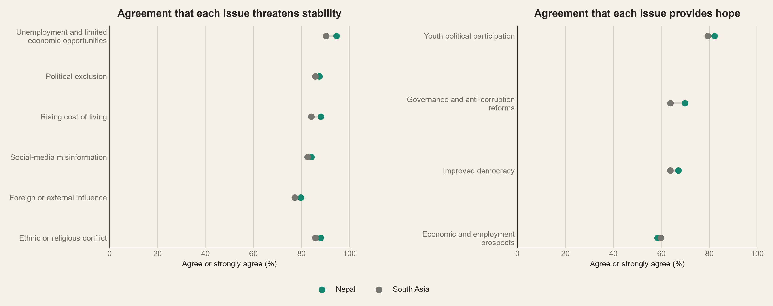
The continuity links the final chapter with the initial two chapters. Firstly, in chapter it was found that students are politically engaged and attentive to public affairs followed by second chapter, which assessed Nepal’s political direction and their belief in youth participation as a source of change. Finally, this chapter extends confidence to South Asia. Yet it is uncertain if economic structures and labor markets will deliver the opportunities students want. Regardless, youth participation is perceived as a source of hope, but it is not a substitute for effective institutions, accountable governance, and job creation.

