**CSCI 428 Assignment 01**

60 points

Qn1. Hands-on Practice: Eclipse and IntelliJ with JavaFX (20 points, 4 points each)

1. Step1: Install JavaJDK and Eclipse IDE by referring to the document and video under “Software installation/Eclipse/”
2. 

Step 2: Create and Run your first Java Project, “CSCI428”, and Java class “HelloWorld” to print out the strings “Welcome to CSCI 428” and “Name: [Your full name] and CWID: [CWID]”.

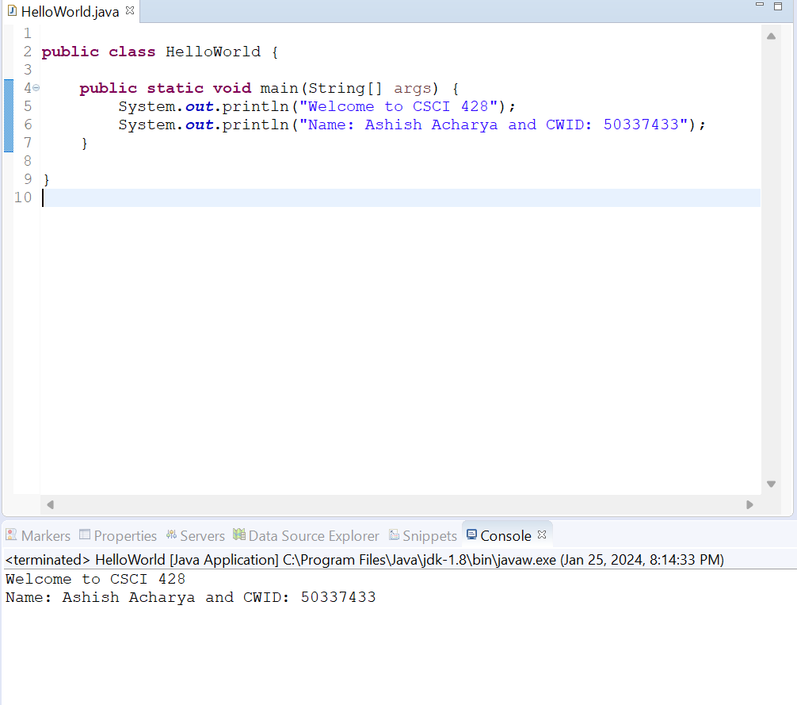

Step 3: Download JavaFX and IntelliJ.

Qn2. (10 points) Write declarations for storing the following quantities. Choose between integers and floating-point numbers. Declare constants when appropriate.

a. The number of days per week

**final int DAYS_PER_WEEK = 7**

b. The number of days until the end of the semester

**int daysUntilEndOfSemester;**

c. The number of centimeters in an inch

**final double CM_PER_INCH = 2.54;**

d. The height of the tallest person in your class, in centimeters

**double heightOfTallestPerson;**

e. The price of a single can of Coca-Cola

**double cokeCanPrice;**

f. Texas A&M University-Commerce fringe benefit rate for student workers

**final double TAMUC_FRINGE_BENEFIT_RATE = 0.12;**

// Assuming the rate is in decimal form

g. Your current age

**int currentAge;**

h. The number of students in CSCI 428

**int numStudentsCsci428;**

i. The minimum hourly rate for student workers that you may know or guess.

**double minimumHourlyRateForStudent;**

j. The length of a football field

**double lengthOfFootballField;**

Qn3. (15 points) Write Java statements that accomplish the following.

Here are Java statements that accomplish the tasks described:

a. Declare int variables x and y.

**int x, y;**

b. Declare String variables firstName and lastName.

**String firstName, lastName;**

c. Initialize an int variable x to the last two digits of your CWID.

**int x = 33;**

d. Declare and initialize a char variable ch to the first letter of your first name.

**char ch = 'A';**

e. Initialize the String variables to your first name and last name.

**String** **firstName = "Ashish";**

**String lastName = "Acharya";**

f. Update the value of an int variable x by adding 5 to it.

**int x += 5;**

g. Declare and initialize a double variable payRate to 12.50.

**double payRate = 12.50;**

h. Copy the value of an int variable firstNum into an int variable tempNum.

**int firstNum = 10; // Replace with the actual value**

**int tempNum = firstNum;**

i. Swap the contents of the int variables x and y.

**int temp = x;**

**x = y;**

**y = temp;**

j. Declare and initialize a String variable fullName by using the variables firstName and lastName.

**String fullName = firstName + " " + lastName;**

k. Output the values of x, y, and the expression x + 12 / y – 18.

**System.out.println("x: " + x);**

**System.out.println("y: " + y);**

**System.out.println("Expression result: " + (x + 12.0 / y - 18));**

l. Declare a char variable grade and set the value of the grade to 'A'.

**char grade = 'A';**

m. Declare int variables to store four integers.

**int num1, num2, num3, num4;**

n. Copy the value of a double variable z to the nearest integer into an int variable x.

**double z = 15.75;**

**int x = (int) Math.round(z);**

o. Update the variable ch to represent the last digit of your CWID and print out its ASCII value.

**ch = '3';**

**int asciiValue = (int) ch;**

**System.out.println("ASCII value of ch: " + asciiValue);**

Qn4. (15 points) Write a program that prompts the user for two integers and then prints

1. a. The sum
2. b. The difference
3. c. The product
4. d. The average
5. e. The distance (absolute value of the difference)
6. f. The maximum (the larger of the two)
7. g. The minimum (the smaller of the two)
8. h. Suppose the two integers are the lengths of a rectangle’s sides. Print the area and perimeter of the rectangle and the length of the diagonal (use the Pythagorean theorem)

Hint: The max and min functions are declared in the Math class.

**/\*\***

**\*Program that prompts the user for two integers and then perform various calculations**

**\***

**\* @author Acharya, Ashish**

**\* @assignment CSCI 428 Assignment 1 -Qn 4**

**\* @date 01/26/ 2024**

**\*/**

**import java.util.Scanner;**

**public class Assign1Qn4AshishAcharya {**

**public static void main(String[] args) {**

**Scanner scanner = new Scanner(System.*in*);**

**// Prompt the user for two integers**

**System.*out*.print("Enter the first integer: ");**

**int num1 = scanner.nextInt();**

**System.*out*.print("Enter the second integer: ");**

**int num2 = scanner.nextInt();**

**// a. The sum**

**int sum = num1 + num2;**

**System.*out*.println("Sum: " + sum);**

**// b. The difference**

**int difference = num1 - num2;**

**System.*out*.println("Difference: " + difference);**

**// c. The product**

**int product = num1 * num2;**

**System.*out*.println("Product: " + product);**

**// d. The average**

**double average = (double) (num1 + num2) / 2;**

**System.*out*.println("Average: " + average);**

**// e. The distance (absolute value of the difference)**

**int distance = Math.*abs*(difference);**

**System.*out*.println("Distance: " + distance);**

**// f. The maximum (the larger of the two)**

**int maximum = Math.*max*(num1, num2);**

**System.*out*.println("Maximum: " + maximum);**

**// g. The minimum (the smaller of the two)**

**int minimum = Math.*min*(num1, num2);**

**System.*out*.println("Minimum: " + minimum);**

**// h. Rectangle calculations**

**int area = num1 * num2;**

**int perimeter = 2 * (num1 + num2);**

**double diagonal = Math.*sqrt*(Math.*pow*(num1, 2) + Math.*pow*(num2, 2));**

**System.*out*.println("Area of the rectangle: " + area);**

**System.*out*.println("Perimeter of the rectangle: " + perimeter);**

**System.*out*.println("Length of the diagonal: " + diagonal);**

**scanner.close();**

**}**

**}**

**Output Screenshot:**

Qn5. (20 points) Write a program that reads an integer *that is your CWID* and breaks it into a sequence of individual digits. For example, your CWID is 12345678 and can be displayed as

1 2 3 4 5 6 7 8

Please enter your 8-digit CWID: 12345678

The digits are: 1 2 3 4 5 6 7 8

The total is: 36

The average is: 4.5

You may assume that the input has no more than eight digits and is not negative.

**Program:**

**/\*\***

**\* Program that reads an integer that is your CWID and breaks it into a sequence of individual digits and print the total and average of the digits**

**\* @author Acharya, Ashish**

**\* @assignment CSCI 428 Assignment 1-Qn 5**

**\* @date 01/26/ 2024**

**\*/**

**import java.util.Scanner;**

**public class Assign1Qn5AshishAcharya {**

**public static void main(String[] args) {**

**Scanner scanner = new Scanner(System.*in*);**

**// Prompt the user for an 8-digit CWID**

**System.*out*.print("Please enter your 8-digit CWID: ");**

**int cwid = scanner.nextInt();**

**// Break the CWID into individual digits**

**int digit1 = cwid / 10000000 % 10;**

**int digit2 = cwid / 1000000 % 10;**

**int digit3 = cwid / 100000 % 10;**

**int digit4 = cwid / 10000 % 10;**

**int digit5 = cwid / 1000 % 10;**

**int digit6 = cwid / 100 % 10;**

**int digit7 = cwid / 10 % 10;**

**int digit8 = cwid % 10;**

**// Display the individual digits**

**System.*out*.print("The digits are: ");**

**System.*out*.print(digit1 + " " + digit2 + " " + digit3 + " " + digit4 + " "**

**+ digit5 + " " + digit6 + " " + digit7 + " " + digit8);**

**// Calculate the total**

**int total = digit1 + digit2 + digit3 + digit4 + digit5 + digit6 + digit7 + digit8;**

**// Display the total**

**System.*out*.println("\nThe total is: " + total);**

**// Calculate the average**

**double average = (double) total / 8;**

**// Display the average**

**System.*out*.println("The average is: " + average);**

**scanner.close();**

**}**

**}**

**Output Screenshot:**

