

Novar GmbH a Honeywell Company
Forumstraße 30
41468 Neuss, Germany Technische Änderungen vorbehalten!

Internet: www.ackermann-clino.com Technical changes reserved!
E-Mail: info@ackermann-clino.com © 2021 Honeywell International Inc.




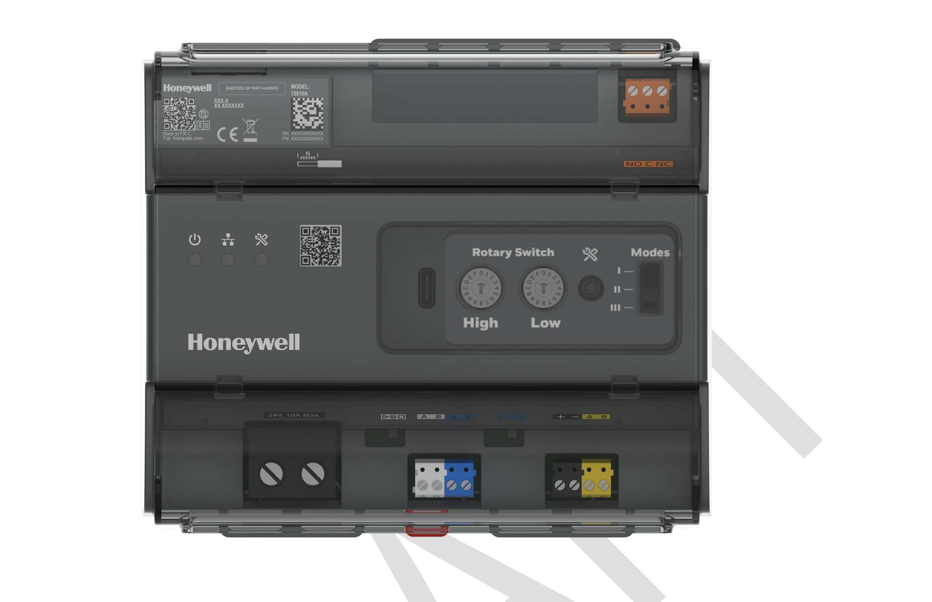
Systevo Control IP+
(From Software V12.10)
Art.-Nr: 72800A

Installation- Commissioning Instruction

89490A1.GB0_V
03.2022

Intended purpose
This products may only be used for the applications outlined in the catalogue and in the technical description, and only in conjunction with the recommended and approved external devices and components.
This documentation contains registered and unregistered trademarks. All trademarks are the property of the respective owners. The use of this documentation does not grant you a licence or any other right to use the name, logo and/or the label.
This documentation is subject to the copyright of Honeywell. The content must not be copied, published, modified, distributed, transmitted, sold or changed without the express prior written permission of Honeywell.
The information contained in this documentation is provided without warranty.

Safety-related user information


This manual includes all information required for the proper use of the products described.
In order to ensure correct and safe operation of the product, all guidelines concerning its transport, storage, installation, and mounting must be observed. This includes the necessary care in operating the product.
The term 'qualified personnel' in the context of the safety information included in this manual or on the product itself designates:
- project engineers who are familiar with the safety guidelines concerning fire alarm and extinguishing systems.
- trained service engineers who are familiar with the components of fire alarm and extinguishing systems and the information on their operation as included in this manual.
- trained installation or service personnel with the necessary qualification for carrying out repairs on fire alarm and extinguishing systems or who are authorised to operate, ground and label electrical circuits and/or safety equipment/systems.

Symbols
The following information is given in the interest of personal safety and to prevent damage to the product described in this manual and all equipment connected to it.
Safety information and warnings for the prevention of dangers putting at risk the life and health of user and maintenance personnel as well as causing damage to the equipment itself are marked by the following pictograms. Within the context of this manual, these pictograms have the following meanings:

Warning - Designates risks for man and/or machine. Non-compliance will create risks to man and/or machine. The level of risk is indicated by the word of warning.

Note - Important information on a topic or a procedure and other important information!

Standards and guidelines - Observe configuration and commissioning information in accordance to the national and local requirements.

Dismantling
In accordance with Directive 2002/96/EG (WEEE), after being dismantled, electrical and electronic equipment is taken back by the manufacturer for proper disposal.

Inhalt
- General Information/ Application 4
  - Associated Documents 4
- Product specifications 5
- Systevo Control IP+ 7
  - Mounting 7
    - Dimensions 7
    - Mounting on a DIN Rail 7

    - Cable routing and fixation 8
    - Mounting accessories 19“ Rack Art.Nr: 72800Z1 8
    - Mounting in 19“ Rack: (available as an accessory) 10
  - Control elements and connection terminals 11
    - LAN connection (2xMOPP), networking of the zone controller 12
    - ZBUS- and ABUS-Termination 13
    - Fault relay 13
    - Power supply 13
    - Service Button / Service LED 14
    - Navigation in the Service Menue 14
    - Extended menu 17
    - Functions in the extended menu 18
- Commissioning 19
  - Requriements 19
  - Prepare the Workstation / Server 19
  - Commissioning of the center (s) 20
    - Determination of the central identification with rotary coding switch 20
    - Check the networking in the LRS module 21
    - Scan / read out SCIPs with the configuration program cp99config/ auslesen 22
    - Update SCIPs if necessary 23
    - Set the operation mode on SCIPs 25
    - Setting the properties of SCIP (name, service group, STIP mode, audio path) 25
See also 4.3.5 Setting the operation mode on SMC's 25
    - Write the SCIP + configuration into the system 26
  - Data backup 27
  - Licenses 28
- Replacement of a Systevo Control IP+ 29
- Expansion of systems with Systevo Control (SMCc) 29
- Accessories 30
- Technical Data 31

General Information/ Application
This documentation provides information about the installation (assembly, wiring, basic commissioning) of the Systevo Control IP + in preparation for the later commissioning in the communication system Systevo Call Ackermann along with information.
After a brief description of the products and their operating elements, the work and settings required to commission the system are described and explained in detail.


Associated Documents

Dokumentation | Art.-Nr:
Commissionig Instruction Nurse Call System | 89440C7
Systevo Call Ackermann with IP Devices | 89470F8.GB0
Commissioning Instructions Systevo Touch Terminal IP (STIP) | 89470J9.GB0
Technical Information to System release V12.xx | TI_217

Supplementary and current information
The performance features, data and product information described in this documentation correspond to the status of the printing of this document (date see cover sheet) and may deviate from the information given here due to product changes and / or changed standards and guidelines during project planning, installation and commissioning. Updated information, declarations of conformity and maintenance specifications are available for comparison on the website www.ackermann-clino.com.

Product specifications

Systevo Control IP + is the consistent further development of the innovative Systevo system platform as a central unit for an organizational unit such as a ward or living area. Systevo Control IP + is used from system release V12.10 to comply with DIN VDE 0834-1: 2016-06 in conjunction with a higher-level system license. With the online licensing process, there is no need for a license card and license-dependent functions can be expanded safely. The compact design enables mounting on top-hat rails as surface installation in wall distributors or in a rack available as an accessory in 19 “cabinets. The integrated fieldbus 99 is connected directly to the station with the connection terminals for the data and audio bus, so that there is no need for an additional plug-in card. The energy supply is preferably obtained from the station supply and thus reduces the overall effort of the installation. Systevo Control IP + organizes the monitoring and synchronization of the entire data traffic as well as the audio connections (conversations, announcements) within the organizational unit and takes over the coordination of the communication to other control centers via IP interface (Ethernet and LAN, with router access). In addition, Systevo Control IP + takes over the control of displays and acoustic call messages, according to defined priorities / services (interconnections) within a system installation. There are four different operating modes available for different applications, which are used depending on the purpose and infrastructure. All operating modes can be used in mixed form within a system, with each central unit being assigned an operating mode. Up to 64 Systevo Control IP + and up to 250 logical groups are supported in the system. A flexible configuration with a comfortable Windows GUI for call types, groups, services, collective announcements, display texts, device parameters, system language etc. is provided via the Systevo workstation / server, depending on customer requirements. The station-wise networking takes place via suitable switches / routers (ETH-LAN: IEEE802.3), which automatically recognize the necessary transmission rates (10, 100, 1000MBit). Port-based VLAN network components with QoS / ToS enable nurse call data services to be prioritized over voice services. Communication takes place on the basis of TCP / IP via defined nurse call pREDocols. Utility programs such as Telnet, FTP are used for remote access and data transfer. Additional network applications (syslog, firewall, etc.) are used for system security and the possible analysis of stored log data. With integrated gateway function for forwarding the data / audio signals from the higher-level bus interface (ETH-LAN, ward bus) to the room bus. Central or decentralized installation in environment class I. Project-specific planning of the central equipment from 500 rooms.
 Requirements and necessary parameters for the communication network are described in the documentation "Systevo Call Ackermann with IP devices" 89470F8.

  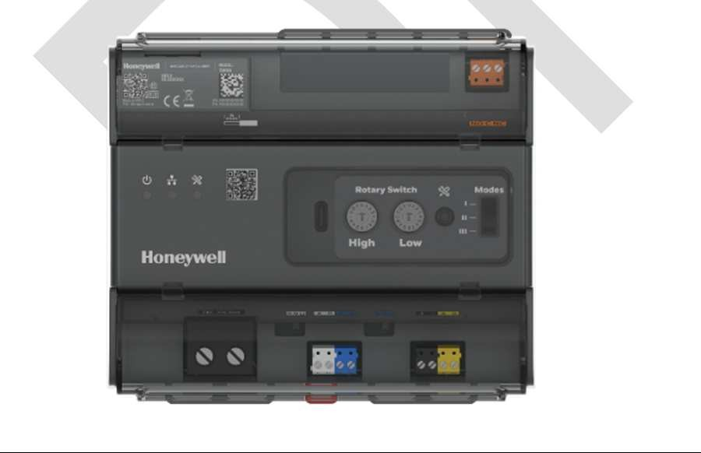  Systevo Control IP+ 72800A1 | Rack 72800Z1
 | 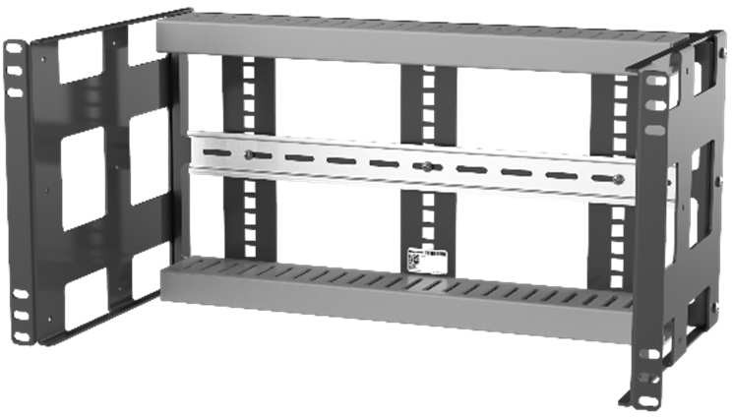

Systevo Control IP+
- Firmware updates possible.
- Prepared for additional service features via license extensions.
- Suitable for mounting on standard DIN rails for wall and 19 “rack mounting
- Compact design enables installation on top-hat rails in floor distributors
- Network LAN interface isolated according to IEC EN60601-1 (2xMOPP)
- Connection terminals for FB99 on board, therefore no fieldbus card as with Systevo Control 72700xx,required.

- Licenses via Voucher with QR-code, therefore no license card, as with Systevo Control 72700xx, required.
- USB-C interface for future applications (currently not implemented)
- Mode switch for defining the operating mode (currently not implemented))

Performance characteristics
- Operation as a master / slave center depending on the addressing / configuration
- Communication (data / audio) with other control centers via ETH-LAN

Service-functions:
- Software download for system components (as far as possible), firmware update, remote maintenance function. (with PC), basic commissioning
- Suitable for mounting on top hat rails
- Central and decentralized installation

Security features:
- Secure data communication in compliance with valid cyber security guidelines
- In the event of a power failure, data is retained even without a UPS (according to DIN VDE 0834, a UPS is required for uninterrupted operation) In the event of a power failure, all call-relevant data are written to a non-volatile flash memory.
- Local emergency function operation in the event of failure of the system master center
- Sequential monitoring of the connected active components, other zone controller in the system network and PC communication in accordance with DIN VDE 0834
- Relay contact for reporting malfunctions (AS / RS)
- Galvanic separation of IEC EN60601-1 (2xMOPP) from other Systevo Control through an ETH LAN connection
- Status display via LEDs
- Flash for data storage of the system
- Max. Number of Systevo Control: 80
- Max. Number of (logical) groups: 290(Per System)
- Max. Number of IP devices (STIP): 80

Systevo Control IP+

Mounting
Systevo Control IP + is attached using a standard top hat rail and can therefore be mounted on the wall as well as in 19 “cabinets.

Dimensions:

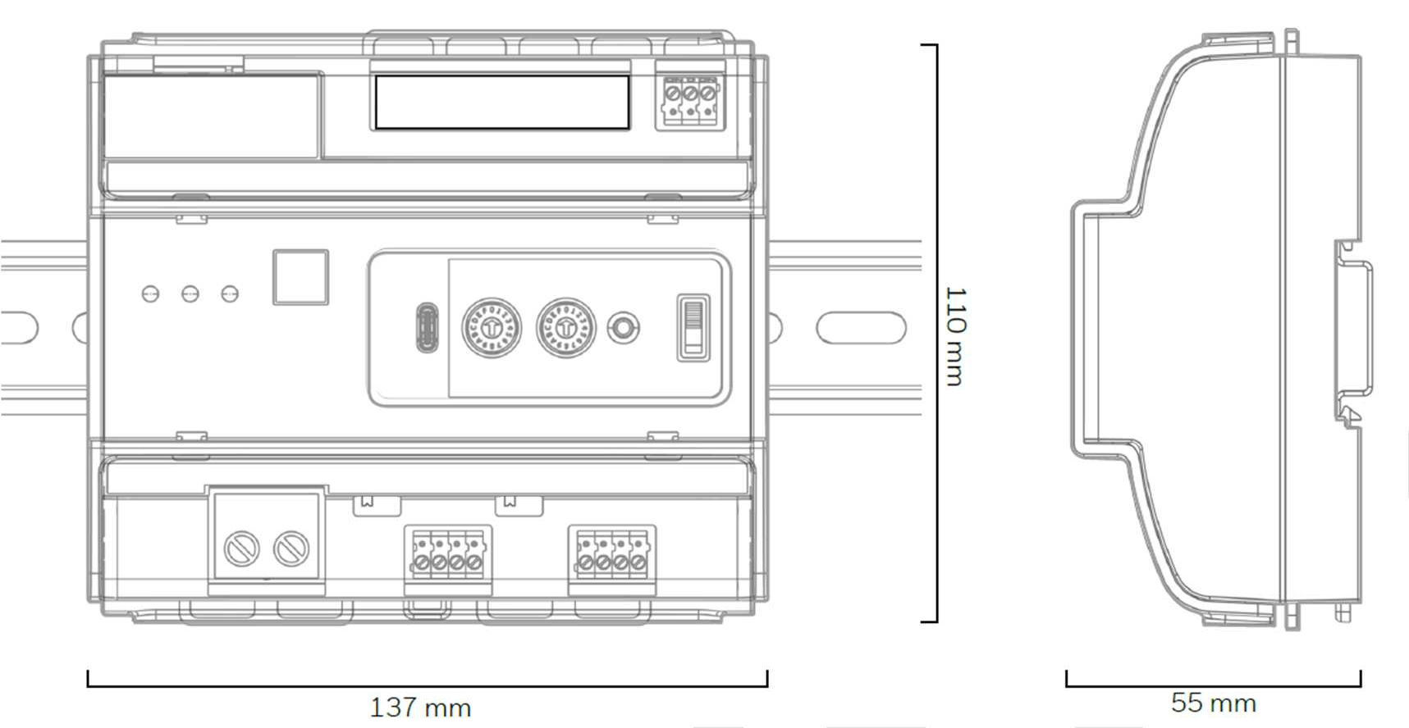
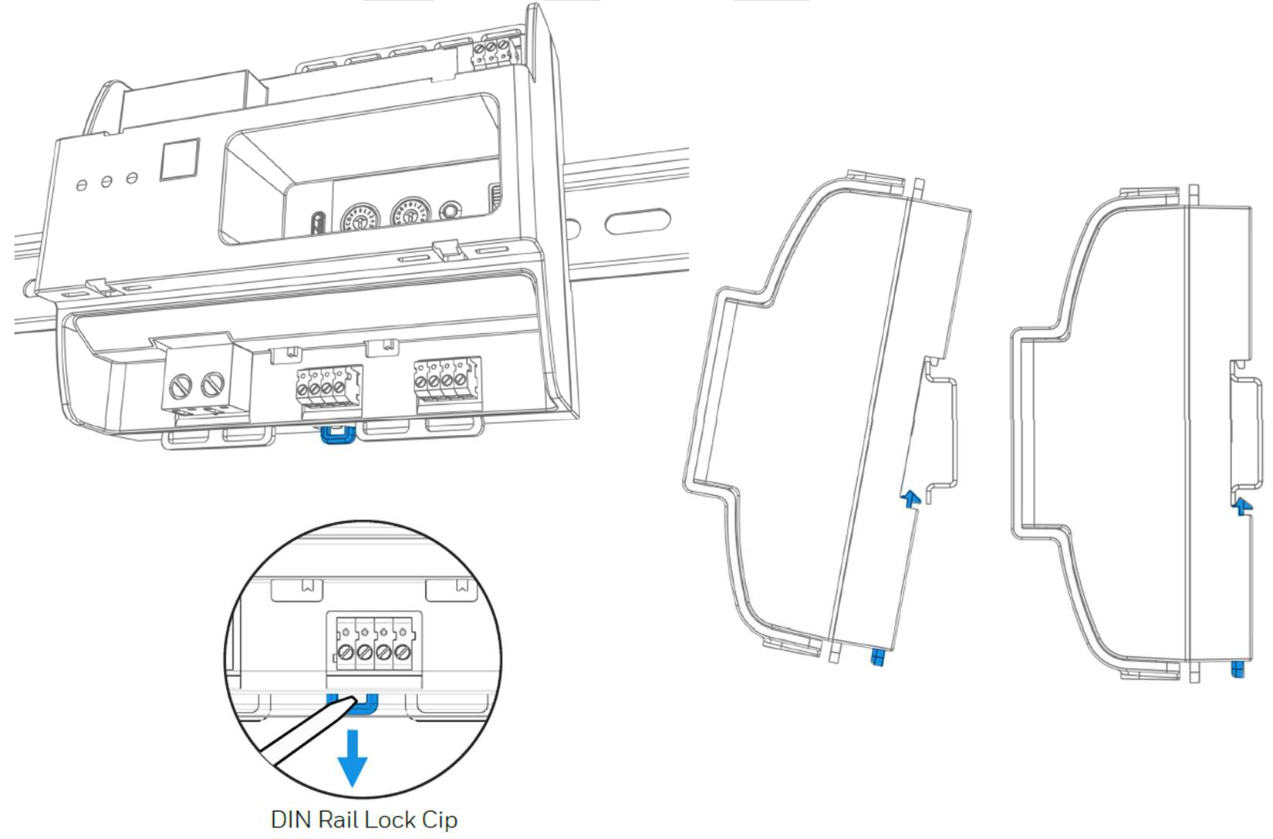

Abb. 1: Systevo Control IP+ dimensions

    - Mounting on a DIN Rail:
Abb. 2: Mounting on a DIN Rail

Use a screwdriver to pull the latch marked in blue in the direction marked and place the device on or off the DIN rail. Then close the lock again.


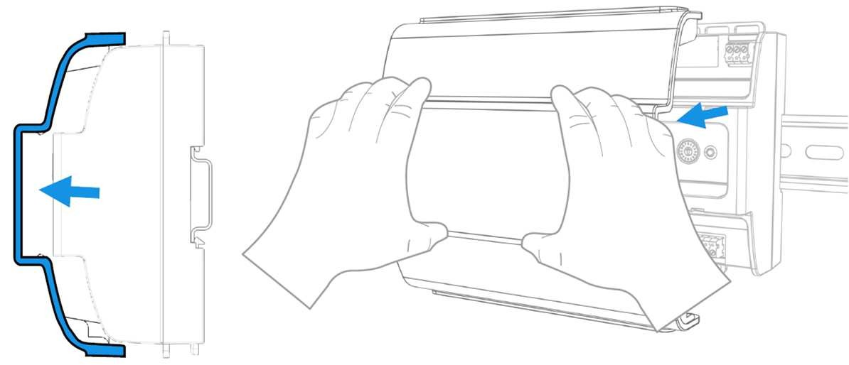
The control and connection elements are located behind a transparent cover. The cover is removed from the device or put back on without tools..

Abb. 3: Remove / replace the transparent cover.

Cable routing and fixation:

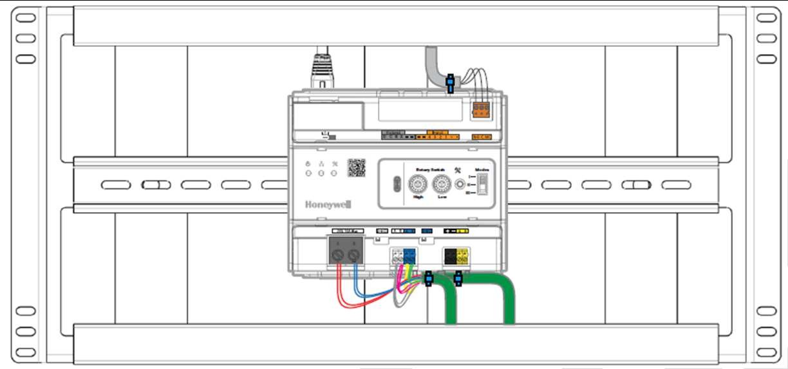 | 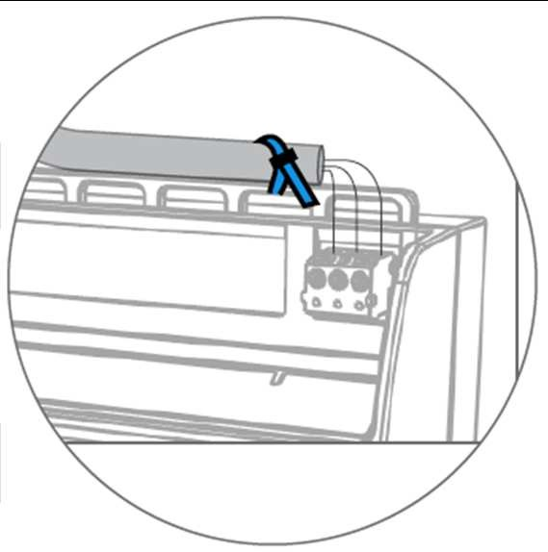
Abb. 4: Routing of the lines network, power supply and bus

Mounting accessories 19“ Rack Art.Nr: 72800Z1

A mounting rack with 5 U to accommodate up to 3 Systevo Control IP + is available for secure attachment and professional cable routing in a 19 “cabinet. In addition to the installation of the Systevo Control IP +, the different installation depths allow the installation of additional components, such as the power supply unit / UPS module, when the maximum depth is used..

Assembly:
The 19 “rack is prepared for the use of two different installation depths and is assembled and screwed to the desired size depending on the project requirements.

Assembly steps:
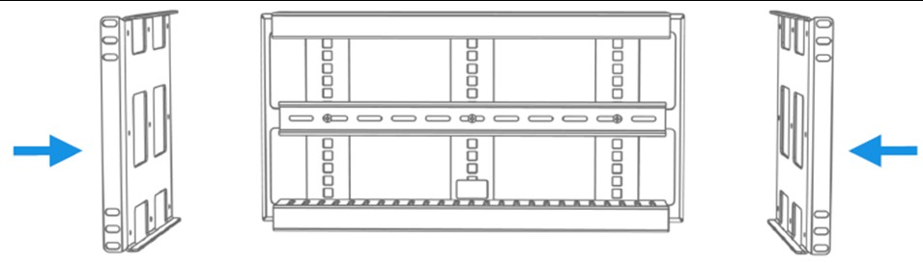 | 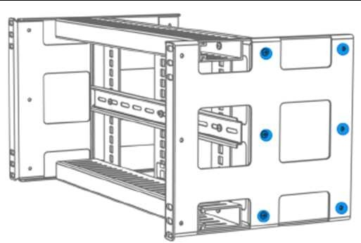
Screw on the side parts (screws included) | Mounting holes for different installation depths

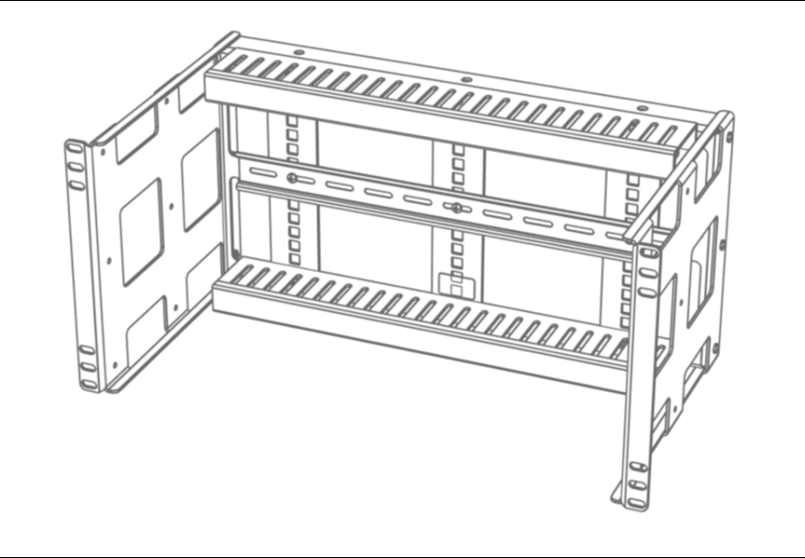 | 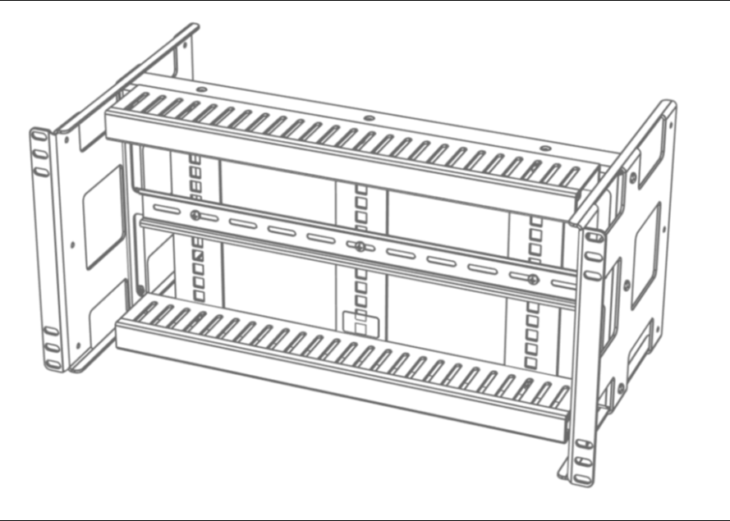
Maximum installation depth (210mm) | Reduced installation depth (100mm)


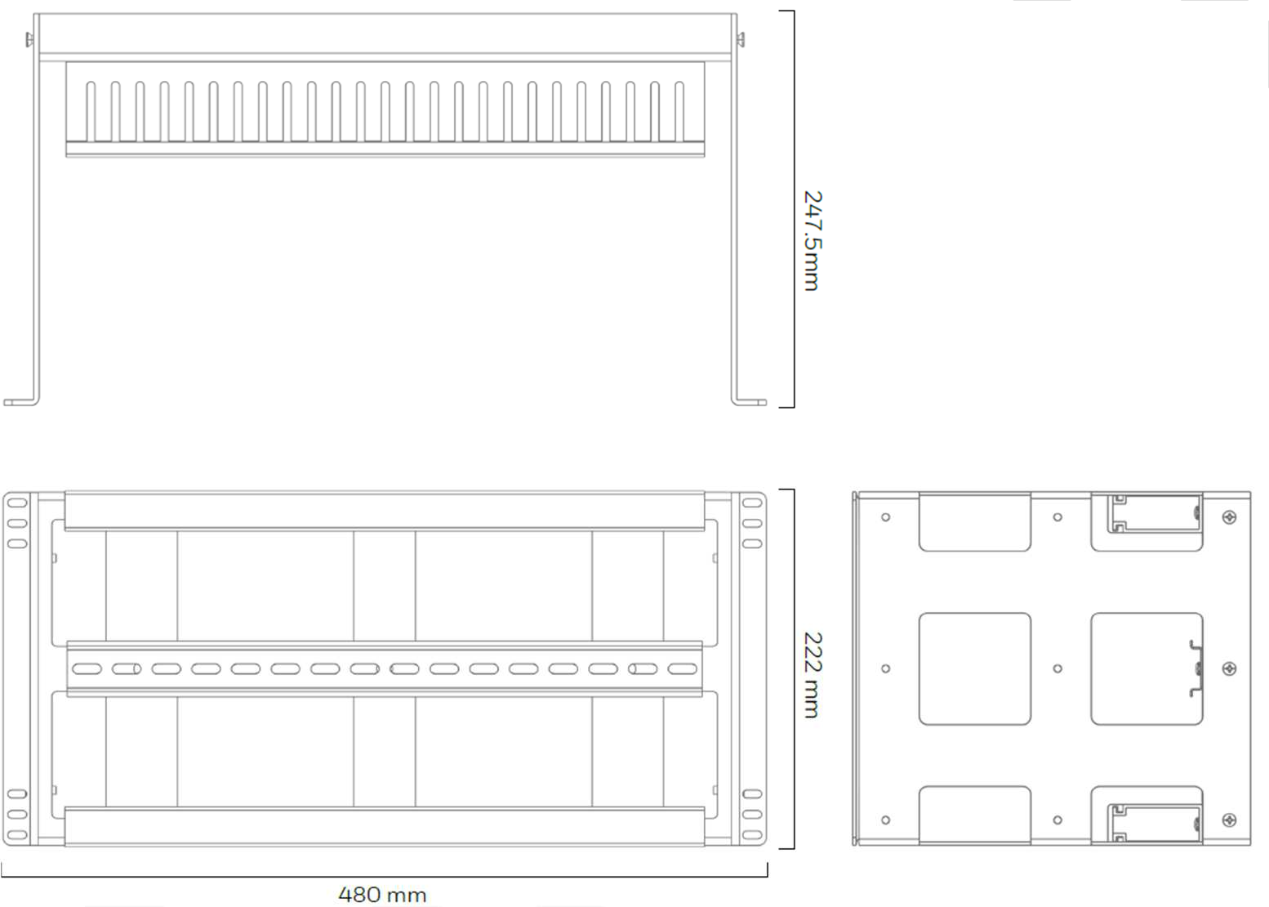
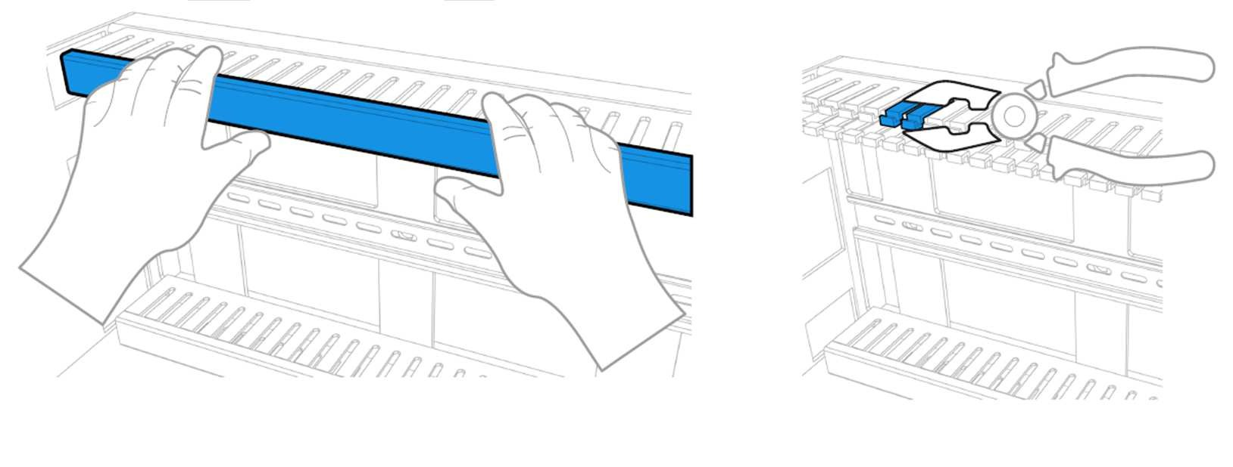
Abb. 7: Professional cable routing in the cable duct of the 19“Rack Art.Nr: 72800Z1
Abb. 5: Assembly of the 19“ Rack Art.Nr: 72800Z1

Dimensions:
Abb. 6: Dimensions of 19“ Rack Art.Nr: 72800Z1
Cable duct for cables:

    - Mounting in 19“ Rack: (available as an accessory)
The 19 “rack can take up to 3 SCIP +.
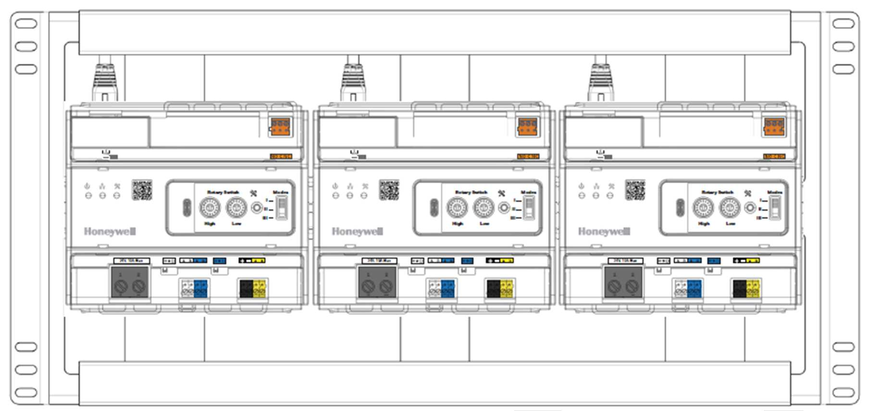
Abb. 8: Mounting in 19“ Rack Art.Nr: 72800Z1


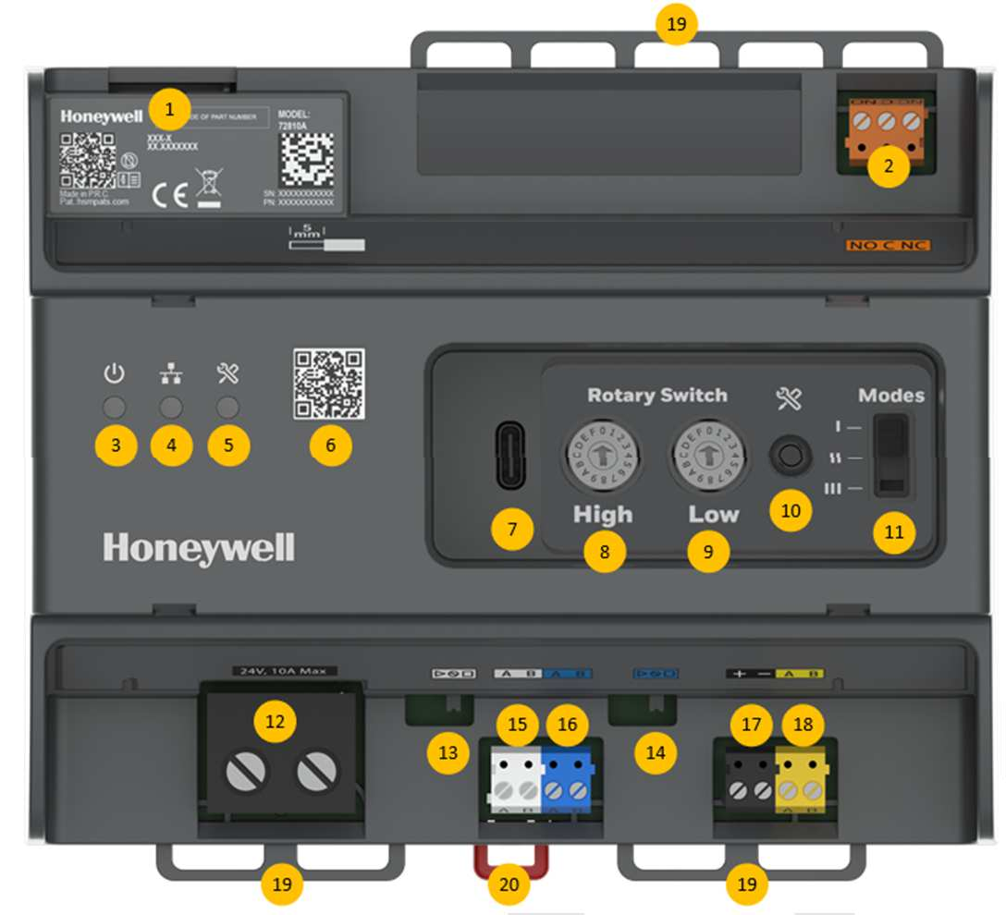
Control elements and connection terminals

1 Lan connection (2xMoPP), establishes the connection to the system switch and to the workstation / server
2 Fault relay
3 Power On LED
4 Display for data traffic on the LAN connection
5 Service LED
6 QR code for commissioning (currently not available)
7 USB-C connection (currently without function)
8 REDary coding switch high: indicates the tens in the range 5..9, A, B.
9 REDary coding switch Low: indicates the units in the range 0..9.
10 Service Button
11 Mode-Switch (currently not available)
12 24V DC power supply
13 ABUS- Termination
14 ZBUS- Termination
15 ABUS Terminal
16 ZBUS Terminal
17 24VDC, (currently not available)
18 DBUS Terminal, (currently not available)
19 Eyelets for fixing the cables
20 Lock for DIN rail

LAN connection (2xMOPP), networking of the zone controller
Each Systevo control IP+ requires an Ethernet connection 10 / 100BT. The Systevo control IP+ communicate with each other while the main control center maintains a constant connection with the operator computer.






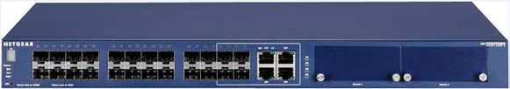
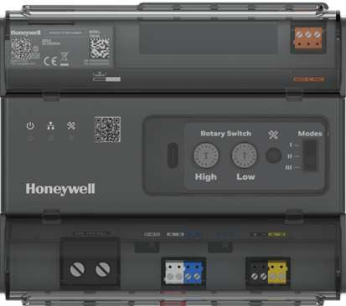
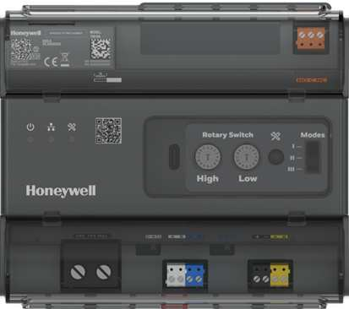
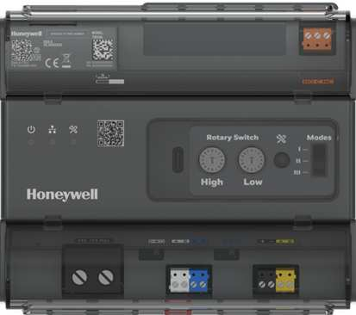





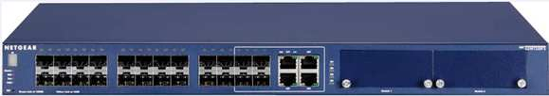

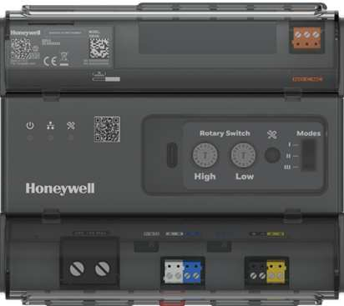
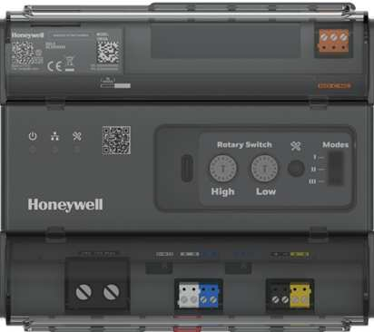
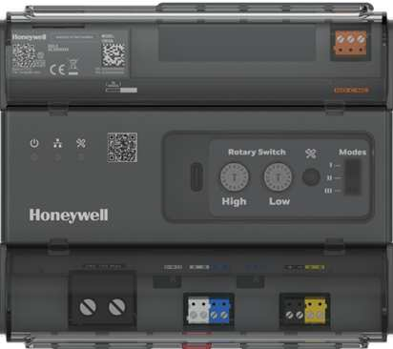
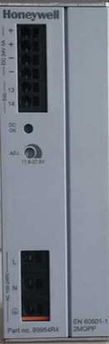
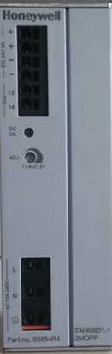
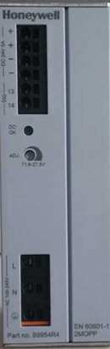




Technical room
Technical room
1
1
2
2
Ward 1
3
:
3
4
3
To Ward 64
From
Ward 2
To Ward 2
From
To Ward 1
From
4
3
:
Ward 64
4
3
LAN
24V DC
ZBUS / ABUS

4 Power Supply / USP
- Workstation / Server
- Switch
- Systevo Control IP ( SCIP+)
Decentralized arrangement of the control centers (e.g. in the ward distribution)
Central arrangement of the control centers (e.g. technical room)
- Standard patch cables with at least Cat5 are used for the LAN connection.
- Lan interface with galvanic isolation according to IEC EN 60601-1 (2 x MOPP).


ZBUS- and ABUS-Termination
13
14





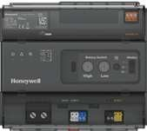
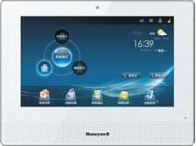
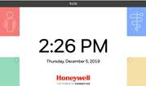
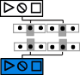
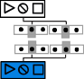
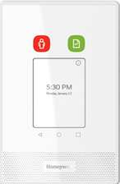
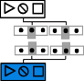
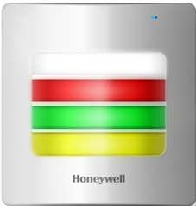
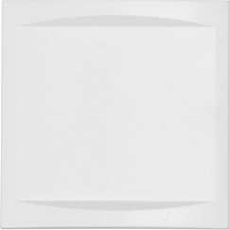
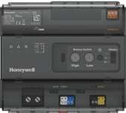
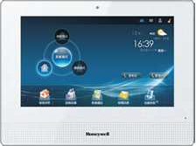
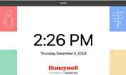
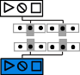
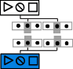
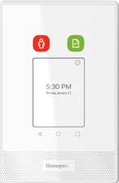
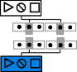
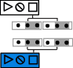
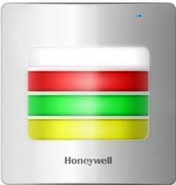
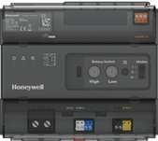
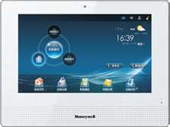
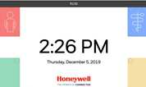
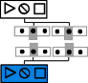
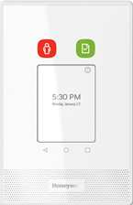
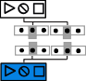
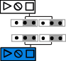
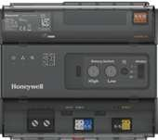
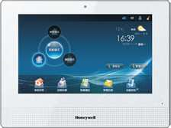
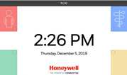
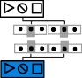
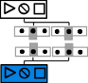
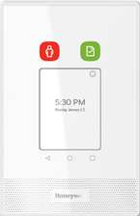
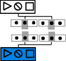
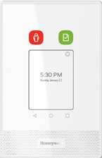
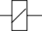
Witch sliding switch
and
the termination on the ZBUS and ABUS is done.

SCIP+ at the beginning of the bus (Termination start)
ABUS
ZBUS

Most frequent application: SCIP is installed at the beginning of the bus, all other devices on the data bus have switched off the termination. At the end a bus termination is installed (72639A) or a device is set as the bus end.

BA
180 Ohm

SCIP+ in the middle of the bus (Termination off)
In some cases it can make sense to install the SCIP + in the middle of the data bus. The termination on the SCIP + is switched off and the beginning and end of the bus is set on the devices.

SCIP+ at the end of the bus (Termination stop)

Fault relay
The control center has a fault signal relay (changeover contact, potential-free) for the transmission of fault messages to external systems.
K
Central unit de-energized or firmware of the central unit is not (yet) active Central active / failure-free
NC
C
NO

Fig.xy relay in the de-energized state

 A connection of the alarm contacts to an external system must meet the requirements of IEC 60601-1 and DIN VDE 0834-1. The separate electronic relay (item no. 89371D) meets the requirements of IEC 60601-1 and DIN VDE 0834-1 along with DIN VSE 0855-1.

Power supply
The power supply for the control panels is preferably taken from the respective station supply and is carried out with the correct polarity on the large connection terminal. It is recommended to supplement

the power supply with an uninterruptible power supply (UPS).
C D E F  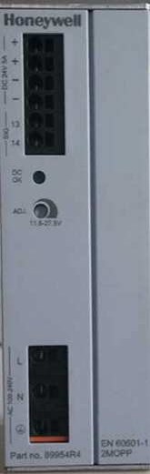  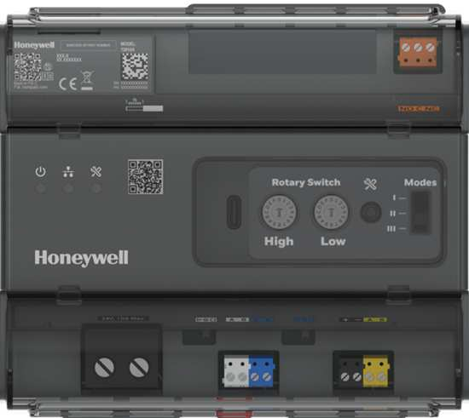  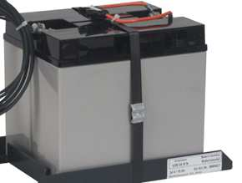    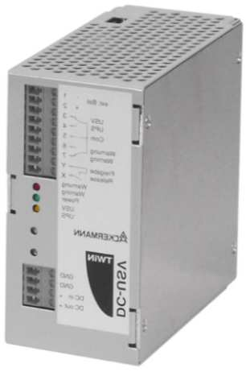  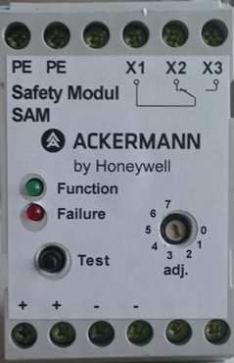  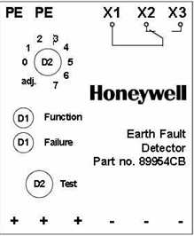                        B  6  5  + - - -  G H  4 I  7  1 2  A 3 |  | A | Mains voltage 230V AC with all-pole disconnection
 |  | B | PE connection, reference ground potential
 |  | C | Message earth fault
 |  | D | Message fault USP, Battery low
 |  | E | LAN (2xMOPP)
 |  | F | Message fault SCIP
 |  | G | ZBUS / ABUS and 24V DC to the ward
 |  | H | Middle power supply (if requried)
 |  | I |   Return line ZBUS / ABUS and 24V DC as a ring line
 |  | 1 | 24V DC power supply (2xMOPP)
 |  | 2 | USP-Module
 |  | 3 | Battery-Module
 |  | 4 | On-site fuse ( max. 10A)
 |  | 5 | Earth fault monitor
 |  | 6 | SCVIP+
 |  | 7 | Bus-Termination


Abb.xyz Power supply of the Systevo Control IP+ from the station supply

Service Button / Service LED
Service access directly to the Systevo Control IP+ is provided by three LEDs (red, blue, green) and a service button. Operating states and errors are displayed during normal operation. A status can be displayed. If there are several events, the status with the highest priority is displayed. (1 is the highest and 9 is the lowest priority.

  Priority | Status | LED |   Blinking tact: 1 unit = 100 ms
1 | Bootloader active | RED
1 | Bootloader active | Blue
1 | Bootloader active | Green
2 | Boot process of the application | RED
2 | Boot process of the application | Blue
2 | Boot process of the application | Green
5 | Fatal Error | RED
5 | Fatal Error | Blue | Off
5 | Fatal Error | Green | Off
7 | Relay for  Error messages active | RED
7 | Relay for  Error messages active | Blue | Off
7 | Relay for  Error messages active | Green | Off
8 | Power supply is  within the tolerance range | RED | Off
8 | Power supply is  within the tolerance range | Blue | Off
8 | Power supply is  within the tolerance range | Green
4 | Power supply is not in the tolerance range | RED
4 | Power supply is not in the tolerance range | Blue | Off
4 | Power supply is not in the tolerance range | Green

The service button is used to start and navigate in the menu and to trigger service functions. If the service menu is active, the LEDs are used for navigation and feedback on service tasks during this time. The menu navigation ends automatically 2 minutes after the last operation. Operating states and error messages are only displayed again after the service menu has ended or failed.

Navigation in the Service Menue
For the start and navigation in the service menu, in addition to pressing the button, its duration is also important. You can advance through the menu when you release the button.

A distinction is made between three operating times of different lengths:

short -> up to 3 seconds

medium -> 3 to 5 seconds

long -> greater than 5 seconds

Reaching the mean time (3-5 seconds) is indicated by rapid flashing (100ms) of the Blue LED, while the Blue LED is continuously switched on from 5 seconds.

The service menu is divided into 2 main levels:

- Basic menu for more frequent activities
- Extended menu for system configuration activities

Functions in the basic menu:
If the control center is in normal operating mode, the basic menu can be accessed directly via the service button. . In the basic menu, faults in the central unit can be devalued or acknowledged and switched to the extended menu.

Evaluate

Service-Button


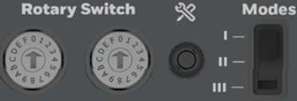
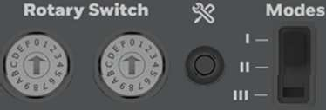
- Briefly press the button -> release immediately after pressing.
- The current status display of the central unit is interrupted.

< < < 1 second > > > >

- Medium press -> release as soon as the Bluee LED flashes very quickly

< < < 1 second> > > >
- Acknowledgment: Bluee LED flashes 2 seconds slower (like doctor call)

< < < 1 second> > > >

Then automatically end menu and normal status display

Start of the extended service menu

Service- Button

- Press the button for a long time -> release it as soon as the blue LED is continuously switched on
< < < 1 second> > > >
- Transition to the extended service menu
- Acknowledgment: Bluee LED lights up continuously / Greene LED flashes every 0.1 seconds


< < < 1 second> > > >

Extended menu
The extended service menu is activated from the basic menu (see function no. 3). LED Green or "RED level" (LED RED) is symbolized - in addition to the Blue LED.


The Green and RED LEDs light up continuously and indicate the function number with short interruptions..

No. |  |  |  |  |  |  |  |  |  |  |  | 1 unit = 100 ms
1
2
3
4
5
6
7
8
9
10

When entering the extended menu, the "Green level" function 1 is preset. Further short key presses switch the 10 functions further. After function RED 10, function 1 Green becomes active again.

Start the function:
- Medium press -> release as soon as the Blue LED flashes very quickly

< < < 1 Sekunde > > > >
- - Acknowledgment: Blue LED flashes 2 seconds slower (like doctor call)

< < < 1 Sekunde > > > >

With the "RED" functions, system changes are carried out and therefore the start function must be carried out twice in succession as described above.

Result display at the end of the function:

At the end of the function, the Blue LED remains switched on and the Greene or RED LED shows the result with a permanent light (Green = OK / RED = Error)
Result ok:
Result not ok:



Exit the result display:

Quit the result display by briefly pressing the button. The central unit is then in the same function preselection as it was before starting the respective function.

Leaving the service menu:

The service menu is exited after a long button press. The menu is closed automatically if no key is pressed for> 2 minutes..


Functions in the extended menu
Description of the functions in the extended menu. The corresponding commands via Telnet are given in round brackets.

Level 1 (green LED) | Description
Function 1 |     Status der letzten Servicefunktion anzeigen
Function 2 | Kaltstart des Systevo Control (>coldstart smc<)
Function 3 | Kaltstart des Systevo Control und Löschen der Störungen (>coldstart smc f<)
Function 4 | Kaltstart des Systems (>coldstart sys<)
Function 5 | Autosetup (>autosetup<) mit Funktion:    - Werkseinstellung ZBUS (>setfactory zbus<)  - Datenbank Erstellung (>makedb<)  - BBUS-Adressierung (>adrbbus<)
Level 2 (red LED) | Description
Function 6 | BBUS-Adressing (>adrbbus<)
Function 7 | ZBUS-Adressing (>adrzbus<)
Function 8 | Create Database (>makedb<)
Function 9 | Factory settingss Systevo Control (>setfactory smc<)
Function 10 | Factory settings ZBUS (>setfactory zbus<)

Commissioning
At this point, the commissioning of the central components is described so that the ward (s) can then be commissioned.

- Commissioning must be carried out by qualified specialists.
- For commissioning of the network and fieldbus level, see documentation (item no. 89470F2)


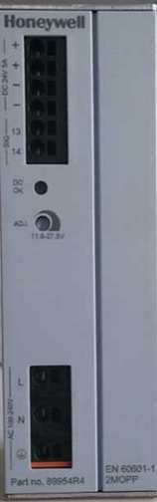
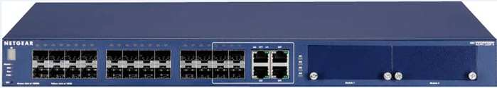

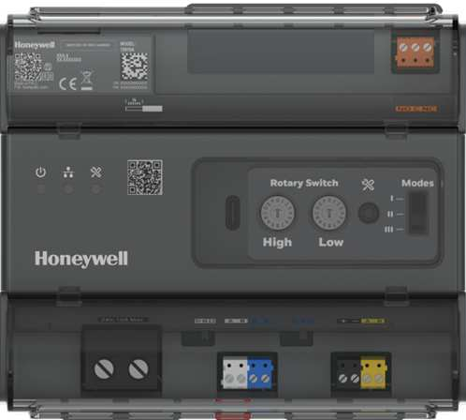
Requriements
- Provision of a dedicated network (VLAN) for the call system (see also technical information "Systevo Call Ackermann with IP devices" 89470F8)
- Networking of the central components such as workstation / server, system switch and SCIP +. „

Prepare the Workstation / Server
It is advisable to update the PC before the planned commissioning and to import the required license keys so that commissioning in the project is limited to the essentials and a planned process is not interrupted by possible updates or by importing required license keys. It makes sense to carry out the measures described below before using them in the project. Before starting any work, it must be ensured that the latest software is used. On the homepage http://www.ackermann-clino.com , current system software and any patches are always available in the protected download area in the directory “Current System Software V12.x”. To update the software and license key, it is recommended to prepare a pre-installation with the following structure.

Switch Worksstation / Server Internet

Lan2 Clino Interface Lan1 Interface

+24V DC

SCIP+
+ 24V DC power supply
Abb.9 Structure for update

- Set the SCIP + as master (identifier 51) with the rotary coding switch.
- Switch on the devices in the order switch, SCIP+, workstation / server
- Make language settings (see Ti 217 chapters 4.2.2 and 4.2.3)
- Download the latest software and patches from http://www.ackermann-clino.com and upload them to the PC (see Ti 217, chapters 4.2.4 and 4.2.5)
- Change IP addresses, if necessary (TI217 chapter 4.2.6) (DHCP, File Zilla, LRS module etc.)
- If extension licenses are required, then read out / export license key with cp99 config and send it to Service for updates with order confirmation.
- Import the updated license key.
- Import licenses for couplings (PSA, ESPA, BMA)
- Carry out Windows licensing
- Register Acronis and create a backup of the delivery status (see Chapter 4.2.9 and Chapter 6.1 in Ti 217))

The PC set up in this way can now be used in the project.

Commissioning of the center (s)
The commissioning of the control center (s) is divided into the following steps:

Define the central identifier with the rotary coding switch

Check the networking in the LRS module

Scan / read out SCIP + ‘s with the configuration program


Update SCIP + ‘s if necessary

Set the operation mode at SCIP + ‘s

Setting the properties of SCIP + (name, service group, STIP mode, audio path)

Write the SCIP + configuration into the system

Determination of the central identification with rotary coding switch

The rotary coding switches are used to define a unique identifier for each central unit prior to commissioning, which is used to identify the central unit in the configuration program (CP99Config). Basically there must be a control center with the identifier 51, all others must be in the valid area between 52 and B4.
      - The rotary coding switch ¹⁰ “High” indicates the tens in the range 5..9, A, B.
      - The rotary coding switch ¹¹ “Low” indicates the units in the range 0..9..
Identification of the zone controller (no. :) with the corresponding position of the rotary coding switch
Nr.: | High | Low | Nr.: | High | Low | Nr.: | High | Low | Nr.: | High | Low | Nr.: | High | Low | Nr.: | High | Low | Nr.: | High | Low
1 | 5 | 1 | 11 | 6 | 1 | 21 | 7 | 1 | 31 | 8 | 1 | 41 | 9 | 1 | 51 | A | 1 | 61 | B | 1
2 | 5 | 2 | 12 | 6 | 2 | 22 | 7 | 2 | 32 | 8 | 2 | 42 | 9 | 2 | 52 | A | 2 | 62 | B | 2
3 | 5 | 3 | 13 | 6 | 3 | 23 | 7 | 3 | 33 | 8 | 3 | 43 | 9 | 3 | 53 | A | 3 | 63 | B | 3
4 | 5 | 4 | 14 | 6 | 4 | 24 | 7 | 4 | 34 | 8 | 4 | 44 | 9 | 4 | 54 | A | 4 | 64 | B | 4
5 | 5 | 5 | 15 | 6 | 5 | 25 | 7 | 5 | 35 | 8 | 5 | 45 | 9 | 5 | 55 | A | 5
6 | 5 | 6 | 16 | 6 | 6 | 26 | 7 | 6 | 36 | 8 | 6 | 46 | 9 | 6 | 56 | A | 6
7 | 5 | 7 | 17 | 6 | 7 | 27 | 7 | 7 | 37 | 8 | 7 | 47 | 9 | 7 | 57 | A | 7
8 | 5 | 8 | 18 | 6 | 8 | 28 | 7 | 8 | 38 | 8 | 8 | 48 | 9 | 8 | 58 | A | 8
9 | 5 | 9 | 19 | 6 | 9 | 29 | 7 | 9 | 39 | 8 | 9 | 49 | 9 | 9 | 59 | A | 9
10 | 6 | 0 | 20 | 7 | 0 | 30 | 8 | 0 | 40 | 9 | 0 | 50 | A | 0 | 60 | B | 0
Tab.1 Highlighted area of control panel identification 51

If the ID of the control center is not in the valid range, the control center cannot go into regular operation and remains inoperative in the disturbed state (fatal error).

Check the networking in the LRS module
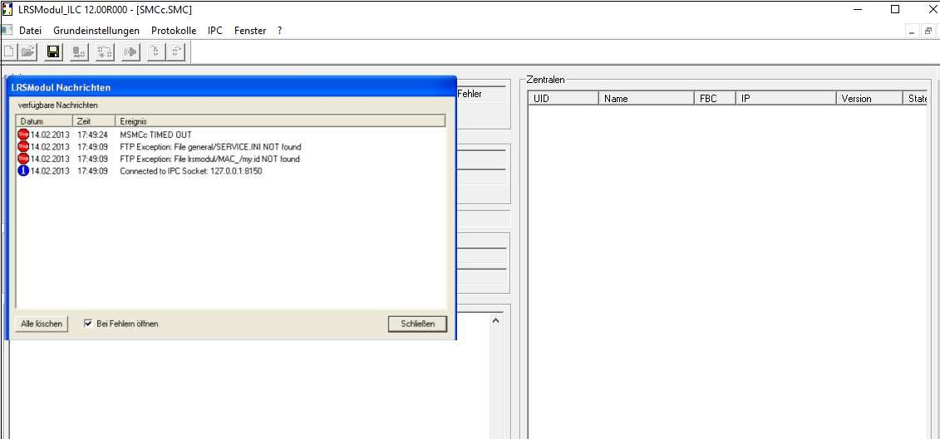
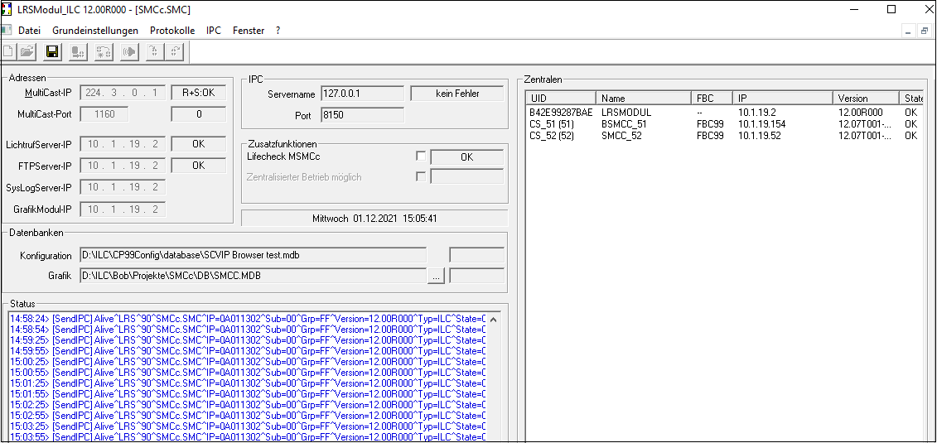
After starting the computer, the LRS module opens. Monitoring for control panels is active and reports errors if they cannot be reached.

Abb.xx Start the computer -> LRS module is opened

All Systevo control IP+ networked with the workstation / server are listed in the monitor window with the ID set.

Abb.xx List of networked Systevo Control IP+

Scan / read out SCIPs with the configuration program cp99config/ auslesen
- The CP99Config program is started and a new project is created.
- A control panel scan (Extras-> Scan system) is carried out. After pressing the "Apply" button, the scanned control panel list is transferred to the left window of the CP99Config program. The names of the control panels each contain the identifier set via the coding switch: e.g. CS_51, CS_52, CS_B1 ... (CS stands for "Coding Switch")
- Extras-> Manage licenses -> read all licenses
- Save the project in the CP99Config program on the operator computer.

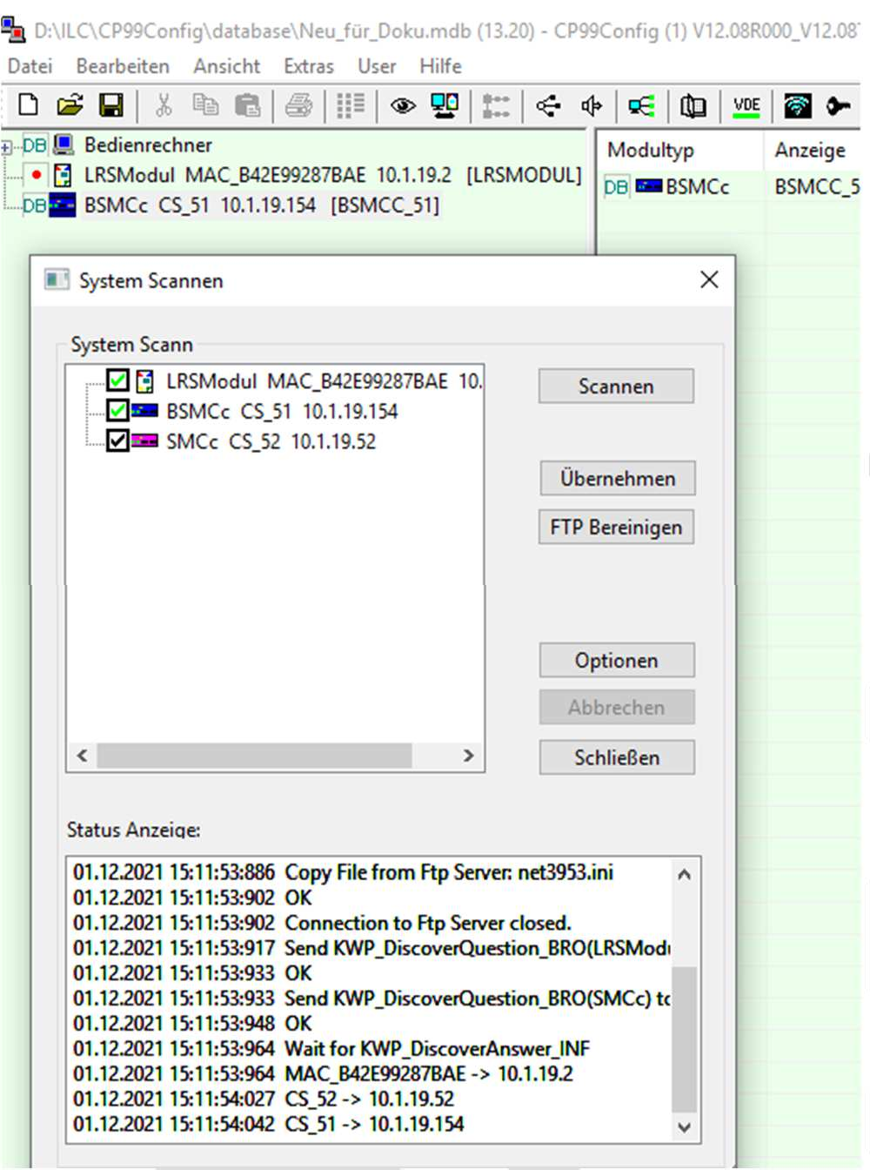
Abb.xx Accept the scanned zone controller

Update SCIPs if necessary
Before doing any further work, we recommend checking the firmware version of the control panels and, if necessary, bringing it up to date. All Systevo Control must always be operated on the same version.

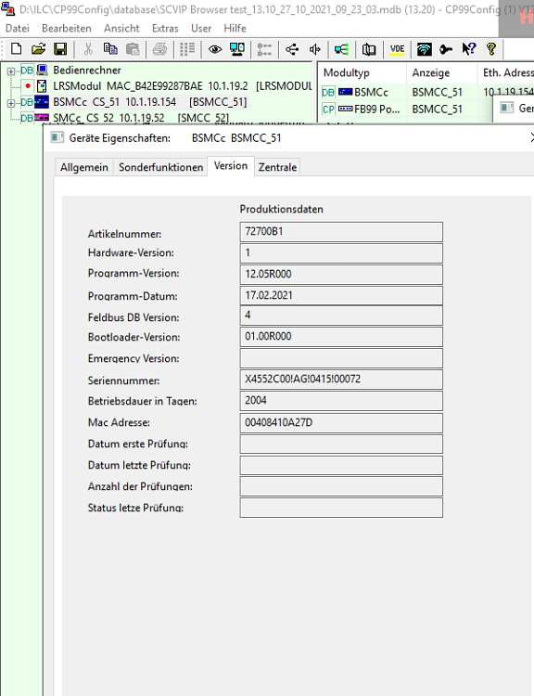
Call up the properties window of the SCIP + with the right mouse button on the control center and check the firmware version. Current software at http://www.ackermann-clino.com

Abb.xyz Check the SCIP + firmware version

The firmware is updated with the CP99FileUpdate program

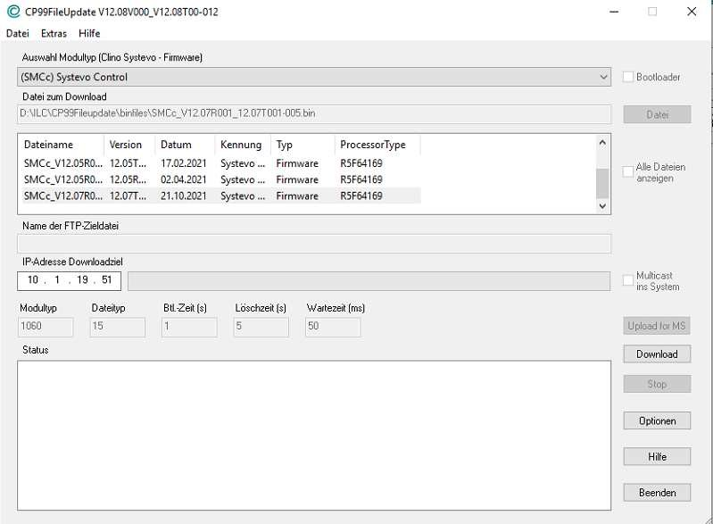 | - Select SMCc for the model type.  - Selection of the current firmware  - Specify the IP address as the download target for a SCIP +.

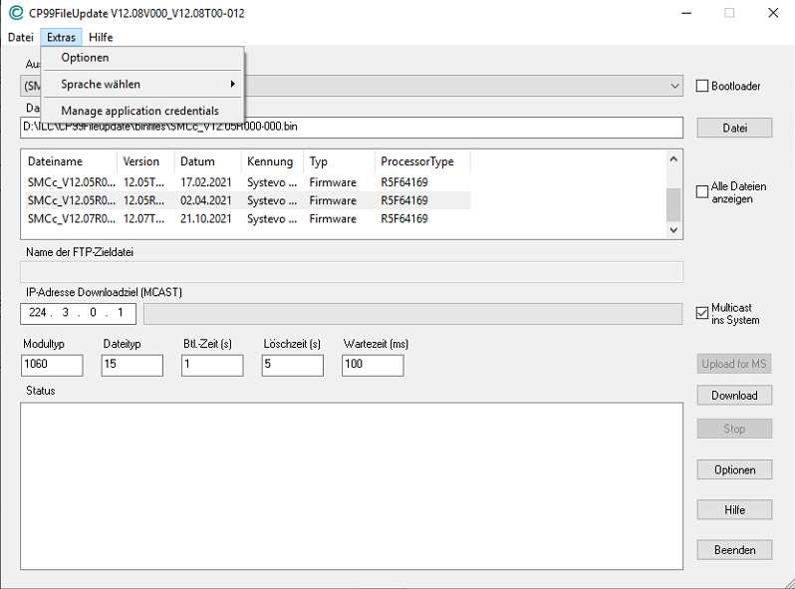 | - By setting the option "Multicast into the system", the update is carried out for all SCIP + in the system.
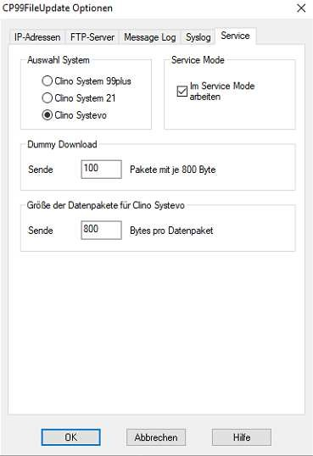 | - In the options, select the  "Service" tab and there select the system and the "Work in service mode" option.  - Then start the update with the "Download" button.
Abb.xyz Update of all centers via multicast.

When the update is finished and the central unit is ready for operation again, the central unit can be reached via the terminal program.
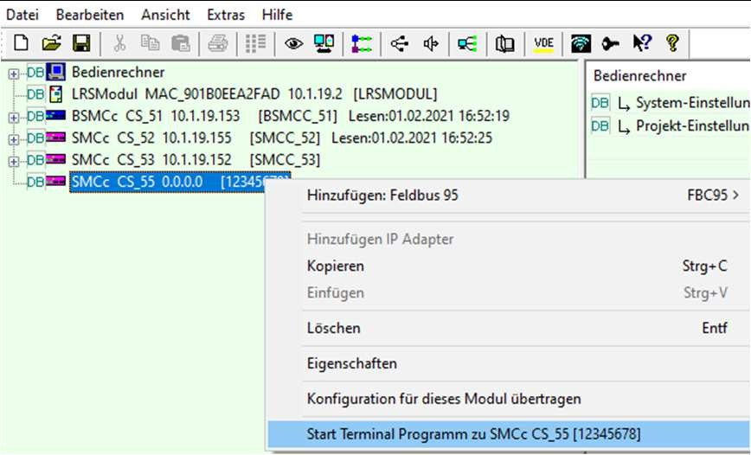 | - If the terminal program can be started with the right mouse button, the loading process of the relevant control center is complete.  - The firmware can be checked in the terminal program.  - If the zone controller are read out again with the CP99Config after the update, the firmware can be checked via the properties window.

If all controller have the latest firmware version, commissioning is continued.

Set the operation mode on SCIPs
Depending on the application and the available infrastructure, different operating modes are available. One operating mode is used for each station controller. The same or different operating modes can be used within an overall system (max. 64 station controllers). The different operating modes determine how the call system functions are processed by the STIP / SCVIP and therefore place different demands on the infrastructure. A total of four operating modes are available, which are explained in more detail below.

Data bus mode

The data bus mode corresponds to the classic nurse call. Data and audio communication is handled via the classic room and audio bus. The use of additional IP services is not possible in the data bus mode. This setting allows the operation of STIP / SCVIP in data bus mode (see also chapter 4.3.6 "STIP mode")

IP+ mode
The IP + mode combines classic nurse call plus additional IP services, such as telephony or task management. This setting allows the operation of STIP / SCVIP in IP + and in data bus mode (see also chapter 4.3.6 "STIP mode")

IP mode
In IP mode everything is handled over IP. The complete data communication for the nurse call as well as additional services such as telephony or task management are implemented via the IP path. This setting allows the operation of STIP / SCVIP in IP mode (see also chapter 4.3.6 "STIP mode")

Hybrid mode
The hybrid mode represents a pairing between IP mode and the classic nurse call. The STIP / SCVIP units are connected to the nurse call via an IP network and are virtually assigned to components of the classic nurse call, such as electronic modules, and thus become a pair connected with each other. There is no physical connection between the components in the classic nurse call and the STIP / SCVIP. This setting allows the operation of STIP / SCVIP in hybrid and data bus mode (see also chapter 4.3.6 "STIP mode")
The operating mode is defined for each SCIP + in the properties window of the SCIP +.

Setting the properties of SCIP (name, service group, STIP mode, audio path)
In the properties window for a SCIP +, the following settings are made under the “General” tab:
Properties from SCIP+
  Dispaly text | Designation (max. 8 characters) how the central unit is to be displayed in the call system.
Extended display text | Text can be entered here in any language with a maximum of 8 characters. This text (according to UTF8 coding) is the alternative to the "display text" used by Systevo Dashboard and STIP. Only available with the “Systevo Dashbord” license.
Service group | When technical work is carried out at a control center, fault reports are often unavoidable and should not unnecessarily disrupt the operation of the overall system. The nurse call group for malfunctions is preconfigured to 254 at the control center. This group is normally not included in the call distribution. This means that the fault  messages remain locally in the station.
Description | A detailed description of the control center with up to 80 characters is possible.
STIP Mode | See also 4.3.5 Setting the operation mode on SMC's
Audio Channel | Specifies the transmission path for the audio channel, ABUS or IP, in IP + mode.

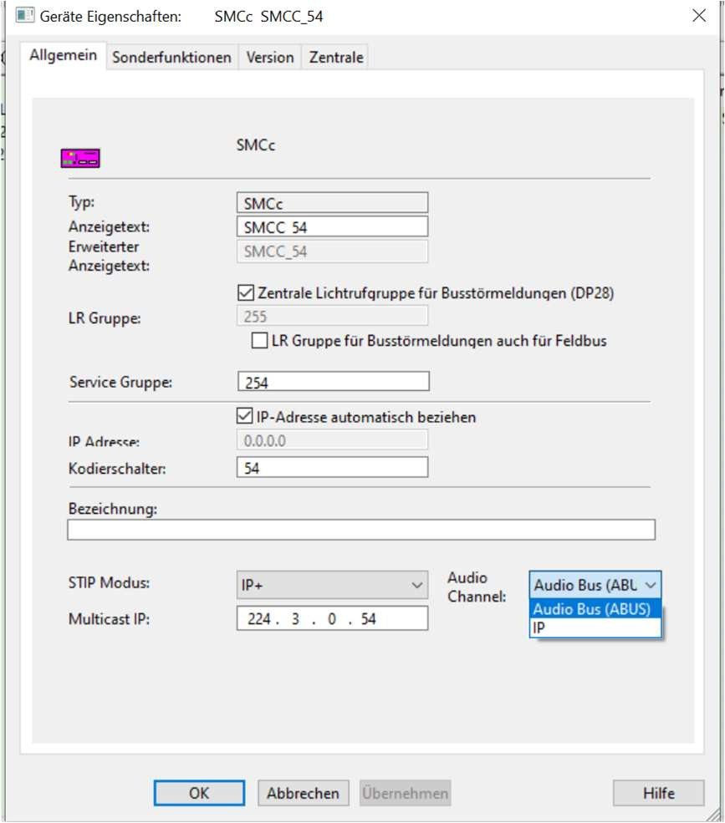
Abb.xy Properties of SCIP +

The operation mode is set on the SCIP+ and defines the possible use.

The STIP mode defines how a single STIP / SCVIP works on a SCIP+.

The setting must match the operating mode of the SCIP+.

Write the SCIP + configuration into the system
In order for the selected properties of the control panels to take effect, the configuration must be written into the system.
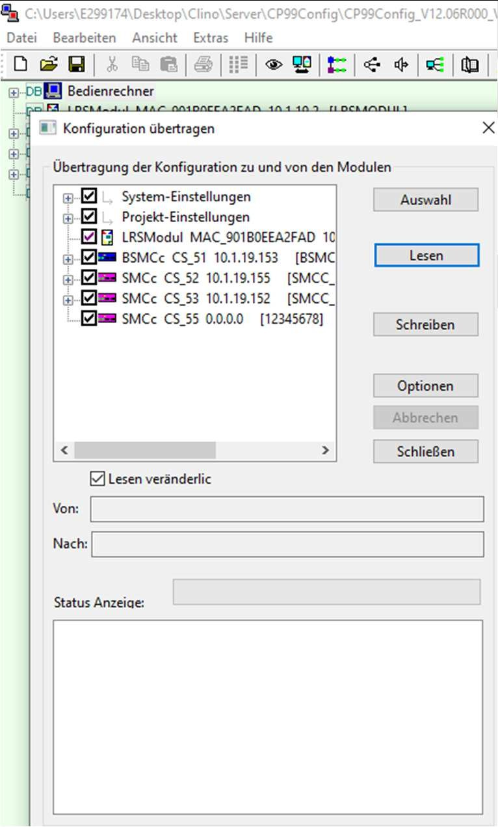 | - Select the "Transfer configuration for all modules" dialog and use the "Write" button to write the configuration to the system.  - The remaining components of the system can then be commissioned and configured. (Commissioning patient call system 89440C4, commissioning STIP / SCVIP 89470F9)
Abb.xyz Write the configuration to the system

Data backup
At the end of commissioning, a backup copy of the hard disk image and a Clino backup of the operating computer should be carried out. (See also Ti217 chapter 6.1)

Licenses
In contrast to the previous licensing procedure, a modified licensing procedure will be used from software release V12.10.
The new licensing procedure does not require a license card. Instead, the licensing is carried out online in a cloud. To do this, license information from purchased licenses and the unique information from the master center installed in the project are combined into a unique license for the project. A license generated in this way cannot be copied and therefore cannot be used in different projects. In the same way, license information can be read from existing systems and, if necessary, expanded with additional licenses.


Requirements:
- SMCc / SCIP+ from version V12.10
- Configuration program cp99config from version V12.10
- System is installed and the basic installation has been carried out (Autosetup)
- Mobile device (cell phone) with QR code reader and internet connection.

System-QR-Code

An OR code with the following information is generated on the nurse call server using the cp99config configuration program:

License Management Home Page

Project number (Project_ID, created from the Mac address of the master panel with identifier CS_51

Software release number

License expiry date

List of participants who can receive a license-dependent function

List of licensed functions included in the system.

Lizenz-QR-Code
- For each license purchased, the customer receives a license sheet with a QR code with the corresponding license data:
  - Function of the license
  - Number of participants
  - Term of the license

Procedure:
- Generate system QR code on Systevo Workstation
- Scan the system QR code with a mobile device (cell phone) and you will be redirected to the website with the license management
- Scan the QR code(s) of the license documents with the mobile device (cell phone) and add them to the license administration, a new system license will be created.
If the nurse call computer is connected to the Internet, the system license can be updated manually or you can wait for the automatic update (every hour).

- If the nurse call computer is not connected to the Internet, the license file is loaded onto the mobile device (cell phone) and must be transferred from here to the nurse call computer and activated manually.

Replacement of a Systevo Control IP+
If a Systevo Control IP+ needs to be replaced, the following steps must be followed:

- Make data backup (see chapter 4.4)
- Unplug the electrical connections of the data / audio bus and power supply etc. as well as the network connection.
- Dismantle the central unit by opening the lock for the top hat rail, the central unit can now be removed from the top hat rail.
- Place the new central unit on the top-hat rail and close the lock.
- Set the rotary switch for addressing in the same coding as for the remote SCIP+ (see chapter 4.3.1)
- Bring the replacement central unit to the software version used in the project or carry out an update.
- Read out the zone controller with the CP99Config program (see chapter 4.3.3) and write the scanned zone controller back into the system.
- Carry out a functional test..

If the master zone controller has to be replaced, it is advisable to convert one of the already installed slave zone controller to the master zone controller and place the new SCIP+ as a slave zone controller. In this way, existing licenses remain unaffected.

Expansion of systems with Systevo Control (SMCc)
So that existing systems can be expanded, a compatible software version from version V12.10 required for all zone controller in the network. Zone controller of the type SMCc (72700A1 / 72700B1) can be upgraded to the required version from Rev.AF from 01/30/2014 (all devices with the serial numbers 884552C00! AF! Xxxx! Xxxxx and higher. The production week and the last five digits are not relevant for this decisive) The hardware version can be checked via the Telnet version output with F2, as well as via CP99Config via the device properties of the control center in the "Version" tab.
After the SMC's have been updated to the required version, the SCIP + is integrated in the usual way.

- Install STIP+ (assemble and connect)
- Set the rotary coding switch
- If necessary, update to SCIP+
- Read out the zone controller with the CP99Config program (see chapter 4.3.3) and write the scanned zone controller back into the system.
- Commissioning of the new SCIP + control center (see chapter 4)

Systevo Control IP (SCIP+) as replacement for Systevo Control (SMCc)
SCIP+ supports firmware from V12.10. If an SMCc is replaced, the specifications for the extension in Chapter 6 apply. Therefore, an exchange can only take place in a system with firmware V12.10 or higher; the existing system may have to be updated first.

- Accessories
A rack for up to 3 SCIP + is available for installation in a 19 “cabinet. A package consisting of the transparent cover and a set of connection plugs is available as a spare part due to damage or loss

Rack 72800Z1 | Cover 7200Z2
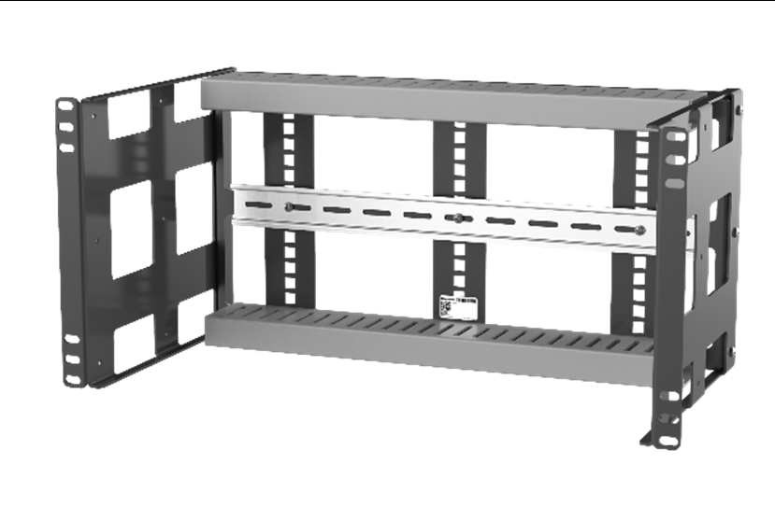 | 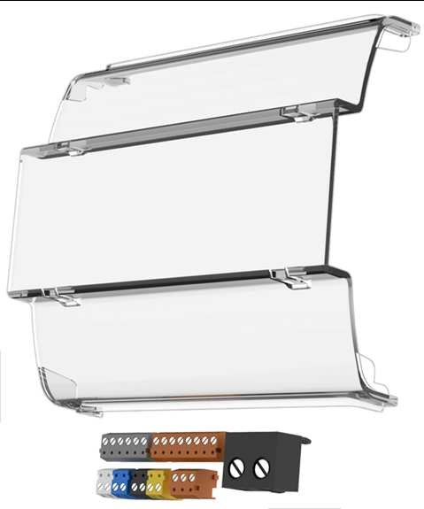

- Technical Data

 | Systevo Control IP+ 72800A | Systevo Control IP+ I/O 72810A | Rack 72800Z1
Approvals:
Approvals/Norm | CE, VDE 0834, UL 1069, UL (component) |  | CE, VDE 0834, UL 1069,  UL (component)
Environmental conditions
Operating Temperature | +5°C .. +40°C |  | +5°C .. +40°C
Storage Temperature | -20°C .. +70°C |  | -20°C .. +70°C
Humidity | 10% to 90% (non-condensing) |  | 10% to 90% (non-condensing)
Environmental Sealing | IP 20 |  | IP 20
Electrical Data
  Power Supply | 24V DC +/- 10%
SIdle state mean current @24V | 1A |   1A
Maximum working state mean Current consumption CPU under full load @24V | TBD | TBD
Normal working state mean Current consumption CPU under common load @24V | TBD | TBD
DBUS Termination | Automatically | Automatically
R-ABUS Termination | Not applicable | Not applicable
ABUS Termination | Bus-device  Start-device End-device | Bus-device  Start-device End-device
ZBUS Termination | Bus-device Start-device  End-device | Bus-device Start-device  End-device
ZBUS Topologie / Termination / Length | Bus only Switch 500m | Bus only Switch 500m
ABUS Topologie / Termination / Length | Bus only Switch 500m | Bus only Switch 500m
R-ABUS Topologie / Termination / Length | Not applicable | Not applicable
DBUS Data rate | 115200bps
Number of DBUS devices | TBD | TBD
Passive output port | Not applicable | Not applicable
Power wiring terminal | Max.10A 2 x 1,5mm²
Data wiring terminals | Per terminal max. 3 wires 0.6mm / 2 wires 0.8mm (non flexible wires)
Mechanical Data
  Dimensios of the product (H x W x D) in mm | 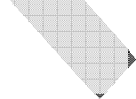  21,4 x 61,9 x 164,7 | 21,4 x 61,9 x 164,7
Dimensios of the package (B x H x T) in mm
Net weight | 310g | TBD
Antimicrobial | Yes | Yes
Desinfection-Materials: | 70% Isopropyl Alkohol, Descosept AF Wipes, Sterillum (floor), Sani-Cloth HB, Sani-Cloth Plus, Super Sani-Cloth, 70% Isopropyl Alkohol Wipes, Virex 256, CaviWipes, 409  Glass and Surface Cleaner, Windex Blue,

