Software Testing Assignment Module–1

1. What is SDLC

Ans- SDLC stands for software development life cycle.

SDLC is a structure which define the process of developing software.

When we develop a software it go to different phases like analysis phase,

Design phase, implementation phase, testing phase, maintenance phase.

1. What is agile methodology

Ans- agile is a SDLC model it is combination of iterative and incremental model because it break product into small incremental builds.

Agile model focus on process adaptability and client satisfaction by deliver of working software product. Every iteration take one to three weeks to finish it. Agile is most popular and widely used model.

In every iteration multiple people are working on planning, requirement gathering, design, coding, unit testing, acceptance testing.

In the end of iteration you get working product and it can displayed to the client. It is easy to manage and give flexibility to devlopers.

It is suitable for fixed or changing requirement project and deliver partial working.

1. What is SRS

Ans- SRS stands for software requirement specification.

In SRS proper description of project is defined.

It include all diagrams like usecase diagram, activity diagram, sequence diagram.

It describe in which language software are developed which database is used, which platform is supported by software.

It describe functional and non functional requirement .

SRS is a blue print of software to be developed.

1. What is oops?

Ans- Oops stands for object oriented programming

In oops programming is done by object and class.

In oops development is fast and maintenance is chepe.

Oops follows bottom up approach to devlop application or software.

1. Write basic concept of oops

Ans- 1, object 2, class, 3, abstraction 4, encaptulation 5, inheritance

6, polymorphism

1. What is object

Ans- object is real word entity. When object is created memory allocated.

1. What is class

Ans- class is collection of object or logical entity. Every class will be having veriables and methods.

1. What is encaptulation

Ans- binding veriable and method under single entity.

1. What is inheritance

Ans- acquiring the properties of one class to another class.

Child class can acquire properties of perent class.

5 types of inheritance

1, single inheritance 2, multilevel inheritance 3, multiple inheritance

4, hierarchical inheritance 5, hybrid inheritance

1. What is polymorphism

Ans- performing same task or method in different way.

Two types of polymorphism

1, runtime polymorphism

2, compiletime polymorphism

1. What is RDBMS

Ans- RDBMS stands for relational database management system.

RDBMS provide bridge between user and application and databse.

All morden database management system like SQL, mySQL, orecal are based on RDBMS.

It contains several tables, and each tables has its primary key and all tables are very well organized so it can be accessed easily in RDBMS.

1. What is SQL

Ans- SQL stands for structure query language

SQL is language of database it provide database creation, deletation, fetching row and modifying row.

1. Write SQL commands

Ans- DDL – Data Definition Language, DML – Data Manipulation Language,

DCL – Data Control Language, DQL – Data Query Language.

1. Draw Usecase on Online book shopping

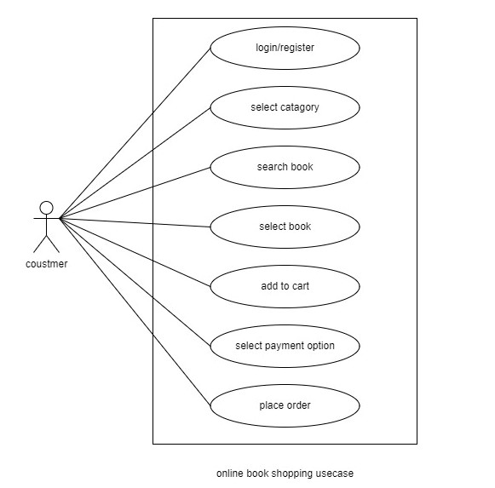

1. Draw Usecase on online bill payment system (paytm)

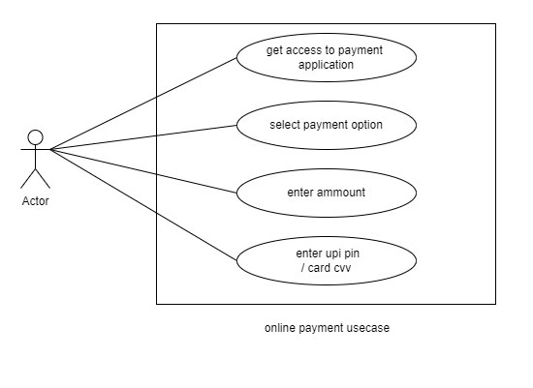

1. Write SDLC phases with basic introduction

Ans- 1-analysis phse:- in this phase the specialist collect requirements from the customer to find solution of their needs.

2- design phase:- in this phase design architecture document, implementation plan, test plan is done.

3- implementation phase:- in this phase the development team start coding according to document and critical error, performance and quality issue can be done.

4- testing phase:- in this phase testing team will start testing according to the test plan regression testing, unit testing, internal testing, application testing, stress testing is done in this phase.

5- Maintenance Phase:- in this phase after deploying the software services provided. After deployment user found a bug or any defect then software company debug it and fix the issue.

There is 3 types of maintenance

1, corrective maintenance 2, adaptive maintenance

3, perfective maintenance

1. Explain Phases of the waterfall model

Ans- 1- requirements collection:- this phase involves understanding what needs to design and what is its function, purpose, etc.

2-system design:- the requirement collection from first phase are studied in this phase and the system design help in specifying hardware and system requirement define.

3- implementation:- in this phase coding start according to document.

4- testing:- in this phase testing team will test the product and try to find bug and finded bug assigned to development team for debugging.

5-maintenance:- in this phase software compny provide service after deploying the product.

1. Write phases of spiral model

Ans- 1, determine objectives and find alternate solutions

2, risk analysis and resolving 3, develop and test

4, review and planning of next phase

1. Write agile manifesto principles

Ans- 1, Individuals and interactions 2, Working software

3, Customer collaboration 4, Responding to change

1. What is join?

Ans- a join is an SQL operation performed to establish connection between two or more database tables based on matching columns, creating relationship between the tables. Most complex queires in an SQL database management system involve join commands.

1. Write type of joins

Ans- there is two types of join

1, inner join 2, outer join

1. Explain working methodology of agile model and also write pros and cons

Ans- agile is a SDLC model it is combination of iterative and incremental model because it break product into small incremental builds.

Agile model focus on process adaptability and client satisfaction by deliver of working software product. Every iteration take one to three weeks to finish it. Agile is most popular and widely used model.

In every iteration multiple people are working on planning, requirement gathering, design, coding, unit testing, acceptance testing.

In the end of iteration you get working product and it can displayed to the client. It is easy to manage and give flexibility to devlopers.

Pros:

Is a realistic approach to software development .

Promotes teamwork and cross training.

Resource requirements are minimum.

Suitable for fixed or changing requirements.

Good model for environments that change steadily.

Good model for environments that change steadily.

Cons;

Not suitable for handling complex dependencies.

More risk of sustainability, maintainability and extensibility.

Depends heavily on customer interaction, so if customer is not clear, team can be driven in the wrong direction.

There is very high individual dependency, since there is minimum documentation generated.

An overall plan, an agile leader and agile PM practice is a must without which it will not work.

1. Draw usecase on Online shopping product using COD

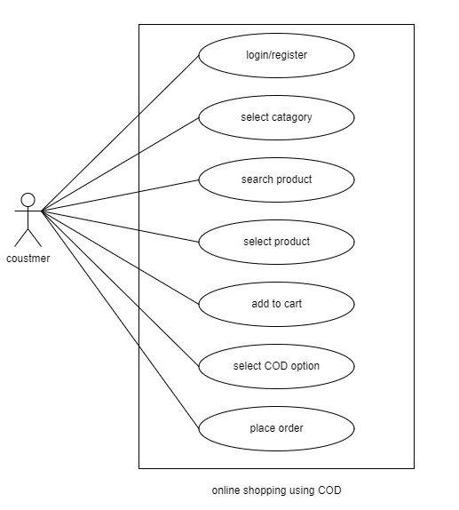

1. Draw usecase on Online shopping product using payment gateway

