ESTIMATING R/C MODEL AERODYNAMICS AND PERFORMANCE

Dr. Leland M. Nicolai, Technical Fellow
Lockheed Martin Aeronautical Company

June 2009

I OVERVIEW

The purpose of this white paper is to enlighten students participating in the SAE Aero Design competition on how to estimate the aerodynamics and performance of their R/C models.

The student needs to understand that the analysis and performance of the R/C model is identical to a full scale airplane such as a Cessna 172. The only differences between the R/C model and the full scale airplane are the wing loading, Reynolds Number and the moments of inertia.

The R/C model wing loading is one to two orders of magnitude less than a full scale airplane (because of the “square-cube law” … look it up). R/C models typically have wing loadings of 1-3 lb/ft² whereas the full scale airplanes are greater than 10 (Cessna 172 is 12.6 lb/ft²). The impact is lower stall speeds and lower take-off and landing distances.

The R/C model will typically have Reynolds Numbers less than 500,000 which gives the wing a predominately laminar boundary layer. Full scale airplanes are greater than one million Reynolds Number and have turbulent boundary layer wings. The impact is that the full scale airplanes have higher maximum lift coefficients due to the turbulent boundary layer delaying flow separation over the wing better than the laminar boundary layer. The R/C models and the full scale airplanes are in a Reynolds Number region where the drag coefficients are about the same.

The R/C model will have much smaller moments of inertia than the full scale airplane. The impact is that the time-to-double-amplitude t₂ from a disturbance will be much shorter for the R/C model since t₂ = fn (1/(moment of inertia)^{½} . The R/C pilot will have his hands full with a neutral or unstable model.

II DEFINITIONS

LIFT: The aerodynamic force resolved in the direction normal to the free stream due to the integrated effect of the static pressures acting normal to the surfaces.

DRAG: The aerodynamic force resolved in the direction parallel to the free stream due to (1) viscous shearing stresses, (2) integrated effect of the static pressures acting normal to the surfaces and (3) the influence of the trailing vortices on the aerodynamic center of the body.

INVISCID DRAG-DUE-TO-LIFT: Usually called induced drag. The drag that results from the influence of trailing vortices (shed downstream of a lifting surface of finite aspect ratio) on the wing aerodynamic center. The influence is an impressed downwash at the wing aerodynamic center which induces a downward incline to the local flow. (Note: it is present in the absence of viscosity)

VISCOUS DRAG-DUE-TO-LIFT: The drag that results due to the integrated effect of the static pressure acting normal to a surface resolved in the drag direction when an airfoil angle-of-attack is increased to generate lift. (Note: it is present without vortices)

SKIN FRICTION DRAG: The drag on a body resulting from viscous shearing stress over its wetted surface.

PRESSURE DRAG: Sometimes called form drag. The drag on a body resulting from the integrated effect of the static pressure acting normal to its surface resolved in the drag direction.

INTERFERENCE DRAG: The increment in drag from bringing two bodies in proximity to each other. For example, the total drag of a wing-fuselage combination will usually be greater than the sum of the wing drag and fuselage drag independent of one another.

PROFILE DRAG: Usually taken to mean the sum of the skin friction drag and the pressure drag for a two-dimensional airfoil.

TRIM DRAG: The increment in drag resulting from the aerodynamic forces required to trim the aircraft about its center of gravity. Usually this takes the form of added drag-due-to-lift on the horizontal tail.

BASE DRAG: The specific contribution to the pressure drag attributed to a separated boundary layer acting on an aft facing surface.

WAVE DRAG: Limited to supersonic flow. This drag is a pressure drag resulting from noncancelling static pressure components on either side of a shock wave acting on the surface of the body from which the wave is emanating.

COOLING DRAG: The drag resulting from the momentum lost by the air that passes through the power plant installation (ie; heat exchanger) for purposes of cooling the engine, oil and etc.

RAM DRAG: The drag resulting from the momentum lost by the air as it slows down to enter an inlet.

AIRFOIL: The two-dimensional wing shape in the X and Z axes. The airfoil gives the wing its basic angle-of-attack at zero lift (α_{OL}), maximum lift coefficient (C_{lmax}), moment about the aerodynamic center (that point where C_{mα} = 0), C_{l} for minimum drag and viscous drag-due-to-lift. Two-dimensional airfoil test data is obtained in a wind tunnel by extending the wing span across the tunnel and preventing the formation of trailing vortices at the tip (essentially an infinite aspect ratio wing with zero induced drag). The 2D aerodynamic coefficients of lift, drag and moment are denoted by lower case letters (ie; C_{l,} C_{d} and C_{m})

REYNOLDS NUMBER: The Reynolds number is a major similarity parameter and is the ratio of the inertia forces to the viscous forces. The equation for Reynolds number is
Re = ρVl/μ
Where ρ = density (slugs/ ft³)
V = flight speed (ft/sec)
L = characteristic length such as wing/tail MAC (mean aerodynamic chord), fuselage length (feet)
μ = coefficient of viscosity (slugs/ft-sec)

III APPROACH

We approximate the aircraft drag polar by the expression

C_{D} = C_{Dmin} + K’C_{L}² + K’’( C_{L} - C_{Lmin})² (1)

The C_{Dmin} is made up of the pressure and skin friction drag from the fuselage, wing, tails, landing gear, engine, etc. With the exception of the landing gear and engine, the C_{Dmin} contributions are primarily skin friction since we take deliberate design actions to minimize separation pressure drag (ie; fairings, tapered aft bodies, high fineness ratio bodies, etc).

The second term in the C_{D} equation is the inviscid drag-due-to-lift (or induced drag) and K’ is the inviscid or induced factor = 1/(π AR e). The e in the K’ factor can be determined using inviscid vortex lattice codes such as AVL. The e for low speed, low sweep wings is typically 0.9 – 0.95 (a function of the lift distribution).

The third term is the viscous drag-due-to-lift where K’’ is the viscous factor = fn(LE radius, t/c, camber) and C_{Lmin} is the C_{L} for minimum wing drag. Both K” and C_{Lmin} are determined from airfoil data.The K’’ term is difficult to estimate (see reference 2, page 11-11) and is often omitted. It is usually determined from 2D airfoil test data and will be discussed in Section IV.

IV SECTION AND WING DATA

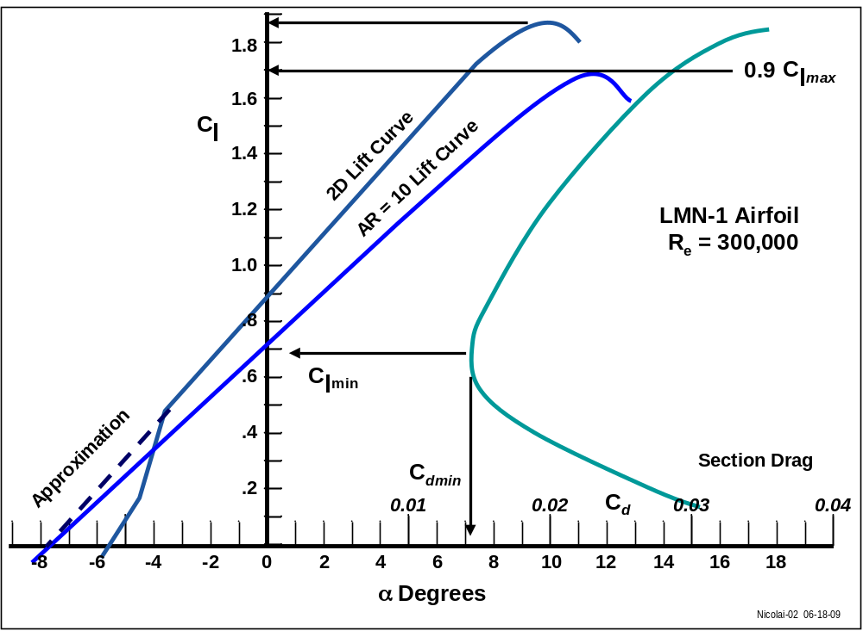
The two dimensional section data needs to be corrected for finite wing effects. These corrections will be discussed below using the notional airfoil (termed the LMN-1) shown in Figure 1. The LMN-1 airfoil is a 17% thick highly cambered shape with its maximum thickness at 35% chord. This airfoil is similar to the shapes used by the SAE Aero Design teams (ie; the Selig 1223, Liebeck LD-X17A, and Wortman FX-74-CL5 1223).

Figure 1 Notional LMN-1 airfoil data at Re = 300,000

The first thing the user needs to check is that the data is for the appropriate Reynolds Number. If we assume an altitude of 3000 ft, standard day conditions and a flight speed of 55 ft/sec, the ρ = 0.002175 slugs/ ft³ , μ = 0.3677x10⁻⁶ slugs/ft-sec the Reynolds Number per ft is 325,000. Thus the airfoil data of Figure 1 will be good for a wing having a chord of about one foot.

From the airfoil data in Figure 1 the section C_{lmax} = 1.85 can be determined for a 2D α_{stall} = 10°. Notice that the airfoil has a nasty inverted stall at α ≈ -2.5° (ie; the lower surface is separated). Since we do not plan on operating at negative α this is OK. Notice also that the linear lift curve slope has been approximated to an α_{OL} = -8° on Figure 1.
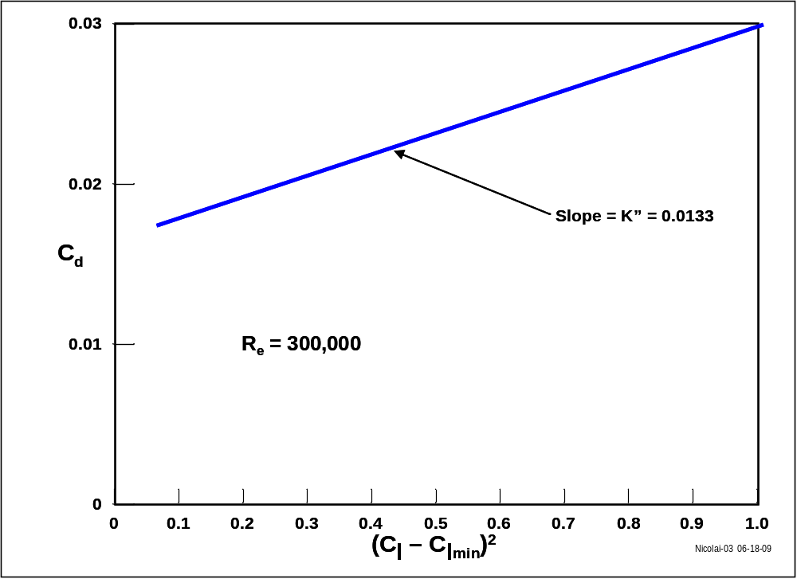
The section lift data needs to be corrected for 3D, finite wing effects. The low speed unswept finite wing lift curve slope is estimated as follows for AR > 3 (see Reference 1, page 264 or Reference 2, page 8):

dC_{L}/dα = C_{Lα} = C_{lα} AR/(2 + (4 + AR²)^{½}) (2)

where C_{lα} = section lift curve slope (typically 2π per radian)
and AR = wing aspect ratio = (span)²/wing area

Figure 1 shows the construction of a three dimensional AR = 10 wing lift curve using the 2D and the section lift curve slope. The α_{OL} is an anchor point for constructing the 3D wing lift characteristics since at α_{OL} the lift is zero and there is no correction to the 3D lift curve for the trailing vortices. Estimate the 3D wing lift curve slope for the model aspect ratio using equation 2 and draw it on the C_{l} vs a. For large AR (ie; AR > 5) low speed, unswept wings, the wing C_{Lmax} ≈ 0.9 C_{lmax} = 1.67 (Reference 2, page 9-15). The 3D α_{stall} is approximated using the 2D stall characteristics and is about 11.5º.

The section drag polar data is used to estimate the following wing data:

C_{Lmin} ≈ C_{lmin} = 0.7

C_{Dmin} ≈ C_{dmin} = 0.0145

and the wing viscous drag-due-to-lift factor K’’ = 0.0133 as shown on Figure 2.

Figure 2 Viscous drag-due-to-lift factor for the LMN-1 airfoil

V ESTIMATING MODEL DRAG

As mentioned earlier we will approximate the aircraft drag polar by the expression

C_{D} = C_{Dmin} + K’C_{L}² + K’’(C_{L} - C_{Lmin})² (1)

The C_{Dmin} term is primarily skin friction and the data on Figure 3 will be used in its estimation. The boundary layer can be one of three types: laminar, turbulent or separated. We eliminate the separated BL (except in the case of stall) by careful design. For Re < 10⁵ the BL is most likely laminar. At a Re = 5x10⁵ the BL is tending to transition to turbulent with a marked increase in skin friction. By Re = 10⁶ the BL is usually fully turbulent. Notice that our model Re is right in the transition region shown on Figure 3.
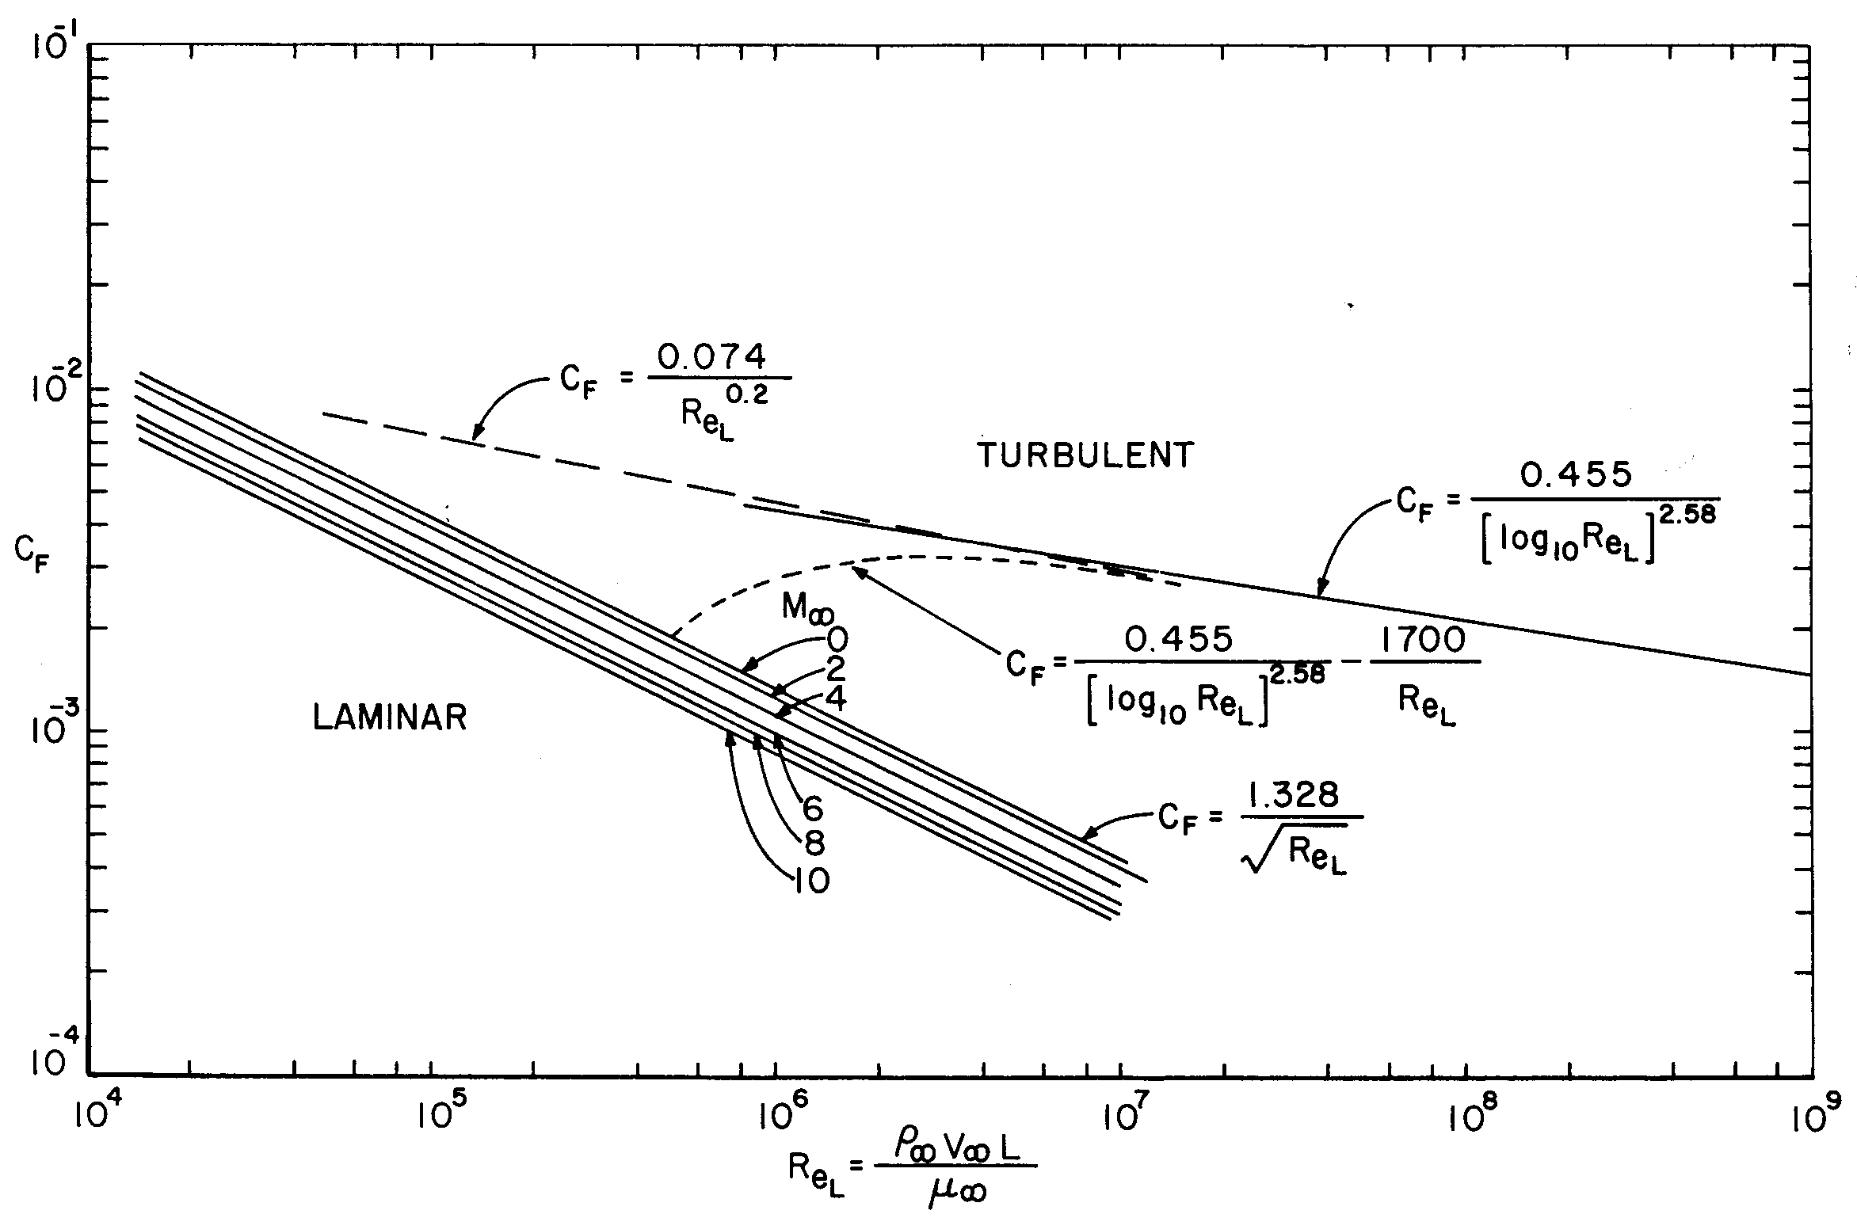

Figure 3 Skin friction coefficient versus Reynolds Number

We will demonstrate the methodology by estimating the drag of a notional R/C model with the following characteristics:

Configuration: Fuselage/payload pod with a boom holding a horizontal and vertical tail.
Fuselage/boom length = 84 in,
Fuselage length = 25 in, Fuselage width = 5 in
Wing AR = 10, Wing taper = 0.5
Wing area = S_{Ref} = 1440 in² = 10 ft² (total planform area)
Wing span = 120 in
Landing gear: tricycle
Take-off weight w/o payload = 12 lb

Item Planform Wetted Reference
Area Area Length
(in²) (in²) (in)
Fuselage 151 605 25
Engine /mount 15 100 na
Horiz Tail 126 252 7 (MAC)
Tail Boom 14 28 48 + fuselage
Landing gear 12 24 na
Wing (exposed) 1360 2720 12.4 (MAC)
Vert Tail 0 189 9.8 (MAC)

The drag coefficients for the model components are estimated as follows (all based on S_{Ref} = 10 ft² ).

Fuselage
Re = 625,000, assume BL is turbulent

Fuselage C_{Dmin} = FF_{F} C_{f} S_{Wet}/S_{Ref} (3)

Where FF is a form factor (Reference 1, pg 281 or Reference 2, page 11-21) representing a pressure drag contribution. Form factors are empirically based and can be replaced with CFD or wind tunnel data. S_{Wet} is the wetted area of the component (fuselage) and the C_{f} is the skin friction coefficient of the component (fuselage) determined from Figure 3.

FF_{F} = 1 + 60/(FR)³ + 0.0025 FR (4)

For our model the FR = fuselage fineness ratio = fuselage length/diameter = 25/5 = 5 giving a FF_{F} = 1.49 and a fuselage C_{Dmin} = 0.0032

Wing
Re = 310,000

Wing C_{Dmin} = FF_{W} C_{f} S_{Wet}/S_{Ref} (5)

Where FF_{W} = [1 + L(t/c) + 100(t/c)⁴] R (6)
and L is the airfoil thickness location parameter (L = 1.2 for the max t/c located at ≥ 0.3c and L = 2.0 for the max t/c < 0.3c)and R is the lifting surface correlation parameter. Thus L = 1.2. R is determined from Reference 1, page 281 or Reference 2, page 11-13. For a low speed, unswept wing R is approximately 1.05.

Since a wing Re = 310,000 could be either laminar or turbulent, we will calculate the minimum drag coefficient both ways and compare with the section C_{dmin} = 0.0145 (from Figure 1).

If the BL is laminar, the wing C_{f} = 0.00239 and wing C_{Dmin} = 0.0057.
If the BL is turbulent, the wing C_{f} = 0.0059 and wing C_{Dmin} = 0.014.
Thus the wing boundary layer must be turbulent and we will use wing C_{Dmin} = 0.0145.

Horizontal Tail
The Re = 175,000, therefore we’ll assume the BL is laminar. The tail (both horizontal and vertical) C_{Dmin} equation is the same as for the wing. For a t/c = 0.09 airfoil with L = 1.2 and R = 1.05, the horiz tail C_{Dmin} = 0.00046.

Vertical Tail
The Re = 245,000, therefore assume the BL is laminar. For a t/c = 0.09 airfoil with L = 1.2 and R = 1.05, the vert tail C_{Dmin} = 0.00039.

Tail Boom
The reference length for the tail boom is the fuselage length plus the boom length since the BL will start on the fuselage and continue onto the boom. Thus the tail boom Re = 1.825x10⁶ and the BL is turbulent. Thus
Tail Boom C_{Dmin} = 1.05 C_{f} S_{Wet}/S_{Ref} = 0.00009.
Where the factor 1.05 accounts for tail/boom interference drag.

Landing Gear
From Reference 3, page 13.14 a single strut and wheel (4 inch diameter, 0.5 inch wide) has a C_{Dmin} = 1.01 based upon frontal area. Thus the tricycle gear C_{Dmin} = (3)(1.01)(2)/1440 = 0.0042 based upon the wing reference area..

Engine
From Reference 3, page 13.4, Figure 13 the engine C_{Dmin} = 0.34 based upon frontal area. For a 6 in² frontal area the engine C_{Dmin} = 0.002 based upon the wing reference area..

Total C_{Dmin}
The total C_{Dmin} is the sum of all the components. Thus the total model
C_{Dmin} = 0.02484 based upon a wing reference area of 10 ft² .

Note #1: As a sanity check of our C_{Dmin} we compare it with a Cessna 172 which has a C_{Dmin} = 0.026 based upon a wing reference area of 175 ft² .

Note #2: The wing is the largest drag item due to its large wetted area. However the second largest drag item is the landing gear which is the case for all full scale airplanes. This drag can be cut in half by putting wheel fairings over the wheels. Is it surprising that airplane designers go to the trouble of designing retractable landing gears?

Total Drag Expression

Assuming a wing efficiency e = 0.95 gives an induced drag factor
K’ = 1/(π AR e) = 0.0335. Notice that the often omitted viscous drag factor K’’ = 0.0133 is 40% of the induced drag factor. The total drag expression is

C_{D} = 0.02484 + 0.0335C_{L}² + 0.0133(C_{L} – 0.7)²

The untrimmed (neglecting the horizontal tail drag-due-to lift) model drag polar and L/D are shown on Figure 4.

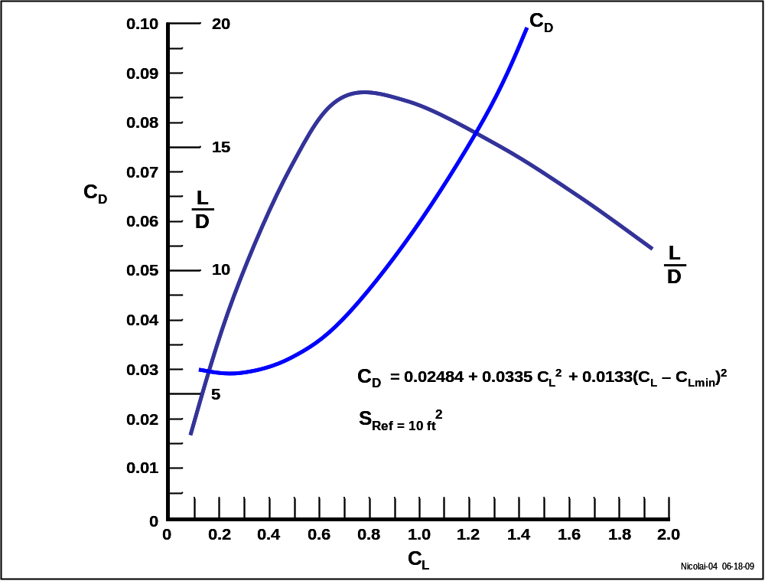

Figure 4 Notional model aircraft total drag polar and L/D

VI ESTIMATING PERFORMANCE

Takeoff

The takeoff ground roll distance S_{G} is the distance required to accelerate from
V = 0 to a speed V_{TO}, rotate to 0.8 C_{Lmax} and have L = W. The 0.8 C_{Lmax} is an accepted value to allow some margin for gusts, over rotation, maneuver, etc.

Assuming a W = 45 lb (12 lb model and 33 lb payload), altitude = 3000 feet (standard day) and a C_{Lmax} = 1.67 (from Figure 1) gives the following V_{TO}

V_{TO} = [2 W/(S ρ 0.8 C_{Lmax})]^{½} = 55.65 ft/sec = 38 mph

The takeoff acceleration will vary during the ground roll and is given by the following expression (see discussion in Reference 2, Chapter 10)

a = (g/W)[(T – D) - F_{C} (W – L)] (7)

where g = gravitational constant = 32.2 ft/sec² and
F_{C} = coefficient of rolling friction = 0.03 (typical value for a Cessna 172 on an average runway).

Note: A useful ground test is to measure the coefficient of rolling friction for your airplane. The testing is fairly simple using a fish scale to measure the rolling force for different loading conditions. The value for F_{C} can increase dramatically if the landing gear is damaged, the wheels do not track straight or the take-off is in tall grass. The landing gear needs to be sturdy with large diameter wheels.

A useful expression for the ground roll distance S_{G} is given by the equation (from reference 2, page 10-7)

S_{G} = V_{TO}²/(2 a_{mean}) (8)

where a_{mean} = acceleration at 0.7 V_{TO}

Using the notional model aircraft with the wing at 0º angle of incidence (α for minimum drag during the ground run) and data from Figures 1 and 4 gives

Ground roll C_{L} = 0.7 (from Figure 1)

Ground roll C_{D} = 0.0412 (from Figure 4)

C_{LTO} = 1.34 @ α = 7° (0.8 C_{Lmax} )

The static thrust available is assumed to be 20 lb. This thrust will degrade with forward speed as shown on Figure 5. The data scatter represents measurements by different SAE Aero Design teams.
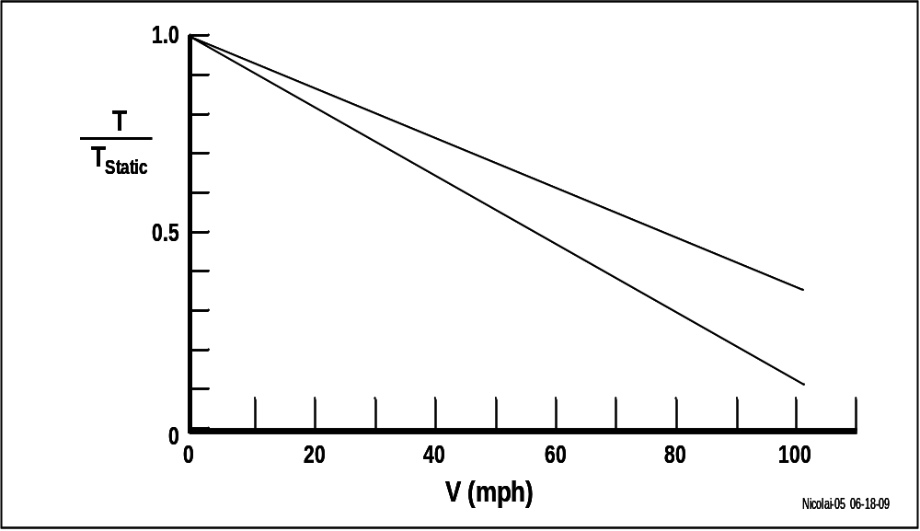

Figure 5 Thrust variation with forward speed for a fixed pitch prop

A static thrust of 20 lb gives an S_{G} = 151 feet. It is useful to examine the different pieces of this ground roll distance. The mean acceleration is

acceleration @ 0.7 V_{TO} = (32.2/45)[ 20(0.8) – 0.68 – 1.02] = 10.25 ft/sec²

Notice that the ground roll drag (0.68 lb) and the rolling friction force (1.02 lb) are overwhelmed by the available thrust force. If the static thrust was reduced by 20% to 12 lb then S_{G} = 210 feet. Thus the critical ingredient to lifting a certain payload is having sufficient thrust to accelerate to V_{TO} in less than 200 feet and having a large useable C_{Lmax} so that V_{TO} is small. Having a headwind will reduce V_{TO} which has a significant effect on S_{G} due to the square of the V_{TO} in the S_{G} equation.

After the ground roll, the aircraft rotates to 0.8 C_{Lmax} = 1.34 and lifts off. Note that this rotation will take a certain distance (typical rotation time is 1/3 second) and is part of the 200 feet takeoff distance limit. After liftoff the model accelerates and climbs to a safe altitude where the α is reduced to ~ 0° (C_{L} = 0.7) and the power reduced for a steady state L = W, T = D cruise.

Bottom line for the notional model in this white paper is a max payload of about 33 lb for a no wind takeoff at 3000 feet standard day.

Maximum Level Flight Speed

The maximum level flight speed occurs when T = D at L = W as shown on Figure 6. For the notional model at L = W = 45 lb and 3,000 ft altitude the maximum speed is 144 ft/sec or 98 mph where T = D = 6.6 lb.

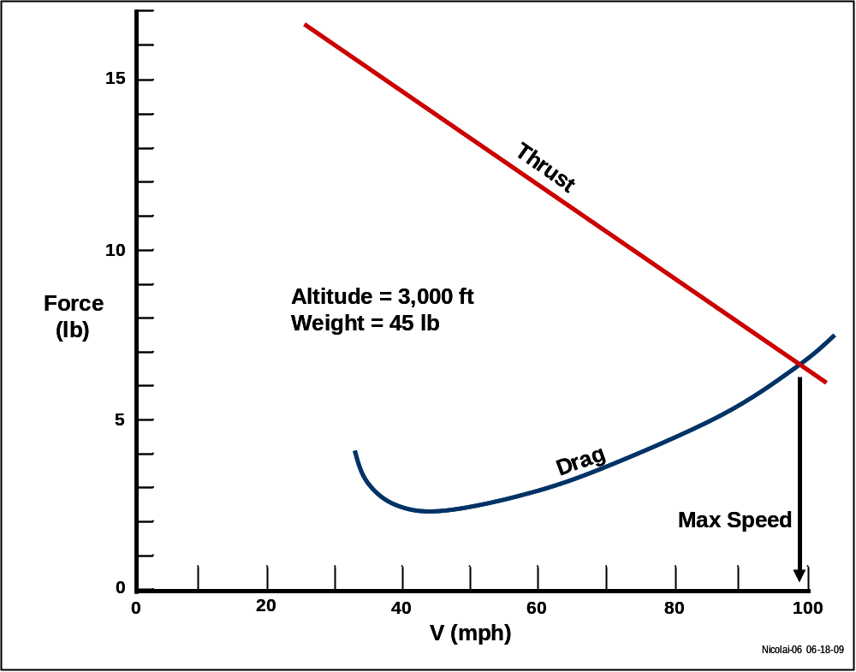

Figure 6 Thrust available Vs required (drag)

VII REFERENCES

- Raymer, Daniel P, “Aircraft Design: A Conceptual Approach”, AIAA, Reston, Va, 1992
- Nicolai, Leland M., “Fundamentals of Aircraft Design”, METS Inc, 6520 Kingsland Ct, San Jose, Ca 95120, 1975 (Reference 6 is a rewrite of this reference)
- Hoerner, Sighard F., ”Fluid Dynamic Drag”, 148 Busteed Dr, Midland Park, NJ, 1958
- Abbot, Ira H. and Von Doenhoff, Albert E., “Theory of Wing Sections”, Dover Publications, New York, NY, 1959
- Selig, Michael, “Summary of Low Speed Airfoil Data: Volume 2”, SoarTech Publications, 1996
- Nicolai, Leland M. and Carichner, Grant, “Fundamentals of Aircraft and Airship Design, Volume I, Aircraft Design”, AIAA, Reston, Va, 2010

