SDD

Index:

|  |  |  |
| --- | --- | --- |
| Sr.No. | Title | Page No. |
| 1 | Project Name | 1 |
| 2 | Use Case Name | 1 |
| 3 | Name of Stack Holder | 1 |
| 4 | Portfolio | 1 |
| 5 | Team Name | 1 |
| 6 | Description | 1 |
| 7 | AS IS Flow | 1 - 2 |
| 8 | To Be Flow | 2 |
| 9 | Flow Diagram | 2 |
| 10 | Exception | 3 |
| 11 | Success Criteria | 3 |
| 12 | Type of Logs | 4 |
| 13 | Date of Testing | 5 |
| 14 | Date of Deployment | 5 |
| 15 | Efforts Saved | 5 |

**Project Name**: Kroger

**Use Case Name**: Removing Associated from Gem store

**Name of Stack Holder**: Rupesh Raman <rupeshkumar.raman@kroger.coms>

**Portfolio**: MX

**Team Name**: Jewelry

**Description:** Jewelry team getting the user incidents for removing the associates from the Stores. Details of user and store Id is mentioned in Incident itself, they are taking the user details from incident and removing the associates from the store and verifying from salesforce data file.

**AS IS Flow:**

1. Go to service now and take the store ID and user’s first name and last name from work note.
2. Go to **PCMS** portal and find the EUID’s of user with the help of first name and last name.
3. Go to this link [**Jewelry POS (Point Of Sale) - DCP - Confluence (kroger.com)**](https://nam12.safelinks.protection.outlook.com/?url=https%3A%2F%2Fconfluence.kroger.com%2Fconfluence%2Fpages%2Fviewpage.action%3FpageId%3D282078081&data=05%7C01%7Cdivya.sisodiya%40kroger.com%7C6c8f3c8ffcc84a32fb2608da9a42969d%7C8331e14a91344288bf5a5e2c8412f074%7C0%7C0%7C637991908048028256%7CUnknown%7CTWFpbGZsb3d8eyJWIjoiMC4wLjAwMDAiLCJQIjoiV2luMzIiLCJBTiI6Ik1haWwiLCJXVCI6Mn0%3D%7C3000%7C%7C%7C&sdata=LveqvYv98O0atCbqSLmIZnv2%2BlBdCDveHF%2Ft70Hculg%3D&reserved=0) then login with user id and password and then we redirect to Fred Meyer page which is jewelry support site then click on perform task tab then scroll down and click on remove employee, after that choose Production as the environment and fill store-Id and associate EUID, there we can add more than one associate while clicking the additional EUID , then we remove the associate from gem-store.
4. Go to **data distribution** portal and requesting the cache for the same store which we have removed associates.
5. Then we check the associate is removed or not from the gem store with help of salesforce bat file.

**To Be Flow:**

1. MonitorJewelry queue and fetch the latest incident which belong to our use case description criteria with the help of service now API.
2. With the help of incident number fetch the user EUID and store details.
3. Go to this link [**Jewelry POS (Point Of Sale) - DCP - Confluence (kroger.com)**](https://nam12.safelinks.protection.outlook.com/?url=https%3A%2F%2Fconfluence.kroger.com%2Fconfluence%2Fpages%2Fviewpage.action%3FpageId%3D282078081&data=05%7C01%7Cdivya.sisodiya%40kroger.com%7C6c8f3c8ffcc84a32fb2608da9a42969d%7C8331e14a91344288bf5a5e2c8412f074%7C0%7C0%7C637991908048028256%7CUnknown%7CTWFpbGZsb3d8eyJWIjoiMC4wLjAwMDAiLCJQIjoiV2luMzIiLCJBTiI6Ik1haWwiLCJXVCI6Mn0%3D%7C3000%7C%7C%7C&sdata=LveqvYv98O0atCbqSLmIZnv2%2BlBdCDveHF%2Ft70Hculg%3D&reserved=0) then login with user id and password and then we redirect to Fred Meyer page which is jewelry support site then click on perform task tab then scroll down and click on remove employee, after that choose Production as the environment and fill store-Id and associate EUID, there we can add more than one associate while clicking the additional EUID , then we remove the associate from gem-store with the help of selenium.
4. Go to data distribution portal and requesting the cache for the same store which we have removed associates.
5. Add incident details, user detail, store Id in Incident Fetch for automation table in DB.
6. Monitor Incident Fetch for automation table in every **10 minutes** which contain **Cache Requested** in details column.
7. Go to data distribution portal and verify the requested cache for the same store id
   1. if it contains **Successfully Received and Applied** then check the time of cache requested, if time is after of removed employee then close the incident with appropriate work note and send the closer mail to respective team with details of incident number, store Id and user details and add task details in summary table.
   2. if it does not contains **Successfully Received and Applied** then check the time when we removed associates
      1. if difference between current time and cache requested time is more than 40 min then add appropriate work note in service now incident and send a re-assign mail to respective team with details of incident number, store Id and user details and add task details in summary table.
      2. if difference between current time and cache requested time is less than 40 min then again request a cache for the same store Id in data distribution portal and update the details in incident fetch for automation table.

**Flow Diagram:**

1. **Remove Associates from Gem store:**

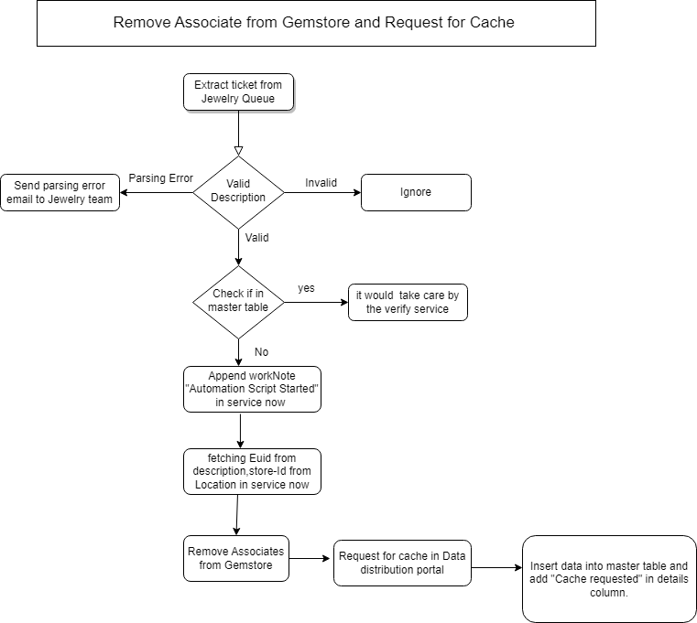

1. **Verify Cache from Data distribution Portal:**

**Exception:**

**1**.This is a user incident so if we did not get the appropriate description and details of user then we send a parsing exception mail to respective team**.**

**2.** Due to some reason we failed to send a mail to respective team.

**Success Criteria:**

1. Associate removed successfully from gem store and Cache also requested and verified successfully from Data distribution portal.
2. Incident successfully closed from service now portal.
3. Email sent successfully to respective team for closer or re-assign of incident.

**Type of logs:**

1. Logging the incident details and user details in DB.
2. Logging Execution of task in DB either of success or failure.

**Date of Testing:**

**Date of deployment in Production:**

**Effort Saved:** 1.6667