**Simple Queries**

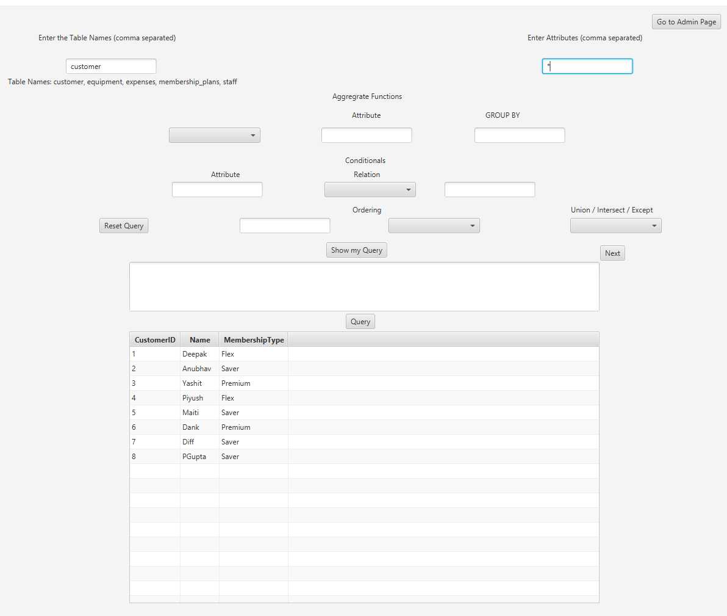

Query **SELECT * FROM customer**

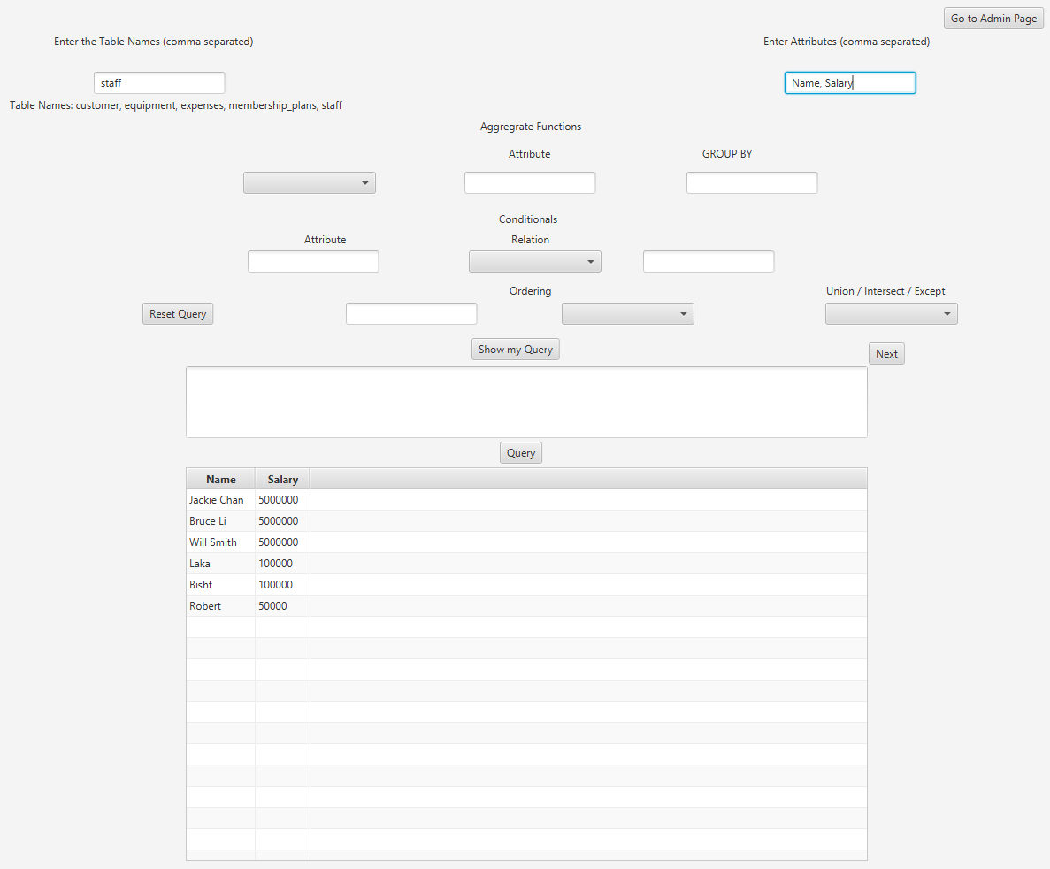

QUERY **SELECT Name, Salary FROM staff**

**Input**

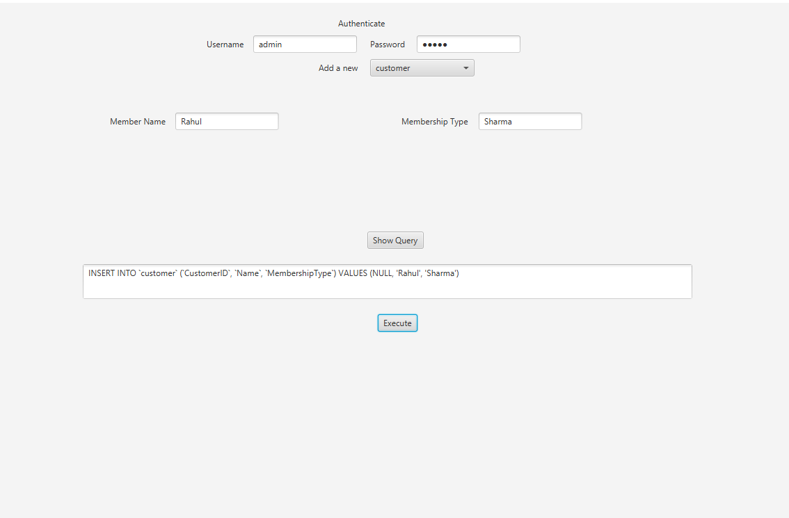

**Output**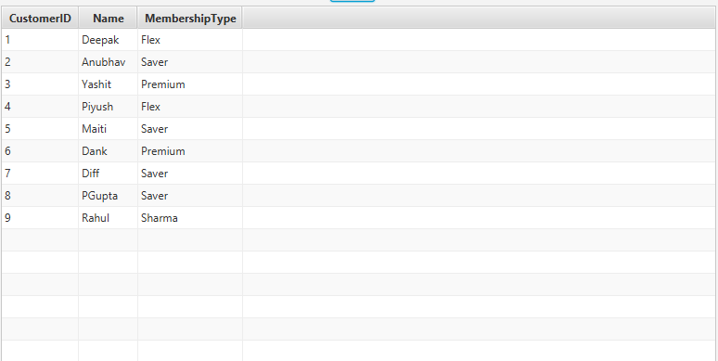

**Rahul Sharma Added**

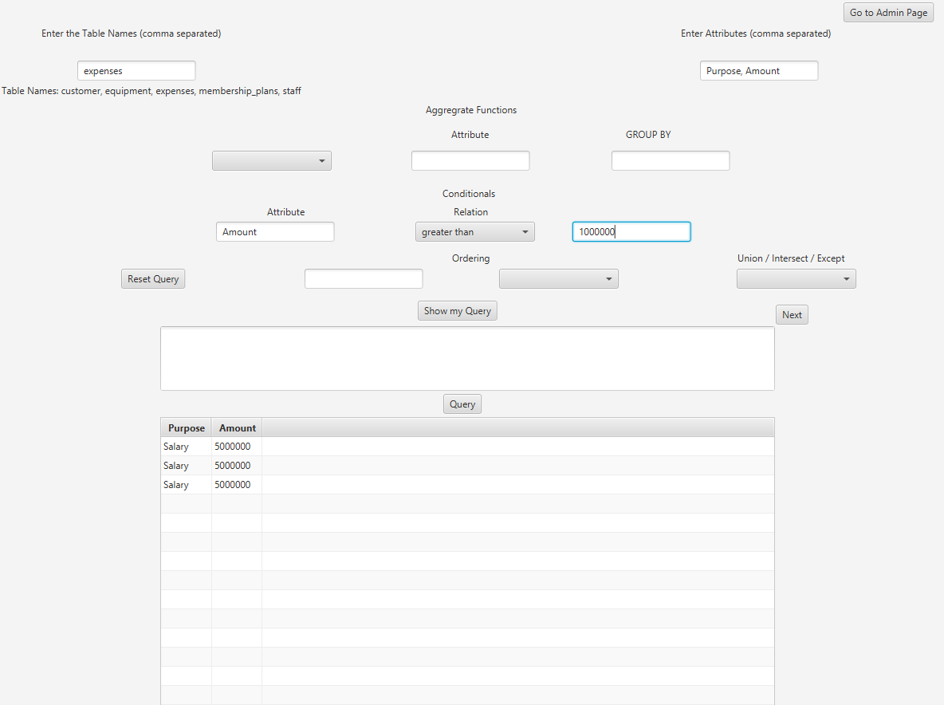

Query **SELECT Purpose, Amount FROM expenses WHERE Amount > 1000000**

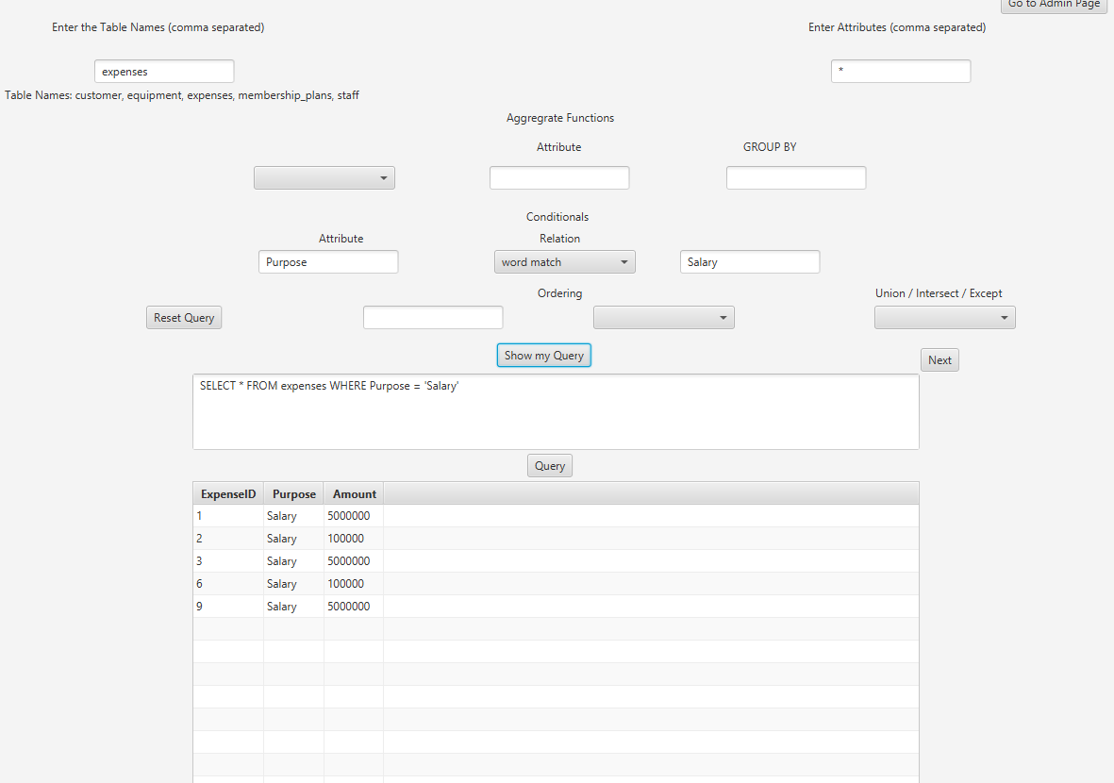

Query **SELECT * FROM expenses WHERE Purpose = 'Salary'**

Apart from these the following also work:

Greater Than

Less Than

Like

Equal To

Matching a substring

**Complex Queries**

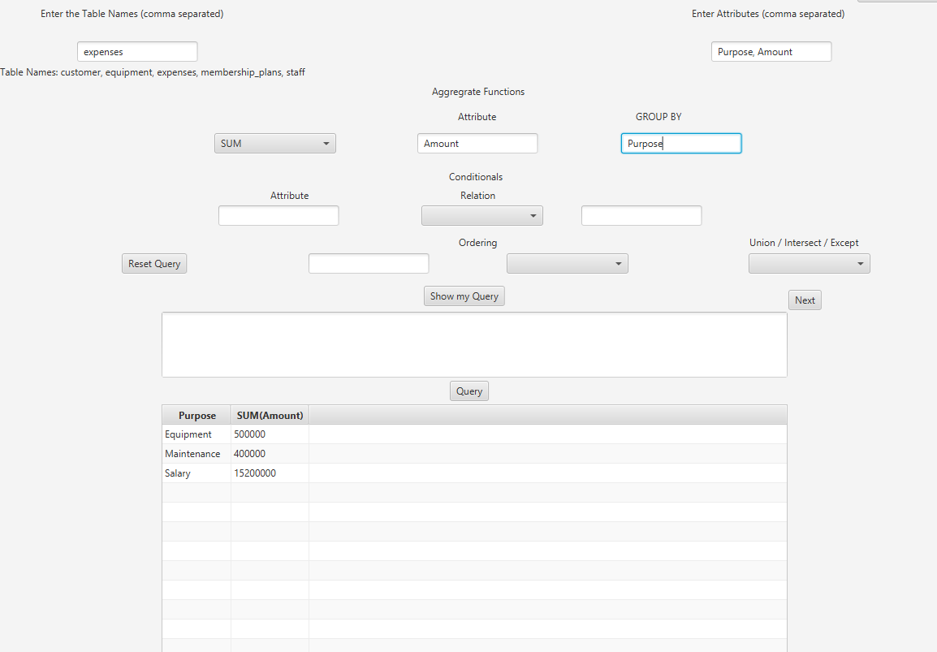

SELECT Purpose, SUM(Amount) FROM expenses GROUP BY Purpose

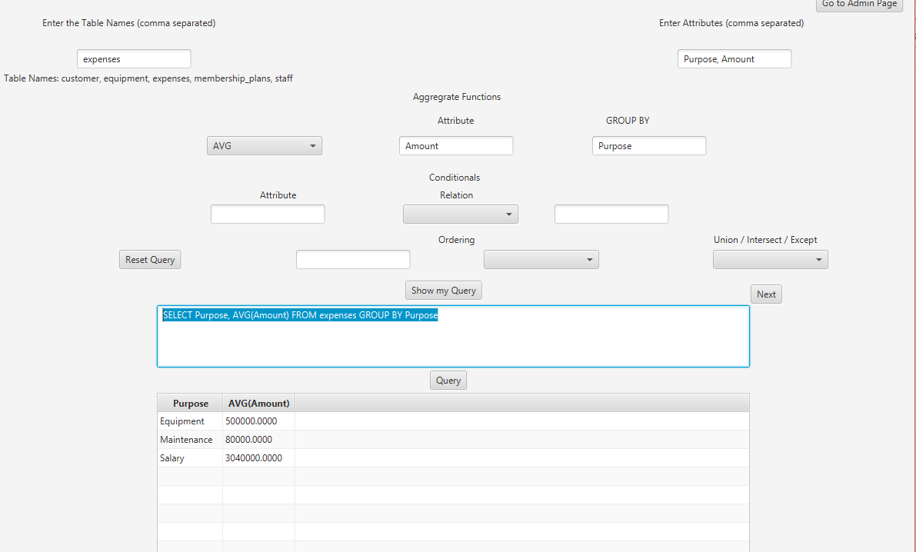

SELECT Purpose, AVG(Amount) FROM expenses GROUP BY Purpose