Payments Module Screen Designs - Sprint 1

This document provides the screen designs for the Payments module.



Contents

Table of Contents 2

Payments Search 3

Screen Design 3

Payments Screen 4

Screen Design 4

Payments Transaction Details 5

Payment Details 6

Card and Bank Maintenance 7

Screen Design 7

Remote Authorisation 8

Screen Design 8

# Payments Search

## Screen Design

The User should be able to

* Select a date range for orders/agreements created
* Search by Order Number Whats this? Need more details This is the Sales Order number which will be generated from Sales before an account number is assigned.
* Search by Customer First/Last Name
* Search by Customer ID
* Search by Customer Account Number
* Search by Agreement number what is an Agreement number? Don’t understand. This is an agreement number, like the sub RF number. Currently we have lots and lots of account numbers, under the new design we will have 1 account number and each credit agreement will have an agreement number.

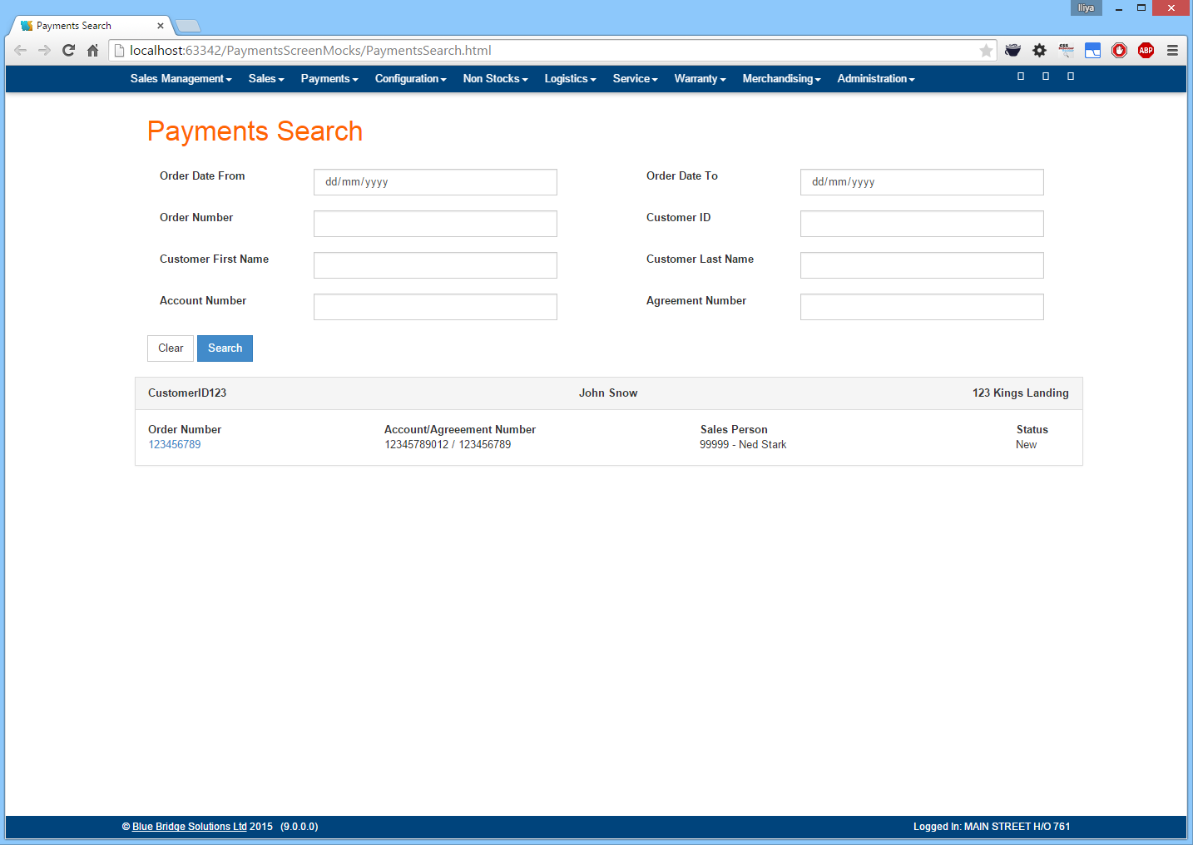

# Payments Screen

## Screen Design

Once the user select the relevant order/agreement/customer he will be taken to the Payments screen

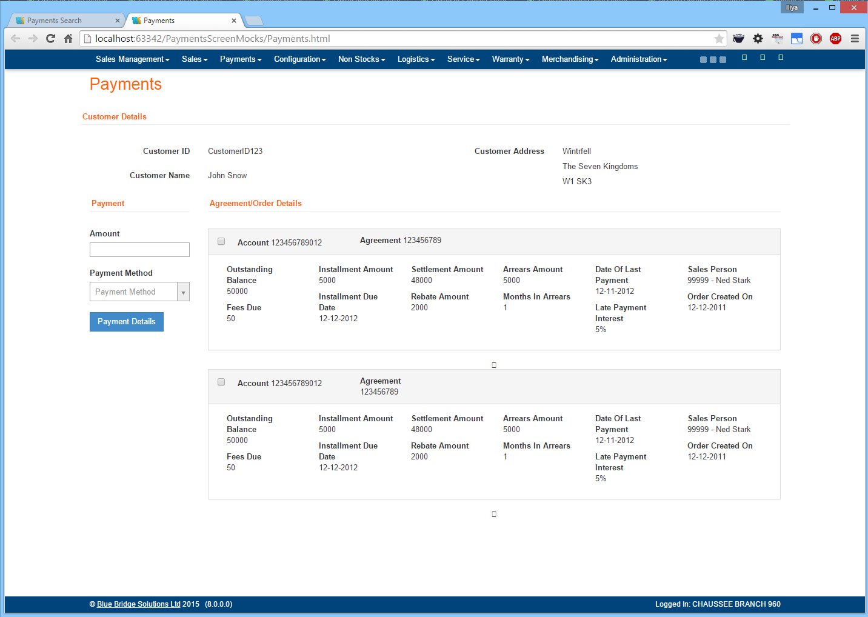

Late payment Interest should be an amount and not a % Noted

There should be an indicator to say that the account is with a Collector/Bailiff Noted

Need Delivery date Noted

Need agreement total Noted

If partial delivery, need to show To Follow amount Noted

Don’t need sales person will remove

What does the Payment Details button do? It allows you to take the payment. Not great wording, we will change to ‘take payment’, unless you have any further suggestions?

Can the Cashiers see line items by accessing this via a button? No currently we hadn’t added line items? Do they need this? I assume currently they must go to account details for this information

When the payment is made will the system show how much is allocated to Fee, Late Interest and the account balance? YEs

The screen will show

* Customer Personal Details
* All relevant agreements to the customer
* Details about each agreement/order
* Allow the user to select as many agreements/orders on which the customer wants to make a payment
* Enter the amount the customer wishes to pay
* Select the payment method

## Payments Transaction Details

Each of the Agreements/Orders shown will be expandable showing all the relative transactions

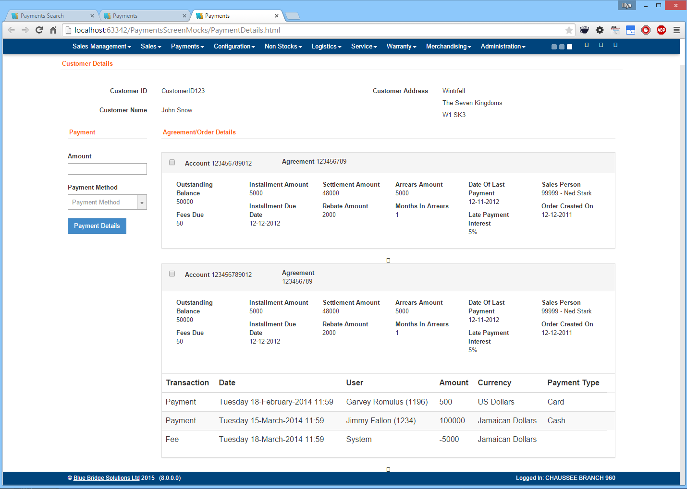

## Payment Details

Once the user clicks on the Payment Details button a pop-up with the relative details (based on the payment method) will be shown

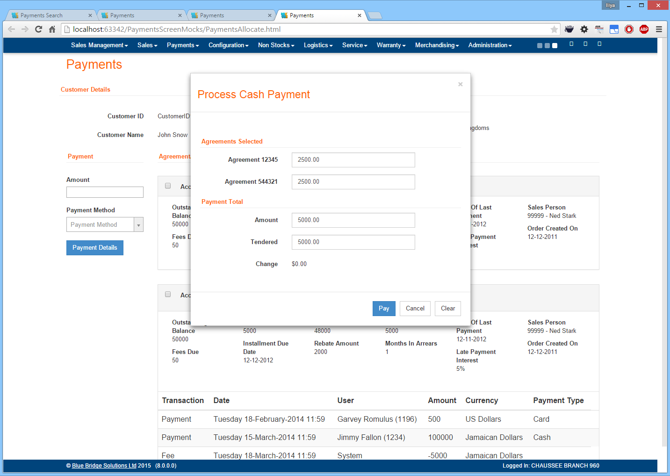

* Initially the system will divide the amount the user entered proportionally onto all selected agreements.
* These amounts will be left editable in case the user wishes to make any adjustments
* Upon clicking the Pay button the payment will be processed and a receipt printed
* System to allow for multiple pay methods on the account Noted.

# Card and Bank Maintenance

## Screen Design

The User should be able to

* Add/Remove Card types accepted by the store. Store, would it better at Facia?
* Add/Remove Banks the store works with and the effective date

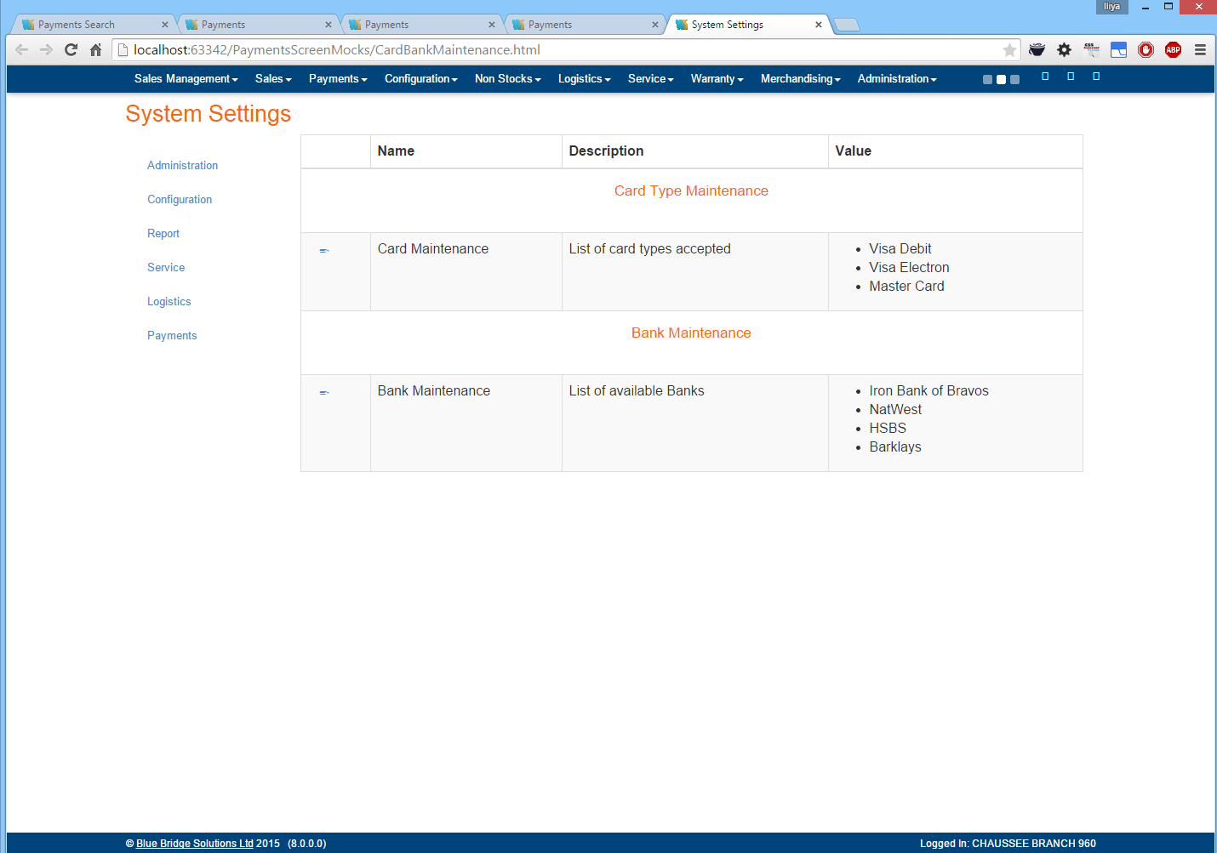

# Remote Authorisation

## Screen Design

The User should be able to

* Add/Remove the remote authorisation links assigned to each branch. Will make this clearer

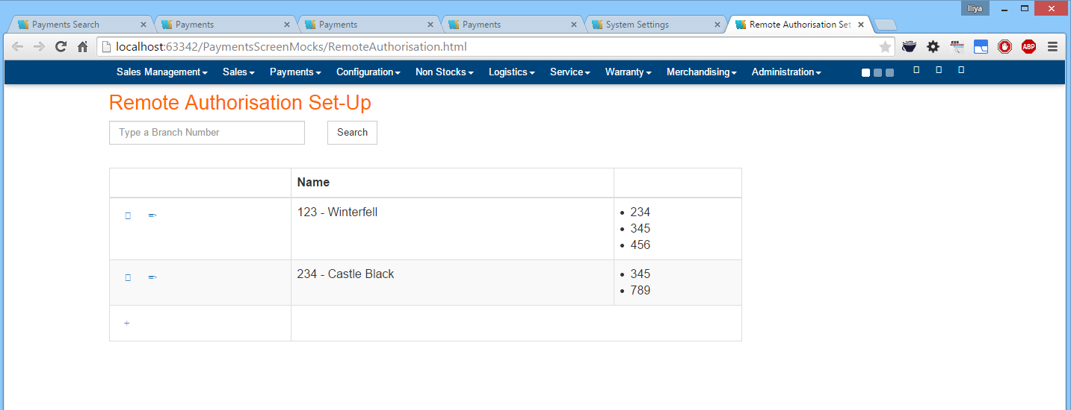

In the above examples users in branch 123 will be able to request authorisation from supervisors logged into branches 234, 345 and 456