I would definitely recommend k-nearest neighbours with any k value 13 to 26 as the maximum accuracy above 70% is achieved using these values. Also as the outputs are classes and not continuous data, neural networks is not much of use here.

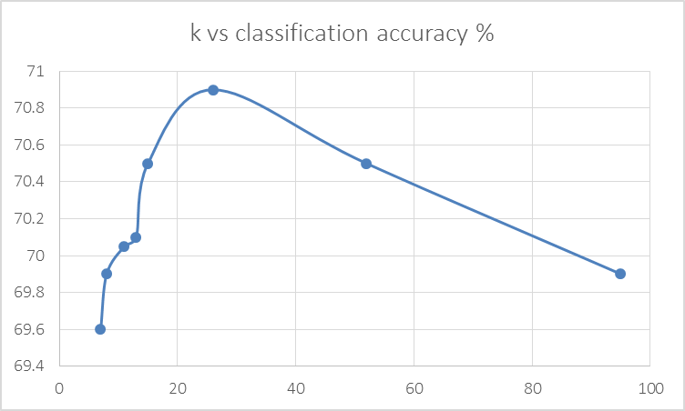Here are my accuracy % values for different combinations of designs

K –nearest neighbours

K=>accuracy%

7 => 69.6 | 8 => 69.9 | 11 => 70.05 | 13 => 70.1 | 15 => 70.5 | 26 =>70.9 | 52 => 70.5 | 95 => 69.9

Neural Networks

No. of hidden layers = 1

Hidden layer neuron count = mean (input dimensions, output dimensions) => 96

Classification accuracy =?

Ran out of memory on my system