DATA VORTEX — Round 1, Phase 1
Exploratory Data Analysis and Data Recovery Report
Theme: Rebuilding the Social Engine

1. Objective
Round 1 Phase 1 requires restoring the Social Engine intake pipeline from a deliberately corrupted social-media dataset. This report covers cleaning, missing-value handling, anomaly identification, and exploratory analysis with plots. Missing fields are not invented. Values are computed from db1.csv (users) and db2.csv (posts), matching DataVortexEDAR1.ipynb.

2. Datasets
Dataset | File | Role | Rows | Columns
Dataset 1 — posts | db2.csv | Post / content events | 12,360 (raw) | 8
Dataset 2 — users | db1.csv | Account profiles | 1,500 (raw) | 5

Post fields: post_id, user_id, platform, text_content, timestamp, likes, shares, comments.
User fields: user_id, location, language, account_created, follower_count.
After duplicate removal, 12,000 unique posts remain. All 12,000 join to a user (100.0%). Every one of the 1,500 users has at least one post (minimum 1, maximum 22, mean 8.00). There are no orphan posts and no unused user profiles.

3. Data quality

3.1 Missing values — posts (raw, n = 12,360)
Column | Missing count | Missing % | Notes
post_id | 0 | 0.00% | Complete identifier
user_id | 0 | 0.00% | Complete foreign key
platform | 1,846 | 14.94% | No source to infer platform
text_content | 1,746 | 14.13% | Text cannot be reconstructed
timestamp | 0 | 0.00% | Present but mixed encodings
likes | 1,858 | 15.03% | Separate from 525 negative likes
shares | 0 | 0.00% | Complete
comments | 0 | 0.00% | Complete

3.2 Missing values — users (raw, n = 1,500)
Column | Missing count | Missing %
user_id | 0 | 0.00%
location | 0 | 0.00%
language | 0 | 0.00%
account_created | 0 | 0.00%
follower_count | 0 | 0.00%

Inference: corruption is concentrated in the post table (platform, text, likes). The user table is complete and can be used as a lookup without row drops.

4. Anomalies and recovery actions
Issue | Finding | Action | Justification
Duplicate post IDs | 360 extra rows; 12,000 unique of 12,360 | Drop duplicate post_id, keep first | post_id is the record key
Conflicting duplicates | 0 groups with differing content | None beyond de-duplication | The 360 extras are exact copies
Negative likes | 525 rows (4.25% of raw posts) | Set likes to missing | Counts cannot be negative
Negative shares / comments | 0 / 0 | None | Valid as received
Missing platform | 1,846 raw; 1,784 after de-duplication | Keep as missing | Cannot infer without guessing
Missing text | 1,746 raw; 1,688 after de-duplication | Keep as missing | Body cannot be reconstructed
Missing likes | 1,858 raw (15.03%) | Keep as missing | Fill would fabricate engagement
Mixed timestamps | 4,950 ISO; 3,788 Unix; 3,622 DD-MM-YYYY | Parse to one datetime | Valid encodings of the same field
HTML entities | 341 posts | html.unescape | Formatting recovery
HTML tags | 663 posts | Strip tags; <br> to space | Markup cleanup
UTF-8 / Latin-1 mojibake | 316 posts | Repair reversible cases | Encoding correction

4.1 Assumptions
1. post_id uniquely identifies a post. Duplicate IDs are repeated records.
2. Negative engagement is invalid, not a coded special value.
3. Missing platform, text, and likes stay missing.
4. Timestamp standardisation unifies representation only.
5. HTML and reversible mojibake repair restore formatting, not new content.
6. user_id is a stable join key.

5. Cleaning outcome
Step | Before | After
Posts | 12,360 rows | 12,000 unique posts
Users | 1,500 rows | 1,500 rows (none removed)
Likes usable | 10,502 non-missing, including negatives | 9,677 non-negative likes
Likes missing (cleaned) | 1,858 | 2,323 (original missing + 509 unique-post negatives)
Timestamp | Three mixed formats | YYYY-MM-DD HH:MM:SS; 0 unparsed
Join | — | 12,000 / 12,000 matched (100%)

6. Statistical summary — posts

6.1 Engagement (cleaned unique posts)
Raw likes are distorted by negatives (minimum −4,987). The raw likes mean of 2,247.08 is not usable. After treating negatives as missing, likes are nearly symmetric (skew ≈ 0.005).
Metric | Likes (cleaned) | Shares (cleaned) | Comments (cleaned)
Count used | 9,677 | 12,000 | 12,000
Missing | 2,323 | 0 | 0
Mean | 2,493.51 | 1,007.17 | 504.35
Std. deviation | 1,438.29 | 575.07 | 288.68
Minimum | 0 | 0 | 0
25th percentile | 1,240 | 510 | 253
Median | 2,502 | 1,018 | 503
75th percentile | 3,724 | 1,501 | 755
Maximum | 5,000 | 2,000 | 1,000
Skewness | 0.005 | −0.014 | −0.015

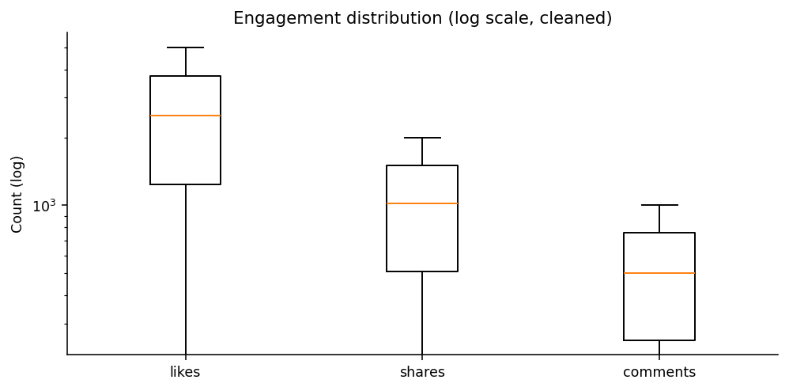
Figure 1. Engagement boxplots on a log scale (outliers hidden). Caps sit near 5,000 / 2,000 / 1,000.
Inference: likes, shares, and comments look like bounded draws, not heavy-tailed social engagement. Zero engagement is rare (1 post with 0 likes among valid likes; 5 with 0 shares; 13 with 0 comments). Dropping rows with missing likes would discard 19.4% of unique posts.

6.2 Platform
Platform | Raw posts | Unique posts | Share of unique | Mean likes | Mean shares | Mean comments
Facebook | 2,135 | 2,074 | 17.28% | 2,526.55 | 984.17 | 506.94
YouTube | 2,136 | 2,073 | 17.28% | 2,528.33 | 1,011.83 | 504.38
Twitter | 2,119 | 2,049 | 17.08% | 2,439.87 | 1,005.39 | 506.13
Reddit | 2,086 | 2,031 | 16.93% | 2,487.80 | 1,002.23 | 511.18
Instagram | 2,038 | 1,989 | 16.58% | 2,494.51 | 1,040.84 | 499.80
Missing | 1,846 | 1,784 | 14.87% | 2,480.82 | 998.61 | 496.54

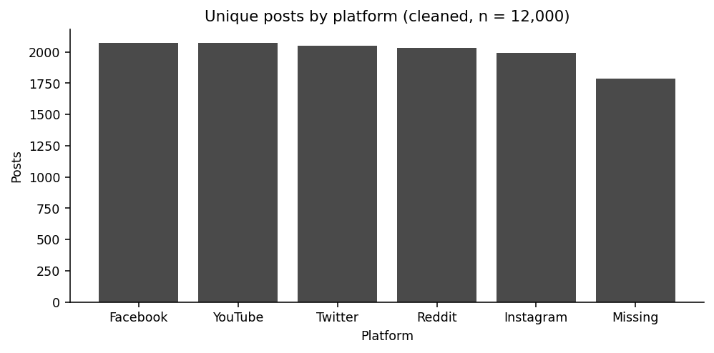
Figure 2. Unique posts by platform, including Missing.
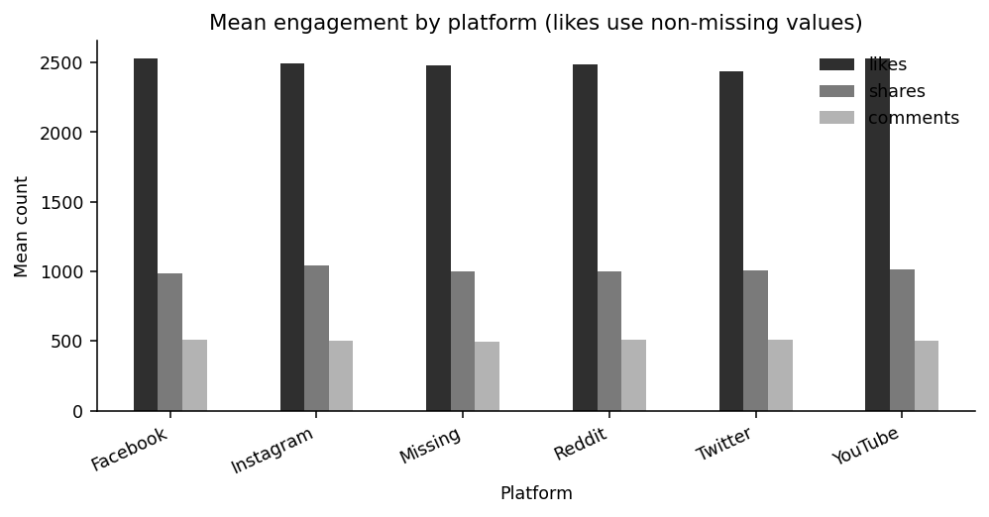
Figure 3. Mean likes, shares, and comments by platform.
Inference: named platforms are nearly even (16.6–17.3%). Missing platform is almost as large as any named platform (14.87%). Mean likes only range from 2,439.87 to 2,528.33. Platform is not a strong splitter of engagement.

6.3 Time
Parsed timestamps cover 1 May 2024 through 30 April 2025 inclusive (365 distinct dates; 0 gaps). On cleaned unique posts, daily volume mean is 32.88, median 33, minimum 18, maximum 54. (Including the 360 duplicate rows, daily mean would be 33.86 and maximum 59.)
Month | Posts
2024-05 | 1,038
2024-06 | 979
2024-07 | 996
2024-08 | 1,015
2024-09 | 974
2024-10 | 1,029
2024-11 | 1,025
2024-12 | 1,035
2025-01 | 1,007
2025-02 | 914
2025-03 | 1,013
2025-04 | 975

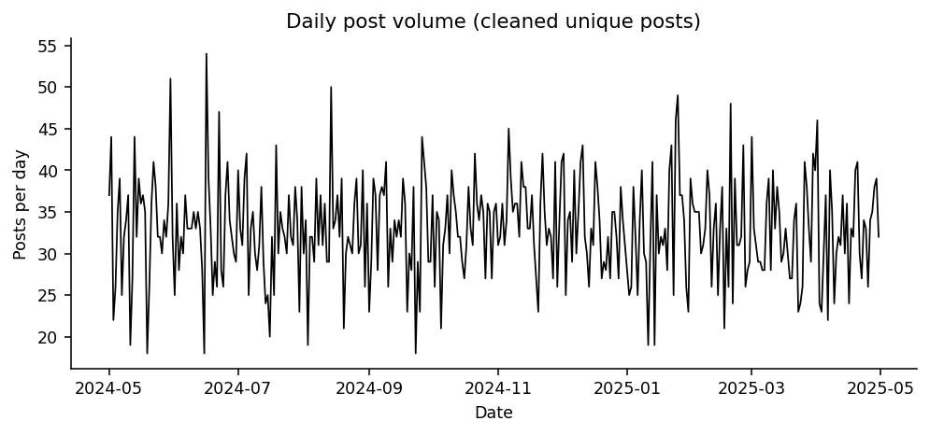
Figure 4. Daily post volume after de-duplication.
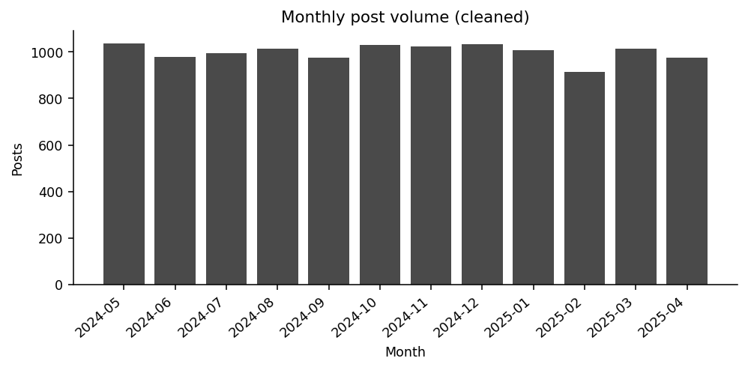
Figure 5. Monthly post volume. February 2025 is lowest (914), consistent with a shorter month.
Weekday | Posts | Mean likes
Monday | 1,720 | 2,487.69
Tuesday | 1,677 | 2,468.99
Wednesday | 1,771 | 2,510.90
Thursday | 1,718 | 2,479.43
Friday | 1,723 | 2,473.39
Saturday | 1,675 | 2,502.05
Sunday | 1,716 | 2,531.63

Inference: posting is steady. Weekdays are close to even (1,675–1,771). Mean likes stay in 2,469–2,532. The intake looks like a continuous stream, not bursty campaigns.

6.4 Text
Among non-missing raw text: 10,520 posts contain hashtags and 1,415 contain @-mentions. After cleaning, the most frequent hashtags are evenly sized marketing tokens (Reviews 750, Fitness 749, BestValue 732, Eco 723, SpecialOffer 723). That evenness suggests generated review-style content.

7. Statistical summary — users
Metric | follower_count
Count | 1,500
Missing | 0
Mean | 24,964.02
Std. deviation | 14,185.48
Minimum | 109
25th percentile | 12,771.75
Median | 24,741.50
75th percentile | 37,097.25
Maximum | 49,944
Skewness | 0.016
Negative values | 0

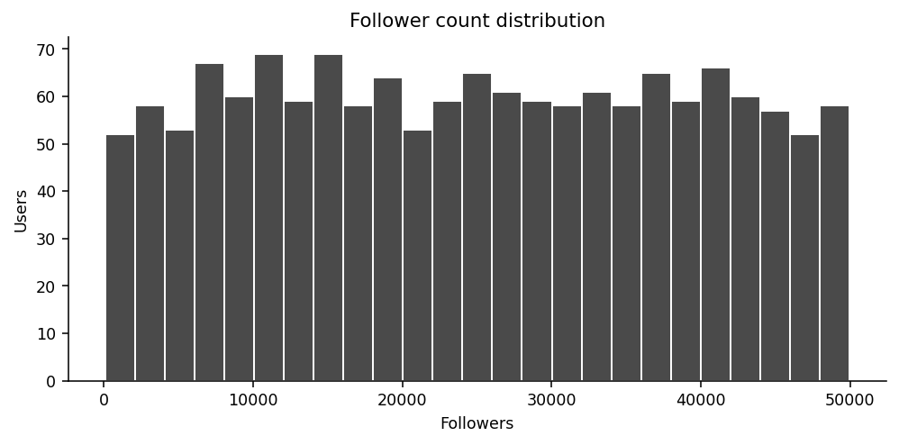
Figure 6. Follower counts are nearly symmetric around ~25,000, with a cap near 50,000.
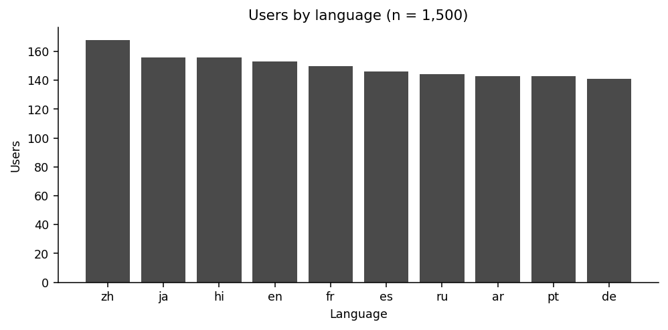
Figure 7. Language codes are almost uniform (141–168 users each).
Account created dates run from 1 January 2023 to 31 December 2023. There are 10 language codes and 33 locations. Users by language: zh 168, ja 156, hi 156, en 153, fr 150, es 146, ru 144, ar 143, pt 143, de 141. Largest cities: Shanghai and Barcelona (56 users each).
Country / territory (from location) | Users
USA | 203
China | 107
Germany | 97
Italy | 96
Japan | 94
Brazil | 93
Spain | 92
India | 92
UK | 86
Canada | 83
France | 82
Australia | 80
UAE | 53
Singapore | 49
South Africa | 48
Mexico | 40
Egypt | 39
South Korea | 36
Nigeria | 30

Inference: follower_count is unlike a typical right-skewed social graph. Combined with even languages and platforms, the user base looks synthetically balanced.

8. User posting behaviour
Posts per user (cleaned) | Value
Users with ≥1 post | 1,500 / 1,500
Mean | 8.00
Std. deviation | 2.85
Minimum | 1
25th percentile | 6
Median | 8
75th percentile | 10
Maximum | 22
Share of posts from top 10 users | 1.47%
Share from top 50 users | 6.25%
Share from top 100 users | 11.61%

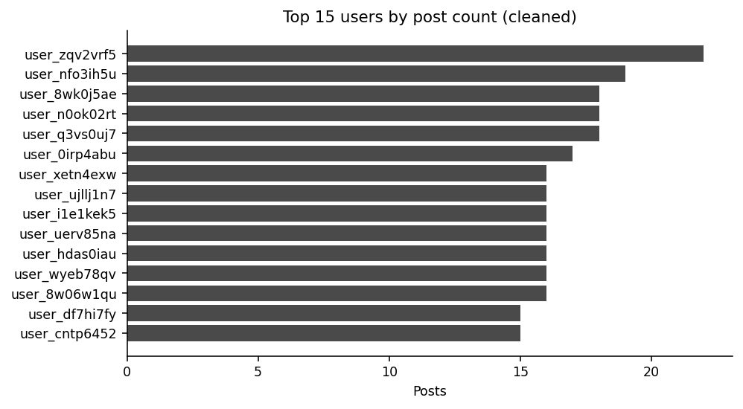
Figure 8. Top 15 users by posts. Activity is only mildly concentrated.
Inference: the busiest user has 22 posts; the top 100 users write 11.61% of posts. Mean posts per user of exactly 8.00 on 12,000 posts and 1,500 users is consistent with a designed panel.

9. Cross-dataset analysis

9.1 Correlation (pairwise complete observations)
 | likes | shares | comments | follower_count
likes | 1.000 | −0.003 | 0.013 | 0.008
shares | −0.003 | 1.000 | 0.024 | −0.014
comments | 0.013 | 0.024 | 1.000 | 0.000
follower_count | 0.008 | −0.014 | 0.000 | 1.000

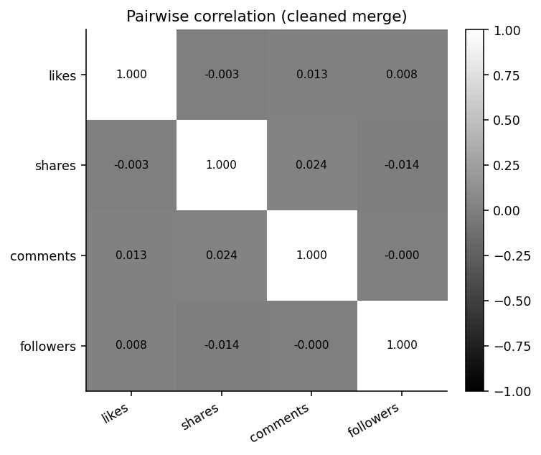
Figure 9. Correlation heatmap. Associations are essentially null.
Inference: followers do not track likes (r = 0.008). Likes, shares, and comments are uncorrelated (|r| ≤ 0.024). Correlation is descriptive only; it is not causation.

9.2 Mean engagement by follower quartile
Follower quartile | Mean likes | Mean shares | Mean comments
Q1 (lowest followers) | 2,462.17 | 1,023.39 | 504.78
Q2 | 2,503.50 | 1,002.34 | 505.51
Q3 | 2,500.71 | 999.57 | 499.41
Q4 (highest followers) | 2,508.16 | 1,003.37 | 507.68

Inference: moving from the lowest to highest follower quartile changes mean likes by only about 46 points on a ~2,500 scale.

9.3 Mean likes by profile language
Language | Posts | Mean likes | Mean shares | Mean comments
en | 1,220 | 2,571.37 | 997.11 | 504.18
ar | 1,123 | 2,544.39 | 1,032.73 | 495.48
ja | 1,298 | 2,509.30 | 995.97 | 510.10
zh | 1,369 | 2,506.07 | 1,022.98 | 500.12
fr | 1,156 | 2,498.82 | 980.25 | 519.76
pt | 1,132 | 2,491.87 | 1,036.90 | 509.70
ru | 1,119 | 2,484.44 | 991.12 | 512.72
de | 1,149 | 2,472.33 | 1,003.82 | 498.80
es | 1,143 | 2,459.46 | 1,032.32 | 488.74
hi | 1,291 | 2,398.82 | 981.56 | 503.90

Highest location-level mean likes: Cairo 2,635.98; Barcelona 2,629.68; London 2,610.65. Lowest among locations checked: Lyon 2,325.58; Seoul 2,369.79; Johannesburg 2,389.94.

10. Findings for the restored intake
1. The post table was the corrupted intake. The user table did not need row-level repair.
2. De-duplication (12,360 → 12,000) and converting 525 negative likes to missing restore consistency without fabricating replacements.
3. Time coverage is complete for one year with stable daily volume. Mixed timestamp formats were a representation problem.
4. Engagement and follower fields look independently generated and range-bounded.
5. Platform, language, and location are balanced. Missing platform (~15%) should stay unknown, not redistributed.
6. Text is hashtag-heavy promotional copy. Keep missing text as missing.

11. Reproducibility
DataVortexEDAR1.ipynb loads both CSVs, profiles missingness, counts duplicate IDs and negative likes, parses the three timestamp formats, cleans reversible text corruption, drops duplicate post_id rows, joins users on user_id, and writes cleaned CSVs. Figures in this report were generated from the cleaned unique-post table (dataset1_cleaned_posts.csv / Final_dataset.csv) and db1.csv / db2.csv.

12. Rulebook compliance (Phase 1)
Requirement | How it is met
Cleaned dataset (CSV/JSON) | 12,000 posts, 1,500 users, 12,000-row Final_dataset.csv
EDA report | This document: quality, cleaning, statistics, plots, inferences
Code notebook | DataVortexEDAR1.ipynb
Justify transformations | Section 4
State assumptions | Section 4.1
No fabrication | No imputed platform, text, or likes

