Chicago Divvy Bikeshare 2024 – Exploratory Data Analysis Report

# 1. Introduction

This report presents an exploratory data analysis (EDA) of the 2024 Chicago Divvy bikeshare dataset. The purpose of the analysis is to uncover seasonal patterns, compare user behavior between casual riders and annual members, and generate insights to support business and operational decisions.  
  
The dataset was obtained from the official Divvy bikeshare data for 2024. The analysis was conducted using Python, Pandas, Matplotlib, Seaborn, and Google Colab.

# 2. Data Preparation

- Monthly trip data files (Jan–Dec 2024) were merged.  
- Data cleaning included handling missing values, correcting datetime formats, removing fractional seconds, and calculating trip duration in minutes.  
- User types were categorized as 'member' or 'casual'.  
- Final dataset contained 5 millions of rows after cleaning.

# 3. Exploratory Data Analysis

## 3.1 Seasonal Trends

The analysis shows that trip volume increases significantly during the summer months (July–August), while the lowest usage is observed in winter months (December–February).

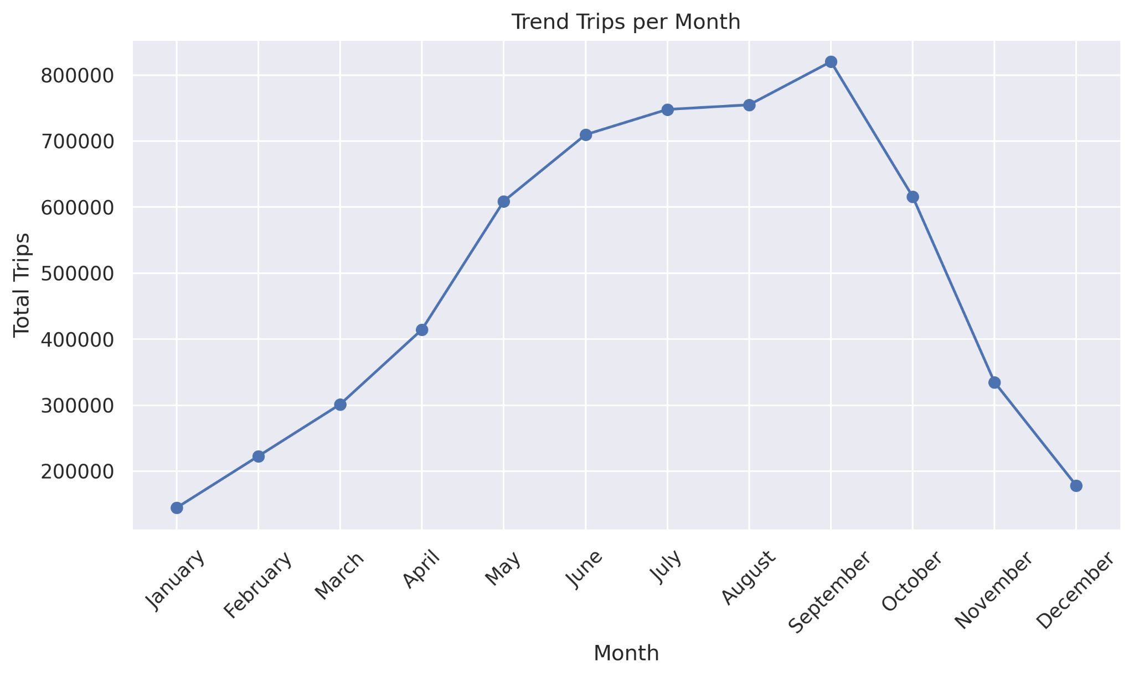

## 3.2 User Type Comparison

- Members consistently take more trips than casual riders.  
- Casual riders, however, take longer trips on average.  
- Members’ behavior indicates bikeshare is primarily used for commuting (short and frequent trips).

- Casual riders show patterns aligned with leisure and tourism (longer trips, concentrated in summer).

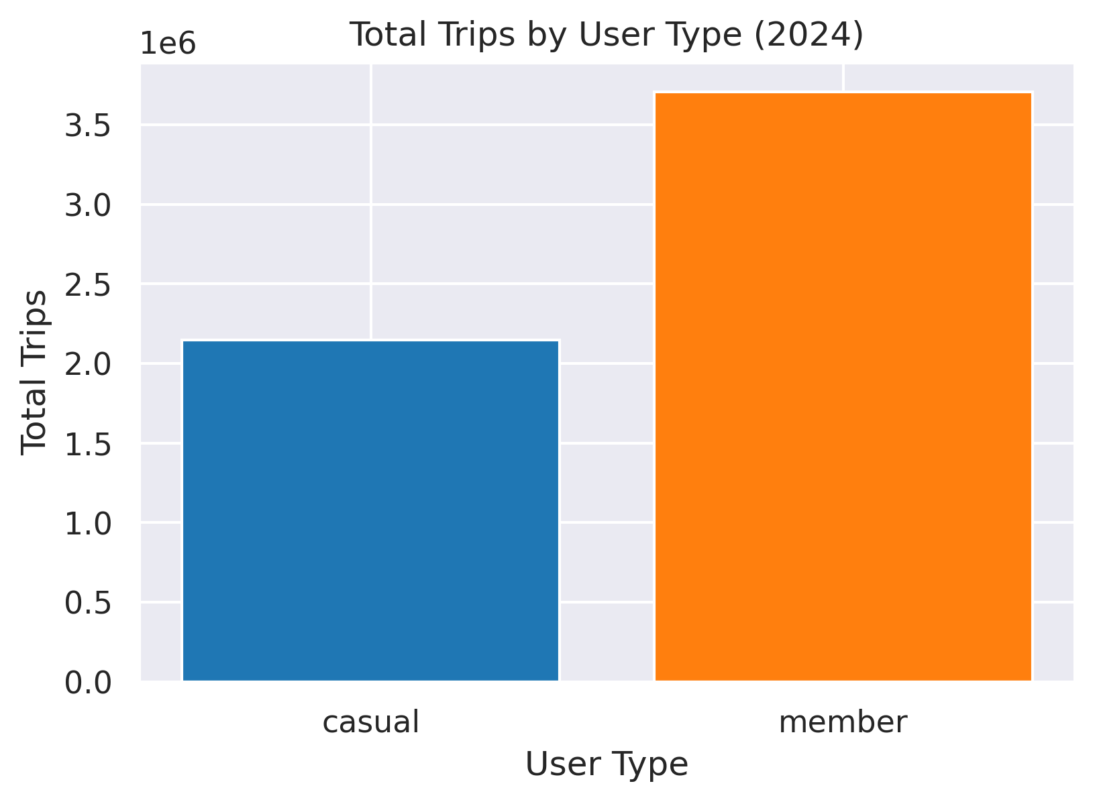

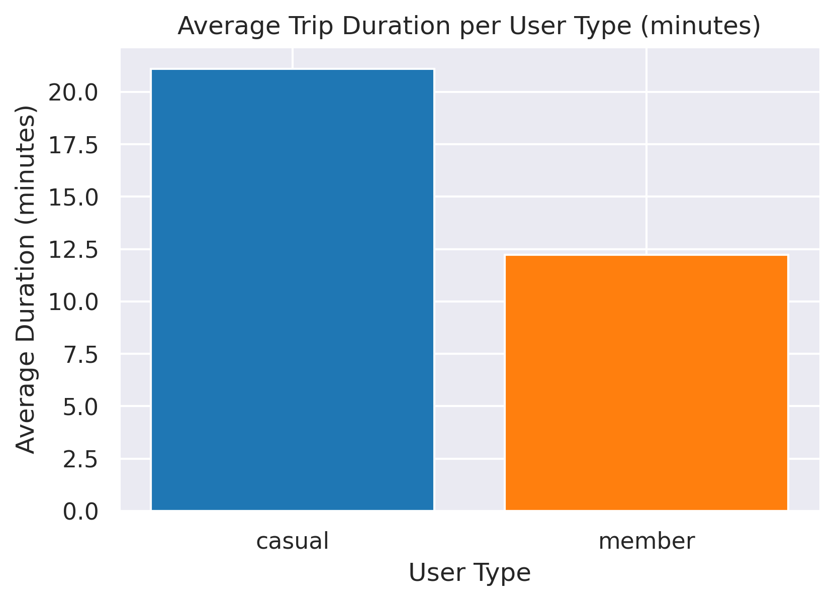

## 3.3 Day of Week Trends

- On weekdays, members dominate usage, consistent with commuting.  
- On weekends, casual rider activity increases, reflecting recreational trips

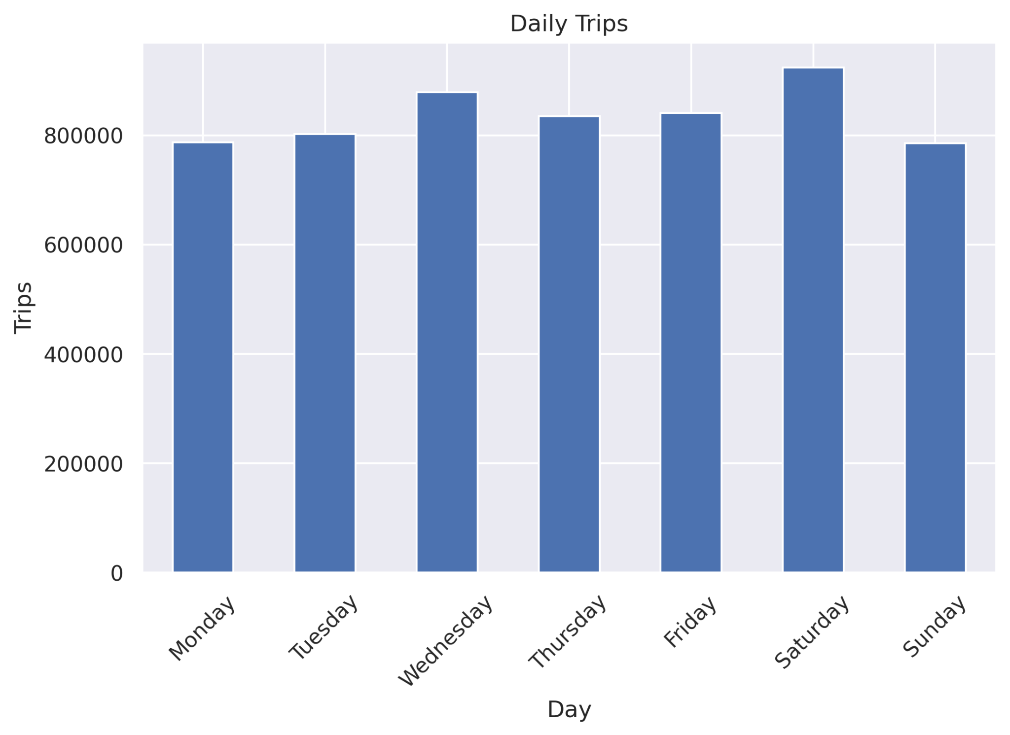

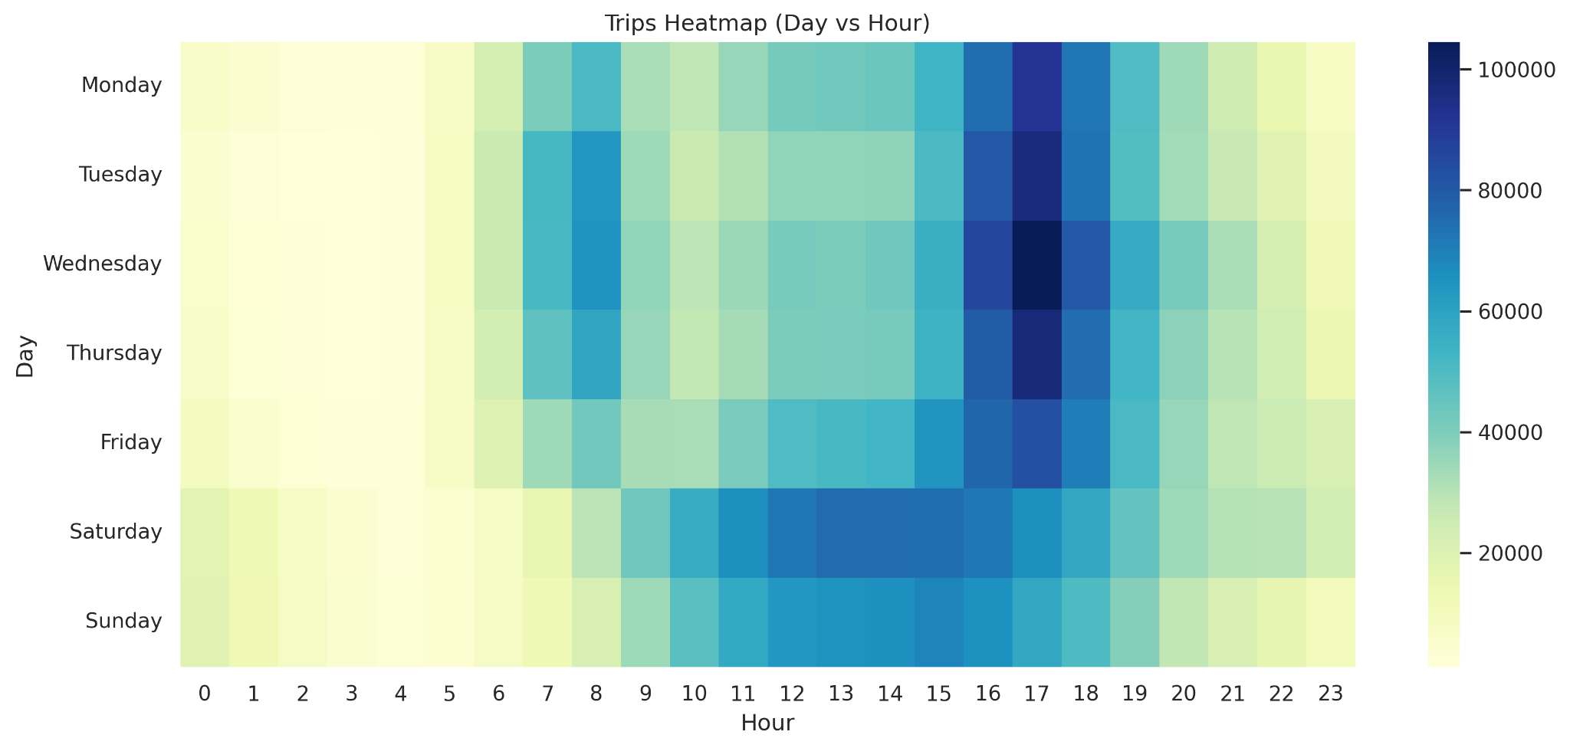

# 4. Key Insights

1. Clear seasonality exists in bikeshare usage, with peaks in summer months.  
2. Members provide a stable usage base across the year.  
3. Casual riders significantly contribute during peak months and weekends.

# 5. Business Recommendations

- Target casual riders with summer promotions (tourism packages, group discounts).  
- Strengthen member loyalty programs to retain consistent user base.  
- Allocate more bikes and rebalance operations during July–August.  
- Partner with tourism boards for peak-season promotions.

# 6. Conclusion

The analysis highlights distinct behaviors between casual and member riders, strongly influenced by seasonality. Members provide stable usage throughout the year, while casual riders contribute significantly during summer months with longer trip durations. These insights can guide operational planning and marketing strategies to optimize bikeshare service performance and customer satisfaction.

Prepared by: [Marsel Luase]