IT Girls

# Lab 02

## Overview

Go over the elements of an HTML page in more detail and create a BLOG webpage.

## This lab covers:

1. What is an HTML tag/element?
2. Applying Basic HTML Elements

## What is an HTML tag/element?

We’ve already seen some the required elements/tags for a basic HTML page. But let's take a step back and review basic building blocks of HTML.

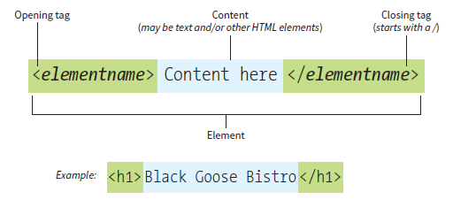

HTML elements are made up of:

* opening tags that start with the < symbol and end with the > symbol
* closing tags that add a / after the < symbol

A tag can define a paragraph, display an image, define a section of the document, etc. The example tag above says that the text "Black Goose Bistro" is going to be a heading on the page. The browser has a default way of displaying anything marked as a header and it will be bolder and larger than normal text.

## Basic HTML Elements

Let’s add some of these HTML elements/tags to the bio page we made. Here's a list of the html elements we will add to our bio first.

|  |  |  |
| --- | --- | --- |
| **Tag** | **Use** | **Example** |
| h1 | Most important heading | <h1>Page Title</h1> |
| h2 | Second most important heading | <h2>Section Title</h2> |
| p | Paragraph | <p>Lots of text.</p> |
| strong | Define important text | <strong>Important</strong> |

We will add these to the bio to describe different parts of our content.

1. Open the index file you created in VS Code. You can do this by launching VS Code and going to File -> Open File and locating your index file.

Here's what mine looks like right now:

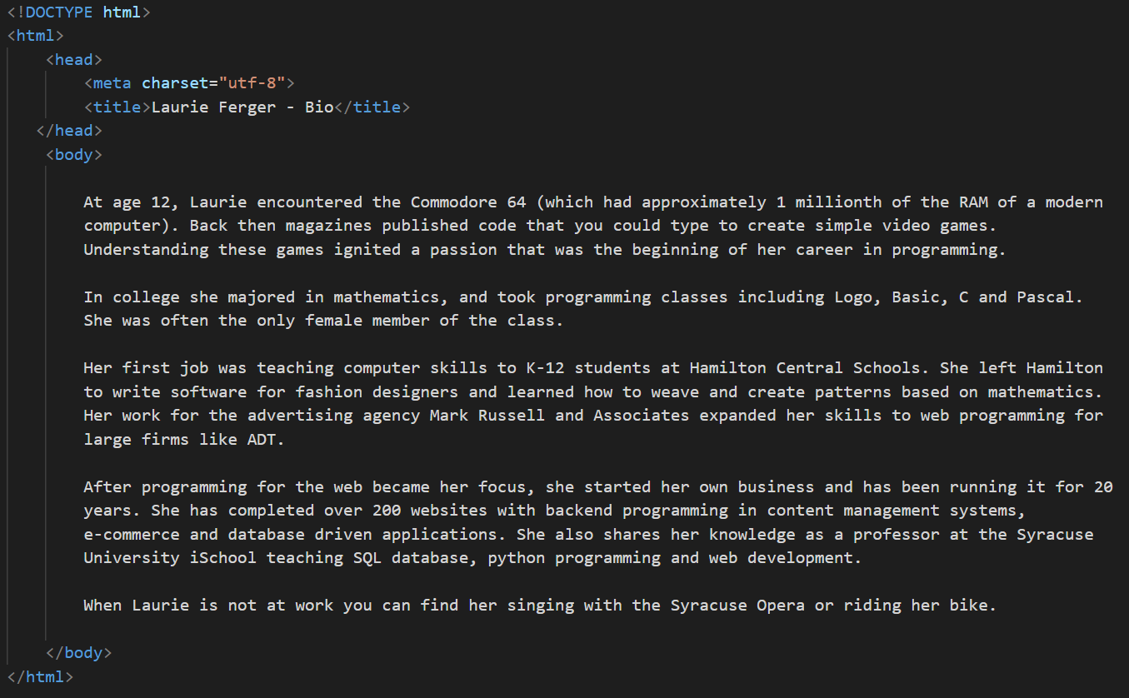

1. Remember all the content on an HTML page goes inside the <body></body> tags. We are going to add a heading to our bio using the h1 tag. At the top of your content add <h1> [Your Name's] Biography</h1>.   
     
   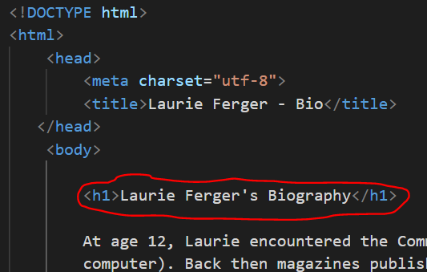  
     
   Note: Students often confuse the title and h1 elements. Title changes what displays on the tab at the top of your browser. It does not display in the main content area of the browser. H1 is used for the biggest title in the content area of your browser.
2. We also need to identify the paragraphs in our HTML document. We do this with the <p> tag. Add an open and close <p> tag at the beginning and end of all your paragraphs in the bio. This tells the browser where the paragraphs start and end.  
   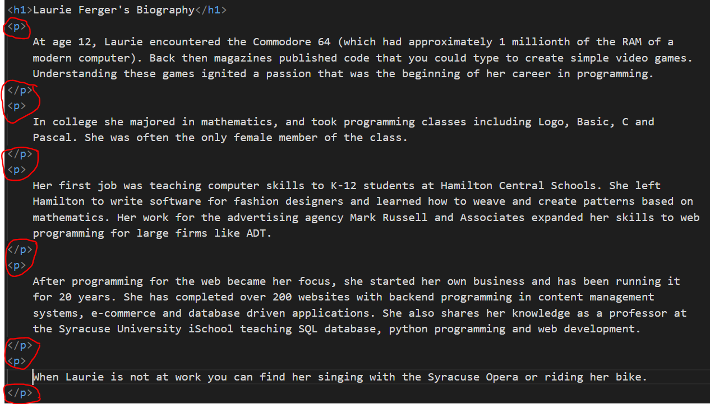
3. Let's add a subheading showing where our personal information is written to help break up the bio. Add a subheading called Personal info before the paragraph where you wrote that. Make sure to put it inside <h2> tags.
4. Find some important text on your page that you would like to emphasize. I choose the text "Commodor 64". Add the <strong> tags around that text.

Here's what the code inside my body tags looks like right now:

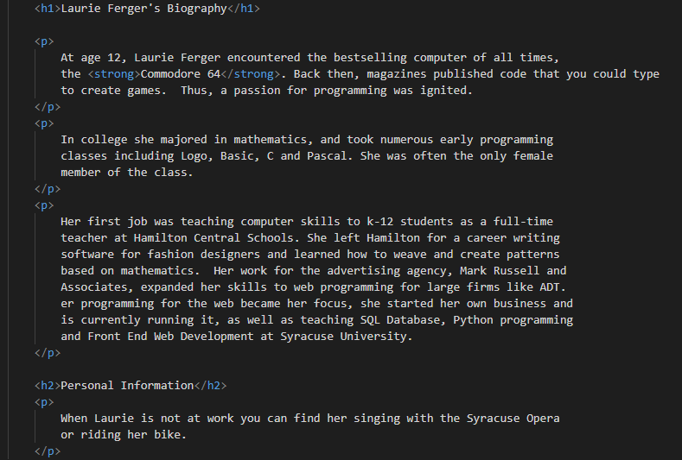  
Notice some of the tags are nested. That means a tag inside another tag. For example, the <strong> tag is inside the <p> tag. We'll talk more about tag nesting later, but for now I just want you to be aware that this happens.

### Uploading to Github and viewing your page changes on the web

1. Go to: <https://github.com/>
2. Click the Sign In Link on the top right and login with your username and password.
3. Click your repository from the list on the left.
4. Click add file -> upload files to upload the changes you just made. When you are done press the commit changes button.
5. The url to view your page is:  
   https://suitgirls.github.io/YourSyracuseUsername