Alex Chen
CS 32
Project 2 Report

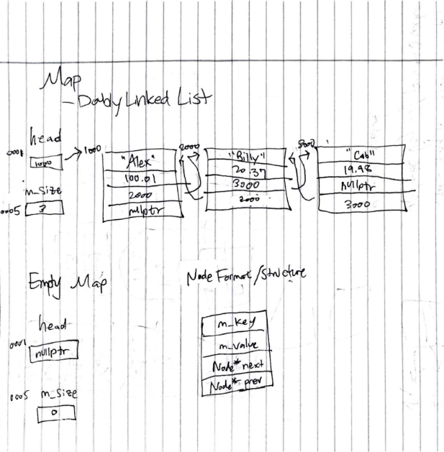
- My doubly linked list implementation contains as many nodes as created that are linked by next and previous pointers (named “next” and “prev”). Each node also has a key and value pair (named “m_key” and “m_value”). The first Node of the doubly linked list is pointed to by the “head” pointer. The linked list is not circular, as the first Node does not point to the last Node, but rather, points to nullptr, and likewise, the last Node points to nullptr, rather than the first node. The list also does not have a dummy node – the first node is the start of the stored key value pairs. The nodes are not in any particular order; the only ordering convention is that when nodes are inserted, they are inserted to the end of the linked list.

- Map::Map(const Map& src)
Initialize m_size and head (head to nullptr)
Traverse through src linked list, inserting each key and value pair into this linked list

Map& Map::operator=(const Map& src)
Delete all elements in linked list, set head = nullptr
Traverse through src linked list, inserting each key and value pair into the linked list
Return this object

bool Map::insert(const KeyType& key, const ValueType& value)
if no Nodes exist
allocate new Node and assign key, value, next, and prev
increment size
else
traverse through list, returning false if a Node’s key is equal to key
if no Nodes have same key
allocate new Node and assign key, value, next, and prev
increment size

bool Map::erase(const KeyType& key)
if no elements exist
return false
else if one element exists and element contains key
delete Node, set head to nullptr, decrement size
else
traverse through list until key is found
make a copy of Node, assign key, value, next, and prev
decrement size

bool combine(const Map& m1, const Map& m2, Map& result)
copy one map into result
traverse through other map
compare each key and value to key and value pairs in result
if key matches but values do not, remove key value pair from result
if key not found, insert key and value pair to result

void reassign(const Map& m, Map& result)
if m and result point to same Map, return
copy m into result
traverse through first half of result
swap values for each key pair with values in second half of result

- Tests performed on a map from strings to doubles.

#include "Map.h"
#include <iostream>
#include <cassert>

int main()
{
Map m; // new map
assert(m.size() == 0 && m.empty()); // test size() and empty()
assert(m.insert("Alex", 5.23)); // test insert()
assert(m.size() == 1); // insure insert increments size
assert(m.contains("Alex")); // test contains()
KeyType k; // string to be used for tests
ValueType v; // double to be used for tests
assert(m.get("Alex", v) && v == 5.23); // test get(string, double)
assert(m.get(0, k, v) && k == "Alex" && v == 5.23); // test get(i, string, double)
assert(m.update("Alex", 3.02)); // test update()
assert(m.get("Alex", v) && v == 3.02); // test get(string, double) after update()
assert(m.insert("Billy", 4.11) && !m.empty() && m.size() == 2); // test insert() and empty() and size() after insertion()
assert(m.get("Billy", v) && v == 4.11);
assert(m.get(1, k, v) && k == "Billy" && v == 4.11);
assert(!m.get(2, k, v) && !m.get("slfkj", v)); // test failure of get(i, string, double) and get(string, double)
assert(m.contains("Billy")); // test contains()
assert(!m.update("aldskj", v)); // test failure of update()
assert(m.insertOrUpdate("Alex", 10.2)); // test insertOrUpdate when key exists
assert(m.insertOrUpdate("Casey", 100.01)); // test insertOrUpdate when key does not exist
assert(m.insertOrUpdate("Don", 23.4));

Map test = m; // test copy constructor
assert(test.size() == 4);
assert(test.get("Alex", v) && v == 10.2);

// test erase on all elements in list
assert(m.erase("Don"));
assert(!m.erase("Esuc"));
assert(m.erase("Billy"));
assert(m.erase("Casey"));
assert(m.erase("Alex"));

assert(m.size() == 0);
assert(m.insert("Elaine", 4.002));
assert(m.insert("Foo", 23.09));
Map test2 = m;
assert(test2.size() == 2);
m = test; // test assignment operator
assert(m.size() == 4);
assert(test.size() == 4);
assert(m.get("Alex", v) && v == 10.2);
m.swap(test2); // test swap()
assert(m.size() == 2); // ensure test worked
assert(m.get("Foo", v) && v == 23.09); // ensure test values swapped
std::cout << "All test cases (1st round) passed!" << std::endl;

Map testing1;
testing1.insert("Alex", 50.2);
testing1.insert("Billy", 404.2);
testing1.insert("Cab", 401.09);
Map testing2;
testing2.insert("Derrick", 909.3);
testing2.insert("Elaine", 43.2);
Map result;
assert(combine(testing1, testing2, result)); // test combine()
assert(result.size() == 5); // ensure size of result is correct
assert(result.get(3, k, v) && k == "Derrick" && v == 909.3);
assert(result.get(1, k, v) && k == "Billy" && v == 404.2);
assert(testing1.insert("Derrick", 909.3));
assert(combine(testing1, testing2, result));
assert(result.size() == 5); // ensure combine works when derrick existed already
assert(testing1.insert("Elaine", 10.1));
assert(testing1.insert("Fos", 22.2) && testing2.insert("Foul", 33.3));
assert(!combine(testing2, testing1, result));
assert(result.size() == 6); // ensure combine works when key is same but value is not
assert(!combine(testing2, testing1, result));
assert(result.size() == 6);
std::cout << "All test cases (2nd round) passed!" << std::endl;

Map result2;
Map testing3 = testing1;
assert(testing3.insert("Gary", 69.3));
reassign(testing3, result2); // test reassign()
assert(result2.size() == 7);
for (int i=0; i<result2.size(); i++) // compare key and value pairs
{
result2.get(i, k, v);
std::cout << k << " " << v << std::endl;
testing3.get(i, k, v);
std::cout << k << " " << v << std::endl;
}
std::cout << "All test cases (3rd round) passed!" << std::endl;

