CprE 3810, Computer Organization and

Assembly Level Programming

Lab 1 Report

Student Name Cai Chen

What the TPU does: X * Y + W = oY

1v. Waveform Picture
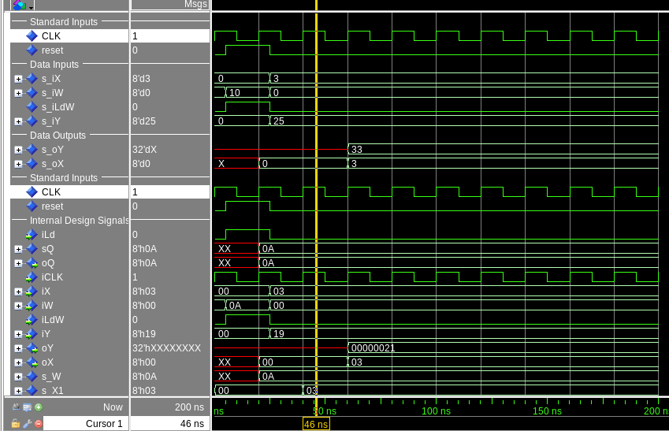
There is a bug here since the MAC is supposed to do (3 * 0) + 25, which equals 25 but on the waveform oY equals 33.

Submit a typeset pdf version of this on Canvas by the due date. Refer to the highlighted language in the lab document for the context of the following questions.

[Part 3.1.c] Think of three more cases and record them in your lab report.

[Part 3.1.e] For labels 1, 7, 22, and 28, specify where (VHDL file and line number) these values are located – some will be found in more than one place. Also attempt to explain the functionality of each label as it occurs in the code

[Part 3.1.f] Implement your test cases from part c into this testbench. Remember to include these in
your waveform screenshot.

[Part 3.1.g.v] In your lab report, include a screenshot of the waveform. Describe, in plain English, any differences between what you expected and what the simulation showed.

[Part 3.1.h] In your lab report, include a screenshot of the waveform. Describe, in plain English, how your waveform matches the expected result (e.g., reference the specific cycles and times). In your submission zip file, provide the completed TPU_MV_Element.vhd file in a folder called ‘MAC’.

[Part 3.3.a] Draw the truth table, Boolean equation, and Boolean circuit equivalent (using only two-input gates) that implements a 2:1 mux. Include this in your lab report.

[Part 3.3.d] In your lab report, include a screenshot of the waveform. Make sure to label the screenshot with which module it is testing.

[Part 3.3.e] Again, in your lab report, include a labeled screenshot of the waveform showing the dataflow mux implementation working.

[Part 3.4] Include a waveform screenshot and corresponding description demonstrating it is working correctly.

[Part 3.5.b] Include a waveform screenshot and description in your lab report.

[Part 3.6.a] A full adder takes three single-bit inputs and produces two single-bit outputs – a sum and carry for the addition of the three input bits. Draw the truth table, Boolean equation, and Boolean circuit equivalent (using only two-input gates) that implements a 1-bit full adder. Include this in your report.

[Part 3.6.c] Then draw a schematic of the intended design, including inputs and outputs and at least the 0, 1, N-2, and N-1 stages. Include this in your report.

[Part 3.6.d] Include an annotated waveform screenshot in your write-up.

[Part 3.7.a] Draw a schematic (don’t use a schematic capture tool) showing how an N-bit adder/subtractor with control can be implemented using only the three main components designed in earlier parts of this lab (i.e., the N-bit inverter, N-bit 2:1 mux, and N-bit adder). How is the ‘nAdd_Sub’ bit used? Include this in your report.

[Part 3.7.c] Provide multiple waveform screenshots in your write-up to confirm that this component is working correctly. What test-cases did you include and why?

