Andrew Chen 2026 02 18
Report for Breathing Lab
Follow the Colab file “HSI Lab 2 – breath rate.ipynb” and record your process and results in this document.
* For each step, provide sufficient explanation of the process of reaching the final result or plot
* For each plot to report, include proper axis labels and units. For each numerical result to report, include proper units
- Load Raw Data
What I did: used np.genfromtxt to load in the data
Plot: 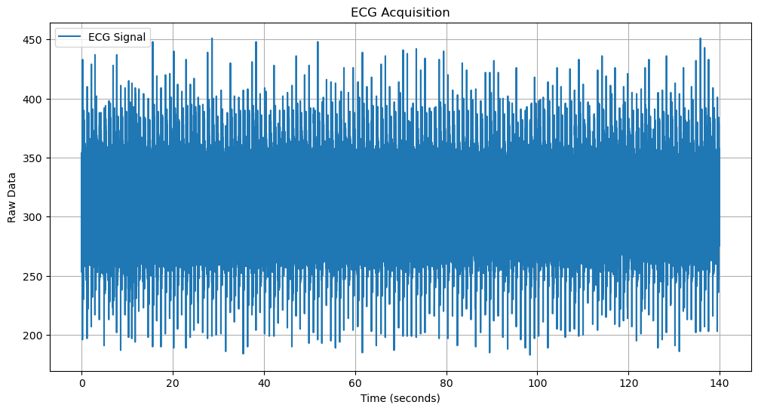

- Apply moving average filter
What I did: Used a moving filter window of 50. I used 5 initially and Professor Adams laughed and suggested I try 50 as a baseline.
Plot: 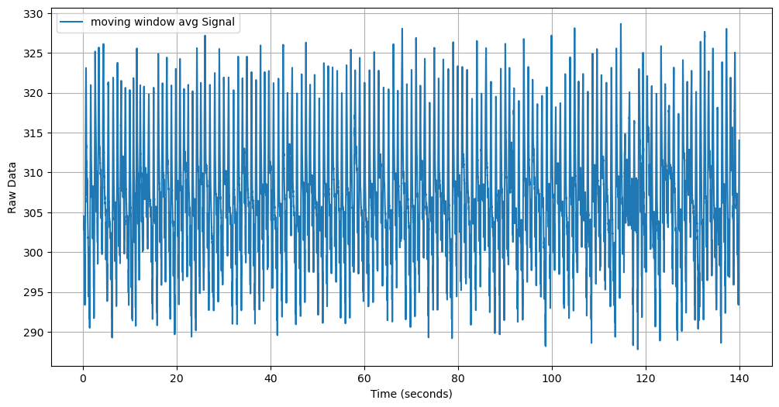

- Apply Savitzky-Golay filter
What I did: Used window size of 500 and a polynomial order of 4. I stayed with 4, as that was recommended by the TA. I played around with the window size until I could see better results.
Plot: 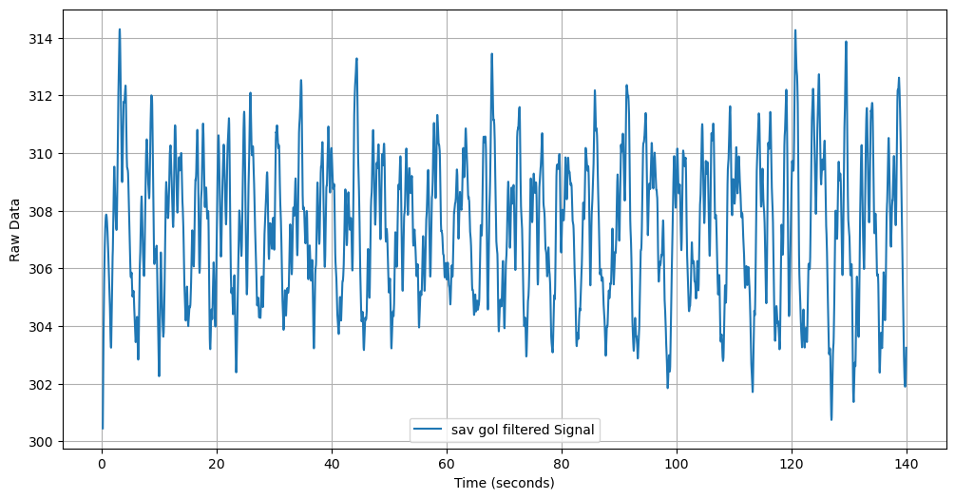

- Apply low-pass filter
What I did: My cutoff for the low-pass filter was 0.5. I figured anything above 0.5 would be unreasonably high.
Plot: 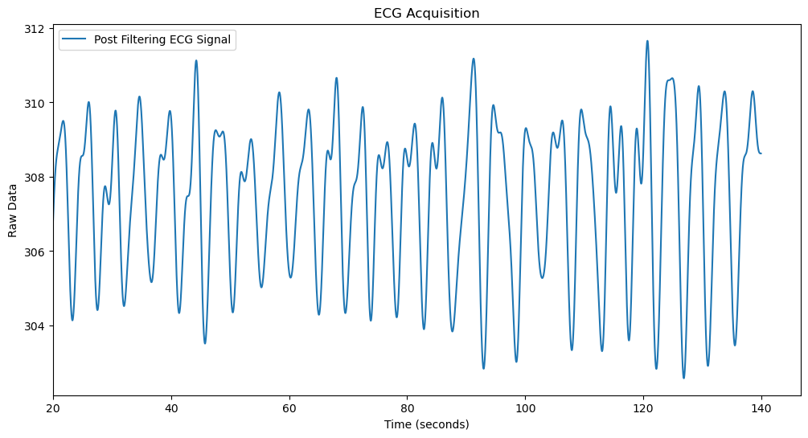

- Normalize data
What I did: Subtracted the mean and divided by standard deviation. Standard normalization.
Plot: 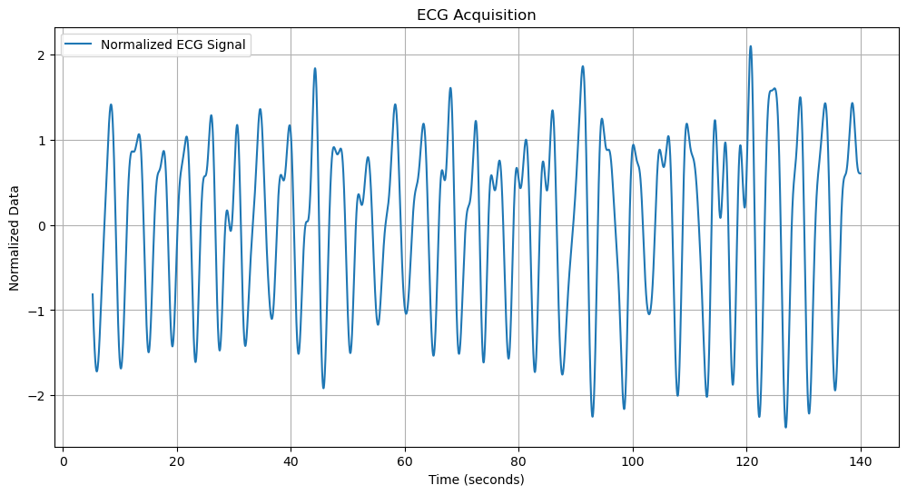

- Perform spectrogram analysis
What I did: used spectrogram() to get f, t, and Sxx values, and used pcolormesh to plot.
Plot: 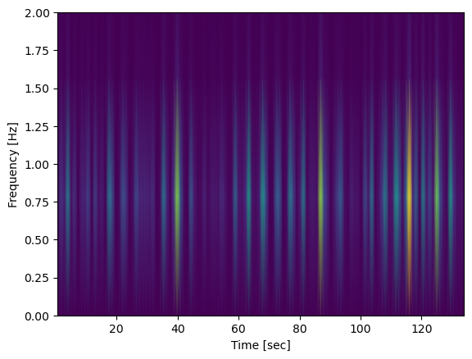
What I observed: Consistent frequency bursts throughout the timeline. Could either be heartbeat or respiration

- Perform Fourier Transform
What I did: calculated fft, and used peak detection to determine the dominant frequency.
Plot: 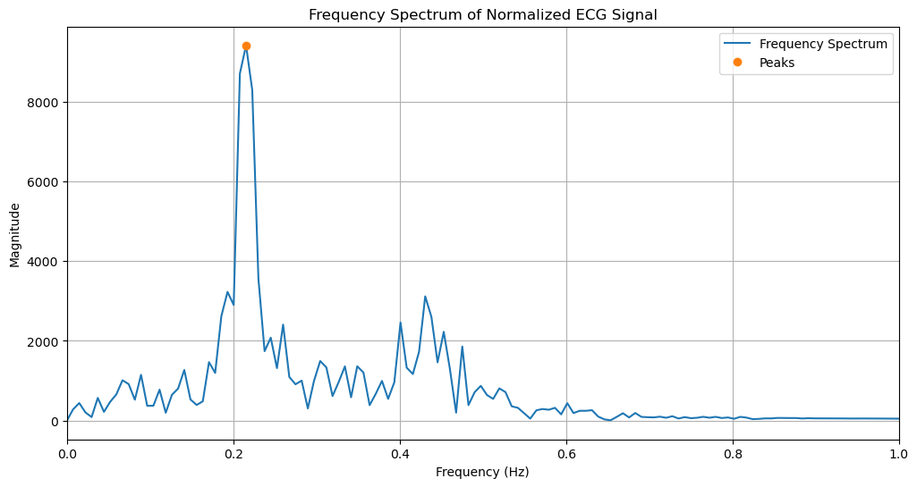

- Calculate Breathing rate
What I did: Multiplied the dominant frequency by 60 to get breaths per minute.
Result: 12.92 breaths per minute

- Alternative Scenario Processing
Walking:
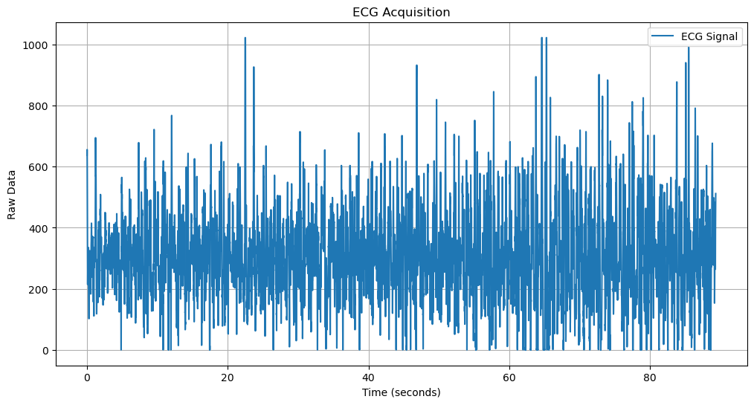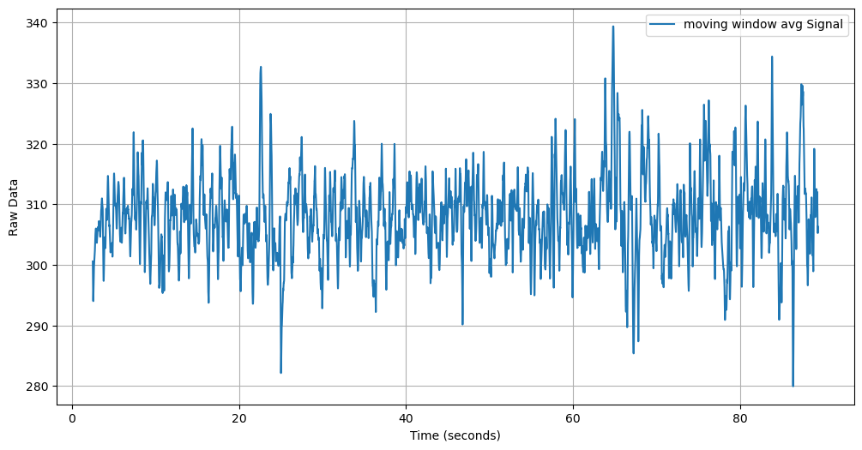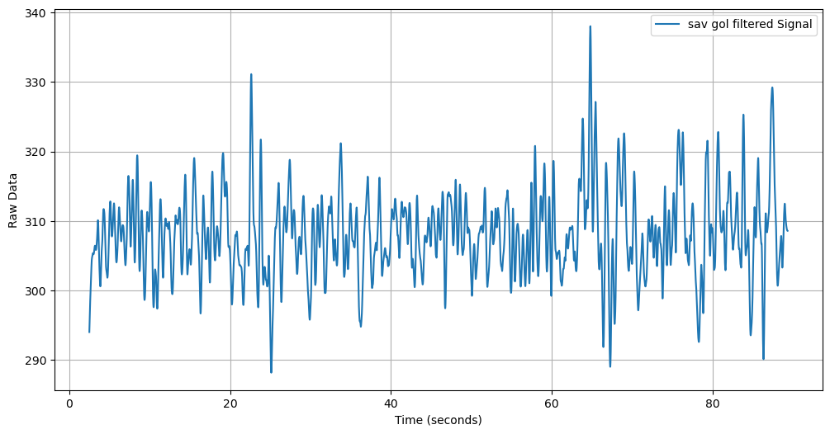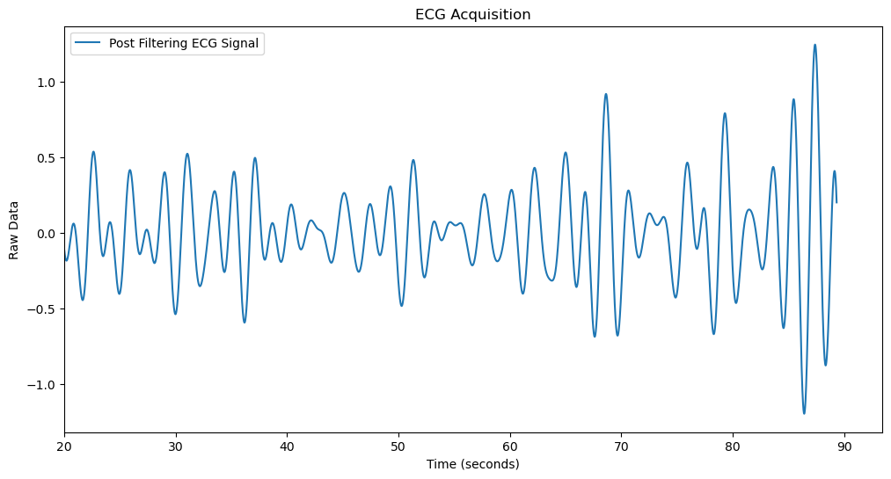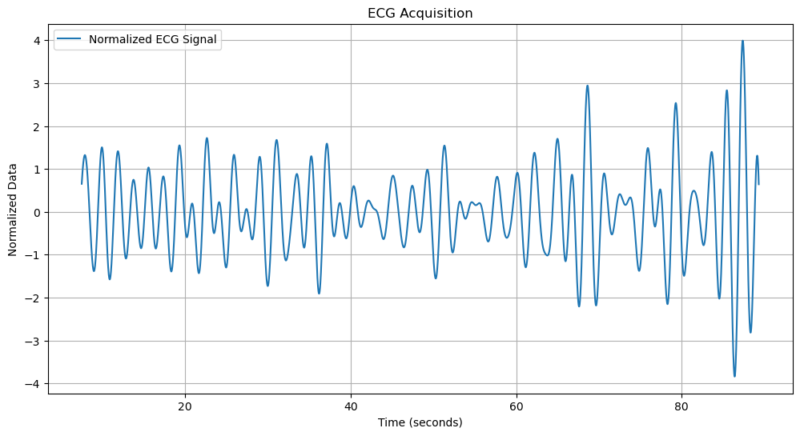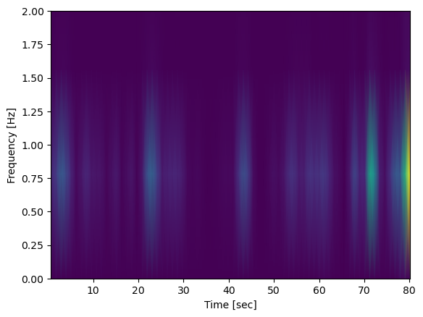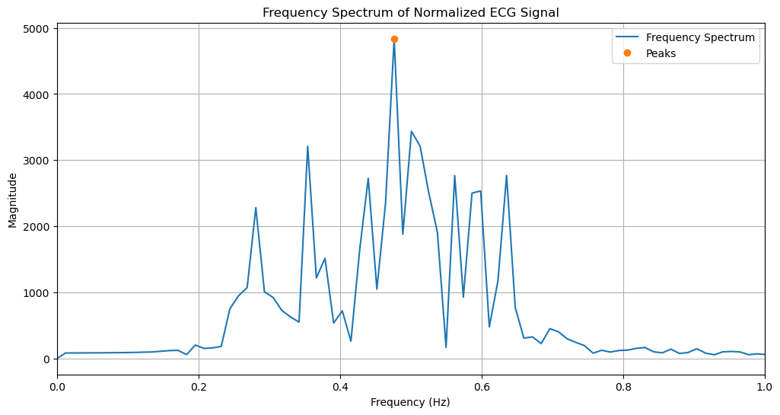
Dominant Frequency: 0.4766 Hz
Breath Rate: 28.59 breaths per minute

Typing:
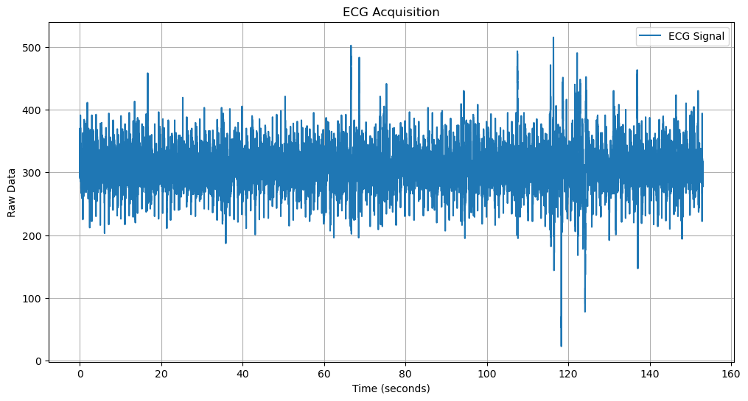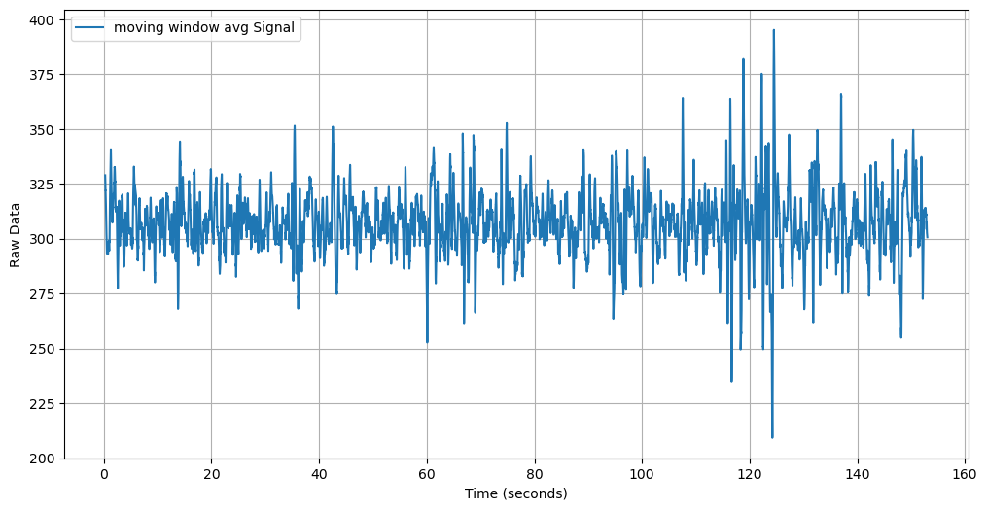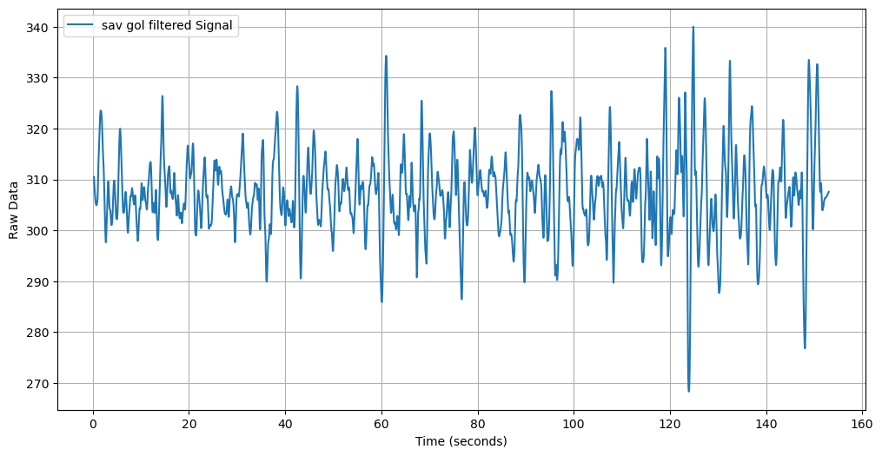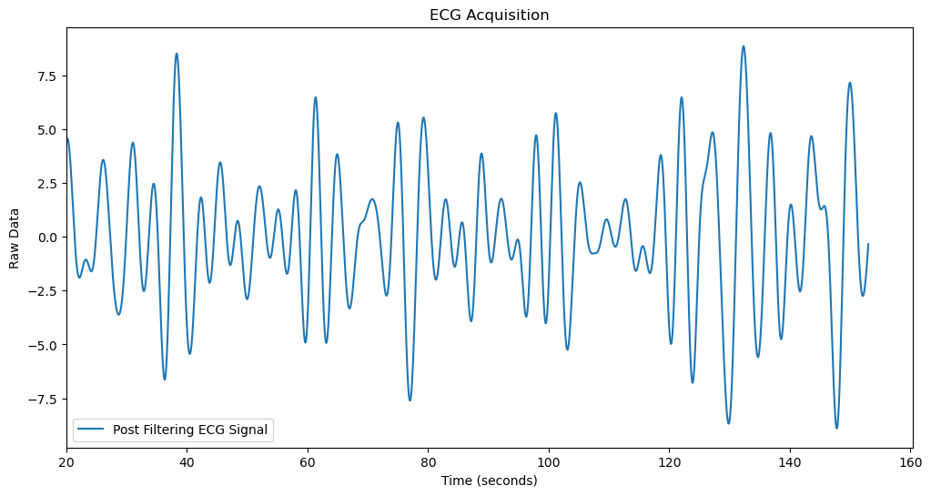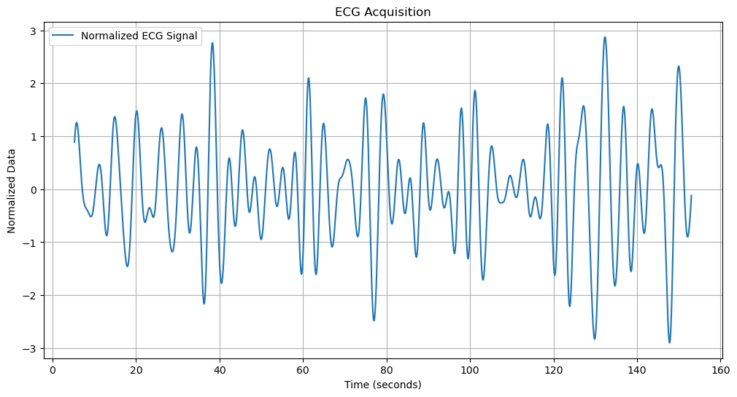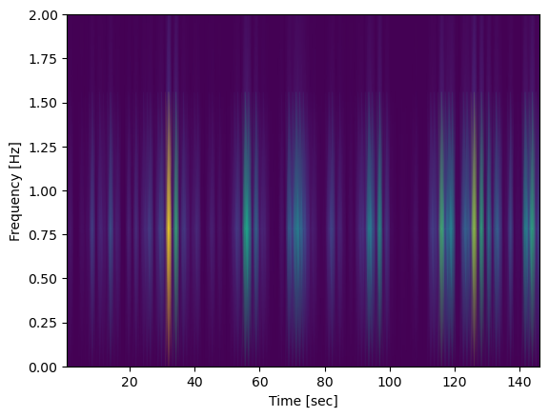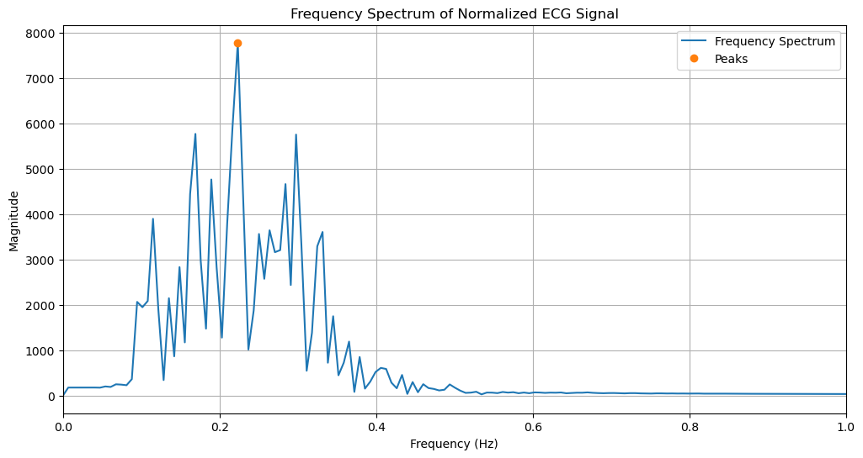Dominant Frequency: 0.2233 Hz
Breath Rate: 13.40 breaths per minute

- Discussion
Comment on the differences in analyzing the different data:
Different datasets were noisy in their own way. I had to approach filtering differently for each dataset. I played with window size, polynomial order, cutoffs, and peak detection differently to extract the cleanest signal.

- Link to Colab file: [Make sure to grant file access to “anyone with the link” to make sure TAs have access to the code]
https://drive.google.com/drive/folders/1xS2171Rs6Dx56Ao6lZ0Ei10gwByyL8ob?usp=sharing

